Table of Content

Installation 1

Locating the Plugin 2

Visibility and Access 2

Functionality Overview 4

Structure 5

General Measures 5

Measures by Tool 9

Forum Measures 11

Quiz Measures 15

BLOCK COURSE STATISTICS

### Installation

To install the plugin, follow these steps:

1. Navigate to Site Administration > Install Plugin.
2. Choose the zip file and upload it.

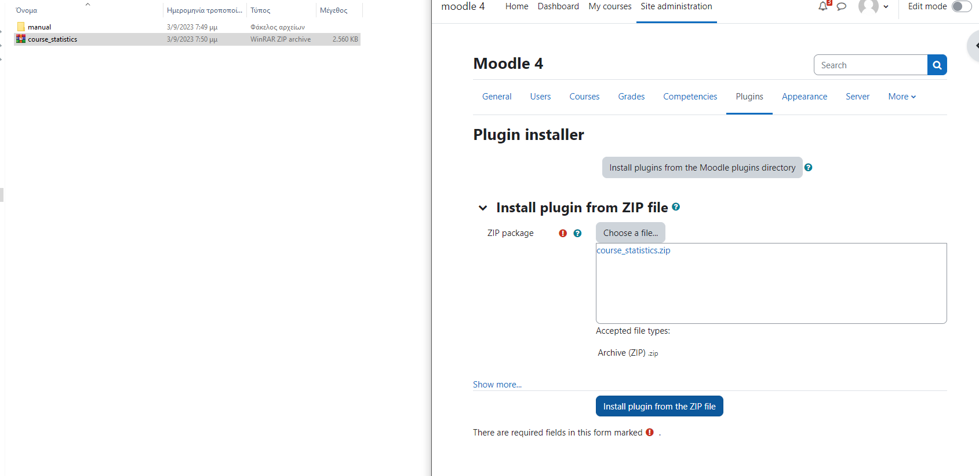

### Locating the Plugin

1. Navigate to Site Administration > Manage Courses and Categories.
2. The plugin will be displayed in the right panel as a block.

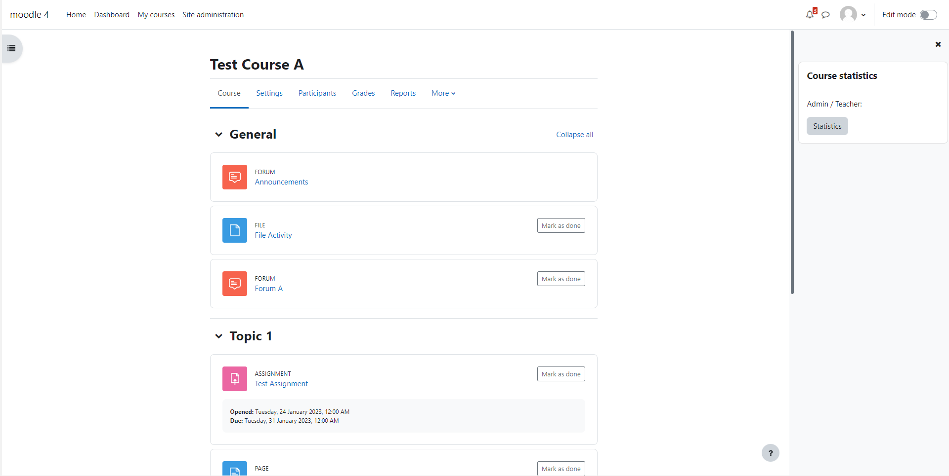

### Visibility and Access

The block is accessible to users with roles such as administrator, course administrator, trainer, and editing trainer. **The block displays statistics for each course that is installed if the option to calculate statistics for the course is enabled in the block configuration settings**.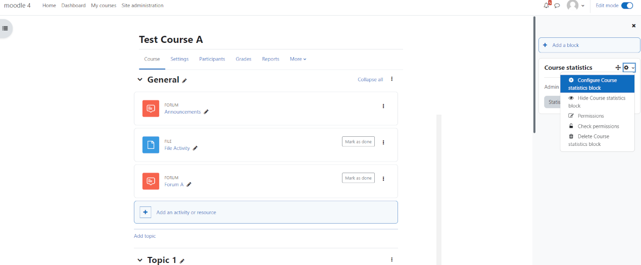

After it is installed, administrators and teachers can view statistics for each course that is defined to measure statistics from the administrator at the configuration settings of the plugin.

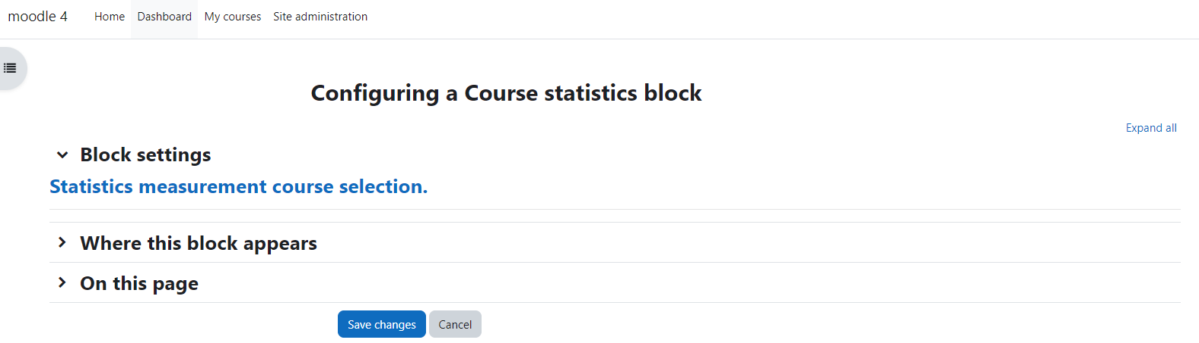

Select Courses for Statistics Calculation.

Data table columns :

* Course Title,
* Course ID, (the index id from mdl_course table),
* Enrolments, (users enrolled in the course),
* Action (The option to measure or not a course)

** The first and last columns doesn’t have a filter option.

** The user to be able to sort the Action column a refresh of page may needed.

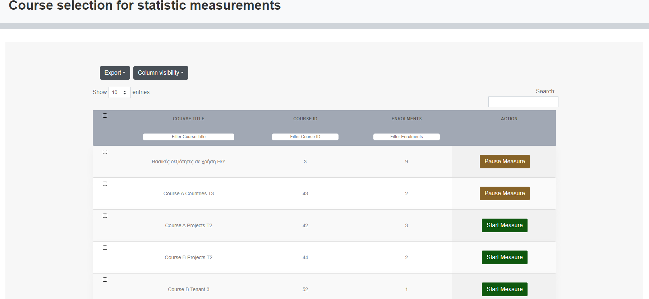

* In this example the administrator has enabled 2 courses to produce statistics. Those two courses will be picked up from the scheduled task and try to find statistics for all users enrolled in these two courses. In case the plugin is installed to a course that is not set to measure statistics at configuration page then the course will show 0 results.

**\*\* *The first run of each course statistics will fetch and save measures from when the course was created and from the first action of a user in it until the last action of his/her. The second run of the scheduled task and every other one, checks the last action of each enrolled user in the course and starts from that point and tries to find any actions of the users if any.***

For teachers, the block must be installed in courses where they have teaching privileges.

Please note that the manuals for admins and teachers are identical.

### Functionality Overview

The block employs a scheduled task called 'Pre-calculate Statistics from Logstore Table' to extract information from Moodle logs and store it in its own tables.

Consequently, the block presents pre-calculated data from Moodle logs. The task is configured to run once a day to collect data from the logs.

**How time calculation works.**

The scheduled task retrieves all user activity entries (start of activity sessions). For each entry, the task attempts to identify the next action taken by the user away from the activity. This action is captured from the logstore and marks the end of the activity session. Consequently, activity sessions may extend for considerable durations. To manage this, all session durations are compared against the system's session timeout value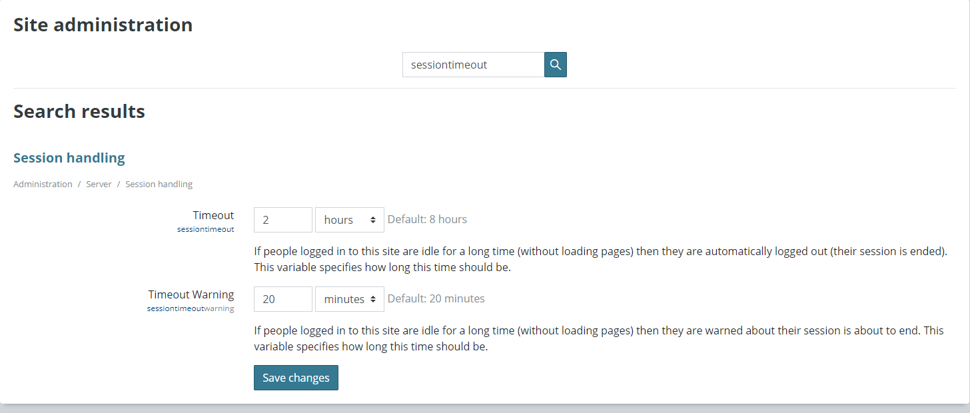

Admin can modify the scheduled task time at Site Administration > Server > Scheduled Tasks.

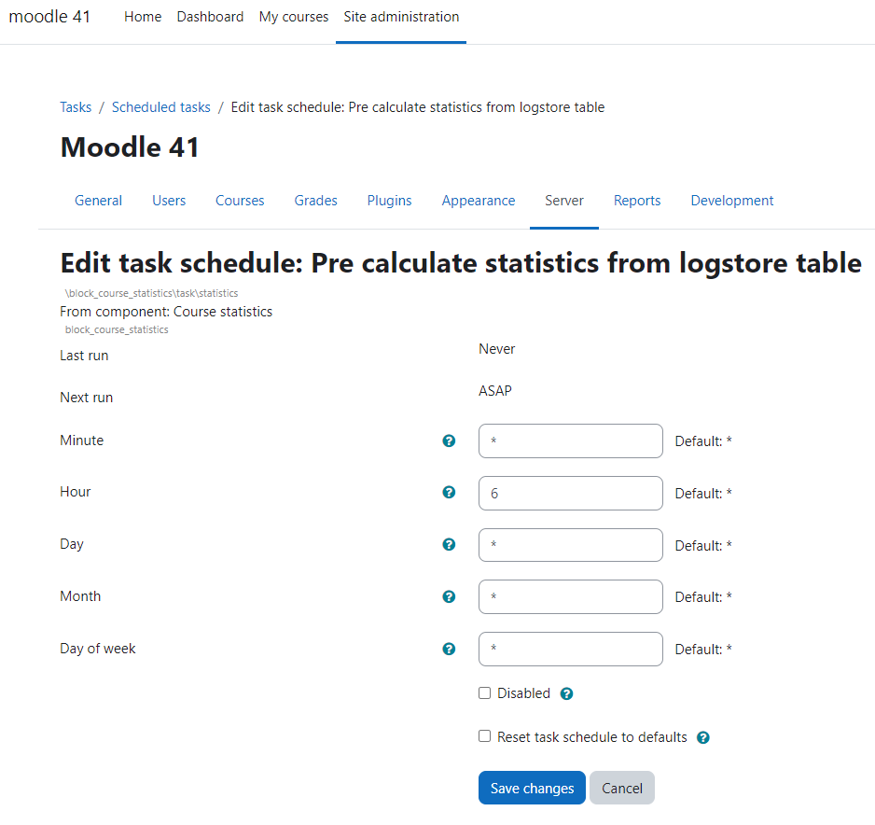

### Structure

The plugin is organized into three main sections:

1. The top section houses the main menu.
2. The middle section contains period filters.
3. The third section displays a data table generated based on the main and period filter selections. **Also, in this section at the top, it includes a navigation between the data tables (breadcrumb)**

The initial page of the plugin showcases the general measures for the course.

### General Measures

In General Measures measure we see statistics of the general use of the users in it.

The measure starts to count for each user from the moment the user enters the course.

For example, in the course below, the total time in the subject is 3 hours and 58 minutes.

The measurement includes the time users were in the course but were inactive and had not yet entered any activity. It also measures the time users spent in activities within the course.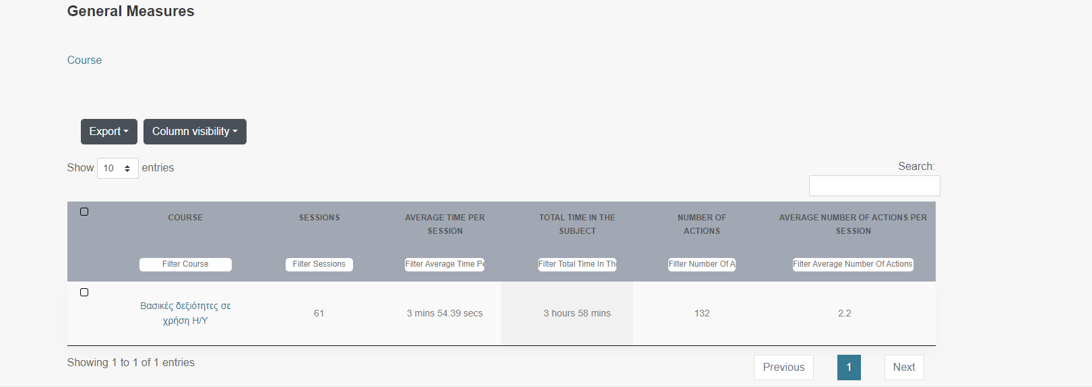

Example.

1. The user logs into the course at 10:47.
2. The user selects an activity within the course, Activity A, at 10:50.
3. The user exits Activity A at 11:00.
4. The user is back in the main course page (has not selected any activity).
5. The user selects Activity B at 12:00.
6. The user logs out of the course at 12:30.

In this example, the General Measurement for the user is from 10:47 am to 12:30 pm.

Total time is 1 hour and 43 minutes.

**While** Activity A has a total measurement of 10 minutes, and Activity B has 30 minutes.

The data table provides the user (teacher/administrator) with fundamental statistics including:

First Data table columns :

* Course,
* Sessions, in Course (number of times users entered the course)
* Average Time per Session (total time spent by users divided by total sessions)
* Total Time in the Subject (course)
* Number of Actions (actions performed by users in the course, e.g., enter forum, write a post)
* Average Number of Actions per Session (total actions divided by total sessions)

Data table Course :

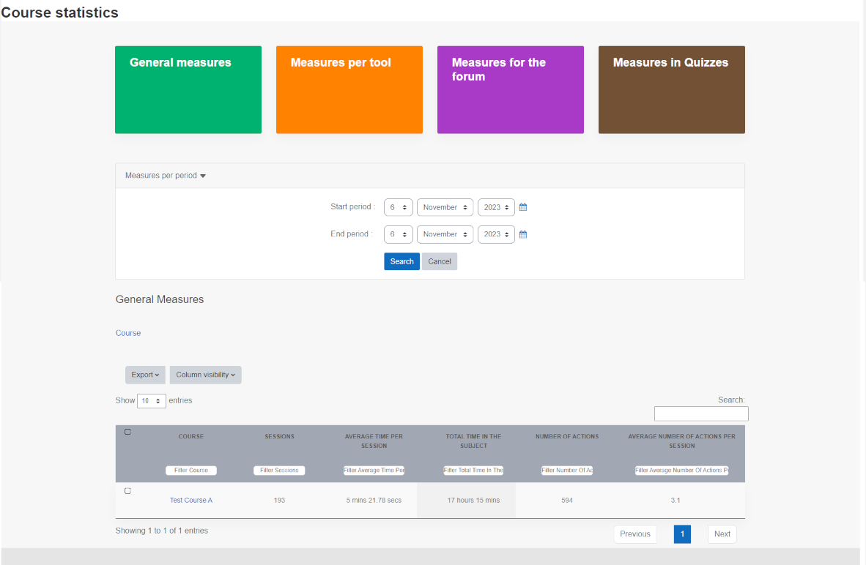By selecting the course title, the user (teacher/administrator) gains access to more detailed statistics for all users in that course.

Second Data table columns :

* Surname,
* First name,
* Course,
* Sessions,
* Average Time Per Session,
* Total Time In The Subject,
* Number Of Actions,
* Average Number Of Actions Per Session

Data table Users :

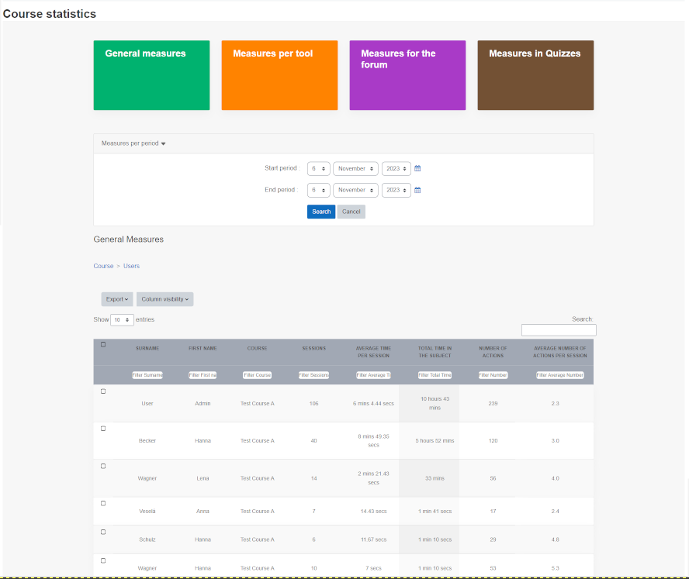

The general measures category consists of two data tables.

The first displays total records for each course, while the second provides records for each user in the selected course.

### Measures by Tool

The initial page of Measures by Tool displays total and average time spent by users in the course for each activity, module, or concrete tool. Teachers/administrators can access more detailed statistics by selecting an activity.

First Data table columns :

* Course,
* Activities,
* Total Time Dedicated,
* Number Of Sessions,
* Average Time In Sessions

Data table Course :

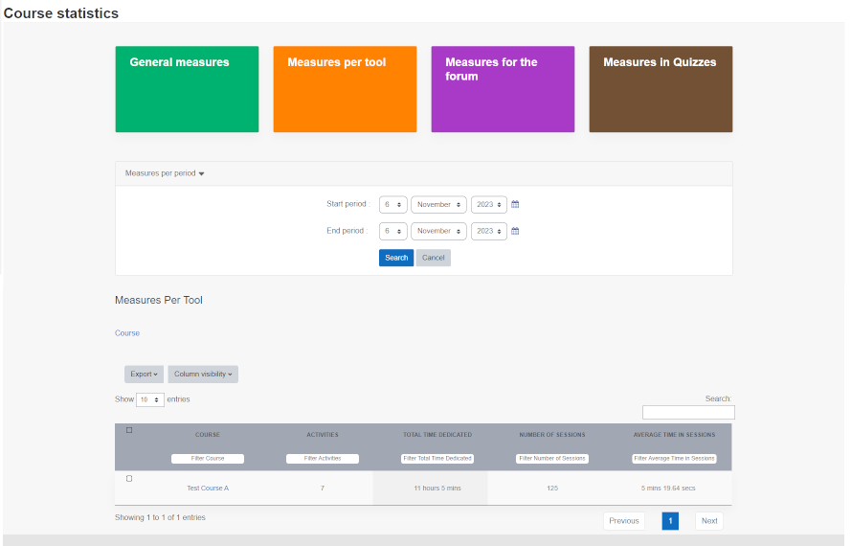

By selecting the course title, the user (teacher/administrator) gains access to more detailed statistics for all activities in that course.

Second Data table columns :

* Course,
* Activity,
* Total Time Dedicated,
* Number Of Sessions,
* Average Time In Sessions,
* Average Use in Sessions

Data table Activities :

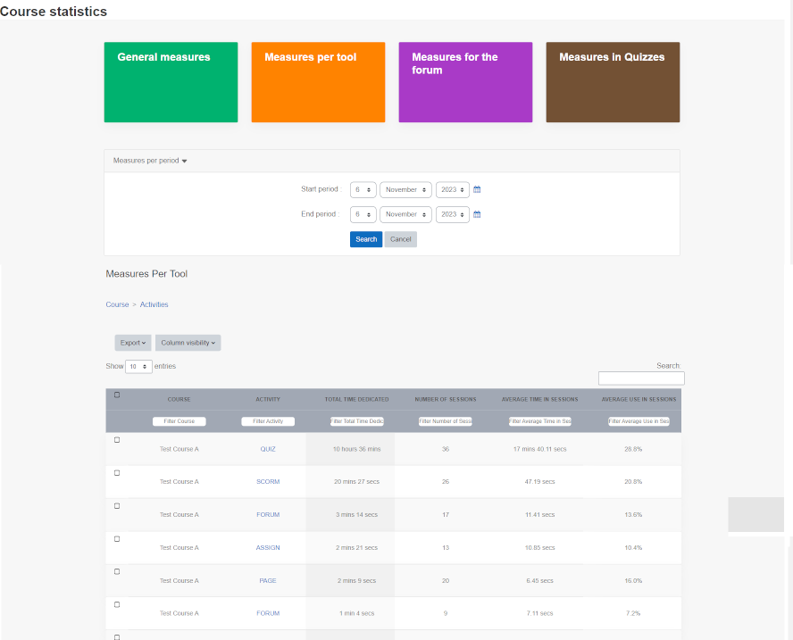

Detailed Data table results for all activities in course.

By selecting an activity, the user (teacher/administrator) gains access to more detailed statistics for all users in that activity.

Third Data table columns :

* Surname,
* First Name,
* Course,
* Activity, (activity in the course where the user was active)
* Total Time Dedicated, (user's time spent in the activity)
* Number Of Sessions, (how many times the user entered the activity)
* Average Time In Sessions, (total time in activity divided by number of sessions)
* Average Use In Sessions (total course sessions divided by number of times user entered the activity)

Data table Users :

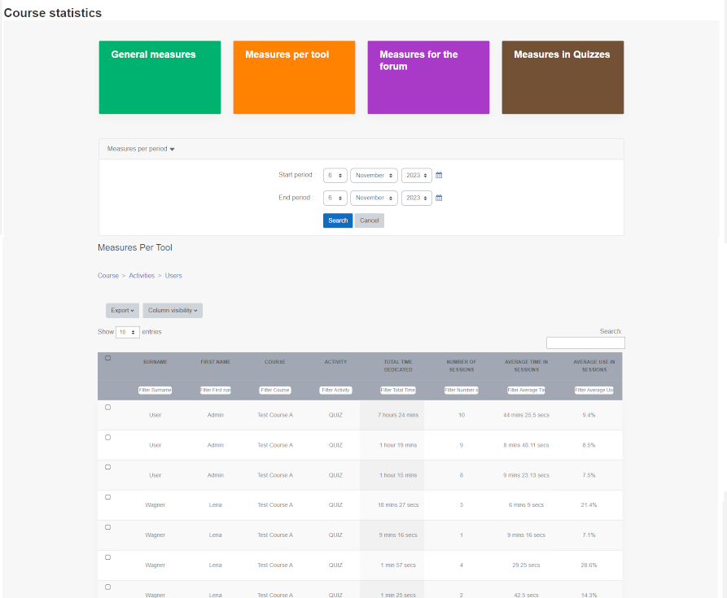

The SCORM and Quiz session time starts when a user enters the activity, not when they start an attempt or SCORM. Both modules/activities include a lobby section. For instance, time spent in the lobby area without entering the quiz or SCORM is counted as a session. Therefore, a session is distinct from an attempt.

The initial page of Measures by Tool displays total and average time spent by users in the course for each activity, module, or concrete tool. Teachers/administrators can access more detailed statistics by selecting an activity.

### Forum Measures

The initial page of Measures For The Forum displays total metrics for the forums included in the course. Teachers/administrators can access more detailed statistics by selecting an activity.

First Data table columns :

* Course,
* Forum,
* Posts,
* Post Answers,
* Topics Initialized,
* Post Reads

Data table Course :

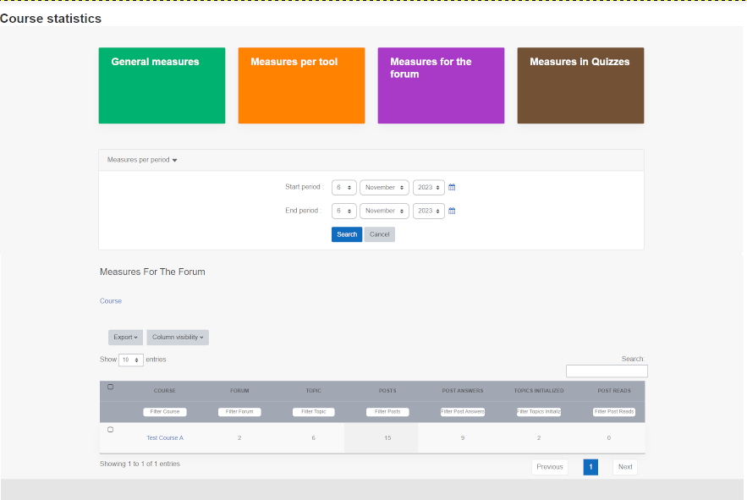

By selecting the course title, the teacher/administrator can access detailed statistics for the forums included in it.

Second Data table fcolumns:

* Course,
* Forum,
* Topic,
* Posts,
* Post Answers,
* Topics Initialized,
* Post Reads

Data table Forums:

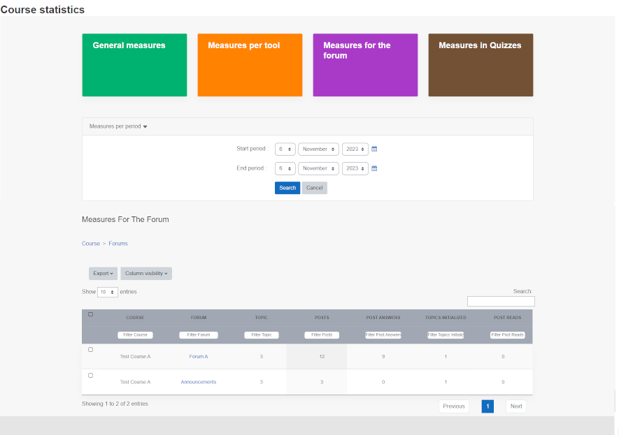

By selecting a forum title, the teacher/administrator can access detailed statistics for each topic in it.

Third Data table columns:

* Course,
* Forum,
* Topic,
* Posts,
* Post Answers,
* Topics Initialized,
* Post Reads

Data table Topics :

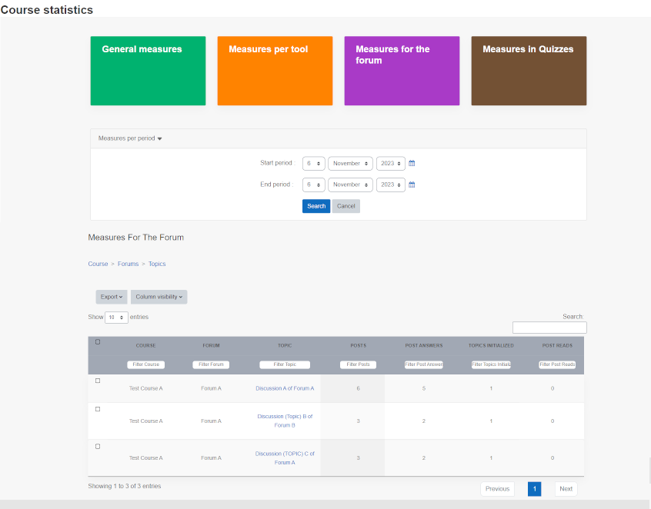

By selecting a topic title, the teacher/administrator can access detailed statistics for each user in it.

Fourth Data table columns:

* Surname
* First name
* Course,
* Forum,
* Topic, (a category in the forum)
* Posts, (number of posts by the user in the topic)
* Post Answers, (number of posts the user has answered)
* Post Reads (number of posts read by the user)

Data table Users :

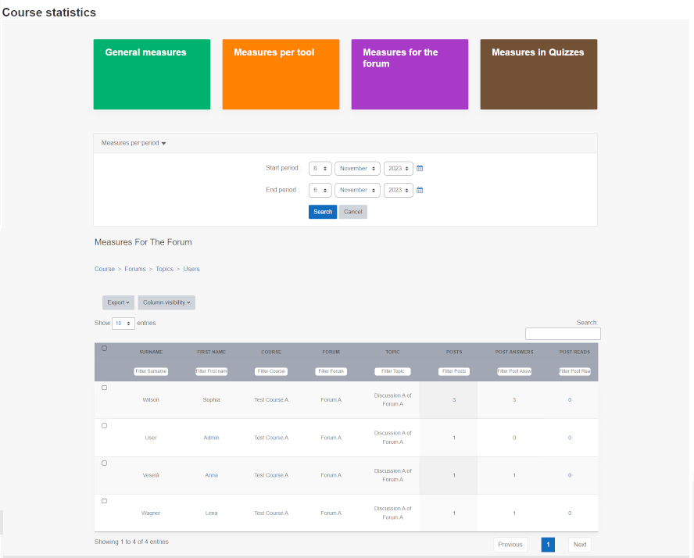

### Quiz Measures

The initial page of Quiz Measures displays total time, attempts, average score, and skipped questions for users in quizzes within the course.

First Data table columns:

* Course,
* Quiz,
* Total Time, (total time attempted by all participants)
* Attempts, (total users attempts)
* Average Score, (average score of all users in the quiz)

Data table Course :

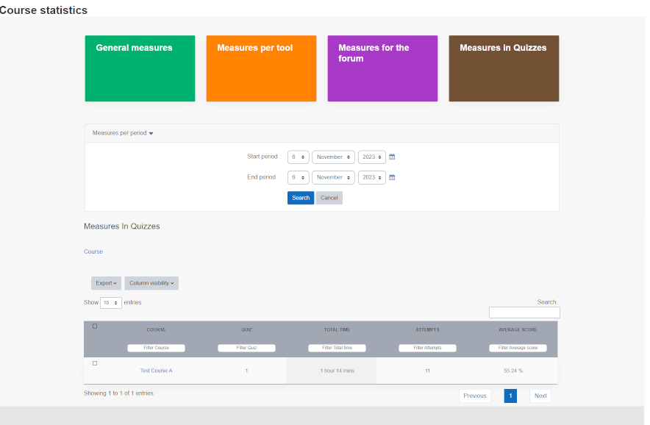

By selecting the Course title, the teacher/administrator can access more detailed statistics about the quizzes listed in course .

Second Data table columns:

* Course,
* Quiz,
* Total Time, (total time attempted by all participants)
* Attempts, (total users attempts)
* Average Score, (average score of all users in the quiz)

Data table Quizzes :

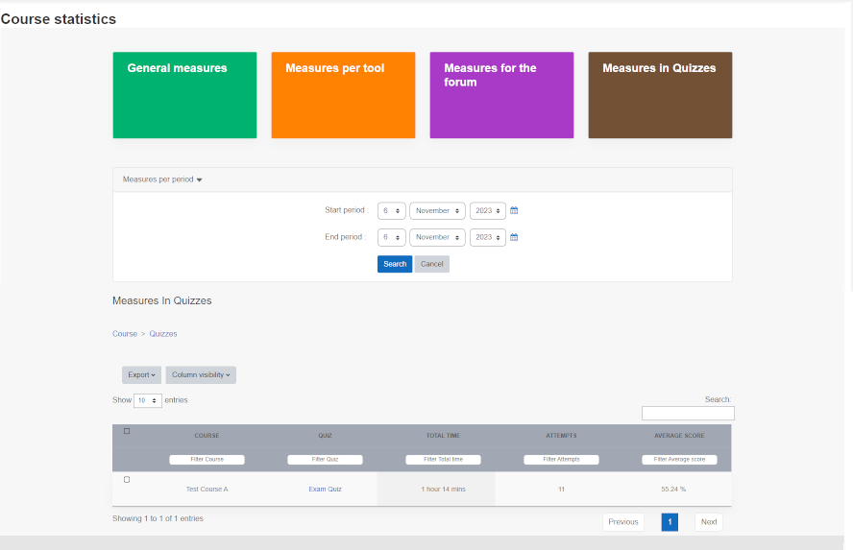

By selecting the Quiz Title, the teacher/administrator can access more detailed statistics about users results.

Data table fields for detailed statistics:

* Surname,
* First Name,
* Course,
* Quiz,
* Total Time, (total time attempted by the user)
* Attempts, (total user attempts, redirects to users attempts)
* Average Score, (average score of user in quiz)

Data table Users :

