Assignment 5: Electromagnetic

Name:________________ ID:________________

**Three Loop model for Loop-loop Frequency Domain EM**

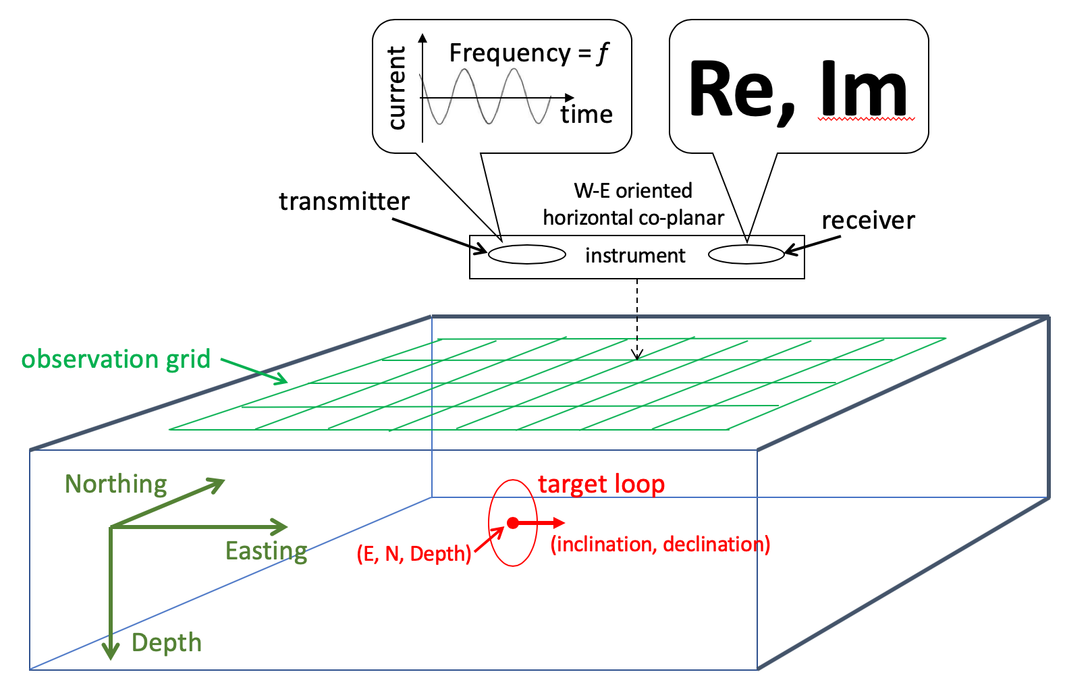

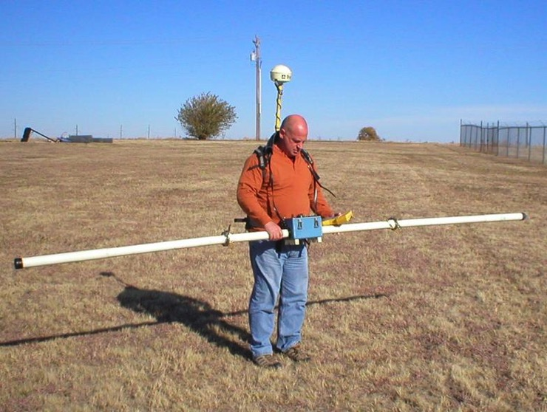

A loop-loop frequency domain EM system contains two horizontal co-planar (HCP) small loops of unity area housed in a long tube or boom. Suppose an EM survey is carried out by moving the boom on the surface over a data grid with a west-east boom orientation. The transmitter and receiver loops are separated by a distance ***s***. The loop-loop system is positioned by its midpoint. The subsurface is simplified as a small conductive loop of a unity area suspended in a non-conductive background. The subsurface loop has an inductance ***L*** and a resistance ***R***. We call the transmitter loop, the subsurface loop and the receiver loop “Loop 1”, “Loop 2” and “Loop 3” respectively. The EM system operates at the frequency ***f***.

**1. Coding**. Make a code that computes the EM responses of the loop-loop system due to the subsurface loop. The EM data is the secondary field from Loop 2 at Loop 3 normalized by the primary field from Loop 1 at Loop 3. The formula reads

gif.gif

which includes two parts. The first part is the coupling coefficient determined by mutual inductances ***M***12, ***M***23, ***M***13 and self-inductance of Loop 2 ***L***. The second part is the response function

gif.gif

where **α** is the induction number

gif.gif.

Mutual inductance ***M***ij can be calculated as the magnetic flux linkage between Loop *i* and Loop *j*. Specifically, if both loops have an area of unity, it is the projection of magnetic flux (B field) from Loop *i* at Loop *j* to the normal direction of Loop *j*. *Copy-paste your code here or send it through email as an attachment.*

**2. Response function**. Make a plot of the real and imaginary parts of the response function for induction number from 10-2 to 102. When L = 0.1, R = 2000 and f = 10 kHz, what is the ratio between the real and imaginary parts?

**3. EM data simulation.** Assume Loop 2 is buried at the depth of 2 m and is with an inclination = 0 and declination = 90 degree. Set the separation of Loop 1 and Loop 3 to 4 m. Design an appropriate data grid that captures the anomalous data from Loop 2. Use surf or contour to visualize the simulated EM data over the data grid. Also plot the data along a profile that goes from west to east right across Loop 2.

**4. Other orientations of Loop 2.** Now change Loop 2 setting to inclination = 0, declination = 0. Compute and plot the data again. Then change Loop 2 inclination = -90 and declination = 0. Compute and plot the data again. Now we have simulated data from three different orientations. Describe and explain the patterns in the data plots.