Assignment 3: Electrical

Name:________________ ID:________________

**Electrical Survey over a Two-layer Earth Model**

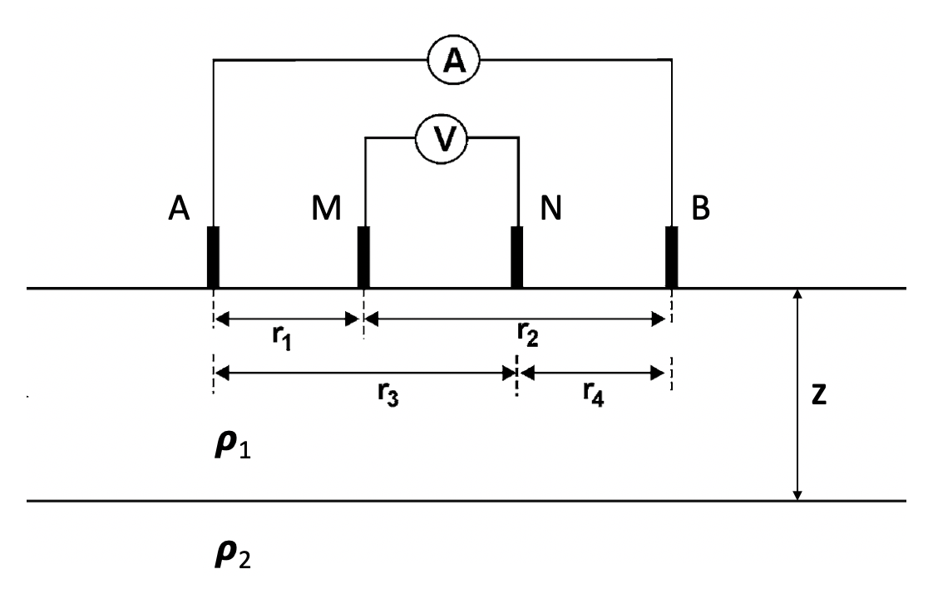

An analytic solution of a layered earth model exists for an arbitrary four-electrode array in dc resistivity. In this exercise, we examine a two-layer model characterized by two resistivity values ρ1, ρ2 and a thickness of the first layer z as shown above. The current and potential electrodes ABMN can be at any locations on the surface and their mutual distances are r1, r2, r3 and r4 respectively. According to Telford et al. (1990), the measured potential difference between M and N is

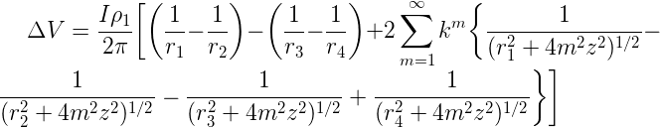

where

https://latex.codecogs.com/gif.latex?%5Cdpi%7B120%7D%20%5Clarge%20k%3D%5Cfrac%7B%20%5Crho_2%20-%20%5Crho_1%7D%7B%5Crho_2%20&plus;%20%5Crho_1%7D

and https://latex.codecogs.com/gif.latex?%5Cdpi%7B120%7D%20%5Clarge%20m is an integer sufficiently large.

**1. Coding.** Make a computer program that calculates the potential difference data in a four-electrode electrical survey. The two resistivities, thickness of the top layer and the electrode locations should be adjustable. Make sure the program can also convert the calculated potential difference data to apparent resistivity. *Copy-paste your code here or send it through email as an attachment.*

**2. Validation**. A simple method of validation is to assign the two layers the same resistivity (as a uniform half-space) and verify if the calculated apparent resistivity is the same as the assigned resistivity. Note the solution in the potential difference equation involves an infinite series. In practice, you must choose a https://latex.codecogs.com/gif.latex?%5Cdpi%7B120%7D%20%5Clarge%20m that is sufficiently large to achieve a stable and accurate solution. In the blank below, report the value of your choice and describe how you chose it.

**3. Simulation.** Use the program you made to calculate the electrical data from a two-layer earth model, in which the top layer is 1500 Ω·m and 10 m thick and the basement layer is 500 Ω·m. Here we consider four types of arrays: dipole-dipole, pole-dipole, pole-pole and Wenner as shown below. The arrays are specified by a-spacing (in meter) and n-spacing (integer).

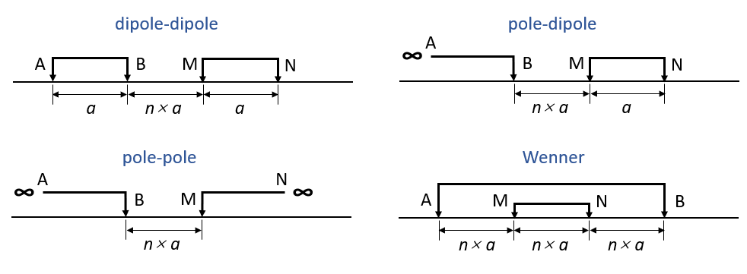

Calculate the potential difference and apparent resistivity for the four arrays based on the two layer model with *a* = 1 m and *n* varying from 1 to 20. Plot curves of potential difference versus n-spacing and apparent resistivity versus n-spacing for each type of array. Attach the plots below. Make sure plots and figures are clearly labelled.

**4. Discussion.** Based on the plots from the previous exercise, discuss:

(1) Which type of array has better resolution for the near-surface property? And how can you tell?

(2) Which type of array has better depth of penetration with the least n-spacing (less expensive field operation)? And how can you tell?

(3) Which type of array has the best balance between near-surface resolution and depth of penetration? And why?