Assignment 4: GPR

Name:________________ ID:________________

**GPR Survey over Underground Storage Tanks**

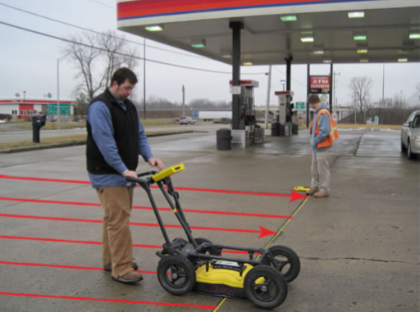

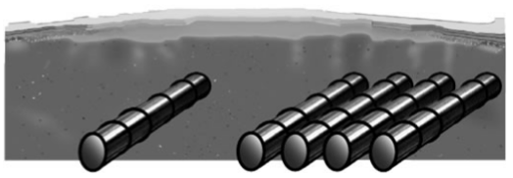

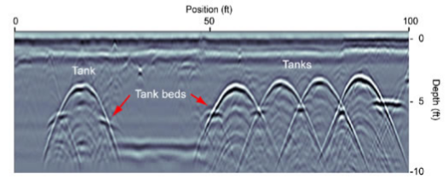

A zero-offset GPR survey is carried out at a gas station to locate some buried metallic tanks that were used for fuel storage. The tanks are known to be long cylinders buried in dry concrete (relative permittivity 6). Complete the following exercises. Note unit in feet (ft).

**1.** **Survey design**. If you know approximate orientation of the tanks, how would you choose the direction of lines? Why? Estimate the EM wave length on the data image, then infer the operating frequency of GPR system used in this survey.

**2. Coding.** Make a computer program that calculates two-way travel time of a zero-offset GPR survey. Consider the reflector as a metallic cylinder of a radius *r* buried *z* meters (cylinder axis) below the surface. The calculation of travel time should take the radius of cylinder into account. Make sure the program can plot arrival time as a function of distance along the survey lines. *Copy-paste your code here or send it through email as an attachment.*

**3. Synthetic example.** Use the code you made to simulate the arrival time response of a fuel tank, which has a radius 1 m and whose center is 1.5 m deep. Next change the parameters to simulate the GPR response of a point reflector buried 0.5 m deep. Plot and compare the two curves of arrival time. If the radius of the tank cannot be ignored, do the reflected signals still form a hyperbola? How can you estimate the EM wave velocity in this case?

**4. Field data interpretation**. Change the radius and depth in your program to fit the curves (reflected signals from the tanks) in the field data radargram. Can the tanks be considered point reflectors? Explain why or why not.

**5. Discussion.** Why aren’t signatures from tank beds entirely visible?