Assignment 2: Magnetic

Name:________________ ID:________________

**Magnetic Anomaly from Susceptible Blocks**

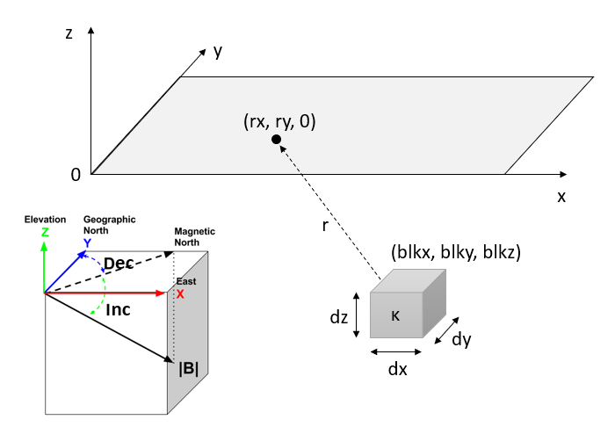

A block of size dx, dy and dz is buried below the surface. The center of block is at (blkx, blky, blkz). The block is magnetically susceptible with a uniform susceptibility **κ**. The regional inducing geomagnetic field **B0** is specified by |**B**|, **Inc** and **Dec** as shown in the figure above. The block generates an induced magnetic field that can be observed on the surface. Use the knowledge and equations learned in class to finish the following tasks.

**1. Coding**. Make a computer program that computes the total-field magnetic anomaly over a survey data grid on surface with an adjustable spacing. Make sure your program is able to adjust the following parameters: block location, block dimensions, susceptibility, geomagnetic field, and data grid. In order to simplify the situation, we approximate the magnetized block as a magnetic dipole, whose direction is the same as the geomagnetic field and strength is determined by

https://latex.codecogs.com/gif.latex?%5Cmathbf%7BM%7D%20%3D%20%5Ckappa%20%5Cmathbf%7BH_0%7D%3D%5Ckappa%20%5Cmathbf%7BB_0%7D/%20%5Cmu_0



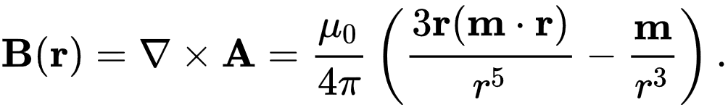

Once the magnetic field **B** from the magnetized block is available, the observed total-field anomaly is the projection of **B** on the direction of **B0**. *Copy-paste your code here or send it through email as an attachment.*

**2. Validation**. Run the interactive Jupyter Notebook in the repository of geosci-labs: geosci-labs/notebooks/mag/[MagneticPrismApplet.ipynb](https://github.com/geoscixyz/geosci-labs/blob/master/notebooks/mag/MagneticPrismApplet.ipynb" \o "MagneticPrismApplet.ipynb). Choose a set of block parameters of your choice and ensure the depth is much greater than the size of block. Plot the magnetic anomaly data on the data grid or along a profile. Compare the results from MagneticPrismApplet and from your code to check their consistency. Support your validation with images or screenshots.

**3. Single-block simulation.** Set the block to be 10 × 10 × 10 m and its center 10 m below the surface. The block’s susceptibility is 0.1 SI unit. Use the IGRF geomagnetic field at Shenzhen. Calculate the total-field magnetic anomalous field on the surface. Make sure the data grid is large enough to cover most of the anomaly. Use *surf* or similar function/command to visualize the data. Attach your image with a color scale below.

**4. Multi-block approximation.** Superposition holds for magnetic data. If there are multiple blocks, the overall effect will be superposition of their individual fields. In the previous exercise, the block is approximated by a single magnetic dipole at the center of block. The block can be further divided into smaller sub-blocks, and the magnetic anomaly data can be obtained by simulating the sub-blocks then sum them up. Now that you have the ability of calculating a single block of any size, please divide the block in Exercise 3 into 8, 9 or even 16 sub-blocks (you decide) and use the superposition to calculate the magnetic anomaly data from the entire block. Attach the images of simulated data below and answer:

(1) Do you always get the same result if you have 1, 4, 8 or 16 sub-blocks?

(2) If yes, why? If no, why not?