Assignment 1: Gravity

Name:________________ ID:________________

**Gravity field of multiple spheres**

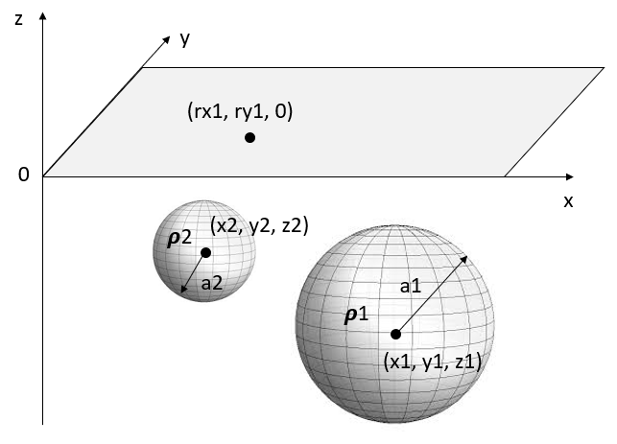

Multiple spheres of uniform density are buried below the surface. Each sphere is specified by its radius, density or density contrast and the (x, y, z) location of its center. Use the knowledge and equations learned in class to finish the following tasks.

**1. Preparation**. Make a computer program that computes the vertical gravity field gz from all the spheres at any location on surface. Make a survey data grid on surface with an adjustable spacing. Be able to simulate gz at the locations on the data gird. No need to attach anything here.

**2. Validation**. Set the number of sphere to 1. Choose a set of sphere parameters of your choice and calculate gz data with your code. Simulate the same sphere in the Jupyter Notebook gravitySphere.ipynb. Plot the gz data along a profile across the sphere. In the area below, attach the plots from your code and from the notebook and compare to see if they are consistent.

**3. Five-sphere simulation.** Generate five spheres of different radius, density and depth (you decide). Simulate the gz data due to all the spheres at the measurement locations on surface (data grid). Use *surf* or similar function/command to visualize the gz data on surface. Attach your image below.

**4. Regional removal.** Use the simulated data of five spheres from the previous task. Choose a method to remove the regional signals from the data. Attach two images below: (1) The regional signals removed and (2) the residual gz data after removal. Very briefly describe your method of regional removal.