Dataset for Related Work Summarization Task (RWSData)

Introduction
In scientific research, a scholar needs to show an understanding of the context of his problem and relate his work to prior community knowledge. A related work section is often the vehicle for this purpose; it contextualizes the scholar’s contribution and helps the reader understand the critical aspects of the previous works that the current work addresses. Creating such a related work summary requires the author to understand the nuances of his own work, and to manipulate the contextual research to support the advantages of his method.

We now envision an NLP application that assists the scholar in creating his related work summary. We propose related work summarization task as a challenge to the automatic summarization community. Given multiple articles (e.g. conference or journal papers) as input, and a set of keywords that describe the topics of interest presented in a hierarchical fashion, the output goal is to create a related work section that finds the relevant related works and contextually describes them in relationship to the topics given.

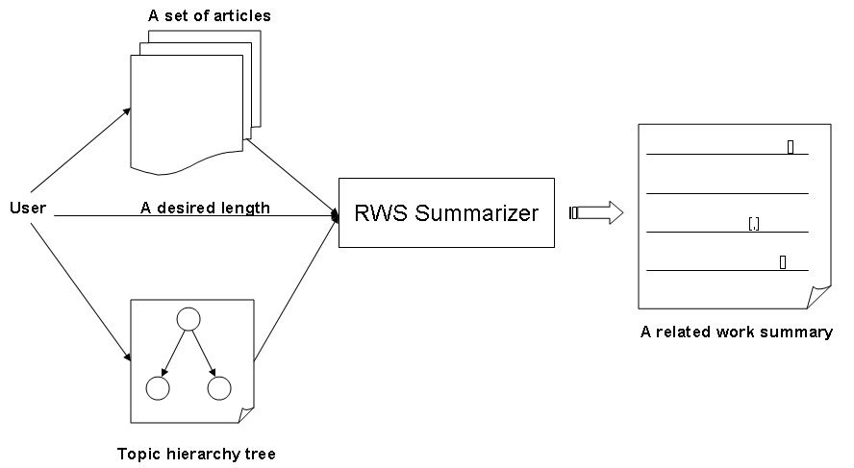
Figure 1: Overview of Related Work Summarization Task

We now release our dataset (namely RWSData) used in our initial experiments for the task (see our papers in Publications for further details). We are welcome to use our dataset for any future research.

Dataset
This dataset contains a collection of 20 article sets. Each set has an ID name (set as folder name), including:
- ref (folder): includes two sub-folders:
  - pdf: original PDF files of referenced articles
  - txt: text files extracted PDF files (pre-processed, cleaned, error-fixed)

- <ID name>.pdf: original PDF file of the article which contains the related work section to be extracted.

- <ID name>.rws: raw texts of related work section extracted from <ID name>.pdf

- <ID name>.rws.seg: sentence by sentence texts from <ID name>.rws. Additionally, each sentence is annotated with topical and reference information, following the formats:
a) <topic index>#<list of names of references separated by semi-colons ‘;’>#<sentence>
b) claim#<sentence>

For the format a), each reference in <sentence> is replaced by numbers referring to the order (left-to-right) of that reference in <list of names of references separated by semi-colons ‘;’>. The <topic index> is mentioned in <ID name>.topic. Further, the format b) is simpler, just mentions that current sentence is the authors’ claim about their own work related to previous works. Such a sentence may not be used in our reported related work summarization process.

For example:
0.1#(barzilay and mckeown 2001)#for example , $1 evaluated their paraphrases by asking judges whether paraphrases were " approximately conceptually equivalent . "
0#(griffiths et al., 2005);(wallach, 2006);(purver et al., 2006);(gruber et al., 2007)# more recent work has attempted to adapt the concepts of topic modeling to more sophisticated representations than a bag of words ; they use these representations to impose stronger constraints on topic assignments $1 $2 $3 $4 .
(claim)#from the methodological side , that body of prior work is largely driven by local pairwise constraints , while we aim to encode global constraints .

- <ID name>.topic: the details of the topic hierarchy tree (manually annotated). It has a XML-like format with tags:
  - <topic index> </topic index>: indicates the position of current topic in topic tree
  - <title> </title>: describe the title of current topic
  - <keywords> </keywords>: a list of key word/phrases describing current topic
For example:

XML-like format of topic tree | Visual format of topic tree
<topic index> 0 </topic index>  <title> paraphrase evaluation methods </title>  <keywords> paraphrase;evaluation;quality; </keywords>  <topic index> 0.1 </topic index>  <title> subjective manual evaluation </title>  <keywords> judge;judgment;judgement;assess;human;subjective;manual; </keywords>  <topic index> 0.2 </topic index>  <title> improving performance on particular tasks </title>  <keywords> improve;gain;quality;performance;translation;answering;SMT;statistical machine translation;machine translation;QA;question answering; </keywords> | 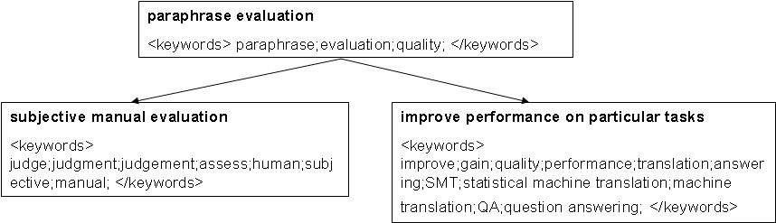

Further, a detailed statistics of the RWSData dataset is provided in the DataStatistics.xls file (Excel file). Also, an additional log file (Logs.txt) which describes the progression of the creation of the RWSData dataset is also attached.

In particular, you can download this dataset from the following URL: Dataset for Related Work Summarization (Zip file, ~73MB).

Publications
Cong Duy Vu Hoang (2010). Towards Automated Related Work Summarization. MSc Thesis. Department of Computer Science, School of Computing, National University of Singapore.

Cong Duy Vu Hoang & Min-Yen Kan (2010). Towards Automated Related Work Summarization. In Proceedings of the 23rd International Conference on Computational Linguistics (COLING 2010). Beijing, China.

Group Members
Cong Duy Vu Hoang (NUS) – hcdvu@comp.nus.edu.sg or duyvuleo@gmail.com
Min-Yen Kan (NUS) – kanmy@comp.nus.edu.sg

