**7 - Association Rules** (also known as *Market Basket Analysis*)

**7.1 – Introduction to Association Rules**

Market Basket Analyses are a common application of association rules. One goal of a market basket analysis is to understand the association between items purchases. The relationship between items purchased at a grocery store will be considered in this handout.

|  |  |
| --- | --- |
| http://imagesus.homeaway.com/mda01/f4e2379a-d720-459f-b9c0-9999fc559022.1.6 |  |

An association rule highlights the fact that some items are more (or less) indicative of the purchase of others. For example, purchasing cereal increases the likelihood of purchasing milk. These types of analyses may also reveals that liquor and milk are rarely purchased together.

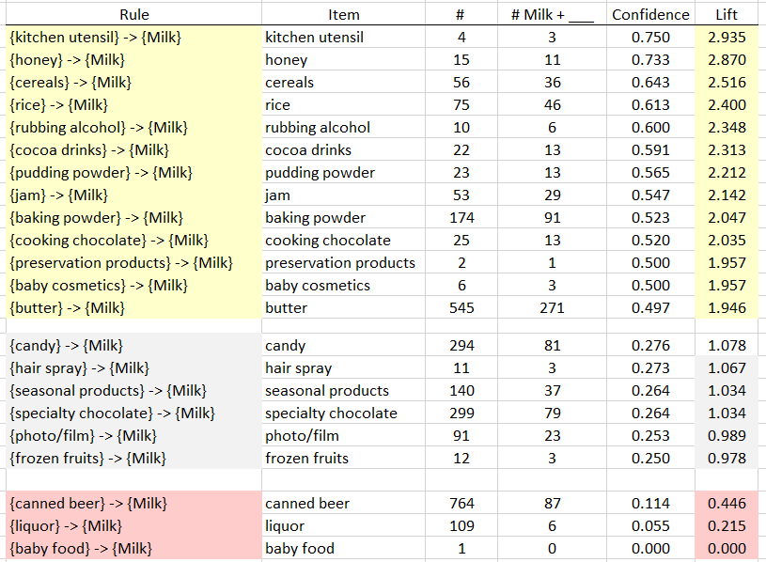

**Association Rules** are used to uncover associations or relationships that exist between items. Often these rules are constructed to identify relationships between items purchased, i.e. Market Basket Analysis.

Procedural Steps

* 1. Determine how often items are purchased.
  2. Determine how often items are purchased in conjunction with other items.
  3. Identify which purchased items are indicative of others being purchased.

Data Technologies

* 1. Filtering/Subsets
  2. Creating Tables
  3. Data Summaries

Example 7.1: Grocery Store Transactions (small subset)

Consider the following subset of data from a collection of transactions from a grocery store.

|  |  |
| --- | --- |
| Transaction ID | Items Purchased |
| 1 | {Bread, Milk} |
| 2 | {Eggs, Ham} |
| 3 | {Bread, Fruit, Milk} |
| 4 | {Beer, Bread, Butter, Fruit, Soda} |
| 5 | {Bread, Fruit, Milk, Soda} |

Association rules are developed under the following guiding principles.

|  |  |  |
| --- | --- | --- |
| 1. | Items should be purchased somewhat often. | **Support** |
| 2. | Reliability, i.e. the degree to which one set of items predicts the purchase of another set of items. | **Confidence** |

**7.2 – Itemsets, Rules, Support, Confidence, and Lift**

An ***itemset*** is a collection of items that could potentially be in the same market basket/transaction. An itemset can consist of a single item.

Examples:

A ***rule*** is simply put says that buying itemset implies they will also buy itemset . Are goal in conducting a market basket analysis is to identify rules where buying itemset also implies you are “likely” to buy itemset . Rules are denoted using the notation: .

Examples:

The ***support*** of a set of items, or rule involving items, (e.g. milk AND bread) is the estimated probability of simultaneously observing both itemsets in a randomly selected market basket/transaction. If and are itemsets, in standard probability notation the support = . The support of a rule can be denoted .

The ***confidence***of a rule is the probability of buying item set given the basket already contains itemset . In standard probability notation . It can also be defined in terms of support as follows:

Example 7.1: Grocery Store Transactions (small subset)

Consider the following association rule – the purchase of Bread indicates the purchase of Milk.

|  |  |
| --- | --- |
| Rule #1 |  |

Compute the support and confidence for this rule.

Questions

1. What is the interpretation of the ?

1. What is the interpretation of Confidence of this rule? Discuss.  
   Note: Remember Confidence is simply a conditional probability, i.e P(Milk | Bread).

Consider a second association rule for the purchase of Milk.

|  |  |
| --- | --- |
| Rule #2 |  |

Compute the support and confidence for this rule.

Question

1. Why might Rule #1 be considered “better” than Rule #2 when interest lies in the purchase of Milk?

Consider a third association rule for the purchase of Milk.

|  |  |
| --- | --- |
| Rule #3 |  |

Compute the support and confidence for this rule.

***Lift*** is another measure often considered when evaluating rules of association. It measures how many times more likely you are to buy itemset given you have bought itemset to the probability you buy without any knowledge of what else is in the market basket/transaction.

Interpretation of Lift

* implies positive association between items
* implies no association between items
* implies negative association between items

We will now compute the lift of the three rules developed above.

Rule #1:

Rule #2:

Rule #3:

For our examples, realize that the support for Milk is fairly large, i.e. Milk was purchased in 60% of all transactions. This provides a baseline value for confidence. That is, rules that exceed this value indicate gains when considering the association provided by the rule. When the lift of a rule is near 1, then the rule provides little information to understanding the purchase of the item.

|  |  |  |  |
| --- | --- | --- | --- |
| **Rule** | **Support** | **Confidence** | **Lift** |
|  |  |  |  |
|  |  |  |  |
|  |  |  |  |

Some Comments

* Association rules with no support have zero confidence. E.g. Beer is never purchased with Milk, so the rule should not be considered.
* The confidence of a rule should not be considered independent of it’s support. For example, the rule has Confidence = 1. That is, 100% of the time eggs were purchased, so was Ham. However, this rule has very low support as Eggs and Ham were only purchased together once.
* Association rules are not invariant. For example, the confidence for the rule is different than the confidence of the rule . In association rule terminology the itemset before the arrow is called the *antecedent* and the tiem following the arrow is called the *consequent*. Which itemset plays which role matters!

**7.3 – Transactional Databases**

A transaction will consist of a list of all items purchased in that transaction. For purposes of finding “good” or “meaningful” association rules however we need to create a binary representation matrix for the set of all transactions. The matrix will have one column for each possible item purchased and each row of the matrix will correspond to a single transaction. For each item in the transaction we place a 1 in appropriate column and a zero in all columns corresponding to items not purchased in the transaction.

Common Data Structure

|  |  |  |
| --- | --- | --- |
| List |  | Binary Representation (Matrix) |

Example 7.2: Grocery Store Transactions (full transactional database)

Next, let us consider the complete grocery store transactional database. This dataset contains one month (30 days) of real-world point-of-sale transaction data from grocery store. These data are contained in the data frame Groceries in the arules package. This transactional database contains transactions and there were a total of 169 unique items purchased amongst all of these transactions.

The Groceries data frame consists of the binary representation of this market basket data. Re  
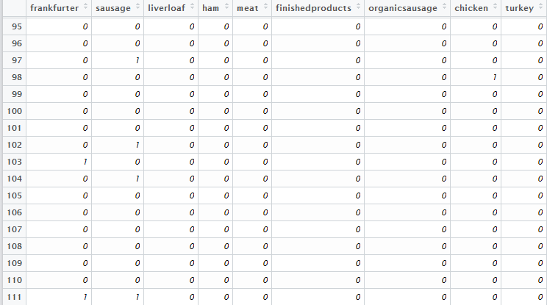

> Groceries.csv = read.table(file.choose(),header=T,sep=”,”) 🡨 read in the file **Groceries.txt**

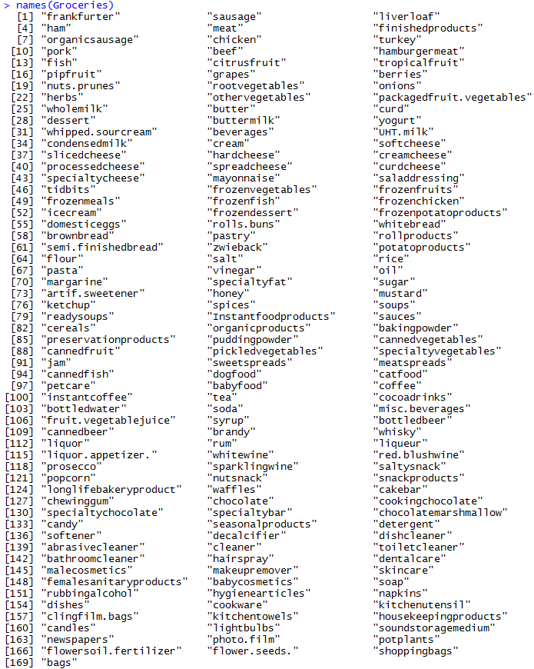

The column names of the Groceries data frame denote the 169 unique items that were purchased amongst the 9835 transactions. We will now look for rules using a single item antecedent that have as the consequent.

e.g.

Using simple logic statements on the columns of Whole Milk and Butter allows one to easy compute the support and confidence for the rule: .

|  |  |  |  |
| --- | --- | --- | --- |
| |  |  | | --- | --- | | Rule |  |   > sum(Groceries$butter==1 & Groceries$wholemilk==1)  [1] 271  > nrow(Groceries)  [1] 9835  > sum(Groceries$butter==1)  [1] 545  > sum(Groceries$wholemilk==1)  [1] 2513 | |
|  |  |
|  | |

Evaluating All Potential Single Item Rules for Whole Milk  
The procedure provided above lack efficiencies and does not scale well when several rules need to be evaluated. For example, there are 169 items in this analysis, a more efficient process would be to write a loop to cycle through all columns automatically. This is the purpose of the code provided below.

|  |  |
| --- | --- |
| Rule #1 |  |
| Rule #2 |  |
| : | : |
| Rule #169 |  |

First we set up a data frame called wholemilk.rules to store the results in a table with meaningful column headings.

> wholemilk.rules = data.frame(Item=rep(NA,169),Numberi=rep(NA,169),

Numberi_Wholemilk=rep(NA,169),Support=rep(NA,169),Confidence=rep(NA,169),

Lift=rep(NA,169))

Compute the support of the itemset which will be the consequent of the rules we are constructing.

> support.wholemilk = sum(Groceries[,25]==1)/length(Groceries[,25])

> support.wholemilk

[1] 0.255516 🡨 chance they unconditionally   
 purchase whole milk.

The loop below will extract the item name of the antecedent, compute the support of the rule , compute the support of the antecedent item, compute the confidence of the rule, i.e. , and finally compute the lift of the rule, i.e. .

> for (i in 1:169){

wholemilk.rules[i,1] = colnames(Groceries)[i]

if (i != 25){

support_i_wholemilk=sum(Groceries[,i]==1 & Groceries[,25]==1)/length(Groceries[,i])

support_i = sum(Groceries[,i]==1)/length(Groceries[,i])

confidence = support_i_wholemilk/support_i

lift = confidence/support.wholemilk

wholemilk.rules[i,2]=sum(Groceries[,i]==1)

wholemilk.rules[i,3]=sum(Groceries[,i]==1 & Groceries[,25]==1)

wholemilk.rules[i,4]=support_i_wholemilk

wholemilk.rules[i,5]=confidence

wholemilk.rules[i,6]=lift

}

}

> View(wholemilk.rules)

Rules sorted by Support (decreasing)

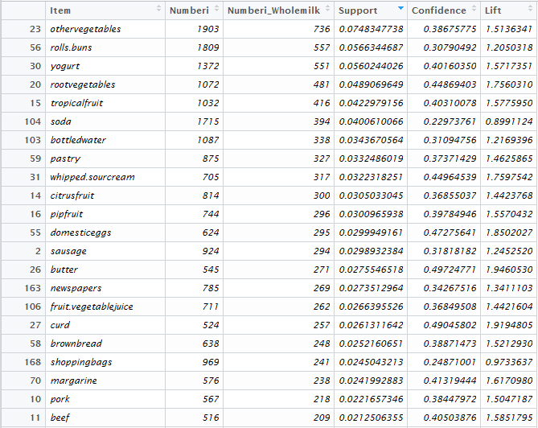

Rules sorted by Confidence/Lift (decreasing)

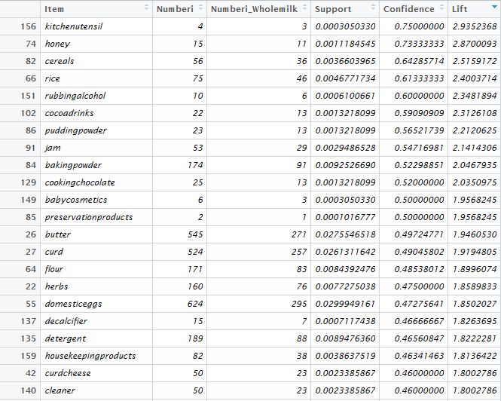

The following items have high lift, , – indicating if these items were purchased they are at least twice as likely to buy milk than if we did not know they had purchased these items.

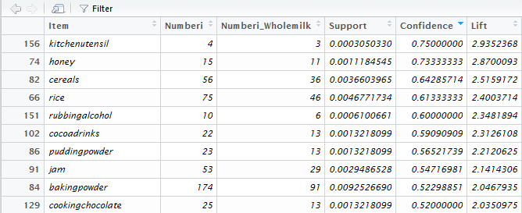

For example, given that we know a customer has purchased cereals the probability they bought whole milk is .6429 or a 64.29% chance. Compare this to probability that a randomly selected customer buys whole milk which is 25.55% chance. The lift is the ratio of these two probabilities which is 2.52 for cereals. Thus buying cereals increases a customer’s likelihood of buying whole milk a 2.5 times.

The following items have a lift value much smaller than 1, i.e. – indicating that customers purchasing items are less likely to buy whole milk.

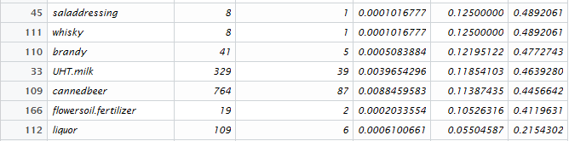

For example, customers that purchase liquor are about one-fifth as likely to also buy whole milk when compared to the general population of customers. If a customer purchases liquor the probability they also buy milk is .055 or a 5.5% chance.

Questions

1. As stated above the Lift for is about 2.5 which is fairly high. Thus, given that the transaction includes cereal, there is 2.5 fold increase in the likelihood of whole milk being purchased.
   1. What is the ?
   2. This value seems fairly low. Why does a low support value negate the usefulness of a rule?
   3. What rules seems to have a fairly high lift AND have a relatively large support?
2. The Lift value for the rule is amongst the lowest on this list. What can be said about the purchase of Canned Beer AND Whole Milk?

Clearly the approach above will not work in general as there are far too many rule combinations that we may wish to explore!! Thus we will use two R packages that have been developed to sort through “all” possible rules and identify those that have desirable properties, i.e. a balance between a reasonable support and confidence/lift. In the next section we will begin using functions in the arules and arulesViz packages for this purpose.

**7.4 – Developing Association Rules in R** (arules/arulesViz)

The packages arules and arulesViz contain functions for constructing and visualizing association rules given a suitable “transactional” database. A suitable database will consist entirely or nominal/ordinal variables. If we have numeric variables they will need to converted to nominal/ordinal first. For example we might convert a continuous variable such as income ($) to an ordinal variable as: Low (income < $25000), Med ($25000 < income < $50000), High (income > $50000).

Example 7.3: Golf today?  
As a preliminary example of using the association rule packages in R consider the following small “transactional” database regarding weather and whether or not we play golf that day.

> Golf

outlook temperature humidity windy play

1 sunny hot high false no

2 sunny hot high true no

3 overcast hot high false yes

4 rainy mild high false yes

5 rainy cool normal false yes

6 rainy cool normal true no

7 overcast cool normal true yes

8 sunny mild high false no

9 sunny cool normal false yes

10 rainy mild normal false yes

11 sunny mild normal true yes

12 overcast mild high true yes

13 overcast hot normal false yes

14 rainy mild high true no

In its current format this dataset could be used to form association rules using the apriori   
function from the arules library. However there is a function for converting a data frame of this type to a transactional database. This conversion will enable us to use other functions within the arules library for inspecting items.

> golf.trans = as(Golf,"transactions")

> golf.trans

transactions in sparse format with

14 transactions (rows) and

12 items (columns)

> summary(golf.trans)

transactions as itemMatrix in sparse format with

14 rows (elements/itemsets/transactions) and

12 columns (items) and a density of 0.4166667

most frequent items:

play=yes windy=false humidity=high humidity=normal temperature=mild

9 8 7 7 6

(Other)

33

element (itemset/transaction) length distribution:

sizes

5

14

Min. 1st Qu. Median Mean 3rd Qu. Max.

5 5 5 5 5 5

includes extended item information - examples:

labels variables levels

1 outlook=overcast outlook overcast

2 outlook=rainy outlook rainy

3 outlook=sunny outlook sunny

includes extended transaction information - examples:

transactionID

1 1

2 2

3 3

> itemFrequencyPlot(golf.trans)

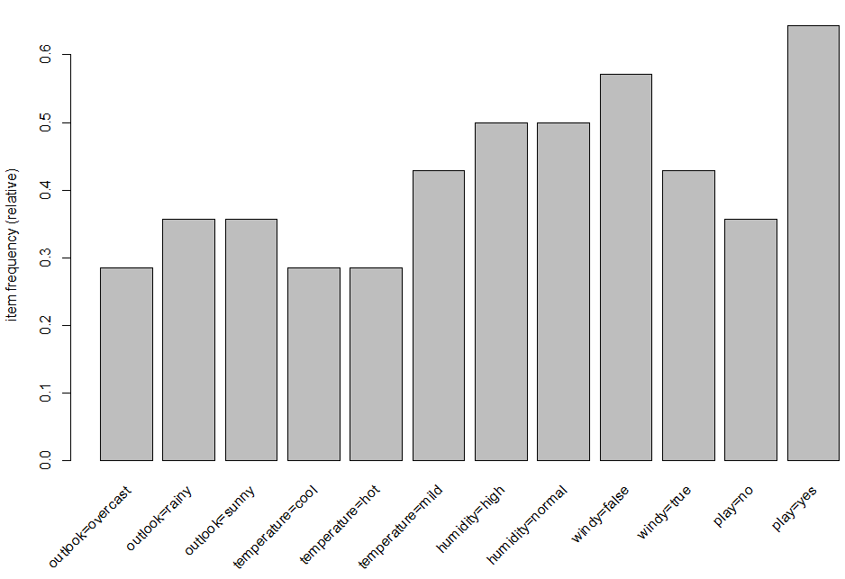

> golf.rules = apriori(golf.trans)

Parameter specification:

confidence minval smax arem aval originalSupport support minlen maxlen target ext

0.8 0.1 1 none FALSE TRUE 0.1 1 10 rules FALSE

Algorithmic control:

filter tree heap memopt load sort verbose

0.1 TRUE TRUE FALSE TRUE 2 TRUE

Warning in apriori(golf.trans) :

You chose a very low absolute support count of 1. You might run out of memory! Increase minimum support.

apriori - find association rules with the apriori algorithm

version 4.21 (2004.05.09) (c) 1996-2004 Christian Borgelt

set item appearances ...[0 item(s)] done [0.00s].

set transactions ...[12 item(s), 14 transaction(s)] done [0.00s].

sorting and recoding items ... [12 item(s)] done [0.00s].

creating transaction tree ... done [0.00s].

checking subsets of size 1 2 3 4 done [0.00s].

writing ... [53 rule(s)] done [0.00s].

creating S4 object ... done [0.00s].

Even for small databases like this one, if we don’t filter out some based on support and/or confidence we will end up with a very large set of rules! The optional argument to do this has the form shown below.  
  
> arules(data, parameter = list(sup=minsup,conf=minconf,target=”rules”))

Below are some examples for the golf/weather database.

> golf.rules = apriori(golf.trans,parameter=list(supp=1/14,conf=.8,target="rules"))

Parameter specification:

confidence minval smax arem aval originalSupport support minlen maxlen target ext

0.8 0.1 1 none FALSE TRUE 0.07142857 1 10 rules FALSE

Algorithmic control:

filter tree heap memopt load sort verbose

0.1 TRUE TRUE FALSE TRUE 2 TRUE

Warning in apriori(golf.trans, parameter = list(supp = 1/14, conf = 0.8, :

You chose a very low absolute support count of 1. You might run out of memory! Increase minimum support.

writing ... [246 rule(s)] done [0.00s].

> golf.rules = apriori(golf.trans,parameter=list(supp=3/14,conf=.9,target="rules"))

Parameter specification:

confidence minval smax arem aval originalSupport support minlen maxlen target ext

0.9 0.1 1 none FALSE TRUE 0.2142857 1 10 rules FALSE

Algorithmic control:

filter tree heap memopt load sort verbose

0.1 TRUE TRUE FALSE TRUE 2 TRUE

writing ... [8 rule(s)] done [0.00s].

> summary(golf.rules)

set of 8 rules

rule length distribution (lhs + rhs):sizes

2 3

2 6

Min. 1st Qu. Median Mean 3rd Qu. Max.

2.00 2.75 3.00 2.75 3.00 3.00

summary of quality measures:

support confidence lift

Min. :0.2143 Min. :1 Min. :1.556

1st Qu.:0.2143 1st Qu.:1 1st Qu.:1.556

Median :0.2143 Median :1 Median :1.875

Mean :0.2411 Mean :1 Mean :1.902

3rd Qu.:0.2857 3rd Qu.:1 3rd Qu.:2.000

Max. :0.2857 Max. :1 Max. :2.800

mining info:

data ntransactions support confidence

golf.trans 14 0.2142857 0.9

> inspect(golf.rules)

lhs rhs support confidence lift

1 {outlook=overcast} => {play=yes} 0.2857143 1 1.555556

2 {temperature=cool} => {humidity=normal} 0.2857143 1 2.000000

3 {temperature=cool,play=yes} => {humidity=normal} 0.2142857 1 2.000000

4 {outlook=sunny,play=no} => {humidity=high} 0.2142857 1 2.000000

5 {outlook=sunny,humidity=high} => {play=no} 0.2142857 1 2.800000

6 {outlook=rainy,windy=false} => {play=yes} 0.2142857 1 1.555556

7 {outlook=rainy,play=yes} => {windy=false} 0.2142857 1 1.750000

8 {humidity=normal,windy=false} => {play=yes} 0.2857143 1 1.555556

We can use the sort() function to display the rules in order in terms of a quality measure, typically lift.

> golf.sort = sort(golf.rules,by=”lift”)

> inspect(golf.sort)

lhs rhs support confidence lift

5 {outlook=sunny,humidity=high} => {play=no} 0.2142857 1 2.800000

2 {temperature=cool} => {humidity=normal} 0.2857143 1 2.000000

3 {temperature=cool,play=yes} => {humidity=normal} 0.2142857 1 2.000000

4 {outlook=sunny,play=no} => {humidity=high} 0.2142857 1 2.000000

7 {outlook=rainy,play=yes} => {windy=false} 0.2142857 1 1.750000

1 {outlook=overcast} => {play=yes} 0.2857143 1 1.555556

6 {outlook=rainy,windy=false} => {play=yes} 0.2142857 1 1.555556

8 {humidity=normal,windy=false} => {play=yes} 0.2857143 1 1.555556

We can use the subset command to filter rules according to desired criterion. The syntax is complicated but two common/typical examples are shown below.

> golf.rules = apriori(golf.trans,parameter =list(supp=2/14,conf=.9,target="rules"))

Apriori

Parameter specification:

confidence minval smax arem aval originalSupport support minlen maxlen target ext

0.9 0.1 1 none FALSE TRUE 0.1428571 1 10 rules FALSE

Algorithmic control:

filter tree heap memopt load sort verbose

0.1 TRUE TRUE FALSE TRUE 2 TRUE

Absolute minimum support count: 2

set item appearances ...[0 item(s)] done [0.00s].

set transactions ...[12 item(s), 14 transaction(s)] done [0.00s].

sorting and recoding items ... [12 item(s)] done [0.00s].

creating transaction tree ... done [0.00s].

checking subsets of size 1 2 3 4 done [0.00s].

writing ... [51 rule(s)] done [0.00s].

creating S4 object ... done [0.00s].

creating S4 object ... done [0.00s].

> golf.subset = subset(golf.rules,subset=lift>2.0)

> summary(golf.subset)

set of 16 rules

rule length distribution (lhs + rhs):sizes

3 4

9 7

Min. 1st Qu. Median Mean 3rd Qu. Max.

3.000 3.000 3.000 3.438 4.000 4.000

summary of quality measures:

support confidence lift

Min. :0.1429 Min. :1 Min. :2.333

1st Qu.:0.1429 1st Qu.:1 1st Qu.:2.800

Median :0.1429 Median :1 Median :2.800

Mean :0.1473 Mean :1 Mean :2.917

3rd Qu.:0.1429 3rd Qu.:1 3rd Qu.:2.975

Max. :0.2143 Max. :1 Max. :3.500

mining info:

data ntransactions support confidence

golf.trans 14 0.1 0.8

> inspect(golf.subset)

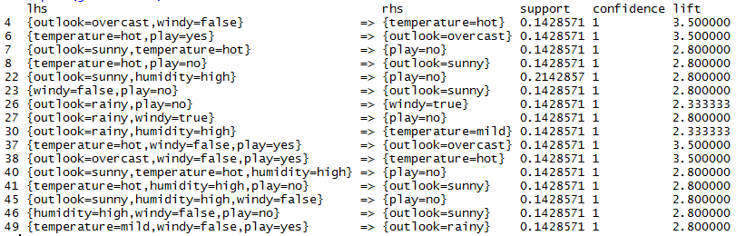

> golf.subset2 = subset(golf.rules,subset=rhs %in% "play=yes")

> summary(golf.subset2)

set of 16 rules

rule length distribution (lhs + rhs):sizes

2 3 4

2 10 4

Min. 1st Qu. Median Mean 3rd Qu. Max.

2.000 3.000 3.000 3.125 3.250 4.000

summary of quality measures:

support confidence lift

Min. :0.1429 Min. :0.8571 Min. :1.333

1st Qu.:0.1429 1st Qu.:1.0000 1st Qu.:1.556

Median :0.1429 Median :1.0000 Median :1.556

Mean :0.1830 Mean :0.9911 Mean :1.542

3rd Qu.:0.1607 3rd Qu.:1.0000 3rd Qu.:1.556

Max. :0.4286 Max. :1.0000 Max. :1.556

mining info:

data ntransactions support confidence

golf.trans 14 0.1 0.8

> inspect(golf.subset2)

lhs rhs support confidence lift

> inspect(golf.subset2)

lhs rhs support confidence lift

1 {outlook=overcast} => {play=yes} 0.2857143 1 1.555556

5 {outlook=overcast,temperature=hot} => {play=yes} 0.1428571 1 1.555556

12 {outlook=overcast,windy=true} => {play=yes} 0.1428571 1 1.555556

13 {outlook=overcast,humidity=high} => {play=yes} 0.1428571 1 1.555556

14 {outlook=overcast,humidity=normal} => {play=yes} 0.1428571 1 1.555556

15 {outlook=overcast,windy=false} => {play=yes} 0.1428571 1 1.555556

20 {temperature=cool,windy=false} => {play=yes} 0.1428571 1 1.555556

24 {outlook=sunny,humidity=normal} => {play=yes} 0.1428571 1 1.555556

31 {outlook=rainy,windy=false} => {play=yes} 0.2142857 1 1.555556

33 {temperature=mild,humidity=normal} => {play=yes} 0.1428571 1 1.555556

34 {humidity=normal,windy=false} => {play=yes} 0.2857143 1 1.555556

35 {outlook=overcast,temperature=hot,windy=false} => {play=yes} 0.1428571 1 1.555556

42 {temperature=cool,humidity=normal,windy=false} => {play=yes} 0.1428571 1 1.555556

47 {outlook=rainy,temperature=mild,windy=false} => {play=yes} 0.1428571 1 1.555556

50 {outlook=rainy,humidity=normal,windy=false} => {play=yes} 0.1428571 1 1.555556

If you have a fairly small subset of rules you wish to display graphically the plot function in the aruleViz library has some useful options for doing this.

> plot(golf.subset,method=”graph”)

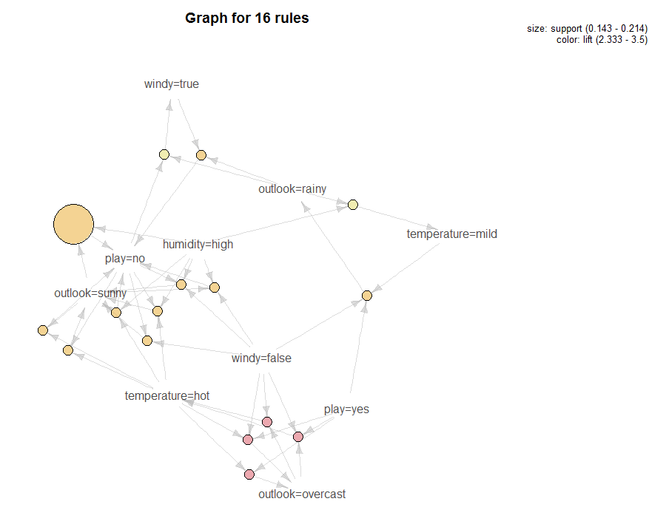

> plot(golf.subset2,method=”graph”)

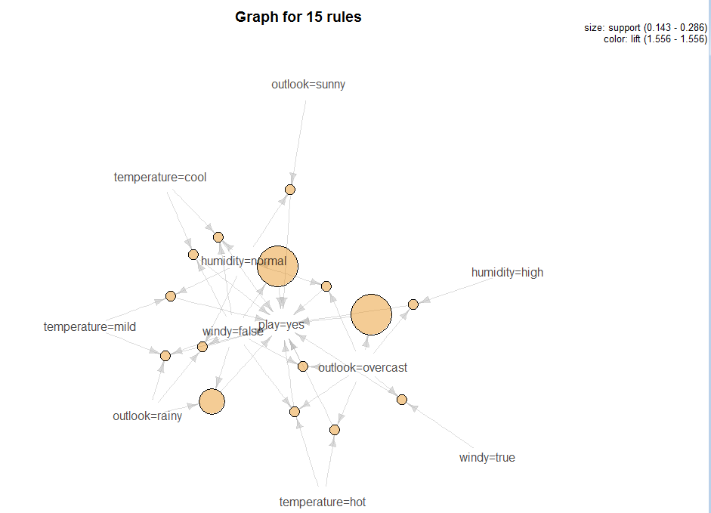

Example 7.4: Association Rules for the Mushroom Data

In this example we look for association rules within the mushroom data set we have looked at previously. We can treat the characteristics of the mushrooms as transactional data and look for characteristics that most associated. For example a rule might be:  
 {cap-surface=f,cap-color=c} => {veil-type=u}.

The mushroom attributes are defined below:

Variable Levels *  
     Poisonous edible=e,poisonous=p

X1 = cap-shape: bell=b,conical=c,convex=x,flat=f,  
 knobbed=k,sunken=s  
 X2 = cap-surface: fibrous=f,grooves=g,scaly=y,smooth=s  
 X3 = cap-color: brown=n,buff=b,cinnamon=c,gray=g,green=r,  
 pink=p,purple=u,red=e,white=w,yellow=y  
 X4 = bruises?: true=t,false=f  
 X5 = odor: almond=a,anise=l,creosote=c,fishy=y,foul=f,  
 musty=m,none=n,pungent=p,spicy=s  
 X6 = gill-attachment: attached=a, free=f  
 X7 = gill-spacing: close=c,crowded=w  
 X8 = gill-size: broad=b,narrow=n  
 X9 = gill-color: black=k,brown=n,buff=b,chocolate=h,gray=g,  
 green=r,orange=o,pink=p,purple=u,red=e,  
 white=w,yellow=y  
 X10 = stalk-shape: enlarging=e,tapering=t  
 X11 = stalk-root: bulbous=b,club=c,cup=u,equal=e,  
 rhizomorphs=z,rooted=r,missing=? 🡨 has lots of missing values!  
 X12 = stalk-surface-above-ring: ibrous=f,scaly=y,silky=k,smooth=s  
 X13 = stalk-surface-below-ring: ibrous=f,scaly=y,silky=k,smooth=s 🡨 has lots of missing values!  
 X14 = stalk-color-above-ring: brown=n,buff=b,cinnamon=c,gray=g,orange=o,  
 pink=p,red=e,white=w,yellow=y  
 X15 = stalk-color-below-ring: brown=n,buff=b,cinnamon=c,gray=g,orange=o,  
 pink=p,red=e,white=w,yellow=y  
 X16 = veil-type: partial=p,universal=u 🡨 All partial (no universal)!  
 X17 = veil-color: brown=n,orange=o,white=w,yellow=y  
 X18 = ring-number: none=n,one=o,two=t  
 X19 = ring-type: cobwebby=c,evanescent=e,flaring=f,large=l,  
 none=n,pendant=p,sheathing=s,zone=z 🡨 some levels not represented  
 X20 = spore-print-color: black=k,brown=n,buff=b,chocolate=h,green=r,  
 orange=o,purple=u,white=w,yellow=y  
 X21 = population: abundant=a,clustered=c,numerous=n,  
 scattered=s,several=v,solitary=y  
 X22 = habitat: grasses=g,leaves=l,meadows=m,paths=p,  
 urban=u,waste=w,woods=d

Note: We have used these data previously in Section 2 – Measuring Distances.

> mushrooms = Mushrooms.train[,-c(12,17)]

> summary(mushsubset)

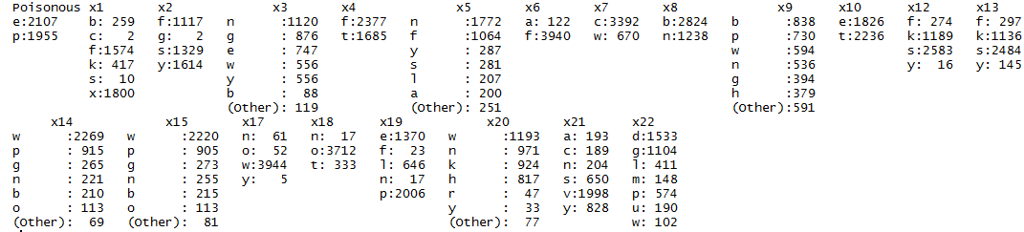

> mush.trans = as(mushsubset,"transactions")

> mush.trans

transactions in sparse format with

4062 transactions (rows) and

113 items (columns)

> summary(mush.trans)

transactions as itemMatrix in sparse format with

4062 rows (elements/itemsets/transactions) and

113 columns (items) and a density of 0.1858407

most frequent items:

x17=w x6=f x18=o x7=c x8=b (Other)

3944 3940 3712 3392 2824 67490

element (itemset/transaction) length distribution:

sizes

21

4062

Min. 1st Qu. Median Mean 3rd Qu. Max.

21 21 21 21 21 21

includes extended item information - examples:

labels variables levels

1 Poisonous=e Poisonous e

2 Poisonous=p Poisonous p

3 x1=b x1 b

includes extended transaction information - examples:

transactionID

1 7251

2 724

3 2997

> itemFrequencyPlot(mush.trans,cex=.6)

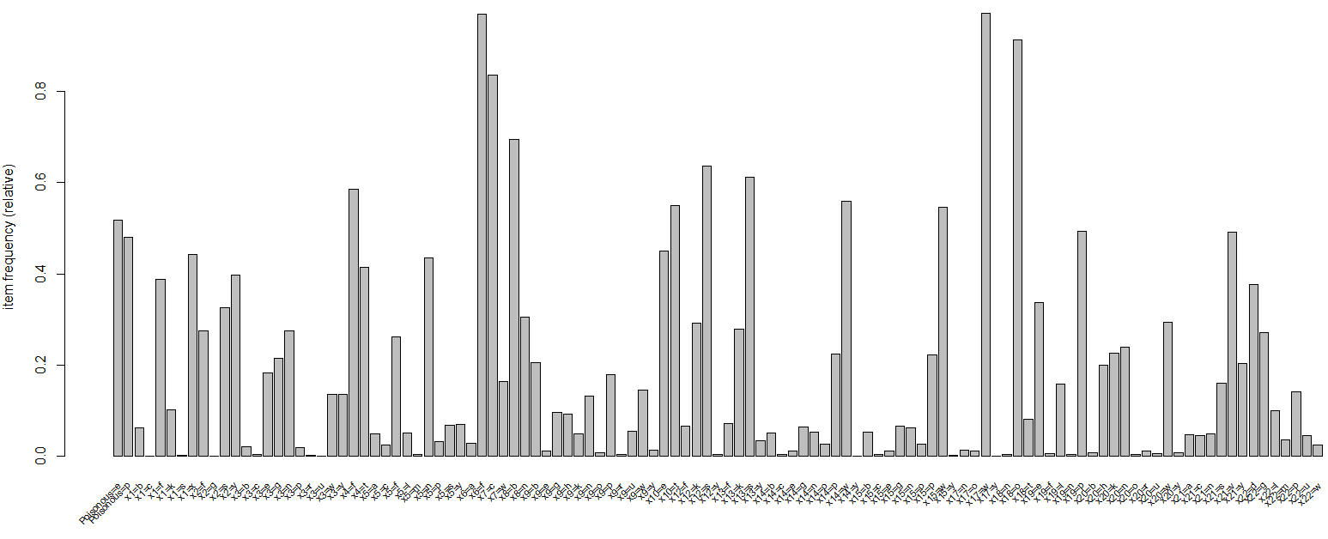

> itemFrequencyPlot(mush.trans,support=.4)

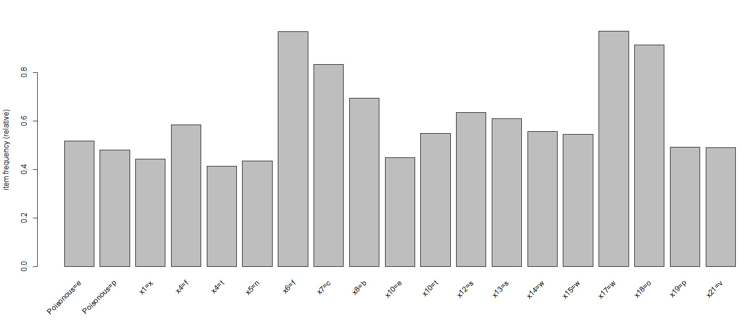

> itemFrequencyPlot(mush.trans,topN=25)

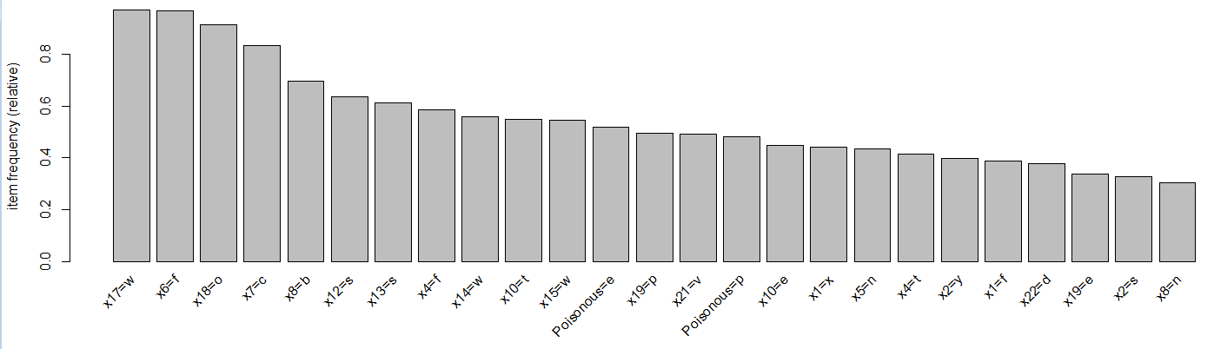

> mush.rules = apriori(mush.trans)

> mush.rules = apriori(mush.trans)

Apriori

Parameter specification:

confidence minval smax arem aval originalSupport support minlen maxlen target ext

0.8 0.1 1 none FALSE TRUE 0.1 1 10 rules FALSE

Algorithmic control:

filter tree heap memopt load sort verbose

0.1 TRUE TRUE FALSE TRUE 2 TRUE

Absolute minimum support count: 406

set item appearances ...[0 item(s)] done [0.00s].

set transactions ...[113 item(s), 4062 transaction(s)] done [0.00s].

sorting and recoding items ... [52 item(s)] done [0.00s].

creating transaction tree ... done [0.00s].

checking subsets of size 1 2 3 4 5 6 7 8 9 10 done [0.64s].

writing ... [686273 rule(s)] done [0.14s].

creating S4 object ... done [0.29s].

This is way too many rules to plot or interact with! We have a few options to reduce or filter this rule set:

1. filter out some of these rules by choosing only those with a high support, confidence/lift
2. sort and inspect only those rules with the highest “quality”
3. put more stringent requirements when calling the apriori function
4. inspect only those with a specific RHS/consequent

> summary(mush.rules)

set of 686273 rules

rule length distribution (lhs + rhs):sizes

1 2 3 4 5 6 7 8 9 10

4 272 3805 20547 60973 116429 156321 154157 112927 60838

Min. 1st Qu. Median Mean 3rd Qu. Max.

1.000 6.000 7.000 7.358 9.000 10.000

summary of quality measures:

support confidence lift

Min. :0.1002 Min. :0.8000 Min. :0.8243

1st Qu.:0.1022 1st Qu.:1.0000 1st Qu.:1.0943

Median :0.1041 Median :1.0000 Median :1.7089

Mean :0.1241 Mean :0.9859 Mean :1.8902

3rd Qu.:0.1297 3rd Qu.:1.0000 3rd Qu.:2.0849

Max. :0.9710 Max. :1.0000 Max. :6.2879

mining info:

data ntransactions support confidence

mush.trans 4062 0.1 0.8

We will first use option (1). We can save the quality measures to an object and then use the quality object to filter our rules.

> mush.quality = quality(mush.rules)

Here we filter out rules with and , or grab only those with lift > 2.50 and support > 0.20.

> mush.subset = mush.rules[mush.quality$lift>2.5 & mush.quality$supp>.2]

> summary(mush.subset)

set of 9142 rules

rule length distribution (lhs + rhs):sizes

2 3 4 5 6 7 8 9 10

3 74 413 1140 1938 2242 1839 1068 425

Min. 1st Qu. Median Mean 3rd Qu. Max.

2.000 6.000 7.000 6.943 8.000 10.000

summary of quality measures:

support confidence lift

Min. :0.2026 Min. :0.8096 Min. :2.509

1st Qu.:0.2063 1st Qu.:1.0000 1st Qu.:2.965

Median :0.2063 Median :1.0000 Median :3.281

Mean :0.2065 Mean :0.9902 Mean :3.386

3rd Qu.:0.2063 3rd Qu.:1.0000 3rd Qu.:3.405

Max. :0.3003 Max. :1.0000 Max. :4.847

mining info:

data ntransactions support confidence

mush.trans 4062 0.1 0.8

> plot(mush.subset,method=”grouped”)

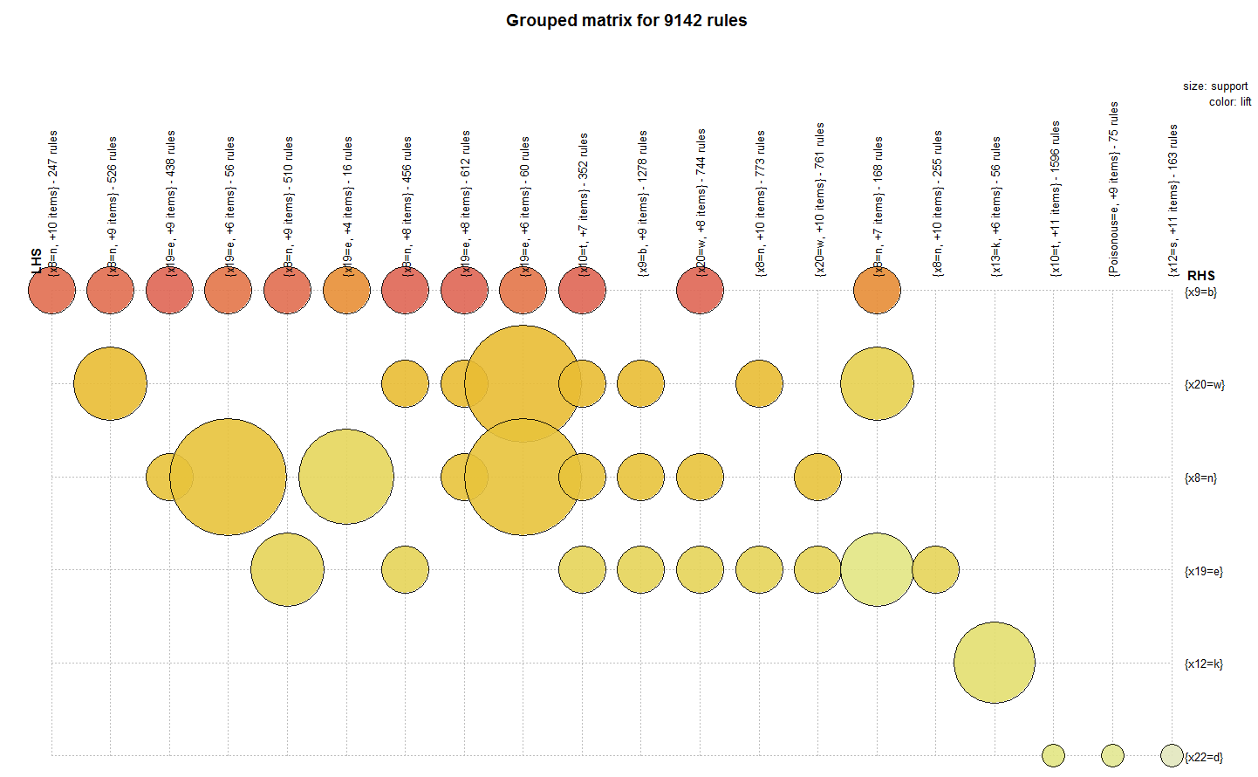

> plot(mush.subset)

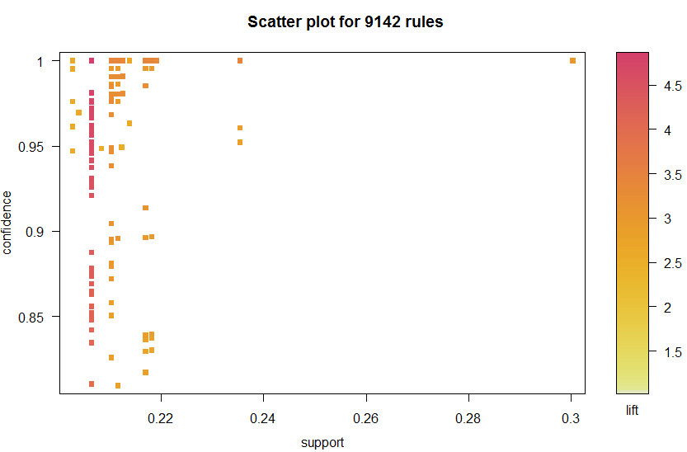

We can inspect and further filter these rules interactively by using the interactive=T option to the plot function.

> sel = plot(mush.subset,interactive=T)

Interactive mode.

Select a region with two clicks!

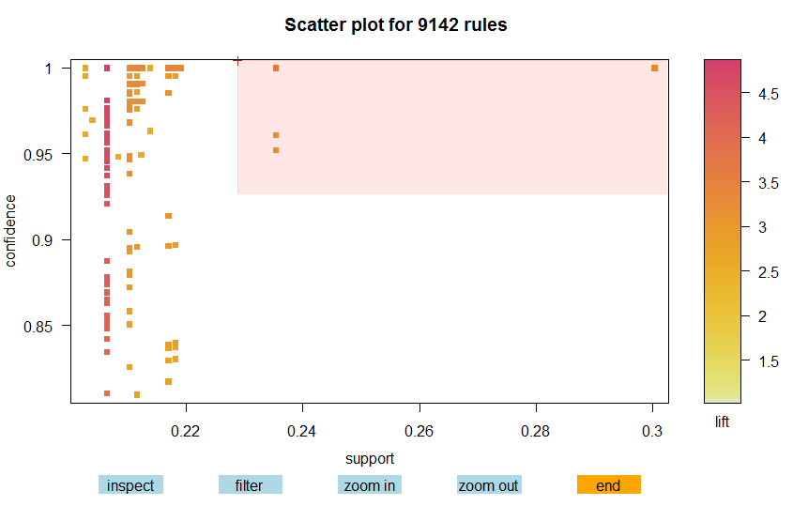

Number of rules selected: 16

lhs rhs support confidence lift order

2583 {x7=c,x19=e} => {x20=w} 0.2353520 1.0000000 3.404862 3

16178 {x6=f,x7=c,x19=e} => {x20=w} 0.2353520 1.0000000 3.404862 4

16182 {x7=c,x17=w,x19=e} => {x20=w} 0.2353520 1.0000000 3.404862 4

60402 {x6=f,x7=c,x17=w,x19=e} => {x20=w} 0.2353520 1.0000000 3.404862 5

2919 {x4=f,x10=t} => {x19=e} 0.3003447 1.0000000 2.964964 3

18123 {x4=f,x10=t,x18=o} => {x19=e} 0.3003447 1.0000000 2.964964 4

18127 {x4=f,x6=f,x10=t} => {x19=e} 0.3003447 1.0000000 2.964964 4

18131 {x4=f,x10=t,x17=w} => {x19=e} 0.3003447 1.0000000 2.964964 4

65654 {x4=f,x6=f,x10=t,x18=o} => {x19=e} 0.3003447 1.0000000 2.964964 5

65659 {x4=f,x10=t,x17=w,x18=o} => {x19=e} 0.3003447 1.0000000 2.964964 5

65664 {x4=f,x6=f,x10=t,x17=w} => {x19=e} 0.3003447 1.0000000 2.964964 5

163588 {x4=f,x6=f,x10=t,x17=w,x18=o} => {x19=e} 0.3003447 1.0000000 2.964964 6

16177 {x6=f,x7=c,x20=w} => {x19=e} 0.2353520 0.9608040 2.848749 4

60401 {x6=f,x7=c,x17=w,x20=w} => {x19=e} 0.2353520 0.9608040 2.848749 5

2582 {x7=c,x20=w} => {x19=e} 0.2353520 0.9521912 2.823212 3

16181 {x7=c,x17=w,x20=w} => {x19=e} 0.2353520 0.9521912 2.823212 4

Using option (2) we can sort the original large rule set by some criterion, e.g. by lift.

> inspect(sort(mush.rules,by="lift")[1:10]) 🡨 show the top 10 rules by lift

lhs rhs support confidence lift

490 {x13=k,x20=h} => {x19=l} 0.159035 1 6.287926

493 {x12=k,x20=h} => {x19=l} 0.159035 1 6.287926

522 {x5=f,x10=e} => {x19=l} 0.159035 1 6.287926

4480 {x5=f,x13=k,x20=h} => {x19=l} 0.159035 1 6.287926

4484 {x5=f,x12=k,x20=h} => {x19=l} 0.159035 1 6.287926

4488 {x5=f,x10=e,x20=h} => {x19=l} 0.159035 1 6.287926

4496 {x4=f,x5=f,x20=h} => {x19=l} 0.159035 1 6.287926

4520 {x12=k,x13=k,x20=h} => {x19=l} 0.159035 1 6.287926

4524 {x10=e,x13=k,x20=h} => {x19=l} 0.159035 1 6.287926

4528 {Poisonous=p,x13=k,x20=h} => {x19=l} 0.159035 1 6.287926

We can set rule filters based on quality measures directly into the apriori function call as shown below (Option 3).

> highconfrules = apriori(mush.trans,parameter=list(support=0.2,conf=.98))

Apriori

Parameter specification:

confidence minval smax arem aval originalSupport support minlen maxlen target ext

0.98 0.1 1 none FALSE TRUE 0.2 1 10 rules FALSE

Algorithmic control:

filter tree heap memopt load sort verbose

0.1 TRUE TRUE FALSE TRUE 2 TRUE

Absolute minimum support count: 812

writing ... [58411 rule(s)] done [0.01s].

> plot(highconfrules,method="grouped")

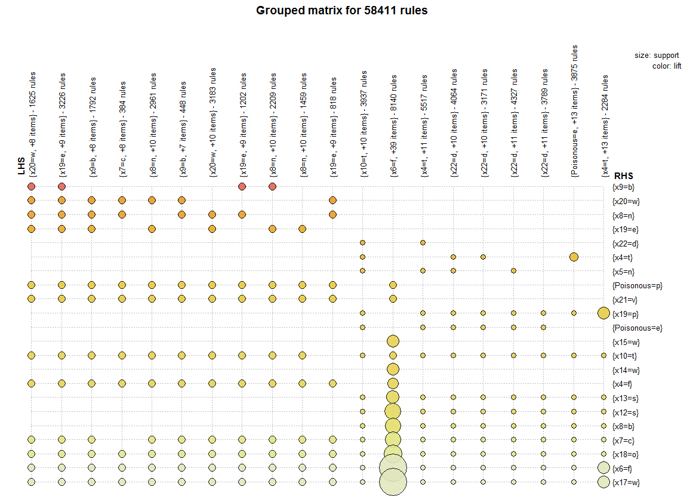

The rules in the upper left corner of this plot for most part have the highest lift. We can change the number of groups (columns) which has *k = 20* by default.

> plot(highconfrules,method="grouped",control=list(k=40))  
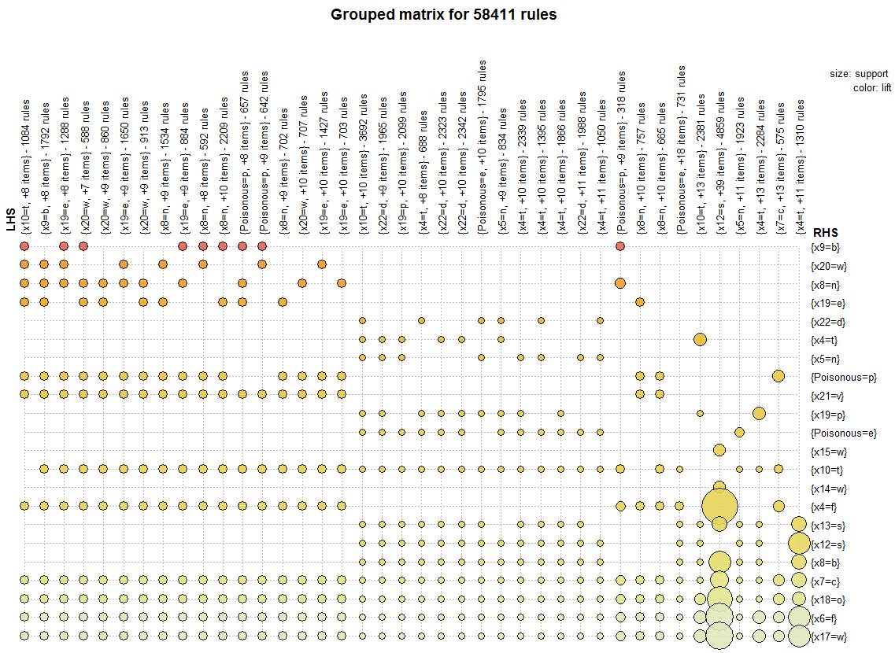  
  
> confonerules = apriori(mush.trans,parameter=list(support=.4,conf=.98))

Parameter specification:

confidence minval smax arem aval originalSupport support minlen maxlen target ext

0.98 0.1 1 none FALSE TRUE 0.25 1 10 rules FALSE

Algorithmic control:

filter tree heap memopt load sort verbose

0.1 TRUE TRUE FALSE TRUE 2 TRUE

writing ... [4266 rule(s)] done [0.00s].

creating S4 object ... done [0.00s].

> plot(confonerules)  
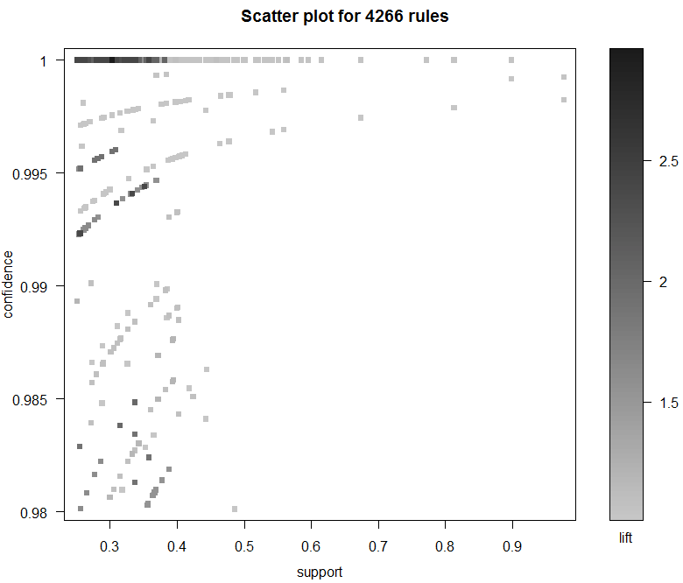

We can again interactively select rules from this plot.

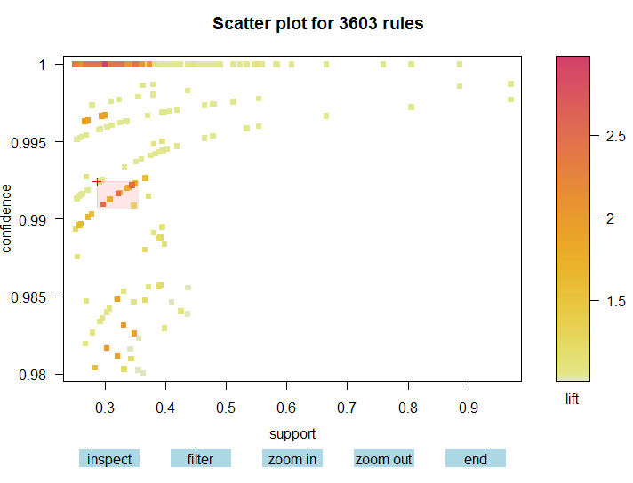

Number of rules selected: 26

lhs rhs support confidence lift order

1418 {x6=f,x7=c,x8=b,x19=p} => {x4=t} 0.3446578 0.9922041 2.391889 5

1421 {x7=c,x8=b,x17=w,x19=p} => {x4=t} 0.3446578 0.9922041 2.391889 5

2324 {x6=f,x7=c,x8=b,x17=w,x19=p} => {x4=t} 0.3446578 0.9922041 2.391889 6

1481 {Poisonous=e,x6=f,x7=c,x8=b} => {x4=t} 0.3217627 0.9916540 2.390563 5

1485 {Poisonous=e,x7=c,x8=b,x17=w} => {x4=t} 0.3217627 0.9916540 2.390563 5

2414 {Poisonous=e,x6=f,x7=c,x8=b,x17=w} => {x4=t} 0.3217627 0.9916540 2.390563 6

2218 {Poisonous=e,x6=f,x7=c,x8=b,x19=p} => {x4=t} 0.2966519 0.9909539 2.388875 6

2222 {Poisonous=e,x7=c,x8=b,x17=w,x19=p} => {x4=t} 0.2966519 0.9909539 2.388875 6

2961 {Poisonous=e,x6=f,x7=c,x8=b,x17=w,x19=p} => {x4=t} 0.2966519 0.9909539 2.388875 7

940 {Poisonous=e,x7=c,x8=b} => {x12=s} 0.3495815 0.9923131 1.560502 4

942 {Poisonous=e,x6=f,x7=c} => {x12=s} 0.3387494 0.9920692 1.560118 4

943 {Poisonous=e,x7=c,x17=w} => {x12=s} 0.3387494 0.9920692 1.560118 4

1912 {Poisonous=e,x6=f,x7=c,x17=w} => {x12=s} 0.3387494 0.9920692 1.560118 5

858 {Poisonous=e,x7=c,x19=p} => {x12=s} 0.3357952 0.9920000 1.560009 4

1762 {Poisonous=e,x7=c,x8=b,x19=p} => {x12=s} 0.3244707 0.9917231 1.559574 5

1904 {Poisonous=e,x6=f,x7=c,x8=b} => {x12=s} 0.3217627 0.9916540 1.559465 5

1905 {Poisonous=e,x7=c,x8=b,x17=w} => {x12=s} 0.3217627 0.9916540 1.559465 5

2764 {Poisonous=e,x6=f,x7=c,x8=b,x17=w} => {x12=s} 0.3217627 0.9916540 1.559465 6

1767 {Poisonous=e,x6=f,x7=c,x19=p} => {x12=s} 0.3079764 0.9912837 1.558883 5

1768 {Poisonous=e,x7=c,x17=w,x19=p} => {x12=s} 0.3079764 0.9912837 1.558883 5

2657 {Poisonous=e,x6=f,x7=c,x17=w,x19=p} => {x12=s} 0.3079764 0.9912837 1.558883 6

2643 {Poisonous=e,x6=f,x7=c,x8=b,x19=p} => {x12=s} 0.2966519 0.9909539 1.558364 6

2644 {Poisonous=e,x7=c,x8=b,x17=w,x19=p} => {x12=s} 0.2966519 0.9909539 1.558364 6

3251 {Poisonous=e,x6=f,x7=c,x8=b,x17=w,x19=p} => {x12=s} 0.2966519 0.9909539 1.558364 7

580 {x6=f,x7=c,x22=d} => {x18=o} 0.3476120 0.9908772 1.084306 4

1323 {x6=f,x7=c,x17=w,x22=d} => {x18=o} 0.3476120 0.9908772 1.084306 5

We can also specify restrictions for the LHS (antecedent) and RHS (consequent) in the association rule search. For example, suppose we wish to find the rules that imply the mushroom is poisonous. We would then use the following apriori function call.

> Poison.rules = apriori(mush.trans,appearance=list(default="lhs",rhs="Poisonous=p"))

Apriori

Parameter specification:

confidence minval smax arem aval originalSupport support minlen maxlen target ext

0.8 0.1 1 none FALSE TRUE 0.1 1 10 rules FALSE

writing ... [27744 rule(s)] done [0.01s].

> summary(Poison.rules)

set of 27744 rules

rule length distribution (lhs + rhs):sizes

2 3 4 5 6 7 8 9 10

8 145 840 2582 4960 6566 6251 4301 2091

Min. 1st Qu. Median Mean 3rd Qu. Max.

2.000 6.000 7.000 7.283 8.000 10.000

summary of quality measures:

support confidence lift

Min. :0.1002 Min. :0.8017 Min. :1.666

1st Qu.:0.1022 1st Qu.:1.0000 1st Qu.:2.078

Median :0.1041 Median :1.0000 Median :2.078

Mean :0.1206 Mean :0.9947 Mean :2.067

3rd Qu.:0.1118 3rd Qu.:1.0000 3rd Qu.:2.078

Max. :0.3848 Max. :1.0000 Max. :2.078

> Poison.rules = sort(Poison.rules,by="lift")

> inspect(Poison.rules[1:20])

lhs rhs support confidence lift

2 {x19=l} => {Poisonous=p} 0.1590350 1 2.077749

4 {x9=b} => {Poisonous=p} 0.2063023 1 2.077749

5 {x5=f} => {Poisonous=p} 0.2619399 1 2.077749

14 {x19=l,x20=h} => {Poisonous=p} 0.1590350 1 2.077749

15 {x5=f,x19=l} => {Poisonous=p} 0.1590350 1 2.077749

16 {x13=k,x19=l} => {Poisonous=p} 0.1590350 1 2.077749

17 {x12=k,x19=l} => {Poisonous=p} 0.1590350 1 2.077749

18 {x10=e,x19=l} => {Poisonous=p} 0.1590350 1 2.077749

19 {x4=f,x19=l} => {Poisonous=p} 0.1590350 1 2.077749

20 {x8=b,x19=l} => {Poisonous=p} 0.1590350 1 2.077749

21 {x7=c,x19=l} => {Poisonous=p} 0.1590350 1 2.077749

22 {x18=o,x19=l} => {Poisonous=p} 0.1590350 1 2.077749

23 {x6=f,x19=l} => {Poisonous=p} 0.1590350 1 2.077749

24 {x17=w,x19=l} => {Poisonous=p} 0.1590350 1 2.077749

25 {x3=e,x9=b} => {Poisonous=p} 0.1058592 1 2.077749

27 {x3=e,x8=n} => {Poisonous=p} 0.1058592 1 2.077749

29 {x3=e,x4=f} => {Poisonous=p} 0.1070901 1 2.077749

30 {x5=f,x20=h} => {Poisonous=p} 0.1954702 1 2.077749

31 {x13=k,x20=h} => {Poisonous=p} 0.1590350 1 2.077749

32 {x12=k,x20=h} => {Poisonous=p} 0.1590350 1 2.077749

Again we use plots to interactive select a subset of higher quality rules.

> sel2 = plot(Poison.rules,interactive=T)

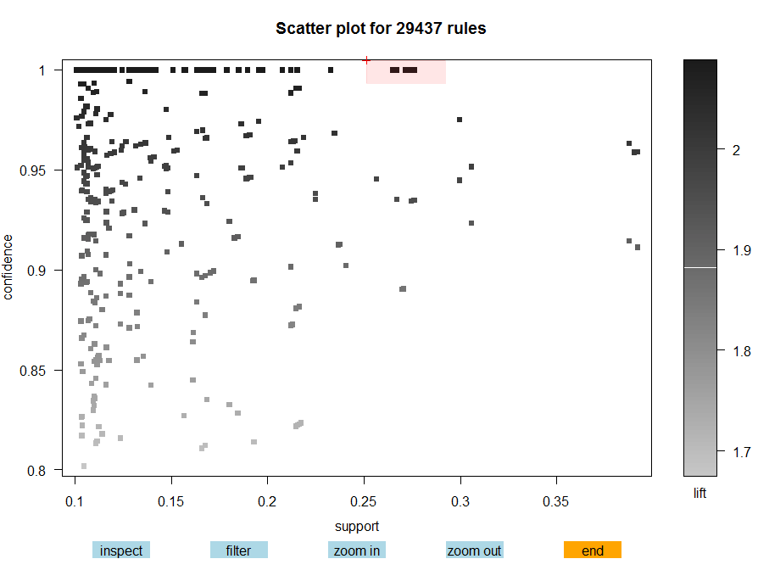

Sel2 – max lift with support of 25%

Sel 3 – lift = 2.0 and max support.

Number of rules selected: 24

lhs rhs support confidence lift order

117 {x7=c,x12=k} => {Poisonous=p} 0.2735106 1 2.077749 3

118 {x12=k,x18=o} => {Poisonous=p} 0.2693255 1 2.077749 3

758 {x4=f,x7=c,x12=k} => {Poisonous=p} 0.2735106 1 2.077749 4

759 {x4=f,x12=k,x18=o} => {Poisonous=p} 0.2693255 1 2.077749 4

766 {x7=c,x12=k,x18=o} => {Poisonous=p} 0.2693255 1 2.077749 4

767 {x6=f,x7=c,x12=k} => {Poisonous=p} 0.2712949 1 2.077749 4

768 {x7=c,x12=k,x17=w} => {Poisonous=p} 0.2735106 1 2.077749 4

769 {x6=f,x12=k,x18=o} => {Poisonous=p} 0.2693255 1 2.077749 4

770 {x12=k,x17=w,x18=o} => {Poisonous=p} 0.2693255 1 2.077749 4

2854 {x4=f,x7=c,x12=k,x18=o} => {Poisonous=p} 0.2693255 1 2.077749 5

2855 {x4=f,x6=f,x7=c,x12=k} => {Poisonous=p} 0.2712949 1 2.077749 5

2856 {x4=f,x7=c,x12=k,x17=w} => {Poisonous=p} 0.2735106 1 2.077749 5

2857 {x4=f,x6=f,x12=k,x18=o} => {Poisonous=p} 0.2693255 1 2.077749 5

2858 {x4=f,x12=k,x17=w,x18=o} => {Poisonous=p} 0.2693255 1 2.077749 5

2866 {x6=f,x7=c,x12=k,x18=o} => {Poisonous=p} 0.2693255 1 2.077749 5

2867 {x7=c,x12=k,x17=w,x18=o} => {Poisonous=p} 0.2693255 1 2.077749 5

2868 {x6=f,x7=c,x12=k,x17=w} => {Poisonous=p} 0.2712949 1 2.077749 5

2869 {x6=f,x12=k,x17=w,x18=o} => {Poisonous=p} 0.2693255 1 2.077749 5

7262 {x4=f,x6=f,x7=c,x12=k,x18=o} => {Poisonous=p} 0.2693255 1 2.077749 6

7263 {x4=f,x7=c,x12=k,x17=w,x18=o} => {Poisonous=p} 0.2693255 1 2.077749 6

7264 {x4=f,x6=f,x7=c,x12=k,x17=w} => {Poisonous=p} 0.2712949 1 2.077749 6

7265 {x4=f,x6=f,x12=k,x17=w,x18=o} => {Poisonous=p} 0.2693255 1 2.077749 6

7270 {x6=f,x7=c,x12=k,x17=w,x18=o} => {Poisonous=p} 0.2693255 1 2.077749 6

13631 {x4=f,x6=f,x7=c,x12=k,x17=w,x18=o} => {Poisonous=p} 0.2693255 1 2.077749 7

The second selection highlighted “sel3”.

> inspect(sel3)

lhs rhs support confidence lift order

3573 {x4=f,x6=f,x7=c,x18=o} => {Poisonous=p} 0.3806007 0.9572755 1.988979 5

3574 {x4=f,x7=c,x17=w,x18=o} => {Poisonous=p} 0.3806007 0.9572755 1.988979 5

8535 {x4=f,x6=f,x7=c,x17=w,x18=o} => {Poisonous=p} 0.3806007 0.9572755 1.988979 6

993 {x4=f,x7=c,x17=w} => {Poisonous=p} 0.3847858 0.9513086 1.976581 4

992 {x4=f,x6=f,x7=c} => {Poisonous=p} 0.3825702 0.9510404 1.976024 4

3575 {x4=f,x6=f,x7=c,x17=w} => {Poisonous=p} 0.3825702 0.9510404 1.976024 5

Plot of the rules in the sel2 region.

> plot(sel2,method=”graph”)

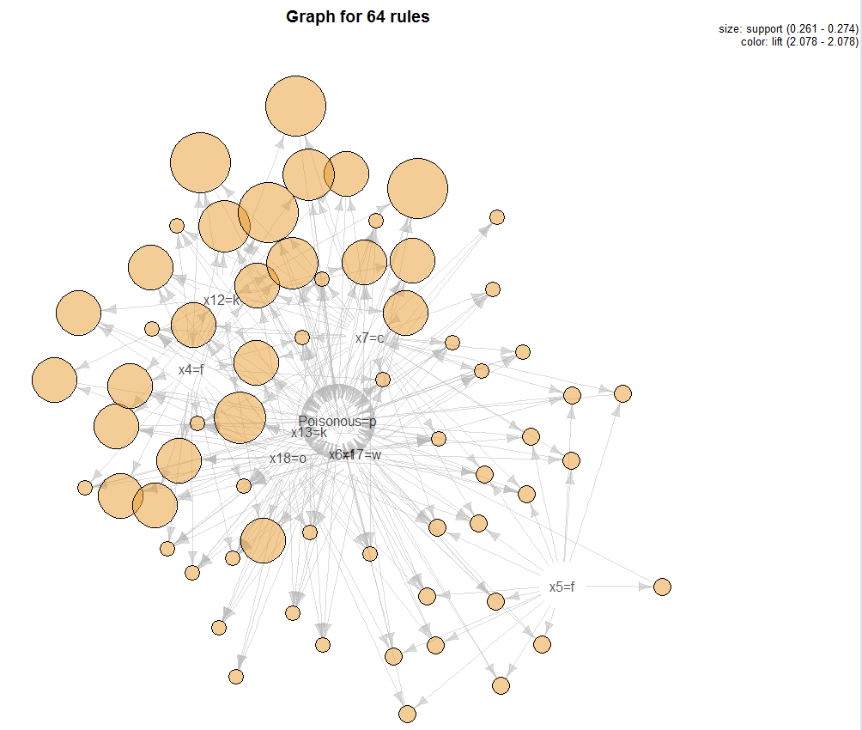

Plot of the rules in the sel3 region.

> plot(sel3,method=”graph”)

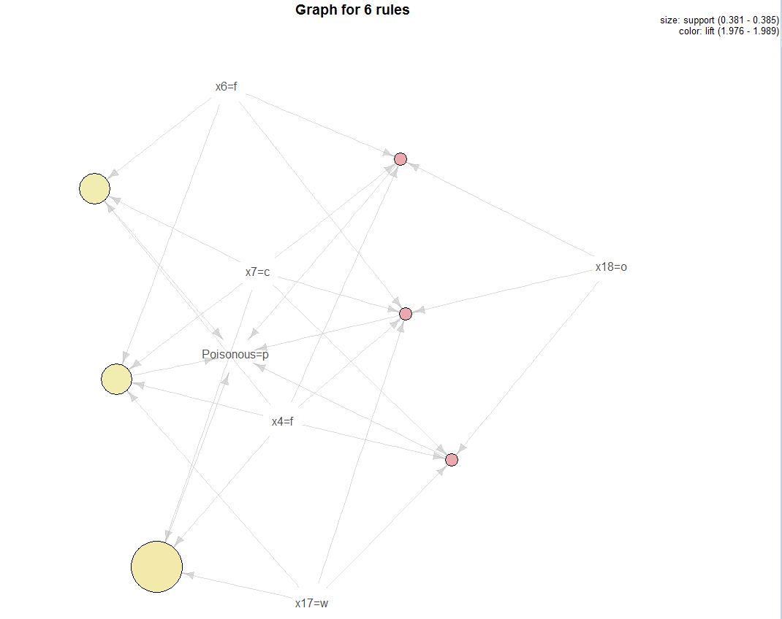

We can specify that we want to see shorter length rules using the maxlen option. There is also a minlen option if you want to see longer rules.

> Poison.rules = apriori(mush.trans,parameter=list(supp=.25,conf=.9,maxlen=3),

appearance=list(default="lhs",rhs="Poisonous=p"))

Apriori

Parameter specification:

confidence minval smax arem aval originalSupport support minlen maxlen target ext

0.9 0.1 1 none FALSE TRUE 0.25 1 3 rules FALSE

Algorithmic control:

filter tree heap memopt load sort verbose

0.1 TRUE TRUE FALSE TRUE 2 TRUE

Absolute minimum support count: 1015

checking subsets of size 1 2 3 done [0.00s].

writing ... [19 rule(s)] done [0.00s].

> summary(Poison.rules)

set of 19 rules

rule length distribution (lhs + rhs):sizes

2 3

3 16

Min. 1st Qu. Median Mean 3rd Qu. Max.

2.000 3.000 3.000 2.842 3.000 3.000

summary of quality measures:

support confidence lift

Min. :0.2546 Min. :0.9156 Min. :1.902

1st Qu.:0.2612 1st Qu.:0.9340 1st Qu.:1.941

Median :0.2619 Median :0.9374 Median :1.948

Mean :0.2669 Mean :0.9645 Mean :2.004

3rd Qu.:0.2724 3rd Qu.:1.0000 3rd Qu.:2.078

Max. :0.3045 Max. :1.0000 Max. :2.078

mining info:

data ntransactions support confidence

mush.trans 4062 0.25 0.9

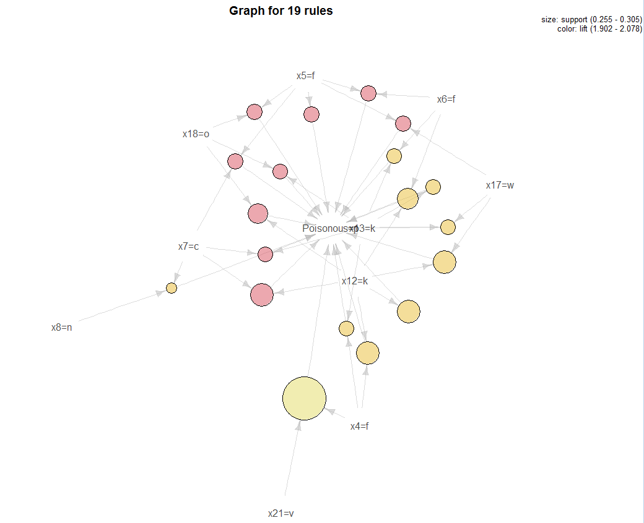

> sixrules = sample(Poison.rules,6)

> plot(sixrules,method="graph",interactive=T) 🡨 allows you to move nodes around!

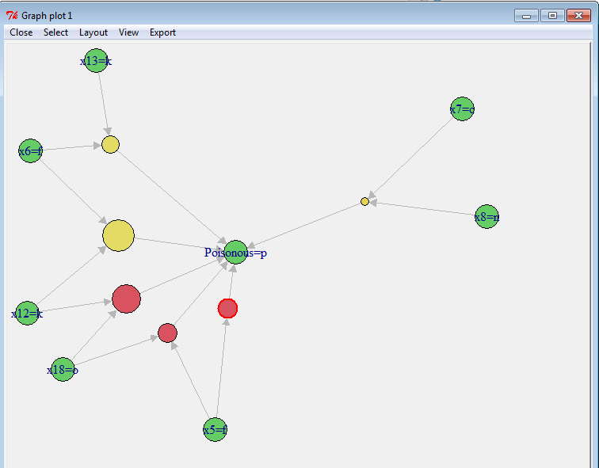

**More examples of visualizing rules**

> mush.rules = apriori(mush.trans)

> subrules2 = head(sort(mush.rules,by="lift"),10) 🡨 save the 10 rules with highest lift

> plot(subrules2,method="graph")

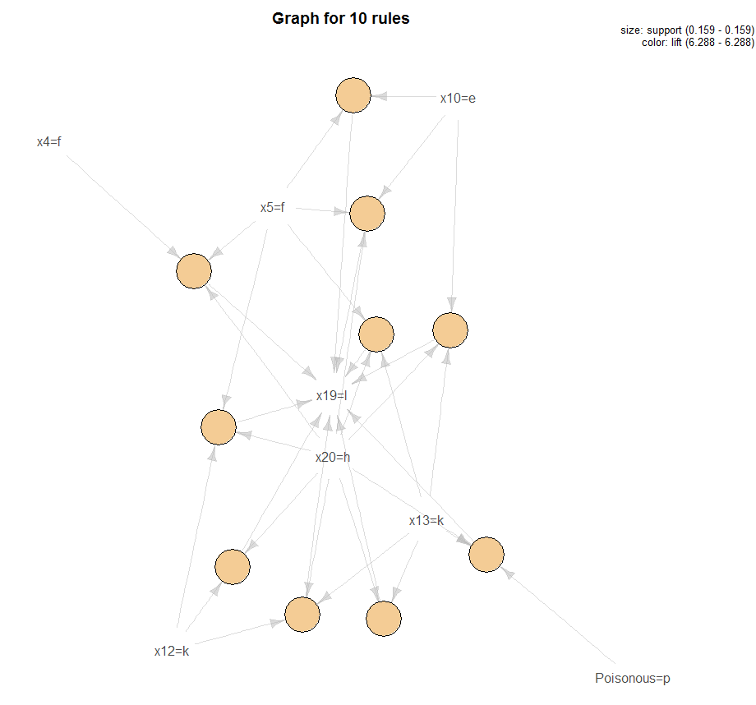

> plot(subrules2,method=”paracoord”)

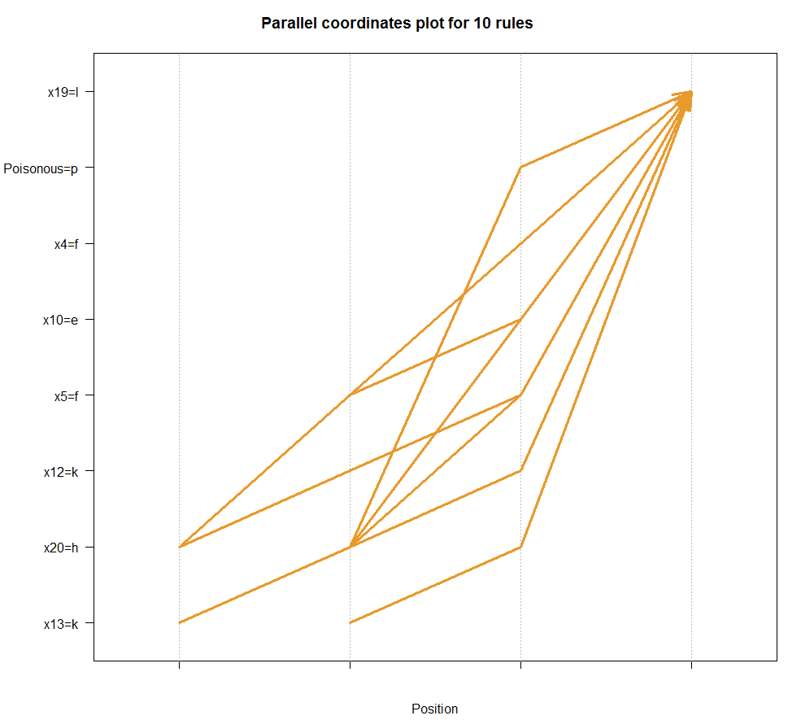

> oneRule = sample(mush.rules,1)

> inspect(oneRule)

lhs rhs support confidence lift

51231 {x1=x,x8=b,x18=o,x22=g} => {x17=w} 0.1033973 1 1.029919

> plot(oneRule,method="doubledecker",data=mush.trans)

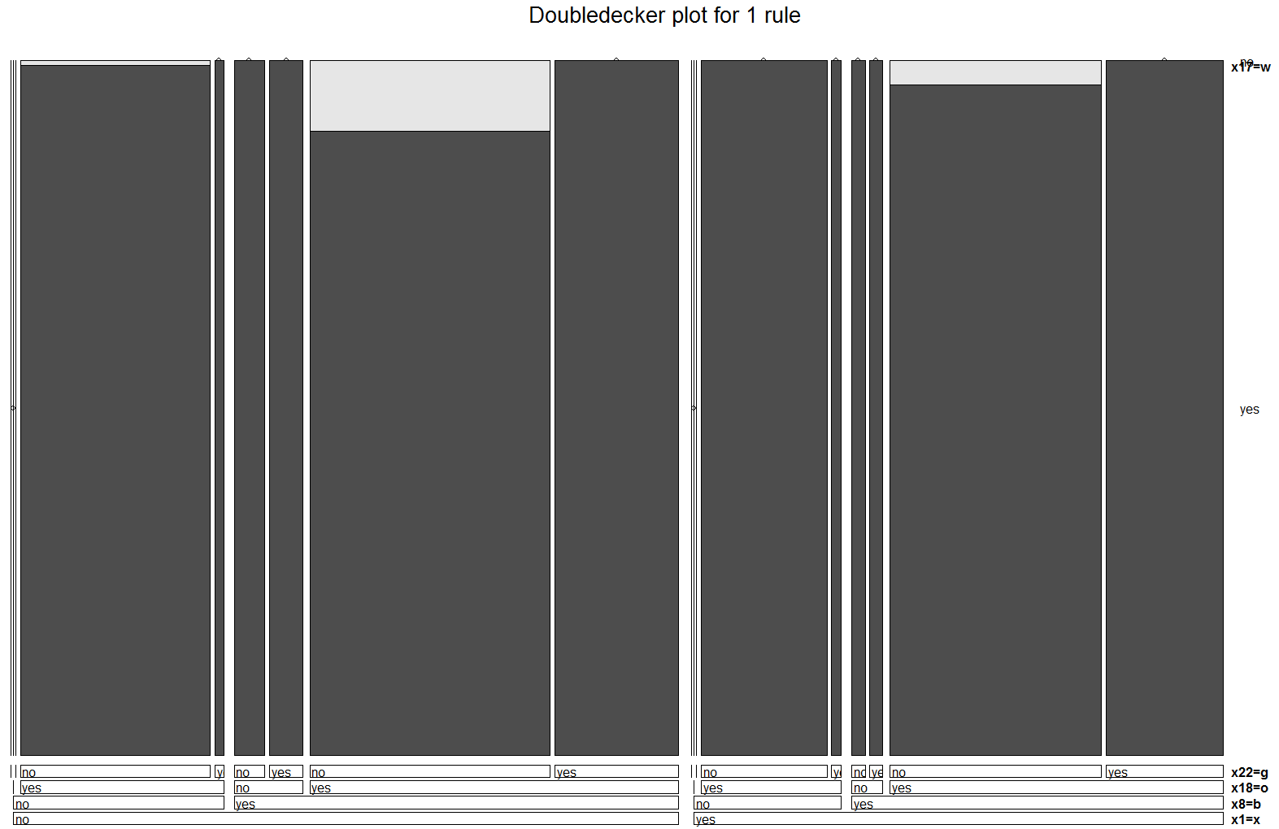

Example 7.5: Retail Sales in a Belgian Supermarket

These data contain the market baskets from 88161 transactions where there are total of 16470 different items sold. The data is contained a text file where each row corresponds to the set of items bought by one of the 88162 customers. We wish to identify association rules within in this large transactional data base.

> BelgRetail = readLines("http://fimi.ua.ac.be/data/retail.dat")

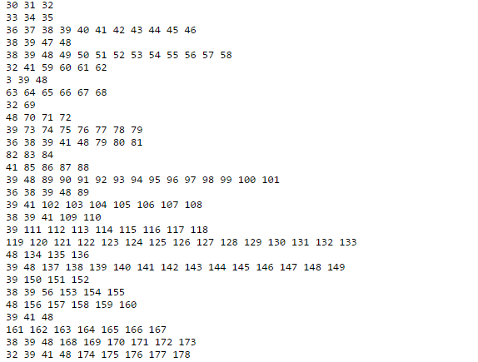🡨 note each line corresponds to a transaction with items purchased listed

> head(BelgRetail)

[1] "0 1 2 3 4 5 6 7 8 9 10 11 12 13 14 15 16 17 18 19 20 21 22 23 24 25 26 27 28 29 " 🡨 This transaction does not look legitimate so we will remove it.

[2] "30 31 32 "

[3] "33 34 35 "

[4] "36 37 38 39 40 41 42 43 44 45 46 "

[5] "38 39 47 48 "

[6] "38 39 48 49 50 51 52 53 54 55 56 57 58 "

> BelgRetail = BelgRetail[-1] 🡨 Remove suspicious transaction

> BelgRetail = strsplit(BelgRetail," ") 🡨creates an array where each element is   
 transaction list for each customer.

> head(BelgRetail)

[[1]]

[1] "30" "31" "32"

[[2]]

[1] "33" "34" "35"

[[3]]

[1] "36" "37" "38" "39" "40" "41" "42" "43" "44" "45" "46"

[[4]]

[1] "38" "39" "47" "48"

[[5]]

[1] "38" "39" "48" "49" "50" "51" "52" "53" "54" "55" "56" "57" "58"

[[6]]

[1] "32" "41" "59" "60" "61" "62"

> numCustomers = length(BelgRetail)

> numCustomers

[1] 88161  
> prodCount = sapply(BelgRetail,length)

> hist(prodCount,xlab="Number of Products Purchased per Transaction")

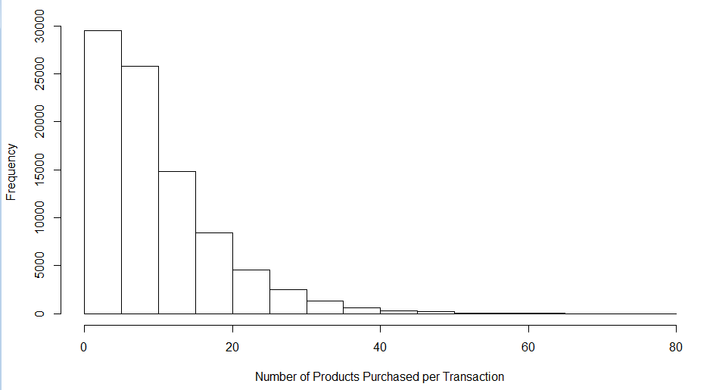

> maxCount = max(prodCount)

> maxCount

[1] 76 🡨 maximum number of products bought by a single customer

> BelgRetail.trans = as(BelgRetail,"transactions") 🡨turn this into a transactional database

> Belg.rules = apriori(BelgRetail.trans)

Apriori

Parameter specification:

confidence minval smax arem aval originalSupport support minlen maxlen target ext

0.8 0.1 1 none FALSE TRUE 0.1 1 10 rules FALSE

Algorithmic control:

filter tree heap memopt load sort verbose

0.1 TRUE TRUE FALSE TRUE 2 TRUE

Absolute minimum support count: 8816

set item appearances ...[0 item(s)] done [0.00s].

set transactions ...[16470 item(s), 88161 transaction(s)] done [0.11s].

sorting and recoding items ... [5 item(s)] done [0.00s].

creating transaction tree ... done [0.02s].

checking subsets of size 1 2 3 done [0.00s].

writing ... [0 rule(s)] done [0.00s]. 🡨 NO RULES RETURNED!!! WHY DID THIS HAPPEN??

creating S4 object ... done [0.00s].

> summary(BelgRetail.trans)

transactions as itemMatrix in sparse format with

88161 rows (elements/itemsets/transactions) and

16470 columns (items) and a density of 0.0006257154

most frequent items:

39 48 38 32 41 (Other)

50675 42135 15596 15167 14945 770028

element (itemset/transaction) length distribution:

sizes

1 2 3 4 5 6 7 8 9 10 11 12 13 14 15 16 17 18 19

3016 5516 6919 7210 6814 6163 5746 5143 4660 4086 3751 3285 2866 2620 2310 2115 1874 1645 1469

20 21 22 23 24 25 26 27 28 29 30 31 32 33 34 35 36 37 38

1290 1205 981 887 819 684 586 582 472 480 354 310 303 272 234 194 136 153 123

39 40 41 42 43 44 45 46 47 48 49 50 51 52 53 54 55 56 57

115 112 76 66 71 60 50 44 37 37 33 22 24 21 21 10 11 10 9

58 59 60 61 62 63 64 65 66 67 68 71 73 74 76

11 4 9 7 4 5 2 2 5 3 3 1 1 1 1

Min. 1st Qu. Median Mean 3rd Qu. Max.

1.00 4.00 8.00 10.31 14.00 76.00

includes extended item information - examples:

labels

1 0

2 1

3 10  
  
> Belg.rules = apriori(BelgRetail.trans,parameter=list(supp=.005))  
Apriori

Parameter specification:

confidence minval smax arem aval originalSupport support minlen maxlen target ext

0.8 0.1 1 none FALSE TRUE 0.005 1 10 rules FALSE

Algorithmic control:

filter tree heap memopt load sort verbose

0.1 TRUE TRUE FALSE TRUE 2 TRUE

Absolute minimum support count: 440

set item appearances ...[0 item(s)] done [0.00s].

set transactions ...[16470 item(s), 88161 transaction(s)] done [0.12s].

sorting and recoding items ... [221 item(s)] done [0.01s].

creating transaction tree ... done [0.03s].

checking subsets of size 1 2 3 4 5 done [0.01s].

writing ... [62 rule(s)] done [0.00s].

> summary(Belg.rules)

set of 62 rules

rule length distribution (lhs + rhs):sizes

2 3 4 5

13 31 17 1

Min. 1st Qu. Median Mean 3rd Qu. Max.

2.0 3.0 3.0 3.1 4.0 5.0

summary of quality measures:

support confidence lift

Min. :0.005 Min. :0.80 Min. : 1

1st Qu.:0.006 1st Qu.:0.84 1st Qu.: 2

Median :0.007 Median :0.96 Median : 5

Mean :0.011 Mean :0.92 Mean : 5

3rd Qu.:0.012 3rd Qu.:0.98 3rd Qu.: 6

Max. :0.084 Max. :0.99 Max. :65

mining info:

data ntransactions support confidence

BelgRetail.trans 88161 0.005 0.8

> plot(Belg.rules,method=”graph”,interactive=T)🡨 allows you to move nodes around

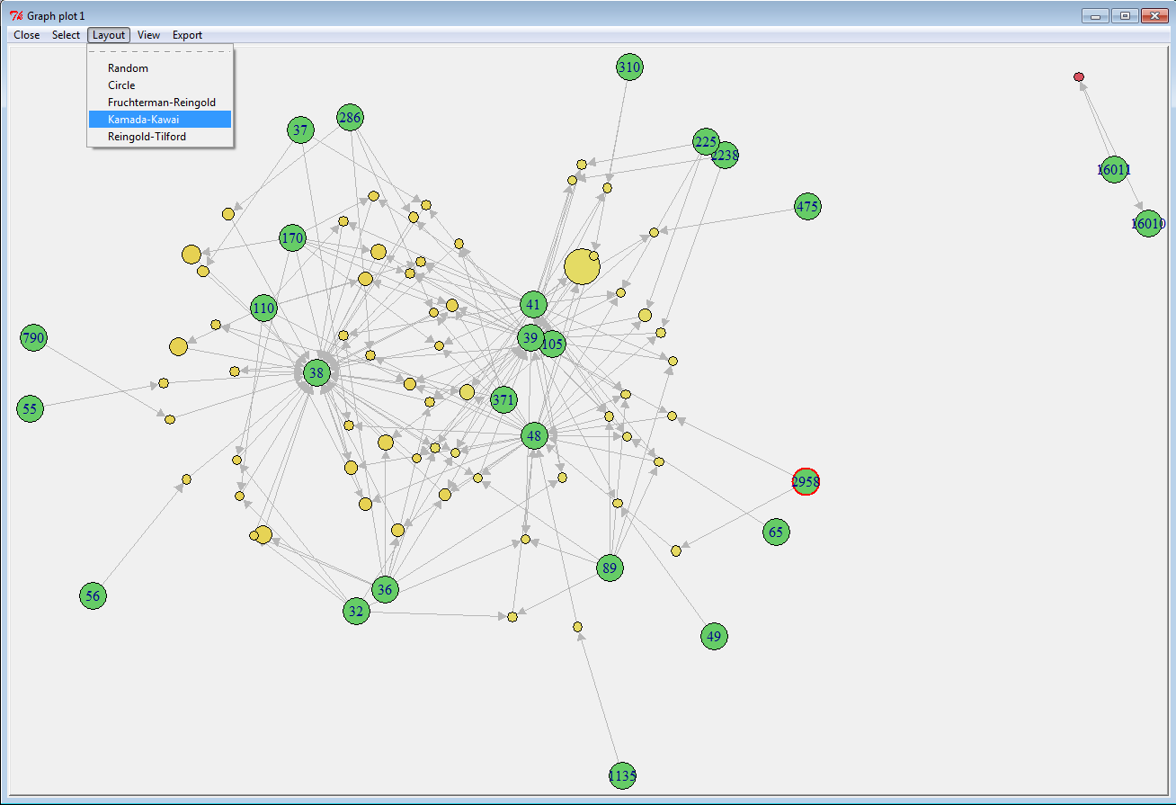

There are optimal node layout algorithms called *Forced Directed Graph Drawing* techniques that allow you to more clearly see the association rules. The Kamada-Kawai and the Fruchterman-Reingold both produce nice displays of the rules for these data.

Because of the large number of potential items in the retail store and the fairly small numbers of items per cart, we need to lower the support substantially in order find some “quality” association rules. Most of the rules have RHS resulting in items 32, 36, 38, 39, 48 and there is one very strong rule associating items 16010 & 16011. The lift values for some of the rules found are very large, indicating strong associations between some of the items in this fairly sparse transactional database.

> plot(Belg.rules,method=”graph”,interactive=T)🡨 allows you to move nodes around

