R: Twitter/Text Mining

**Setting up an API, i.e. Twitter Side**

Twitter uses an Application Programming Interface (API) that allows developers to pull Twitter data.

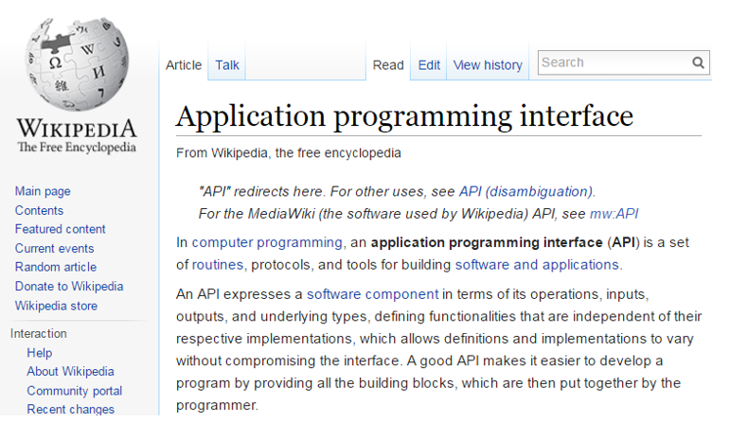

To setup an API, go to <http://apps.twitter.com>, sign in using an existing Twitter account.

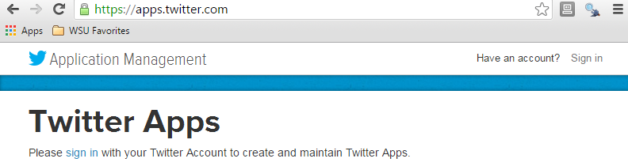

Once logged in, select Create New App

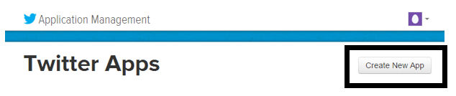

Next, specify the requested information to create a new application.

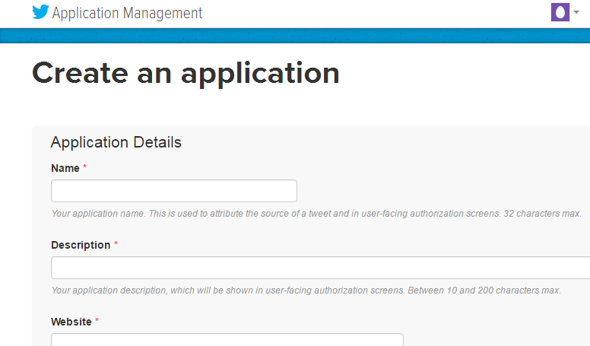

DSCI210_TwitterPull is the newly created application.



After a successful application has been setup, the following information is required to access Twitter’s data API from R.

* Consumer Key
* Consumer Secret
* Access Token
* Access Token Secret

These information can be obtained under the Keys and Access Tokens tab on the Twitter site.

|  |  |
| --- | --- |
|  |  |

Working with Twitter Pulls in R

The following packages/libraries will be used to analyze Twitter data in R.

library(twitteR)

library(RCurl)

library(tm)

library(wordcloud)

The following information is obtained from the DSCI210_TwitterPull application on Twitter side.

#Specified from Twitter Account - DSCI_210 is app name

consumer_key <- "*<consumer_key>*"

consumer_secert <- "*<consumer_secert>*"

token_key <- "*<token_key>*"

token_secert <- "*<token_secert>*"

Setting up the OAUTH connection in R.

*Note*: OAUTH is an open protocol to allow secure authorization in a simple and standard method from web, mobile and desktop applications.

#Setting up OAUTH in R

setup_twitter_oauth(consumer_key,consumer_secert,token_key,token_secert)

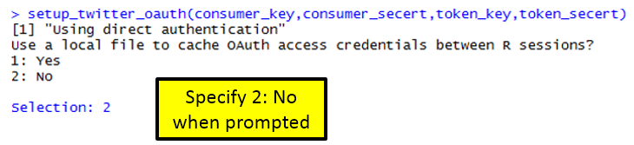

Getting a Twitter pull

#Gettting a pull on recent Ecuador Earthquake

pull <- searchTwitter("#EcuadorEarthquake", n=1000, lang="en")

The object returned by the searchTwitter() function is a list.

#Checking to see if object is indeed a list

is.list(pull)

This (somewhat unstructured) list can be converted a standard data.frame using the following.

#Converting list to dataframe

df <- do.call("rbind", lapply(pull, as.data.frame))

View(df)

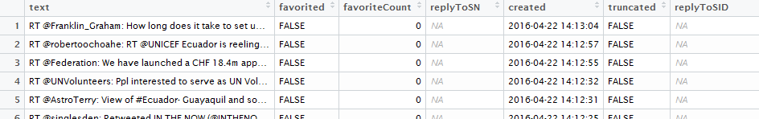

Writing data.frame to comma delimited file

#The write.csv() function to write this data.frame into a *.csv file

write.csv(df,file=<director/filename>")

A summary of screenname

Get # posts by screenName

table(df$screenName)

#Plotting results

plot(table(df$screenName))

#adding a horizontal line at 3

abline(h=3)

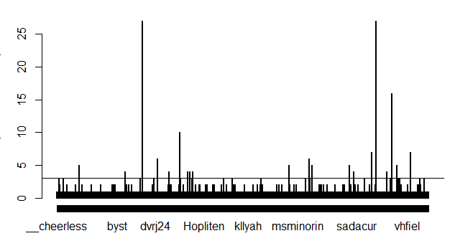

#Idenitfy screenNames with more than 3 counts

which(table(df$screenName)>3)

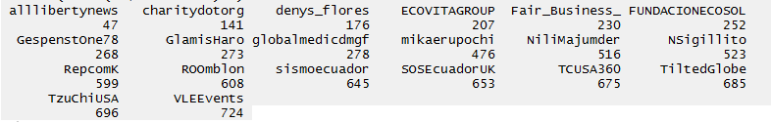

Gain an understating the of the variable types in this data.frame.

#Getting the structure of our data.frame

str(df)

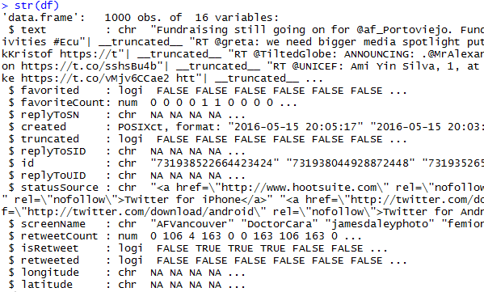

#Plotting twitter pull across days

plot(table(as.Date(df$created)))

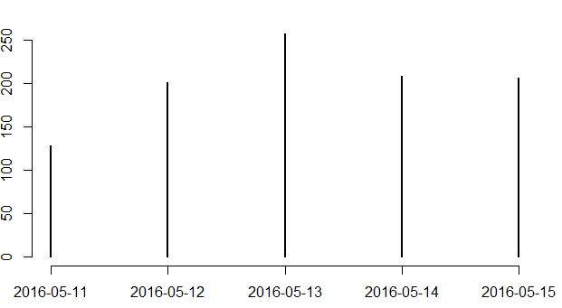

#The following can be used to pull hour off created variable

as.POSIXlt(df$created)$hour

#Next, table/plot outcome

plot(table(as.POSIXlt(df$created)$hour))

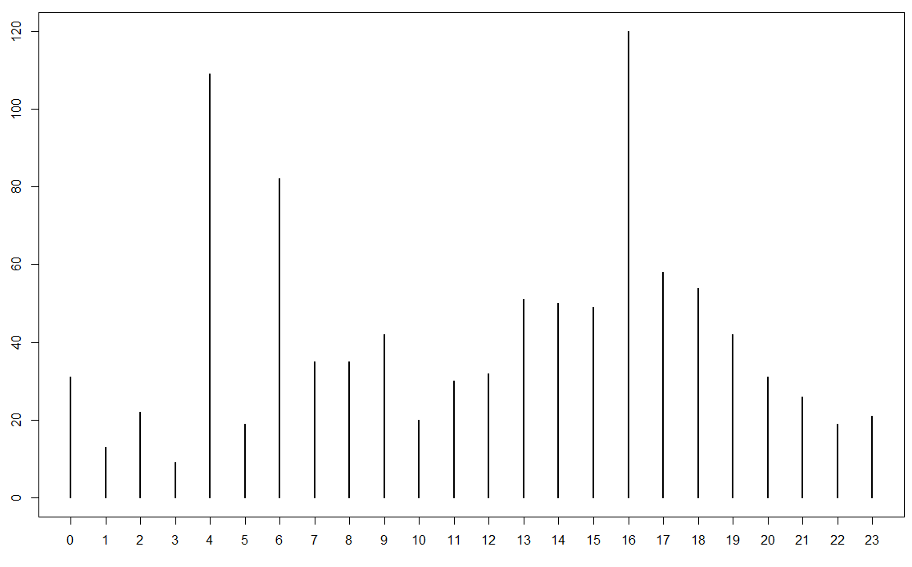

**Text Mining Procedures**

#using the tm library for text mining

myCorpus <- Corpus(VectorSource(df$text))

#Clean up text using the tm_map() function

myCorpus <- tm_map(myCorpus, tolower)

myCorpus <- tm_map(myCorpus, removePunctuation)

myCorpus <- tm_map(myCorpus, removeNumbers)

Necessary to get rid of common English words. The stopwords() function can be used to accomplish this in R.

#Getting rid of common english words

myStopwords <- c(stopwords('english'))

myCorpus <- tm_map(myCorpus, removeWords, myStopwords)

The following is used to convert the Corpus object into a TermDocumentMatrix which is then converted to a matrix, and eventually a data.frame.

myDtm <- TermDocumentMatrix(myCorpus, control = list(minWordLength = 1))

m <- as.matrix(myDtm)

v <- sort(rowSums(m), decreasing=TRUE)

myNames <- names(v)

#Creating data.frame for wordcloud

d <- data.frame(word=myNames, freq=v)

wordcloud(d$word, d$freq, min.freq=3)

A Wordcloud of text from Twitter pull.

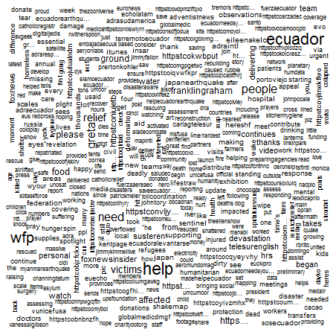

The wordcloud() function allows specification of a minimum frequency when plotting. This can be used to identify the most common words.

wordcloud(d$word, d$freq, min.freq=40)

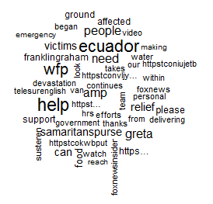

**Task**

Obtain a Twitter pull on a topic of your choice. Complete the following for your data.

1. Write the Twitter data into a CSV file.
2. Does the number of tweets vary much over day? If some days are more tweets than others, why might this be the case?
3. Doe the number of tweets vary much over time of day?
4. Create a reasonable workcloud for your twitter date. If necessary, remove any over-represented words by modifying the myStopwords line above in the code.