


WISDAM - USER MANUAL

Version 1.1.0 September 2026
About WISDAM 3
Metadata Concept 4
Image Metadata 4
Object Metadata 4
Resight Set 5
Environmental Metadata 6
Basic Window Handling 7
Status Information 8
Thumbnail Popup 8
Management of Projects 9
Load Project 9
Create a New Project (Beta) 9
Configure Image Paths 10
Configure Colours 10
Configure Mapper 11
Image List Pane 12
Start Screen 13
Project Cockpit Page 13
Object Inspector Page 14
Import Page 15
Import Images 15
GIS Page 16
Image Pane 16
Selection 16
Visibility and Colouring Pane 16
Possible Actions 16
Objects Groups by Location/Area (Beta) 17
Object Digitiser Page 18
Image Viewer Pane 19
Geometric Operations 19
Navigation 19
Colour/Visibility of Objects 20
Gallery Page 21
Thumbnail 21
Possible Actions 22
Filter/Order/Size Pane 22
AI Page 23
AI Thumbnail Viewer 23
Import AI 24
Filter Pane 24
Using AI Workflows 24
Compare Projects Page (Beta) 25
Modes 25
Load/Generate Comparison 25
Correspondence List 25
Object Handling 26
Handle Comparison Objects - Buttons 26
Save or Export – Buttons 26
Export Page 27
Appendix I - Data Concept 28
Database Tables 28
Appendix II – Object Type Configuration File 30
Appendix III – AI Generic Format 31
Appendix IV - MAD-v2 31

About WISDAM
WISDAM (Wildlife Imagery Survey – Detection and Mapping) is a software package for the detection, digitisation, and mapping of objects within images. WISDAM is designed to optimise the workflow of processing wildlife imagery and is focused on fast and easy handling of images, digitisation of objects and their mapping.
WISDAM can use a wide range of georeference information to map image footprint and objects, and project objects back into overlapping images. As an imagery source, all kind of images and orthophotos can be used. Objects and images can be enriched with meta-information, and objects from external sources (such as AI workflows) can be imported into WISDAM.
More information about the WISDAM project can be found at www.wisdamapp.org
The software’s source code can be found at www.github.com/wisdamapp
NOTIFICATION – for usage on all scientific output (e.g. publications, thesis, presentations etc.), please cite the following papers and state the GitHub link.
Hodgson A, Kelly N, Peel D (2013) Unmanned Aerial Vehicles (UAVs) for Surveying Marine Fauna: A Dugong Case Study. PLoS ONE 8(11): e79556. https://doi.org/10.1371/journal.pone.0079556
WISDAM is released under the term of GPLv3 and written in Python Language to provide the scientific community with the ability to contribute to the project. While it is noted that Python may not be the fastest option, it is the programming language most used in the scientific community. Speed is not of major concern or development goal in the software package but anyhow it is as much as possible considered that the software is stable and can run smoothly and as fast as possible.
The package will continue to grow over time and provide a rich toolset for dealing with monitoring wildlife. All inputs and contributions on statistic implementations, further tooling, or general handling are highly welcome.
weitsicht
The WISDAM software depends on a library called weitsicht, which is the core module for all mapping related functions. Image mapping is released as an open-source package and can be found at https://github.com/MartinW-S2M/weitsicht
It is designed to provide easy access to photogrammetric functions, such as projection of coordinates into image space, and for mapping image pixel coordinates into the 3D space.

Metadata Concept
Metadata structures are used to enrich images and objects with additional information. Within WISDAM, metadata is generated automatically by the software (e.g. ground sampling distance (GSD), timestamps, and focal length of camera objective used). Other metadata must be entered by the user (e.g. survey ID, and animal species etc.).
In the design phase, experience from different institutions was used to establish a pre-defined metadata structure that contains a common basis, but that also allows for flexible adjustments for certain metadata types. These can be defined upon project creation.
There are four main metadata structures defined in WISDAM:
- Image metadata
- Object metadata
- Resight set
- Environmental Metadata

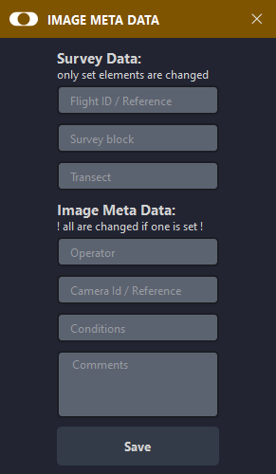
Image Metadata
Contains attributes about the capture or survey mission, including both user-entered and automatically estimated attributes (e.g. GSD, area, image ID, image datum).
These metadata are fixed and include:
- Flight ID/Reference*
- Survey Block*
- Transect*
- JSON-like structure for Operator, CameraID/Reference, Conditions, and Comments
*can be used for colouring the GIS page.

The image group is another important metadata and allows users to group images from within the GIS page, providing a more flexible option for the grouping of images. Ideas are present to add functions (spatial statistics) to automatically group image by their transect using flight lines. But this not included up to date.

Object Metadata
This is the main metadata used to describe the attributes of labelled objects and information about the review process.
While some metadata (such as object type or group area) are predefined, the structure also includes a number of variables (such as text fields, drop down lists, and sliders) that can be configured according to the project requirements.

For example, our predefined attributes for marine animal sightings for example include:
- Taxa – this is considered the object type and is the high-level classification of the animal sighted (e.g. whale, dolphin, bird, turtle etc.).
- Individual type – single, mother, or calf.
- Water position – for marine fauna, whether at the surface, mid-water or on the sea floor.
- Certainty – yes or no, according to whether the user is one hundred percent certain of the taxa classification.
- First certain – where there are multiple sightings of the same individual animal, yes or no according to whether this is the first in the sequence of sightings and where the user is one hundred percent certain of the taxa classification (adjusted automatically).
- Resight – yes or no, according to whether the individual animal has been sighted in previous images (adjusted automatically).
- Animal/Species – a more detailed classification of the animal (e.g. to species level).
- Species surety – a subjective assessment of the user’s confidence in their classification of the species (i.e. certain, probable, or guess).

Variable metadata of objects is stored as JSON-like text in the tables (e.g. data and data_env), while the mapping/configuration of the meta-structure is stored in the configuration table.

Resight Set
This is a metadata for objects and is used to assign correspondences of resights of an object. Detections of the same individual animal within the overlap of multiple images can be merged into a Resight Set to allow the software to know which objects are the same individual. This is only permitted for detections appearing in different images and that are of the same object and metatype.
Assigning an object to a Resight Set will change the First Certain and Resight variables of an object. These two variables are always present, regardless of the project configuration, and no other user define variable can use these names.
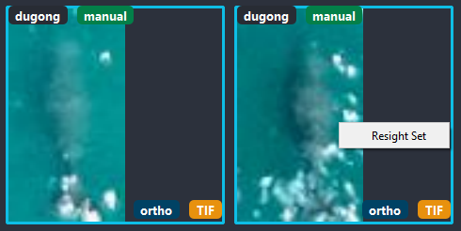 | 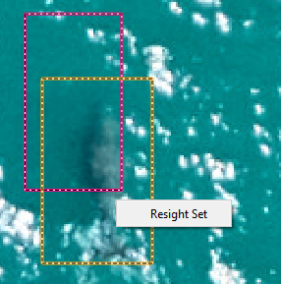

Automatic assigning of first certain and resight
The First Certain and Resight attributes of grouped detections are automatically adjusted, based on the image ID. Only the first detection (i.e. appearing in the image with the lowest ID) labelled certain = yes will become first certain = yes. All other certain = yes objects will be assigned first certain = no. All detections after the first detection (based on image ID) will set to resight = yes.
If a detection is removed from a Resight Set, its Resight and First Certain values will become no and any original First Certain label of single objects will be lost.

If an object/detection is deleted completely and it was assigned to a Resight Set, all other objects in that set will be recalculated. If there is only one other detection in that set, this detection will no longer be assigned to a Resight Set.

Environmental Metadata
This structure can be assigned to images and objects. It currently supports 6 independent variables, with an unlimited count of numeric and alphanumeric values.
Our pre-determined attributes are designed for marine studies and include the following categories, each with numerical values:
- Water visibility - turbidity and bottom visibility.
- Sea state - based on the Beaufort scale.
- Glare – a subjective measure, based on how much of the image is affected.

Initially, no environmental data is set for an image. The environmental attributes of an image are propagated to a newly created object, regardless of whether it is manually digitised or comes from an AI or external import.
Setting one environmental variable will set all of them.

Within the Image Digitiser page, changing the value of one attribute will change the environmental data box to a green background. The image’s environmental data will be propagated to the next or previous image when you navigate between images using the ENTER or RETURN keys. If Propagate Always is activated, it will override the existing environmental data when navigating between images. Certain configurations can be set when starting a new project (for example, setting an object’s environmental data to propagate to the image, if there is currently no environmental data set). If the environmental data originates from propagation of another image, it will appear with a brown background.
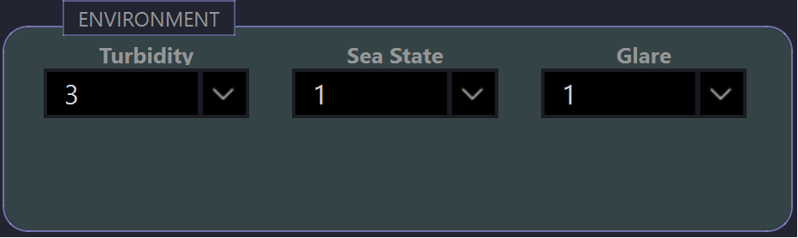
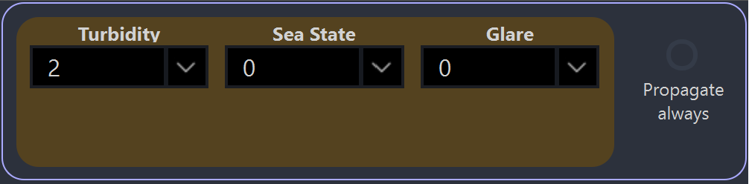

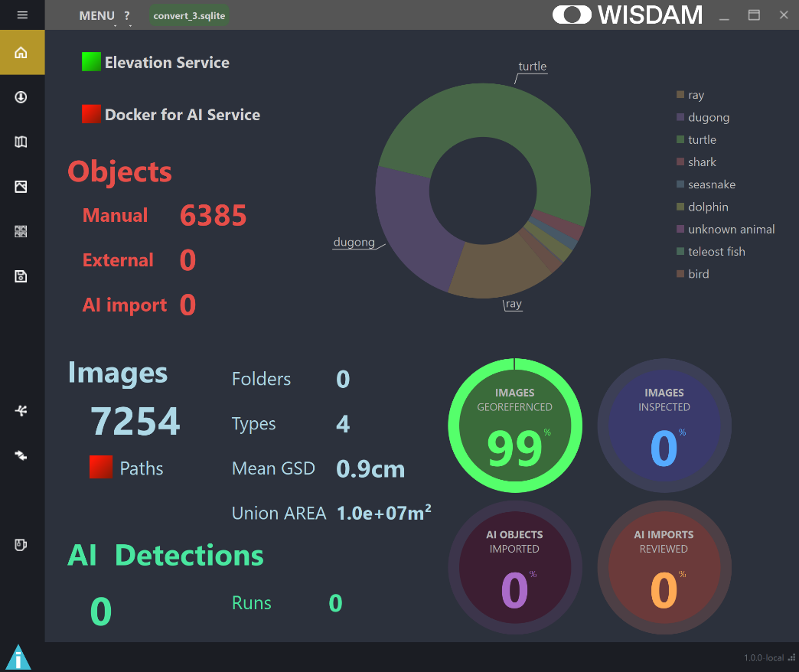
Basic Window Handling
6
5
2
1
7
8
4
- Fold/Unfold the menu names
- Menu and About Action
- Project Name
- Move window with top bar
- Minimize, maximize, close
- Change size of window
- Open/close status window
- Navigate through pages

3
Most windows and popups can be moved on the upper part of the window.

Some of the interaction elements can be set to fold/unfold, if that symbol is clicked. For example, the image list pane in the GIS and Digitiser page, or the filter and colour options in most pages.
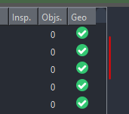
For some areas, it is also possible to change the width, by dragging the white border line of that area. For example, the image list pane can be stretched to see more information. The proportions in the Compare page between list and objects can also be changed. This is only possible if the window is not minimised to where the minimal area for the image viewer is fixed.
Panning and zooming within the GIS page and the image view of the digitiser are done by clicking on and using the middle mouse wheel.

For most processes, a spinning wheel will appear to indicate that the process is in progress. The standard spinning wheel for loading databases and images is located on the left side, over the status symbol; while for others, it is on the page where the process is started.

Some windows and popups are configured to always be in the foreground of the screen and the main window is not accessible while that window is open.

Status Information
The status window will show information status, warnings, errors, and finished operations. If messages are printed, the status window will appear immediately in different colours, according to the status. Only normal information will show immediately and be printed without the window. The window can be opened or closed by clicking on the status icon. Once the status is clicked, it will change to the normal information icon. The log messages can be saved to a text file by clicking on the save symbol.
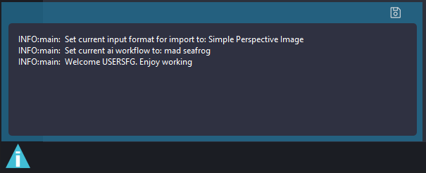



Warning
Info
Error
The saved log messages can be useful for developers, as error messages will be displayed.
To help us to further develop the software, please file bug reports by following the template under www.github.com/WISDAMapp/WISDAM/issues and add the saved log files.

Thumbnail Popup
Hovering over an object at the Object Digitiser and GIS page will show a popup with both the object’s basic information and bounding box image.
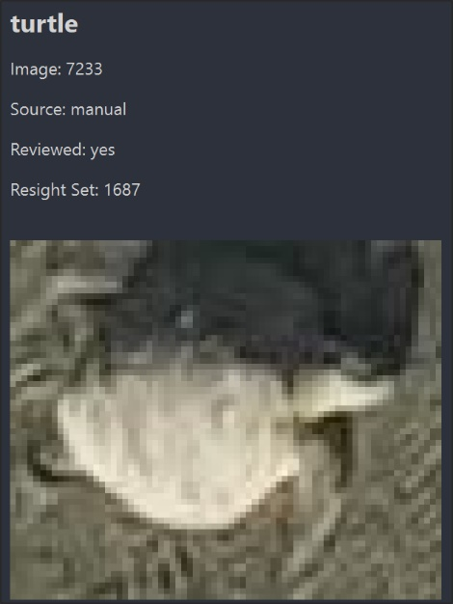

Management of Projects

Load Project
To load a project, go to Menu and select Load Project. This will open a file dialogue window where an existing project database (SQLite file) can be chosen.

Create a New Project (Beta)
To create a new project, go to Menu and select Create New Project. This will open a new window and allow you to configure the metadata settings. A new project database file will be created.
Note that if you use the same name of an already existing database, the existing one will be overwritten!
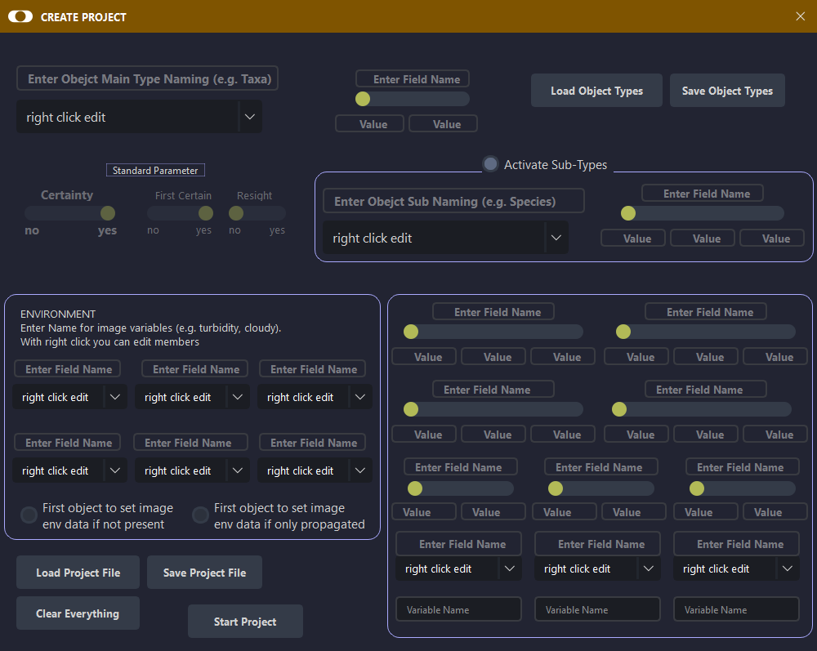
As described in the metadata section, there are two kinds of metadata that can be configured.
- Environmental data - where up to 6 dropdown boxes can be configured. The top text box allows users to enter the name of the variable and add variables within the combo boxes. This environmental data can later be assigned individually to images and objects. The values can be of mixed numerical or alphanumerical values. At least one environmental variable must be specified. With the two checkboxes, overwriting rules can be defined, where an object is created and environmental data is assigned in the object inspector but the image has no env-data or is only propagated.

- Object metadata – the minimum configuration is the main object type name and one object type. Everything else is optional. Several different metadata types can be used to configure the project. The standard parameters Certainty, First Certain, and Resight will always be used within the project and cannot be turned off. Notes for each object can be entered in a text box and do not need to be configured. For each configured data field, the field name and values for each slider position must be entered. For the drop down variables, at least one value needs to be present.
Configurations can be saved or loaded, or everything can be cleared. It is also possible to save and load object main and sub types (see
Appendix II – Object Type Configuration File).
Variable names of the environmental data and the metadata must be unique. Otherwise, a warning will be displayed and you will not be able to save the configuration or start a new project.
Once the user saves the project by specifying a file location in the file dialogue, the project is created and the window Configure Mapper will be opened. This window can not be closed or discarded without setting a mapper to be used.

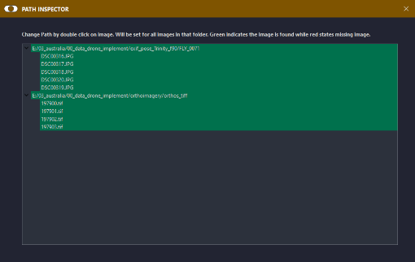
Configure Image Paths
To configure an image path, open the window by clicking on Menu and selecting Configure Image Paths. The images list by folder, and colours indicate if that image is available at the paths stored in the database on the current system. Red indicates that the image is not found at the path stored in the project. Double click on an image to select the correct folder, which is used for all files in the same folder.

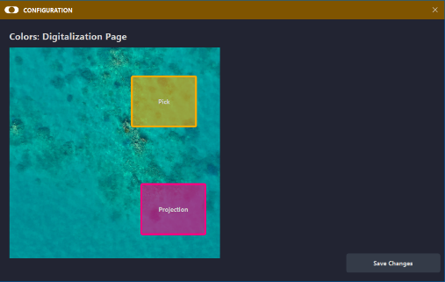

Configure Colours
To configure colours, click on Menu and select Configure Colours. The colour of objects can be modified within the same image, as can the projection of objects from other images.

Configure Mapper
This window can be accessed by clicking on Menu and selecting Configure Mapper. WISDAM provides two options for mapping.
Option 1 - a horizontal plane where the height is specified and the corresponding coordinate system is EPSG code. For example, if you want to use height 0.0 for sea level, you would use a coordinate system aligned to the real surface or the geoid, such as the EGM2008 height model (e.g. to use a world geoid height system, you could specify EPSG:4326+3855).
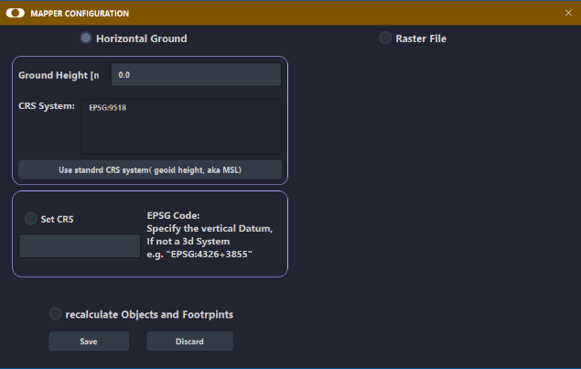
Option 2 - it is possible to use a raster file as terrain reference, aka a terrain model/DTM/DSM or similar. WISDAM can read most file formats used in the GIS domain and will also try to capture the coordinate reference system from the provided raster file. It is possible to override the raster’s coordinate system by selecting the box where you tick Set CRS and specifying the EPSG code you want to use. This is important if your raster data has no vertical component of the coordinate system stored. It is quite common to get raster terrain data that only has a 2D coordinate reference system specified, whereas WISDAM requires the user to also specify the height system that the data is referencing.

The vertical component of the CRS is always needed to be able to save the mapper. If you do use raster data, you will need to make sure you know which system the data is in (e.g. national height system).
If you want to recalculate the project’s existing data, tick the box labelled Recalculate Objects and Footprints. This may take some time, depending on the number of objects and the mapping option used.
Recalculating mapping of Objects and Images may take some time. The calculation is performed as background process.

Image List Pane
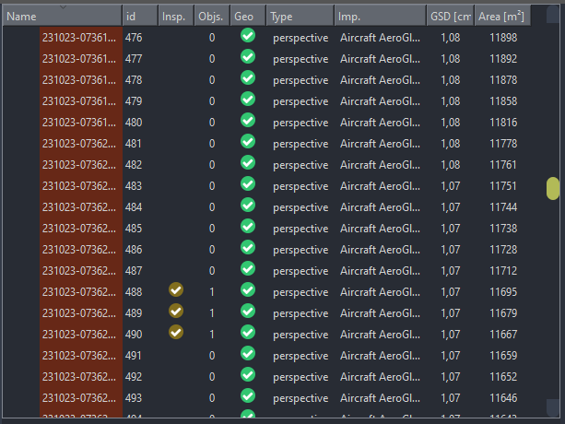
All images are shown in sub-hierarchies of their folder. For each image, the file name and database ID are shown together with some information/status of that image. Double clicking on an image will show this image in the viewer and will zoom on the GIS page to that position, if the georeferencing information is present.
Columns, colours, and symbols indicate the status of the images:
- Green Background Active image.
- Red File Name Image cannot be loaded (it is likely missing from the directory folder).
- Yellow Tick Image has already been inspected or is currently opened.
- Nr. of Sightings Indicates the number of objects (detections) present in that image.
- Blue Text Indication of image type (normal vs. orthophoto imagery).
- Green Tick/Red Cross Image’s georeference status.
For single images or selections, different actions can be performed on right click:
- Delete images - will delete all images and objects stored from this image.
- Change image metadata - will show in another window where you can change values for standard image information, such as transect, flight reference, etc.
- Assign environment to selected images - will assign the environmental data from the image to all selected images you have right clicked on.
- Assign environment to selected images and sightings - the same as above, but environmental data will also be assigned to the digitised objects of that image.
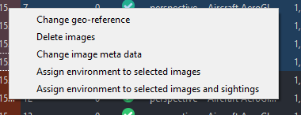

Start Screen
When starting the program, you will be asked to be enter a User Name to continue. This can be in the form of text, an abbreviation, or some affiliation. The entered text will be stored on all new database entries (e.g. images, objects, AI runs, etc.) added to the project.
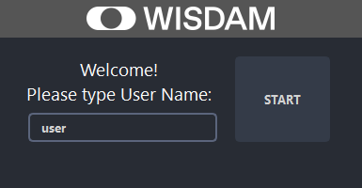

Project Cockpit Page
Within the Project Cockpit, basic information about the project is shown. This includes the status of the elevation service (e.g. if a raster mapper is used or if the raster is available on the specified file path), as well as an indicator under Images to show if all images are available on the file system.

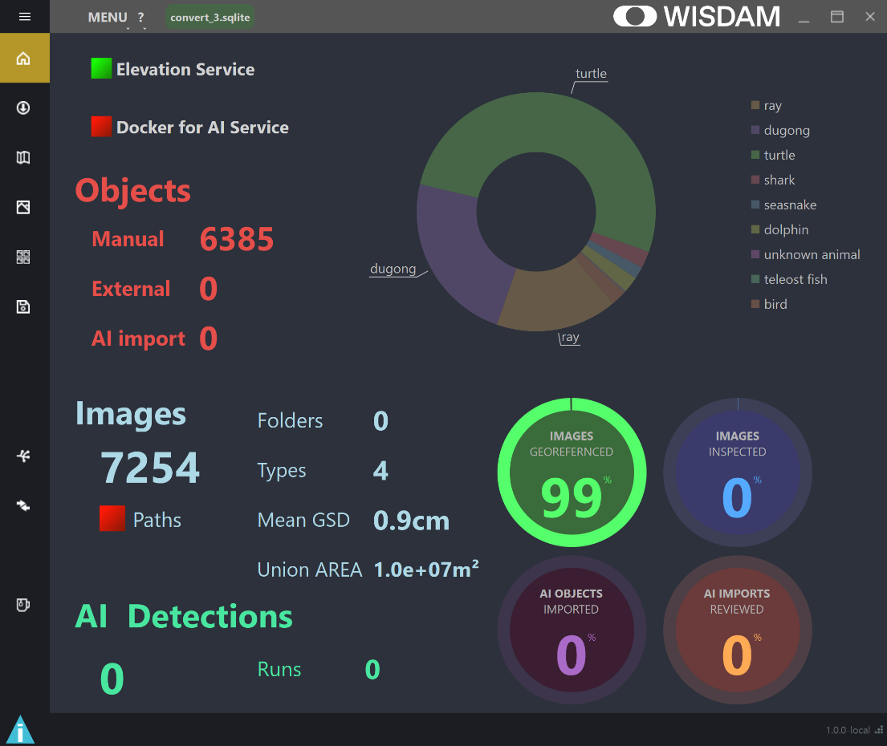

Object Inspector Page
The Object Inspector page allows the metadata of objects to be changed. Once a new object is created, the Object Inspector will open automatically. It can also be opened either by double clicking on an object in the image viewer or within the Gallery Page.
Changes are saved to the database by clicking on Save Changes. Objects can be deleted by clicking on Delete Object. Closing the window will discard changes made to the attributes, if they have not previously been saved.
If the object type or sub-object type you have detected is not listed, you can add it by right clicking on the drop down menus. This will add the new type to the project configuration.

Certain/First Certain/Resight
These standard metadata are available, regardless of the configurations.
Certain Select yes if you are 100% certain that the object type is correct.
First Certain Select yes if this is the first detection of the individual animal (object) and you have selected certain = yes, OR, if there have been multiple detections of the individual animal (object) but this is the first detection for which you have selected certain = yes.
Resight Select yes if this is not the first time the individual animal (object) has been sighted (regardless of certainty).
Note that the First Certain and Resight selections will be automatically adjusted if you use merge objects into Resight Sets.
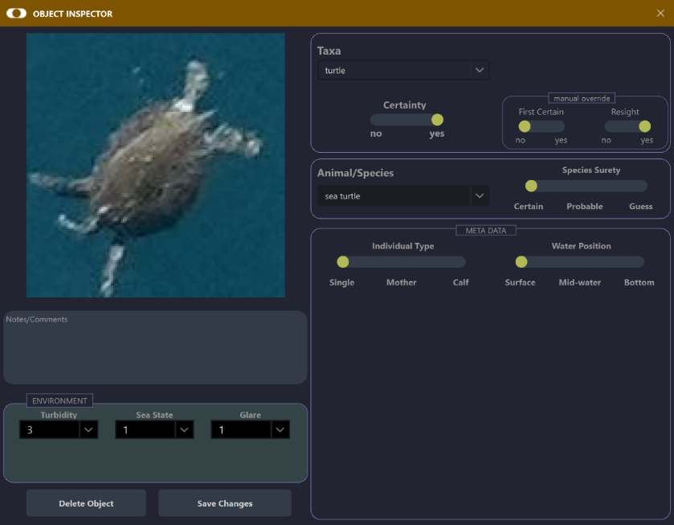

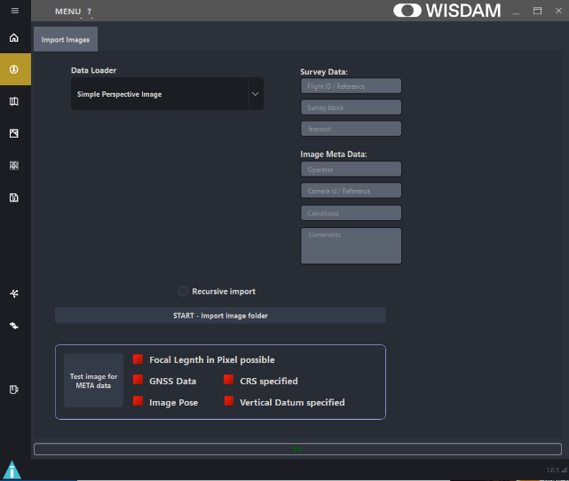
Import Page
The Import page only allows images to be loaded. The ability to import external objects is hoped to be made available in the near future.

Import Images
Several workflows are implemented to load images and georeference data in different forms. The import workflow is designed so that it is relatively simple to implement new images or telemetry data.

To import images, click on the drop down menu under Data Loader and select from the following image type importers:
- Simple Perspective Image - if you don’t have any georeferencing information associated with your images.
- EXIF pose loader - if your imagery has all needed telemetry data saved in the EXIF metadata of the image.
- Specific loader workflow - several custom importers are currently implemented.
- OrthoRasterio - if you have orthophotos that contain a georeference scheme, either within the image (e.g. for TIF) or with complete external georeference information about location and projection (e.g. .prj, .jgw, etc.). If the coordinate system is not defined, you can specify or override an existing one by entering CRS string.
If the selected image type needs a log file (that has the associated telemetry data), an extra button for selecting the log file appears. Click on Select Log File and choose the file holding the telemetry data associated with the images that you wish to import.
Click on Import Folder to directly load images by choosing the folder that includes the images (Note: you will not see the list of images in the folder). By checking Recursive Import, all subfolders will be searched for images; however, this works only for specific importers.
Additional metadata for the imported images can be entered in the text fields on the right. This metadata will be associated with each image imported into the image table every time you import data. The metadata will be exported in the footprint export.
If the selected image type requires georeferencing data but these data are not found, a warning will appear. For such images, footprint and geometries cannot be projected to real world coordinates.
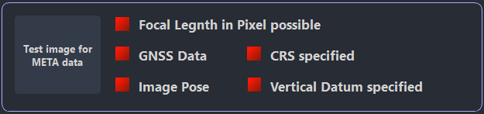
There are tools implemented to test if a file contains the required telemetry data in the EXIF metadata or if the orthophoto contains everything needed.
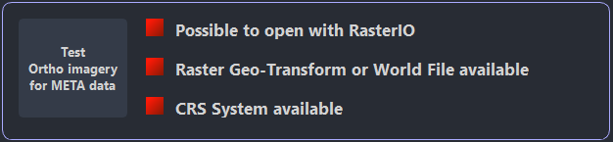

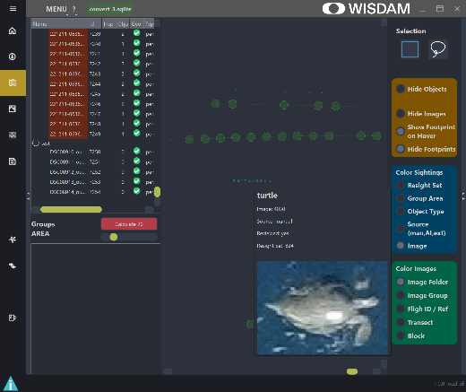
GIS Page
The GIS page allows you to handle images and objects (detections) in a GIS-like environment. Footprints of images (centre point and footprint shape) and outlines of object geometries (if the georeference data is available for the images) are shown on a world map.

Image Pane
The Image Pane on the left side works in the same manner as on the Object Digitiser page. Double clicking on an image will zoom to that image and the columns will show image attributes. This pane can be hidden/shown by the triangles on the left.

Selection
Images can be selected by the rectangle or lasso tool (selection of tool on the top right) or by clicking on the centre point. Holding CTRL allows for multiple selections or to continue the selection. Holding CTRL while objects/images are selected and adding a right mouse click will show a menu with additional actions, including Group Images, Change Transect/Block, or Change Other Image Metadata.

Visibility and Colouring Pane
Visibility of objects and images can be changed individually, as can the appearance of the footprint shape.
Objects can be coloured by several attributes individually.

Possible Actions
Hover over an object - will show the thumbnail of that object and basic information. Hovering over an image centre point will show the footprint, or the image’s ID or name (if users stay on the spot with the mouse).
Double click on an object - will open the Object Inspector.
Right click on an object or image - will jump to the Object Digitiser page and load the image.
Mouse wheel click - allows you to pan around (move) the image footprints or navigate through layers of overlapping objects. The current active object will turn green.
Resight Set - selected objects of the same object type and from different images can be assigned to a resight set by holding CTRL and clicking the right mouse button.
Remove Resight Set - single selected objects can be removed from the resight group by holding CTRL and clicking the right mouse button on that object.
Image Meta - for selected images, a couple of attributes can be changed. See available options by holding CTRL and right clicking the mouse.

Objects Groups by Location/Area (Beta)
The Spatial Cluster function within the GIS page allows you to group objects into Area Groups, according to their spatial location and proximity to one another. Objects (detections) are searched in the order of their ID and grouped together, if they are within a range of an initial object. Grouping is done in a background process, indicated by a spinning wheel. The distance used for searching can be changed by the slider.
Once grouping is complete, each group is displayed in the Groups Area Panel. Double right clicking on a group in the list will centre the GIS view to that group, but will not zoom to the group. Zooming can be done manually.
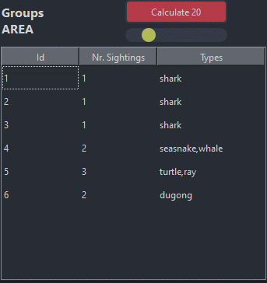
The purpose of this function is to provide potential Resight Sets. It does not automatically assign detections to Resight Sets, but rather to Area Groups. You can then inspect these area groups to determine if they are all Resight Sets of an individual, or if they are appearances of multiple individuals.

Object Digitiser Page
The Object Digitiser page shows full images and objects (either from within that image or projections from other images). The digitiser is designed to digitise objects, change metadata of objects, and group them. Environmental attributes can also be changed for that image.
If a georeference is present for the current image, objects mapped from other images will be searched and displayed if they are within the current image’s footprint. Four geometry types can be drawn (Point, Line, Rectangle, and Polygon), and objects can be grouped as Resight Sets for the same individual animals (i.e. you can assign a relationship between the same objects (sightings) visible in different overlapping images).
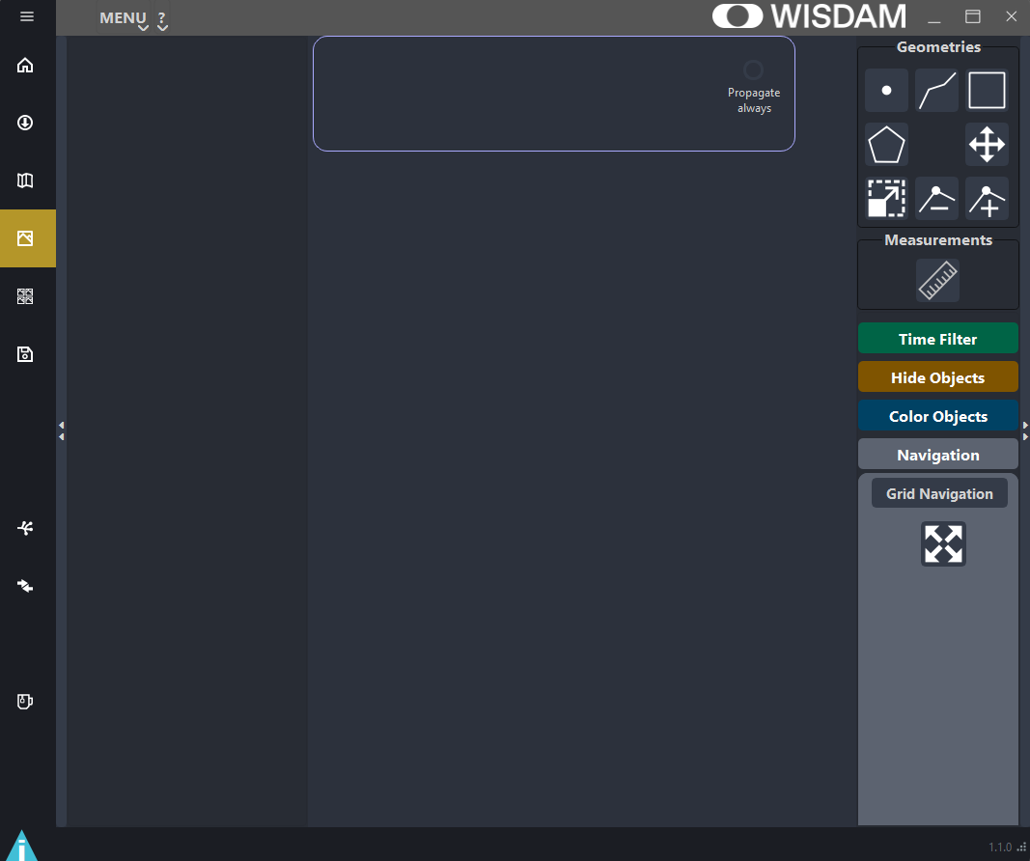
- Image List Pane
- Image Viewer
- Environmental Data
- Operation/Colour/Navigation

4
2
3
1

Image Viewer Pane
The image viewer shows the current image and geometries (detections) drawn on the image or projected from other images.

Possible Actions
Hovering over an object projected from another image - will show the thumbnail of that object and basic information.
Left double click - opens the Object Inspector.
Right click - draws new geometry. Rectangles must be closed by one right click. Polygons and Lines are created for each right click and must be closed by one left click.
Mouse wheel click - allows the user to pan the image (i.e. grab the image and move it) or navigate through layers of overlapping objects. The current active object turns green.
Enter - will jump to the next image.
Backspace - will jump to the previous image.
Objects of the same type (taxa) from different images - can be assigned to a Resight Set by holding CTRL and selecting objects with the right mouse button. If one of the objects is already in a resight group, all selected objects will be assigned to that resight group. (Note: this is only possible if they are not on the same image but are the same object type (i.e. same taxa)).
Single selected objects - can be removed from that resight group by holding CTRL and adding a right mouse click on that object. If only two objects are present in a group, the resight group will be deleted for both objects.

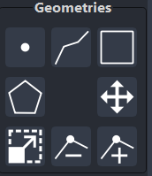
Geometric Operations
To draw a geometry, simply choose your preferred geometry type from those shown on the screen. Points are drawn by a right mouse click. Lines are drawn by right mouse clicks and finished by a left mouse click. Rectangles are drawn by right click and finished with right click. If, while drawing the rectangle, an item is selected with a left mouse click, you can deselect the item by left clicking the mouse in an open area of the screen and finish the rectangle with a right mouse click. Polygons are started with a right mouse click and nodes can also be added by right clicking the mouse. Polygons are closed by a left mouse click. A polygon will be created only if more than 2 nodes are created within the polygon. If a line, polygon, rectangle, or linestring is in an active state (i.e. the drawing operation has started), the geometry type cannot be changed until the current drawing operation has finished. It is also possible to resize geometries or add/remove nodes for polygons and linestrings or move geometry. For that action the geometry must be selected.

Navigation
You can choose between the basic modes of Free Navigation (i.e. mouse navigation) and Grid Navigation (i.e. fixed movements) by clicking on that your preferred option.
Free Navigation:
- Mouse Wheel – used to zoom in on the image. The image will continue to be centred on the mouse position as you zoom.
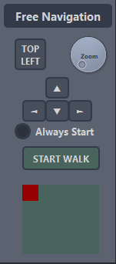
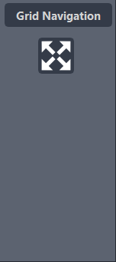
- Middle Mouse Button – hold button to pan the image.
- A click on the symbol - will zoom out to the full image.
Grid Navigation:
- Choose zoom level via dial button (Zoom).
- Navigate - with arrow buttons on display or with the keyboard’s arrow keys.
Walking Mode:
The Walking Mode is specially designed to navigate quickly and easily through images at your chosen zoom level. Once Start Walk is selected, you can navigate through the images using the right and left arrow keys on display or on your keyboard. This take you through the image in a snake like route, starting from the top left of the image. The red box within the green area shows the visible area of the image in the context of the full image.
If Always Start is selected, the walking mode will be automatically activated once loading another image by mouse click, enter or backspace.
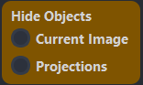
Colour/Visibility of Objects
You can show or hide objects, either from the selected image (by selecting Current Image) or objects projected from other images (by selecting Projections).
Objects visible on that image can be colour coded, according to different attributes.
Colours are assigned relatively and are designed to be distinguishable, depending on the objects/attributes present for an image. Therefore, colours may change from image to image.

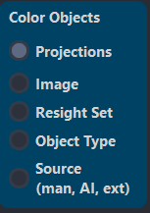
For example, if Object Type is chosen as the colour scheme and there are 2 objects with different object types within the one image, the colours will change if you add a new object with another object type or if you navigate to an image with more than 2 object types. This may be confusing, but some attributes are dynamic and it is, therefore, hard to set fixed colour spaces.

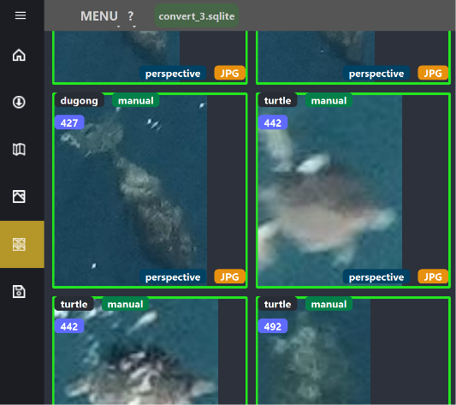
Gallery Page
The Gallery page displays all objects in a grid format. Thumbnails can be filtered and ordered according to selections in the right side panel, which can be closed by clicking on the triangles to the far right. The size of the images can also be changed. All images are plotted within a square grid, while the aspect ratio of the original bounding box is preserved. Individual actions can be conducted on thumbnails, such as Resight. Objects can also be highlighted.

Thumbnail
A thumbnail is shown for each object, along with basic information, including:
- Type Object Type (i.e. selected taxa).
- Source From manual review, AI or external import.
- Group Resight The number of the Resight Set, if assigned. See Resight Set.
- Spatial Cluster The number of the Area Group, if assigned. See Groups by Location/Area (Beta).
- Highlighted Option to highlight particular objects.
- Review Status Indicates if an AI object has been inspected with the Object Inspector. All objects must be reviewed for the object to be exported within the data set.
- Image Format For example, JPG or TIF.
- Image Type For example, aerial (from a drone) or ortho.
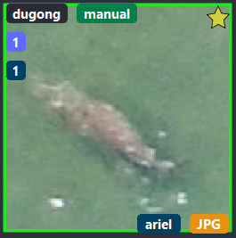
Image Format
Image Type
Spatial Cluster
Resight Set
Highlighted
Type
Source
Review Status

Possible Actions
Double click on an object to open the Object Inspector.
Right click on an object to open a dialogue menu. It is possible to Activate/Deactivate, highlight (yellow star will appear on the image), jump to the Image Viewer (Object Digitiser Page) to see the full image, delete the object to completely delete it from the database, or copy the path of the image that the object appears in.
Resight Set - selected objects of same type and from different images can be assigned to a Resight Set by CTRL and right mouse click.
Remove Resight Set - to remove an object from a Resight Set, select a single object and press CTRL and right mouse click.

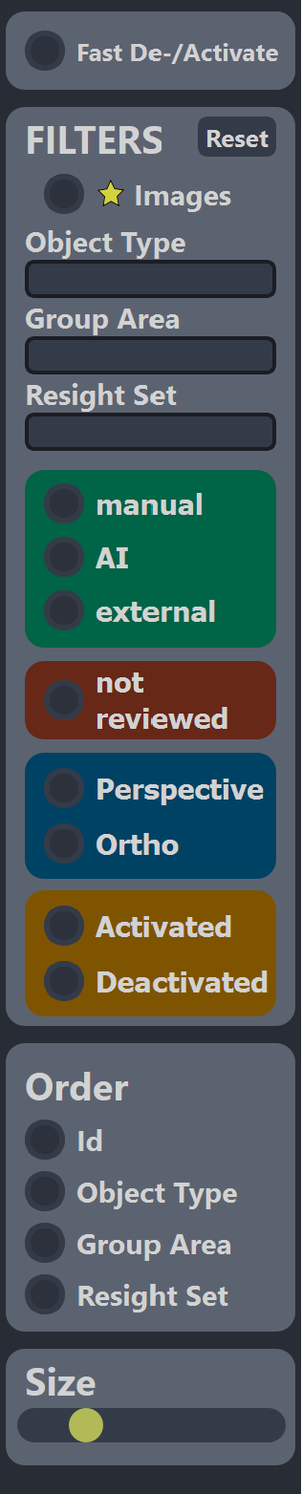
Filter/Order/Size Pane

Filter Options
All detections appearing in the viewer can be filtered according to the options provided in the Filter Panel. The Object Type, Spatial Cluster and Resight Set are entered into the text box (e.g. enter dugong in the Object Type text box to see all dugong sightings in the gallery). If you select not reviewed, you will only see the AI detections (see AI Page) that have not yet been reviewed within the Object Inspector.

Ordering
Objects can be ordered, according to the attributes of ID (number), Object Type (taxa), Spatial Cluster, and Resight Set.
Be aware that each change in the ordering will result in a reload of the gallery view. Currently sorting is done via a database query.

Size of Gallery Items
The size of thumbnails as they appear in the Gallery can be changed by the slider on the bottom of the right panel.

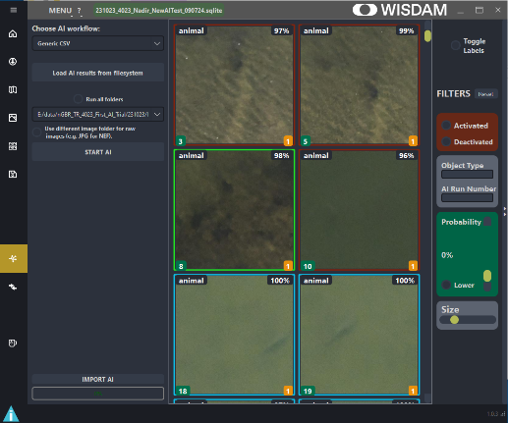
AI Page
The AI page handles all AI processed data and allows the user to validate AI detections and import them into the object table. WISDAM provides several pre-configured workflows. The easiest option is to use the Generic CSV (see Appendix III – AI Generic Format) import, which allows the user to import external AI detections with minimal effort, to generate the files needed.
Imported AI detections are automatically defaulted to deactivated, given the likelihood of more false positives through AI detections.

AI Thumbnail Viewer
The thumbnail viewer on the AI Page displays predicted detections and allows users to action those predictions. The outline of each thumbnail is colour coded, as follows:
Red: AI detection is deactivated (or considered a false detection).
Green: AI detection is activated (or considered a true detection).
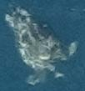
Blue: AI detection that has been imported to the object database.
Possible Actions
Activate or Deactivate (i.e. alternate between false/true positive) with a left mouse click. The colour of the border corresponds to true (green)/false (red) positives.
Change the initial Object Type (Taxa) assigned by the AI by right mouse clicking on the thumbnail, selecting Change Metadata, and typing in the correct Object Type (Taxa). This can only be done before an object is imported .
Probability of
True Positive
Predicted Object Type (Taxa)
Image ID
AI Process Number
turtle
83%
1
1

Import AI
All true positives (i.e. activated objects outlined in green) are imported to the object database upon clicking the Import AI button. Only new AI detections (not previously identified) will be imported, and detections will be checked to see if the same geometry and Object Type exists for that image. Background processing of imports is indicated by a spinning wheel. All imported detections will appear with a blue outline

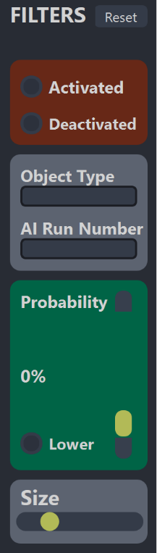
Filter Pane
This pane can be hidden/shown by clicking on the triangles to the right.
AI detections appearing in the viewer can be filtered according to true and false positive detections (Activated and Deactivated), Object Type (by typing in a text), AI Run (by typing in an integer value), and Probability of the detection (using the slider).

Using AI Workflows
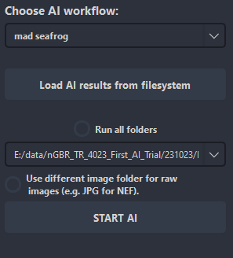
The software is designed to implement different AI workflows (either by loading results or starting the detection program), with minimal programming effort. All implemented workflows are show in the drop down menu. Depending on the option selected, AI results can be loaded from the workflow via the file system or by starting the AI for each image folder (either individually or for all image folders of the current project). This is run as a background process and a status report will be provided once finished, to show the number of detections that have been imported.

Currently no AI model can be started from within WISDAM and only loading from the file system is accessible.

The definition of the generic CSV to load results can be found at Appendix III – AI Generic Format

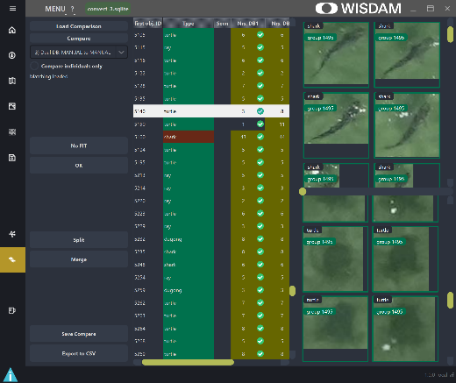
Compare Projects Page (Beta)
This page allows objects within a project or from different projects to be compared (e.g. manual detections compared to AI detections). The same images must be present in both databases for this to work.
Comparisons are generated by the program searching within the same images (identical image path) to find objects that have similar coordinates or that are within a resight group. The spatial search is done by the intersection of geometries or their bounding boxes.
Modes:
- Single DB: SELF to AI - will compare manual drawn objects within the current opened project to those from AI.
- Single DB: AI to AI REVIEW - will compare the AI detected Object Types to those changed by the reviewer in the AI panel.
- Dual DB: MANUAL to MANUAL - will compare the manual digitised objects from two Databases/Projects.
- Dual DB: ALL to ALL - will compare all (manual and AI) digitised objects from two Databases/Projects.

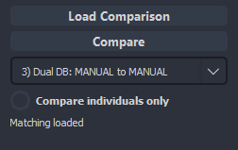
Load/Generate Comparison
A comparison can be loaded from a JSON file, once it has been saved by using the Load Comparison button. To start a new comparison, use the Compare button to choose your preferred mode from the drop down menu. Checking the option Compare individuals only will ensure the Resight Sets are not used to merge objects.

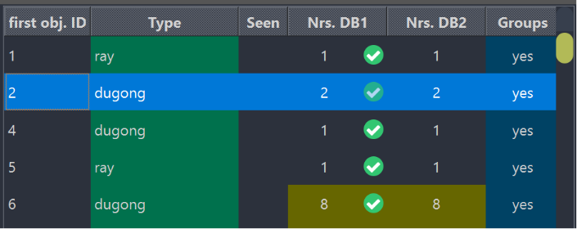
Correspondence List
The Correspondence list shows objects for databases and whether any counterparts have been found. Different colours will indicate where something is found, groups are used, or objects are not matching.
A green tick indicates a counterpart has been found, while a red cross at the Nrs. Compare column indicates no counterparts were found.
A green colour on the Type field indicates where an object/group has been found in a counterpart and they all have the same object type. A red colour on the Type field indicates that there are different object types within the found counterparts.
If Resight Sets are present, or if comparisons are merged, some fields will become yellow underlined and all elements of that resight group will be shown.
Double clicking on an item of the list will show the single objects on the right side windows.

Object Handling
Corresponding objects will be displayed within the two windows on the right side. The upper window shows objects from database 1, while those from database 2 are shown in the lower window. The validity of objects and splitting status can be set within these 2 windows.
All elements are initially assigned to valid status, indicated by a green background, which can be changed by left clicking on the mouse. Clicking on one element will change all elements on the row to invalid (i.e. a red background) from which single elements can then be set to be valid.
If more objects are within one comparison, only the first one of each window (on the right) that is marked as valid will be used to export meta-information to the CSV. If all objects within the panel are invalid, the first invalid object will be used for the metadata export and the flag “valid” will be 0.

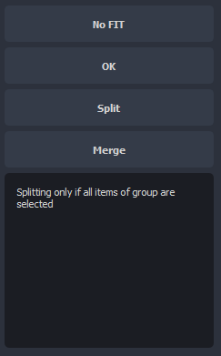
Handle Comparison Objects - Buttons
These four buttons can be used to state whether an entry on the comparison list is a fit (Ok) or not a valid fit (No Fit). Colour codes of list entries will change to green or red, depending on whether it is a fit or not, and the next entry will be loaded automatically.
The Split and Merge buttons allow users to either drag out (split) objects of a comparison item or merge comparison rows.
Selecting objects for splitting is done by right clicking on elements in the object windows on the right. Objects displayed with a yellow background can be split and will be assigned to a new entry at the end of the list. If resight groups are present, this option will only be possible if the entire group is selected. Single objects can be split to be a new comparison item (for example, if you want to split up mother and calf, as they are too close on the image space).
The Merge button allows you to merge multiple comparison objects (rows) into one. You can select several rows by holding CTRL and left clicking on the rows. Items will be merged into the first item selected.

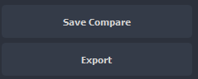
Save or Export – Buttons
Comparison results can be saved to a JSON file for later reloading by selecting Save Compare, or exported to a CSV file by selecting Export.
CSV file formats will export most information for these objects. See the exported CSV Header for more information.
Check the CSV file to see how validity flags and matching information are exported.

Export Page
The Export page allows users to save various exports and formats.
Exports are saved into a folder that is created in the same directory as the project file (.SQLite) and is named PROJECTNAME_export, unless a prompt asks for the destination path.
Exports:
- Project information - will contain information about user, images, and objects.
- Trainings data for an AI training - can be exported in the form of images of objects and as an ASCII text file containing object information. Within the chosen export folder, a new folder is created containing the exported training data called trainingsdata-datetime. The option Include Full Image will add all full images with objects to the folder. The option Exclude AI Detections excludes objects stored by an AI workflow.
- Footprints - mapped and information of images.
- Objects information and mapped geometry - can be restricted to objects which are only First Certain. Image information will also be included for objects.
GEO JSON is the most stable and developed export option and includes the most information about the footprints and objects.
The coordinate system of exported geometries is standard ellipsoidal 3D WGS84 – EPSG:4979.

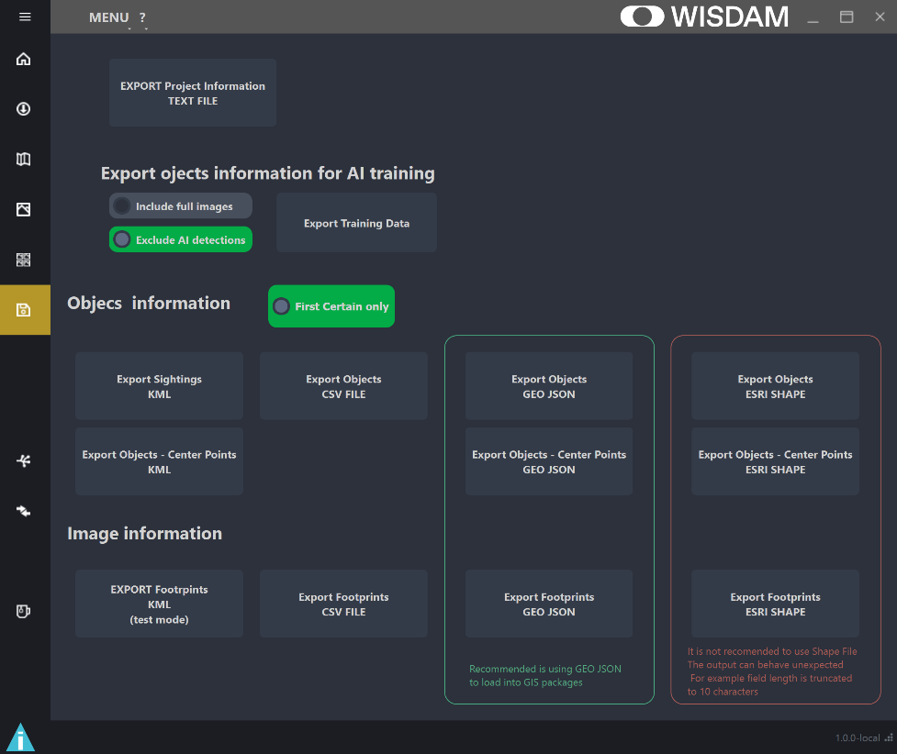

Appendix I - Data Concept
This section provides information about how the software works, including the backend structure, what data is used and how it is stored. You do not need to understand this section to use the software.

All data is stored within a SQLite database. All changes are mostly applied immediately in the database to protect the data against tool crashes. Database corruption during crashes has not yet been observed and should be prevented by the SQLite library itself.
The SQLite is used with the SpatialLite extension for geometries and spatial queries.

Database Tables
Five tables are present within the database.

configuration
Basic information about the project:
created_by User who created the project.
version Used WISDAM version from which the project was created.
date_created Date and time the project was created.
last_image ID from image table of the last inspected image, which is used to load the last image at project loading.
area Union area of all mapped footprints
gsd Median GSD (ground sampling distance) of all footprints
mapper Mapper which is configured for the project as JSON dictionary.
configuration Project configuration as JSON dictionary. Holds all the information about different metadata configurations (object types and metadata fields) and the environment settings which can be set for images and objects.
colour_scheme Colour scheme configurations as JSON dictionary

images
Image relevant information about the mathematic model and meta-information:
user User who imported the image.
flight_ref Spatial meta information about the image’s context. Can be any kind of text and can be used for statistics. Used in WISDAM as colour option for images in the GIS page.
transect/block Same as flight_ref. Users can define how these are used. These two elements can be changed at the GIS panel map.
group_image Spatial image group as integer, used to group images in the GIS page.
width/height Width and height of the image in pixels.
math_model Mathematic model which is used for calculations. Based on the image classes from the image_mapping module.
type The type of image class used in the math_model.
data_env Environmental data as JSON dictionary, as specified in the configuration.
importer Importer workflow used to add the image to the project (e.g. EXIF pose).
inspected Integer 0/1. 1 indicates that the user has already inspected that image.
name Image File Name with suffix.
path Image File Path.
datetime Date/Time of image creation, if available; otherwise the date/time from import is used.
meta_image Make (manufacturer of camera); camera model, f-number, lens info, iso.
area / gsd Area of footprint and ground sampling distance/spatial resolution of image or orthophoto.
meta_user Common information which is added while importing the images.
tags Not used - for future features.
Geometries Position of the image, mapped footprint, and mapped centre point.
Coordinate System is WGS84 (EPSG:4979)

objects
Object relevant information and metadata, which is assigned by the user:
image Index to ID in images table. (Reference to image’s ID)
user User who created the object.
source Source of creation as integer (0: manual, 1: AI workflow; 2: external import).
reviewed Indicates if AI/external import was reviewed (1) by user or not (0).
area/gsd Area and ground sampling distance of mapped object.
resight_set Integer of the Resight Set (identical objects in different images).
resight_data JSON where the information about First Certain and Certainty is stored.
group_area Integer of the spatial area group this object belongs to.
meta_type String with the name of the metadata type, as defined in the configuration.
object_type String with the object type name.
data Meta data of that object according to the meta type, as JSON dictionary.
data_env Environmental data as JSON dictionary, as specified in the configuration.
active Indicates if the object is activated (1) or deactivated (0).
highlighted Indicates if the object is highlighted (1) or not (0). Will show in the gallery view with a star at the cropped image.
tags Not used - for future features.
cropped image Blob of cropped image of object, as binary JPG. The cropped image will be stored directly in the database, which may become sizeable if too many cropped images are saved within it. Cropped images can be used for training AI algorithms.
Geometries: Geom2d holds the geometry in image space pixel coordinates. Geom3d holds the 3D geometry of the object in WGS84 (EPSG:4979)

aiI_processes (Currently Under Development)
AI workflows are stored in a table.
ai_name Name of the AI workflow which was used.
user User who started the AI workflow
folder Folder containing the AI results.
command Command which was used by the subprocess or docker to start the workflow.
info Info about the workflow.
output Output from the workflow or docker

ai_detections
Single detections by an AI workflow are stored in a table. The objects in that table are not mapped. In AI detections, the single detections are stored and linked to the AI Process table containing:
imported Flag if detections were already imported to objects table.
image Reference to the image as ID of image table (reference to image’s ID).
ai_run Incremental Number of AI processes performed (reference to ai_processes ID).
object_type_orig Object type estimated by the AI.
object_type Object type assigned by the user in the AI view.
data_orig Data stored by the AI.
data Data assigned by the user (not yet used).
active Status flag if detection was disabled or is enable.
probability Probability of the object type from 0 to 1.
Outline Rectangle as JSON dictionary (no geometry) with xmin, ymin, xmax, ymax.
Example: {"xmin": 4740, "ymin": 3508, "xmax": 4895, "ymax": 3625}
image_detection JPG blob holding the image of the detection from the original output or from the processed one, depending on the workflow.

Appendix II – Object Type Configuration File
It is possible to preload object types at the project configuration, which can be specified in a text file. Within this file, it is possible to specify main object types (e.g. Taxa) and subtypes (e.g. Species). These types are also shown in the Object Inspector, where new types can be added, if needed (see Object Inspector).
Thy syntax is as follows: Object Type; SubType1; SubType2; …
# First entry is object main name (e.g. Taxa)
# Followed by object sub names (e.g. Species)
# To have standard empty as first sub item add ;; (empty sub name)
#
Dugong;;Dugong
Dolphin;Unknown;Common Dolphin
Ray;Unknown;Stingray;Skates;Electric Ray;Shovelnose;Unidentified small;Unidentified large
Shark;Unknown;White;Hammerhead
SeaSnake;Unknown;SeaSnake
Whale;Unknown;Antarctic;Minke;Killer;Southern Right;Antarctic;Humpback;Fin;Pygmy Blue;Sperm;Pilot;Unidentified small;Unidentified large
Turtle;Unknown;Sea Turtle
Bird;Unknown;Penguins;Albatross;Pelican;Gull;Unidentified large
Unknown Animal

Appendix III – AI Generic Format
The generic format can be used to import AI detection results into the project. It is designed to allow users to easily import their own detections. The file needs to be formatted as CSV in UTF-8. If special characters are present, standard CSV quoting needs to be used. The first line needs to contain the header, as shown in the example below. The image coordinates are defined from the top left corner, with x pointing to the right and y down. The probability is in the range from 0.0 to 1.0. If you have no probability, set it to whatever value you choose, for example 1.0.
image_path,type,probability,xmin,ymin,xmax,ymax,cropped_detection
D:\widamapp_test_images\_PRT5410.JPG,ray,1.00,285,605,362,656,C:\test_data\ray_01.jpg
D:\widamapp_test_images\_PRT5411.JPG,ray,1.00,317,588,393,638,C:\test_data\ray 02.jpg
D:\widamapp_test_images\_PRT5412.JPG,ray,1.00,352,587,429,639
D:\widamapp_test_images\_PRT5413.JPG,ray,1.00,387,613,460,666
D:\widamapp_test_images\_PRT5414.JPG,ray,1.00,417,641,498,693
D:\widamapp_test_images\_PRT5410.JPG,ray,1.00,285,605,362,656
D:\widamapp_test_images\_PRT5411.JPG,ray,1.00,317,588,393,638
D:\widamapp_test_images\_PRT5412.JPG,ray,1.00,352,587,429,639
D:\widamapp_test_images\_PRT5413.JPG,ray,1.00,387,613,460,666
D:\widamapp_test_images\_PRT5414.JPG,ray,1.00,417,641,498,693

Optional: if you have cropped images of your detections, you can add these within the column cropped_detection and specify the path to that cropped image. If not present for a detection, the image will be cropped from the original image.
Be aware that these cropped detection images will be stored in the database. The size of the database can significantly increase with hundreds of thousands of cropped images, particularly if the extend of the provided cropped images is much greater than the detection bounds.

Appendix IV - MAD-v2
A suitable AI workflow has been developed and is provided in conjunction with the Team of Dr. Frederic Maire. You can find the latest package and installation instruction at https://gitlab.com/f.maire/2024-mad-v2
This package is not provided with the binary of WISDAM and must be installed separately by users. The results can be loaded into WISDAM via the AI page.

