List of Acronyms

COE Cost of Energy

DOE Department of Energy

FAST Fatigue, Aerodynamics, Structures, and Turbulence

HSS High-Speed Shaft

LSS Low-Speed Shaft

LUT Look-Up Table

NREL National Renewable Energy Laboratory

WindPACT Wind Partnerships for Advanced Component Technology

Nomenclature

$α$ Region 2 Torque Constant

$c$ Chord

$c_{DT}$ Drivetrain Torsional Damper

GBR Gearbox Ratio

GenIner Generator Inertia

$GS(θ)$ Gain Scheduling Function

$k_{DT}$ Drivetrain Torsional Spring

$m$ Mass

$Ω_{rated}$ Rated Generator Speed

$R$ Rotor Radius

RotIner Rotor Inertia

$T(s)$ Transfer Function

$τ_{rated}$ Rated Torque

$θ$ Pitch Angle

$x$ Spanwise Distance

${\vec{x}}_{cm}$ Location of Center of Mass

$ζ$ Percent Critical Damping

Executive Summary

The WindPACT design studies created four baseline wind turbine models (750 kW, 1.5 MW, 3.0 MW, and 5.0 MW) for use in scaling and optimization studies. The rotor scaling study created FAST_AD models, a predecessor to the current simulation tool FAST, but the model files have not been updated to FAST 7. We have recreated the models for the four turbines using archived files of the wind turbine structural properties and have verified that the turbine models behave as expected. This document provides the FAST input parameters for the four developed baseline models and explanations of the calculations that yield the given values.

Table of Contents

1 Introduction 1

2 Blade Properties 2

2.1 Airfoil Schedule 2

2.2 Blade Structural Properties 2

2.3 Blade Modal Properties 3

3 AeroDyn Properties 4

4 Nacelle Properties 5

5 Tower Properties 7

6 Control System Properties 8

7 Steady-State Behavior 10

8 Conclusions 13

References 14

List of Figures

Figure 1. Chord schedule for WindPACT blades. 2

Figure 2. Simple torque controller. 8

Figure 3. Steady-state behavior for 0.75 MW baseline model. 11

Figure 4. Steady-state behavior for 1.5 MW baseline model. 11

Figure 5. Steady-state behavior for 3.0 MW baseline model. 12

Figure 6. Steady-state behavior for 5.0 MW baseline model. 12

List of Tables

Table 1. Gross properties for WindPACT reference models. 1

Table 2. Airfoil schedule for WindPACT blades. 2

Table 3. Blade modal damping. 3

Table 4. AeroDyn properties. 4

Table 5. Nacelle properties for WindPACT reference models. 6

Table 6. Tower parameters. 7

Table 7. Control parameters. 8

1. Introduction

In the early 2000s, the National Renewable Energy Laboratory (NREL) had a large project called the Wind Partnership for Advanced Component Technology (WindPACT) that sought to identify technology improvements to lower the cost of energy (COE) (Poore, 2003; Malcolm, 2006). These projects were cooperative with industry partners and spanned topics from rotor scaling studies (Malcolm, 2006) to innovative drivetrain designs (Poore, 2003). One of these studies, the rotor scaling study (Malcolm, 2006), designed four wind turbine reference models to investigate the effects of rotor scaling on the COE. To investigate the scaling effects, the four models had the same underlying design but were scaled to four different sizes: 750 kW, 1.5 MW, 3.0 MW, and 5.0 MW. Multiple rotor configurations were also examined to determine the effect of the configuration changes on the resulting COE.

Due to the scaled nature of the four developed reference models, they are extremely attractive for use in controls or optimization studies. However, the WindPACT reference models were never adapted to the current popular versions of NREL's open-source wind-turbine simulator FAST (Fatigue, Aerodynamics, Structures, and Turbulence). This report summarizes the technical parameters for the WindPACT models that are necessary for FAST v7 input files. The turbine steady-state behaviors are also provided. Electronic versions of the FAST 7 input files can be downloaded from GitHub (link).

The majority of the turbine parameters were determined from an archived copy of the original Microsoft Excel design files. An updated copy of these design files with the calculations of all of the FAST 7 parameters can be found at LINK. While these design files provided the majority of the parameters necessary to construct the FAST 7 files, there were several parameters that were not in the design files. Some of these missing values were taken from the "CertTest #13" model in the FAST 7 distribution, which is based upon a different configuration of the WindPACT 1.5 MW model. Other values were derived using well-known equations in the literature. The origin of each FAST parameter is detailed in the follow sections in this report. A summary of the gross turbine properties is given in Table 1.

Table 1. Gross properties for WindPACT reference models.

|  |  |  |  |  |
| --- | --- | --- | --- | --- |
| Parameter | 750 kW | 1.5 MW | 3.0 MW | 5.0 MW |
| Turbine Configuration | Upwind, 3-Bladed, Variable Speed, Collective Pitch | | | |
| Rotor, Hub Diameter (m) | 50, 2.50 | 70, 3.50 | 99, 4.95 | 128, 6.40 |
| Hub Height (m) | 60 | 84 | 119 | 154 |
| Rated Generator Speed (rpm) | 1800 | | | |
| Rated Tip Speed (m/s) | 75 | | | |
| Overhang (m) | -2.33 | -3.30 | -4.65 | -6.00 |
| Shaft Tilt, Precone (deg) | -5.0°, 0.0° | | | |
| Rotor Mass (kg) | 12,381 | 32,167 | 101,319 | 209,407 |
| Nacelle Mass (kg) | 20,950 | 52,839 | 132,598 | 270,669 |
| Tower Mass (kg) | 53,776 | 125,363 | 336,721 | 775,097 |

1. Blade Properties

The WindPACT baseline models have three identical blades, and the values for the blade properties are based on the WindPACT blade scaling study that had just been completed at the time of the rotor design study (Griffin, 2001). The blades for all four baseline models have the same airfoil scheduling and material properties assumptions. Explanations of the different blade parameters are given in the subsequent sections.

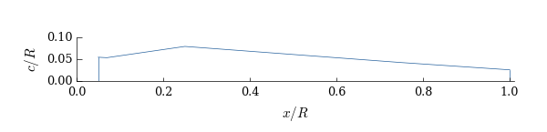

Figure 1. Chord schedule for WindPACT blades.

* 1. Airfoil Schedule

The blades utilize a set of NREL S-series airfoils that have been scaled and truncated to yield a finite edge thickness, identified as more "structurally suitable" for larger blades (Malcolm, 2006). The chord schedule for all four baseline models is shown in Figure 1. The blade extends from $0.05R$ to $R$, where $R$ is the rotor radius. The blade geometry has a circular airfoil at 5% and 7%, an S818 airfoil at 25%, an S825 at 75%, and S826 at 100% radius. The three non-cylindrical airfoils listed in the original design files ("s818_2702.dat", "s825_2102.dat", and "s826_2102.dat") could not be located, so the following airfoils were used: s818_2702, s825_2703, s826_1603. The aerodynamic twist proceeded from 10.5 degrees at the base of the blade to -0.6 degrees at the tip. The airfoil schedule is show in Table 2.

Table 2. Airfoil schedule for WindPACT blades.

|  |  |  |  |  |  |  |
| --- | --- | --- | --- | --- | --- | --- |
| Parameter | 5% R | 7% R | 25% R | 50% | 75% R | 100% R |
| Chord/Blade Radius | 5.40% | 5.40% | 8.00% | 6.13% | 4.27% | 2.59% |
| Airfoil | cylinder | cylinder | s818_2703 | s825_2103 | - | s826_1603 |
| Twist (deg) | 10.5 | 10.5 | 10.5 | 2.5 | 0.0 | -0.6 |

* 1. Blade Structural Properties

No modifications were made from the original blade design, so the blade structural properties were taken directly from the Excel design files. The relevant assumptions will be briefly outlined here; a more detailed discussion of the blade design can be found either in the original blade design project (Griffin, 2001) or in the rotor scaling study (Malcolm, 2006).

The blades for all four baseline models are assumed to be composed of a 1.78-mm thick fiberglass skin surrounding a core of balsa wood. The blades contain a box spar of uniaxial glass fibers that extends longitudinally from 25% span to the end of the blade and laterally from 15% chord to 50% chord.

* 1. Blade Modal Properties

The blade mode shapes were calculated using Modes v2.22, an open-source mode shape calculated produced by NREL. The Modes input files were generated using the structural properties in the Excel design files. The blade modal damping properties were not provided in the original design files, so the damping values from CertTest #13 in the FAST 7 distribution, shown in Table 3, were used.

Table 3. Blade modal damping.

|  |  |  |
| --- | --- | --- |
| 1st Flapwise | 2nd Flapwise | 1st Edgewise |
| 3.882% | 3.882% | 5.900% |

1. AeroDyn Properties

Almost none of the aerodynamic parameters were specified in the design files, so the majority of them were assumed to be equal to the values from CertTest #13. The very important exception to this is the inflow model: CertTest #13 uses the dynamic inflow model, which can become numerically unstable for wind speeds near the 8 m/s range. No tower shadow was assumed, so the tower shadow velocity deficit was zero and the half-widths and reference points were set to very large numbers.

Table 4. AeroDyn properties.

|  |  |
| --- | --- |
| Parameter | Setting |
| Units | SI |
| Stall Model | Beddoes |
| Use CM? | No |
| Inflow Model | Equilibrium |
| Induction Model | Swirl |
| Induction Tolerance | 0.005 |
| Loss Model | Prandtl |
| Air Density | 1.225 kg/m3 |
| Kinematic Viscosity | 1.463910-5 m2/s |
| AeroDyn Time Step | 0.005 s |

1. Nacelle Properties

The FAST nacelle properties were all taken directly from the Excel design files, with a few exceptions that are detailed below. The details of the modelling of the hub, pitch bearings, and drive train components can be found in the rotor scaling study (Malcolm, 2006).

The following FAST parameters were not directly specified in the Excel design files and were specified as detailed below:

* *Nacelle mass*: the masses of the main frame, low-speed shaft (LSS), and high-speed shaft (HSS) were provided separately in the design files. These masses were summed to produce the nacelle mass.
* *Nacelle center of mass*: the locations of the centers of mass of the main frame, LSS, and HSS were provided in the Excel files in addition to the values of the masses themselves. The center of mass of the total nacelle was therefore calculated according to

$${\vec{x}}_{cm,nacelle}=\frac{m_{MF}{\vec{x}}_{cm,MF}+m_{LSS}{\vec{x}}_{cm,LSS}+m_{HSS}{\vec{x}}_{cm,HSS}}{m_{nacelle}}$$

where ${\vec{x}}_{cm,i}$ and $m_{i}$ indicate the center of mass and mass, respectively, of component $i$.

* *Nacelle y-inertia*: the inertia of the nacelle in the y direction was determined by superimposing the inertias of the main frame, LSS, and HSS, which were given in the Excel design files.
* *Generator inertia*: the Excel design files provided separate inertial terms for the generator rotor, HSS, coupling, and brake disk, and the values were given in the LSS reference frame. The generator inertia was calculated from these values by combining them all into a single inertial term and then dividing the result by the square of the gearbox ratio to convert it to the HSS reference frame.
* *Generator efficiency*: the Excel design files contained generator efficiency models that varied as functions of power, but a simple 95% value was assumed based on CertTest #13 and the NREL 5.0 MW reference turbine (Jonkman, 2009).
* *Drivetrain torsional damping*: the value for the drivetrain torsional spring was provided in the design Excel files but not the damping value. The torsional damping value was calculated by assuming a 5% critical damping ratio $ζ_{DT}$ based on the NREL 5.0 MW reference model (Jonkman, 2009) and then using the following equation:

$$c_{DT}=2×ζ_{DT}×\sqrt{k_{DT}\left(\frac{RotIner_{LSS}×GenIner_{HSS}×GBR^{2}}{RotIner_{LSS}+GenIner_{HSS}×GBR^{2}}\right)}$$

Here, $c_{DT}$ and $k_{DT}$ are the drivetrain torsional spring and damper, respectively, $RotIner_{LSS}$ represents the rotor inertia in the LSS reference frame, $GenIner_{HSS}$ is the generator inertia in the HSS reference frame, and GBR is the gearbox ratio. This equation can be derived from Eq. 4 in (Girsang, 2014). The value of the rotor inertia was taken from the FAST summary file that was generated with a dummy value for the drivetrain torsional damper.

Table 5. Nacelle properties for WindPACT reference models.

|  |  |  |  |  |
| --- | --- | --- | --- | --- |
| Parameter | 750 kW | 1.5 MW | 3.0 MW | 5.0 MW |
| Overhang (m) | -2.33 | -3.30 | -4.65 | -6.00 |
| Downwind, Lateral, Vertical Distance from Tower Top to Nacelle CM (m) | -0.0600,  0.0,  1.2043 | -0.1681,  0.0,  1.3845 | -0.2257,  0.0,  1.8609 | -0.3256,  0.0,  2.3429 |
| Tower Top to Shaft (m) | 1.33 | 1.61 | 2.27 | 2.93 |
| Nacelle Mass (kg) | 20,950 | 52,839 | 132,600 | 270,670 |
| Hub Mass (kg) | 6,574 | 19,187 | 61,671 | 125,970 |
| Nacelle Yaw Inertia (kg m2) | 8623 | 45,380 | 211,700 | 739,600 |
| HSS Generator Inertia (kg m2) | 16.651 | 56.442 | 177.885 | 438.855 |
| Hub Inertia (kg m2) | 5,161 | 29,980 | 198,000 | 668,500 |
| Gearbox Ratio | 62.832 | 87.965 | 124.407 | 160.850 |
| Drivetrain Torsional Spring (N-m/rad) | 1.3108 | 4.8108 | 1.0109 | 2.3109 |
| Drivetrain Torsional Damper (N-m-s/rad) | 2.8105 | 1.4106 | 5.0106 | 1.5107 |

1. Tower Properties

The WindPACT towers were designed as simple steel tubes with linearly tapered wall thicknesses from the base to the top. The tower parameters are given in Table 6. The tower was assumed to be made of steel, and the density, Young's modulus, and shear modulus, were taken to be 7850 $kg/m^{3}$, $2×{10}^{11} N/m^{2}$, and $7.69×{10}^{10} N/m^{2}$, respectively. The tower damping values were not given in the design files, so we used the 3.345% value used in CertTest #13. Ten stations were defined along the height of the tower to specify the input parameters in the input file.

Table 6. Tower parameters.

|  |  |  |  |  |
| --- | --- | --- | --- | --- |
| Parameter | 750 kW | 1.5 MW | 3.0 MW | 5.0 MW |
| Tower Top to Hub Height (m) | 1.33 | 1.61 | 2.27 | 2.93 |
| Base Diameter (m) | 3.75 | 5.66 | 8.00 | 10.17 |
| Base Thickness (mm) | 15.00 | 17.39 | 26.10 | 35.70 |
| Top Diameter (m) | 2.0 | 2.57 | 3.70 | 4.41 |
| Top Thickness (mm) | 9.00 | 10.26 | 11.90 | 16.00 |
| Parasitic Weight Increase | 5% | | | |

1. Control System Properties

The WindPACT controller is a simple variable-speed, pitch-to-feather configuration with the controller parameters summarized in Table 7. There is no Region 1½ or 2½, and the torque constant in Region 2 is chosen such that there is no discontinuity in the torque look-up table below rated:

$$α=\frac{τ_{rated}}{{\left(Ω_{rated}\right)}^{2} }$$

where $τ_{rated}$ and $Ω_{rated}$ represent the generator torque and speed at rated, respectively. This simplistic choice of the Region 2 constant (in place of the optimal constant as is done by Jonkman (2009)) was based on the pitch.ipt file from CertTest #13. A diagram of the variable-speed torque controller is given in Figure 2.

Table 7. Control parameters.

|  |  |  |  |  |
| --- | --- | --- | --- | --- |
| Parameter | 750 kW | 1.5 MW | 3.0 MW | 5.0 MW |
| Rated Generator Speed (rpm) | 1800.0 | | | |
| Rated Torque (N-m) | 4188.29 | 8376.58 | 16753.15 | 27921.92 |
| Region 2 Constant (N-m/HSS rpm) | 0.001293 | 0.002585 | 0.005171 | 0.008618 |
| Min, Max Pitch Angle (deg) | 2.6°, 90° | | | |
| Pitch Controller Time Step (s) | 0.025 | | | |
| Gain Sched. Start, End Angle (rad) | 0.04538, 0.5236 | | | |
| Gain Sched. Coefficient, Exponent | 0.2130, -0.5 | | | |
| Pitch Actuator Nat. Freq. (rad/s) | 12.00 | 8.57 | 6.06 | 4.69 |
| Pitch Actuator Damping | 80% | | | |

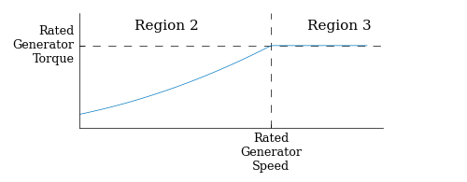

Figure 2. Simple torque controller.

The pitch controller, developed by Craig Hansen of Windward Engineering, was a simple gain-scheduled PID controller as documented in Appendix E of Malcolm (2006). The PID constants from CertTest #13 were used for all four turbine models. The pitch controller implemented the PID control in the form of the following two transfer functions:

$$T_{I}\left(s\right)=\frac{2.22}{s}$$

$$T_{PD}\left(s\right)=\frac{0.08s+5.14}{0.02s+1}$$

where $T_{I}\left(s\right)$ and $T_{PD}\left(s\right)$ are the integral and proportional-derivative transfer functions, respectively. The control scheme also had an anti-windup gain that was set to 0.3 rpm/deg per the documentation. Gain scheduling was applied for blade pitch angles between 2.6° and 30° (0.0454 rad and 0.5236 rad, respectively) by multiplying the PID coefficients by the following function:

$$GS\left(θ\right)=\left\{\begin{matrix}1 & θ<0.0454 \\ 0.213⋅θ^{-0.5} & 0.0454≤θ≤0.5236 \\ 0.2944 & θ>0.5236\end{matrix}\right.$$

where $θ$ is the blade pitch angle in radians. Lastly, the pitch actuator is modeled as a second-order transfer function with the following form:

$$T_{PA}\left(s\right)=\frac{{\left(4Ω_{rated}\right)}^{2}}{s^{2}+2ζ_{PA}\left(4Ω_{rated}\right)s+{\left(4Ω_{rated}\right)}^{2}}$$

where $Ω_{rated}$ is the rotor angular velocity and rad/s and $ζ_{PA}$ is the percent of critical damping (declared in the documentation to be 80%).

1. Steady-State Behavior

When automatically generating the FAST input files for the training data calculations, it was important that the initial conditions were chosen to minimize transience at the beginning of the record. We chose to create look-up tables (LUTs) for each WindPACT model that stored the steady-state values for a variety of FAST parameters as a function of the steady wind speed. The LUTs were calculated by simulating a series of 140-second simulations with steady wind values that ranged from 3 m/s to 25 m/s and averaging the last 80 seconds to ensure the simulation had converged. The resulting steady-state values were then used as the initial condition for the next highest wind speed. Plots of select steady-state values for the four models are given in Figure 3 through Figure 6.

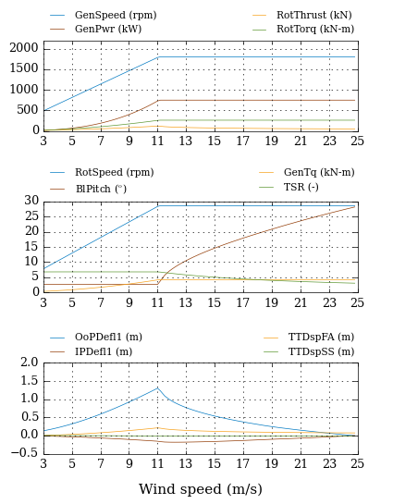

Figure 3. Steady-state behavior for 0.75 MW baseline model.

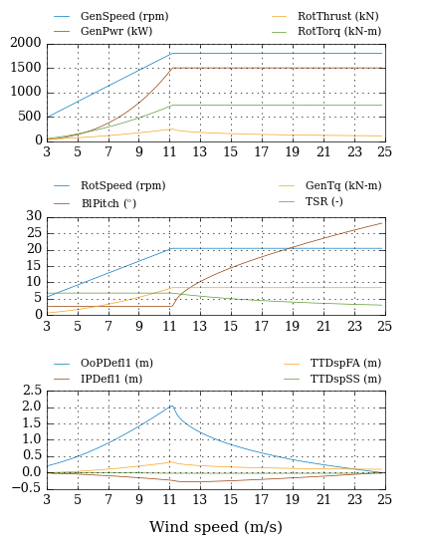

Figure 4. Steady-state behavior for 1.5 MW baseline model.

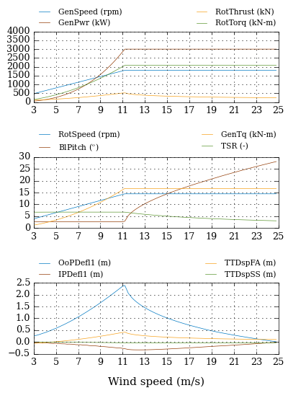

Figure 5. Steady-state behavior for 3.0 MW baseline model.

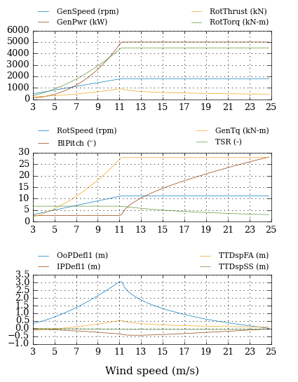

Figure 6. Steady-state behavior for 5.0 MW baseline model.

1. Conclusions

As part of the WindPACT studies in the early 2000s, four baseline wind turbine models (750 kW, 1.5 MW, 3.0 MW, and 5.0 MW) were developed for scaling studies. This report develops and presents the turbine parameters for FAST 7 to enable future researchers to use the model. The FAST input parameters were developed based on the project's Microsoft Excel files that were used to design the baseline models. Copies of the Excel files can be found online at LINK, and the FAST 7 input files can be found at LINK.

References

Girsang, I.P.; Dhupia, J.S.; Muljadi, E.; Singh, M.; Pao, L.Y. (2014) "Gearbox and Drivetrain Models to Study Dynamic Effects of Modern Wind Turbines." *IEEE Transactions on Industry Applications* (50:6); pp. 3777-3786.

Griffin, D.A. (2001) *WindPACT Turbine Design Scaling Studies Technical Area 1—Composite Blades for 80- to 120-meter Rotor*. NREL/SR-599-29492. Golden, CO: NREL.

Jonkman, J.; Butterfield, S.; Musial, W.; Scott, G. (2009) *Definition of a 5-MW Reference Wind Turbine for Offshore System Development*. NREL/TP-500-38060. Golden, CO: NREL.

Malcolm, D.J.; Hansen, A.C. (2006) *WindPACT Turbine Rotor Design Study*. NREL/SR-500-32495. Golden, CO: NREL.

Poore, R.; Lettenmaier, T. (2003). *Alternative Design Study Report: WindPACT Advanced Wind Turbine Drive Train Designs Study*. NREL/SR-500-33196. Golden, CO: NREL.