1. 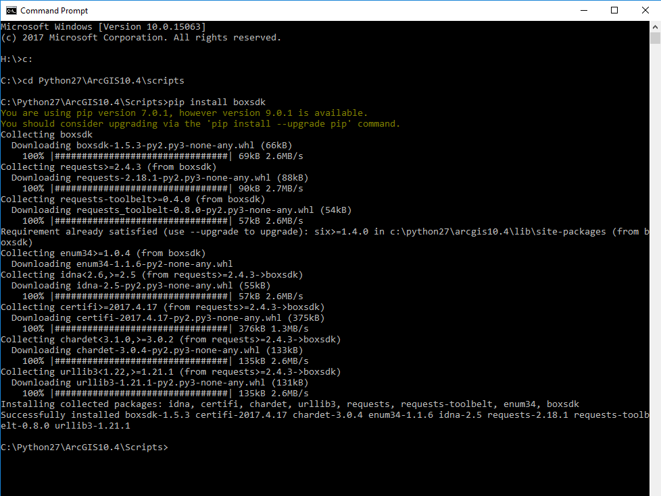Make sure to install the Box sdk with something like this:
2. Navigate to the folder with the code (currently C:\00_SCO\00_Parcels\V3\05_Distribution\01_County_Data_Distribution\00_V300)
3. Open the tool, configure the tool to run as “phase 1”
4. Upon completion of phase 1, open up the tool’s script and be sure to read the directives about how to procure an access_token the token will only last about an hour, so you may need to refresh it and start the tool again.
5. Make sure that there is a new Box directory that is named the same as the “**Box Directory Name**” parameter of the tool. It doesn’t matter which directory it exists in, the script will find it (but avoid duplicate names, that’s not expected by the script).

