
成绩：

实 验 报 告

课程名称： | JAVA语言
实验项目： | 图形用户界面设计
姓 名： | 黄勉嘉
专 业： | 计算机科学与技术
班 级： | 计算机22-6
学 号： | 2201020106

计算机科学与技术学院

2024 年 6 月 11 日

- 实验目的
掌握图形用户界面程序的设计方法
二、实验环境
JDK1.8,WindowsPC主机
三、实验内容
窗体及其创建方法；组件、组件事件及其使用方法；布局管理器及使用方法
四 、实验结果
实验5、6一起完成，通过GUI设计一个P2Pclient客户端：
package 实验改.实验56;

import javax.swing.*;
import java.awt.*;
import java.awt.event.ActionEvent;
import java.awt.event.ActionListener;
import java.io.*;
import java.net.ServerSocket;
import java.net.Socket;
import java.util.Map;
import java.util.Timer;
import java.util.TimerTask;
import java.util.concurrent.ConcurrentHashMap;

public class P2PClient {
private static final String HOST = "localhost";
private static final int RELAY_PORT = 8000;

private ServerSocket serverSocket;
private String username;
private Map<String, Integer> peerPorts = new ConcurrentHashMap<>();
private Map<String, Socket> peerConnections = new ConcurrentHashMap<>();
private Timer keepAliveTimer;
private TimerTask keepAliveTask;

private JFrame frame;
private JTextField usernameField;
private JButton loginButton;
private JButton logoutButton;
private JButton refreshButton;
private JList<String> onlineUsersList;
private JButton connectToUserButton;
private JTextArea messagesArea;
private JTextField messageField;
private JButton sendButton;
private JButton sendFileButton;
private JButton exitButton;

public P2PClient() {
frame = new JFrame("P2P Client");

JPanel topPanel = new JPanel();
usernameField = new JTextField(20);
topPanel.add(new JLabel("User name:"));
topPanel.add(usernameField);

loginButton = new JButton("Log In");
topPanel.add(loginButton);

logoutButton = new JButton("Log Out");
topPanel.add(logoutButton);

loginButton.addActionListener(new ActionListener() {
@Override
public void actionPerformed(ActionEvent e) {
// 连接服务断
try {
serverSocket = new ServerSocket(0);
username = usernameField.getText();
Socket relaySocket = new Socket(HOST, RELAY_PORT);
DataOutputStream output = new DataOutputStream(relaySocket.getOutputStream());
output.writeUTF("NEW");
output.writeInt(serverSocket.getLocalPort());
output.writeUTF(username);
output.flush();
output.close();
relaySocket.close();

messagesArea.append("Logged in as: " + username + " on port: " + serverSocket.getLocalPort() + "\n");

new Thread(new Runnable() {
@Override
public void run() {
while (!serverSocket.isClosed()) {
try {
Socket peerSocket = serverSocket.accept();
DataInputStream input = new DataInputStream(peerSocket.getInputStream());
String peerUsername = input.readUTF();
peerConnections.put(peerUsername, peerSocket);
new Thread(new ReceiveRunnable(peerSocket, peerUsername)).start();
} catch (IOException ioException) {
if (!serverSocket.isClosed()) {
ioException.printStackTrace();
}
}
}
}
}).start();
} catch (IOException ioException) {
ioException.printStackTrace();
}

// 保活
startKeepAliveTimer();
}
});

logoutButton.addActionListener(new ActionListener() {
@Override
public void actionPerformed(ActionEvent e) {
disconnectFromServer();
closePeerConnections();
clearData();
}
});

refreshButton = new JButton("Refresh");
topPanel.add(refreshButton);

refreshButton.addActionListener(new ActionListener() {
@Override
public void actionPerformed(ActionEvent e) {
try {
Socket relaySocketRefresh = new Socket(HOST, RELAY_PORT);
DataOutputStream outputRefresh = new DataOutputStream(relaySocketRefresh.getOutputStream());
outputRefresh.writeUTF("REQUEST");
outputRefresh.flush();

DataInputStream inputRefresh = new DataInputStream(relaySocketRefresh.getInputStream());
int size = inputRefresh.readInt();
peerPorts.clear();
DefaultListModel<String> listModel = new DefaultListModel<>();
for (int i = 0; i < size; i++) {
String peerUsername = inputRefresh.readUTF();
int peerPort = inputRefresh.readInt();
peerPorts.put(peerUsername, peerPort);
listModel.addElement(peerUsername);
}
onlineUsersList.setModel(listModel);

inputRefresh.close();
relaySocketRefresh.close();
} catch (IOException ioException) {
ioException.printStackTrace();
}
}
});

onlineUsersList = new JList<>();
JScrollPane onlineUsersScroll = new JScrollPane(onlineUsersList);

connectToUserButton = new JButton("Connect");
connectToUserButton.addActionListener(new ActionListener() {
@Override
public void actionPerformed(ActionEvent e) {
String selectedUser = onlineUsersList.getSelectedValue();
if (selectedUser != null) {
try {
Socket peerSocket = new Socket(HOST, peerPorts.get(selectedUser));
DataOutputStream output = new DataOutputStream(peerSocket.getOutputStream());
output.writeUTF(username);
output.flush();
peerConnections.put(selectedUser, peerSocket);
new Thread(new ReceiveRunnable(peerSocket, selectedUser)).start();
} catch (IOException ioException) {
ioException.printStackTrace();
}
}
}
});

JPanel usersPanel = new JPanel(new BorderLayout());
usersPanel.add(onlineUsersScroll, BorderLayout.CENTER);
usersPanel.add(connectToUserButton, BorderLayout.SOUTH);

messagesArea = new JTextArea(20, 50);
JScrollPane messagesScroll = new JScrollPane(messagesArea);

JPanel bottomPanel = new JPanel();
messageField = new JTextField(30);
sendButton = new JButton("Send");
sendButton.addActionListener(new ActionListener() {
@Override
public void actionPerformed(ActionEvent e) {
String selectedUser = onlineUsersList.getSelectedValue();
if (selectedUser != null) {
Socket peerSocket = peerConnections.get(selectedUser);
if (peerSocket != null) {
try {
DataOutputStream output = new DataOutputStream(peerSocket.getOutputStream());
output.writeUTF("MESSAGE");
output.writeUTF(messageField.getText());
String formattedMessage = "send to " + selectedUser + ": " + messageField.getText() + "\n";
messagesArea.append(formattedMessage);
output.flush();
} catch (IOException ioException) {
ioException.printStackTrace();
}
}
}
}
});

sendFileButton = new JButton("Send File");
sendFileButton.addActionListener(new ActionListener() {
@Override
public void actionPerformed(ActionEvent e) {
String selectedUser = onlineUsersList.getSelectedValue();
if (selectedUser != null) {
JFileChooser fileChooser = new JFileChooser();
int returnVal = fileChooser.showOpenDialog(frame);
if (returnVal == JFileChooser.APPROVE_OPTION) {
File file = fileChooser.getSelectedFile();
sendFile(selectedUser, file);
}
}
}
});

bottomPanel.add(messageField);
bottomPanel.add(sendButton);
bottomPanel.add(sendFileButton);

exitButton = new JButton("Exit");
topPanel.add(exitButton);

exitButton.addActionListener(new ActionListener() {
@Override
public void actionPerformed(ActionEvent e) {
exit();
}
});

frame.getContentPane().add(topPanel, BorderLayout.NORTH);
frame.getContentPane().add(usersPanel, BorderLayout.WEST);
frame.getContentPane().add(messagesScroll, BorderLayout.CENTER);
frame.getContentPane().add(bottomPanel, BorderLayout.SOUTH);

frame.setDefaultCloseOperation(JFrame.DO_NOTHING_ON_CLOSE);
frame.pack();
frame.setVisible(true);
}

private void sendFile(String receiver, File file) {
Socket peerSocket = peerConnections.get(receiver);
if (peerSocket != null) {
try {
DataOutputStream output = new DataOutputStream(peerSocket.getOutputStream());
output.writeUTF("FILE");
output.writeUTF(file.getName());
output.writeLong(file.length());

FileInputStream fileInputStream = new FileInputStream(file);
byte[] buffer = new byte[4096];
int bytesRead;
while ((bytesRead = fileInputStream.read(buffer)) != -1) {
output.write(buffer, 0, bytesRead);
}
fileInputStream.close();
output.flush();
} catch (IOException e) {
e.printStackTrace();
}
}
}

class ReceiveRunnable implements Runnable {
private final Socket socket;
private final String username;

public ReceiveRunnable(Socket socket, String username) {
this.socket = socket;
this.username = username;
}

@Override
public void run() {
try {
DataInputStream input = new DataInputStream(socket.getInputStream());
while (!socket.isClosed()) {
String messageType = input.readUTF();
if (messageType.equals("MESSAGE")) {
String message = input.readUTF();
messagesArea.append(username + ": " + message + "\n");
} else if (messageType.equals("FILE")) {
String fileName = input.readUTF();
long fileSize = input.readLong();
receiveFile(username, fileName, fileSize, input);
}
}
} catch (IOException e) {
if (!socket.isClosed()) {
e.printStackTrace();
}
} finally {
try {
socket.close();
} catch (IOException e) {
e.printStackTrace();
}
}
}

private void receiveFile(String sender, String fileName, long fileSize, DataInputStream input) throws IOException {
JFileChooser fileChooser = new JFileChooser();
fileChooser.setSelectedFile(new File(fileName));
int returnVal = fileChooser.showSaveDialog(frame);
if (returnVal == JFileChooser.APPROVE_OPTION) {
File file = fileChooser.getSelectedFile();
FileOutputStream fileOutputStream = new FileOutputStream(file);
byte[] buffer = new byte[4096];
long remainingSize = fileSize;
int bytesRead;
while (remainingSize > 0
&& (bytesRead = input.read(buffer, 0, (int) Math.min(buffer.length, remainingSize))) != -1) {
fileOutputStream.write(buffer, 0, bytesRead);
remainingSize -= bytesRead;
}
fileOutputStream.close();
messagesArea.append(sender + " sent a file: " + fileName + " (" + fileSize + " bytes)\n");
}
}
}

private void disconnectFromServer() {
try {
// 断开连接
Socket relaySocket = new Socket(HOST, RELAY_PORT);
DataOutputStream output = new DataOutputStream(relaySocket.getOutputStream());
output.writeUTF("REMOVE");
output.writeUTF(username);
output.flush();
output.close();
relaySocket.close();

messagesArea.append("Disconnected from the server\n");
} catch (IOException ioException) {
ioException.printStackTrace();
}

// 取消保活
keepAliveTask.cancel();
}

private void closePeerConnections() {
// 关闭所有对等连接
for (Socket socket : peerConnections.values()) {
try {
socket.close();
} catch (IOException e) {
e.printStackTrace();
}
}
peerConnections.clear();

messagesArea.append("Closed all peer connections\n");
}

private void clearData() {
// 清理数据
serverSocket = null;
peerPorts.clear();
DefaultListModel<String> listModel = new DefaultListModel<>();
onlineUsersList.setModel(listModel);

messagesArea.append("Cleared data\n");
}

private void exit() {
disconnectFromServer();
closePeerConnections();
clearData();

// 关闭Socket
if (serverSocket != null && !serverSocket.isClosed()) {
try {
serverSocket.close();
} catch (IOException ex) {
ex.printStackTrace();
}
}

// 退出
System.exit(0);
}

private void sendKeepAliveSignal() {
try {
Socket relaySocket = new Socket(HOST, RELAY_PORT);
DataOutputStream output = new DataOutputStream(relaySocket.getOutputStream());
output.writeUTF("KEEP_ALIVE");
output.writeUTF(username);
output.flush();
output.close();
relaySocket.close();
} catch (IOException e) {
e.printStackTrace();
}
}

private void startKeepAliveTimer() {
keepAliveTimer = new Timer();
keepAliveTask = new TimerTask() {
@Override
public void run() {
sendKeepAliveSignal();
}
};
keepAliveTimer.schedule(keepAliveTask, 10000, 10000); // 每10秒保活
}

public static void main(String[] args) {
new P2PClient();
}
}
结果：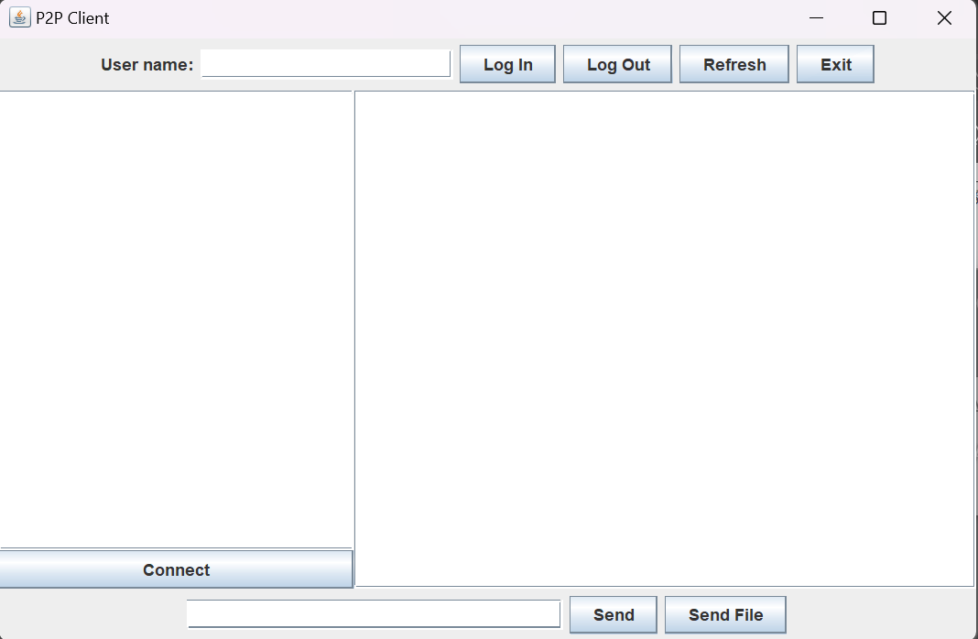

五、实验总结
本次实验使用了Java的Swing库来创建图形用户界面(GUI)。Swing是Java的一部分，用于创建窗口式应用程序。它是建立在Java的AWT API之上的，提供了更丰富的图形界面组件集。
以下是代码中使用的一些Swing组件和它们的用途：
JFrame：这是一个窗口，可以添加其他Swing组件。在这个代码中，frame是一个JFrame对象，代表了应用程序的主窗口。
JPanel：这是一个容器，可以包含其他Swing组件。在这个代码中，topPanel、usersPanel和bottomPanel都是JPanel对象，用于组织和布局其他组件。
JButton：这是一个按钮，用户可以点击它来触发事件。在这个代码中，loginButton、logoutButton、refreshButton、connectToUserButton、sendButton、sendFileButton和exitButton都是JButton对象。
JTextField：这是一个文本输入框，用户可以在其中输入文本。在这个代码中，usernameField和messageField都是JTextField对象。
JTextArea：这是一个可以显示多行文本的区域。在这个代码中，messagesArea是一个JTextArea对象，用于显示消息。
JList：这是一个可以显示列表的组件。在这个代码中，onlineUsersList是一个JList对象，用于显示在线用户。
JScrollPane：这是一个带有滚动条的容器，可以包含其他Swing组件。在这个代码中，onlineUsersScroll和messagesScroll都是JScrollPane对象，分别包含了onlineUsersList和messagesArea。
JFileChooser：这是一个文件选择器，用户可以用它来选择文件。在这个代码中，fileChooser是一个JFileChooser对象，用于选择要发送的文件。
在本次的实验中，我学会了如何设计java图形页面，并成功通过图形界面实现操作Client实现socket通信功能，达成了实验目的。

