
成绩：

实 验 报 告

课程名称： | JAVA语言
实验项目： | 套接字多线程通讯
姓 名： | 黄勉嘉
专 业： | 计算机科学与技术
班 级： | 计算机22-6
学 号： | 2201020106

计算机科学与技术学院

2024 年 6 月 11 日

- 实验目的
掌握套接字通讯方法并使用套接字进行通讯，进一步理解和掌握多线程程序设计
二、实验环境
JDK1.8,WindowsPC主机
三、实验内容
设计服务器端的多线程程序使之能同 时与多个客户通讯，设计客户端程序能与服务器进行通讯。
四 、实验结果
P2Pclient客户端：
package 实验改.实验56;

import javax.swing.*;
import java.awt.*;
import java.awt.event.ActionEvent;
import java.awt.event.ActionListener;
import java.io.*;
import java.net.ServerSocket;
import java.net.Socket;
import java.util.Map;
import java.util.Timer;
import java.util.TimerTask;
import java.util.concurrent.ConcurrentHashMap;

public class P2PClient {
private static final String HOST = "localhost";
private static final int RELAY_PORT = 8000;

private ServerSocket serverSocket;
private String username;
private Map<String, Integer> peerPorts = new ConcurrentHashMap<>();
private Map<String, Socket> peerConnections = new ConcurrentHashMap<>();
private Timer keepAliveTimer;
private TimerTask keepAliveTask;

private JFrame frame;
private JTextField usernameField;
private JButton loginButton;
private JButton logoutButton;
private JButton refreshButton;
private JList<String> onlineUsersList;
private JButton connectToUserButton;
private JTextArea messagesArea;
private JTextField messageField;
private JButton sendButton;
private JButton sendFileButton;
private JButton exitButton;

public P2PClient() {
frame = new JFrame("P2P Client");

JPanel topPanel = new JPanel();
usernameField = new JTextField(20);
topPanel.add(new JLabel("User name:"));
topPanel.add(usernameField);

loginButton = new JButton("Log In");
topPanel.add(loginButton);

logoutButton = new JButton("Log Out");
topPanel.add(logoutButton);

loginButton.addActionListener(new ActionListener() {
@Override
public void actionPerformed(ActionEvent e) {
// 连接服务断
try {
serverSocket = new ServerSocket(0);
username = usernameField.getText();
Socket relaySocket = new Socket(HOST, RELAY_PORT);
DataOutputStream output = new DataOutputStream(relaySocket.getOutputStream());
output.writeUTF("NEW");
output.writeInt(serverSocket.getLocalPort());
output.writeUTF(username);
output.flush();
output.close();
relaySocket.close();

messagesArea.append("Logged in as: " + username + " on port: " + serverSocket.getLocalPort() + "\n");

new Thread(new Runnable() {
@Override
public void run() {
while (!serverSocket.isClosed()) {
try {
Socket peerSocket = serverSocket.accept();
DataInputStream input = new DataInputStream(peerSocket.getInputStream());
String peerUsername = input.readUTF();
peerConnections.put(peerUsername, peerSocket);
new Thread(new ReceiveRunnable(peerSocket, peerUsername)).start();
} catch (IOException ioException) {
if (!serverSocket.isClosed()) {
ioException.printStackTrace();
}
}
}
}
}).start();
} catch (IOException ioException) {
ioException.printStackTrace();
}

// 保活
startKeepAliveTimer();
}
});

logoutButton.addActionListener(new ActionListener() {
@Override
public void actionPerformed(ActionEvent e) {
disconnectFromServer();
closePeerConnections();
clearData();
}
});

refreshButton = new JButton("Refresh");
topPanel.add(refreshButton);

refreshButton.addActionListener(new ActionListener() {
@Override
public void actionPerformed(ActionEvent e) {
try {
Socket relaySocketRefresh = new Socket(HOST, RELAY_PORT);
DataOutputStream outputRefresh = new DataOutputStream(relaySocketRefresh.getOutputStream());
outputRefresh.writeUTF("REQUEST");
outputRefresh.flush();

DataInputStream inputRefresh = new DataInputStream(relaySocketRefresh.getInputStream());
int size = inputRefresh.readInt();
peerPorts.clear();
DefaultListModel<String> listModel = new DefaultListModel<>();
for (int i = 0; i < size; i++) {
String peerUsername = inputRefresh.readUTF();
int peerPort = inputRefresh.readInt();
peerPorts.put(peerUsername, peerPort);
listModel.addElement(peerUsername);
}
onlineUsersList.setModel(listModel);

inputRefresh.close();
relaySocketRefresh.close();
} catch (IOException ioException) {
ioException.printStackTrace();
}
}
});

onlineUsersList = new JList<>();
JScrollPane onlineUsersScroll = new JScrollPane(onlineUsersList);

connectToUserButton = new JButton("Connect");
connectToUserButton.addActionListener(new ActionListener() {
@Override
public void actionPerformed(ActionEvent e) {
String selectedUser = onlineUsersList.getSelectedValue();
if (selectedUser != null) {
try {
Socket peerSocket = new Socket(HOST, peerPorts.get(selectedUser));
DataOutputStream output = new DataOutputStream(peerSocket.getOutputStream());
output.writeUTF(username);
output.flush();
peerConnections.put(selectedUser, peerSocket);
new Thread(new ReceiveRunnable(peerSocket, selectedUser)).start();
} catch (IOException ioException) {
ioException.printStackTrace();
}
}
}
});

JPanel usersPanel = new JPanel(new BorderLayout());
usersPanel.add(onlineUsersScroll, BorderLayout.CENTER);
usersPanel.add(connectToUserButton, BorderLayout.SOUTH);

messagesArea = new JTextArea(20, 50);
JScrollPane messagesScroll = new JScrollPane(messagesArea);

JPanel bottomPanel = new JPanel();
messageField = new JTextField(30);
sendButton = new JButton("Send");
sendButton.addActionListener(new ActionListener() {
@Override
public void actionPerformed(ActionEvent e) {
String selectedUser = onlineUsersList.getSelectedValue();
if (selectedUser != null) {
Socket peerSocket = peerConnections.get(selectedUser);
if (peerSocket != null) {
try {
DataOutputStream output = new DataOutputStream(peerSocket.getOutputStream());
output.writeUTF("MESSAGE");
output.writeUTF(messageField.getText());
String formattedMessage = "send to " + selectedUser + ": " + messageField.getText() + "\n";
messagesArea.append(formattedMessage);
output.flush();
} catch (IOException ioException) {
ioException.printStackTrace();
}
}
}
}
});

sendFileButton = new JButton("Send File");
sendFileButton.addActionListener(new ActionListener() {
@Override
public void actionPerformed(ActionEvent e) {
String selectedUser = onlineUsersList.getSelectedValue();
if (selectedUser != null) {
JFileChooser fileChooser = new JFileChooser();
int returnVal = fileChooser.showOpenDialog(frame);
if (returnVal == JFileChooser.APPROVE_OPTION) {
File file = fileChooser.getSelectedFile();
sendFile(selectedUser, file);
}
}
}
});

bottomPanel.add(messageField);
bottomPanel.add(sendButton);
bottomPanel.add(sendFileButton);

exitButton = new JButton("Exit");
topPanel.add(exitButton);

exitButton.addActionListener(new ActionListener() {
@Override
public void actionPerformed(ActionEvent e) {
exit();
}
});

frame.getContentPane().add(topPanel, BorderLayout.NORTH);
frame.getContentPane().add(usersPanel, BorderLayout.WEST);
frame.getContentPane().add(messagesScroll, BorderLayout.CENTER);
frame.getContentPane().add(bottomPanel, BorderLayout.SOUTH);

frame.setDefaultCloseOperation(JFrame.DO_NOTHING_ON_CLOSE);
frame.pack();
frame.setVisible(true);
}

private void sendFile(String receiver, File file) {
Socket peerSocket = peerConnections.get(receiver);
if (peerSocket != null) {
try {
DataOutputStream output = new DataOutputStream(peerSocket.getOutputStream());
output.writeUTF("FILE");
output.writeUTF(file.getName());
output.writeLong(file.length());

FileInputStream fileInputStream = new FileInputStream(file);
byte[] buffer = new byte[4096];
int bytesRead;
while ((bytesRead = fileInputStream.read(buffer)) != -1) {
output.write(buffer, 0, bytesRead);
}
fileInputStream.close();
output.flush();
} catch (IOException e) {
e.printStackTrace();
}
}
}

class ReceiveRunnable implements Runnable {
private final Socket socket;
private final String username;

public ReceiveRunnable(Socket socket, String username) {
this.socket = socket;
this.username = username;
}

@Override
public void run() {
try {
DataInputStream input = new DataInputStream(socket.getInputStream());
while (!socket.isClosed()) {
String messageType = input.readUTF();
if (messageType.equals("MESSAGE")) {
String message = input.readUTF();
messagesArea.append(username + ": " + message + "\n");
} else if (messageType.equals("FILE")) {
String fileName = input.readUTF();
long fileSize = input.readLong();
receiveFile(username, fileName, fileSize, input);
}
}
} catch (IOException e) {
if (!socket.isClosed()) {
e.printStackTrace();
}
} finally {
try {
socket.close();
} catch (IOException e) {
e.printStackTrace();
}
}
}

private void receiveFile(String sender, String fileName, long fileSize, DataInputStream input) throws IOException {
JFileChooser fileChooser = new JFileChooser();
fileChooser.setSelectedFile(new File(fileName));
int returnVal = fileChooser.showSaveDialog(frame);
if (returnVal == JFileChooser.APPROVE_OPTION) {
File file = fileChooser.getSelectedFile();
FileOutputStream fileOutputStream = new FileOutputStream(file);
byte[] buffer = new byte[4096];
long remainingSize = fileSize;
int bytesRead;
while (remainingSize > 0
&& (bytesRead = input.read(buffer, 0, (int) Math.min(buffer.length, remainingSize))) != -1) {
fileOutputStream.write(buffer, 0, bytesRead);
remainingSize -= bytesRead;
}
fileOutputStream.close();
messagesArea.append(sender + " sent a file: " + fileName + " (" + fileSize + " bytes)\n");
}
}
}

private void disconnectFromServer() {
try {
// 断开连接
Socket relaySocket = new Socket(HOST, RELAY_PORT);
DataOutputStream output = new DataOutputStream(relaySocket.getOutputStream());
output.writeUTF("REMOVE");
output.writeUTF(username);
output.flush();
output.close();
relaySocket.close();

messagesArea.append("Disconnected from the server\n");
} catch (IOException ioException) {
ioException.printStackTrace();
}

// 取消保活
keepAliveTask.cancel();
}

private void closePeerConnections() {
// 关闭所有对等连接
for (Socket socket : peerConnections.values()) {
try {
socket.close();
} catch (IOException e) {
e.printStackTrace();
}
}
peerConnections.clear();

messagesArea.append("Closed all peer connections\n");
}

private void clearData() {
// 清理数据
serverSocket = null;
peerPorts.clear();
DefaultListModel<String> listModel = new DefaultListModel<>();
onlineUsersList.setModel(listModel);

messagesArea.append("Cleared data\n");
}

private void exit() {
disconnectFromServer();
closePeerConnections();
clearData();

// 关闭Socket
if (serverSocket != null && !serverSocket.isClosed()) {
try {
serverSocket.close();
} catch (IOException ex) {
ex.printStackTrace();
}
}

// 退出
System.exit(0);
}

private void sendKeepAliveSignal() {
try {
Socket relaySocket = new Socket(HOST, RELAY_PORT);
DataOutputStream output = new DataOutputStream(relaySocket.getOutputStream());
output.writeUTF("KEEP_ALIVE");
output.writeUTF(username);
output.flush();
output.close();
relaySocket.close();
} catch (IOException e) {
e.printStackTrace();
}
}

private void startKeepAliveTimer() {
keepAliveTimer = new Timer();
keepAliveTask = new TimerTask() {
@Override
public void run() {
sendKeepAliveSignal();
}
};
keepAliveTimer.schedule(keepAliveTask, 10000, 10000); // 每10秒保活
}

public static void main(String[] args) {
new P2PClient();
}
}

Server服务端：
package 实验改.实验56;

import java.io.*;
import java.net.*;
import java.util.*;
import java.util.concurrent.*;

public class Server {
private static final int PORT = 8000;
private static final Map<String, Integer> clientPorts = new ConcurrentHashMap<>();
private static final Map<String, Long> lastSignalTime = new ConcurrentHashMap<>();

public static void main(String[] args) throws IOException {
ServerSocket serverSocket = new ServerSocket(PORT);
System.out.println("Relay server started on port: " + PORT);
Runnable checkInactiveClients = () -> {
long currentTime = System.currentTimeMillis();
for (Map.Entry<String, Long> entry : lastSignalTime.entrySet()) {
String username = entry.getKey();
long lastSignal = entry.getValue();
if (currentTime - lastSignal > 30000) {
clientPorts.remove(username);
lastSignalTime.remove(username);
System.out.println(username + " is offline.");
}
}
};
ScheduledExecutorService executorService = Executors.newScheduledThreadPool(1);
executorService.scheduleAtFixedRate(checkInactiveClients, 0, 1000, TimeUnit.MILLISECONDS);

while (true) {
Socket socket = new Socket();
try {
socket = serverSocket.accept();
DataInputStream input = new DataInputStream(socket.getInputStream());
DataOutputStream output = new DataOutputStream(socket.getOutputStream());

String command = input.readUTF();
if (command.equals("NEW")) {
int port = input.readInt();
String username = input.readUTF();
clientPorts.put(username, port);
lastSignalTime.put(username, System.currentTimeMillis());
System.out.println(username + " joined on port: " + port);
} else if (command.equals("REQUEST")) {
output.writeInt(clientPorts.size());
for (Map.Entry<String, Integer> entry : clientPorts.entrySet()) {
output.writeUTF(entry.getKey());
output.writeInt(entry.getValue());
}
output.flush();
} else if (command.equals("REMOVE")) {
String username = input.readUTF();
clientPorts.remove(username);
lastSignalTime.remove(username);
System.out.println(username + " has left.");
} else if (command.equals("KEEP_ALIVE")) {
String username = input.readUTF();
lastSignalTime.put(username, System.currentTimeMillis());
}
} catch (IOException e) {
e.printStackTrace();
} finally {
try {
socket.close();
} catch (IOException e) {
e.printStackTrace();
}
}
}
}
}
结果：
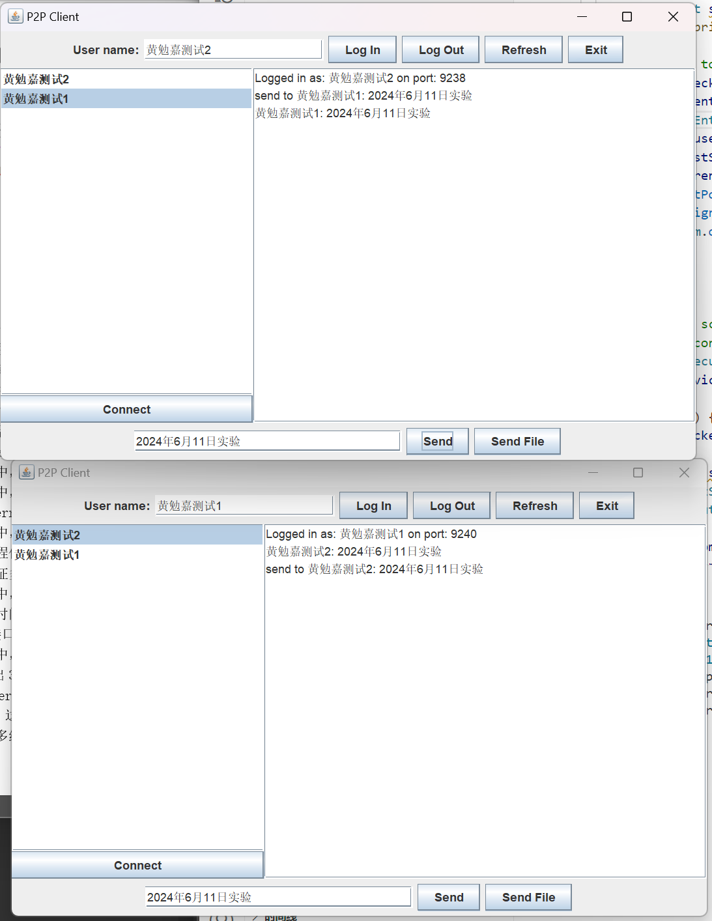
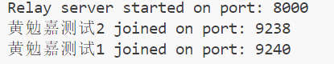

五、实验总结
Client使用 Java 编写。P2P 技术允许两个或更多的计算机通过网络直接进行通信，而无需通过中心服务器。这个客户端使用 Java Swing 库来创建图形用户界面 (GUI)，并使用 Java 的 Socket 类来处理网络通信。
在 P2PClient 类中，定义了一些私有变量来存储客户端的状态，包括服务器套接字、用户名、对等端口、对等连接、计时器等。此外，还定义了一些 GUI 组件，如按钮、文本字段、列表等。
P2PClient 的构造函数初始化了这些 GUI 组件，并设置了它们的行为。例如，当用户点击 "Log In" 按钮时，客户端会尝试连接到服务器，并向服务器发送新客户端的信息。当用户点击 "Log Out" 按钮时，客户端会断开与服务器的连接，关闭所有对等连接，并清除所有数据。
sendFile 方法允许客户端向选定的对等端发送文件。它首先打开一个文件选择器对话框，让用户选择要发送的文件，然后读取文件内容并通过 Socket 连接发送。
ReceiveRunnable 类是一个内部类，它实现了 Runnable 接口，用于在新线程中接收来自对等端的消息。它可以接收两种类型的消息："MESSAGE" 和 "FILE"。对于 "MESSAGE" 类型的消息，它会将消息添加到消息区域。对于 "FILE" 类型的消息，它会打开一个文件保存对话框，让用户选择保存文件的位置。
disconnectFromServer、closePeerConnections 和 clearData 方法分别用于断开与服务器的连接、关闭所有对等连接和清除所有数据。
exit 方法首先调用上述三个方法，然后尝试关闭服务器套接字，并退出应用程序。
sendKeepAliveSignal 方法向服务器发送 "KEEP_ALIVE" 消息，以通知服务器客户端仍然活动。startKeepAliveTimer 方法启动一个计时器，每 10 秒调用一次 sendKeepAliveSignal 方法。
最后，main 方法创建一个新的 P2PClient 实例，启动客户端。
Server使用Java的Socket编程来处理客户端的连接和请求。服务器在8000端口上监听，使用两个ConcurrentHashMap来跟踪连接的客户端。一个映射是clientPorts，它将用户名映射到他们的端口号。另一个映射是lastSignalTime，它将用户名映射到他们最后一次发送信号的时间。
服务器使用一个Runnable来检查并移除那些超过30秒没有活动的客户端。这个Runnable会遍历lastSignalTime映射，并检查当前时间与最后一次信号时间的差值是否超过30秒。如果是，那么就从两个映射中移除这个客户端，并打印一条消息表示该客户端已经离线。
然后，服务器使用一个ScheduledExecutorService来定期运行这个Runnable。这个ExecutorService被配置为每秒运行一次，以便及时检测并移除那些不活动的客户端。
在主循环中，服务器等待新的客户端连接。当一个新的连接被接受时，服务器会创建输入和输出流来与客户端通信。然后，服务器读取一个命令字符串。如果命令是"NEW"，那么服务器会读取端口号和用户名，然后将这些信息添加到两个映射中，并打印一条消息表示新的客户端已经加入。如果命令是"REQUEST"，那么服务器会向客户端发送当前连接的客户端数量。

