**3 Things To Do If Invoke-SqlCmd Is Not Recognized in Windows PowerShell**

Posted on [March 5, 2012](http://jasonq.com/2012/03/3-things-to-do-if-invoke-sqlcmd-is-not-recognized-in-windows-powershell/) by [JasonQ](http://jasonq.com/author/jasonq/) — [22 Comments ↓](http://jasonq.com/2012/03/3-things-to-do-if-invoke-sqlcmd-is-not-recognized-in-windows-powershell/#comments)

FROM: <http://jasonq.com/2012/03/3-things-to-do-if-invoke-sqlcmd-is-not-recognized-in-windows-powershell/>

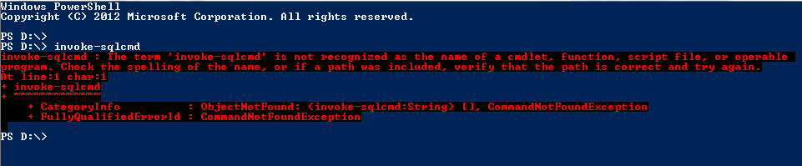

I had a client request a data export from their web application to be FTP’d to a server of theirs on a daily basis. So, I quickly set about writing a sqlcmd script to pull out the data that I needed and save it to a file. It wasn’t long before I wanted the deliciousness that Windows PowerShell provides, and a quick search showed me ‘[Invoke-Sqlcmd](http://msdn.microsoft.com/en-us/library/cc281720(v=sql.105).aspx)‘. When I tried to run it, I got this error:

The term 'invoke-sqlcmd' is not recognized as the name of a cmdlet, function, script file, or operable program.

The source script that I was using to guide me assumed that invoke client was available when it wasn’t. After a lot of reading and trial and error, I was finally able to get it to run on my machine, and then also on the server.

Since all of the steps I required weren’t listed in one place, I thought I’d list them here in case it helps anyone:

1. Install SQL Server 2008 R2 Management Objects using [Web PI](http://www.microsoft.com/web/downloads/platform.aspx) (I’m not sure about versions prior to 2008 R2… if you have more info, please let us know in the comments)
2. Install ‘Windows PowerShell Extensions for SQL Server’ from the [Microsoft® SQL Server® 2008 R2 Feature Pack](http://www.microsoft.com/download/en/details.aspx?id=16978#PowerShell) page (it’s about halfway down the page).
3. Run these two commands before calling invoke-sqlcmd in your script:
4. Add-PSSnapin SqlServerCmdletSnapin100

Add-PSSnapin SqlServerProviderSnapin100

Hopefully this helps someone!