**Adding a log shipping monitor**

**By** [**Luke Campbell**](http://www.sqlservercentral.com/Authors/Articles/Luke_Campbell/414364/)**, 2012/03/15**

**FROM: http://www.sqlservercentral.com/articles/Log+Shipping/77295/**

Total article views: 1241 | Views in the last 30 days: 1241

http://www.sqlservercentral.com/Resources/Images/FilledStar.pnghttp://www.sqlservercentral.com/Resources/Images/FilledStar.pnghttp://www.sqlservercentral.com/Resources/Images/FilledStar.pnghttp://www.sqlservercentral.com/Resources/Images/FilledStar.pnghttp://www.sqlservercentral.com/Resources/Images/FilledStar.png[Rate this](javascript:;) | http://www.sqlservercentral.com/Resources/Images/Discuss.gif  [Join the discussion](http://www.sqlservercentral.com/Forums/FindPost1267237.aspx) | [[http://www.sqlservercentral.com/Resources/Images/Briefcase.gif](javascript:;) Briefcase](javascript:;) | http://www.sqlservercentral.com/Resources/Images/print.gif  [Print](http://www.sqlservercentral.com/articles/Log+Shipping/77295/)

**0**diggsdigg

[Delicious](http://delicious.com/post?url=http%3a%2f%2fwww.sqlservercentral.com%2farticles%2fLog%2bShipping%2f77295%2f&title=Adding+a+log+shipping+monitor)

[Delicious](http://technorati.com/faves?add=http%3a%2f%2fwww.sqlservercentral.com%2farticles%2fLog%2bShipping%2f77295%2f)

[in**Share**](javascript:void(0);)

Have you ever spent time setting up your log shipping servers and configuring the necessary backup directories, backup schedules, and restore schedules only to remember, after the fact, that you needed to add the log shipping monitor?  It was a bit disappointing to find the following note on Microsoft's [website](http://msdn.microsoft.com/en-us/library/ms190224.aspx).

*To monitor a log shipping configuration, you must add the monitor server when you enable log shipping. If you add a monitor server later, you must remove the log shipping configuration and then replace it with a new configuration that includes a monitor server.*

What I hope to show here is how this can be done without removing and rebuilding our log shipping configuration.  Here's our test setup and what we'll be accomplishing.

1. Three SQL Server 2008 instances with SP1 applied.  Primary, Secondary, and our monitoring instance.  (Primary - SQL2008LSDEMO\LS1, Secondary - SQL2008LSDEMO\LS2 and Monitor - SQL2008LSDEMO\LS3)
2. Log shipping setup using the Adventureworks2008R2 sample database found [here](http://msftdbprodsamples.codeplex.com/releases/view/55926).
3. Describe the parameters of both msdb.dbo.sp_processlogshippingmonitorprimary and msdb.dbo.sp_processlogshippingmonitorsecondary.
4. Verify the monitor is working correctly.

**Setting up log shipping (I won't be covering every detail here but just a quick run through.)**

**1.**  Change the recovery mode for the AdventureWorks2008R2 database to full and then take a full backup.

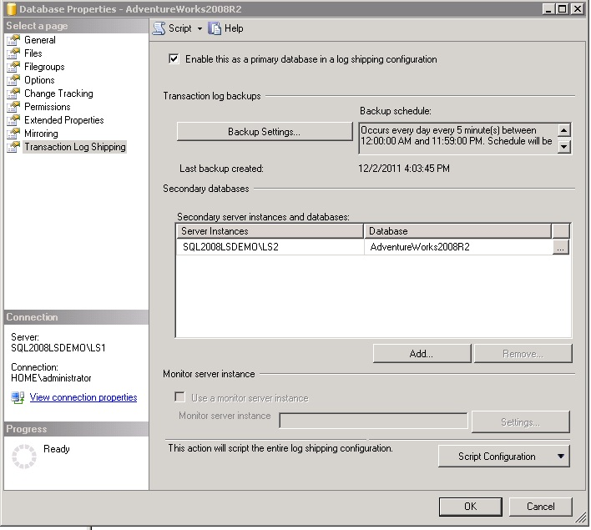

http://www.sqlservercentral.com/Resources/Images/zoom.gif[Zoom in](javascript:;)  |  [Open in new window](javascript:;)

**2.** To add our monitor we'll need to collect information from the log_shipping_monitor_primary system table found in the MSDB database using the following query.  This will need to run on the PRIMARY server in the log shipping configuration.

USE MSDB

GO

SELECT

 primary_id,

 primary_server,

 primary_database,

 backup_threshold,

 threshold_alert,

 threshold_alert_enabled,

 history_retention_period

FROM msdb.dbo.log_shipping_monitor_primary

WHERE primary_database = 'AdventureWorks2008R2'  --DB you're working with

**3.** Next we'll need to collect information from the log_shipping_monitor_secondary system table found in the MSDB database using the following query.  This will need to run on the SECONDARY server in the log shipping configuration.

USE MSDB

GO

SELECT

 secondary_id,

 secondary_server,

 secondary_database,

 restore_threshold,

 threshold_alert,

 threshold_alert_enabled,

 history_retention_period

FROM msdb.dbo.log_shipping_monitor_secondary

WHERE primary_database = 'AdventureWorks2008R2'

AND primary_server = 'SQL2008LSDemo\LS1'

**4.** The next query will need to be executed on the new monitoring instance.  Here is where we'll use our collected values from the previous two queries.

USE MSDB

GO

--Add the primary to the monitor

EXEC msdb.dbo.sp_processlogshippingmonitorprimary

@mode = 1

,@primary_id = '6D35B8B0-74A7-49D5-9C73-88F620E8414D'

,@primary_server = N'SQL2008LSDEMO\LS1'

,@monitor_server = N'SQL2008LSDEMO\LS3' --Intended monitor server

,@monitor_server_security_mode = 1

,@primary_database = N'AdventureWorks2008R2'

,@backup_threshold = 5

,@threshold_alert = 14420

,@threshold_alert_enabled = 1

,@history_retention_period = 5760

--Add the secondary to the monitor

EXEC msdb.dbo.sp_processlogshippingmonitorsecondary

@mode = 1

,@secondary_server = N'SQL2008LSDEMO\LS2'

,@secondary_database = N'AdventureWorks2008R2'

,@secondary_id = '134B1AC3-2B4E-4D39-B779-BEAFEBEED67C'

,@primary_server = N'SQL2008LSDEMO\LS1'

,@primary_database = N'AdventureWorks2008R2'

,@restore_threshold = 5

,@threshold_alert = 14421

,@threshold_alert_enabled = 1

,@history_retention_period = 5760

,@monitor_server = N'SQL2008LSDEMO\LS3' --Intended monitor server

,@monitor_server_security_mode = 1

**5.**  We’ll pause here for a description of each parameter.

**sp_processLogShippingMonitorPrimary**

|  |  |
| --- | --- |
| **Parameter** | **Description** |
| @mode | Restore mode of the secondary database.  0 = Restore log with NORECOVERY.  1 = restore log with STANDBY |
| @primary_id | ID of the primary database for the log shipping configuration. |
| @primary_server | Name of the primary instance in the log shipping configuration. |
| @monitor_server | Name of the monitoring instance in the log shipping configuration. |
| @monitor_server_security_mode | The security mode used to connect to the monitor server.  1 = Windows Authentication  0 = SQL Server Authentication |
| @primary_database | Name of the primary database for the log shipping configuration |
| @backup_threshold | Length of time, in minutes, after the last backup before a threshold alert is raised. |
| @threshold_alert | The alert to be raised when the backup threshold is exceeded. |
| @threshold_alert_enabled | 1 = enabled, 0 = disabled |
| @history_retention_period | Length of time in minutes in which the history will be retained. |

**sp_processLogShippingMonitorSecondary**

|  |  |
| --- | --- |
| **Parameter** | **Description** |
| @mode | Restore mode of the secondary database.  0 = Restore log with NORECOVERY.  1 = restore log with STANDBY |
| @secondary_id | ID of the secondary database for the log shipping configuration. |
| @secondary_server | Name of the secondary instance in the log shipping configuration. |
| @monitor_server | Name of the monitoring instance in the log shipping configuration. |
| @primary_server | Name of the primary instance in the log shipping configuration. |
| @primary_database | Name of the primary database for the log shipping configuration |
| @monitor_server_security_mode | The security mode used to connect to the monitor server.  1 = Windows Authentication  0 = SQL Server Authentication |
| @primary_database | Name of the primary database for the log shipping configuration |
| @backup_threshold | Length of time, in minutes, after the last backup before a threshold alert is raised. |
| @threshold_alert | The alert to be raised when the restore threshold is exceeded. |
| @threshold_alert_enabled | 1 = enabled, 0 = disabled |
| @history_retention_period | Length of time in minutes in which the history will be retained. |

**6.**  After running this query check to ensure the LSAlert job was created on the monitoring instance.

**7.**  Now that we have the new monitoring instance setup we can update the primary and secondary instances with the monitor server name.  Run the following query on the primary instance.

USE MSDB

GO

UPDATE msdb.dbo.log_shipping_primary_databases

SET monitor_server = 'SQL2008LSDEMO\LS3'

, user_specified_monitor = 1

WHERE primary_id = '6D35B8B0-74A7-49D5-9C73-88F620E8414D'

--ID of primary database

**8.** Run this query on the secondary instance.

USE MSDB

GO

UPDATE msdb.dbo.log_shipping_secondary

SET monitor_server = 'SQL2008LSDEMO\LS3'

, user_specified_monitor = 1

WHERE secondary_id = '134B1AC3-2B4E-4D39-B779-BEAFEBEED67C'

--ID of secondary database

**9.** Verify the log shipping monitor is now enabled from the database properties page.

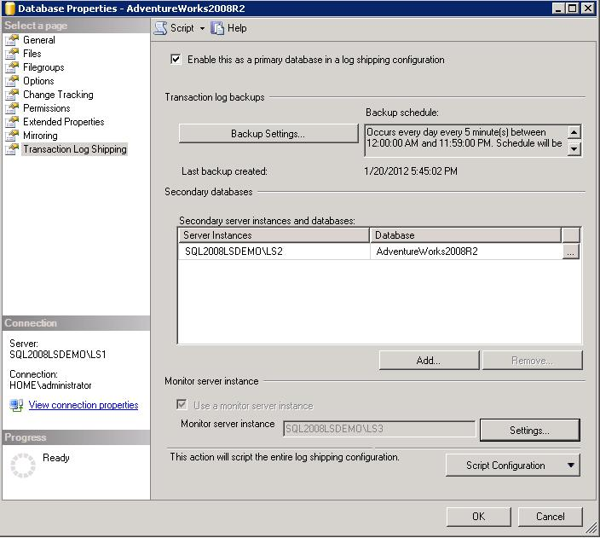

http://www.sqlservercentral.com/Resources/Images/zoom.gif[Zoom in](javascript:;)  |  [Open in new window](javascript:;)

**10.**  Verify that the monitor is receiving updates by reviewing the Transaction Log Shipping Status Report on the new monitor.

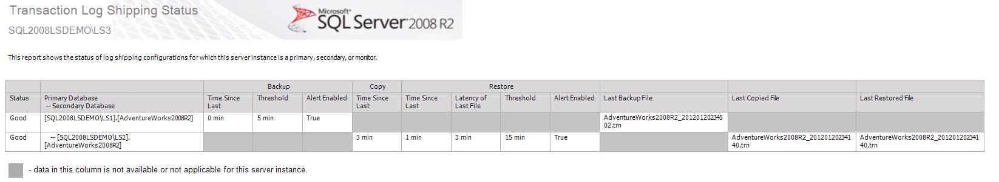

http://www.sqlservercentral.com/Resources/Images/zoom.gif[Zoom in](javascript:;)  |  [Open in new window](javascript:;)

**11.**  Once verified, the old LSAlert jobs on the primary and secondary instances can be deleted.

**Thanks for reading!**

**0**diggsdigg

[Delicious](http://delicious.com/post?url=http%3a%2f%2fwww.sqlservercentral.com%2farticles%2fLog%2bShipping%2f77295%2f&title=Adding+a+log+shipping+monitor)

[Delicious](http://technorati.com/faves?add=http%3a%2f%2fwww.sqlservercentral.com%2farticles%2fLog%2bShipping%2f77295%2f)

[in**Share**](javascript:void(0);)