**Analyze SQL Server Results in Excel with Conditional Formatting**

By: [Jim Evans](https://www.mssqltips.com/sqlserverauthor/335/jim-evans/)   |   Updated: 2020-02-24

FROM: <https://www.mssqltips.com/sqlservertip/6339/analyze-sql-server-results-in-excel-with-conditional-formatting/?utm_source=dailynewsletter&utm_medium=email&utm_content=headline&utm_campaign=20200224>

**Problem**

In this article I show a couple of very easy techniques for formatting data from SQL Server in Microsoft Excel that helps in analyzing results. In a previous article I demonstrated a technique for showing [database activity based on transaction log activity](https://www.mssqltips.com/sqlservertip/6096/sql-server-database-activity-based-on-transaction-log-backup-size/).  In this solution I will use a similar result set and show how to use Excel conditional formatting to make it interesting and easy to analyze the results showing the lows and highs of transaction log activity.

**Solution**

In this solution I will show how to take a vanilla result set that is hard to interpret, such as **Example A** below and easily turn it in to an interpretable visualization like **Example B** below.

**Example A**

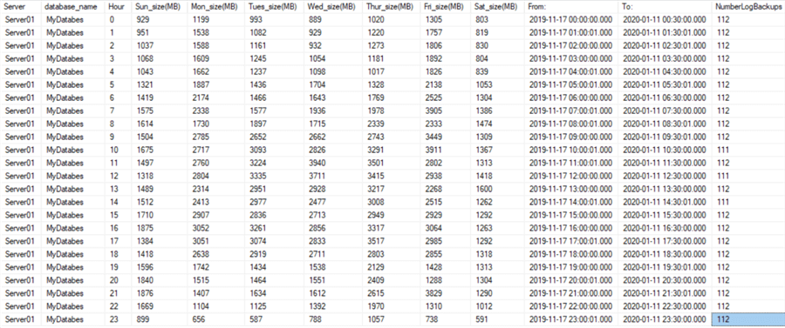

**Example B**

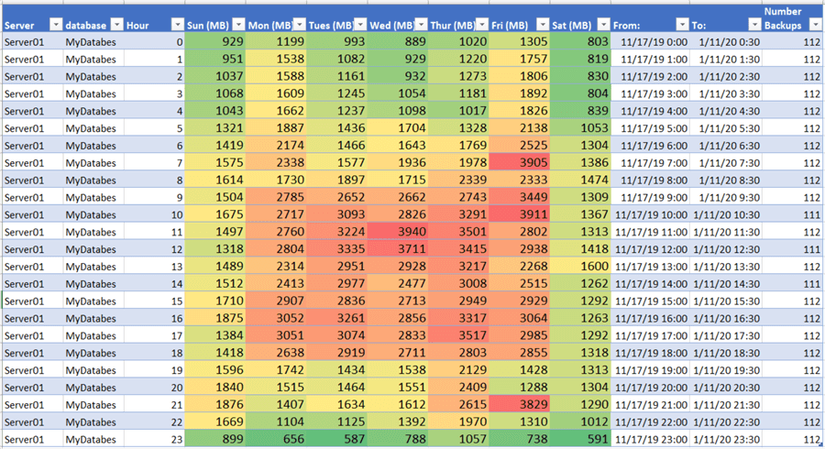

Step 1 – Activity Based on Transaction Log Size – Database Level

In this example I am using the SUM aggregate to get total transaction log backup sizes in MB rolled up by hour for each day of the week.

This has 2 parameters: (1) @NumWeeks which I will set to 8 weeks and (2) @Database which can be set to analyze a single database or set to NULL to analyze all the databases on a server with transaction log backups.

--Database LEVEL: SUM

--SUM: May be large for a large date range for analysis. this is my preferred over an 8 week period.

DECLARE @NumWeeks INT = 8 --<< SET the number of weeks to analyze.

DECLARE @Database nvarchar(100) = DB_Name() --'YourDBName'

SELECT

@@servername as 'Server', --For all full recovery model DBs

a.database_name,

datepart(Hour,a.backup_start_date) as 'Hour',

convert(INT, SUM(CASE WHEN datename(weekday,a.backup_start_date) = 'Sunday' THEN ceiling (a.backup_size/1048576.00) ELSE 0 END)) as 'Sun_size(MB)',

convert(INT, SUM(CASE WHEN datename(weekday,a.backup_start_date) = 'Monday' THEN ceiling (a.backup_size/1048576.00) ELSE 0 END)) as 'Mon_size(MB)',

convert(INT, SUM(CASE WHEN datename(weekday,a.backup_start_date) = 'Tuesday' THEN ceiling (a.backup_size/1048576.00) ELSE 0 END)) as 'Tues_size(MB)',

convert(INT, SUM(CASE WHEN datename(weekday,a.backup_start_date) = 'Wednesday' THEN ceiling (a.backup_size/1048576.00) ELSE 0 END)) as 'Wed_size(MB)',

convert(INT, SUM(CASE WHEN datename(weekday,a.backup_start_date) = 'Thursday' THEN ceiling (a.backup_size/1048576.00) ELSE 0 END)) as 'Thur_size(MB)',

convert(INT, SUM(CASE WHEN datename(weekday,a.backup_start_date) = 'Friday' THEN ceiling (a.backup_size/1048576.00) ELSE 0 END)) as 'Fri_size(MB)',

convert(INT, SUM(CASE WHEN datename(weekday,a.backup_start_date) = 'Saturday' THEN ceiling (a.backup_size/1048576.00) ELSE 0 END)) as 'Sat_size(MB)'

,MIN(a.backup_start_date ) as 'From:'

,MAX(a.backup_start_date ) as 'To:'

,COUNT(*) as 'NumberLogBackups'

FROM msdb.dbo.backupset a (NOLOCK)

WHERE a.type = 'L' --log backups

AND (a.database_name = @Database --Target Database

OR @Database IS NULL)

AND a.backup_start_date >= DATEADD(WEEK, DATEDIFF(WEEK,-1,GETDATE())-1*@NumWeeks,-1)  --Note: -1 Starts us at Sunday.

AND a.backup_start_date < DATEADD(WEEK, DATEDIFF(WEEK,-1,GETDATE()),-1)

GROUP BY a.database_name,

  datepart(Hour,a.backup_start_date)

ORDER BY a.database_name,

  datepart(Hour,a.backup_start_date)

GO

Step 2 – Copy the Results and Paste to Excel Workbook

After running the query with results to grid, click the upper left corner of the result set grid and select **Copy with Headers**.

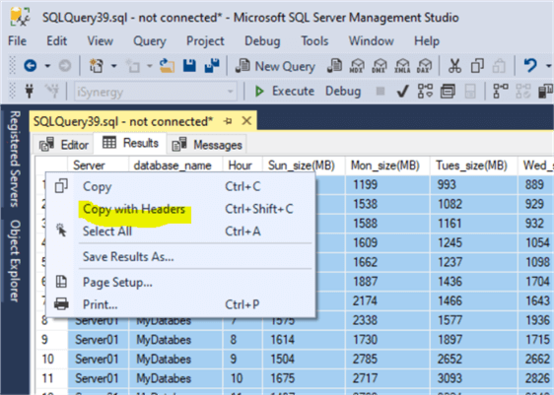

Step 3 – Paste the Results to Excel

Open Microsoft Excel and paste the results in cell A1.

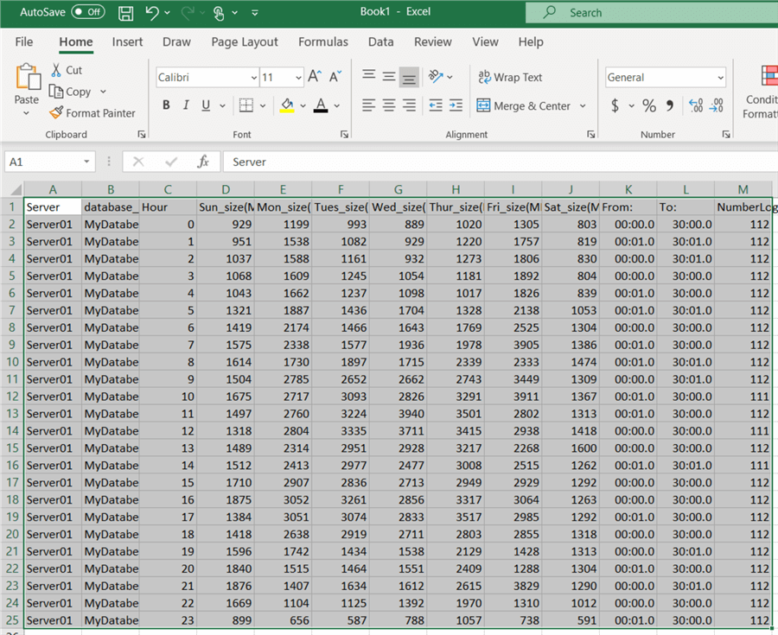

Step 4 – Excel Standard Formatting to Table

With the Results highlighted, select "Insert" from the top menu, then Table.  In the Create Table dialog box check "My Table has headers". This turns your results into a nicely formatted table with alternating color rows and an automatic filter on each column.

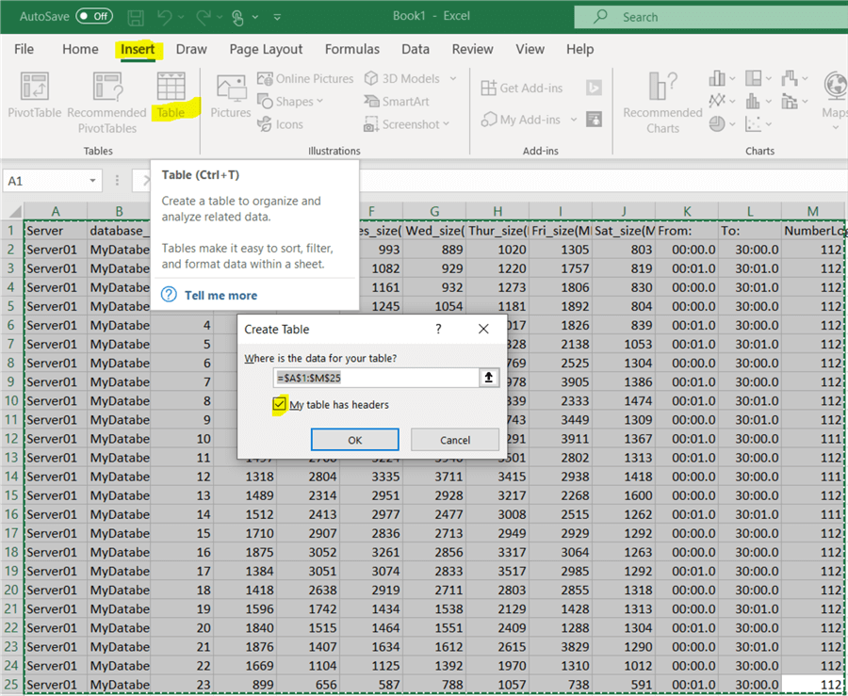

Below shows the formatted results. I do this often when I paste data into Excel.

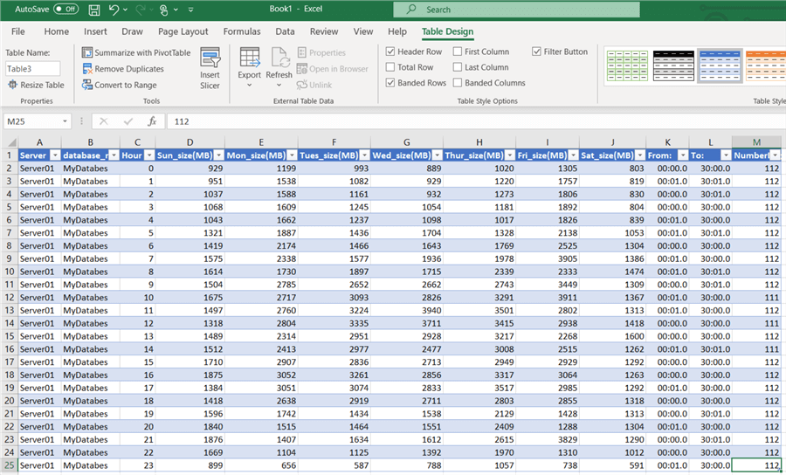

Step 5 – Add Conditional Formatting

First highlight the data area to be formatted.  In this case all the data that comprises of the Transaction Log sizes. With the Results highlighted, select the **Home** tab, select **Conditional Formatting** and then "**Color Scales**".

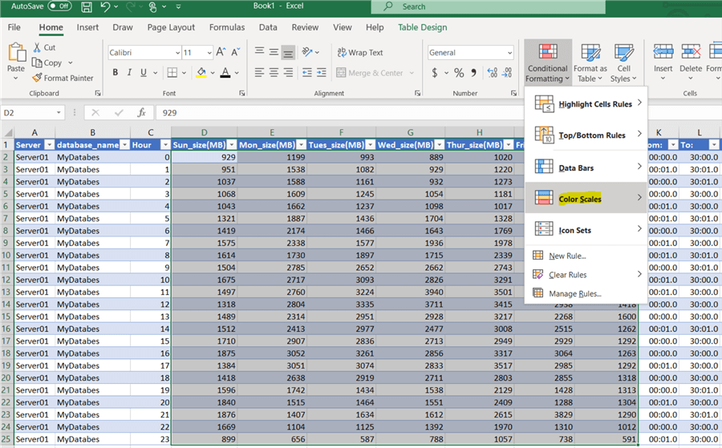

Step 6 – Add Conditional Formatting

Next select the **Color Scale Rules** relevant for your results set.  In this case I select from Red to Green with red showing highest intensity.

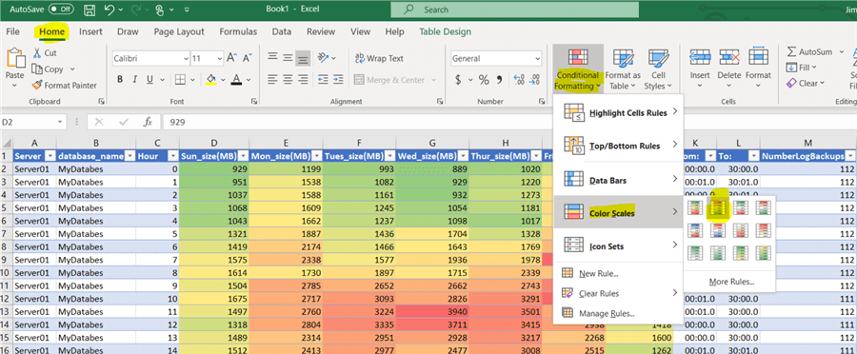

Final Results Conditional Formatting

Here are the final results.

I also, formatted dates in the From and To columns and shortened the Week day column names and adjusted the font size to make this easier to read. You can easily see the **trends** and the **Hot Spots** for the transaction log sizes each hour throughout the 8 weeks giving a visual of the normal weekly activity of the database.



Wrap Up

I hope you find this demo useful in visualizing your database traffic patterns.  Certainly, you will be able to wow your co-workers when you share your results.  Look for other results set where using conditional formatting will help visualize the results.

**Next Steps**

* Review my previous article: [SQL Server Database Activity Based on Transaction Log Backup Size](https://www.mssqltips.com/sqlservertip/6096/sql-server-database-activity-based-on-transaction-log-backup-size/).
* Here is an Excel Charting example:  [Analyze Windows Performance Monitor Counters Using Excel](https://www.mssqltips.com/sqlservertutorial/9187/analyze-windows-performance-monitor-counters-using-excel/).
* Read about [SQL Server and Microsoft Excel Integration Tips](https://www.mssqltips.com/sql-server-tip-category/114/microsoft-excel-integration/).
* Learn more tips on Excel from [Study material for exam 70-779 Analyzing and Visualizing Data with Microsoft Excel](https://www.mssqltips.com/sqlservertip/5051/study-material-for-exam-70779-analyzing-and-visualizing-data-with-microsoft-excel/)

Last Updated: 2020-02-24

|  |  |
| --- | --- |
| **Monday, February 24, 2020 - 9:48:13 AM - Tim Emerick** | [Back To Top](https://www.mssqltips.com/sqlservertip/6339/analyze-sql-server-results-in-excel-with-conditional-formatting/?utm_source=dailynewsletter&utm_medium=email&utm_content=headline&utm_campaign=20200224#top) |
| I was thinking the same thing as Scott Stanek then took a step back.  This is more about how to use Excel's conditional formatting to visualize the data than about using sp's and Excel's ETL capabilities.  In that spirit, well done explanation and easily usable for an excel novice.  Personally, I would take the next step as and Scott suggested and use Excel's parameterized data query entirely and probably roll it up into a pivot chart. The stored procedure may be unnecessary as excel could probably turn the entire thing into a native query, NOLOCK excepted. | |

|  |  |
| --- | --- |
| **Monday, February 24, 2020 - 8:52:12 AM - Scott Stanek** | [Back To Top](https://www.mssqltips.com/sqlservertip/6339/analyze-sql-server-results-in-excel-with-conditional-formatting/?utm_source=dailynewsletter&utm_medium=email&utm_content=headline&utm_campaign=20200224#top) |
| Just curious why you wouldn't wrap the code you have in a stored procedure call and use Excel Data Query to call that stored proc with 'Exec ' as Step 2? The result would be refreshable, already is a table and would not require Step 3. For style points, you could pass the name of the database as a parameter so it would just be changing the "Exec" call to look into other places the same way. | |