Erik Darling says:

## [Another Hidden Parallelism Killer: Scalar UDFs In Check Constraints](http://brentozar.us2.list-manage.com/track/click?u=9082566fb63d87be35c0662bc&id=867ab9d3e9&e=b137e91a2b)

### Every single time

Really. Every single time. It started off kind of funny. Scalar functions in queries: no parallelism. Scalar functions in computed columns: no parallelism, even if you’re not selecting the computed column. Every time I think of a place where someone could stick a scalar function into some SQL, it ends up killing parallelism. Now it’s just sad.

This is (hopefully. HOPEFULLY.) a less common scenario, since uh… I know most of you aren’t actually using any constraints. So there’s that! Developer laziness might be a saving grace here. But if you read the title, you know what’s coming. Here’s a quick example.

USE [tempdb]

SET NOCOUNT ON

SELECT TOP 10000

ROW_NUMBER() OVER ( ORDER BY ( SELECT NULL ) ) [ID] ,

DATEADD(MINUTE, [m].[message_id], SYSDATETIME()) [SomeDate]

INTO

[dbo].[constraint_test]

FROM

[sys].[messages] AS [m] ,

[sys].[messages] AS [m2];

GO

CREATE FUNCTION [dbo].[DateCheck] ( @d DATETIME2(7) )

RETURNS BIT

WITH RETURNS NULL ON NULL INPUT

AS

BEGIN

DECLARE @Out BIT;

SELECT

@Out = CASE WHEN @d < DATEADD(DAY, 30, SYSDATETIME()) THEN 1

ELSE 0

END;

RETURN @Out;

END;

GO

ALTER TABLE [dbo].[constraint_test] ADD CONSTRAINT [ck_cc_dt] CHECK([dbo].[DateCheck](SomeDate) = 1)

SELECT *

FROM [dbo].[constraint_test]

OPTION(QUERYTRACEON 8649, MAXDOP 0, RECOMPILE)

Parallelism appears to be rejected for maintenance operations as well as queries, just like with [computed columns](http://brentozar.us2.list-manage.com/track/click?u=9082566fb63d87be35c0662bc&id=90ba5d2b5a&e=b137e91a2b).

Interestingly, if we look in the plan XML (the execution plan itself just confirms that the query didn’t go parallel) we can see SQL tried to get a parallel plan, but couldn’t.

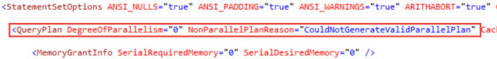

Garbagio

There’s a short list of possible reasons for plans not going parallel [here](http://brentozar.us2.list-manage1.com/track/click?u=9082566fb63d87be35c0662bc&id=3e9d70a9e9&e=b137e91a2b) from a while back. A quick search didn’t turn up a newer or more complete list.

### Check yourself, etc. and so forth

How do you know if this is happening to you? Here’s a simple query to look at constraint definitions and search them for function names. This query is dumb and ugly, but my wife is staring at me because it’s 5:30 on a Saturday and I’m supposed to be getting ready. If you have a better idea, feel free to share in the comments.

WITH [c1] AS (

SELECT [name] , [definition]

FROM [sys].[check_constraints]

UNION ALL

SELECT [name] , [definition]

FROM [sys].[default_constraints]

)

SELECT *

FROM [c1], [sys].[objects] AS [o]

WHERE [o].[type] IN ('FN', 'TF')

AND [c1].[definition] LIKE '%' + o.[name] + '%'

Thanks for reading!

*To celebrate our five year anniversary, get 50% off our online courses with the coupon code HighFive.* [*Shop now.*](http://brentozar.us2.list-manage.com/track/click?u=9082566fb63d87be35c0662bc&id=52275264a9&e=b137e91a2b)

### [Read the comments.](http://brentozar.us2.list-manage.com/track/click?u=9082566fb63d87be35c0662bc&id=8db9a2b082&e=b137e91a2b)

Brent Ozar says:

## [I’m on the RunAsRadio Podcast](http://brentozar.us2.list-manage.com/track/click?u=9082566fb63d87be35c0662bc&id=92d28d05bd&e=b137e91a2b)

[](http://brentozar.us2.list-manage1.com/track/click?u=9082566fb63d87be35c0662bc&id=f9d2ffd73f&e=b137e91a2b)

Pixelated for your pleasure

It’s always fun to talk to Richard Campbell about what’s going on, and this time around, it’s SQL Server 2016:

[Listen to me chat with Richard about what’s coming in vNext.](http://brentozar.us2.list-manage1.com/track/click?u=9082566fb63d87be35c0662bc&id=02f580bf9c&e=b137e91a2b)

We’re now in the second quarter of the year, and we still don’t have pricing, licensing, or edition/feature lists. Normally, when you release software, you need to educate users on how to choose the right box, but to do that, you need to train the trainers first. There simply hasn’t been any community guidance available yet on the questions end users – and managers – ask the most: how is this thing gonna be licensed?

That means one of two things: either it’s gonna be exactly the same (which doesn’t seem likely, given the crazy number of new features that are going into the boxed product this time around), or it’s gonna be wildly different, and passionate discussions might still be going on.

I think this is the best release since 2005. Granted, there’s still a couple of massive problems – for example, CHECKDB simply skips In-Memory OLTP and stretch tables, so I think you’d have to be an outright idiot to deploy either of those features on data you care about. Don’t think you care about the data? Remember, if there’s any corruption in your Hekaton tables, your entire database doesn’t start up. [None of your other tables are accessible](http://brentozar.us2.list-manage.com/track/click?u=9082566fb63d87be35c0662bc&id=1056e276c9&e=b137e91a2b), and you have to restore from your last full backup plus your transaction logs. (You were taking those, right?)

But aside from that, SQL Server 2016 is fantastic, and in the podcast with Richard, we talk about Query Store, AlwaysEncrypted, the run to the cloud, and more. Enjoy!

*To celebrate our five year anniversary, get 50% off our online courses with the coupon code HighFive.* [*Shop now.*](http://brentozar.us2.list-manage1.com/track/click?u=9082566fb63d87be35c0662bc&id=e464dea8b7&e=b137e91a2b)

### [Read the comments.](http://brentozar.us2.list-manage2.com/track/click?u=9082566fb63d87be35c0662bc&id=36504f15e4&e=b137e91a2b)

Brent Ozar says:

## [For Technical Interviews, Don’t Ask Questions. Show Screenshots.](http://brentozar.us2.list-manage.com/track/click?u=9082566fb63d87be35c0662bc&id=40e98c8849&e=b137e91a2b)

When you’re hiring a DBA, sysadmin, or developer, you’re not paying them to answer Trivial Pursuit questions all day long.

You’re hiring them to look at a screen, connect a few dots, and interpret what’s happening.

So for a position, I build a PowerPoint deck with a bunch of screenshots from the actual environment they’ll be working in. I start the deck by explaining that there’s no right or wrong answers – I just want to hear them think out loud about what they’re seeing.

For example, I’ll show a database administrator or developer this:

[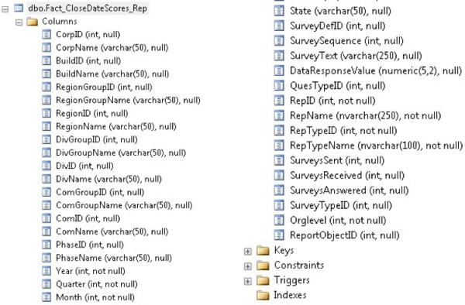](http://brentozar.us2.list-manage1.com/track/click?u=9082566fb63d87be35c0662bc&id=100bb01566&e=b137e91a2b)

Tell me what you see in this ink blot.

Typical reactions include things like:

* **“Oh, that’s a fact table.”** – What does that mean? Where have you seen a fact table before? How do you handle them differently than other kinds of tables?
* **“It seems really wide.”** – What does that mean? Are there strengths or challenges with wide tables? How many columns should a table have?
* **“The fields are mostly nullable.”** – Is that the default? How do fields end up that way? What would you recommend changing? How might it break things, and how would you check to see if they were going to break? Would end users notice the impact of your changes?
* **“It isn’t normalized – it has both IDs and names.”** – What kinds of tables might have that design pattern? What would be the performance impact of this design?

Whenever they say anything out loud, follow the thought. Don’t assume that they believe the same thing you do – ask open-ended questions to get them to explain what they know.

Let them talk until they’re silent for several seconds, and that’s their normal knowledge base. Resist the temptation to make suggestions like, “Did you notice how there doesn’t seem to be a clustered index?” If they don’t notice it, they don’t notice it – that’s your sign.

Another example – I’ll say, “Someone brought this query to you and complained that it’s slow. Where might you look for improvements?”

[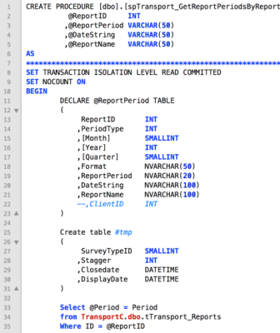](http://brentozar.us2.list-manage.com/track/click?u=9082566fb63d87be35c0662bc&id=b5cbc0b717&e=b137e91a2b)

The query is abridged, but even just in that first screenshot, I want to hear their thought process around where they look, how they might run the query to check its effects, how to measure their work.

In your own interviewing, try to use real screenshots from your own environment. Show them the kinds of screens that they’re going to have to look at independently in their day-to-day work, and just let them brain dump about what they’re seeing.

Hearing their thought process is way more valuable than playing Trivial Pursuit.

*To celebrate our five year anniversary, get 50% off our online courses with the coupon code HighFive.* [*Shop now.*](http://brentozar.us2.list-manage1.com/track/click?u=9082566fb63d87be35c0662bc&id=a3beddf717&e=b137e91a2b)

[**Read the comments.**](http://brentozar.us2.list-manage.com/track/click?u=9082566fb63d87be35c0662bc&id=180da3d1c5&e=b137e91a2b)