**Attach Sample Database - Adventureworks in SQL Server 2012**

By: [Rajendra Gupta](https://www.mssqltips.com/sqlserverauthor/72/rajendra-gupta/)

FROM: https://www.mssqltips.com/sqlservertip/2638/attach-sample-database--adventureworks-in-sql-server-2012/

**Problem**

The sample database AdventureWorks plays an important role while performing test operations and learning about new features. So after the installation of SQL Server 2012 and searching for the sample database AdventureWorks I found that it contains only the "mdf" file to download.  This tip gives you the steps you need to follow to install the sample database with only the data (mdf) file.

**Solution**

First of all, download the AdventureWorks for SQL Server 2012 from this Microsoft link: [Download Adventure Works for SQL Server 2012](http://msftdbprodsamples.codeplex.com/releases/view/55330#DownloadId=165399) (Notice that the download only contains the mdf file).

Attach Using SSMS

I tried to attach the database using SQL Server Management Studio as follows:

Right Click on Databases > Attach and click Add... > select the AdventureWorks mdf file.

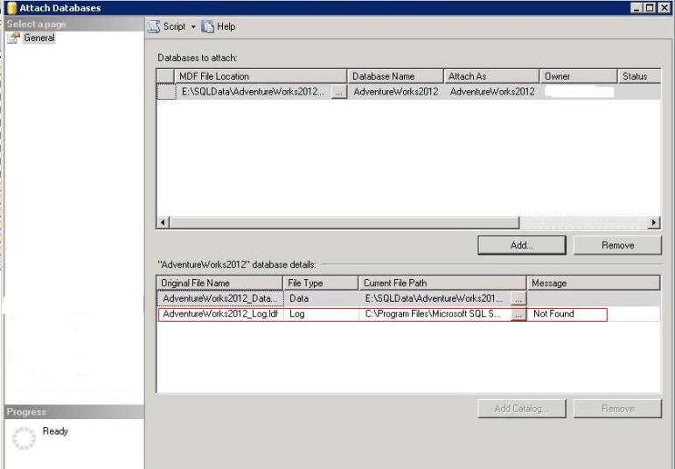

Notice the message above in front of log file **"Not Found"**. However if I click on OK to proceed with the attach database I get the following error.

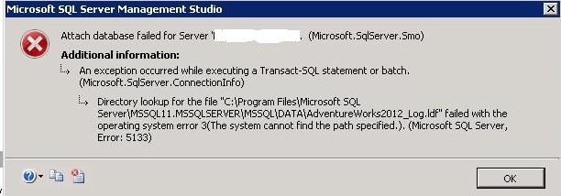

By using SQL Server Management Studio we cannot simply attach the sample database "AdventureWorks" without the log file.  What we need to do is to delete the log file from the attach database.

To do this, select the log file which is showing as "Not Found" as seen below.

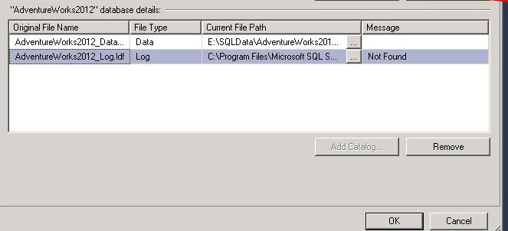

Select the log file and remove the log file by clicking on the Remove button.  The attach now only contains the MDF as shown below. Click OK to attach the database and this should work.

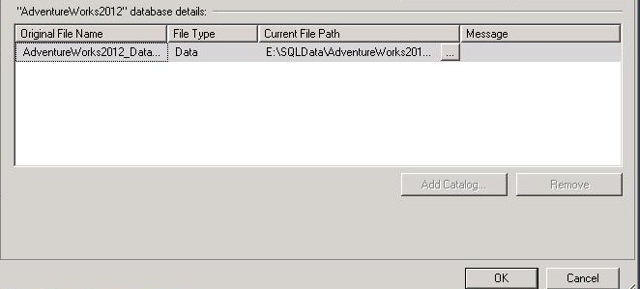

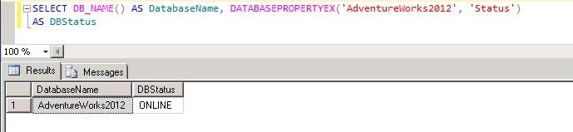

Using T-SQL to Attach the Database

To attach a database without the log file we need to use the Attach_Rebuild_Log option.

The **ATTACH_REBUILD_LOG** specifies that the database is created by attaching an existing set of operating system files. If one or more transaction log files are missing, the log file is rebuilt using this command. The ATTACH_REBUILD_LOG automatically creates a new, 1-MB log file and this file is placed in the default log file location.

So the command would be:

CREATE DATABASE AdventureWorks2012_Data

ON (FILENAME = N'E:\SQLData\AdventureWorks2012_Data.mdf')

FOR ATTACH_REBUILD_LOG

Go

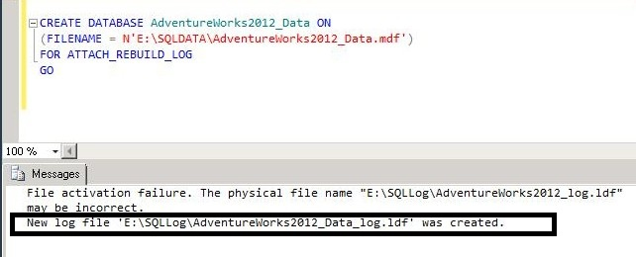

As the screenshot above shows SQL Server created a new log file for the database.

In order to use the **ATTACH_REBUILD_LOG** this requires the following:

* A clean shutdown of the database
* All data files (MDF and NDF) must be available

Verify Logical and Physical Integrity of Database

Once we have the database attached, we can check the logical and physical integrity of all the objects within the database by executing a DBCC CHECKDB.

DBCC CHECKDB ('AdventureWorks2012_Data')

GO

**Next Steps**

* Download the AdvertureWorks database and use it to test some of the new features in SQL Server 2012
* Review these other [SQL Server 2012 Tips](https://www.mssqltips.com/sql-server-tip-category/117/sql-server-2012/)

Last Update: 5/14/2012

[**View all my tips**](https://www.mssqltips.com/sqlserverauthor/72/rajendra-gupta/)

|  |  |
| --- | --- |
| **Saturday, October 15, 2016 - 3:54:57 AM - Dres** | [Back To Top](https://www.mssqltips.com/sqlservertip/2638/attach-sample-database--adventureworks-in-sql-server-2012/#top) |
| Thank you for the step-by-step... it worked! | |

|  |  |
| --- | --- |
| **Saturday, October 08, 2016 - 11:04:10 AM - kumar sunny** | [Back To Top](https://www.mssqltips.com/sqlservertip/2638/attach-sample-database--adventureworks-in-sql-server-2012/#top) |
| thnaks sir...its absolutely working | |

|  |  |
| --- | --- |
| **Thursday, September 15, 2016 - 3:34:26 AM - Uchendu Korieocha** | [Back To Top](https://www.mssqltips.com/sqlservertip/2638/attach-sample-database--adventureworks-in-sql-server-2012/#top) |
| Thanks for this brief tutorial and the good comments below. i was able to attach the AdventureWorksDW_2012 database by running SSMS as an administrator. this works perfect. | |

|  |  |
| --- | --- |
| **Monday, June 20, 2016 - 3:44:03 AM - Daniel Waduka** | [Back To Top](https://www.mssqltips.com/sqlservertip/2638/attach-sample-database--adventureworks-in-sql-server-2012/#top) |
| Thank you very much. I was really stuck at this point. | |

|  |  |
| --- | --- |
| **Tuesday, May 31, 2016 - 8:23:13 AM - Marvin** | [Back To Top](https://www.mssqltips.com/sqlservertip/2638/attach-sample-database--adventureworks-in-sql-server-2012/#top) |
| You can also run SSMS as an administrator, and try to attach the .mdf file adain it should work.    Regards | |

|  |  |
| --- | --- |
| **Friday, April 08, 2016 - 8:24:09 AM - Zsolt** | [Back To Top](https://www.mssqltips.com/sqlservertip/2638/attach-sample-database--adventureworks-in-sql-server-2012/#top) |
| Thanks Rajendra for sharing. It's working on Microsoft SQL Server Express (64-bit) Ver:12.0.2269.0 | |

|  |  |
| --- | --- |
| **Friday, April 08, 2016 - 4:49:42 AM - Gideon** | [Back To Top](https://www.mssqltips.com/sqlservertip/2638/attach-sample-database--adventureworks-in-sql-server-2012/#top) |
| This really did solve the issue. Thanks. | |

|  |  |
| --- | --- |
| **Wednesday, March 23, 2016 - 2:44:32 AM - viswa** | [Back To Top](https://www.mssqltips.com/sqlservertip/2638/attach-sample-database--adventureworks-in-sql-server-2012/#top) |
| Thanks Rajendra for sharing    It is working in Microsoft Sql server 2012 But where as in MS SQL Server 2005 iam not able to add the .MDF File.  Is there any alternate procedure. | |

|  |  |
| --- | --- |
| **Saturday, October 24, 2015 - 4:33:34 AM - Paul McKillop** | [Back To Top](https://www.mssqltips.com/sqlservertip/2638/attach-sample-database--adventureworks-in-sql-server-2012/#top) |
| Thanks Rajendra. Asimple, straightforward explanation at last. | |

|  |  |
| --- | --- |
| **Thursday, September 10, 2015 - 11:15:17 AM - Sheila** | [Back To Top](https://www.mssqltips.com/sqlservertip/2638/attach-sample-database--adventureworks-in-sql-server-2012/#top) |
| Thank you for this well described method for integrating AdventureWorks into the SQL Server Management program. | |

|  |  |
| --- | --- |
| **Tuesday, June 23, 2015 - 3:17:38 AM - Prashant Gupta** | [Back To Top](https://www.mssqltips.com/sqlservertip/2638/attach-sample-database--adventureworks-in-sql-server-2012/#top) |
| Thanks for sharing | |

|  |  |
| --- | --- |
| **Friday, April 03, 2015 - 11:33:44 PM - RobertQ** | [Back To Top](https://www.mssqltips.com/sqlservertip/2638/attach-sample-database--adventureworks-in-sql-server-2012/#top) |
| Thanks for the tip! it did solve my problem. | |

|  |  |
| --- | --- |
| **Thursday, January 15, 2015 - 1:08:21 AM - rosemary** | [Back To Top](https://www.mssqltips.com/sqlservertip/2638/attach-sample-database--adventureworks-in-sql-server-2012/#top) |
| This tip was very useful me. Thanks!!!  Rosemary | |

|  |  |
| --- | --- |
| **Monday, January 12, 2015 - 2:20:06 AM - rajendra** | [Back To Top](https://www.mssqltips.com/sqlservertip/2638/attach-sample-database--adventureworks-in-sql-server-2012/#top) |
| what is the error you are getting? | |

|  |  |
| --- | --- |
| **Saturday, January 10, 2015 - 5:17:32 AM - ali** | [Back To Top](https://www.mssqltips.com/sqlservertip/2638/attach-sample-database--adventureworks-in-sql-server-2012/#top) |
| hi,  I have installed the SQL Server 2012, when i am attaching the sample database, there is a log file and even if remove the log file the database is not going to be attached, can you pelase help me to solve this problem.  thanks  ali | |

|  |  |
| --- | --- |
| **Tuesday, October 07, 2014 - 12:55:54 PM - koti** | [Back To Top](https://www.mssqltips.com/sqlservertip/2638/attach-sample-database--adventureworks-in-sql-server-2012/#top) |
| Hi friends,   when I attached adventureworks database 2012 the below error occured.please suggest right path    An error occurred when attaching the database(s).  Click the hyperlink in the Message column for details. | |

|  |  |
| --- | --- |
| **Thursday, October 02, 2014 - 5:46:42 AM - Arni Aravind** | [Back To Top](https://www.mssqltips.com/sqlservertip/2638/attach-sample-database--adventureworks-in-sql-server-2012/#top) |
| Hi Dave ,  Thank you for the post. SOLVED my pblm. | |

|  |  |
| --- | --- |
| **Thursday, August 07, 2014 - 5:27:45 PM - Bishop** | [Back To Top](https://www.mssqltips.com/sqlservertip/2638/attach-sample-database--adventureworks-in-sql-server-2012/#top) |
| To Peter:  CREATE FILE encountered operating system error 5(Access is denied.) while attempting to open or create the physical file 'C:\Program Files\Microsoft SQL Server\AdventureWorks2012_Data_log.ldf'.  Right click C:\Program Files\Microsoft SQL Server\MSSQL11.SQLEXPRESS\MSSQL\DATA  Go to Security tab. Add your account and make sure EVERYTHING is checked:  Full Control  Modify  Read & Execute  List folder | |

|  |  |
| --- | --- |
| **Tuesday, July 01, 2014 - 3:33:45 PM - Dante Quaglietta** | [Back To Top](https://www.mssqltips.com/sqlservertip/2638/attach-sample-database--adventureworks-in-sql-server-2012/#top) |
| Hi, your tip work ! Thank you very much | |

|  |  |
| --- | --- |
| **Thursday, June 12, 2014 - 9:03:18 AM - Dmitriy** | [Back To Top](https://www.mssqltips.com/sqlservertip/2638/attach-sample-database--adventureworks-in-sql-server-2012/#top) |
| Thanks so much! You're the best! I could not figure it out for two days! You're the savior! | |

|  |  |
| --- | --- |
| **Thursday, February 20, 2014 - 10:59:27 AM - Peter** | [Back To Top](https://www.mssqltips.com/sqlservertip/2638/attach-sample-database--adventureworks-in-sql-server-2012/#top) |
| CREATE FILE encountered operating system error 5(Access is denied.) while attempting to open or create the physical file 'C:\Program Files\Microsoft SQL Server\AdventureWorks2012_Data_log.ldf'. Could not open new database 'AdventureWorks2012'. CREATE DATABASE is aborted. File activation failure. The physical file name "C:\Program Files\Microsoft SQL Server\MSSQL11.MSSQLSERVER\MSSQL\DATA\AdventureWorks2012_Log.ldf" may be incorrect. (Microsoft SQL Server, Error: 5123)    I received the error above and cannot get the database to attach. I am logged in as an administrator and have ensured I has rights to everything. I am trying to teach myself SQL Server 2012 but can't even get past this first step. Any help would be much appreciated. Thank you! | |

|  |  |
| --- | --- |
| **Friday, July 05, 2013 - 4:42:42 AM - Tebo** | [Back To Top](https://www.mssqltips.com/sqlservertip/2638/attach-sample-database--adventureworks-in-sql-server-2012/#top) |
| Hi    This wa huge help to me....:) | |

|  |  |
| --- | --- |
| **Thursday, May 02, 2013 - 9:07:35 PM - Michael Pomeroy** | [Back To Top](https://www.mssqltips.com/sqlservertip/2638/attach-sample-database--adventureworks-in-sql-server-2012/#top) |
| Thank you for the info on how to connect the sample database. I was working with a book and was totally lost until I found you info,  Very clear and simple.   -Thanks | |

|  |  |
| --- | --- |
| **Friday, March 22, 2013 - 12:16:56 PM - mohsen** | [Back To Top](https://www.mssqltips.com/sqlservertip/2638/attach-sample-database--adventureworks-in-sql-server-2012/#top) |
| Thanks. very infprormative and useful. It helped me alot.A simple solution but very critical. | |

|  |  |
| --- | --- |
| **Wednesday, January 23, 2013 - 1:01:36 PM - Joyce C** | [Back To Top](https://www.mssqltips.com/sqlservertip/2638/attach-sample-database--adventureworks-in-sql-server-2012/#top) |
| Just wanted to say thanks for the information regarding Attaching Sample Database - Adventureworks in SQL Server 2012  It was a real time saver. | |

|  |  |
| --- | --- |
| **Wednesday, December 05, 2012 - 3:27:45 AM - Mohsen** | [Back To Top](https://www.mssqltips.com/sqlservertip/2638/attach-sample-database--adventureworks-in-sql-server-2012/#top) |
| File activation failure. The physical file name "C:\Program Files\Microsoft SQL Server\MSSQL11.MSSQLSERVER\MSSQL\DATA\AdventureWorks2012_Log.ldf" may be incorrect.    New log file 'D:\AdventureWorks2012_log.ldf' was created.    Converting database 'AdventureWorks2012' from version 705 to the current version 706.    Database 'AdventureWorks2012' running the upgrade step from version 705 to version 706.    Hi  what the meaning of above message , appear when i run your suggested script  thaks | |

|  |  |
| --- | --- |
| **Monday, May 14, 2012 - 9:02:31 AM - Maneesh Bhatt** | [Back To Top](https://www.mssqltips.com/sqlservertip/2638/attach-sample-database--adventureworks-in-sql-server-2012/#top) |
| Nice information ..Thanks | |