**Attach a SQL Server database with a missing transaction log file**

By: [Ashish Kumar Mehta](https://www.mssqltips.com/sqlserverauthor/36/ashish-kumar-mehta/)

**Problem**The development team approached me with an MDF file of a SQL Server database which they wanted to restore on their server. The developer had some very critical and complex stored procedures which were stored in the ProductsDB.MDF file. However, since this database was kept offline; during the disk cleanup unfortunately one of the developers deleted the transaction log file for this database. As this was a development server there were no database backup jobs scheduled. Since, this database was very critical for the development team they wanted to know if there was a way to recover and use this database. In this tip, we will cover how to attach a database that does not have its transaction log files.

**Solution**In this tip, we will go through the steps which need to be performed to recover a database when you only have the MDF file of a SQL Server database. The below steps work in both SQL Server 2005 and SQL Server 2008.

**Using SQL Server Management Studio - Attach a SQL Server Database without a Transactional Log File**

1. Connect to SQL Server 2008 Instance using SQL Server Management Studio

2. In Object Explorer, right click Databases node and select "Attach..." option from the drop down list as shown in the snippet below.

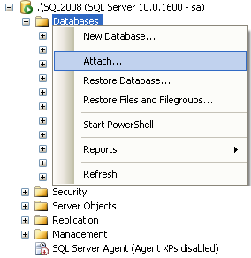

3. This will open up an Attach Databases window as shown in the below snippet.

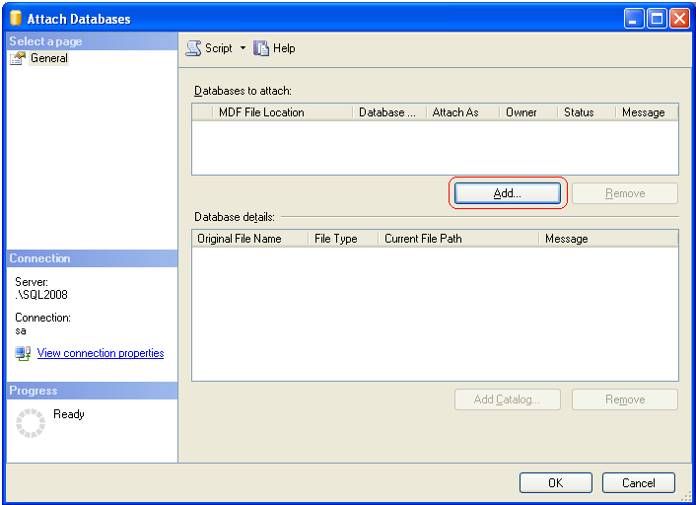

4. In the Attach Databases window click on "Add..." button as highlighted in the above snippet to open the Locate Databases Files window as shown below.

5. In Locate Databases Files window you need to browse and locate the MDF file which is relevant to the database you want to attach and then click OK.  In our example I am using the "ProductsDB.mdf" file.

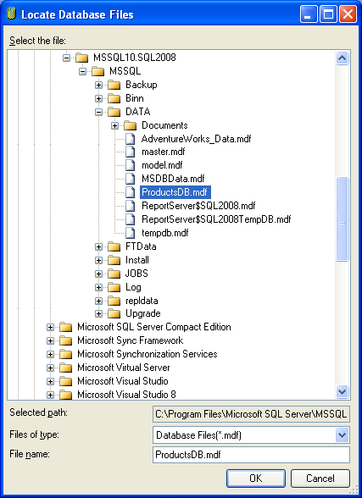

6. In the Attach Databases window; you will see that SQL Server informs us that the log file is not found, in our case the missing file is "ProductsDB_Log.LDF". In order to attach the database without the ProductsDB_Log.LDF transaction log file you need to select the file as highlighted in the below snippet and click the "Remove" button and finally click OK to attach ProductsDB database without the transaction log file.

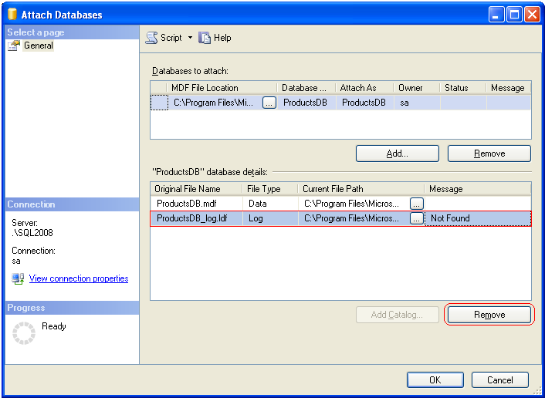

7. That's it you have successfully attached a database without using the transaction log file.  SQL Server will create a new transaction log file for you and will place the file in the same folder as the data file.

**Using T-SQL - Attach a SQL Server Database without a Transaction Log File**

DBAs can also attach a SQL Server database without a transaction log file using the below T-SQL code.

In this first script we are using the CREATE DATABASE with ATTACH option and specifying the name and location of the mdf file that we have for this database.

|  |
| --- |
| USE [master]  GO  CREATE DATABASE [ProductsDB] ON  ( FILENAME = N'C:\Program Files\Microsoft SQL Server\MSSQL10.SQL2008\MSSQL\DATA\ProductsDB.mdf' )  FOR ATTACH  GO |

Once the above T-SQL code has executed successfully you will get the below message which informs you that SQL Server has created a new transaction log file for the database.

|  |
| --- |
| File activation failure. The physical file name "C:\Program Files\Microsoft SQL Server\MSSQL10.SQL2008\MSSQL\DATA\ProductsDB_log.ldf" may be incorrect.  New log file 'C:\Program Files\Microsoft SQL Server\MSSQL10.SQL2008\MSSQL\DATA\ProductsDB_log.LDF' was created. |

**Verify Logical and Physical Integrity of Database**

DBAs can check the logical and physical integrity of all the objects within the database by executing a DBCC CHECKDB.  In our case we are using the "ProductsDB" database.

|  |
| --- |
| DBCC CHECKDB ('ProductsDB')  GO |

**Next Steps**

* If your database has multiple data files you can use this approach as well to create a new transaction log file.
* If your database had multiple transaction log files look at using the ATTACH_REBUILD_LOG option with the CREATE DATABASE command
* If you loose one of your data files for a database you can not use this approach.  This will only rebuild a new transaction log file for you it does not recreate data files.
* Refer to these other [Database Administrator tips](https://www.mssqltips.com/category.asp?catid=60)

Last Update: 12/7/2009

[**View all my tips**](https://www.mssqltips.com/sqlserverauthor/36/ashish-kumar-mehta/)

|  |  |
| --- | --- |
| **Wednesday, August 19, 2015 - 9:11:15 PM - bala** | [Back To Top](https://www.mssqltips.com/sqlservertip/1894/attach-a-sql-server-database-with-a-missing-transaction-log-file/#top) |
| Excellent i never expect. very very very very usefull thanks a lot | |

|  |  |
| --- | --- |
| **Wednesday, December 10, 2014 - 12:37:51 PM - Shane** | [Back To Top](https://www.mssqltips.com/sqlservertip/1894/attach-a-sql-server-database-with-a-missing-transaction-log-file/#top) |
| Thank you! | |

|  |  |
| --- | --- |
| **Tuesday, June 24, 2014 - 10:45:03 AM - nagesh** | [Back To Top](https://www.mssqltips.com/sqlservertip/1894/attach-a-sql-server-database-with-a-missing-transaction-log-file/#top) |
| Dear Author and all,  While attaching a database which contains 16 mdf and 4ldf files, iam facing the below errors. as per the below error i have tried lot some methods including your article but there is no use. Kindly suggest me to bring back the database.    File activation failure. The physical file name "O:\DBFolder\Testdb_LOG2.ldf" may be incorrect.  The log cannot be rebuilt because the database was not cleanly shut down.  Msg 1813, Level 16, State 2, Line 3  Could not open new database ' Testdb '. CREATE DATABASE is aborted.  Msg 823, Level 24, State 6, Line 3  The operating system returned error 38(Reached the end of the file.) to SQL Server during a read at offset 0000000000000000 in file ' O:\DBFolder\Testdb_LOG2.ldf'. Additional messages in the SQL Server error log and system event log may provide more detail. This is a severe system-level error condition that threatens database integrity and must be corrected immediately. Complete a full database consistency check (DBCC CHECKDB). This error can be caused by many factors; for more information, see SQL Server Books Online.    Thanks in advance,  Nagesh | |

|  |  |
| --- | --- |
| **Tuesday, May 27, 2014 - 5:23:59 AM - elliswhite** | [Back To Top](https://www.mssqltips.com/sqlservertip/1894/attach-a-sql-server-database-with-a-missing-transaction-log-file/#top) |
| Go through this learn how to attach MDF file without LDF file[:- https://www.google.com/search?q=trusted+sql+database+recovery](https://www.google.com/search?q=trusted+sql+database+recovery) | |

|  |  |
| --- | --- |
| **Sunday, February 16, 2014 - 3:26:04 AM - Rahul** | [Back To Top](https://www.mssqltips.com/sqlservertip/1894/attach-a-sql-server-database-with-a-missing-transaction-log-file/#top) |
| Set Database to offline state, Dettach the database and then re-attach the database. Check your DATA file...you will find a .LDF file :) | |

|  |  |
| --- | --- |
| **Friday, February 14, 2014 - 4:53:39 AM - SQLSACT** | [Back To Top](https://www.mssqltips.com/sqlservertip/1894/attach-a-sql-server-database-with-a-missing-transaction-log-file/#top) |
| This solution works great if the database was shutdown cleanly, if not then the database will have to be hacked into SQL Server  I believe Gail Shaw has an excellent article that highlights this. | |

|  |  |
| --- | --- |
| **Wednesday, October 02, 2013 - 12:13:38 PM - Bill** | [Back To Top](https://www.mssqltips.com/sqlservertip/1894/attach-a-sql-server-database-with-a-missing-transaction-log-file/#top) |
| Thanks for the article; but what about SQL 2000?  I have this exact problem and was helping a buddy migrate his small business.  They have SQL 2000, and deleted transaction log.  I only have the MDF.  What can I do in sql 2000 SP3? | |

|  |  |
| --- | --- |
| **Tuesday, July 16, 2013 - 7:49:33 AM - Vinay** | [Back To Top](https://www.mssqltips.com/sqlservertip/1894/attach-a-sql-server-database-with-a-missing-transaction-log-file/#top) |
| This article resolved my problem. Thanks. | |

|  |  |
| --- | --- |
| **Saturday, November 17, 2012 - 1:28:33 AM - Arup** | [Back To Top](https://www.mssqltips.com/sqlservertip/1894/attach-a-sql-server-database-with-a-missing-transaction-log-file/#top) |
| File activation failure. The physical file name "E:\ASWEBTECH\SaradaModelDB-2011-2012_log.ldf" may be incorrect.  New log file 'C:\Program Files\Microsoft SQL Server\MSSQL.1\MSSQL\Data\SaradaModelDB_log.LDF' was created.  **Msg 1813, Level 16, State 2, Line 1**  **Could not open new database 'SaradaModelDB'. CREATE DATABASE is aborted.**  **Msg 824, Level 24, State 2, Line 1**  **SQL Server detected a logical consistency-based I/O error: incorrect checksum (expected: 0x66666666; actual: 0x33333333). It occurred during a read of page (1:1202) in database ID 6 at offset 0x00000000964000 in file 'C:\Program Files\Microsoft SQL Server\MSSQL.1\MSSQL\Data\SaradaModelDB.mdf'.  Additional messages in the SQL Server error log or system event log may provide more detail. This is a severe error condition that threatens database integrity and must be corrected immediately. Complete a full database consistency check (DBCC CHECKDB). This error can be caused by many factors; for more information, see SQL Server Books Online.**      Hi have this problem. please help. | |

|  |  |
| --- | --- |
| **Saturday, November 03, 2012 - 3:43:39 AM - Robert Hamill** | [Back To Top](https://www.mssqltips.com/sqlservertip/1894/attach-a-sql-server-database-with-a-missing-transaction-log-file/#top) |
| HI  This is the best site for SQL explanations and troubleshooting I have found.  With this article, you have again saved me hours of research and work  Thank you - keep up good work :)    Bob Hamill | |

|  |  |
| --- | --- |
| **Friday, July 06, 2012 - 7:38:22 AM - Thinus** | [Back To Top](https://www.mssqltips.com/sqlservertip/1894/attach-a-sql-server-database-with-a-missing-transaction-log-file/#top) |
| Hi this is very nice, I have a question if you only have the Log file is it posible to recover the log information if you don't have the .mdf file.    Our It Deleted the .mdf file and I only have the log file it's kind of urgent if their is a way please let me know.    Will be appreciated. | |

|  |  |
| --- | --- |
| **Monday, April 02, 2012 - 3:31:04 AM - Krishnaraj** | [Back To Top](https://www.mssqltips.com/sqlservertip/1894/attach-a-sql-server-database-with-a-missing-transaction-log-file/#top) |
| Above solution will work only in case if DB is cleanly shutdowned else DB server will throw error with message "The log cannot be rebuilt because the database was not cleanly shut down". Please let me know if you have any solution for this problem.  Thank you. | |

|  |  |
| --- | --- |
| **Sunday, March 25, 2012 - 4:41:06 PM - shivrudra** | [Back To Top](https://www.mssqltips.com/sqlservertip/1894/attach-a-sql-server-database-with-a-missing-transaction-log-file/#top) |
| hI,    IF YOU ENCOUNTER ANY PROBLEM OF ACCESS DENIED WHILE ATTACHING SAME START SMS BY RUN AS ADMINISTRATOR AND TRY AGAIN | |

|  |  |
| --- | --- |
| **Thursday, July 28, 2011 - 9:48:47 PM - rodoss** | [Back To Top](https://www.mssqltips.com/sqlservertip/1894/attach-a-sql-server-database-with-a-missing-transaction-log-file/#top) |
| It solved my problem!  Thank you. | |