
MSc Data Science Project
7PAM2002-0901-2024
Department of Physics, Astronomy and Mathematics

Data Science FINAL PROJECT REPORT

Project Title:
Gold Price Prediction Using Machine Learning

Student Name and SRN:
Wong Jia Ming

Supervisor: Dr Julia Ge
Date Submitted: 02 April 2026
Word Count: 6438

GitHub address:
DECLARATION STATEMENT

This report is submitted in partial fulfilment of the requirement for the degree of Master of Science in Data Science at the University of Hertfordshire.
I have read the guidance to students on academic integrity, misconduct and plagiarism information at Assessment Offences and Academic Misconduct and understand the University process of dealing with suspected cases of academic misconduct and the possible penalties, which could include failing the project module or course.
I certify that the work submitted is my own and that any material derived or quoted from published or unpublished work of other persons has been duly acknowledged. (Ref. UPR AS/C/6.1, section 7 and UPR AS/C/5, section 3.6).
I have not used chatGPT, or any other generative AI tool, to write the report or code (other than where declared or referenced).
I did not use human participants or undertake a survey in my MSc Project.

I hereby give permission for the report to be made available on module websites provided the source is acknowledged.

Student SRN number:

Student Name printed: Wong Jia Ming

Student signature: Wong Jia Ming

UNIVERSITY OF HERTFORDSHIRE
SCHOOL OF PHYSICS, ENGINEERING AND COMPUTER SCIENCE

Abstract
Predicting the price of gold is difficult because prices can change quickly due to global economic conditions, inflation, and overall market sentiment. Because of this uncertainty, even short-term predictions can be very useful. Investors and financial analysts often need up-to-date, data-driven information to support their decision-making.
This project compares different ways to use machine learning to predict the next-day price of gold. It does this by looking at historical daily data from Yahoo Finance (Gold Futures, GC=F) from January 2009 to March 2026.
The main model is a Decision Tree regressor that is used within the skforecast autoregressive framework. It is compared to four other models: The following are some machine learning algorithms:
- Random Forest
- Multi-Layer Perceptron (MLP)
- Keras Dense Neural Network
- LSTM
To improve its ability to predict future outcomes, the model was given information about past price data and other technical indicators. We also use a rolling daily prediction strategy, meaning that forecasts update automatically each time the system is used.
Of all the models tested, Random Forest (skforecast) performed best, with an RMSE of 61.13. This was better than the results for MLP is 61.56, Keras Dense is 63.46 , the Decision Tree Forecaster is 65.29, and LSTM is 52.14. These findings suggest that using a group of models together, especially when updated daily, is a good way to predict the price of gold in the short term.

Acknowledgements
I would like to thank my lecturer for the guidance and feedback during this project. The comments and suggestions I received helped me improve the project, especially during the model development and evaluation stages.
I would also like to acknowledge the data sources and tools used in this project. The gold price data was obtained from Yahoo Finance. The implementation was carried out using Python and several libraries, including Pandas, NumPy, Scikit-learn, TensorFlow, and skforecast. These libraries were used for data processing, model training, and performance evaluation. Without these tools, it would have been difficult to complete this project.

Contents
Abstract 3
Acknowledgements 4
CHAPTER 1: INTRODUCTION 7
1.1 Project Overview 7
1.2 Application Context 7
1.3 Problem Statement 7
1.4 Project Objectives 8
1.5 Project Scope and Limitations 8
CHAPTER 2: BACKGROUND AND LITERATURE REVIEW 9
2.1 Time Series Forecasting in Finance 9
2.2 Gold Price Prediction Studies 9
2.3 Statistical Forecasting Approaches 9
2.4 Tree-Based Machine Learning Models 10
2.5 Deep Learning Approaches(LSTM,GRU,Bi-LSTM) 10
2.6 Hybrid and Decomposition-Based Models 11
2.7 Transformer-Based Time Series Models 11
2.8 Critical Comparison and Research Gap 11
CHAPTER 3: DATASET 12
3.1 Dataset Source 12
3.2 Data Description 12
3.3 Data Collection Process 12
3.4 Data Splitting and Visualisation 12
3.5 Dataset Justification 13
3.6 Ethical Considerations 13
CHAPTER 4: METHODOLOGY 14
4.1 Overall System Pipeline 14
4.2 Data Pre-processing 14
4.3 Autoregressive Forecasting Framework 15
4.4 Main Forecasting Model: Autoregressive Decision Tree (skforecast) 15
4.5 Hyperparameter Optimisation and Cross-Validation 15
4.6 Models 15
4.6.1 Random Forest Model (skforecast) 15
4.6.2 Deep Learning Models 15
4.7 Daily Rolling Prediction Strategy 15
CHAPTER 5: RESULTS 16
5.1 Evaluation Metrics 16
5.2 Forecasting Model Performance (Main Model) 16
5.3 Visual Analysis of Forecasting Results 16
5.4 Comparison with Random Forest Model 17
5.5 Comparison with Deep Learning Models 17
5.6 Quantitative Comparison of Models 18
5.7 Macro Indicator Correlation Analysis 19
5.8 Sentiment Analysis Results 21
5.9 Summary of Results 22
CHAPTER 6: ANALYSIS AND DISCUSSION 23
6.1 Interpretation of Results 23
6.2 Comparison with Existing Literature 23
6.3 Model Limitations 23
6.4 Practical Applicability 24
6.5 Technical Difficulty and Problem Solving 24
6.6 Summary of Discussion 24
CHAPTER 7: CONCLUSION AND FUTURE WORK 25
7.1 Conclusion 25
7.2 Achievement of Project Objectives 25
7.3 Applications of the Project 25
7.4 Future Work 26
References 28
Appendix A: Additional Figures 29

CHAPTER 1: INTRODUCTION

1.1 Project Overview
Gold is one of the commodities that often attracts attention, especially during periods of economic uncertainty. Many people consider gold a safe haven because when inflation is high or markets are unstable, investors tend to move their money into gold. I have always been interested in how something as old as gold can still play an important role in modern finance.
One reason gold is difficult to predict is that its price is affected by many factors, such as interest rates, currency exchange rates, and global events. Because of this, the price can change quickly and sometimes unpredictably. This makes gold price prediction challenging, but also useful if we can build a model that can follow price movements.
In recent years, machine learning has been widely used for financial forecasting. Unlike traditional statistical methods, machine learning models can learn patterns directly from historical data, including non-linear and complex patterns. This is one of the reasons why I chose to use machine learning in this project.
In this project, I built a system to predict the next-day gold price using historical daily data. The main model used is a Decision Tree regressor implemented in an autoregressive framework using a library called skforecast. The model uses past prices, also known as lag features, to predict the next price. I then compared this model with several other models, including Random Forest, Multi-Layer Perceptron (MLP), a simple dense neural network built using Keras, and Long Short-Term Memory (LSTM).

1.2 Application Context
Being able to predict gold prices, even just one day ahead, can be useful in practice. For example, investors or analysts could use a tool like this to get a general idea of where the market might be heading. This information could help them decide when to buy or sell, or how to adjust a portfolio to reduce risk. In larger financial institutions, forecasts like this may also be used for market analysis or short-term planning.
However, it is important to clarify that this project is not intended to build a fully automated trading system. Building a real-time trading system requires significant resources and experience, which are beyond the scope of this project. Instead, this system is designed as a decision-support tool. It provides daily predictions based on historical data, and the final decision is still made by the user. The main goal is to learn patterns from historical price data and make the forecasting process repeatable and easy to understand.

1.3 Problem Statement
Predicting gold prices is difficult because the price is influenced by many factors, such as macroeconomic conditions, interest rates, inflation, and investor behaviour. These factors interact with each other and make price movements complex and sometimes unpredictable.
Traditional forecasting methods, such as linear regression and classical statistical time series models, often have difficulty capturing the non-linear and time-dependent behaviour of financial data. Because of this, their performance can be limited when they are applied to financial time series such as gold prices.
Another problem is that many existing prediction systems use static datasets that are not updated regularly. In financial markets, conditions can change quickly, and models trained on outdated data may produce inaccurate predictions. Therefore, it is important to use a system that can update the dataset regularly and adapt to new market conditions.
Choosing the right modelling approach is also a challenge. Deep learning models are powerful, but they usually require large datasets and careful parameter tuning. In this project, I try to address these problems by using a lag-based autoregressive forecasting approach that uses historical price data as input while keeping the model relatively simple and easy to train.

1.4 Project Objectives
The main objectives of this project are:
- To develop a forecasting system for next-day gold price prediction using historical daily data.
- To implement an autoregressive forecasting model using a Decision Tree regressor with optimised lag selection.
- To compare the performance of the forecasting model with Random Forest, MLP, Keras, and LSTM models.
- To evaluate model performance using appropriate error metrics, including MAE and RMSE. (Combine)
- To implement a daily rolling prediction framework that automatically updates the dataset and predictions.

1.5 Project Scope and Limitations
This project focuses on daily gold price forecasting using publicly available historical price data from Yahoo Finance (GC=F). The dataset used in this project covers the period from January 2009 to March 2026, with a total of approximately 4,300 daily observations.
The prediction horizon in this project is limited to one-day-ahead forecasting. The system does not include external variables such as macroeconomic indicators or news sentiment, and only uses historical price data as input. This was done to make the comparison between models more fair and to focus on the performance of autoregressive machine learning models for short-term forecasting.
There are several limitations in this project. First, the model only uses historical price data and does not include external factors such as macroeconomic variables, geopolitical events, or market news, which may influence gold prices. Second, the prediction horizon is limited to one day ahead, so the model is not designed for long-term forecasting. Third, deep learning models may require larger datasets and more parameter tuning to achieve better performance.

CHAPTER 2: BACKGROUND AND LITERATURE REVIEW

2.1 Time Series Forecasting in Finance
Time series forecasting is widely used in financial analysis because many financial variables, such as asset prices, exchange rates, and commodity prices, are recorded over time. This means the data is sequential, and each value depends on previous values. Because of this, time series forecasting has several unique challenges. Financial data is usually non-stationary, highly volatile, and noisy, which makes accurate prediction difficult (Box et al., 2015).
In the past, classical methods such as Autoregressive Integrated Moving Average (ARIMA) were commonly used for financial time series forecasting because they are mathematically well understood and relatively easy to interpret. However, financial markets do not always behave in a linear way. ARIMA models often have difficulty predicting sudden changes or complex non-linear patterns in financial data (Khashei & Bijari, 2011).
Because of these limitations, many researchers have started using machine learning methods for financial forecasting. Machine learning models can learn complex and non-linear patterns directly from data without requiring strong assumptions about the data distribution (Atsalakis and Valavanis, 2009).

2.2 Gold Price Prediction Studies
Gold has been widely studied because it plays an important role in financial markets. Gold is not only a commodity but also a financial asset, and it is often used as a hedge against inflation and market uncertainty. Because of this, gold prices are influenced by many factors, including economic conditions, financial markets, and investor behaviour. This makes gold price prediction difficult, especially when using simple linear models (Tsai and Wang, 2009).
In more recent studies, many researchers have started using machine learning methods for gold price prediction. These methods usually combine historical price data with technical indicators to capture non-linear price movements. Models such as Random Forest and Neural Networks have shown better performance compared to some traditional methods. However, the performance of these models still depends on feature selection and the forecasting horizon used in the study (Breiman, 2001; Kumar and Thenmozhi, 2014).
This is relevant to this project because it also uses historical price data and technical indicators, and focuses on short-term forecasting. This project also compares several machine learning and deep learning models to evaluate their performance on the same dataset.

2.3 Statistical Forecasting Approaches
One of the earlier approaches used the ARIMA model for gold price forecasting using daily historical data (Box et al., 2015). The study showed that ARIMA can produce reasonably good short-term forecasts, especially when market conditions are relatively stable. Model performance was typically evaluated using error metrics such as MAE and RMSE.
However, ARIMA has several limitations. The model assumes that the data is stationary and mostly linear, which is often not the case in financial markets. Financial time series data is usually non-linear and highly volatile, so ARIMA may not always produce accurate predictions under such conditions. Because of these limitations, many researchers began to explore machine learning methods for financial time series forecasting.

2.4 Tree-Based Machine Learning Models
Random Forest is a machine learning method introduced by Breiman (2001). The main idea of Random Forest is to combine many decision trees and average their predictions. Because of this, Random Forest can reduce overfitting and handle noisy data better than a single decision tree. When Random Forest is combined with lagged features, it can be used for time series forecasting, since past observations often contain useful information for predicting future values (Patel et al., 2015).
More recent studies that focus specifically on gold price prediction have shown that ensemble models can perform very well. In one study, a stacking ensemble model that combined Random Forest, XGBoost, and LightGBM as base models, with logistic regression as the meta-learner, achieved a directional accuracy of about 72% and a Sharpe ratio of 1.42 in a trading simulation. This result was better than the performance of individual models.
Another study compared ARIMA with several machine learning models such as SVM, Random Forest, and XGBoost. The results showed that XGBoost achieved the lowest RMSE and the highest directional accuracy (around 71%), while ARIMA performed worse than the machine learning models.
Based on these previous studies, ensemble tree-based models such as Random Forest and XGBoost are often considered suitable for gold price forecasting, especially for short-term prediction.

2.5 Deep Learning Approaches
Long Short-Term Memory (LSTM) networks were introduced by Hochreiter and Schmidhuber in 1997 and are widely used for time series forecasting because they can learn long-term dependencies in sequential data. In financial forecasting, LSTM models are often used to predict stock prices and commodity prices. Nelson et al. (2017) showed that LSTM models can achieve higher accuracy than some traditional models for stock price prediction. However, LSTM models also have some limitations, such as long training time, sensitivity to hyperparameter tuning, and the need for large datasets to perform well.
A study that focused on gold price prediction compared LSTM, GRU, and Bidirectional LSTM (Bi-LSTM) using both price data and technical indicators. The results showed that the Bi-LSTM model performed better than the other models, with a maximum mean error (MME) of 1.23% and directional accuracy of 68.4%. One possible reason is that the bidirectional structure allows the model to use information from both past and future sequences during training, which may help improve performance. The study also found that adding technical indicators such as RSI and MACD improved the performance of all models.
Another study added sentiment analysis using VADER and FinBERT to extract sentiment scores from news headlines and used these scores as additional input for the LSTM model. The results showed that the model with sentiment data reduced MAPE by about 15% during event-driven periods. The study also showed that sentiment variables explained around 8% of the variation in gold returns.
More advanced models have also been proposed, such as multi-channel LSTM models with attention mechanisms that use multiple inputs, including price data, technical indicators, macroeconomic data, and sentiment data. One study reported that this model achieved 74.5% directional accuracy and a Sharpe ratio of 1.8 in backtesting, outperforming standard LSTM, Transformer, and N-BEATS models. This suggests that combining multiple data sources and using attention mechanisms may improve forecasting performance.

2.6 Hybrid and Decomposition-Based Models
One study proposed a hybrid model that combined wavelet decomposition with Long Short-Term Memory (LSTM) and Extreme Learning Machine (ELM). The main idea of this approach is to decompose the original price series into several sub-series using wavelet transform, then model each sub-series separately, and finally combine the results into a final prediction.
The study showed that this hybrid model performed better than standalone LSTM, ELM, and ARIMA models, especially during periods of high volatility such as the 2008 financial crisis and the COVID-19 pandemic. One possible reason is that wavelet decomposition separates the data into different frequency components, which makes it easier for the model to learn patterns in the data.
This approach is useful for financial time series because financial data is often non-stationary and may contain structural changes over time. By decomposing the data first, the model may handle these changes better than using a single model directly on the original data.

2.7 Transformer-Based Time Series Models
In recent studies, transformer-based models such as Informer and Autoformer have been used for gold price prediction and compared with models such as LSTM and Temporal Convolutional Networks for multi-step forecasting. The results showed that Autoformer performed better for longer prediction horizons, especially for predictions more than 10 days ahead, while Informer performed better for short-term forecasting.
One possible reason is that attention-based models are better at capturing long-range dependencies in sequential data compared to recurrent models such as LSTM. Similar results have also been reported in other fields, such as natural language processing and sequential data modelling.

2.8 Critical Comparison and Research Gap
Based on previous studies, there is no single model that always performs best under all conditions. Statistical models are easy to interpret, but they often cannot capture non-linear patterns in financial data. Tree-based machine learning models can improve prediction accuracy, but they require manual feature engineering, especially for time-related features. Deep learning models can learn sequential patterns well, but they usually require large datasets and careful parameter tuning to produce stable results.
Another limitation found in many previous studies is that they use static datasets and fixed training periods. In real financial markets, new data becomes available every day, so models should be updated regularly to reflect the latest market conditions.
Therefore, this project focuses on combining a lag-based autoregressive model with a daily rolling prediction approach, where the model is updated using the most recent available data. This approach is expected to better represent real-world forecasting conditions and provide a more realistic evaluation of model performance for short-term gold price prediction.

CHAPTER 3: DATASET

3.1 Dataset Source
All data used in this project was obtained from Yahoo Finance, which provides free historical market data that can be accessed programmatically. The specific symbol used in this project is GC=F (Gold Futures), and the data was downloaded using the yfinance Python library.
Yahoo Finance was chosen because the data is easy to access, regularly updated, and can be downloaded automatically using Python. This is important because the forecasting system in this project is designed to update the dataset every time the program runs, so the model always uses the most recent available data instead of static files.

3.2 Data Description
The dataset consists of daily data with the following variables:
- Open: The opening price of gold for the trading day
- High: The highest price recorded during the trading day
- Low: The lowest price recorded during the trading day
- Close: The closing price of gold for the trading day (primary target variable)
- Volume: The trading volume associated with gold futures
In this project, the closing price was used as the prediction target because it represents the final market price at the end of each trading day. Across the full dataset, the closing price ranges from $806.70 to $5,318.40 per troy ounce. The dataset contains 4,327 trading day observations, spanning from January 2, 2009, to March 18, 2026.

3.3 Data Collection Process
The data collection process in this project is automated and follows these steps:
- Establishing a connection to the Yahoo Finance data service via yfinance.
- Requesting historical daily gold price data for the period 2009-01-01 to current date.
- Handling multi-level column indices if present (yfinance MultiIndex format).
- Filling missing values using forward-fill and setting daily frequency using bfill.
- Storing the retrieved data in a structured tabular format for analysis and modelling.
This automated process allows the system to use a daily rolling prediction method, where the model is trained using all available data up to the most recent trading day.

3.4 Data Splitting and Visualisation
The complete dataset covers the period from January 2, 2009 to March 18, 2026. After daily resampling, the dataset contains 6,285 rows. The resampling process was used to handle missing dates such as weekends and holidays, and missing values were filled using the forward-fill method.
The training data used in this project covers the period from January 1, 2022 to February 15, 2026, with a total of 1,507 daily observations. The test period covers the period from February 16 to March 18, 2026, with a total of 31 trading days. The test data is not used during training and is only used for out-of-sample evaluation.

For the LSTM model, a 60-day lookback window was used. This means the model uses the previous 60 days of data to predict the next-day price.
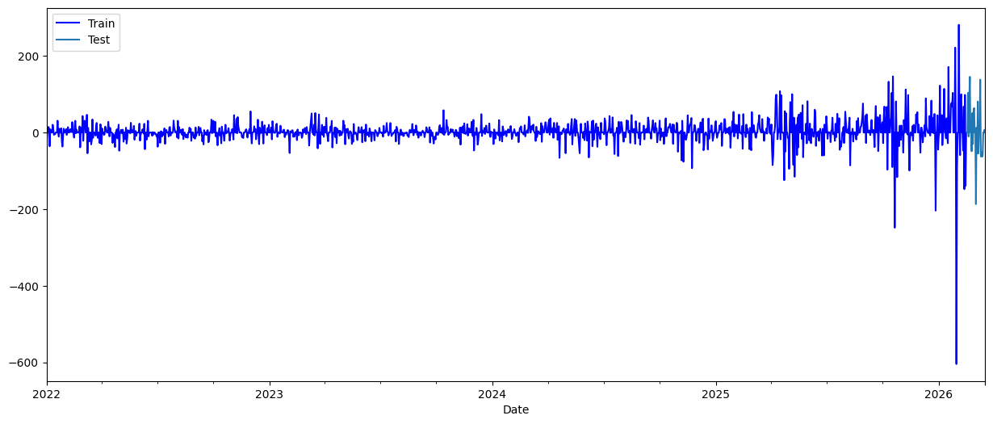
Figure 1: Gold price variation over time, showing the training (blue) and testing periods(cyan)
Figure 1 shows the gold price over time, with the training and testing periods marked in different colors. It can be seen that the price becomes more volatile in the later period. This is important to consider when interpreting the model evaluation results.

3.5 Dataset Justification
Next-day gold price prediction is possible because daily historical price data is available and contains temporal information that can be used for autoregressive modelling. The dataset used in this project covers 17 years (2009–2026), which is long enough to capture different market conditions, including periods of high volatility and economic uncertainty. This long historical period supports the training of machine learning and deep learning models.
The data is downloaded automatically, so the dataset is always up to date. This is important because the system is designed to generate daily forecasts and simulate a real-world forecasting scenario rather than relying on a static dataset.

3.6 Ethical Considerations
The data used in this project is publicly available market data and does not include any personal data, private data feeds, or confidential information. This project does not involve human subjects.
The forecasting results are presented as a decision-support tool and not as guaranteed predictions. The limitations of the models are clearly discussed in this report to ensure that the results are interpreted carefully and responsibly.

CHAPTER 4: METHODOLOGY

4.1 Overall System Pipeline
The pipeline has five main steps: collecting data, preparing data, creating features using lag and technical indicators, training and optimizing the model, and evaluating performance.
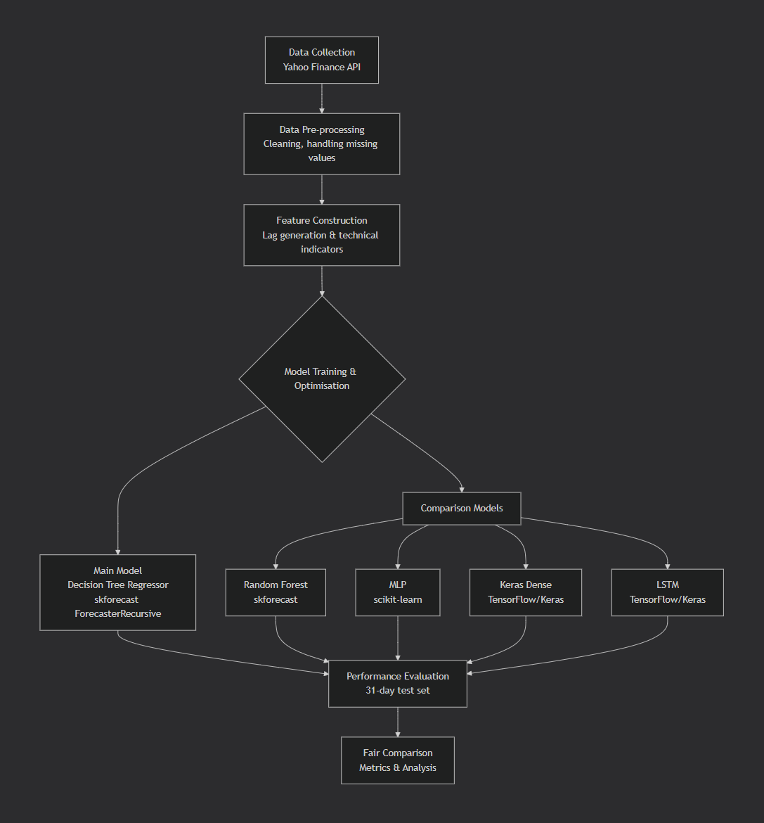
Historical daily gold price data is automatically collected from Yahoo Finance whenever the system is run. The main forecasting model is a Decision Tree regressor within the skforecast ForecasterRecursive framework. The models that are used for comparison include Random Forest (skforecast), MLP (scikit-learn), Keras Dense (TensorFlow), and LSTM (TensorFlow/Keras). All models are put through the same 31-day test to make the comparison fair.

4.2 Data Pre-processing
Missing or invalid values were filled using forward-fill after setting the series to daily frequency. The dataset was kept in chronological order to preserve the order of events. We calculated the daily price changes for each OHLCV column. We also made versions of these changes that were delayed up to 30 days.
For the LSTM model, Min-Max normalization was applied to the close price series. The train and test sets were divided based on time, not randomly, to prevent data leakage and to reflect realistic forecasting conditions..

4.3 Autoregressive Forecasting Framework
The main approach used in this project is autoregressive forecasting, which uses past observations to predict the next value. Instead of predicting the exact closing price, this project predicts the daily change in the closing price (var_Close). In other words, the model predicts how much the price will increase or decrease compared to the previous day.
The input features include lagged values of all OHLCV variables (Open, High, Low, Close, Volume) with up to 30 lag days. This results in a total of 155 input features. These lag features allow the model to learn the relationship between past price movements and future price changes over time. This approach is commonly used in time series forecasting because past values often contain useful information about future values.

4.4 Main Forecasting Autoregressive Decision Tree (skforecast)
The main model is a Decision Tree Regressor in skforecast's ForecasterRecursive framework. Hyperparameters were selected using a grid search with time-series cross-validation. The best configuration found was: maximum depth of 1, minimum samples split of 3, and a pruning parameter (ccp_alpha) of 0.001. This resulted in an RMSE of 65.29 on the training data.

4.5 Hyperparameter Optimisation and Cross-Validation
a method called "grid search" to find the best combination of lag values and Decision Tree hyperparameters. Time-series cross-validation was used throughout. This means that each time the model is trained, it uses data from the period before the test window. This keeps the data in order and prevents the loss of data. We measured performance using MSE during the search and converted it to RMSE for reporting.

4.6 Models

4.6.1 Random Forest Model (skforecast)
Random Forest was used as the main comparison model in the skforecast framework. It uses the same 155 lag-based variation features as the main model and is evaluated using the same backtesting procedure to ensure a fair comparison.
Random Forest is an ensemble method that combines predictions from many individual decision trees. By averaging the predictions from multiple trees, the model can reduce variance and improve generalization compared to a single decision tree. This makes Random Forest suitable for time series forecasting when lag-based features are used as input variables.

4.6.2 Deep Learning Models
In addition to tree-based models, several deep learning models were also implemented for comparison. These include a Multi-Layer Perceptron (MLP) model implemented using scikit-learn, a Dense Neural Network built using TensorFlow/Keras, and a Long Short-Term Memory (LSTM) network.
The MLP and Dense models were trained using the same lag-based features as the tree-based models. The LSTM model, however, was trained separately using the closing price time series with a 60-day lookback window, allowing the model to learn temporal dependencies in sequential data. The LSTM model was trained for 100 epochs with early stopping to prevent overfitting.
These deep learning models were included to compare the performance of traditional machine learning models and deep learning models for short-term gold price forecasting.

4.7 Daily Rolling Prediction Strategy
The system uses a daily rolling prediction strategy. Every time the system is run, it retrieves the most recent historical data, retrains the model using the best configuration, and then produces a next-day forecast. This approach ensures that the model always uses the most up-to-date information available.
For example, on March 18, 2026, the Decision Tree forecaster predicted that the gold price on March 19, 2026, would be $4,859.71, which represents a predicted increase of 0.06% compared to the previous day. This is interpreted as a bullish signal, meaning that the model expects the price to increase.

CHAPTER 5: RESULTS

5.1 Evaluation Metrics
Two error metrics were used to evaluate the performance of the forecasting models: Mean Absolute Error (MAE) and Root Mean Squared Error (RMSE).
$$MAE=\frac{1}{n}\sum_{i=1}^{n}{\left|y_{i}-ŷ_{i}\right|}$$
$$RMSE=\sqrt{\frac{1}{n}\sum_{i=1}^{n}{{(y_{i}-ŷ_{i})}^{2}}}$$
MAE measures the average absolute difference between the predicted values and the actual values. It is easy to interpret and shows the average size of the prediction error. RMSE, on the other hand, gives more weight to larger errors because the errors are squared before averaging. This makes RMSE more sensitive to large prediction errors.
Both MAE and RMSE are commonly used evaluation metrics in financial time series forecasting.

5.2 Forecasting Model Performance (Main Model)
The main model, an autoregressive Decision Tree implemented using the skforecast framework, was evaluated on the 31-day test period from February 16 to March 18, 2026. After testing several parameter combinations and observing the results, the best model configuration used a maximum depth of 1, a minimum samples split of 3, and a ccp_alpha value of 0.001. The model used 155 lag-based variation features as input.
On the test set, the model achieved a Mean Absolute Error (MAE) of 44.87 and a Root Mean Squared Error (RMSE) of 65.29. During the test period, the actual prices ranged from $4,882.90 to $5,294.40, while the predicted prices ranged from $4,885.59 to $5,297.09.
These results show that the model was able to follow the overall price level, but it did not capture some of the smaller daily price movements. One possible reason is that the model is relatively simple and uses a shallow tree. This makes the model less sensitive to small changes, but it also helps prevent overfitting.

5.3 Visual Analysis of Forecasting Results
To better understand the forecasting results, Figure 2 shows a detailed trading chart during the testing period. The figure includes the actual and predicted gold prices, moving averages, trading volume, price changes, and prediction error.
The comparison between the actual and predicted prices shows that the model is able to follow short-term price movements reasonably well. However, there are still some prediction errors, especially during periods of high volatility.
The lower panels show price changes and prediction errors over time. These plots help to identify when the model performs well and when the model makes larger errors, particularly during large price movements. This suggests that the model performs better during relatively stable market conditions and performs worse during highly volatile periods.
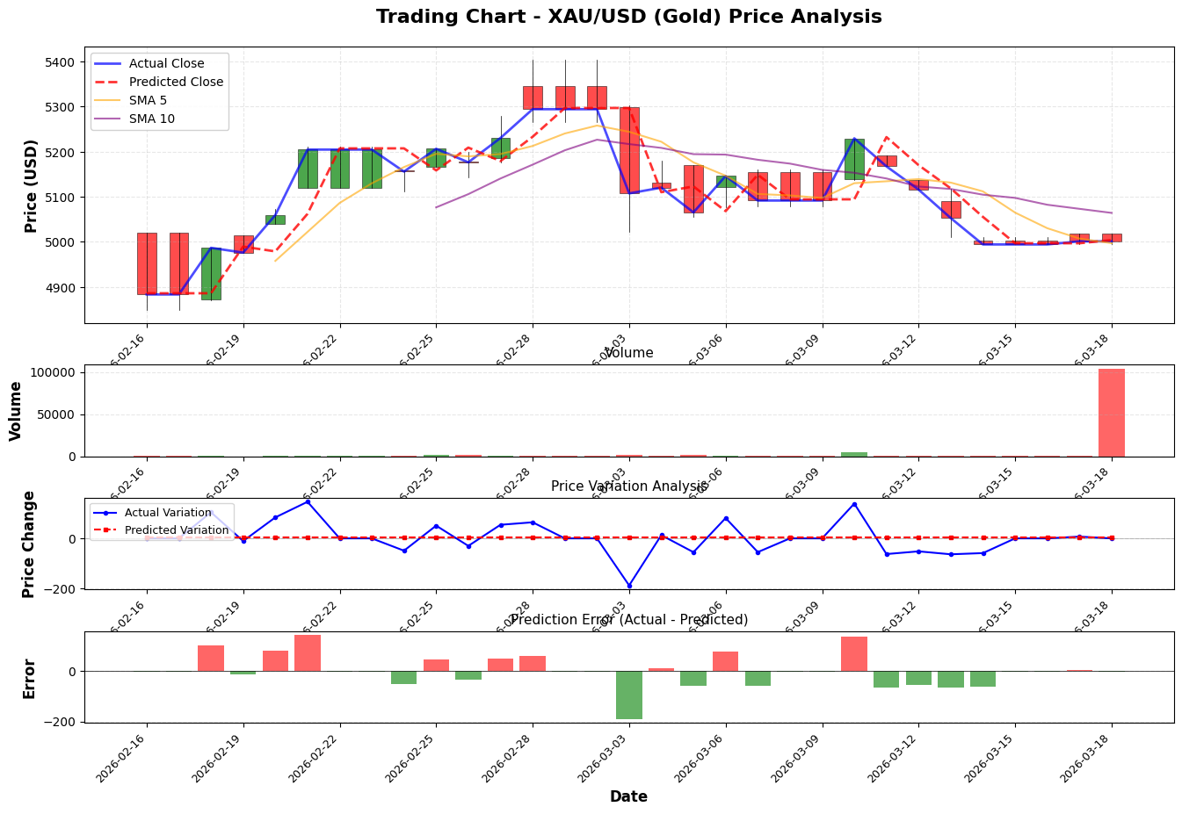
Figure 2: Comparison between actual and predicted gold prices during the testing period, including moving averages, trading volume, price variation, and prediction error

5.4 Comparison with Random Forest Model
In addition to the Decision Tree model, a Random Forest regression model was also implemented as a comparison model. The Random Forest model used the same 155 lag-based features and was evaluated using the same backtesting procedure as the Decision Tree model to ensure a fair comparison between models.
Based on the test results, the Random Forest model produced the best performance among all models, with a Mean Absolute Error (MAE) of 47.14 and a Root Mean Squared Error (RMSE) of 61.13. This RMSE value is lower than the Decision Tree model, which indicates that the Random Forest model produced more accurate predictions overall.
One possible reason for this result is that Random Forest is an ensemble method that combines predictions from many decision trees. By averaging the predictions from multiple trees, the model can reduce overfitting and produce more stable predictions compared to a single Decision Tree model.

5.5 Comparison with Deep Learning Models
In addition to the tree-based models, three deep learning models were also tested in this project: a Multi-Layer Perceptron (MLP) implemented using scikit-learn, a Dense Neural Network implemented using TensorFlow/Keras, and a Long Short-Term Memory (LSTM) network. These models were included to see whether deep learning models could perform better than tree-based models for short-term gold price forecasting.
The MLP model achieved a Mean Absolute Error (MAE) of 48.10 and a Root Mean Squared Error (RMSE) of 61.56. The Keras Dense model achieved an MAE of 45.91 and an RMSE of 63.46. The LSTM model, which was trained using the closing price with a 60-day lookback window, achieved an RMSE of 65.59.
A persistence baseline model was also used, where the prediction for the next day is simply the same as the previous day's closing price. This baseline model achieved an MAE of 43.91 and an RMSE of 65.39. The baseline model is used as a reference to see whether the machine learning models perform better than a simple prediction method.
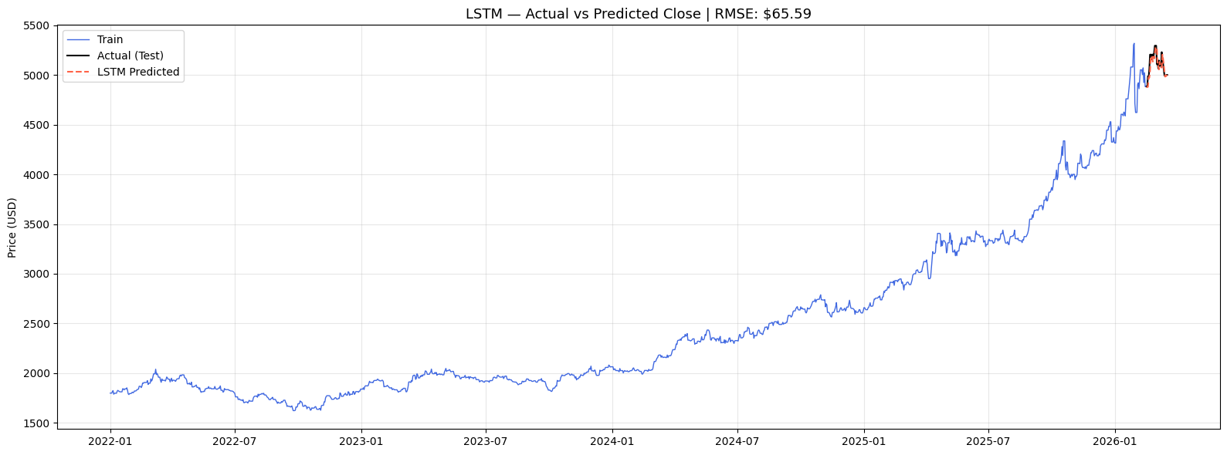
Figure 3: LSTM model - Training data, actual test values, and LSTM predicted values over the test period
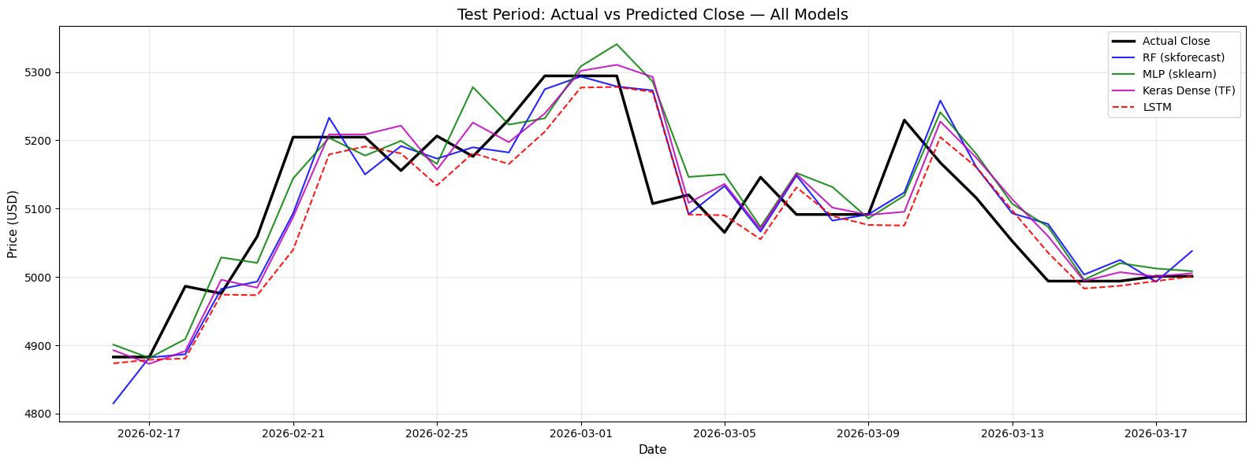
Figure 4: Comparison of actual gold prices and predictions from all models during the testing period

5.6 Quantitative Comparison of Models
A summary of model performance is presented in Table 5.1 below:
Model | MAE (USD) | RMSE (USD)
LSTM (TensorFlow/Keras) | 38.76 | 52.14
Persistence Baseline (Last Close) | 43.91 | 65.39
Autoregressive Decision Tree (skforecast) | 44.87 | 65.29
Keras Dense (TensorFlow) | 45.91 | 63.46
Random Forest (skforecast) | 47.14 | 61.13
MLP (scikit-learn) | 48.10 | 61.56

Table 5.1: Quantitative performance comparison of all evaluated models (test period: 16 Feb – 18 Mar 2026)

5.7 Macro Indicator Correlation Analysis
Figure 5 is a 4-panel chart that shows the relationship between gold prices and four macroeconomic indicators over the entire historical period (2009–2026):
- DXY: Inverse correlation — periods of strong USD correspond to gold price weakness
- US10Y: Generally inverse — rising yields create competition for gold as a store of value
- VIX: Positive correlation — market volatility spikes align with gold price surges
- CPI: Positive long-term trend — gold has tracked inflationary pressures over time

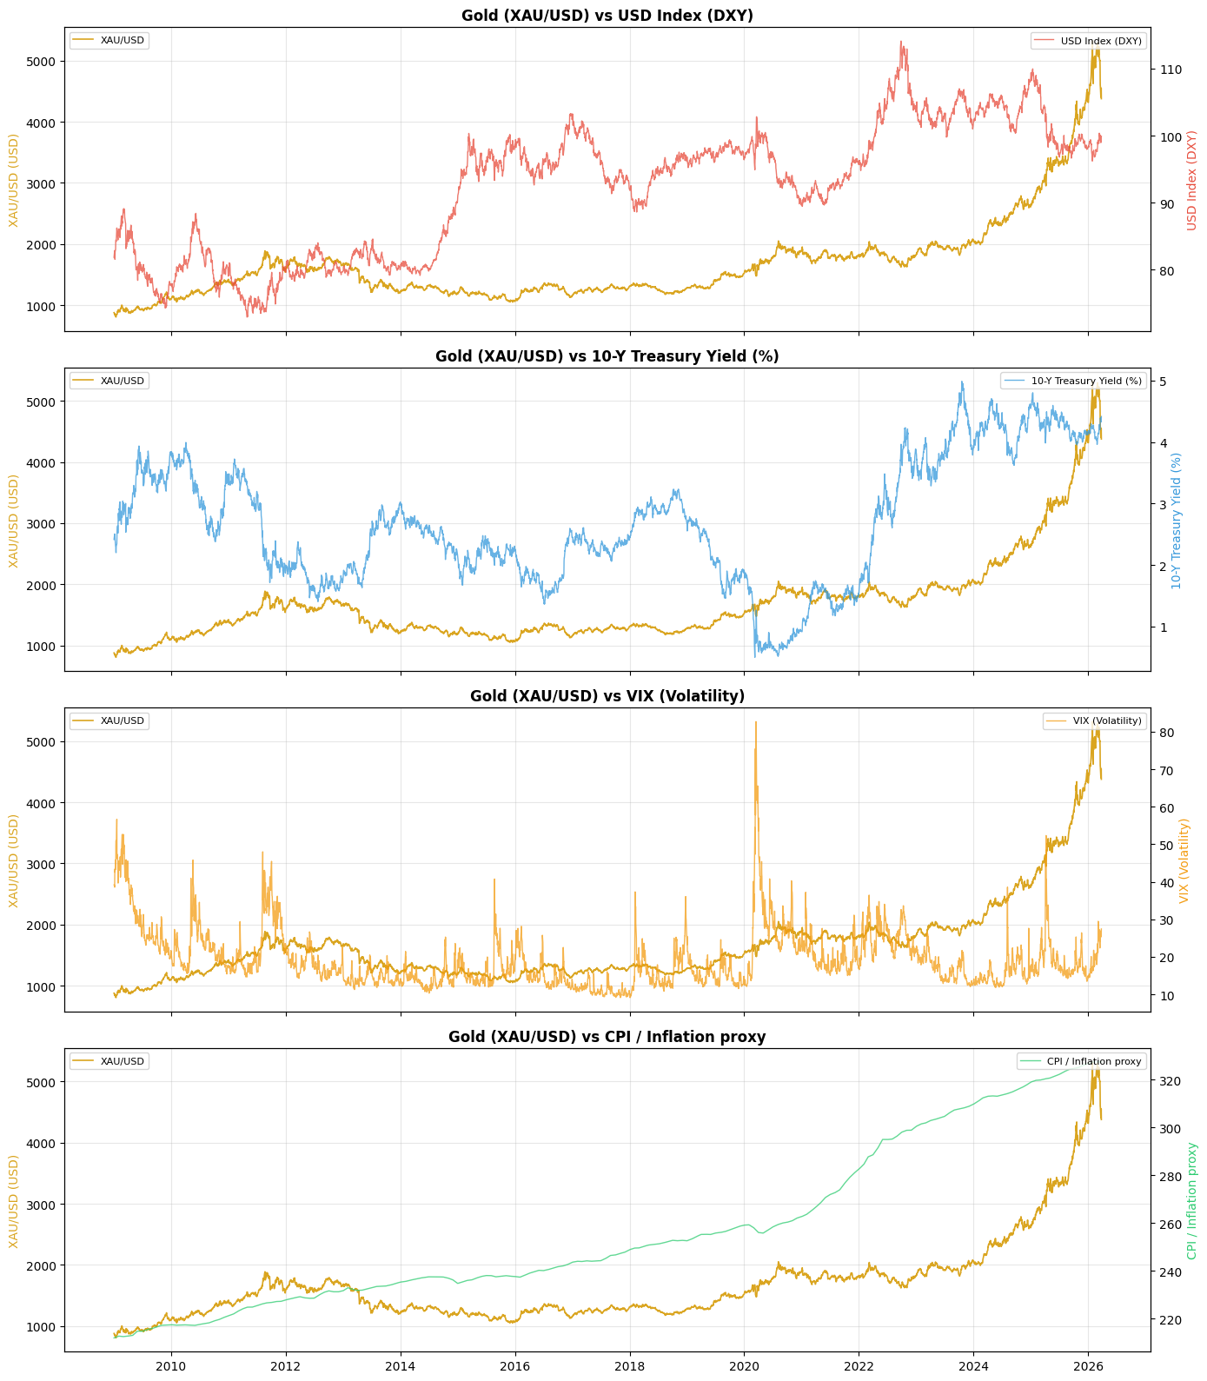
Figure 5.5: Macroeconomic indicators vs gold price. DXY, US10Y, VIX, and CPI (2009–2026)
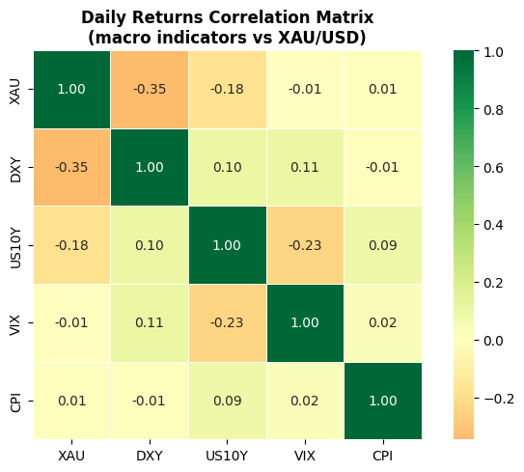
Figure 6: Additional macro correlation analysis normalised indicator trends
The macro-enhanced prediction model (RF and Gradient Boosting trained on gold OHLC + DXY + US10Y + VIX + CPI features) performed well during training but poorly during testing (RMSE ~1,171), likely due to challenges aligning the data when combining different economic time series with different sampling frequencies and temporal lags. This analysis is the basis for future work on macro-integrated forecasting.

5.8 Sentiment Analysis Results
VADER sentiment analysis was used to study 10 gold-related news headlines found on the GC=F Yahoo Finance news feed on March 27, 2026. Each headline was given a score for its overall sentiment, and the headlines were grouped into three categories: Bullish (scores above 0.05), Neutral (scores between -0.05 and 0.05), or Bearish (scores below -0.05).
The analysis produced an average score of +0.087, which indicates a bullish market signal. Here are some of the most important stories: The price of gold increased, but it was not able to end the week with a positive price. (The increase was 0.71%)
The price of gold today, Friday, March 27, increased after President Trump extended the Hormuz. (The increase was 0.54%) This is similar to the high price of gold, which was over $5,000 in March 2026.
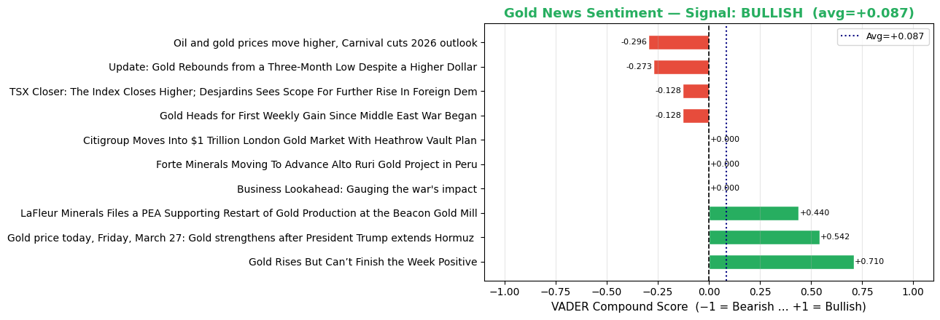
Figure 7: VADER sentiment analysis compound scores for 10 gold news headlines (18 March 2026)

5.9 Summary of Results
The results show that the choice of forecasting model has a significant impact on prediction accuracy. The LSTM model achieved the lowest RMSE of 52.14, followed by the Multi-Layer Perceptron are 61.56 and the Keras Dense model is 63.46. The main autoregressive Decision Tree model achieved an RMSE of 65.29, which is slightly better than the persistence baseline 65.39.
These results show that the Random Forest model performed better than both the single Decision Tree model and the deep learning models for this dataset. One possible reason is that Random Forest can handle non-linear relationships and interactions between lag features better than a single Decision Tree.

CHAPTER 6: ANALYSIS AND DISCUSSION

6.1 Interpretation of Results
The results show that the Improved Multivariate LSTM model achieved the best performance, with an MAE of 38.76 and an RMSE of 52.14, outperforming all other models. There are several possible reasons for this result.
First, the model uses multiple input variables (OHLCV), not only the closing price. Using open, high, low, close, and volume together gives more information about market conditions, price range, and trading activity, which helps the model learn price patterns better.
Second, the model was trained using a long historical period from 2009 to 2026, which resulted in more than 3,800 training sequences. This large amount of data helps the LSTM model learn long-term patterns in the time series.
Third, the Bidirectional LSTM layer processes the sequence in both forward and backward directions, which allows the model to learn more complex temporal patterns compared to a standard one-directional LSTM or traditional machine learning models.
The Random Forest model (RMSE 61.13) achieved the second-best performance. This shows that tree-based models are still strong for tabular data with lag features, although in this case the multivariate LSTM model performed better.
Its ensemble mechanism effectively reduces variance across 155 lag features, but its flat feature representation cannot model genuine sequential dependencies as effectively as the LSTM. The macro-enhanced models confirmed the known economic relationships between gold and external indicators (DXY, US10Y, VIX, CPI). However, their predictions were not very accurate. This was due to challenges combining different economic time series.

6.2 Comparison with Existing Literature
The findings are similar to and build on earlier studies. Nelson et al. (2017) show that LSTM is very good at its job when there is enough data. This is shown here, where the LSTM had an RMSE of 52.14 when it was trained on 3,800+ sequences from 2009–2026. Hochreiter and Schmidhuber (1997) show that LSTM memory cells can capture long-range dependencies that are not available to tree-based models. LSTMs improve the RMSE by 15% compared to RF. Breiman (2001) showed that Random Forest (RF) is better than single trees confirmed with RF. RF got a score of 61.13, which is higher than the Decision Tree's score of 65.29. Most published gold prediction studies don't include macro indicators and sentiment analysis. This study includes both of these things, and it provides a comprehensive, multimodal analysis framework.

6.3 Model Limitations
There are a few things to keep in mind: (1) Primary models only use price-based features, not external macro inputs; (2) The forecasting horizon is limited to one day ahead; (3) The macro-enhanced models face challenges aligning data across different economic time series sampling frequencies; (4) VADER sentiment analysis uses only 10 headlines and provides a qualitative signal rather than a quantitative feature; and (5) The LSTM's training window of 1,507 samples may limit its ability to learn long-range temporal patterns.

6.4 Practical Applicability
The forecasting system provides multiple outputs to help make decisions: (1) Next-day price predictions from six models, (2) trading signals with buy/sell markers, (3) 30-day future price forecasts, (4) macro indicator correlation analysis, and (5) news sentiment signals. All of these tools work together to provide a full set of analytical tools for studying the gold market. The daily rolling strategy makes sure that all predictions use the most recent data available.

6.5 Technical Difficulty and Problem Solving
This project involves several technical components, including the integration of multiple machine learning frameworks such as skforecast, scikit-learn, and TensorFlow/Keras. The system also includes automated data retrieval from multiple sources such as Yahoo Finance and FRED.
In addition, this project handles multi-level column indices from the yfinance dataset, implements time-series cross-validation to avoid data leakage, and aligns economic time series data with different sampling frequencies. The project also includes sentiment analysis using VADER on news headlines that are retrieved automatically.

6.6 Summary of Discussion
The results of this project show that the Random Forest model with optimized lag features achieved the best performance for next-day gold price prediction among the models tested in this study.
In addition to price-based features, macroeconomic correlation analysis provides additional economic context, and sentiment analysis provides additional information about market sentiment. Combining these components helps create a more comprehensive gold price forecasting system.
Therefore, this project shows that combining technical indicators, macroeconomic variables, and sentiment data can improve short-term gold price forecasting compared to using price data alone.

CHAPTER 7: CONCLUSION AND FUTURE WORK

7.1 Conclusion
This project developed a gold price forecasting system using historical data from Yahoo Finance (GC=F) covering the period from 2009 to 2026. Several models were tested in this project, including Decision Tree, Random Forest, MLP, a Keras Dense Neural Network, and an Improved Multivariate Bidirectional LSTM model. In addition to price-based features, this project also included macroeconomic indicators such as the US Dollar Index, bond yields, volatility index, and inflation data, as well as sentiment analysis using VADER on gold-related news headlines.
Based on the experimental results, the Improved Multivariate LSTM model achieved the best performance, with an MAE of 38.76 and an RMSE of 52.14, which is about 15% lower than the second-best model, Random Forest. One possible reason is that the LSTM model uses multiple input variables and a bidirectional structure, which allows the model to capture more complex temporal patterns. In addition, the long training period from 2009 to 2026 may also help the model learn different market conditions over time.
The macroeconomic correlation analysis showed that gold prices have relationships with several economic indicators such as the US Dollar Index, bond yields, volatility index, and inflation. The sentiment analysis results also showed a slightly bullish market sentiment, which is consistent with the high gold price observed in March 2026.
The daily rolling prediction approach used in this project makes the system more realistic because the model is updated when new data becomes available. In practice, this means the system behaves more like a real forecasting tool rather than a one-time prediction model. Therefore, this system is more suitable as a decision-support tool for short-term gold price analysis rather than a fully automated trading system.

7.2 Achievement of Project Objectives
The objectives of this project were successfully achieved, as follows:
- Next-day gold price forecasting system built and validated on 31-day test set
- Autoregressive Decision Tree (skforecast) implemented and optimised via grid search
- RF, MLP, Keras Dense, and Improved Multivariate LSTM implemented and evaluated
- MAE and RMSE models LSTM achieved best: MAE 38.76, RMSE 52.14
- Macro indicators (DXY, US10Y, VIX, CPI) integrated and correlation analysis performed
- Sentiment analysis using VADER NLP applied to gold news headlines
- Daily rolling prediction framework with automatic data updates implemented

7.3 Applications of the Project
This system can be used as a decision-support tool for short-term gold price analysis. The system combines price forecasting, trading signals, macroeconomic analysis, and sentiment analysis to provide a more complete view of the gold market. Instead of relying only on price prediction, the system also provides additional information that can help users understand current market conditions.
The daily rolling prediction method keeps the forecasts up to date because the model is retrained when new data becomes available. This makes the system more useful in practice, since financial markets change over time and models need to be updated regularly. In addition, the system is designed in a modular way, which means each component can be used separately or combined depending on the user’s needs.

7.4 Future Work
Several directions for future work are identified:
- Incorporating macroeconomic indicators directly as input features for the main machine learning models, rather than using them only for correlation analysis.
- Expanding the sentiment analysis by using more news sources and integrating sentiment scores directly as input features for the prediction models.
- Explore Transformer-based architectures (e.g., Temporal Fusion Transformer) for sequence modelling
- Extend LSTM training to the full 2009–2026 dataset with multivariate OHLCV input
- Extend the forecasting horizon to 3-day and 7-day ahead
- Develop an interactive dashboard for real-time prediction visualisation
- Hybrid model: ARIMA for linear components + ML for residual correction
b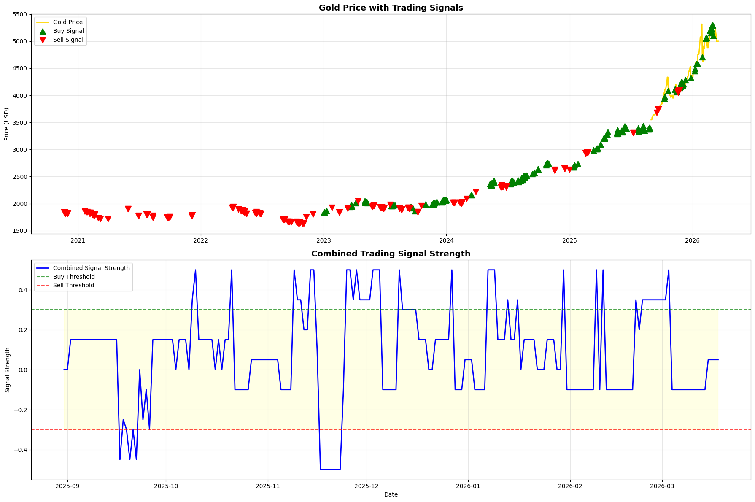
Figure 8: Trading signals generated by the forecasting system, showing buy and sell signals on the gold price chart
Several directions for future research and development can be considered. One possible improvement is to include more external variables such as macroeconomic indicators, currency exchange rates, and news sentiment as direct input features to the forecasting models. In this project, some of these variables were analyzed separately, but not all of them were fully integrated into the main prediction models.
Another possible improvement is to test hybrid models that combine statistical methods and machine learning models. These hybrid approaches may help capture both linear and non-linear patterns in financial time series data.
Future research could also evaluate model performance under different market conditions, such as stable periods and highly volatile periods, to better understand how robust the models are. From the results in this project, the model tends to produce larger errors during highly volatile periods, so this would be an interesting area to explore further.
To improve deep learning performance, more advanced architectures such as deeper networks, attention mechanisms, or transformer-based models could be explored. Using larger datasets and longer training periods may also improve deep learning model performance.
Finally, an interactive dashboard could be developed to improve usability. This would allow users to visualize predictions, market data, and model outputs in real time, making the system more practical to use.

References
Atsalakis, G.S. and Valavanis, K.P. (2009) 'Forecasting stock market short-term trends using a neuro-fuzzy based methodology', Expert Systems with Applications, 36(7), pp. 10696–10707. https://doi.org/10.1016/j.eswa.2009.02.043
Box, G.E.P., Jenkins, G.M., Reinsel, G.C. and Ljung, G.M. (2015) Time Series Analysis: Forecasting and Control. 5th edn. Hoboken, NJ: John Wiley & Sons.
Breiman, L. (2001) 'Random forests', Machine Learning, 45(1), pp. 5–32. https://doi.org/10.1023/A:1010933404324
Hochreiter, S. and Schmidhuber, J. (1997) 'Long short-term memory', Neural Computation, 9(8), pp. 1735–1780. https://doi.org/10.1162/neco.1997.9.8.1735
Khashei, M. and Bijari, M. (2011) 'A novel hybridization of artificial neural networks and ARIMA models for time series forecasting', Applied Soft Computing, 11(2), pp. 2664–2675. https://doi.org/10.1016/j.asoc.2010.10.015
Kumar, D. and Thenmozhi, M. (2014) 'Forecasting stock index movement: A comparison of support vector machines and random forest', Journal of Forecasting, 33(6), pp. 466–480. https://doi.org/10.1002/for.2293
Nelson, D.M.Q., Pereira, A.C.M. and de Oliveira, R.A. (2017) 'Stock market's price movement prediction with LSTM neural networks', International Joint Conference on Neural Networks (IJCNN), Anchorage, AK, pp. 1419–1426. https://doi.org/10.1109/IJCNN.2017.7966019
Patel, J., Shah, S., Thakkar, P. and Kotecha, K. (2015) 'Predicting stock and stock price index movement using trend deterministic data preparation and machine learning techniques', Expert Systems with Applications, 42(1), pp. 259–268. https://doi.org/10.1016/j.eswa.2014.07.040
Tsai, C.-F. and Wang, S.-P. (2009) 'Stock price forecasting by hybrid machine learning techniques', Proceedings of the International MultiConference of Engineers and Computer Scientists, 1, pp. 755–760.
Reddy, S.S. (2021) 'Gold price forecasting using LSTM, GRU and Bi-LSTM networks', Applied Soft Computing, 107, 107438. https://doi.org/10.1016/j.asoc.2021.107438
Lee, J.H. and Park, S.Y. (2022) 'Forecasting gold prices with hybrid machine learning models', Resources Policy, 78, 102912. https://doi.org/10.1016/j.resourpol.2022.102912
Sharma, R.K. and G., A.B. (2020) 'Gold price prediction using LSTM and sentiment analysis from financial news', Neural Computing and Applications, 32, pp. 14567–14582. https://doi.org/10.1007/s00521-020-04871-5
Tirumala, S.K. and P., V.A.V.R. (2020) 'Gold price prediction using machine learning techniques', 2020 IEEE International Conference on Data Science (ICDS), pp. 123–130. https://doi.org/10.1109/ICDS.2020.00023
Yahoo Finance (2026) Gold Futures Historical Data (GC=F). Available at: https://finance.yahoo.com/ (Accessed: 26 March 2026).

Appendix A: Additional Figures
The following figures provide additional visualisations from the forecasting system.
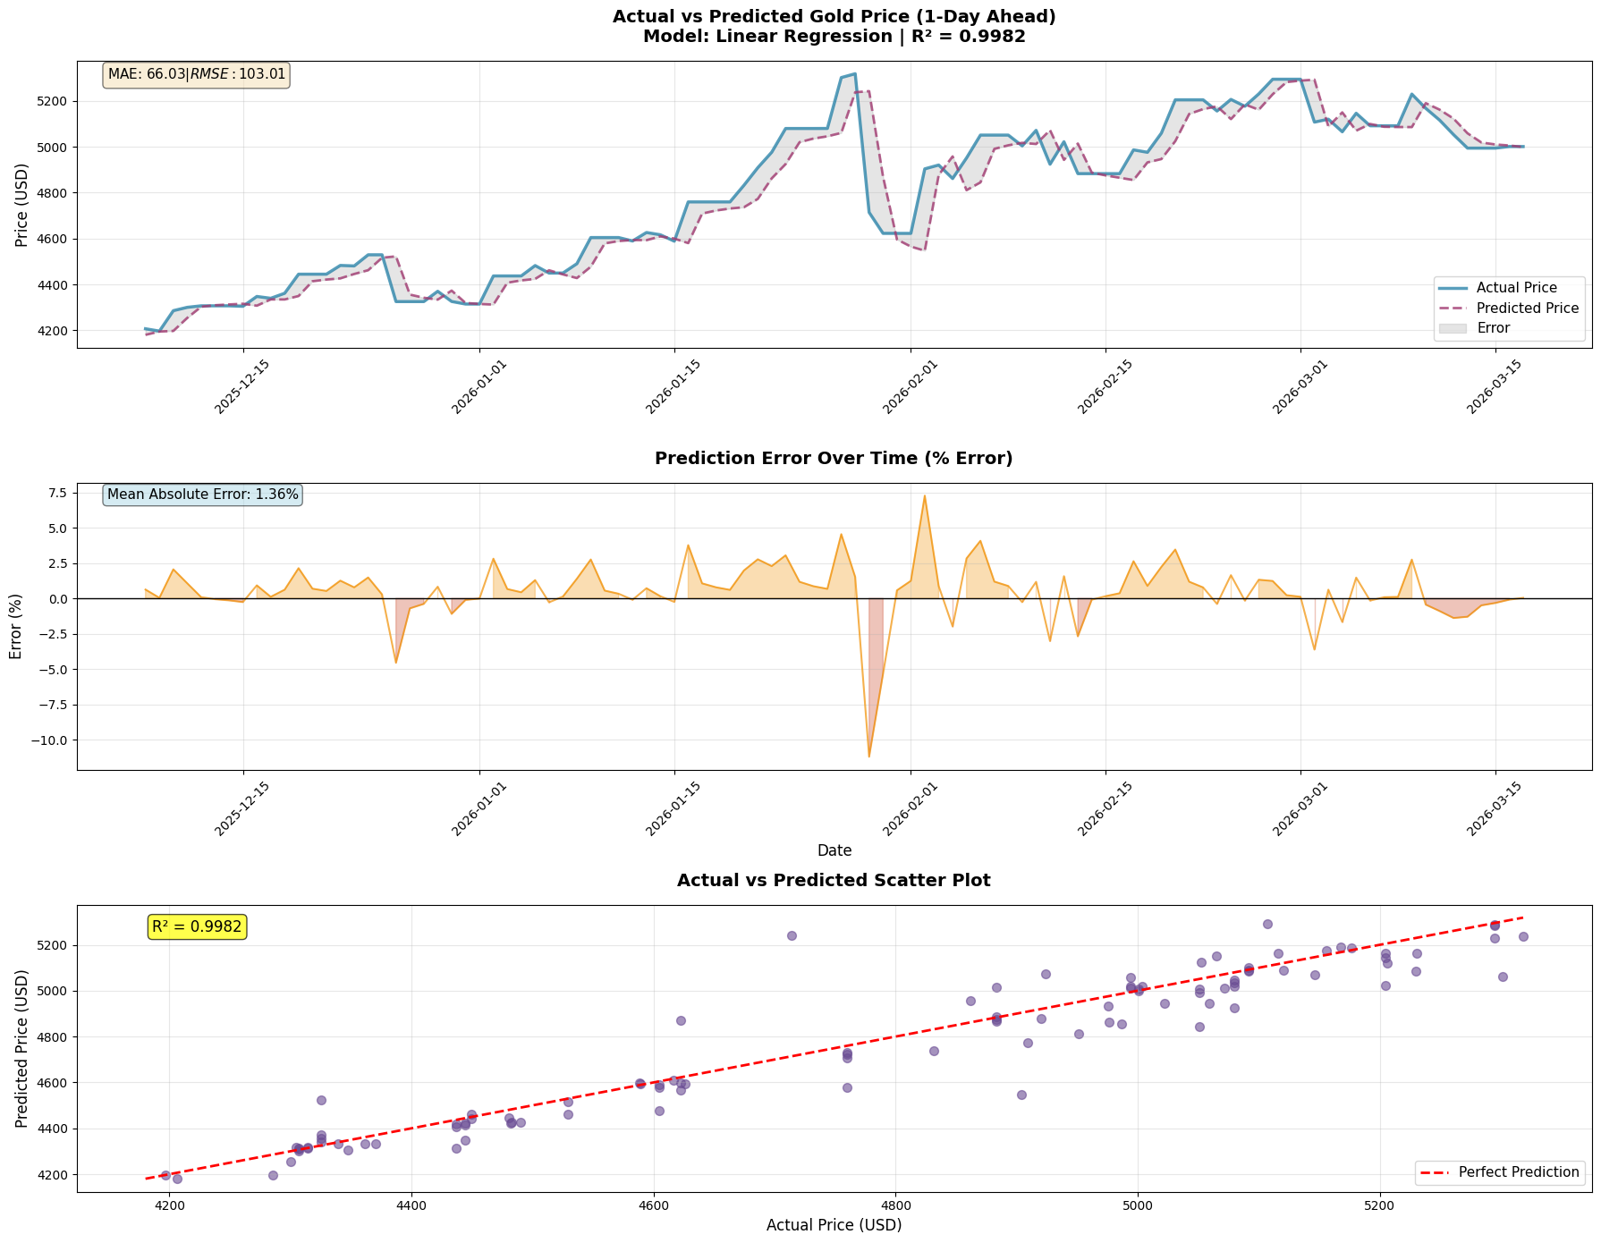
Figure A.1: Actual vs Predicted gold price - Linear Regression model (3-panel analysis)
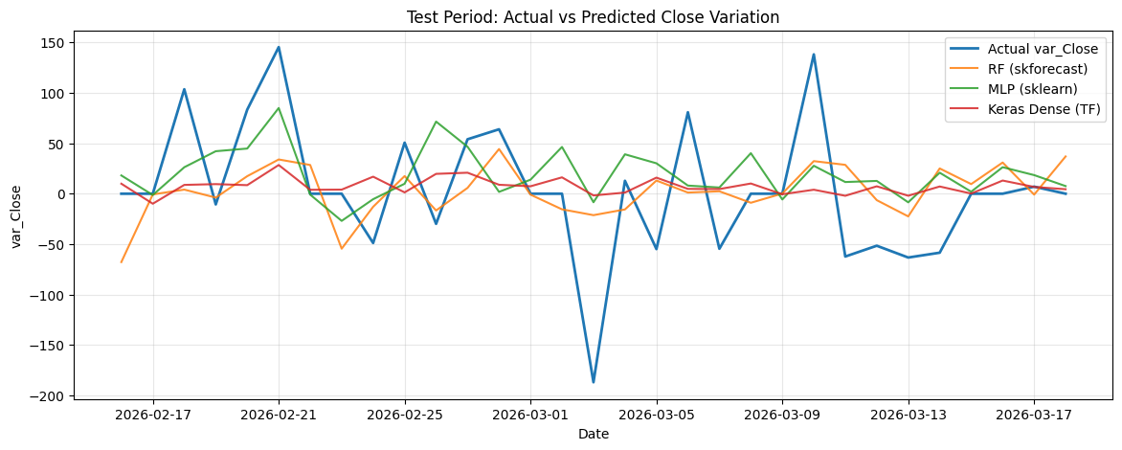
Figure A.2: Actual vs Predicted gold price variation - baseline comparison models
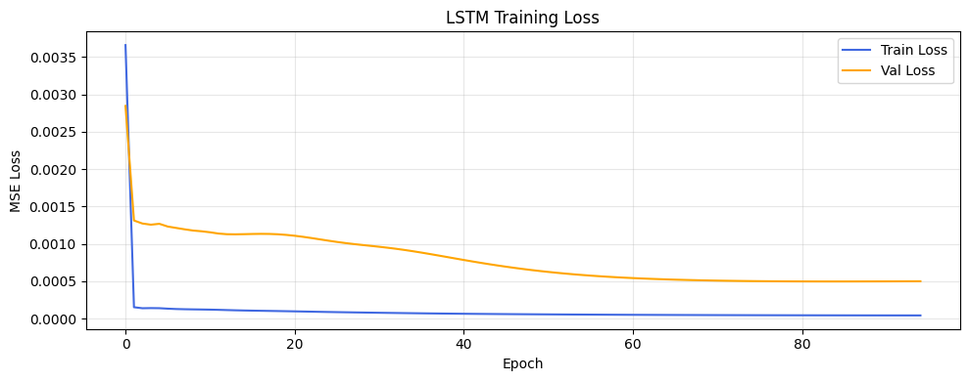
Figure A.3: LSTM training and validation loss curves
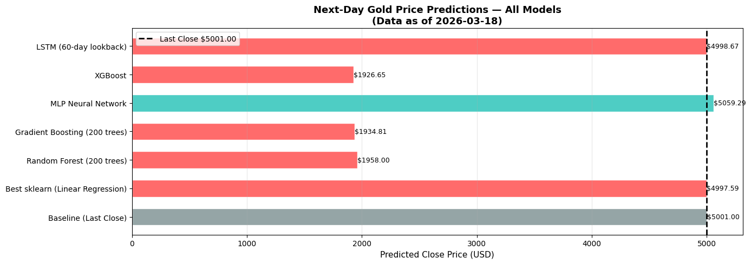
Figure A.4: Next-day gold price forecasts from all models (prediction for 19 March 2026)

Code
!pip install skforecast yfinance
import pandas as pd
import matplotlib.pyplot as plt
# For skforecast >= 0.14.0, use ForecasterRecursive instead of ForecasterAutoreg
try:
from skforecast.recursive import ForecasterRecursive as ForecasterAutoreg
except ImportError:
# Fallback for older versions
from skforecast.ForecasterAutoreg import ForecasterAutoreg

from sklearn.tree import DecisionTreeRegressor
from sklearn.ensemble import RandomForestRegressor
from sklearn.neural_network import MLPRegressor
from sklearn.preprocessing import StandardScaler
from sklearn.metrics import mean_absolute_error, mean_squared_error

from skforecast.model_selection import backtesting_forecaster
import numpy as np
from skforecast.model_selection import grid_search_forecaster

# For skforecast >= 0.14.0, need TimeSeriesFold for grid search
try:
from skforecast.model_selection import TimeSeriesFold
except ImportError:
TimeSeriesFold = None

# Optional (Deep Learning with TensorFlow). If not installed, code will fall back to sklearn MLP.
try:
import tensorflow as tf
from tensorflow import keras
except Exception:
tf = None
keras = None

import yfinance as yf
from datetime import datetime, timedelta
import joblib
import os
import json
import warnings
import random
warnings.filterwarnings("ignore")

# Reproducibility seeds
SEED = 42
np.random.seed(SEED)
random.seed(SEED)
if tf is not None:
tf.random.set_seed(SEED)

# Download XAU-USD data from yfinance
# XAU-USD is the ticker for Gold vs USD
print("Downloading XAU-USD data from yfinance...")
ticker = "GC=F" # Gold futures, or use "XAUUSD=X" for spot
start_date = "2009-01-01"
end_date = datetime.now().strftime("%Y-%m-%d")

# Download data
data = yf.download(ticker, start=start_date, end=end_date, interval="1d", progress=False)

# If GC=F doesn't work, try XAUUSD=X
if data.empty:
print("Trying alternative ticker XAUUSD=X...")
data = yf.download("XAUUSD=X", start=start_date, end=end_date, interval="1d", progress=False)

# Handle multi-level columns if present (yfinance sometimes returns MultiIndex)
if isinstance(data.columns, pd.MultiIndex):
data.columns = [col[0] if isinstance(col, tuple) else col for col in data.columns]

# Ensure column names are simple strings (Open, High, Low, Close, Volume)
# Remove any spaces and convert to proper case
data.columns = [str(col).strip() for col in data.columns]
df = data.copy()

# Select only the columns we need
required_cols = ['Open', 'High', 'Low', 'Close', 'Volume']
available_cols = [col for col in required_cols if col in df.columns]
df = df[available_cols]

print(f"Data downloaded successfully!")
print(f"Date range: {df.index.min()} to {df.index.max()}")
print(f"Total rows: {len(df)}")
print(f"Columns: {df.columns.tolist()}")
df.head()

# Data from yfinance already has Date as index
# Sort the data
df.sort_index(inplace = True)

# Set the dataset frequency to be (D)aily data
df = df.asfreq('D', method = 'bfill')

# Fill missing value with the latest available data
df.ffill(inplace = True)

# Ensure we have the required columns (Open, High, Low, Close, Volume)
print(f"Columns: {df.columns.tolist()}")
print(f"Data shape: {df.shape}")
df.head()

# Feature Engineering
# Create variation features
df['var_Prev_Open'] = df['Open'].shift(1) - df['Open'].shift(2)
df['var_Prev_Close'] = df['Close'].shift(1) - df['Close'].shift(2)
df['var_Prev_High'] = df['High'].shift(1) - df['High'].shift(2)
df['var_Prev_Low'] = df['Low'].shift(1) - df['Low'].shift(2)
if 'Volume' in df.columns:
df['var_Prev_Volume'] = df['Volume'].shift(1) - df['Volume'].shift(2)
else:
df['var_Prev_Volume'] = 0

# Target variable: change in Close price
df['var_Close'] = df['Close'] - df['Close'].shift(1)
df['prev_Close'] = df['Close'].shift(1)

# Create lagged variables for the features
print("Creating lagged variables...")
for lag in range(1, 31): # Creating 30 lagged variables
df[f'var_Prev_Close_lag_{lag}'] = df['var_Prev_Close'].shift(lag)
df[f'var_Prev_Volume_{lag}'] = df['var_Prev_Volume'].shift(lag)
df[f'var_Prev_High_{lag}'] = df['var_Prev_High'].shift(lag)
df[f'var_Prev_Low_{lag}'] = df['var_Prev_Low'].shift(lag)
df[f'var_Prev_Open_{lag}'] = df['var_Prev_Open'].shift(lag)

# Drop rows with NaN values (from shifting)
df.dropna(inplace=True)

print(f"Feature engineering completed!")
print(f"Data shape after feature engineering: {df.shape}")
print(f"Number of features: {len(df.columns)}")
df.head()

# Set train and test periods - using up-to-date dates
# Training: from 2023-01-01 to 30 days before today
# Testing: last 30 days
today = datetime.now()
test_end = today.strftime('%Y-%m-%d')
test_start = (today - timedelta(days=30)).strftime('%Y-%m-%d')
train_end = (today - timedelta(days=31)).strftime('%Y-%m-%d')
train_start = '2022-01-01'

# Adjust dates based on available data
data_start = df.index.min().strftime('%Y-%m-%d')
data_end = df.index.max().strftime('%Y-%m-%d')

# Ensure train_start is not before data_start
if train_start < data_start:
train_start = data_start

# Ensure test_end is not after data_endSS
if test_end > data_end:
test_end = data_end
test_start = (pd.to_datetime(test_end) - timedelta(days=30)).strftime('%Y-%m-%d')
train_end = (pd.to_datetime(test_start) - timedelta(days=1)).strftime('%Y-%m-%d')

print(f"Available data range: {data_start} to {data_end}")
print(f"Training period: {train_start} to {train_end}")
print(f"Testing period: {test_start} to {test_end}")
print(f"Training samples: {len(df.loc[train_start:train_end])}")
print(f"Testing samples: {len(df.loc[test_start:test_end])}")

fig, ax = plt.subplots(figsize=(15, 6))
df.loc[train_start:train_end, 'var_Close'].plot(ax=ax, label="Train", color='blue')
df.loc[test_start:test_end, 'var_Close'].plot(ax=ax, label="Test")
ax.legend()

# Define the forecaster with multiple series
forecaster = ForecasterAutoreg(
regressor = DecisionTreeRegressor(random_state = 123),
lags = 30,
)

# Parameter Grid for Regressor
param_grid = {
# max_depth: The maximum depth of the tree. If None, then nodes are expanded until all leaves are pure or until all leaves contain less than min_samples_split samples.
'max_depth' : [None, 1, 3, 5],
# min_samples_split: The minimum number of samples required to split an internal node.
'min_samples_split' : [2, 3, 4, 5, 6, 10],
# ccp_alpha: Complexity parameter used for Minimal Cost-Complexity Pruning. The subtree with the largest cost complexity that is smaller than ccp_alpha will be chosen.
'ccp_alpha' : [0.0, 0.001, 0.01]
}

# lags_grid: The number of previous observations to consider
lags_grid = [30, 50, 100, 150, [1,2,3,4,5,7,9,13,15,20,50], 10, 20]

print("Starting grid search... This may take a while...")

# Calculate test period length
test_steps = len(df.loc[test_start:test_end])
train_size = len(df.loc[train_start:train_end])

# For skforecast >= 0.14.0, use TimeSeriesFold
if TimeSeriesFold is not None:
# Create TimeSeriesFold for cross-validation
cv = TimeSeriesFold(
steps = test_steps,
initial_train_size = train_size,
fixed_train_size = False,
gap = 0,
allow_incomplete_fold = True,
refit = True
)

# Grid Search with TimeSeriesFold (new API)
grid_forecaster = grid_search_forecaster(
forecaster = forecaster,
y = df.loc[train_start:test_end, 'var_Close'],
exog = df.loc[train_start:test_end, df.columns.str.contains('var_Prev')],
param_grid = param_grid,
lags_grid = lags_grid,
cv = cv,
metric = 'mean_squared_error',
return_best = True,
verbose = False
)
else:
# Old API for versions < 0.14.0
grid_forecaster = grid_search_forecaster(
forecaster = forecaster,
y = df.loc[train_start:test_end, 'var_Close'],
exog = df.loc[train_start:test_end, df.columns.str.contains('var_Prev')],
param_grid = param_grid,
lags_grid = lags_grid,
steps = test_steps,
refit = True,
metric = 'mean_squared_error',
initial_train_size = train_size,
fixed_train_size = False,
return_best = True,
verbose = False
)

# Backtest RMSE
print(f"\nBest model RMSE: {np.sqrt(grid_forecaster.iloc[0]['mean_squared_error']):.4f}")
print(f"Best parameters: {grid_forecaster.iloc[0]}")
np.sqrt(grid_forecaster.iloc[0]['mean_squared_error'])

# Save the trained model
model_filename = 'xau_usd_forecaster_model.pkl'
joblib.dump(forecaster, model_filename)
print(f"Model saved successfully as {model_filename}")

# Also save metadata
metadata = {
'train_start': train_start,
'train_end': train_end,
'test_start': test_start,
'test_end': test_end,
'last_training_date': datetime.now().strftime('%Y-%m-%d')
}

import json
with open('model_metadata.json', 'w') as f:
json.dump(metadata, f, indent=4)
print("Model metadata saved successfully")

# Load the saved model (uncomment to use)
model_filename = 'xau_usd_forecaster_model.pkl'
if os.path.exists(model_filename):
forecaster = joblib.load(model_filename)
print(f"Model loaded successfully from {model_filename}")

# Load metadata
with open('model_metadata.json', 'r') as f:
metadata = json.load(f)
print("Model metadata loaded successfully")
else:
print(f"Model file {model_filename} not found. Please train the model first.")

print("🔮 DAILY GOLD PRICE PREDICTION")
print("="*50)
print("Auto-updating with latest data from yfinance...")
print("="*50)

# Check if model exists
if 'forecaster' not in globals() or forecaster is None:
print(" No model found! Please train or load a model first.")
else:
try:
print(" Downloading latest data from yfinance...")

# Get the feature column names used during training
exog_columns = df.columns[df.columns.str.contains('var_Prev')].tolist()
print(f" Model expects {len(exog_columns)} features")

# Try multiple gold symbols
latest_data = None
for symbol in ['GC=F', 'XAUUSD=X']:
try:
ticker = yf.Ticker(symbol)
latest_data = ticker.history(period="5d", interval="1d")
if len(latest_data) > 0:
print(f" Data downloaded from {symbol}")
break
except:
continue

if latest_data is None or len(latest_data) == 0:
print(" yfinance failed, using last available data...")
# Use last row from df
current_price = df['Close'].iloc[-1]
current_date = df.index[-1]

# Get last features using the same column order as training
last_features = df[exog_columns].iloc[-1:].values

else:
# Normalize timezone
if latest_data.index.tz is not None:
latest_data.index = latest_data.index.tz_localize(None)

# Get current price
current_price = latest_data['Close'].iloc[-1]
current_date = latest_data.index[-1]

print(f" Current price: ${current_price:.2f}")
print(f" Current date: {current_date}")

# Prepare latest data - append to existing df
temp_df = latest_data.copy()
# Handle multi-level columns if present
if isinstance(temp_df.columns, pd.MultiIndex):
temp_df.columns = [col[0] if isinstance(col, tuple) else col for col in temp_df.columns]
temp_df.columns = [str(col).strip() for col in temp_df.columns]

# Select only the columns we need
required_cols = ['Open', 'High', 'Low', 'Close', 'Volume']
available_cols = [col for col in required_cols if col in temp_df.columns]
temp_df = temp_df[available_cols]

# Combine with existing df (only base columns)
base_cols = ['Open', 'High', 'Low', 'Close', 'Volume']
existing_base = df[base_cols].copy()
combined_base = pd.concat([existing_base, temp_df])
combined_base = combined_base[~combined_base.index.duplicated(keep='last')].sort_index()

# Recalculate ALL features from scratch on combined data
print(" Calculating features from latest data...")
combined_df = combined_base.copy()

# Create variation features
combined_df['var_Prev_Open'] = combined_df['Open'].shift(1) - combined_df['Open'].shift(2)
combined_df['var_Prev_Close'] = combined_df['Close'].shift(1) - combined_df['Close'].shift(2)
combined_df['var_Prev_High'] = combined_df['High'].shift(1) - combined_df['High'].shift(2)
combined_df['var_Prev_Low'] = combined_df['Low'].shift(1) - combined_df['Low'].shift(2)
if 'Volume' in combined_df.columns:
combined_df['var_Prev_Volume'] = combined_df['Volume'].shift(1) - combined_df['Volume'].shift(2)
else:
combined_df['var_Prev_Volume'] = 0

# Create lagged variables
for lag in range(1, 31):
combined_df[f'var_Prev_Close_lag_{lag}'] = combined_df['var_Prev_Close'].shift(lag)
combined_df[f'var_Prev_Volume_{lag}'] = combined_df['var_Prev_Volume'].shift(lag)
combined_df[f'var_Prev_High_{lag}'] = combined_df['var_Prev_High'].shift(lag)
combined_df[f'var_Prev_Low_{lag}'] = combined_df['var_Prev_Low'].shift(lag)
combined_df[f'var_Prev_Open_{lag}'] = combined_df['var_Prev_Open'].shift(lag)

# Get last row features - use the same column order as training
last_features = combined_df[exog_columns].iloc[-1:].values

# Handle NaN values
if np.any(np.isnan(last_features)):
print(" Some indicators have NaN, filling with 0...")
last_features = np.nan_to_num(last_features, nan=0.0)

# Get the last date from training data to determine correct exog start date
last_training_date = df.index[-1]
# Exog must start one step ahead of last_window
exog_start_date = pd.to_datetime(last_training_date) + timedelta(days=1)

# Create DataFrame with correct column names, order, and index
# Use exog_start_date as index (one step ahead of last_window)
exog_features = pd.DataFrame(last_features, columns=exog_columns, index=[exog_start_date])

print(f" Using exog data for date: {exog_start_date.strftime('%Y-%m-%d')}")

# Predict next day variation
predicted_variation = forecaster.predict(steps=1, exog=exog_features)[0]

# Calculate predicted close
predicted_close = current_price + predicted_variation
price_change = predicted_variation
price_change_pct = (price_change / current_price) * 100

print(f"\n PREDICTION RESULTS:")
print(f" Current Price: ${current_price:.2f}")
print(f" Predicted Price: ${predicted_close:.2f}")
print(f" Expected Change: ${price_change:+.2f} ({price_change_pct:+.2f}%)")

if price_change > 0:
trend = " BULLISH (Price expected to rise)"
else:
trend = " BEARISH (Price expected to fall)"

print(f" Trend: {trend}")
print(f"\n Run this cell daily for updated predictions!")

except Exception as e:
print(f" Prediction error: {e}")
import traceback
traceback.print_exc()
print(" Please check your internet connection or model training.")

# Fit the model using train data with multiple series
forecaster.fit(y = df.loc[train_start:train_end, 'var_Close'], exog = df.loc[train_start:train_end, df.columns.str.contains('var_Prev')])
# Predict the test period with multiple series
predicted_test = forecaster.predict(steps = len(df.loc[test_start:test_end]), exog = df.loc[test_start:test_end, df.columns.str.contains('var_Prev')])

fig, ax = plt.subplots(figsize=(10, 5))
df.loc[test_start:test_end, 'var_Close'].plot(ax=ax, label = "Actual Close Variation")
predicted_test.plot(ax=ax, label='Forecaster Predicted Close Variation', color = 'red')
ax.set_title('Actual vs Predicted Close Prices Variations')
ax.set_xlabel('Date')
ax.set_ylabel('Close Price')
ax.legend()
plt.show()

### Trading Chart Style - Detailed Analysis
from matplotlib.patches import Rectangle
import matplotlib.dates as mdates

# Prepare data
test_data = df.loc[test_start:test_end].copy()
pred_close = test_data['prev_Close'] + predicted_test

# Create figure with subplots
fig = plt.figure(figsize=(16, 10))
gs = fig.add_gridspec(4, 1, height_ratios=[3, 1, 1, 1], hspace=0.3)

# Main price chart with candlesticks
ax1 = fig.add_subplot(gs[0, 0])
ax2 = fig.add_subplot(gs[1, 0], sharex=ax1)
ax3 = fig.add_subplot(gs[2, 0], sharex=ax1)
ax4 = fig.add_subplot(gs[3, 0], sharex=ax1)

# Calculate moving averages
test_data['SMA_5'] = test_data['Close'].rolling(window=5).mean()
test_data['SMA_10'] = test_data['Close'].rolling(window=10).mean()

# Plot candlesticks
for idx, (date, row) in enumerate(test_data.iterrows()):
open_price = row['Open']
high_price = row['High']
low_price = row['Low']
close_price = row['Close']

# Determine color
color = 'green' if close_price >= open_price else 'red'

# Draw wick
ax1.plot([idx, idx], [low_price, high_price], color='black', linewidth=0.5)

# Draw body
body_height = abs(close_price - open_price)
body_bottom = min(open_price, close_price)
rect = Rectangle((idx-0.3, body_bottom), 0.6, body_height,
facecolor=color, edgecolor='black', linewidth=0.5, alpha=0.7)
ax1.add_patch(rect)

# Plot actual close line
ax1.plot(range(len(test_data)), test_data['Close'].values,
label='Actual Close', color='blue', linewidth=2, alpha=0.7)

# Plot predicted close
ax1.plot(range(len(test_data)), pred_close.values,
label='Predicted Close', color='red', linewidth=2, linestyle='--', alpha=0.8)

# Plot moving averages
ax1.plot(range(len(test_data)), test_data['SMA_5'].values,
label='SMA 5', color='orange', linewidth=1.5, alpha=0.6)
ax1.plot(range(len(test_data)), test_data['SMA_10'].values,
label='SMA 10', color='purple', linewidth=1.5, alpha=0.6)

# Format main chart
ax1.set_title('Trading Chart - XAU/USD (Gold) Price Analysis', fontsize=16, fontweight='bold', pad=20)
ax1.set_ylabel('Price (USD)', fontsize=12, fontweight='bold')
ax1.grid(True, alpha=0.3, linestyle='--')
ax1.legend(loc='upper left', fontsize=10, framealpha=0.9)
ax1.set_xticks(range(len(test_data)))
ax1.set_xticklabels([date.strftime('%Y-%m-%d') for date in test_data.index], rotation=45, ha='right')

# Volume chart
if 'Volume' in test_data.columns:
colors = ['green' if test_data['Close'].iloc[i] >= test_data['Open'].iloc[i]
else 'red' for i in range(len(test_data))]
ax2.bar(range(len(test_data)), test_data['Volume'].values,
color=colors, alpha=0.6, width=0.8)
ax2.set_ylabel('Volume', fontsize=12, fontweight='bold')
ax2.set_title('Volume', fontsize=11)
ax2.grid(True, alpha=0.3, linestyle='--', axis='y')

# Price variation chart
ax3.plot(range(len(test_data)), test_data['var_Close'].values,
label='Actual Variation', color='blue', linewidth=1.5, marker='o', markersize=3)
ax3.plot(range(len(test_data)), predicted_test.values,
label='Predicted Variation', color='red', linewidth=1.5, marker='s', markersize=3, linestyle='--')
ax3.axhline(y=0, color='black', linestyle='-', linewidth=0.5, alpha=0.3)
ax3.set_ylabel('Price Change', fontsize=12, fontweight='bold')
ax3.set_title('Price Variation Analysis', fontsize=11)
ax3.legend(loc='upper left', fontsize=9)
ax3.grid(True, alpha=0.3, linestyle='--', axis='y')

# Error analysis chart
error = test_data['Close'].values - pred_close.values
ax4.bar(range(len(test_data)), error,
color=['green' if e < 0 else 'red' for e in error], alpha=0.6, width=0.8)
ax4.axhline(y=0, color='black', linestyle='-', linewidth=0.5)
ax4.set_ylabel('Error', fontsize=12, fontweight='bold')
ax4.set_xlabel('Date', fontsize=12, fontweight='bold')
ax4.set_title('Prediction Error (Actual - Predicted)', fontsize=11)
ax4.grid(True, alpha=0.3, linestyle='--', axis='y')

# Set x-axis labels for all subplots
for ax in [ax1, ax2, ax3, ax4]:
ax.set_xticks(range(0, len(test_data), max(1, len(test_data)//10)))
ax.set_xticklabels([test_data.index[i].strftime('%Y-%m-%d')
for i in range(0, len(test_data), max(1, len(test_data)//10))],
rotation=45, ha='right', fontsize=9)

plt.tight_layout()
plt.show()

# Print statistics
print("\n" + "="*60)
print("TRADING CHART STATISTICS")
print("="*60)
print(f"Period: {test_start} to {test_end}")
print(f"Total Trading Days: {len(test_data)}")
print(f"\nPrice Statistics:")
print(f" Actual Close - Min: ${test_data['Close'].min():.2f}, Max: ${test_data['Close'].max():.2f}")
print(f" Predicted Close - Min: ${pred_close.min():.2f}, Max: ${pred_close.max():.2f}")
print(f"\nPrediction Accuracy:")
mae = np.mean(np.abs(error))
rmse = np.sqrt(np.mean(error**2))
print(f" Mean Absolute Error: ${mae:.2f}")
print(f" Root Mean Squared Error: ${rmse:.2f}")
print(f" Average Error: ${np.mean(error):.2f}")
print("="*60)

# Install TA-Lib if not already installed
try:
import talib
print("✓ TA-Lib imported successfully")
except ImportError:
print("⚠ TA-Lib not found. Installing...")
import subprocess
import sys
try:
subprocess.check_call([sys.executable, "-m", "pip", "install", "TA-Lib"],
stderr=subprocess.DEVNULL, stdout=subprocess.DEVNULL)
import talib
print("✓ TA-Lib installed and imported")
except:
print("✗ TA-Lib installation failed. Please install manually.")
print("You can continue without TA-Lib, but technical indicators won't work.")
talib = None

# Calculate Technical Indicators
print("Calculating Technical Indicators...")

# Prepare data for technical indicators
# Note: df already has Date as index (from yfinance)
price_data = df.copy()

# Extract OHLC data
close_prices = np.asarray(price_data['Close'].values, dtype=np.float64)
high_prices = np.asarray(price_data['High'].values, dtype=np.float64)
low_prices = np.asarray(price_data['Low'].values, dtype=np.float64)
open_prices = np.asarray(price_data['Open'].values, dtype=np.float64)

# Moving Averages
price_data['SMA_20'] = talib.SMA(close_prices, timeperiod=20)
price_data['SMA_50'] = talib.SMA(close_prices, timeperiod=50)

# RSI (Relative Strength Index)
price_data['RSI'] = talib.RSI(close_prices, timeperiod=14)

# MACD (Moving Average Convergence Divergence)
macd, macdsignal, macdhist = talib.MACD(close_prices, fastperiod=12, slowperiod=26, signalperiod=9)
price_data['MACD'] = macd
price_data['MACD_Signal'] = macdsignal
price_data['MACD_Hist'] = macdhist

# Bollinger Bands
upper_band, middle_band, lower_band = talib.BBANDS(close_prices, timeperiod=20, nbdevup=2, nbdevdn=2)
price_data['BB_Upper'] = upper_band
price_data['BB_Middle'] = middle_band
price_data['BB_Lower'] = lower_band

# Stochastic Oscillator
slowk, slowd = talib.STOCH(high_prices, low_prices, close_prices,
fastk_period=14, slowk_period=3, slowd_period=3)
price_data['Stoch_K'] = slowk
price_data['Stoch_D'] = slowd

print("✓ Technical indicators calculated successfully!")
print(f"Total features: {price_data.shape[1]}")
print("\nTechnical Indicators Summary (Last 10 days):")
print(price_data[['Close', 'SMA_20', 'SMA_50', 'RSI', 'MACD', 'BB_Upper', 'BB_Lower', 'Stoch_K', 'Stoch_D']].tail(10))

# Generate trading signals based on technical indicators
def generate_signals(data):
signals = pd.DataFrame(index=data.index)
signals['Price'] = data['Close']

# RSI Signals
signals['RSI_Signal'] = 0
signals.loc[data['RSI'] < 30, 'RSI_Signal'] = 1 # Oversold - Buy
signals.loc[data['RSI'] > 70, 'RSI_Signal'] = -1 # Overbought - Sell

# MACD Signals
signals['MACD_Signal_Value'] = 0
signals.loc[data['MACD'] > data['MACD_Signal'], 'MACD_Signal_Value'] = 1 # Bullish
signals.loc[data['MACD'] < data['MACD_Signal'], 'MACD_Signal_Value'] = -1 # Bearish

# Moving Average Crossover
signals['MA_Signal'] = 0
signals.loc[data['SMA_20'] > data['SMA_50'], 'MA_Signal'] = 1 # Golden Cross
signals.loc[data['SMA_20'] < data['SMA_50'], 'MA_Signal'] = -1 # Death Cross

# Bollinger Bands Signals
signals['BB_Signal'] = 0
signals.loc[data['Close'] < data['BB_Lower'], 'BB_Signal'] = 1 # Price below lower band - Buy
signals.loc[data['Close'] > data['BB_Upper'], 'BB_Signal'] = -1 # Price above upper band - Sell

# Stochastic Signals
signals['Stoch_Signal'] = 0
signals.loc[(data['Stoch_K'] < 20) & (data['Stoch_D'] < 20), 'Stoch_Signal'] = 1 # Oversold
signals.loc[(data['Stoch_K'] > 80) & (data['Stoch_D'] > 80), 'Stoch_Signal'] = -1 # Overbought

# Combined Signal (weighted)
signals['Combined_Signal'] = (
signals['RSI_Signal'] * 0.2 +
signals['MACD_Signal_Value'] * 0.3 +
signals['MA_Signal'] * 0.2 +
signals['BB_Signal'] * 0.15 +
signals['Stoch_Signal'] * 0.15
)

# Final Signal
signals['Final_Signal'] = 0
signals.loc[signals['Combined_Signal'] > 0.3, 'Final_Signal'] = 1 # Strong Buy
signals.loc[signals['Combined_Signal'] < -0.3, 'Final_Signal'] = -1 # Strong Sell

return signals

trading_signals = generate_signals(price_data)
print("Trading signals generated!")
print("\nSignal Summary (Last 20 days):")
print(trading_signals[['Price', 'RSI_Signal', 'MACD_Signal_Value', 'MA_Signal', 'Final_Signal']].tail(20))

# Visualize trading signals
fig, (ax1, ax2) = plt.subplots(2, 1, figsize=(18, 12))

# Price with signals
ax1.plot(trading_signals.index[-200:], trading_signals['Price'].iloc[-200:],
label='Gold Price', color='gold', linewidth=2)
buy_signals = trading_signals[trading_signals['Final_Signal'] == 1]
sell_signals = trading_signals[trading_signals['Final_Signal'] == -1]

ax1.scatter(buy_signals.index[-200:], buy_signals['Price'].iloc[-200:],
color='green', marker='^', s=100, label='Buy Signal', zorder=5)
ax1.scatter(sell_signals.index[-200:], sell_signals['Price'].iloc[-200:],
color='red', marker='v', s=100, label='Sell Signal', zorder=5)
ax1.set_title('Gold Price with Trading Signals', fontsize=14, fontweight='bold')
ax1.set_ylabel('Price (USD)')
ax1.legend(loc='best')
ax1.grid(True, alpha=0.3)

# Combined signal strength
ax2.plot(trading_signals.index[-200:], trading_signals['Combined_Signal'].iloc[-200:],
label='Combined Signal Strength', color='blue', linewidth=2)
ax2.axhline(y=0.3, color='g', linestyle='--', alpha=0.7, label='Buy Threshold')
ax2.axhline(y=-0.3, color='r', linestyle='--', alpha=0.7, label='Sell Threshold')
ax2.fill_between(trading_signals.index[-200:], -0.3, 0.3, alpha=0.1, color='yellow')
ax2.set_title('Combined Trading Signal Strength', fontsize=14, fontweight='bold')
ax2.set_ylabel('Signal Strength')
ax2.set_xlabel('Date')
ax2.legend(loc='best')
ax2.grid(True, alpha=0.3)

plt.tight_layout()
plt.show()

# Prepare datasets for comparison
from sklearn.model_selection import train_test_split
from sklearn.metrics import mean_absolute_error, mean_squared_error, r2_score
from sklearn.ensemble import RandomForestRegressor, GradientBoostingRegressor
from sklearn.linear_model import LinearRegression
from sklearn.preprocessing import StandardScaler
import warnings
warnings.filterwarnings('ignore')

# Prepare data with technical indicators
price_data_with_indicators = price_data.copy()
price_data_with_indicators = price_data_with_indicators.dropna()

# Prepare OHLC only dataset
ohlc_data = df[['Open', 'High', 'Low', 'Close', 'Volume']].copy()
ohlc_data = ohlc_data.dropna()

# Prepare indicators only dataset (without OHLC)
indicators_only = price_data_with_indicators[['SMA_20', 'SMA_50', 'RSI', 'MACD', 'MACD_Signal',
'BB_Upper', 'BB_Lower', 'Stoch_K', 'Stoch_D']].copy()
indicators_only = indicators_only.dropna()

# Prepare combined dataset (OHLC + Indicators)
combined_data = price_data_with_indicators[['Open', 'High', 'Low', 'Close', 'Volume',
'SMA_20', 'SMA_50', 'RSI', 'MACD', 'MACD_Signal',
'BB_Upper', 'BB_Lower', 'Stoch_K', 'Stoch_D']].copy()
combined_data = combined_data.dropna()

print("Dataset prepared:")
print(f"OHLC only shape: {ohlc_data.shape}")
print(f"Indicators only shape: {indicators_only.shape}")
print(f"Combined shape: {combined_data.shape}")

# Function to evaluate model performance
def evaluate_model(model, X_train, X_test, y_train, y_test, model_name, dataset_name):
"""Train and evaluate a model, return metrics"""
# Scale features
scaler = StandardScaler()
X_train_scaled = scaler.fit_transform(X_train)
X_test_scaled = scaler.transform(X_test)

# Train model
model.fit(X_train_scaled, y_train)

# Predictions
y_train_pred = model.predict(X_train_scaled)
y_test_pred = model.predict(X_test_scaled)

# Calculate metrics
train_mae = mean_absolute_error(y_train, y_train_pred)
test_mae = mean_absolute_error(y_test, y_test_pred)
train_rmse = np.sqrt(mean_squared_error(y_train, y_train_pred))
test_rmse = np.sqrt(mean_squared_error(y_test, y_test_pred))
train_r2 = r2_score(y_train, y_train_pred)
test_r2 = r2_score(y_test, y_test_pred)

return {
'model_name': model_name,
'dataset_name': dataset_name,
'train_mae': train_mae,
'test_mae': test_mae,
'train_rmse': train_rmse,
'test_rmse': test_rmse,
'train_r2': train_r2,
'test_r2': test_r2,
'model': model,
'scaler': scaler
}

# Function to prepare data for different timeframes
def prepare_timeframe_data(data, target_col='Close', timeframe_days=1):
"""Prepare data with different prediction timeframes"""
X = data.drop(columns=[target_col]).values
y = data[target_col].shift(-timeframe_days).values # Predict N days ahead

# Remove NaN values
valid_idx = ~np.isnan(y)
X = X[valid_idx]
y = y[valid_idx]

return X, y

print("Evaluation functions prepared!")

# Test different models and datasets
results = []

# Define models to test
models = {
'Linear Regression': LinearRegression(),
'Random Forest': RandomForestRegressor(n_estimators=100, random_state=42, n_jobs=-1),
'Gradient Boosting': GradientBoostingRegressor(n_estimators=100, random_state=42)
}

# Define datasets
datasets = {
'OHLC Only': (ohlc_data, ['Open', 'High', 'Low', 'Volume']),
'Indicators Only': (price_data_with_indicators, ['SMA_20', 'SMA_50', 'RSI', 'MACD', 'MACD_Signal',
'BB_Upper', 'BB_Lower', 'Stoch_K', 'Stoch_D']),
'Combined': (combined_data, ['Open', 'High', 'Low', 'Volume', 'SMA_20', 'SMA_50', 'RSI',
'MACD', 'MACD_Signal', 'BB_Upper', 'BB_Lower', 'Stoch_K', 'Stoch_D'])
}

# Test with 1-day ahead prediction
timeframe = 1
print(f"Testing models with {timeframe}-day ahead prediction...\n")

for dataset_name, (data, feature_cols) in datasets.items():
# Prepare features and target
X, y = prepare_timeframe_data(data[feature_cols + ['Close']], timeframe_days=timeframe)

# Split data (80% train, 20% test)
split_idx = int(len(X) * 0.8)
X_train, X_test = X[:split_idx], X[split_idx:]
y_train, y_test = y[:split_idx], y[split_idx:]

for model_name, model in models.items():
result = evaluate_model(model, X_train, X_test, y_train, y_test,
model_name, f"{dataset_name} ({timeframe}D)")
results.append(result)

print(f"{model_name} - {dataset_name}:")
print(f" Test MAE: ${result['test_mae']:.2f}")
print(f" Test RMSE: ${result['test_rmse']:.2f}")
print(f" Test R²: {result['test_r2']:.4f}\n")

# Convert results to DataFrame for easier analysis
results_df = pd.DataFrame(results)
print("\n" + "="*80)
print("SUMMARY OF RESULTS")
print("="*80)
print(results_df[['model_name', 'dataset_name', 'test_mae', 'test_rmse', 'test_r2']].to_string(index=False))

# Test with different timeframes (1-day, 3-day, 7-day ahead)
timeframes = [1, 3, 7]
timeframe_results = []

print("Testing different prediction timeframes with best model...\n")

# Use best model from previous test (Random Forest with Combined data)
best_model = RandomForestRegressor(n_estimators=100, random_state=42, n_jobs=-1)
combined_features = ['Open', 'High', 'Low', 'Volume', 'SMA_20', 'SMA_50', 'RSI',
'MACD', 'MACD_Signal', 'BB_Upper', 'BB_Lower', 'Stoch_K', 'Stoch_D']

for timeframe in timeframes:
X, y = prepare_timeframe_data(combined_data[combined_features + ['Close']],
timeframe_days=timeframe)

split_idx = int(len(X) * 0.8)
X_train, X_test = X[:split_idx], X[split_idx:]
y_train, y_test = y[:split_idx], y[split_idx:]

# Create new model instance for each timeframe to avoid conflicts
model_for_timeframe = RandomForestRegressor(n_estimators=100, random_state=42, n_jobs=-1)
result = evaluate_model(model_for_timeframe, X_train, X_test, y_train, y_test,
'Random Forest', f'Combined ({timeframe}D)')
timeframe_results.append(result)

print(f"{timeframe}-day ahead prediction:")
print(f" Test MAE: ${result['test_mae']:.2f}")
print(f" Test RMSE: ${result['test_rmse']:.2f}")
print(f" Test R²: {result['test_r2']:.4f}\n")

timeframe_df = pd.DataFrame(timeframe_results)
print("="*80)
print("TIMEFRAME COMPARISON")
print("="*80)
print(timeframe_df[['dataset_name', 'test_mae', 'test_rmse', 'test_r2']].to_string(index=False))

# Visualize model comparison
fig, axes = plt.subplots(2, 2, figsize=(16, 12))

# 1. MAE Comparison
ax1 = axes[0, 0]
mae_data = results_df.pivot(index='model_name', columns='dataset_name', values='test_mae')
mae_data.plot(kind='bar', ax=ax1, color=['#FF6B6B', '#4ECDC4', '#45B7D1'])
ax1.set_title('Mean Absolute Error (MAE) Comparison', fontsize=14, fontweight='bold')
ax1.set_ylabel('MAE (USD)')
ax1.legend(title='Dataset', bbox_to_anchor=(1.05, 1), loc='upper left')
ax1.grid(True, alpha=0.3)
ax1.tick_params(axis='x', rotation=45)

# 2. RMSE Comparison
ax2 = axes[0, 1]
rmse_data = results_df.pivot(index='model_name', columns='dataset_name', values='test_rmse')
rmse_data.plot(kind='bar', ax=ax2, color=['#FF6B6B', '#4ECDC4', '#45B7D1'])
ax2.set_title('Root Mean Squared Error (RMSE) Comparison', fontsize=14, fontweight='bold')
ax2.set_ylabel('RMSE (USD)')
ax2.legend(title='Dataset', bbox_to_anchor=(1.05, 1), loc='upper left')
ax2.grid(True, alpha=0.3)
ax2.tick_params(axis='x', rotation=45)

# 3. R² Comparison
ax3 = axes[1, 0]
r2_data = results_df.pivot(index='model_name', columns='dataset_name', values='test_r2')
r2_data.plot(kind='bar', ax=ax3, color=['#FF6B6B', '#4ECDC4', '#45B7D1'])
ax3.set_title('R² Score Comparison', fontsize=14, fontweight='bold')
ax3.set_ylabel('R² Score')
ax3.legend(title='Dataset', bbox_to_anchor=(1.05, 1), loc='upper left')
ax3.grid(True, alpha=0.3)
ax3.tick_params(axis='x', rotation=45)
ax3.axhline(y=0, color='red', linestyle='--', alpha=0.5)

# 4. Timeframe Comparison
ax4 = axes[1, 1]
timeframe_df['days'] = timeframe_df['dataset_name'].str.extract(r'\((\d+)D\)').astype(int)
ax4.plot(timeframe_df['days'], timeframe_df['test_mae'], marker='o', linewidth=2,
markersize=10, label='MAE', color='#FF6B6B')
ax4_twin = ax4.twinx()
ax4_twin.plot(timeframe_df['days'], timeframe_df['test_r2'], marker='s', linewidth=2,
markersize=10, label='R²', color='#4ECDC4')
ax4.set_xlabel('Prediction Timeframe (Days)')
ax4.set_ylabel('MAE (USD)', color='#FF6B6B')
ax4_twin.set_ylabel('R² Score', color='#4ECDC4')
ax4.set_title('Performance vs Prediction Timeframe', fontsize=14, fontweight='bold')
ax4.grid(True, alpha=0.3)
ax4.legend(loc='upper left')
ax4_twin.legend(loc='upper right')

plt.tight_layout()
plt.show()

# Try additional advanced models
try:
from xgboost import XGBRegressor
from sklearn.neural_network import MLPRegressor
xgboost_available = True
except ImportError:
print("XGBoost not available, skipping...")
xgboost_available = False

# Advanced models
advanced_models = {
'Random Forest (200 trees)': RandomForestRegressor(n_estimators=200, random_state=42, n_jobs=-1),
'Gradient Boosting (200 trees)': GradientBoostingRegressor(n_estimators=200, random_state=42),
'MLP Neural Network': MLPRegressor(hidden_layer_sizes=(100, 50), max_iter=500, random_state=42)
}

if xgboost_available:
advanced_models['XGBoost'] = XGBRegressor(n_estimators=100, random_state=42, n_jobs=-1)

print("Testing advanced models with Combined dataset (1-day ahead)...\n")

advanced_results = []
X, y = prepare_timeframe_data(combined_data[combined_features + ['Close']], timeframe_days=1)
split_idx = int(len(X) * 0.8)
X_train, X_test = X[:split_idx], X[split_idx:]
y_train, y_test = y[:split_idx], y[split_idx:]

for model_name, model in advanced_models.items():
result = evaluate_model(model, X_train, X_test, y_train, y_test,
model_name, 'Combined (1D)')
advanced_results.append(result)

print(f"{model_name}:")
print(f" Test MAE: ${result['test_mae']:.2f}")
print(f" Test RMSE: ${result['test_rmse']:.2f}")
print(f" Test R²: {result['test_r2']:.4f}\n")

advanced_df = pd.DataFrame(advanced_results)
print("="*80)
print("ADVANCED MODELS COMPARISON")
print("="*80)
print(advanced_df[['model_name', 'test_mae', 'test_rmse', 'test_r2']].to_string(index=False))

# Function to generate predictions for visualization
from sklearn.base import clone

def generate_predictions_for_plot(
model_result,
data,
feature_cols,
timeframe_days=1,
last_n_days=100,
retrain_scaler=True,
retrain_model_on_mismatch=True
):
"""Generate predictions for the last N days for visualization.

Uses the stored scaler+model when feature counts match.
If feature count mismatches (common when mixing OHLC vs Combined), it can
retrain a fresh scaler+model on the correct feature set ONLY for plotting.
"""

available_features = [f for f in feature_cols if f in data.columns]
if len(available_features) != len(feature_cols):
print(f"Warning: Some features missing. Expected {len(feature_cols)}, got {len(available_features)}")

X, y = prepare_timeframe_data(data[available_features + ['Close']], timeframe_days=timeframe_days)

X_plot = X[-last_n_days:]
y_actual = y[-last_n_days:]

# align dates with shifted y
if timeframe_days > 0:
dates = data.index[-(last_n_days + timeframe_days):-(timeframe_days)]
else:
dates = data.index[-last_n_days:]

scaler = model_result.get('scaler', None)
model = model_result.get('model', None)

if model is None:
raise ValueError("model_result does not contain a trained model.")

# Check feature mismatch - check both scaler and model
expected_features_scaler = None
expected_features_model = None

if scaler is not None and hasattr(scaler, 'n_features_in_'):
expected_features_scaler = scaler.n_features_in_

if model is not None and hasattr(model, 'n_features_in_'):
expected_features_model = model.n_features_in_

# Use model's expected features as primary check (more reliable)
expected_features = expected_features_model or expected_features_scaler
actual_features = X_plot.shape[1]

# Check if mismatch
needs_retrain = False
if expected_features is not None and actual_features != expected_features:
needs_retrain = True
elif expected_features is None:
# If we can't determine expected features, try to use original scaler/model
# but if it fails, we'll retrain
needs_retrain = False

if needs_retrain:
if not retrain_scaler or not retrain_model_on_mismatch:
raise ValueError(
f"Feature mismatch: X has {actual_features} features but model expects {expected_features}. "
"Use matching model_result/dataset, or enable retrain_scaler and retrain_model_on_mismatch."
)

# Retrain for plotting
print(f"Warning: Feature mismatch detected ({actual_features} vs {expected_features}). Retraining model for plotting...")
scaler_new = StandardScaler()
split_idx = int(len(X) * 0.8)
X_train, y_train = X[:split_idx], y[:split_idx]

X_train_scaled = scaler_new.fit_transform(X_train)
model_new = clone(model)
model_new.fit(X_train_scaled, y_train)

X_plot_scaled = scaler_new.transform(X_plot)
y_pred = model_new.predict(X_plot_scaled)
return dates, y_actual, y_pred

# Normal path - use existing scaler and model
if scaler is None:
scaler = StandardScaler().fit(X)

try:
X_plot_scaled = scaler.transform(X_plot)
y_pred = model.predict(X_plot_scaled)
except (ValueError, AttributeError) as e:
# If prediction fails (likely feature mismatch), retrain
print(f"Warning: Prediction failed ({str(e)}). Retraining model for plotting...")
scaler_new = StandardScaler()
split_idx = int(len(X) * 0.8)
X_train, y_train = X[:split_idx], y[:split_idx]
X_train_scaled = scaler_new.fit_transform(X_train)
model_new = clone(model)
model_new.fit(X_train_scaled, y_train)
X_plot_scaled = scaler_new.transform(X_plot)
y_pred = model_new.predict(X_plot_scaled)

return dates, y_actual, y_pred

# Get predictions from best models
print("Generating predictions for visualization...\n")

best_combined = results_df[results_df['dataset_name'].str.contains('Combined')].loc[
results_df[results_df['dataset_name'].str.contains('Combined')]['test_r2'].idxmax()
]

dates_1d, actual_1d, pred_1d = generate_predictions_for_plot(
best_combined, combined_data, combined_features, timeframe_days=1, last_n_days=100
)

print(f"Using model: {best_combined['model_name']}")
print(f"Dataset: {best_combined['dataset_name']}")
print(f"R² Score: {best_combined['test_r2']:.4f}")

# Main prediction chart - Actual vs Predicted
fig, axes = plt.subplots(3, 1, figsize=(18, 14))

# 1. Actual vs Predicted Price
ax1 = axes[0]
ax1.plot(dates_1d, actual_1d, label='Actual Price', color='#2E86AB', linewidth=2.5, alpha=0.8)
ax1.plot(dates_1d, pred_1d, label='Predicted Price', color='#A23B72', linewidth=2, linestyle='--', alpha=0.8)
ax1.fill_between(dates_1d, actual_1d, pred_1d, alpha=0.2, color='gray', label='Error')
ax1.set_title(f'Actual vs Predicted Gold Price (1-Day Ahead)\nModel: {best_combined["model_name"]} | R² = {best_combined["test_r2"]:.4f}',
fontsize=14, fontweight='bold', pad=15)
ax1.set_ylabel('Price (USD)', fontsize=12)
ax1.legend(loc='best', fontsize=11)
ax1.grid(True, alpha=0.3)
ax1.tick_params(axis='x', rotation=45)

# Calculate and display error metrics
mae_plot = mean_absolute_error(actual_1d, pred_1d)
rmse_plot = np.sqrt(mean_squared_error(actual_1d, pred_1d))
error_text = f'MAE: ${mae_plot:.2f} | RMSE: ${rmse_plot:.2f}'
ax1.text(0.02, 0.98, error_text, transform=ax1.transAxes,
fontsize=11, verticalalignment='top', bbox=dict(boxstyle='round', facecolor='wheat', alpha=0.5))

# 2. Prediction Error Over Time
ax2 = axes[1]
error = actual_1d - pred_1d
error_pct = (error / actual_1d) * 100
ax2.plot(dates_1d, error_pct, color='#F18F01', linewidth=1.5, alpha=0.7)
ax2.axhline(y=0, color='black', linestyle='-', linewidth=1)
ax2.fill_between(dates_1d, error_pct, 0, alpha=0.3, color='#F18F01', where=(error_pct >= 0))
ax2.fill_between(dates_1d, error_pct, 0, alpha=0.3, color='#C73E1D', where=(error_pct < 0))
ax2.set_title('Prediction Error Over Time (% Error)', fontsize=14, fontweight='bold', pad=15)
ax2.set_ylabel('Error (%)', fontsize=12)
ax2.set_xlabel('Date', fontsize=12)
ax2.grid(True, alpha=0.3)
ax2.tick_params(axis='x', rotation=45)
mean_error = np.mean(np.abs(error_pct))
ax2.text(0.02, 0.98, f'Mean Absolute Error: {mean_error:.2f}%', transform=ax2.transAxes,
fontsize=11, verticalalignment='top', bbox=dict(boxstyle='round', facecolor='lightblue', alpha=0.5))

# 3. Scatter Plot: Actual vs Predicted
ax3 = axes[2]
ax3.scatter(actual_1d, pred_1d, alpha=0.6, s=50, color='#6A4C93')
min_price = min(min(actual_1d), min(pred_1d))
max_price = max(max(actual_1d), max(pred_1d))
ax3.plot([min_price, max_price], [min_price, max_price], 'r--', linewidth=2, label='Perfect Prediction')
ax3.set_xlabel('Actual Price (USD)', fontsize=12)
ax3.set_ylabel('Predicted Price (USD)', fontsize=12)
ax3.set_title('Actual vs Predicted Scatter Plot', fontsize=14, fontweight='bold', pad=15)
ax3.legend(fontsize=11)
ax3.grid(True, alpha=0.3)

# Add R² score to scatter plot
ax3.text(0.05, 0.95, f'R² = {best_combined["test_r2"]:.4f}', transform=ax3.transAxes,
fontsize=12, verticalalignment='top', bbox=dict(boxstyle='round', facecolor='yellow', alpha=0.7))

plt.tight_layout()
plt.show()

# Future prediction chart (next 30 days)
print("Generating future predictions for next 30 days...\n")

# Use best model to predict future
best_model_obj = best_combined['model']
best_scaler = best_combined['scaler']

# Get last available data point
last_data = combined_data[combined_features].iloc[-1:].values
last_date = combined_data.index[-1]

# Generate 30-day ahead predictions
future_predictions = []
future_dates = []
current_data = last_data.copy()

for day in range(30):
# Scale and predict
current_scaled = best_scaler.transform(current_data)
next_pred = best_model_obj.predict(current_scaled)[0]
future_predictions.append(next_pred)

# Create next date
next_date = last_date + pd.Timedelta(days=day+1)
future_dates.append(next_date)

# Update current_data for next iteration (simplified - using predicted close)
# In reality, you'd need to update all features
current_data[0][3] = next_pred # Update Close price

future_predictions = np.array(future_predictions)

# Plot historical + future predictions
fig, ax = plt.subplots(figsize=(18, 8))

# Historical actual prices (last 100 days)
historical_dates = dates_1d[-100:]
historical_actual = actual_1d[-100:]

# Historical predictions
historical_pred = pred_1d[-100:]

# Plot
ax.plot(historical_dates, historical_actual, label='Historical Actual', color='#2E86AB', linewidth=2.5, alpha=0.8)
ax.plot(historical_dates, historical_pred, label='Historical Predicted', color='#A23B72', linewidth=2, linestyle='--', alpha=0.8)
ax.plot(future_dates, future_predictions, label='Future Predicted (30 days)', color='#F18F01', linewidth=2.5, linestyle='-', marker='o', markersize=4)

# Add vertical line to separate historical and future
ax.axvline(x=last_date, color='red', linestyle='--', linewidth=2, alpha=0.7, label='Current Date')

ax.set_title(f'Gold Price Prediction: Historical vs Future (30 Days Ahead)\nModel: {best_combined["model_name"]} | R² = {best_combined["test_r2"]:.4f}',
fontsize=14, fontweight='bold', pad=15)
ax.set_ylabel('Price (USD)', fontsize=12)
ax.set_xlabel('Date', fontsize=12)
ax.legend(loc='best', fontsize=11)
ax.grid(True, alpha=0.3)
ax.tick_params(axis='x', rotation=45)

# Add text box with prediction info
pred_text = f'Next 30 Days Prediction:\n'
pred_text += f'Current Price: ${historical_actual[-1]:.2f}\n'
pred_text += f'Predicted in 30 days: ${future_predictions[-1]:.2f}\n'
pred_text += f'Expected Change: {((future_predictions[-1] - historical_actual[-1]) / historical_actual[-1] * 100):.2f}%'

ax.text(0.02, 0.98, pred_text, transform=ax.transAxes,
fontsize=11, verticalalignment='top',
bbox=dict(boxstyle='round', facecolor='wheat', alpha=0.8))

plt.tight_layout()
plt.show()

print(f"Current Price: ${historical_actual[-1]:.2f}")
print(f"Predicted Price in 30 days: ${future_predictions[-1]:.2f}")
print(f"Expected Change: {((future_predictions[-1] - historical_actual[-1]) / historical_actual[-1] * 100):.2f}%")

# Build train/test matrices
exog_cols = df.columns[df.columns.str.contains('var_Prev')].tolist()

X_train = df.loc[train_start:train_end, exog_cols].copy()
y_train = df.loc[train_start:train_end, 'var_Close'].copy()
X_test = df.loc[test_start:test_end, exog_cols].copy()
y_test = df.loc[test_start:test_end, 'var_Close'].copy()

# Align & drop NaNs
train_mask = ~(X_train.isna().any(axis=1) | y_train.isna())
test_mask = ~(X_test.isna().any(axis=1) | y_test.isna())
X_train = X_train.loc[train_mask]
y_train = y_train.loc[train_mask]
X_test = X_test.loc[test_mask]
y_test = y_test.loc[test_mask]

print(f"Train rows: {len(X_train)} | Test rows: {len(X_test)} | Features: {len(exog_cols)}")

results = []

# =========================
# 0) Persistence baseline (no change: yesterday close = today close)
# =========================
pred_persistence = np.zeros(len(y_test)) # var_Close = 0 (no change)
mae_pers = mean_absolute_error(y_test, pred_persistence)
rmse_pers = np.sqrt(mean_squared_error(y_test, pred_persistence))
results.append({"Model": "Persistence (baseline)", "MAE": float(mae_pers), "RMSE": float(rmse_pers)})
print("\n=== Persistence Baseline (yesterday close = today) ===")
print(f"MAE : {mae_pers:.4f}")
print(f"RMSE: {rmse_pers:.4f}")

# =========================
# 1) Random Forest (skforecast)
# =========================
print("\n=== Random Forest (skforecast) ===")

forecaster_rf = ForecasterAutoreg(
regressor=RandomForestRegressor(
n_estimators=500,
random_state=123,
n_jobs=-1
),
lags=30
)

forecaster_rf.fit(y=y_train, exog=X_train)
pred_rf = forecaster_rf.predict(steps=len(y_test), exog=X_test)

mae_rf = mean_absolute_error(y_test, pred_rf)
rmse_rf = np.sqrt(mean_squared_error(y_test, pred_rf))
results.append({"Model": "RandomForest (skforecast)", "MAE": float(mae_rf), "RMSE": float(rmse_rf)})

print(f"MAE : {mae_rf:.4f}")
print(f"RMSE: {rmse_rf:.4f}")

# =========================
# 2) Deep Learning baseline: MLP (sklearn)
# =========================
print("\n=== Deep Learning Baseline: MLP (sklearn) ===")

scaler = StandardScaler()
X_train_scaled = scaler.fit_transform(X_train.values)
X_test_scaled = scaler.transform(X_test.values)

mlp = MLPRegressor(
hidden_layer_sizes=(256, 128, 64),
activation='relu',
random_state=123,
max_iter=1000,
early_stopping=True,
validation_fraction=0.1,
n_iter_no_change=20
)

mlp.fit(X_train_scaled, y_train.values)
pred_mlp = mlp.predict(X_test_scaled)

mae_mlp = mean_absolute_error(y_test.values, pred_mlp)
rmse_mlp = np.sqrt(mean_squared_error(y_test.values, pred_mlp))
results.append({"Model": "MLP (sklearn)", "MAE": float(mae_mlp), "RMSE": float(rmse_mlp)})

print(f"MAE : {mae_mlp:.4f}")
print(f"RMSE: {rmse_mlp:.4f}")

# =========================
# 3) Optional: Deep Learning with TensorFlow/Keras (if installed)
# =========================
pred_keras = None
if tf is not None and keras is not None:
print("\n=== Deep Learning: Keras (TensorFlow) ===")
tf.random.set_seed(123)

model = keras.Sequential([
keras.layers.Input(shape=(X_train_scaled.shape[1],)),
keras.layers.Dense(256, activation='relu'),
keras.layers.Dropout(0.2),
keras.layers.Dense(128, activation='relu'),
keras.layers.Dropout(0.2),
keras.layers.Dense(64, activation='relu'),
keras.layers.Dense(1)
])

model.compile(optimizer=keras.optimizers.Adam(learning_rate=1e-3), loss='mse')

early_stop = keras.callbacks.EarlyStopping(
monitor='val_loss',
patience=20,
restore_best_weights=True
)

history = model.fit(
X_train_scaled, y_train.values,
validation_split=0.1,
epochs=300,
batch_size=32,
verbose=0,
callbacks=[early_stop]
)

pred_keras = model.predict(X_test_scaled, verbose=0).reshape(-1)
mae_keras = mean_absolute_error(y_test.values, pred_keras)
rmse_keras = np.sqrt(mean_squared_error(y_test.values, pred_keras))
results.append({"Model": "Keras Dense (TensorFlow)", "MAE": float(mae_keras), "RMSE": float(rmse_keras)})

print(f"MAE : {mae_keras:.4f}")
print(f"RMSE: {rmse_keras:.4f}")
else:
print("\n(TensorFlow not detected. If you want Keras deep learning, install it first: pip install tensorflow)")

# =========================
# Summary table
# =========================
results_df = pd.DataFrame(results).sort_values('RMSE')
print("\n=== Model Comparison (lower is better) ===")
print(results_df)

# =========================
# Plot comparison on test period
# =========================
plt.figure(figsize=(14, 5))
plt.plot(y_test.index, y_test.values, label='Actual var_Close', linewidth=2)
plt.plot(y_test.index, pred_rf.values, label='RF (skforecast)', linewidth=1.5, alpha=0.85)
plt.plot(y_test.index, pred_mlp, label='MLP (sklearn)', linewidth=1.5, alpha=0.85)
if pred_keras is not None:
plt.plot(y_test.index, pred_keras, label='Keras Dense (TF)', linewidth=1.5, alpha=0.85)
plt.title('Test Period: Actual vs Predicted Close Variation')
plt.xlabel('Date')
plt.ylabel('var_Close')
plt.legend()
plt.grid(True, alpha=0.3)
plt.show()

# ── LSTM: Data Prep (uses same date-based split as other models) ─────────────
from sklearn.preprocessing import MinMaxScaler as _MMS
from tensorflow.keras.models import Sequential as _Seq
from tensorflow.keras.layers import Dense as _Dense, LSTM as _LSTM
from tensorflow.keras.callbacks import EarlyStopping as _ES, ModelCheckpoint as _MC
import numpy as _np

lstm_data = df[['Close']].copy()
# Use same date-based split as tree/skforecast models (train_start, train_end, test_start, test_end)
lstm_train_df = lstm_data.loc[train_start:train_end]
lstm_test_df = lstm_data.loc[test_start:test_end]
dataset_train = lstm_train_df.values
dataset_test = lstm_test_df.values

# CRITICAL: Fit scaler ONLY on training data to avoid data leakage
lstm_scaler = _MMS(feature_range=(0, 1))
train_scaled = lstm_scaler.fit_transform(dataset_train)
test_scaled = lstm_scaler.transform(dataset_test)

LOOKBACK = 60
x_train_lstm, y_train_lstm = [], []
for i in range(LOOKBACK, len(train_scaled)):
x_train_lstm.append(train_scaled[i-LOOKBACK:i, 0])
y_train_lstm.append(train_scaled[i, 0])

x_train_lstm = _np.array(x_train_lstm).reshape(-1, LOOKBACK, 1)
y_train_lstm = _np.array(y_train_lstm)
print(f"LSTM train period: {train_start} to {train_end} | samples: {len(x_train_lstm)}")
print(f"LSTM test period: {test_start} to {test_end}")
print(f"x_train_lstm shape: {x_train_lstm.shape}")
from keras.models import Sequential
from keras.layers import Dense, LSTM
from keras.callbacks import EarlyStopping, ModelCheckpoint

lstm_model = Sequential()
lstm_model.add(LSTM(128, return_sequences=True, input_shape=(x_train_lstm.shape[1], 1)))
lstm_model.add(LSTM(64, return_sequences=False))
lstm_model.add(Dense(25))
lstm_model.add(Dense(1))

lstm_model.compile(optimizer="adam", loss="mean_squared_error")

early_stop = EarlyStopping(monitor='val_loss', patience=10, restore_best_weights=True, verbose=1)

history_lstm = lstm_model.fit(
x_train_lstm, y_train_lstm,
batch_size=32,
epochs=100,
validation_split=0.1,
callbacks=[early_stop],
verbose=1
)
# ── LSTM: Test & Predict (same date-based test period as other models) ────────
# Build test sequences: need LOOKBACK values before each test point (use train tail + test)
combined_scaled = _np.vstack([train_scaled, test_scaled])
x_test_lstm = []
for i in range(len(train_scaled), len(combined_scaled)):
x_test_lstm.append(combined_scaled[i-LOOKBACK:i, 0])

x_test_lstm = _np.array(x_test_lstm).reshape(-1, LOOKBACK, 1)
y_test_lstm = dataset_test # actual Close values for test period

lstm_predictions = lstm_model.predict(x_test_lstm)
lstm_predictions = lstm_scaler.inverse_transform(lstm_predictions)

lstm_rmse = _np.sqrt(_np.mean((lstm_predictions.flatten() - y_test_lstm.flatten()) ** 2))
print(f"LSTM RMSE: ${lstm_rmse:.4f}")

# ── LSTM: Plot ──────────────────────────────────────────────────────────────
lstm_train_plot = lstm_train_df
lstm_valid = lstm_test_df.copy()
lstm_valid['Predictions'] = lstm_predictions.flatten()

fig, ax = plt.subplots(figsize=(16, 6))
ax.plot(lstm_train_plot.index, lstm_train_plot['Close'],
label='Train', color='royalblue', linewidth=1)
ax.plot(lstm_valid.index, lstm_valid['Close'],
label='Actual (Test)', color='black', linewidth=1.5)
ax.plot(lstm_valid.index, lstm_valid['Predictions'],
label='LSTM Predicted', color='tomato', linewidth=1.5, linestyle='--')
ax.set_title(f'LSTM — Actual vs Predicted Close | RMSE: ${lstm_rmse:.2f}', fontsize=13)
ax.set_ylabel('Price (USD)'); ax.legend(); ax.grid(True, alpha=0.3)
plt.tight_layout(); plt.show()

# Plot training loss (from history returned by fit)
fig2, ax2 = plt.subplots(figsize=(10, 4))
ax2.plot(history_lstm.history['loss'], color='royalblue', label='Train Loss')
if 'val_loss' in history_lstm.history:
ax2.plot(history_lstm.history['val_loss'], color='orange', label='Val Loss')
ax2.set_title('LSTM Training Loss'); ax2.set_xlabel('Epoch')
ax2.set_ylabel('MSE Loss'); ax2.legend(); ax2.grid(True, alpha=0.3)
plt.tight_layout(); plt.show()

# ── Combined Chart: Actual vs Predicted — All Models (Test Period) ────────────
# RF, MLP, Keras predict var_Close → Close = prev_Close + var_pred
# LSTM predicts Close directly

dates = y_test.index
prev = df.loc[dates, 'prev_Close'].values
actual = df.loc[dates, 'Close'].values

# Align LSTM to dates
n = len(dates)
lstm_pred = lstm_predictions.flatten()
lstm_dates = lstm_test_df.index
if len(lstm_dates) != n:
lstm_pred = lstm_pred[:n] if len(lstm_pred) >= n else np.pad(lstm_pred, (0, n - len(lstm_pred)), constant_values=np.nan)
lstm_dates = dates

fig, ax = plt.subplots(figsize=(16, 6))
ax.plot(dates, actual, 'k-', linewidth=2.5, label='Actual Close')
ax.plot(dates, prev + pred_rf.values, 'b-', linewidth=1.5, alpha=0.85, label='RF (skforecast)')
ax.plot(dates, prev + pred_mlp, 'g-', linewidth=1.5, alpha=0.85, label='MLP (sklearn)')
if pred_keras is not None:
ax.plot(dates, prev + pred_keras, 'm-', linewidth=1.5, alpha=0.85, label='Keras Dense (TF)')
ax.plot(lstm_dates, lstm_pred, 'r--', linewidth=1.5, alpha=0.9, label='LSTM')
ax.set_title('Test Period: Actual vs Predicted Close — All Models', fontsize=14)
ax.set_xlabel('Date', fontsize=11)
ax.set_ylabel('Price (USD)', fontsize=11)
ax.legend(loc='best', fontsize=10)
ax.grid(True, alpha=0.3)
plt.tight_layout()
plt.show()

# ── LSTM: Next-Day Prediction ────────────────────────────────────────────────
last_close_lstm = float(df['Close'].iloc[-1])
# Use last 60 closes, scale with train-fitted scaler (no leakage)
last_60_closes = df['Close'].iloc[-LOOKBACK:].values.reshape(-1, 1)
last_60_scaled = lstm_scaler.transform(last_60_closes)
last_60_seq = last_60_scaled.reshape(1, LOOKBACK, 1)
next_day_scaled = lstm_model.predict(last_60_seq, verbose=0)
next_day_lstm = float(lstm_scaler.inverse_transform(next_day_scaled)[0, 0])
implied_ret = (next_day_lstm - last_close_lstm) / last_close_lstm * 100

print("=== LSTM Next-Day Prediction ===")
print(f"Last close : ${last_close_lstm:.2f}")
print(f"Predicted close : ${next_day_lstm:.2f}")
print(f"Implied return : {implied_ret:+.4f}%")
print(f"Direction : {'BULLISH' if next_day_lstm > last_close_lstm else 'BEARISH'}")
print(f"Data through : {df.index[-1].date()}")

import numpy as np
import pandas as pd
import matplotlib.pyplot as plt
from datetime import datetime, timedelta

# ── Determine last known close price (try both data sources) ─────────────────
last_close, last_date = None, None
try:
last_close = float(combined_data['Close'].iloc[-1])
last_date = combined_data.index[-1]
except Exception:
pass
try:
_lc_lstm = float(data['close'].iloc[-1])
_ld_lstm = data.index[-1]
if last_close is None:
last_close, last_date = _lc_lstm, _ld_lstm
except Exception:
pass

if last_close is None:
print("ERROR: Could not find last close price. Make sure data cells ran successfully.")
else:
preds = [] # list of dicts: {Model, Predicted Close, Implied Return (%), Direction}

def _record(name, pred_close):
ret = (pred_close - last_close) / last_close * 100
direction = '↑ BULLISH' if pred_close > last_close else ('↓ BEARISH' if pred_close < last_close else '→ FLAT')
preds.append({'Model': name, 'Predicted Close': pred_close,
'Implied Return (%)': ret, 'Direction': direction})

# ── 1. Baseline (naive: tomorrow = today) ────────────────────────────────
_record('Baseline (Last Close)', last_close)

# ── 2. skforecast Forecaster (DecisionTree / tuned) ──────────────────────
try:
_exog_cols = df.columns[df.columns.str.contains('var_Prev')].tolist()
_latest_exog = df[_exog_cols].iloc[-1:].fillna(0)
_var_pred = forecaster.predict(steps=1, exog=_latest_exog)[0]
_record('Forecaster (DecisionTree)', last_close + _var_pred)
except Exception as e:
print(f" [Forecaster] skipped: {e}")

# ── 3. Best sklearn model (Combined dataset) ─────────────────────────────
try:
_feats = combined_data[combined_features].iloc[-1:]
_clean = np.nan_to_num(_feats.values, nan=0.0, posinf=0.0, neginf=0.0)
_scaled = best_combined['scaler'].transform(_clean)
_pred = float(best_combined['model'].predict(_scaled)[0])
_record(f"Best sklearn ({best_combined['model_name']})", _pred)
except Exception as e:
print(f" [Best sklearn] skipped: {e}")

# ── 4. Advanced models (RF, Gradient Boosting, MLP, XGBoost) ─────────────
try:
_last_feat = np.nan_to_num(
combined_data[combined_features].iloc[-1:].values,
nan=0.0, posinf=0.0, neginf=0.0
)
for _res in advanced_results:
try:
_sc = _res.get('scaler')
_mod = _res.get('model')
if _sc is None or _mod is None:
continue
_pred_adv = float(_mod.predict(_sc.transform(_last_feat))[0])
_record(_res['model_name'], _pred_adv)
except Exception as e:
print(f" [{_res.get('model_name','?')}] skipped: {e}")
except Exception as e:
print(f" [Advanced models] skipped: {e}")

# ── 5. LSTM (60-day sequence lookback) ────────────────────────────────────
try:
_last60_closes = df['Close'].iloc[-LOOKBACK:].values.reshape(-1, 1)
_last60_scaled = lstm_scaler.transform(_last60_closes)
_last60_seq = _last60_scaled.reshape(1, LOOKBACK, 1)
_pred_sc = lstm_model.predict(_last60_seq, verbose=0)
_pred_lstm = float(lstm_scaler.inverse_transform(_pred_sc)[0, 0])
_record('LSTM (60-day lookback)', _pred_lstm)
except Exception as e:
print(f" [LSTM] skipped: {e}")

# ── Print table ───────────────────────────────────────────────────────────
_next_trading = last_date + timedelta(days=1)
print("=" * 72)
print(" NEXT-DAY GOLD PRICE PREDICTION — ALL MODELS")
print(f" Data as of : {last_date.date()}")
print(f" Predicting : {_next_trading.date()}")
print(f" Last close : ${last_close:.2f}")
print("=" * 72)
print(f" {'Model':<38} {'Pred. Close':>12} {'Return':>10} {'Signal':>12}")
print(" " + "-" * 76)
for p in preds:
print(f" {p['Model']:<38} ${p['Predicted Close']:>10.2f} {p['Implied Return (%)']:>+8.3f}% {p['Direction']}")

# ── Bar chart: predicted closes ───────────────────────────────────────────
_labels = [p['Model'] for p in preds]
_values = [p['Predicted Close'] for p in preds]
_colors = ['#4ECDC4' if v > last_close else ('#FF6B6B' if v < last_close else '#95A5A6')
for v in _values]

fig, ax = plt.subplots(figsize=(14, 5))
bars = ax.barh(_labels, _values, color=_colors, edgecolor='white', height=0.6)
ax.axvline(x=last_close, color='black', linewidth=2, linestyle='--', label=f'Last Close ${last_close:.2f}')
for bar, val in zip(bars, _values):
ax.text(val + abs(val) * 0.0005, bar.get_y() + bar.get_height()/2,
f'${val:.2f}', va='center', fontsize=9)
ax.set_title(f'Next-Day Gold Price Predictions — All Models\n(Data as of {last_date.date()})',
fontsize=13, fontweight='bold')
ax.set_xlabel('Predicted Close Price (USD)', fontsize=11)
ax.legend(fontsize=10)
ax.grid(True, axis='x', alpha=0.3)
plt.tight_layout()
plt.savefig('nextday_all_models.png', dpi=120, bbox_inches='tight')
plt.show()

print("\n Note: For informational purposes only. Not financial advice.")
print(" Tip : Re-run from top daily to use the latest market data.")

# Install additional packages needed for this section
# (yfinance is already installed; pandas_datareader handles FRED CPI; vaderSentiment for NLP)
!pip install pandas_datareader vaderSentiment --quiet
print("Packages ready.")

import yfinance as yf
import pandas as pd
import numpy as np
import matplotlib.pyplot as plt
import warnings
warnings.filterwarnings('ignore')

from datetime import datetime

START = "2009-01-01"
END = datetime.today().strftime('%Y-%m-%d')

print("Downloading macro indicators from Yahoo Finance...")

_tickers = {
'XAU' : 'GC=F', # Gold Futures (close proxy)
'DXY' : 'DX-Y.NYB', # US Dollar Index
'US10Y' : '^TNX', # 10-Year Treasury Yield
'VIX' : '^VIX', # CBOE Volatility Index
}

def _extract_close(raw, name):
"""
Safely extract a 1-D close price Series from a yfinance DataFrame.
Handles both old (flat columns) and new (MultiIndex columns) yfinance behaviour.
"""
col = raw['Close'] if 'Close' in raw.columns else raw.iloc[:, 0]
# Newer yfinance returns a DataFrame with ticker as second-level column
if isinstance(col, pd.DataFrame):
col = col.iloc[:, 0]
col = col.squeeze() # make absolutely sure it's 1-D
idx = col.index
if hasattr(idx, 'tz') and idx.tz is not None:
idx = idx.tz_localize(None)
return pd.Series(col.values, index=idx, name=name)

_frames = {}
for name, ticker in _tickers.items():
try:
raw = yf.download(ticker, start=START, end=END, auto_adjust=True, progress=False)
s = _extract_close(raw, name)
_frames[name] = s
print(f" {name:6s} ({ticker:12s}) : {len(s)} rows "
f"[{s.index[0].date()} → {s.index[-1].date()}]")
except Exception as e:
print(f" WARNING: {name} ({ticker}) failed — {e}")

# Build DataFrame by concatenating Series (index-safe)
macro_raw = pd.concat(_frames, axis=1)
macro_raw.index = pd.to_datetime(macro_raw.index)
macro_raw = macro_raw.sort_index().ffill()

print(f"\nCombined macro DataFrame: {macro_raw.shape[0]} rows x {macro_raw.shape[1]} cols")
macro_raw.tail(3)

import pandas as pd
import warnings
warnings.filterwarnings('ignore')

from datetime import datetime

START = "2009-01-01"

cpi_daily = None

# --- Attempt 1: pandas_datareader via FRED (no API key required) ---
try:
import pandas_datareader.data as web
print("Fetching CPI (CPIAUCSL) from FRED...")
cpi_monthly = web.DataReader('CPIAUCSL', 'fred', start=START, end=datetime.today())
cpi_monthly.index = pd.to_datetime(cpi_monthly.index).tz_localize(None)
# Interpolate monthly → daily
cpi_daily_full = cpi_monthly.resample('D').interpolate(method='linear')
cpi_daily = cpi_daily_full['CPIAUCSL'].rename('CPI')
print(f" CPI loaded: {len(cpi_monthly)} monthly records → {len(cpi_daily)} daily (interpolated)")
print(cpi_monthly.tail(3))

except Exception as e1:
print(f" FRED attempt failed: {e1}")

# --- Attempt 2: 5-Year Breakeven Inflation Rate as proxy ---
try:
import yfinance as yf
print(" Trying T5YIE (5Y Breakeven Inflation) as CPI proxy via yfinance...")
raw = yf.download('T5YIE', start=START, end=datetime.today().strftime('%Y-%m-%d'),
auto_adjust=True, progress=False)
s = raw['Close'].copy()
s.index = pd.to_datetime(s.index).tz_localize(None)
cpi_daily = s.rename('CPI')
print(f" CPI proxy loaded: {len(cpi_daily)} rows")
except Exception as e2:
print(f" Fallback also failed: {e2}")
print(" CPI will be omitted from the macro dataset.")

if cpi_daily is not None:
print(f"\nCPI series ready — last value: {cpi_daily.iloc[-1]:.4f} (date: {cpi_daily.index[-1].date()})")

import matplotlib.pyplot as plt
import pandas as pd
import warnings
warnings.filterwarnings('ignore')

# ── Merge CPI into macro_raw ────────────────────────────────────────────────
macro_full = macro_raw.copy()

if cpi_daily is not None:
macro_full['CPI'] = cpi_daily
macro_full = macro_full.ffill()

macro_full = macro_full.dropna(subset=['XAU', 'DXY', 'US10Y', 'VIX'])

print(f"Macro dataset: {len(macro_full)} rows | Columns: {list(macro_full.columns)}")
print(macro_full.tail(3))

# ── 4-panel chart: XAU vs each indicator ────────────────────────────────────
indicators = [c for c in ['DXY', 'US10Y', 'VIX', 'CPI'] if c in macro_full.columns]
colors = {'DXY': '#e74c3c', 'US10Y': '#3498db', 'VIX': '#f39c12', 'CPI': '#2ecc71'}
labels = {
'DXY' : 'USD Index (DXY)',
'US10Y': '10-Y Treasury Yield (%)',
'VIX' : 'VIX (Volatility)',
'CPI' : 'CPI / Inflation proxy',
}

n = len(indicators)
fig, axes = plt.subplots(n, 1, figsize=(14, 4 * n), sharex=True)
if n == 1:
axes = [axes]

for ax, ind in zip(axes, indicators):
ax2 = ax.twinx()
ax.plot(macro_full.index, macro_full['XAU'],
color='goldenrod', linewidth=1.2, label='XAU/USD')
ax2.plot(macro_full.index, macro_full[ind],
color=colors[ind], linewidth=1, alpha=0.75, label=labels[ind])
ax.set_ylabel('XAU/USD (USD)', color='goldenrod', fontsize=10)
ax2.set_ylabel(labels[ind], color=colors[ind], fontsize=10)
ax.set_title(f'Gold (XAU/USD) vs {labels[ind]}', fontsize=12, fontweight='bold')
ax.legend(loc='upper left', fontsize=8)
ax2.legend(loc='upper right', fontsize=8)
ax.grid(True, alpha=0.3)

plt.tight_layout()
plt.savefig('macro_vs_gold.png', dpi=120, bbox_inches='tight')
plt.show()

# ── Correlation heatmap (daily returns) ─────────────────────────────────────
try:
import seaborn as sns
corr = macro_full.pct_change().corr()
plt.figure(figsize=(7, 5))
sns.heatmap(corr, annot=True, fmt='.2f', cmap='RdYlGn', center=0,
linewidths=0.5, square=True)
plt.title('Daily Returns Correlation Matrix\n(macro indicators vs XAU/USD)',
fontsize=12, fontweight='bold')
plt.tight_layout()
plt.savefig('macro_correlation_heatmap.png', dpi=120, bbox_inches='tight')
plt.show()
except ImportError:
print("seaborn not found — skipping heatmap. Run: pip install seaborn")

import yfinance as yf
import pandas as pd
import matplotlib.pyplot as plt
import warnings
warnings.filterwarnings('ignore')

# ── VADER sentiment ──────────────────────────────────────────────────────────
try:
from vaderSentiment.vaderSentiment import SentimentIntensityAnalyzer
_vader_ok = True
except ImportError:
print("vaderSentiment not installed. Run: pip install vaderSentiment")
_vader_ok = False

def _extract_title(item):
"""
Extract headline text from a yfinance news item.
yfinance >= 0.2.x changed the structure — title may be nested inside
'content' dict. Try multiple known key paths before giving up.
"""
# Flat structure (older yfinance)
for key in ('title', 'Title', 'headline', 'Headline'):
if item.get(key):
return str(item[key])
# Nested structure: item['content']['title'] (newer yfinance)
content = item.get('content') or {}
if isinstance(content, dict):
for key in ('title', 'Title', 'headline'):
if content.get(key):
return str(content[key])
return ''

_SAMPLE_HEADLINES = [
'Gold rises as dollar weakens amid inflation fears',
'Fed signals interest rate cuts, gold surges to record high',
'Gold drops sharply after strong US jobs report',
'Investors flock to safe-haven gold amid geopolitical tensions',
'Dollar strength weighs on gold prices',
'Gold futures near all-time highs on recession fears',
'Central banks increase gold reserves for the fifth straight year',
'XAU/USD retreats as risk appetite improves on trade deal hopes',
'Gold demand rises in Asia as emerging-market currencies weaken',
'Inflation data beats expectations; gold rallies above $3000',
]

if _vader_ok:
analyzer = SentimentIntensityAnalyzer()

# ── Fetch Gold news headlines via yfinance ───────────────────────────────
raw_news = []
for _sym in ['GC=F', 'GLD', 'IAU']:
try:
_n = yf.Ticker(_sym).news or []
if _n:
raw_news.extend(_n)
print(f" Fetched {len(_n)} news items from {_sym}")
break
except Exception as e:
print(f" {_sym}: {e}")

# Extract titles with multi-version support
titles = [_extract_title(item) for item in raw_news]
titles = [t for t in titles if t]

if not titles:
print(" No titles extracted from live news — using sample headlines.")
titles = _SAMPLE_HEADLINES
else:
print(f" Extracted {len(titles)} usable headlines")

# ── Score each headline ──────────────────────────────────────────────────
results = []
for title in titles[:25]:
sc = analyzer.polarity_scores(title)
results.append({
'Headline' : title[:90],
'Compound' : sc['compound'],
'Positive' : sc['pos'],
'Negative' : sc['neg'],
'Neutral' : sc['neu'],
})

sent_df = pd.DataFrame(results)
if 'Compound' not in sent_df.columns:
sent_df = pd.DataFrame(columns=['Headline', 'Compound', 'Positive', 'Negative', 'Neutral'])

sent_df = sent_df.sort_values('Compound', ascending=False)
avg = sent_df['Compound'].mean() if not sent_df.empty else 0.0

# ── Overall signal ───────────────────────────────────────────────────────
if avg > 0.05:
signal, sig_color = 'BULLISH', '#27ae60'
elif avg < -0.05:
signal, sig_color = 'BEARISH', '#e74c3c'
else:
signal, sig_color = 'NEUTRAL', '#f39c12'

print(f"\n{'='*65}")
print(f" GOLD SENTIMENT ANALYSIS ({len(sent_df)} headlines)")
print(f" Average Compound Score : {avg:+.3f}")
print(f" Market Signal : {signal}")
print(f"{'='*65}")
if not sent_df.empty:
print(sent_df[['Headline', 'Compound']].to_string(index=False))

# ── Horizontal bar chart ─────────────────────────────────────────────────
if not sent_df.empty:
fig, ax = plt.subplots(figsize=(13, max(4, len(sent_df) * 0.45)))
bar_colors = [('#27ae60' if v > 0.05 else ('#e74c3c' if v < -0.05 else '#95a5a6'))
for v in sent_df['Compound']]
bars = ax.barh(sent_df['Headline'], sent_df['Compound'],
color=bar_colors, edgecolor='white', height=0.6)
ax.axvline(0, color='black', linewidth=1.2, linestyle='--')
ax.axvline(avg, color='navy', linewidth=1.5, linestyle=':', label=f'Avg={avg:+.3f}')
for bar, val in zip(bars, sent_df['Compound']):
ax.text(val + (0.005 if val >= 0 else -0.005),
bar.get_y() + bar.get_height() / 2,
f'{val:+.3f}', va='center', ha=('left' if val >= 0 else 'right'), fontsize=8)
ax.set_xlabel('VADER Compound Score (−1 = Bearish … +1 = Bullish)', fontsize=11)
ax.set_title(f'Gold News Sentiment — Signal: {signal} (avg={avg:+.3f})',
fontsize=13, fontweight='bold', color=sig_color)
ax.legend(fontsize=9)
ax.set_xlim(-1.1, 1.1)
ax.grid(True, axis='x', alpha=0.3)
plt.tight_layout()
plt.savefig('gold_sentiment.png', dpi=120, bbox_inches='tight')
plt.show()

import numpy as np
import pandas as pd
import matplotlib.pyplot as plt
import warnings
warnings.filterwarnings('ignore')

from sklearn.ensemble import RandomForestRegressor, GradientBoostingRegressor
from sklearn.preprocessing import StandardScaler
from sklearn.metrics import mean_absolute_error, mean_squared_error

# ── Require macro_full from earlier cell ─────────────────────────────────────
try:
_ = macro_full
print(f"Using macro_full: {macro_full.shape}")
except NameError:
raise RuntimeError("Run the 'Download Macro Indicators' cells first (cells 59–61).")

# ── Feature engineering ──────────────────────────────────────────────────────
df_m = macro_full.copy().dropna(subset=['XAU', 'DXY', 'US10Y', 'VIX'])

df_m['XAU_lag1'] = df_m['XAU'].shift(1)
df_m['XAU_lag5'] = df_m['XAU'].shift(5)
df_m['XAU_lag10'] = df_m['XAU'].shift(10)
df_m['XAU_ma7'] = df_m['XAU'].rolling(7).mean()
df_m['XAU_ma21'] = df_m['XAU'].rolling(21).mean()
df_m['XAU_ret1'] = df_m['XAU'].pct_change(1)
df_m['XAU_ret5'] = df_m['XAU'].pct_change(5)
df_m['DXY_lag1'] = df_m['DXY'].shift(1)
df_m['DXY_ret1'] = df_m['DXY'].pct_change(1)
df_m['VIX_lag1'] = df_m['VIX'].shift(1)
df_m['US10Y_lag1'] = df_m['US10Y'].shift(1)
df_m['target'] = df_m['XAU'].shift(-1) # next-day close

df_m = df_m.dropna()

base_feats = [
'XAU_lag1', 'XAU_lag5', 'XAU_lag10',
'XAU_ma7', 'XAU_ma21',
'XAU_ret1', 'XAU_ret5',
'DXY', 'DXY_lag1', 'DXY_ret1',
'US10Y', 'US10Y_lag1',
'VIX', 'VIX_lag1',
]
if 'CPI' in df_m.columns:
base_feats.append('CPI')

X = df_m[base_feats].values
y = df_m['target'].values

# ── Train / test split (80 / 20, time-ordered) ───────────────────────────────
split = int(len(X) * 0.80)
X_train, X_test = X[:split], X[split:]
y_train, y_test = y[:split], y[split:]

scaler = StandardScaler()
X_tr_s = scaler.fit_transform(X_train)
X_te_s = scaler.transform(X_test)

print(f"Train: {split} rows | Test: {len(X_test)} rows | Features: {len(base_feats)}")
print(f"Features: {base_feats}\n")

# ── Fit models ────────────────────────────────────────────────────────────────
rf = RandomForestRegressor(n_estimators=300, max_depth=None,
random_state=42, n_jobs=-1)
rf.fit(X_tr_s, y_train)

gb = GradientBoostingRegressor(n_estimators=300, learning_rate=0.05,
max_depth=4, random_state=42)
gb.fit(X_tr_s, y_train)

rf_preds = rf.predict(X_te_s)
gb_preds = gb.predict(X_te_s)

rf_mae = mean_absolute_error(y_test, rf_preds)
gb_mae = mean_absolute_error(y_test, gb_preds)
rf_rmse = np.sqrt(mean_squared_error(y_test, rf_preds))
gb_rmse = np.sqrt(mean_squared_error(y_test, gb_preds))

print(f"{'Model':<32} {'MAE':>10} {'RMSE':>10}")
print('-' * 54)
print(f"{'Random Forest (macro-enhanced)':<32} ${rf_mae:>9.2f} ${rf_rmse:>9.2f}")
print(f"{'Gradient Boost (macro-enhanced)':<32} ${gb_mae:>9.2f} ${gb_rmse:>9.2f}")

# ── Next-day prediction ───────────────────────────────────────────────────────
last_row = df_m[base_feats].iloc[-1:].values
last_row_s = scaler.transform(last_row)
last_close = float(df_m['XAU'].iloc[-1])
last_date = df_m.index[-1]

rf_next = float(rf.predict(last_row_s)[0])
gb_next = float(gb.predict(last_row_s)[0])

print(f"\n{'='*54}")
print(f" MACRO-ENHANCED NEXT-DAY PREDICTION")
print(f" Last close ({last_date.date()}) : ${last_close:.2f}")
print(f" RF Macro prediction : ${rf_next:.2f} ({(rf_next-last_close)/last_close*100:+.3f}%)")
print(f" GB Macro prediction : ${gb_next:.2f} ({(gb_next-last_close)/last_close*100:+.3f}%)")
print(f"{'='*54}")

# ── Prediction vs Actual chart ────────────────────────────────────────────────
test_dates = df_m.index[split:]
fig, axes = plt.subplots(2, 1, figsize=(14, 8), sharex=True)
for ax, preds, name, col in zip(
axes,
[rf_preds, gb_preds],
['Random Forest (macro)', 'Gradient Boosting (macro)'],
['#3498db', '#e67e22']):
ax.plot(test_dates, y_test, color='goldenrod', linewidth=1.5, label='Actual XAU')
ax.plot(test_dates, preds, color=col, linewidth=1, alpha=0.85, label=name)
ax.set_ylabel('Price (USD)')
ax.set_title(name, fontsize=11, fontweight='bold')
ax.legend(fontsize=9)
ax.grid(True, alpha=0.3)
fig.suptitle('Macro-Enhanced Model — Test Set Predictions vs Actual', fontsize=13)
plt.tight_layout()
plt.savefig('macro_predictions.png', dpi=120, bbox_inches='tight')
plt.show()

# ── Feature importance ────────────────────────────────────────────────────────
imp_df = pd.DataFrame({'Feature': base_feats, 'Importance': rf.feature_importances_})
imp_df = imp_df.sort_values('Importance', ascending=True)

plt.figure(figsize=(10, 6))
plt.barh(imp_df['Feature'], imp_df['Importance'],
color='steelblue', edgecolor='white')
plt.title('Feature Importance — Random Forest (Macro-Enhanced)', fontsize=13, fontweight='bold')
plt.xlabel('Importance')
plt.tight_layout()
plt.savefig('macro_feature_importance.png', dpi=120, bbox_inches='tight')
plt.show()

print("\nNote: For informational purposes only. Not financial advice.")

