# Q1 Community Detection

Author: Jiyao Wang 20797324

Date: 2021.12.13

For task 1, I use the package of "self-division" in the KDD '17 paper "Framework of Self-Division: From Non-overlapping to Overlapping Clusters". The tool first creates a self-network of nodes. Created a character graph clustered by Louvain's method. The generated overlapping cluster membership is stored as a dictionary.

By using karateclub, the final Nmi = 0.60.

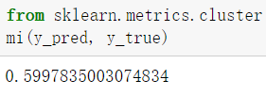

Task 2, if the local and global partitioning algorithms are both O(m), and if the global partitioning is in O(1) round it can use O(m3/2) Total work and O(1) rounds.

Task 3, as I know, for those advanced sample methods, most of them perform on GNN. For example, the graph pooling methods or a readout layer are always used for sub-graph generation or get higher representation of graph.

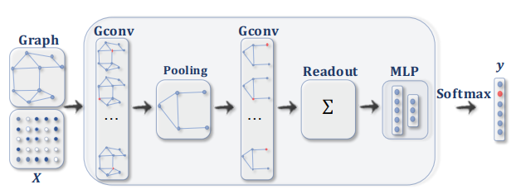

Above is a ConvGNN with pooling and readout layers for graph classification. A graph convolutional layer is followed by a pooling layer to coarsen a graph into sub-graphs so that node representations on coarsened graphs represent higher graph-level representations. A readout layer summarizes the final graph representation by taking the sum/mean of hidden representations of sub-graphs.

Reference:

[1] Z. Wu, S. Pan, F. Chen, G. Long, C. Zhang and P. S. Yu, "A Comprehensive Survey on Graph Neural Networks," in IEEE Transactions on Neural Networks and Learning Systems, vol. 32, no. 1, pp. 4-24, Jan. 2021, doi: 10.1109/TNNLS.2020.2978386.

[2] https://karateclub.readthedocs.io/en/latest/