# Home page: fully understand the basic profile and logo of the website

QM Resources\ Extra Resources\ Practice\Forum\ Search\Sign in

When you open a website, the home page is displayed, and you can click the arrow in the lower right corner to return to the top of the page.

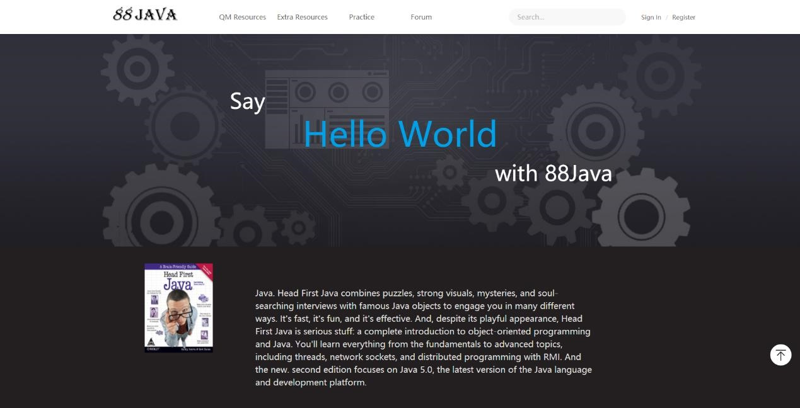

# QM Resources: weekly study materials for the in-class Java course

* QM Resources-Lessons-Slides: Java course PPT in class

The website classifies the PPT of the course by week. People can find the PPT they need and download it.

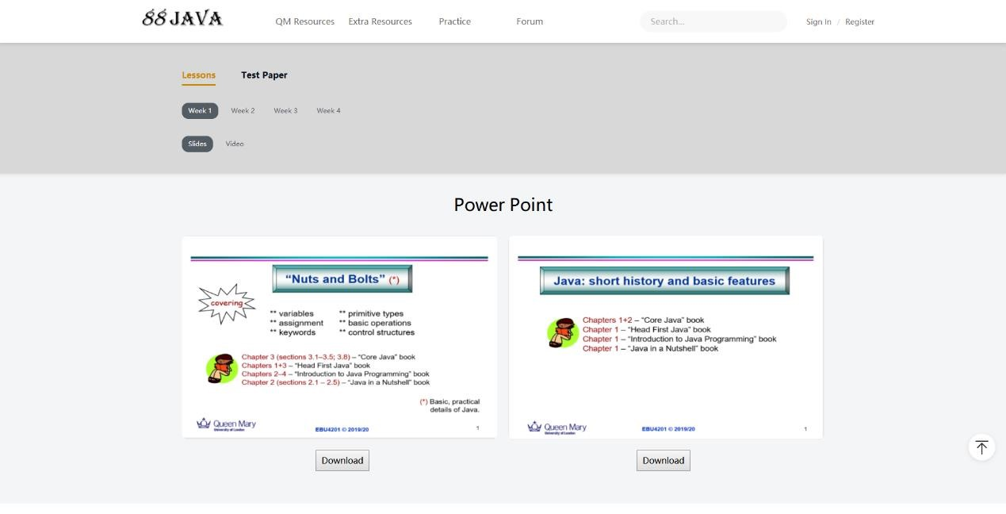

* QM Resources-Lessons-Video: Java course video in class

The website classifies the course videos according to the week, and people can watch the videos on the website according to their own needs.

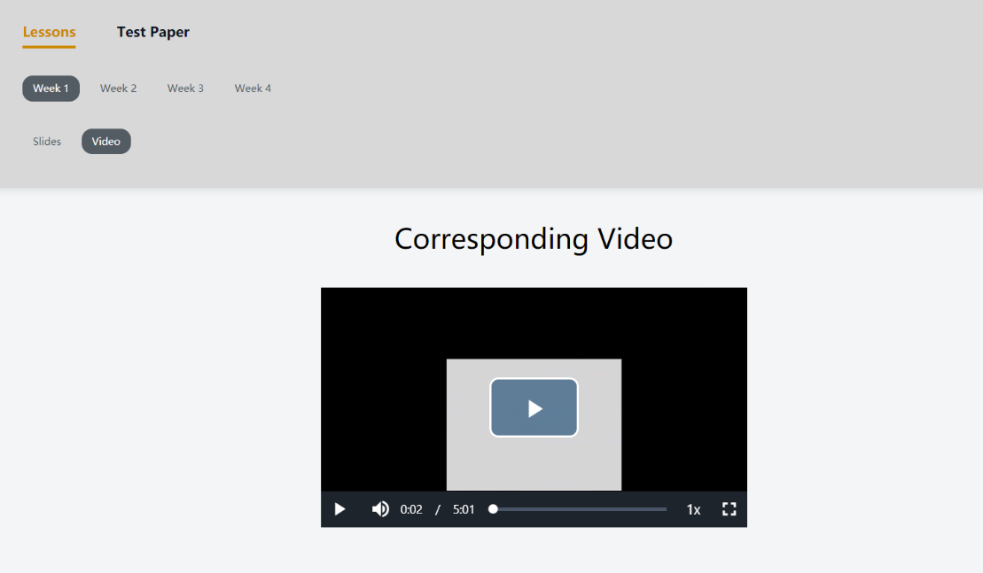

* QM Resources-Test Paper-Slide: the additional test for the Java course content in class

The website classifies the previous examination papers according to the year. Students who need to contact or review can download them

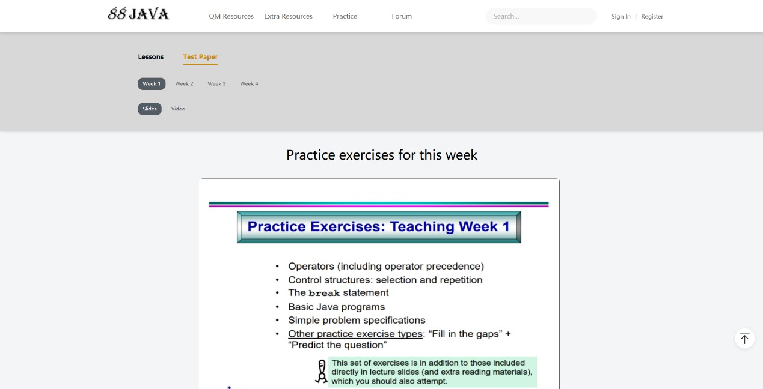

# Extra Resources: other ways to access Java learning resources are available

* Extra Resources- useful reading book

The site lists java-related books that users can choose to study for additional knowledge

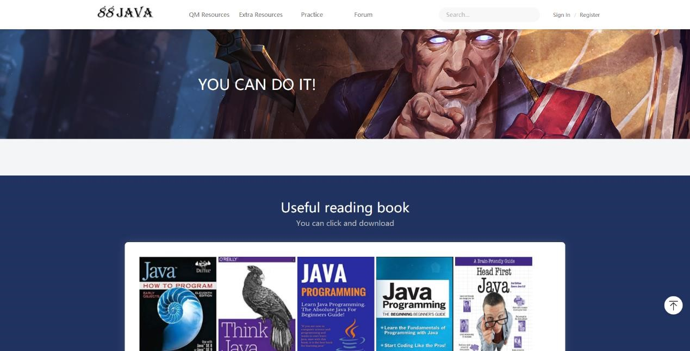

* Extra Resources- useful Websit link: click to go to the relevant Web

The website lists some java-related websites, and users can click to jump to the website directly

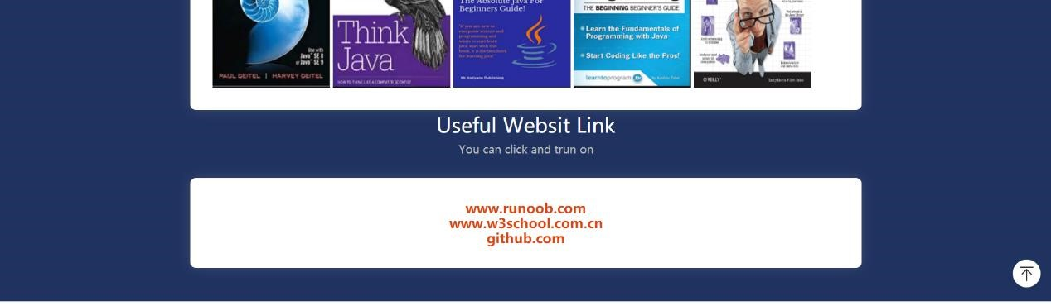

# Practice: some fill-in-the-blank questions that you can self-test

Users can choose exercises according to the learning situation of each week.

We set up two types of problem sets, choice and fill in the blanks

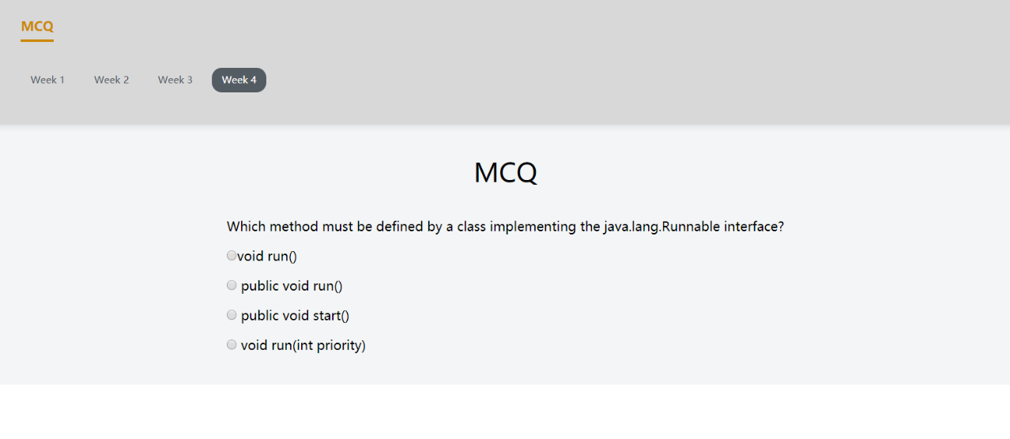

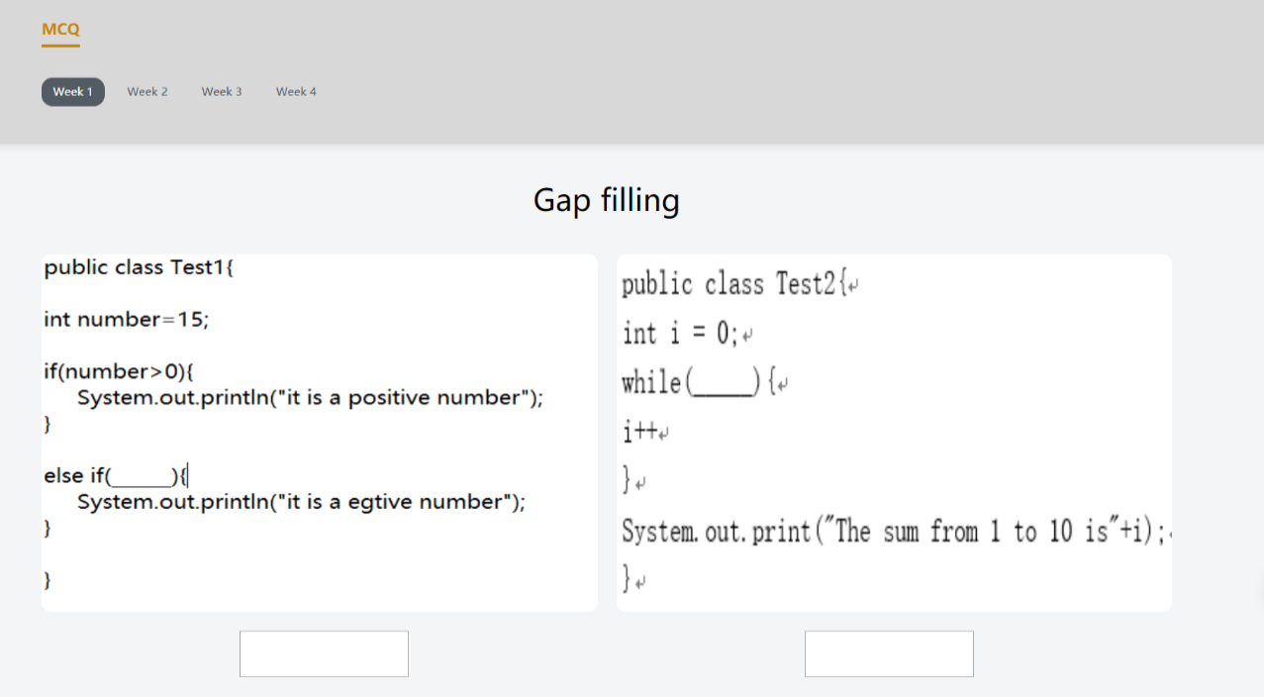

# Forum: students can add comments

Users can discuss and exchange related knowledge in this interface

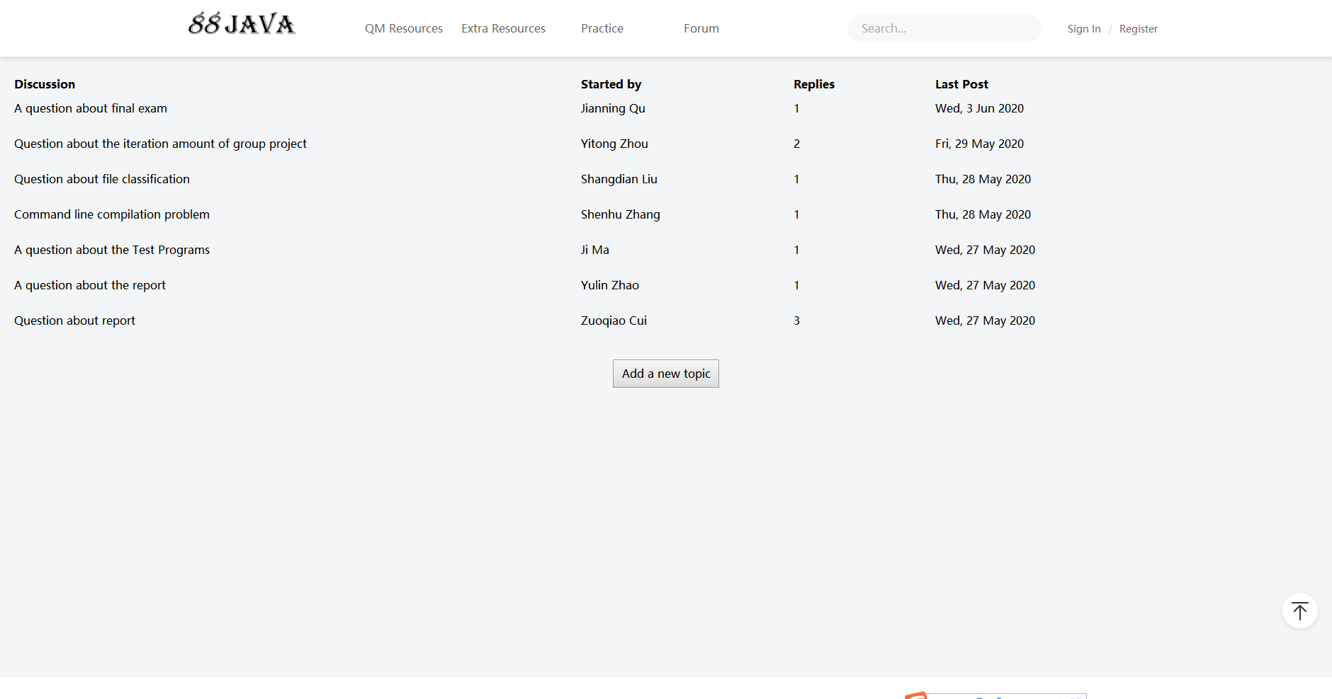

**Sign in:**

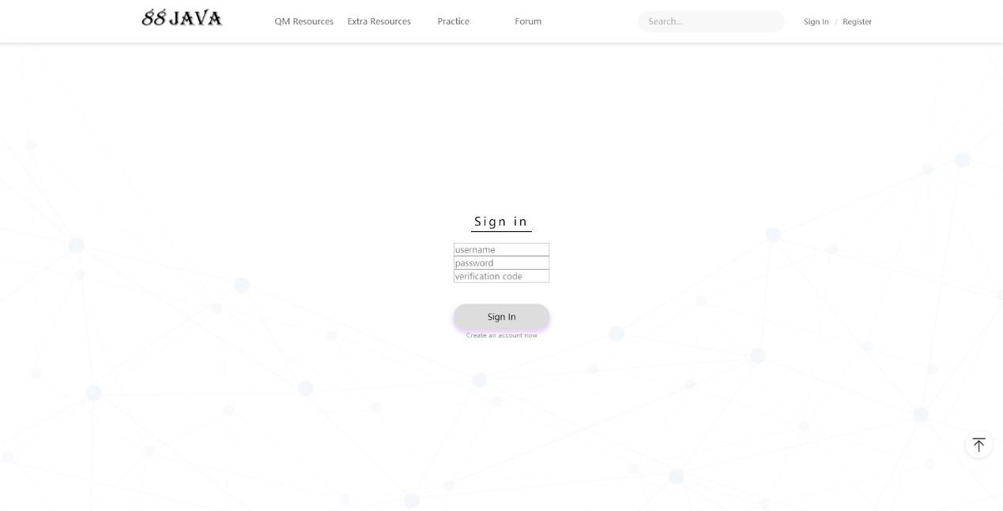

**Register:**

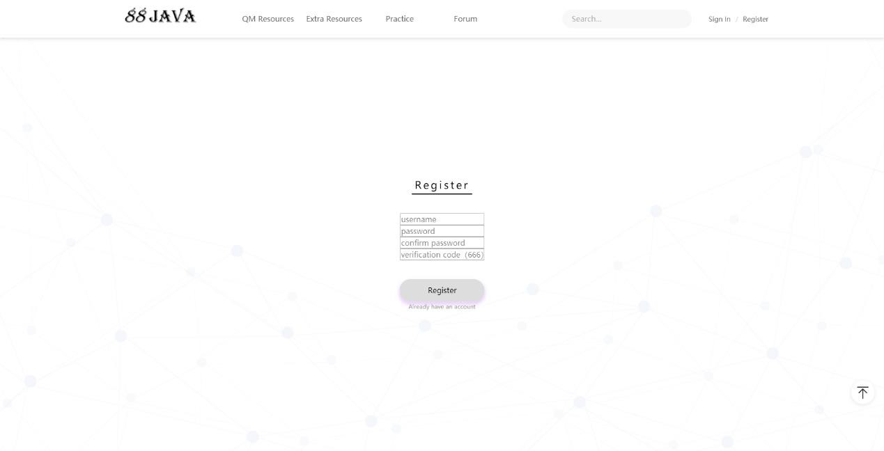

**Qr code**

* Follow our official account: scan the Qr code to follow the website related WeChat public platform

