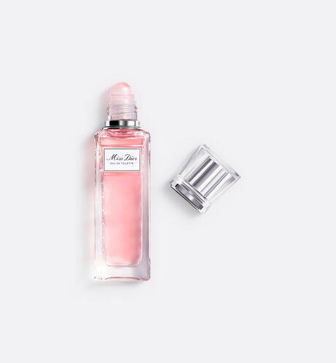

MISS DIOR

**Roller-pearl eau de toilette**

PKR 5,000

Tax Included.

Roll-On 20 mL

IN STOCK

Product Details:

Miss Dior Eau de Toilette is housed in a precious travel-friendly bottle:

the roller-pearl. The glass bottle topped with a delicate pearl delivers the captivating

and refreshing floral olfactory whirlwind with accurate and controlled

application. Sparkling zests of Blood Orange and Mandarin illuminate the top notes.

At the heart of the fragrance, a Lily of the Valley accord brings freshness and lightness to the spicy

burst of a Grasse Rose note. The base of a clear Patchouli accord brings these happy notes together

in an endless round.