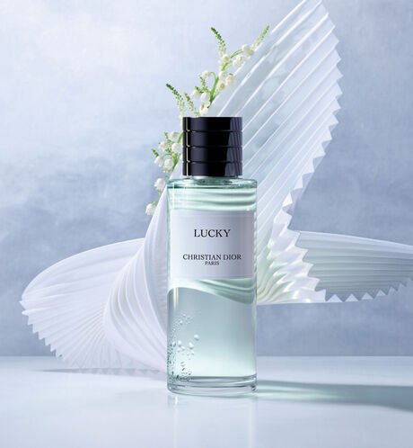

LUCKY

Fragrance

PKR 3,500

Tax Included.

IN STOCK

Product Details:

Lucky is a fragrance that plays with its white flowers and Lily-of-the-Valley notes for a subtle discovery of its scent. Lucky is a fragrance good luck charm, like a scented lucky star, the olfactory signature of luck.

Light. Behind the freshness of white flowers, the fragrance Lucky offers a glimpse of the delicate notes of Lily-of-the-Valley.