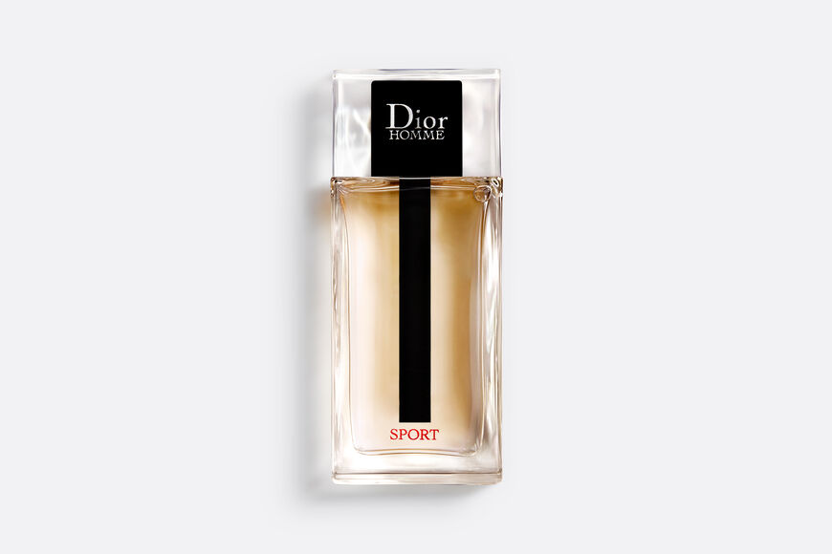

DIOR HOMME SPORT

**Eau de toilette - fresh, woody and spicy notes**

PKR 4,800

Tax Included.

IN STOCK

### Product Details:

Energetic and elegant, the new Dior Homme Sport eau de toilette combines fresh vivacity and charm tinted with sensuality for a duo that strikes like a boxer's uppercut.

The new Dior Homme Sport eau de toilette plays freshness and sensuality. It's a luminous scent enriched with a new, lasting impression that takes hold and lingers like a caress.