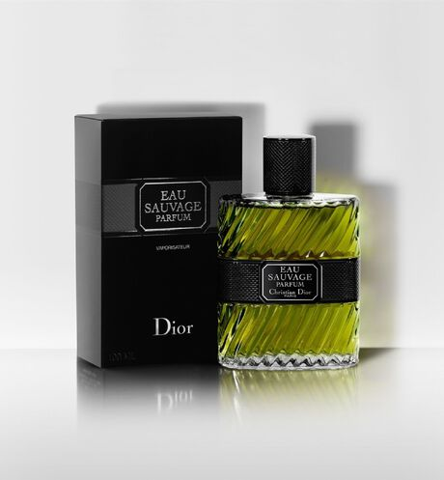

EAU SAUVAGE

**Parfum**

PKR 6,000

Tax Included.

IN STOCK

**Product Details:**

François Demachy revisits the trail of Eau Sauvage in its Parfum interpretation with a refreshed aromatic power. As powerful and sensual as ever, the composition is invigorated with a unique freshness warmed by the Grasse sun.

Deep and full, vibrant and fresh, the new Eau Sauvage Parfum enhances the solar signature of Eau Sauvage with warm and radiant accents.