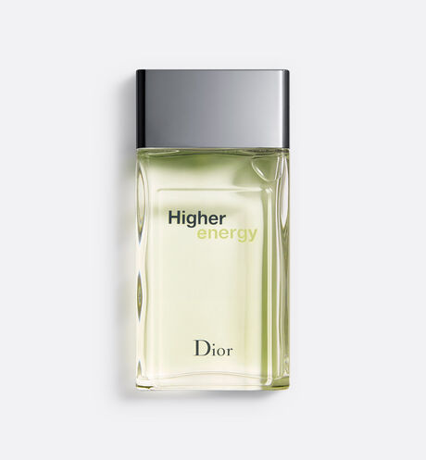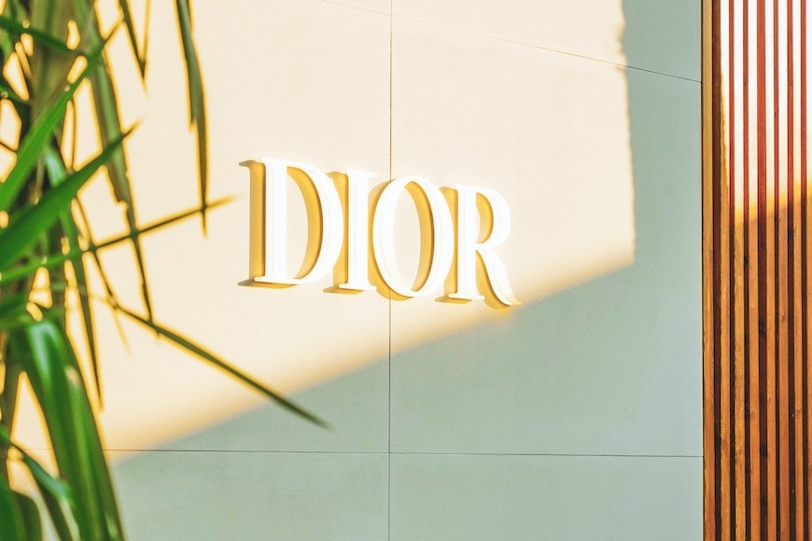

HIGHER ENERGY

**Parfum**

PKR 5,500

Tax Included.

Spray 100 mL

IN STOCK

**Product Details:**

A young, urban fragrance created for the man who is always open to new perspectives and horizons, composed around a harmony of fresh, woody and spicy notes of grapefruit, pepper and vetiver. Luminous and vibrant.