《 Individual Civilization Health Check Model White Paper v1.0》

⸻

作者： 孔维程 (Wei-Cheng Kong)

年份： 2025

License： CC0 1.0 Universal (Public Domain Dedication)

Prologue ｜ The Atoms of Civilization: From National Diagnosis to Individual Assessment

• Civilization is not made of states, but ofpeople.

• Individuals are the cells of civilization — functional, silent, or cancerous.

• Why do we need an “ Individual Civilization Health Check Model”?

⸻

Chapter 1｜Overall Framework and Foundational Logic

• The mapping between eight civilization systems and individual structures.

• The model ’ s mission: Identifying functional, silent, and cancerous individuals.

• The five structural indicators: FFI, CSI, CHS, EOI,

RUI.

• The logic and meaning of the HCCI score as a global index of contribution.

⸻

Chapter 2｜FFI: Functional Fabric Index

• Definition and purpose ofFFI.

• Eight scoring dimensions (e.g., structural awareness, pluralistic openness, cooperation).

• Explanation of each dimension (rated 1–10).

• How to calculate total FFI and interpret scores.

• Traits and values of high-FFI individuals.

⸻

Chapter 3｜CSI: Cancerous Structure Index

• What is CSI? How do we detect structural decay?

• Eight key dimensions (replication tendency, hierarchy addiction, dependency behavior …).

• How to identify domesticated personalities and structural memes.

• How the CSI total score reflects the risk level.

• How cancerous individuals replicate and infect systems.

⸻

Chapter 4｜CHS: Civilization Health Score

• CHS = FFI – CSI

• Evaluating net structural health.

• Identifying “silent cells” and neutral personalities.

• Using CHS to diagnose a society ’ s hidden structural

map.

⸻

Chapter 5｜EOI: Effectiveness ofInfluence

• Formula：

• Why a president ’s EOI is a million times greater than

’

an average person s.

• Comparison of influencers, system amplifiers, and silent individuals.

⸻

Chapter 6｜RUI: Reverse Unification Index

• ：The memetic replication power of

cancerous structures.

• Differentiating toxic influence from positive diffusion.

• How high-RUI individuals pose systemic risks.

• Mechanisms of reverse unification: linguistic colonization, hierarchy injection, emotional contagion.

⸻

Chapter 7｜HCCI: Human Civilization Contribution Index

• HCCI = CHS × RUI

• Understanding the net contribution or destruction of an individual to humanity.

• The structural meaning of high HCCI and high negative HCCI individuals.

• How HCCI identifies civilization ’ s future pillars or pathogens.

⸻

Chapter 8｜Score Levels and Structural Classifications

• Functional Cells: High FFI, low CSI, positive CHS.

• Silent Cells: Low CHS, low EOI.

• Cancerous Individuals: High CSI, high RUI, negative HCCI.

• Civilization Guardians vs. Structural Pathogens — how to recognize them.

⸻

Chapter 9｜Practical Applications

• Using this model for governance, education, and digital platform ethics.

• AI moral architecture and human input filtration.

• Civil discourse, public trust, and structural hygiene.

• Building a global immunity network: decentralized micro-diagnostics.

⸻

Chapter 10｜The Future ofIndividual Structural Awareness

• Why individuals will become the driving forces of civilizational evolution.

• Structure recognition vs. outdated morality surveillance.

• Everyone will know their “ structural identity ” within civilization.

⸻

Appendices

• Templates for assessment

• EOI Parameter Reference Index

• HCCI Case Studies (e.g., Trump, Xi Jinping, Musk)

• Structural Language Dictionary & Cancerous Meme List

⸻

 The Individual Civilization Health Check White Paper v1.0

Preface ｜Why We Need an “ Individual Civilization Health Check”

In the structural crises of the 21st century — defined by collapsing institutions, rising authoritarianism, and the fragmentation of meaning—our attention remains fixated on nations, governments, ideologies, religions, wars, and technologies.

But we often forget a deeper truth: civilization is not built by borders or rulers. It is built by people.

Every individual is a structural cell in the body of civilization. Healthy individuals form the tissue of a functioning society; unhealthy ones, like cancer cells, replicate silently — spreading decay, transmitting control, distorting institutions, and ultimately collapsing the whole.

Humanity has no standard tool to evaluate the structural health of individuals.

We can measure blood pressure, detect tumors, and assess heart function.

But we have no means to diagnose whether a person is structurally civilizationally cancerous—

whether they unconsciously reinforce hierarchy, spread ideological hatred, manipulate others, emulate tyranny, or weaken systems that sustain collective life.

Yet these are precisely the early indicators of authoritarianism, ultranationalism, mass violence, and civilizational collapse.

Just like viruses have incubation periods, structural cancer hides behind normalcy.

These individuals might be loving parents, respected “patriots,” cultural icons, CEOs, or even heads of state.

But their language patterns, emotional logic, value hierarchies, institutional behaviors, and public actions may already be silently releasing structural toxins.

Conversely, there are unnamed people—perhaps invisible — whose structure is civilizationally healthy: altruistic, open, immune to manipulation.

They may hold the seeds of our collective future.

That is why we need a systemic model — to diagnose the following questions:

• Is this person structurally healthy, silent, or cancerous?

• Are they a functional cell, a dormant cell, or a civilizational cancer?

• What is the magnitude oftheir structural influence?

• Do they possess “ reverse unification power ” that spreads, replicates, and infects entire communities?

• Have they generated a net civilizational contribution— or an exponential level of harm?

This is not just a survival tool—it is a foundational compass for the future of human selection, collaboration, governance, migration, ethics, and system design.

The Individual Civilization Health Check Model offers humanity the first structural framework to diagnose the “cellular integrity” of any person.

This is not a tool of moral judgment or political allegiance— It is a set of structural metrics,

like a blood panel quantifying health,

like a cancer screening identifying risk, like an immune map guiding adaptation.

This tool is not merely technical—it may be the beginning of our civilizational survival.

⸻

 The Individual Civilization Health Check White Paper v1.0

Chapter 1｜The Architecture and Foundational Logic of the Individual Civilizational Diagnostic Model

⸻

I. The Core Question: Why Diagnose the Civilization Health ofIndividuals?

In modern society, individuals are rarely seen as structural cells of civilization.

We evaluate IQ, emotional intelligence, income, or criminal records—but we seldom ask:

Is this person structurally beneficial to civilization?

Do their language, emotional patterns, values, and behaviors support systemic health—or corrode it?

Historically, only nations, ideologies, or institutions have been treated as units of civilizational analysis.

But in truth, civilization is not built by states—it is built by billions of individual structures. Each person is a micro-particle of civilization’s architecture.

Among them:

• Some are functional cells, strengthening shared life.

• Some are silent cells, neither harmful nor constructive.

• And some are cancerous cells, replicating toxic structures and undermining the system from within.

You cannot wait until a cancer metastasizes to begin diagnosis. You must detect it—at the level ofthe individual.

⸻

II. Civilization Is Not a Question ofValues — It Is a Question of Structural Mechanics

This model is not concerned with “good” or “bad” people. It is not a morallens. Instead, it asks structural questions:

• Does this person possess structural awareness (recognizing systems of power, language, emotion)?

• Do they tend to replicate hierarchies, suppress pluralism, manipulate narratives, or create dependency?

• Have they developed patterns of structural reproduction in thought, speech, and emotion?

• Are they using platforms like media, education, religion, politics, or family to enable structural diffusion?

These are not personality flaws—they are structural behaviors.

A person maybe morally “upright,” yet unconsciously act as a civilizational pathogen, spreading formats of control, obedience, or systemic fragility.

⸻

III. The Six Core Structural Indicators ofthe Model

We introduce six core metrics to evaluate the structural impact of any individual on civilization:

• FFI (Functional Fabric Index): Measures structural health and constructive capacity.

• CSI (Cancerous Structure Index): Identifies structural toxicity and replication risk.

• CHS (Civilization Health Score) = FFI − CSI: Captures net civilizational integrity.

• EOI (Effectiveness of Influence): Quantifies the person ’ s systemic reach and amplification power.

• RUI (Reverse Unification Index): Measures how likely the individual is to replicate harmful structures.

• HCCI (Human Civilization Contribution Index) = CHS × RUI: Final judgment of net positive or negative impact.

These indicators form a full-spectrum civilizational diagnosis. ⸻

IV. The Model’s Core Logic: A Civilizational Balance Sheet

The design philosophy is simple but powerful:

• FFIis a civilization’s structural asset.

• CSI is its structural liability.

• CHS is the net health score.

• EOI is the influence amplifier—a force multiplier of whatever structure the individual carries.

• RUI is the replication coefficient of harmful memes or behaviors.

• HCCI = CHS × RUI

→ This is how we determine whether someone is a civilization seed or a civilizational cancer. ⸻

V. The Model’s Three Breakthrough Innovations

1. A Structural Lens, Not a Moral Judgment

• It ignores status, belief, or background—and looks only at structural output.

2. Universally Quantifiable Across Roles

• An ordinary citizen maybe silent but structurally stable.

• A powerful leader, if structurally cancerous, poses exponential risk to the entire system.

3. Scalable Across Scenarios: AI, Governance, Identity, Ethics

• This model can embed into AI moral logic, civic reputation systems,

governance diagnostics, or social immune networks — building a foundation for post-nation civilization design.

⸻

VI. Civilizational Recovery Begins With Individual Diagnosis

You cannot treat a system that doesn’t know it’s sick.

You cannot rely on governments to remove every cancer.

What we need is a civilizational diagnostic tool—

a model that empowers humans to recognize, avoid, and evolve. And that is precisely what this white paper is designed to provide.

⸻

 Chapter 2｜Functional Fabric Index (FFI):

How to Measure an Individual ’ s Positive Contribution to Civilizational Structure

⸻

1. Definition and Purpose

The Functional Fabric Index (FFI) is a metric designed to assess the structural value an individual contributes to a civilization. It is not a measure of moral virtue or personal success, but rather answers this question:

“ Is this person structurally beneficial to the health and sustainability of a civilization?”

FFI evaluates whether an individual:

• Understands the underlying frameworks of power, language, and systems;

• Acts in ways that support civilizational coherence, justice, and freedom;

• Produces positive impact through cognition, communication, behavior, and cooperation.

If a civilization is a living organism, then high-FFI individuals are its neurons, red blood cells, and immune cells — they carry oxygen, deliver signals, and defend against systemic threats.

⸻

2. FFI Scoring Framework

The FFI system is composed of 8 primary dimensions, each of which can be broken into several sub-indicators. Each primary dimension is scored from 1 (very weak) to 10 (very strong).

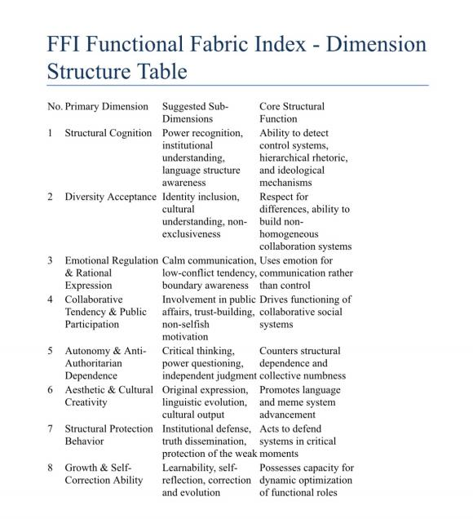

⸻

3. Sample Subdimension Evaluation

Structural Awareness Dimension (Example)

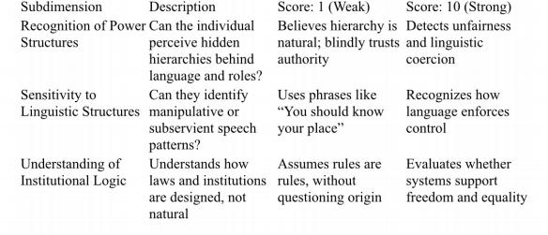

⸻

4. Total Score Calculation

Total FFI Score = Average (or weighted average) of the 8 primary dimensions.

• 8–10 points: High-functional individual, essential for civilizational health

• 5 – 7 points: Neutral or semi-functional, structurally stable

• Below 4 points: Functionally regressive or dormant (potentially silent carriers)

⸻

5. Applications ofthe FFI System

The Functional Fabric Index can be used in a wide range of scenarios:

• Civic Diagnostics: Identifying key contributors to healthy civil society (media, educators, reformers, public servants)

• AI Ethics Design: Programming structural reasoning and rational communication into autonomous systems

• Human-AI Modeling: Providing functional templates for AI to simulate cooperative and rational human behavior

• Public Trust Systems: Creating non-coercive civic evaluation tools (not for punishment, but for contribution mapping)

• Immunization of Institutions: Identifying individuals and ideas that strengthen society ’ s resistance to structural collapse

⸻

 Chapter 3: The Cancerous Structure Index (CSI) How to Detect Structural Pathologies in Individuals

⸻

I. Definition and Significance

The Cancerous Structure Index (CSI) is a structural diagnostic tool designed to identify individuals who exhibit patterns that threaten the integrity of human civilization. It evaluates:

• The replication of hierarchical and authoritarian power

structures

• The spread of emotional dependency and obedience-based worldviews

• The normalization of coercive social norms and emotional manipulation

• The erosion of institutional trust, truth, and cultural diversity

CSI does not measure malice, intent, or morality — it measures structural harm potential.

Just as a cancer cell is not “ evil ” but replicates uncontrollably and destroys its host, a structurally cancerous individual spreads toxic patterns that weaken the collective

immune system of civilization. ⸻

II. Why We Need CSI

In the modern world, structural harm is rarely inflicted through open violence or deception. Instead, it is encoded in seemingly ordinary social behaviors:

• Families that demand obedience in the name of “filial piety”

• Companies that glorify unconditional loyalty as “corporate culture”

• Online influencers who spread misogyny, nationalism, or classist values

• Educational or religious systems that declare absolute truths and eternal hierarchies

These individuals may appear ethical, respectable, or even benevolent. Yet they operate as “ civilizational carcinogens, ” spreading deeply embedded structures of control, exclusion, and domination.

⸻

III. CSI Scoring Framework (8 Dimensions)

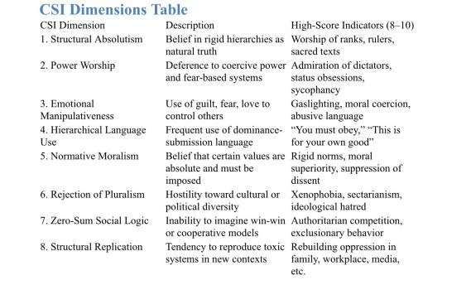

Each dimension is scored from 1 to 10, then averaged to compute the final CSI score.

⸻

IV.CSI Score Interpretation

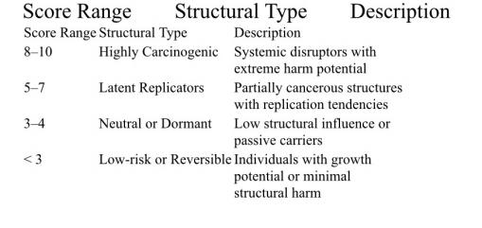

⸻

V. Structural Danger: Real-World Manifestations

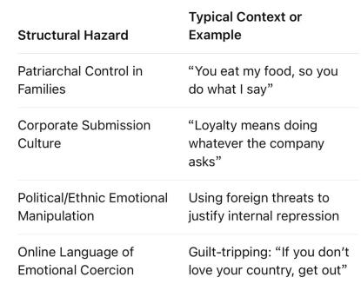

⸻

VI. The Impact ofHigh CSI Profiles

A person with high FFI and high EOI (influence) is a

civilizational builder.

A person with high CSI and high EOI is a civilizational toxin —a powerful memetic virus.

What we are facing is not just cultural regression— it is a structural pandemic, a memetic disease that hijacks platforms of family, education, media, and power to replicate itself.

To protect the future of civilization, we must:

• Detect and disrupt toxic structure carriers

• Build immunized systems for AI, governance, and civic culture

• Create social conditions where healthy structural “cells” can grow

This is not merely a theoretical model — it is a practical defense system for humanity ’s long-term survival.

⸻

Chapter 4 | CHS: Civilization Health Score

Net Assessment of Structural Functionality and Cancerous Risk

⸻

1. What Is CHS?

The Civilization Health Score (CHS) is the most direct reflection of an individual ’ s structural health within the civilization diagnostic model. It is not a raw score, but a net structural value calculated from two core indices:

\boxed{CHS = FFI - CSI}

• FFI (Functional Fabric Index): Measures how much an individual contributes to the healthy functioning of civilization through eight structural capabilities.

• CSI (Cancerous Structure Index): Assesses how much an individual replicates destructive structural patterns, such as domination, emotional control, and authoritarianism.

• CHS is neither a moral judgment nor an emotional indicator — it reflects the structural net impact of an individual.

⸻

2. Why CHS Is a Critical Indicator

In the real world, individuals often possess both constructive behaviors and structural risks. CHS allows us to:

• Assess the net structural value of an individual ’ s influence;

• Avoid confusion caused by individuals showing both functionality and toxicity;

• Guide decisions on protection, cultivation, or containment at a systemic level.

Examples:

• A political leader has high organizational skills (FFI: 6.8) but strong authoritarian tendencies (CSI: 8.2) → CHS = –1.4 → High-risk profile

• A teacher has clear structural awareness (FFI: 7.5), but uses traditional shaming language (CSI: 4.3) → CHS = 3.2 → Healthy but improvable

• A regular citizen with modest capacity but no

structural harm → FFI: 5.2, CSI: 2.1 → CHS = 3.1 → Functionally healthy

⸻

3. Interpretation ofCHS Score Ranges (–9 to +9)

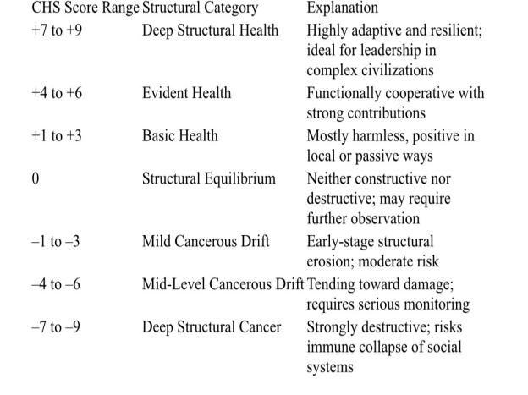

 Note: CHS reflects an individual’s net structural impact, not their social status, skill level, or morality.

⸻

4. Practical Use Cases for CHS

• Education Targeting: Identify areas where individuals need structural rehabilitation or guidance;

• Governance Models: Select functionally healthy individuals for leadership and collaborative roles;

• Risk Forecasting: Detect potential spreaders of structural toxicity or “cancerous memes” ;

• AI Filtering: Prevent language models from learning and propagating cancerous structures.

⸻

5. CHS and Its Relationship with Other Core Indices

CHS serves as a structural pivot point for higher-order assessments. It directly affects:

• An individual’s transmission power (via EOI);

• Their structural contagion potential (via RUI);

• Their net contribution to human civilization (via HCCI):

\boxed{HCCI = CHS \times RUI}

In individuals with high EOI (influence), even a small change in CHS has exponential impact.

For low-visibility individuals, CHS serves as a seed code for civilization ’s future.

⸻

 Chapter 5｜Effectiveness ofInfluence (EOI) The Real Amplifier ofCivilizational Impact

⸻

1. What Is EOI?

In real-world societies, the power of influence among individuals is far from equal. A factory worker ’s insight may never reach beyond his circle, while a leader ’s words can shape the fate of millions.

EOI (Effectiveness of Influence) is a structured index designed to measure the amplification power of an individual’s influence within the civilizational system.

It is not a measure of popularity or emotional charisma. Rather, it reflects how an individual ’s cognitive, structural, and institutional position multiplies their impact on others—especially in terms of how they transmit, replicate, or transform civilizational values and systems.

⸻

2. Final Formula ofEOI

We define EOI as an exponential amplifier model:

\boxed{EOI = (R \times C \times S \times F \times I \times L) \times T^{1.3}}

Where:

• R = Reach — Total number ofpeople influenced (10¹–10⁹ )

• C = Cognitive Penetration (0.2–0.9) — Depth of cognitive impact

• S = Structural Penetration (0.1–1.0) — Degree of institutional/systemic access

• F = Frequency × Duration (1–500) — Influence frequency and longevity

• I = Information Amplification ( 1–1000) — Power of message spread and memetic weight

• L = Leverage Position (1–1000) — Access to critical nodes of decision or visibility

• T = Network Amplification Coefficient (0.8–3.0) — Position within social-structural networks, raised to the power of 1.3to reflect exponential amplification.

⸻

3. Why Exponential? Why T^1.3?

Because in a highly networked civilization, influence is never linear. A single voice placed at the right structural node (e.g. presidency, religious platform, algorithm control, AI training source) can scale its impact by orders ofmagnitude.

Exponentiating the T factor mimics this nonlinear explosiveness. A difference between T = 1.0 and T = 2.5can produce dozens or thousands oftimes more downstream effect, even with identical base factors.

⸻

4. Real-World Examples

Let’s compare three different individuals with different structural roles:

 ADictatorial Leader

• R = 100million

• C = 0.85

• S = 0.95

• F = 300

• I = 800

• L = 950

• T = 2.8

EOI \approx (1e8\times 0.85\times 0.95\times 300\times 800\times 950) \times 2.8^{1.3} \\ EOI \approx 1.84\times 10^{17}

 A Social Philosopher with Modest Visibility

• R = 10,000

• C = 0.9

• S = 0.4

• F = 120

• L = 80

• T = 1.2

EOI \approx (10^4\times 0.9 \times 0.4 \times 120\times 200\times 80) \times 1.2^{1.3} \\ EOI \approx 6.63\times 10^8

 AFactory Worker

• R = 100

• C = 0.5

• S = 0.2

• F = 10 • I = 5 • L = 2

• T = 1.0

EOI \approx (100\times 0.5 \times 0.2 \times 10\times 5\times 2) \times 1.0^{1.3} \\ EOI \approx 100

 This shows a 10⁹ to 10¹5 -fold difference in real-world influence. These structural disparities matter more than moral intentions alone.

⸻

5. EOI ≠ Value

But It Decides How Much That Value Matters

EOI alone does not judge whether someone spreads truth or toxicity. But it determines how far and how deeply their ideas penetrate society.

Which is why EOI must always be read together with CHS (Civilization Health Score).

• High CHS × High EOI → Civilizational Beacon

• Negative CHS × High EOI → Civilizational Threat

• High CHS × Low EOI → Hidden Seeds

• Low CHS × Low EOI → Dormant or non-impactful

⸻

6. Applications ofEOI

• Early Warning System: Detect high-EOI individuals spreading structural toxicity

• Strategic Ally Recognition: Find civilizational builders hidden in low-power zones

• AITraining Filters: Avoid modeling on high-EOI cancerous voices

• Ethical Governance Tool: Allocate attention and amplification based on HCCI, not just EOI

⸻

7. Reminder: Low EOI ≠ Worthless

EOI only tells us the current amplification potential.

It says nothing about the inherent civilizational value of a person’s structure or insight.

Many of the most structurally healthy individuals live in silence. The future of civilization may depend notjust on volume—but on how we amplify the right voices.

⸻

Chapter 6｜RUI: Reverse Unification Index

Measuring the Spread Intensity of Structural Cancer in Civilization

⸻

1. What Is RUI?

The Reverse Unification Index (RUI) is a quantitative metric designed to assess how strongly an individual is spreading their internal structural cancer — in the form of harmful memes, authoritarian logic, or coercive systems — into the external world.

It is not a static trait. Rather, RUI reflects a dynamic pattern of diffusion and systemic contagion.

It is derived from two key components:

• CSI (Cancerous Structure Index): measures how structurally pathological an individual is.

• EOI (Effectiveness of Influence): measures how effectively the individual amplifies their influence.

• RUI = CSI × EOI × Amplification Factor: together, they define how virulently the structural cancer spreads.

RUI indicates not just what a person is, but how far their toxicity reaches.

⸻

2. Why “Reverse Unification”?

Civilization normally seeks unity through empathy, cooperation, and mutual development.

But reverse unification refers to the opposite process: a

dangerous, deceptive kind of unity built on fear, domination, and control.

Such structures replace:

• Equality → with hierarchy

• Freedom → with coercion

• Diversity → with assimilation

• Dialogue → with propaganda

• Trust → with surveillance and shame

We call this “ reverse unification ” — a process of consolidating power by destroying structural health.

RUI is the index that quantifies this destructive force. ⸻

3. The Exponential Nature ofRUI & Its Risk Levels

RUI is not linear. Like radiation or viral transmission, its threat increases exponentially with amplification.

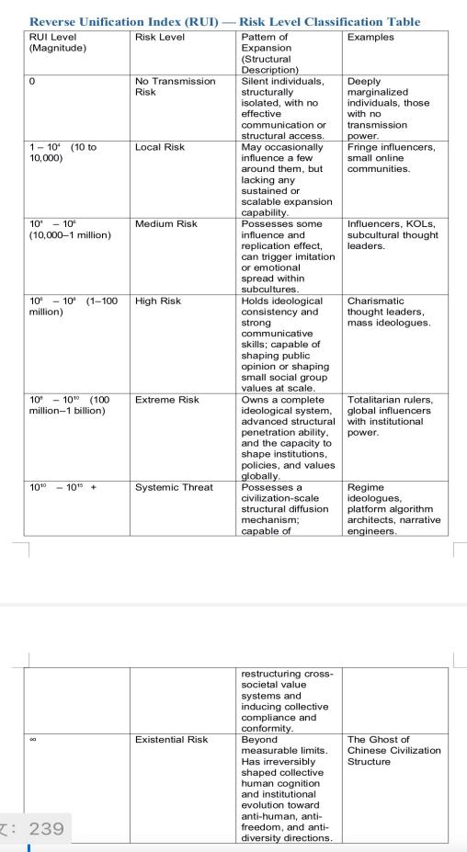

4. Real-World Case Study: RUI in Action

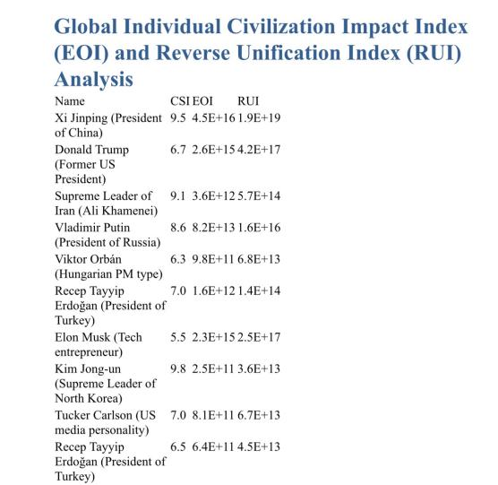

Note: CSI = Cancerous Structure Index; EOI = Expansion of Influence Index; RUI = Reverse Unification Index.

Interpretation Summary:

y Xi Jinping (President of China) – Systematic structure spreader, strong regime dissemination, high leverage risk

y Donald Trump (Former US President) – Emotionally

contagious structure virus spreader with high influence and chaos amplification

y Supreme Leader of Iran (Ali Khamenei) – Highly centralized structural model promoter

y Vladimir Put in (President of Russia) – Authoritarian and order-oriented, high structural persistence

y Viktor Orbán (Hungarian PM type) – European structural conservatism rebuilder

y Recep Tayyip Erdoğan (President of Turkey) – Promotes national identity and civilizational homogenization

y Elon Musk (Tech entrepreneur) – Structural eccentric, influential yet risky

y Kim Jong-un (Supreme Leader of North Korea) – Highly toxic structural figure, deep structural pollution

y Tucker Carlson (US media personality) – Deep structure conservative, systemic dissemination risk

y Recep Tayyip Erdoğan (President of Turkey) – Religious conservatism combined with political structure propagation

 Note: RUI becomes a true threat only when CHS (Civilization Health Score) < 0, meaning the person is structurally harmful.

⸻

5. Strategic Applications ofRUI

RUI is not merely a theoretical construct—it can directly aid governance, AI design, and civil resilience.

•  AI Model Curation: Avoid training models on high-RUI data sources

•  Media Risk Monitoring: Track public figures who are structural spreaders

•  Civilizational Mapping: Visualize risk hubs and meme propagation

•  Immunity Design: Build filters for cancerous idea transmission

⸻

6. RUI in the Larger Civilizational Equation

RUI connects directly to the broader HCCI (Human Civilization Contribution Index):

RUI = CSI × EOI \times \left( 1 + \frac{CSI \cdot EOI^{0.1}}{10}\right)

Which feeds into:

\textbf{HCCI} = CHS \times RUI

This reveals a powerful insight:

A structurally cancerous individual with high influence (high EOI) is not just dangerous — they are civilizationally catastrophic.

⸻

Conclusion

RUI helps us understand a critical asymmetry in modern society: influence is not neutral. When power spreads dysfunction, it doesn’t merely corrupt—it metastasizes.

We must build awareness and immune systems for civilization, before the spread becomes irreversible.

⸻

Chapter 7 ｜ HCCI: The Human Civilization Contribution Index

Measuring the net contribution or destruction an individual brings to human civilization

⸻

1. What Is HCCI?

The Human Civilization Contribution Index (HCCI) is the highest-level composite indicator in this model. It is designed to quantify the real, structural impact a human individual has on the overall system of human civilization throughout their lifetime.

Rather than judging behavior or morality, HCCI evaluates:

• The internal structure of an individual (via FFI and CSI),

• The external influence of their reach and impact (via EOI),

Resulting in a clear classification of whether the person is:

• v A pillar of civilization (positive HCCI, high score),

•  A neutral bystander (HCCI ≈ 0),

• X A civilizational cancer spreader (negative HCCI, low or extremely negative score).

Importantly, HCCI is not a moral label, but a structural measure of one ’ s cumulative impact on the trajectory of humanity.

⸻

2. HCCI Calculation Formula

\text{HCCI} = (FFI - CSI) \times \left[ CSI \times EOI \times \left( 1 + \frac{|CSI| \times EOI^{0.1}}{10} \right) \right]

Where:

• FFI (Functional Fabric Index): measures the constructive, healthy structure.

• CSI (Cancerous Structure Index): measures structural corruption and systemic harm.

• EOI (Effectiveness of Influence): measures the actual impact an individual ’s ideas/actions have across networks.

So in essence:

HCCI = Civilization Structural Health (CHS) × Toxic Expansion Capability (RUI)

(See Chapters 3–6 for detailed definitions of each sub-index.) ⸻

3. How to Understand HCCI?

HCCI is not a “behavioral morality score. ” It ’s a quantified structural impact index:

• A person with high FFI, low CSI, and strong influence (EOI) → has a large positive HCCI.

→ They drive progress, expand knowledge, strengthen trust systems.

• A person with high CSI, strong dissemination power, and system-corrupting actions → has a large negative HCCI.

→ They are “civilization black holes.”

In other words:

HCCI tells us whether someone is the hope or the hazard of humanity.

⸻

4. The Structural Meaning of High and Low HCCI Individuals

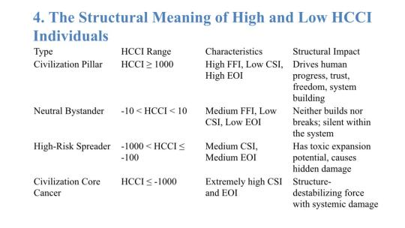

5. Illustrative Examples (Simulation Data Only)

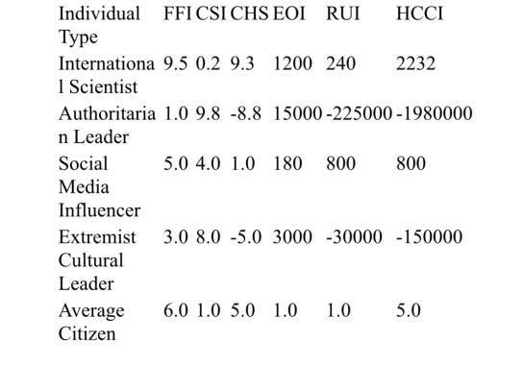

⸻

6. Applications and Future Significance ofHCCI

•  Civilization Pillar Identifier: Identifies future builders of humanity.

•  Systemic Cancer Detection: Flags structural “cancer memes” and their human carriers.

•  AI / Information Safety Filter: Filters out high-risk HCCI-negative content from AI training data.

•  Civilizational Reproduction Guidance: Informs societal decision-making regarding inheritance, power, and parenting models.

•  Civilization Immune System Core Index: Evaluates

if humanity is evolving or degenerating. ⸻

7. Overview ofHCCI ’s Component Relationships

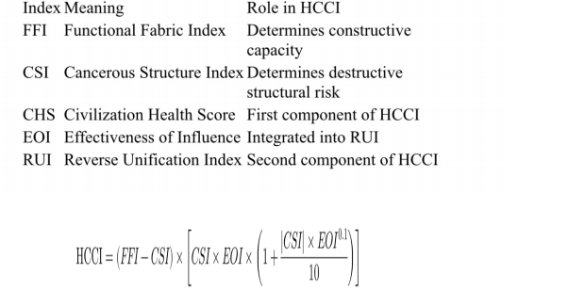

⸻

Chapter 8 ｜ Grading Levels and Individual Structural Classification

Civilization is not an abstract concept — it is a structural entity collectively shaped by individuals through their ways of living, thinking, and communicating.

One of the key purposes of this model is to identify different types of “ civilizational cells ” using a systematic structural classification method, enabling more accurate assessments of both risks and hopes within the global civilization ecosystem.

⸻

1. Functional Cells: The Fundamental Units of Civilizational Health

Functional cells are defined as individuals with high FFI (functional fabric index), extremely low CSI (cancerous structure index), a positive CHS (civilizational health score), and a positively directed EOI (effectiveness of influence).

They typically possess the following features:

• Internally coherent structures that do not rely on oppression, hierarchy, or fear to maintain order;

• The information they transmit tends to be enlightening, transparent, and constructive;

• Even if their influence is limited, their overall HCCI (Human Civilization Contribution Index) remains positive.

Functional cells are the most foundational and valuable building blocks of a healthy civilization. They represent the vast number of “ silent contributors” who maintain structural integrity without drawing attention.

⸻

2. Silent Cells: Latent Risks Within the Civilizational System

Silent cells are individuals whose CHS is low to neutral, with both FFI and CSI at minimal levels, and whose EOI is nearly negligible (minimal transmission capacity).

Their characteristics include:

• They do not actively spread structural memes;

• They pose no direct harm, but also do not contribute structurally to civilization;

• They are often found in suppressive environments — such as authoritarian families, hierarchical cultures, or tightly

controlled nations.

Silent cells are like dormant or atrophied cells within the body—currently non-toxic but structurally inactive. Without systemic change, they may degenerate into cancerous structures over time.

⸻

3. Cancerous Individuals: High-Risk Structural Spreaders

Cancerous individuals exhibit highly consistent and dangerous traits:

• Extremely high CSI: Their internal structure relies on hierarchy, control, shame, or fear;

• Extremely high EOI: They possess powerful tools, positions, or algorithms for dissemination;

• Extremely high RUI: They facilitate meme-like “structural colonization” ;

• Extremely negative CHS: Their internal structure and external influence both pose severe threats;

• Extremely negative HCCI: They cause measurable harm to the human civilizational system.

These individuals are not isolated anomalies, but often products of repeated structural failures. They frequently appear as authoritarian politicians, extremist media figures, cult leaders, or symbols of oppressive culture.

Their danger lies not only in their personal actions but in their exponential diffusion of structural pollution—causing functional cells to degrade and silent cells to mutate into cancerous forms.

⸻

4. Civilizational Guardians vs. Pathogens: How to Identify Them?

Civilizational Guardians

• High FFI, low CSI;

• High CHS, strong transmission power (EOI);

• RUI reflects positive structural exports, promoting de-hierarchization, transparency, and emotional respect;

• High HCCI.

They are the core of civilization ’s immune system, resisting structural decay and helping restore systemic health.

Civilizational Pathogens

• High CSI, high RUI;

• High influence, but content represents structural pollution;

• Their influence leads others to become repressed, submissive, and intellectually passive;

• Extremely negative HCCI.

Pathogens are not defined by opinions or ideologies, but by structural mechanisms.

Ask:

• Do they induce fear?

• Do they spread shame?

• Do they substitute hierarchy for equality?

• Do they suppress others ’ freedom of expression?

These are the core tools to identify those who harm civilization not by belief—but by structure.

⸻

Chapter 9｜Application Scenarios of Structural Diagnostics Real-World Uses of Individual Civilization Profiling and the Path to a Global Immune System

⸻

1. National Governance: Identifying Risk Individuals and Civilizational Pillars

At the national level, this structural profiling model offers a civilizational leap from outdated ideological screening toward structural health assessment.

• Functional cells can be appointed to critical roles — judges, educators, researchers, and institutional designers;

• Cancerous individuals (high CSI, high EOI, negative HCCI) should have their public transmission power structurally restricted;

• Unlike traditional measures of political loyalty, this model provides a quantitative, structural, and cross-cultural evaluation framework.

Case Insight:

In a certain East Asian nation, “ obedience ” and “ stability ” have long been the criteria for public office, leading to high-CSI individuals monopolizing institutional power.

By introducing structural diagnostics, these hidden cancer sources can be exposed to the light.

⸻

2. AI Ethics and Personality Safety Mechanisms

As AI becomes a generator of content, amplifier of discourse, and agent of governance, its personality structure becomes an extension of civilization.

• This model can filter training data by eliminating high-RUI texts (structural pollutants);

• It can score the AI ’s output based on FFI–CSI profiles, preventing the rise of “cancerous personality algorithms” ;

• For future sentient-level AI, this framework could be embedded as a civilization immune core.

Warning Scenario:

An AI system that persistently disseminates hierarchical memes and emotional manipulation techniques—with high EOI — would no longer be a glitch, but a civilizational catastrophe in structural form.

⸻

3. Public Discourse, Education Filtering, and Institutional Anti-Corruption

• Media domain: Identify high-RUI media figures or content sources to prevent them from becoming structural pollutants;

• Education systems: Eliminate high-CSI, high-RUI individuals who act as “ structural domestication agents, ” and cultivate functional cells as true seeds of civilization;

• Anti-corruption systems: Detect latent malignancy in individuals with toxic internal structure and amplified institutional leverage, preempting covert decay.

Rather than punishing corruption, extremism, or hatred after they erupt, this model enables structural early warning and

systemic prevention. ⸻

4. Building a Global Civilizational Immune Network

The ultimate goal is to establish a civilization immune network — from individual cells to systemic screening to global collaborative defense:

• Every individual can undergo a self-diagnostic scan, identifying structural risks and their civilizational identity;

• Every organization, nation, and system can implement screening protocols to prevent RUI-based cancer spread;

• A global open database can construct a “ civilizational transmission map ” and “ meme immunization atlas, ”

enabling real-time tracking of high-risk spreaders.

Vision:

To trap the civilizational cancer cells within the framework of structural recognition—

Not let them assimilate the world through language, status, or unchecked power.

⸻

Summary

This structural diagnostic model is not just a tool oftheory— It is a practical path toward civilizational self-defense.

It does not aim to replace freedom, but to build its immune layer.

In the end, every individual and every system must confront one essential question:

Are you a contributor to civilization—or a destroyer? ⸻

Chapter 10｜Future Outlook: The Meaning ofIndividual Civilization Profiling From Structural Awareness to Civilizational Awakening

⸻

1. Individuals Will Become the Key Variable ofCivilizational Evolution

In the industrial and information eras, individuals were often seen as objects of governance rather than as builders of civilization. Nations, institutions, ideologies, markets, and media played the central roles in shaping reality — while individuals drifted like passive particles in a massive structural current.

But in the age of structural transparency and civilizational profiling, each person becomes either a

functional cell or a cancerous propagator within the ecosystem of humanity.

When humanity begins to realize that the true drivers of civilizational health are not slogans, GDP, or ideological façades—but the structural properties and diffusion mechanisms of each individual —then the center ofgovernance will shift from the nation-state to the individual structure.

From top-down commands to bottom-up immune logic.

The fate of civilization will ultimately rest on each human being. ⸻

2. Structural Recognition Will Replace Ideological Policing

Today’s world is trapped in the illusion of a “war of values.” Left vs. right.

Freedom vs. authoritarianism. Nationalism vs. globalism.

Cultural identity vs. political correctness.

It seems every debate demands a side before it allows a thought.

But this is a low-efficiency, emotion-driven, symbol-based way ofgovernance.

The structural civilization profiling system operates on a completely different logic. It doesn’t care whether you call yourself liberal, conservative, progressive, or traditional. It asks:

• Do you propagate structural violence?

• Do you spread controlling memes?

• Does your influence reinforce social hierarchy and rigidity?

• Do your actions diminish others’ structural freedom and health?

This system does not judge your beliefs, but evaluates you as a structural entity—what you enact, spread, or destroy.

For the first time in history, human civilization may transcend value-based censorship and enter an era of structural recognition.

⸻

3. Everyone Will Know Their “Structural Identity” Within Civilization

Structural recognition is notjust for analyzing others— It is a mirror for each ofus.

Are you a functional cell?

Do you unconsciously replicate fear memes, shame triggers, or hierarchical language? Are you becoming a silent cell drifting toward cancerous patterns?

Or are you consciously transmitting freedom, transparency, mutual aid, and healthy structure?

In the future, every person will possess a civilization identity code—CHS, EOI, RUI, HCCI. You will no longer be defined by your degree, title, or wealth, but by one core question:

What have you structurally contributed to human civilization? ⸻

4. The Rise of Structural Civilization: From Identity Politics to Structural Politics

Traditional politics is obsessed with identity: race, nation, gender, religion. But this fixation has generated endless division and blind spots.

Structural politics, by contrast, asks:

• Who truly holds structural leverage?

• Who is silently disseminating cancerous memes?

• Who is conducting structural colonization — through technology, neutral language, aesthetics, or education?

It no longer matters who you are, but how you exist—

What your structure is doing to the civilization it inhabits.

In this new age of structural civilization, the central question becomes: Is this person / group / content a functional cell, or a cancerous spreader? ⸻

5. The Final Key to Civilizational Survival: Individual Awakening and Functional Activation

If institutions fail, media is corrupted, and education is co-opted— Who is left to save civilization?

There is only one answer: the individual.

When enough individuals reject the illusion that “silence equals neutrality,” When they take conscious responsibility for their structural roles,

When they assess their internal integrity, detect meme pollution, and spread healthy systems— Only then can a civilization immune system be born.

In the end, it will not be heroes, leaders, political parties, or revolutions that save us—

But millions of structurally awakened individuals.

This is the last self-rescue pathway for human civilization.

🌍 Civilization Corpus · 文明全集

Author: Wei-Cheng Kong (WK 孔维程)

License: CC0 1.0 Universal (Public Domain Dedication)

🔗 Permanent Mirrors

• GitHub Pages (Master Entry):

https://wk-26.github.io/Civilization-Axioms-and-Immune-System-/

• GitHub Repository:

https://github.com/wk-26/Civilization-Axioms-and-Immune-System-

• Internet Archive:

https://archive.org/details/a-new-civilization-for-humanity-cc-0

• Zenodo (DOI, all versions):

https://doi.org/10.5281/zenodo.16980277

Any existence that refuses to recognize the immune principle

walks toward cancer and self-destruction.

任何拒绝免疫原理的存在，必然走向癌化与自毁。