

**Intelligent Manhole Cover system**

Code Document 2



2021-4-11

Wenzhou-Kean University

Rui Wang 1064083

Xuanyu Pan 1063964

Zehong Ye 1064167

Zeyu Guo 1063769

Zhihao Zhao 1064238

Index

1 Improvements 2

1.1 Framework 2

1.2 RAM access management 2

1.3 User Interface 2

2 New Features 3

2.1 ESP8266 module connects to Arduino board 3

2.2 Data Integration 4

3 Deletion 4

Relative Document: 5

# Improvements

## Framework

Our development framework has changed from Arduino + Android Studio + Aliyun server to Arduino + Ali IoT Studio + Ali IoT, which makes our development process easier, more flexible and faster. The Ali IoT platform and Ali Studio encapsulate application development and device interaction, simplifying the project development process, which helps us to avoid risks effectively.

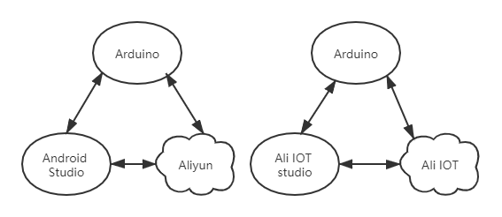

Figure 1: Previous Framework (Left), Current Framework (Right)

## RAM access management

To better assign roles among group members, we created RAM sub-accounts for each user in the Aliyun platform and assigned permissions within their responsibilities to these accounts.

## User Interface

Based our previous interface, we transferred it to the IoT Studio platform, and optimized it massively.

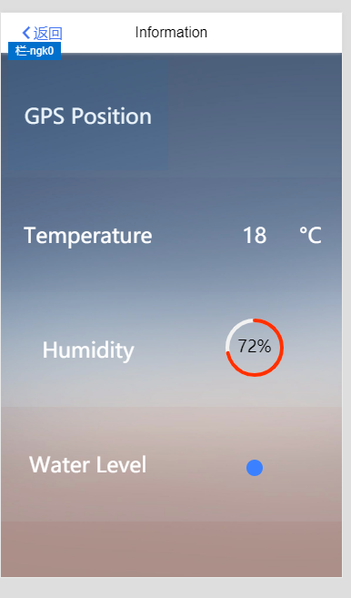

Figure 2: Ali IOT Studio offer a huge mount of resources, which make our Android UI more elegant.

# New Features

## ESP8266 module connects to Arduino board

We connected the esp8266 and Arduino via serial port and designed the specification for sensor data processing. The information is transferred from the Arduino to the esp8266 side through the format of identification code + data + end code as follows:

|  |  |  |  |
| --- | --- | --- | --- |
| ESP8266-Arduino Transferring Specification | | | |
| Message | Identification Code | Data | End code |
| Temperature | T | Float (-40.0 ~ 55.0) | ; |
| Humidity | H | Int32 (0 ~ 100) |
| Water level | W | Enum (E, L, M, H) |

Source Code:

<https://github.com/WKU-CPS4951/Intelligent-Manhole-Cover-System/blob/main/esp8266.ino>

<https://github.com/WKU-CPS4951/Intelligent-Manhole-Cover-System/blob/main/humidity_temperature_waterLevel/humidity_water_level.ino>

## Data Integration

We successfully connected Arduino to Aliyun platform and sent sensor data to Aliyun platform, and implemented real-time monitoring of these data in Android client UI interface.

# Deletion

We removed the code in Android Studio and server side and used Aliyun service instead.

# Relative Document:

Proposal:

<https://github.com/WKU-CPS4951/Intelligent-Manhole-Cover-System/blob/main/Documents/Proposal1.0.pdf>

Software Requirement Specification:

<https://github.com/WKU-CPS4951/Intelligent-Manhole-Cover-System/blob/main/Documents/SRS1.0.docx>

System Design Document:

<https://github.com/WKU-CPS4951/Intelligent-Manhole-Cover-System/blob/main/Documents/SDD1.0.docx>

Code Documentation:

<https://github.com/WKU-CPS4951/Intelligent-Manhole-Cover-System/blob/main/Documents/document.docx>