

**Intelligent Manhole Cover system**

Code Document 3



2021-4-25

Wenzhou-Kean University

Rui Wang 1064083

Xuanyu Pan 1063964

Zehong Ye 1064167

Zeyu Guo 1063769

Zhihao Zhao 1064238

Index

1 New Features 2

1.1 GPS Positioning Function 2

1.2 Web-based Application Access 2

1.3 Android Application Access 3

Relative Document: 4

# New Features

## GPS Positioning Function

The product adds GPS positioning function, which can monitor the position of the manhole cover in real time by getting the coordinates of the cover, so as to achieve the purpose of preventing theft.

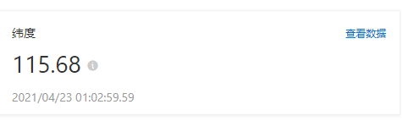

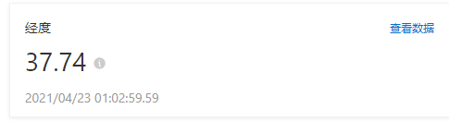

Figure 1: Latitude and Longitude

## Web-based Application Access

For the application administrators, we provide a web site for them to access, where they can monitor the position of the manhole cover, water level, temperature, and humidity indicators in real time.

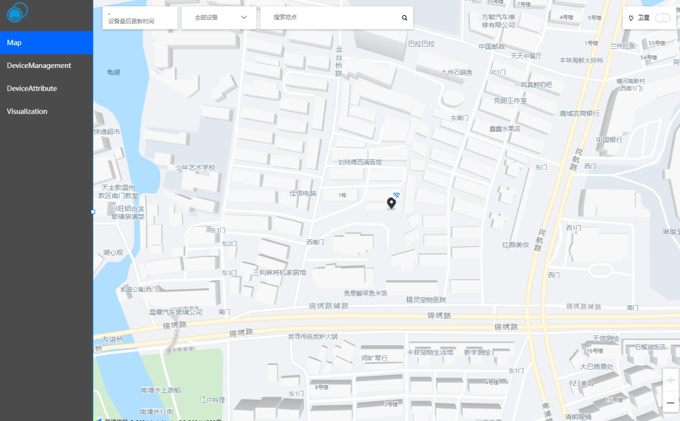

## Android Application Access

For the convenience of our users, we have developed Android applications for their use.

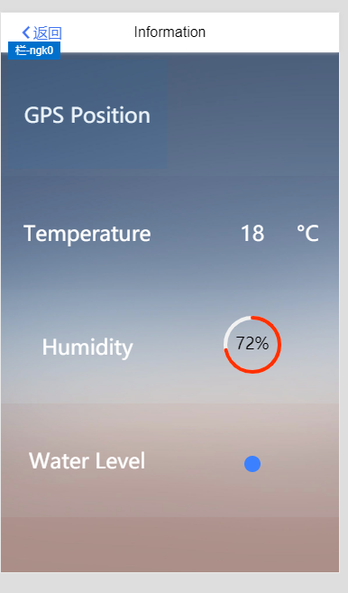

Figure 2: Ali IOT Studio offer a huge mount of resources, which make our Android UI more elegant.

# Relative Document:

Proposal:

<https://github.com/WKU-CPS4951/Intelligent-Manhole-Cover-System/blob/main/Documents/Proposal1.0.pdf>

Software Requirement Specification:

<https://github.com/WKU-CPS4951/Intelligent-Manhole-Cover-System/blob/main/Documents/SRS1.0.docx>

System Design Document:

<https://github.com/WKU-CPS4951/Intelligent-Manhole-Cover-System/blob/main/Documents/SDD1.0.docx>

Code Documentation:

<https://github.com/WKU-CPS4951/Intelligent-Manhole-Cover-System/blob/main/Documents/document.docx>

<https://github.com/WKU-CPS4951/Intelligent-Manhole-Cover-System/blob/main/Documents/document2.docx>