Basic Board Checkout

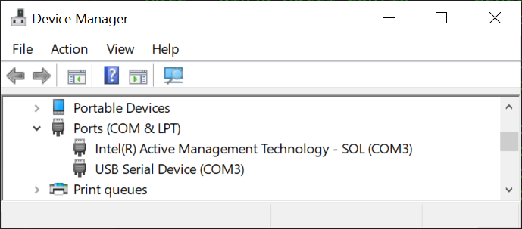Open the Device Manager, and select “Ports” to see something like this:

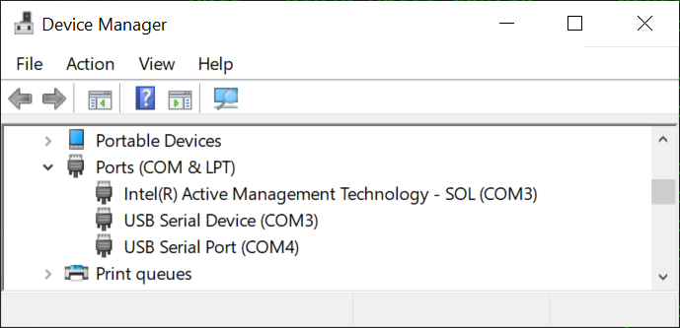Plug in the Device, and it should update to show something like this:

In this case, L1IFStream shows up as COM4. This is a good sign. The device should only register a single COM port in the device manager.

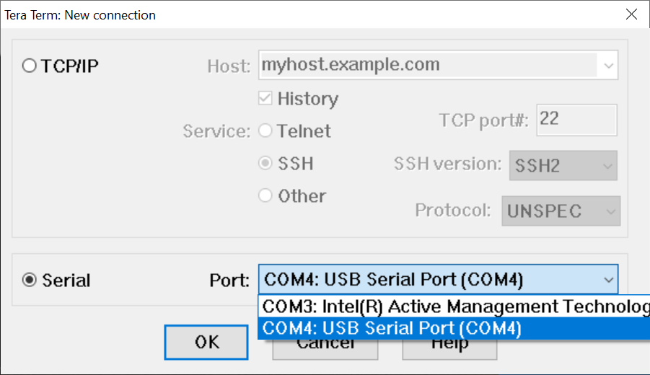Now open Tera Term, select the 🞊Serial option, and pull down the Port selector to highlight the appropriate device port, COM4 in the example:

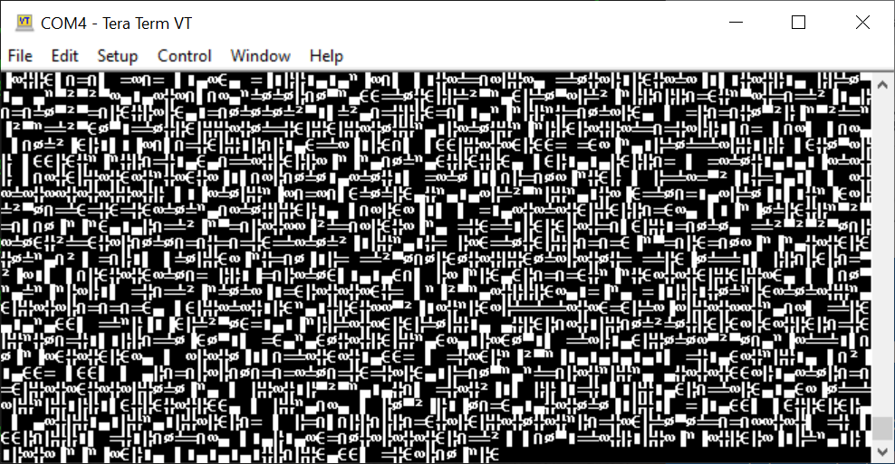Then press the “OK” button. The Tera Term VT screen should flash with patterns like this:

Close Tera Term.