L1 IF Stream
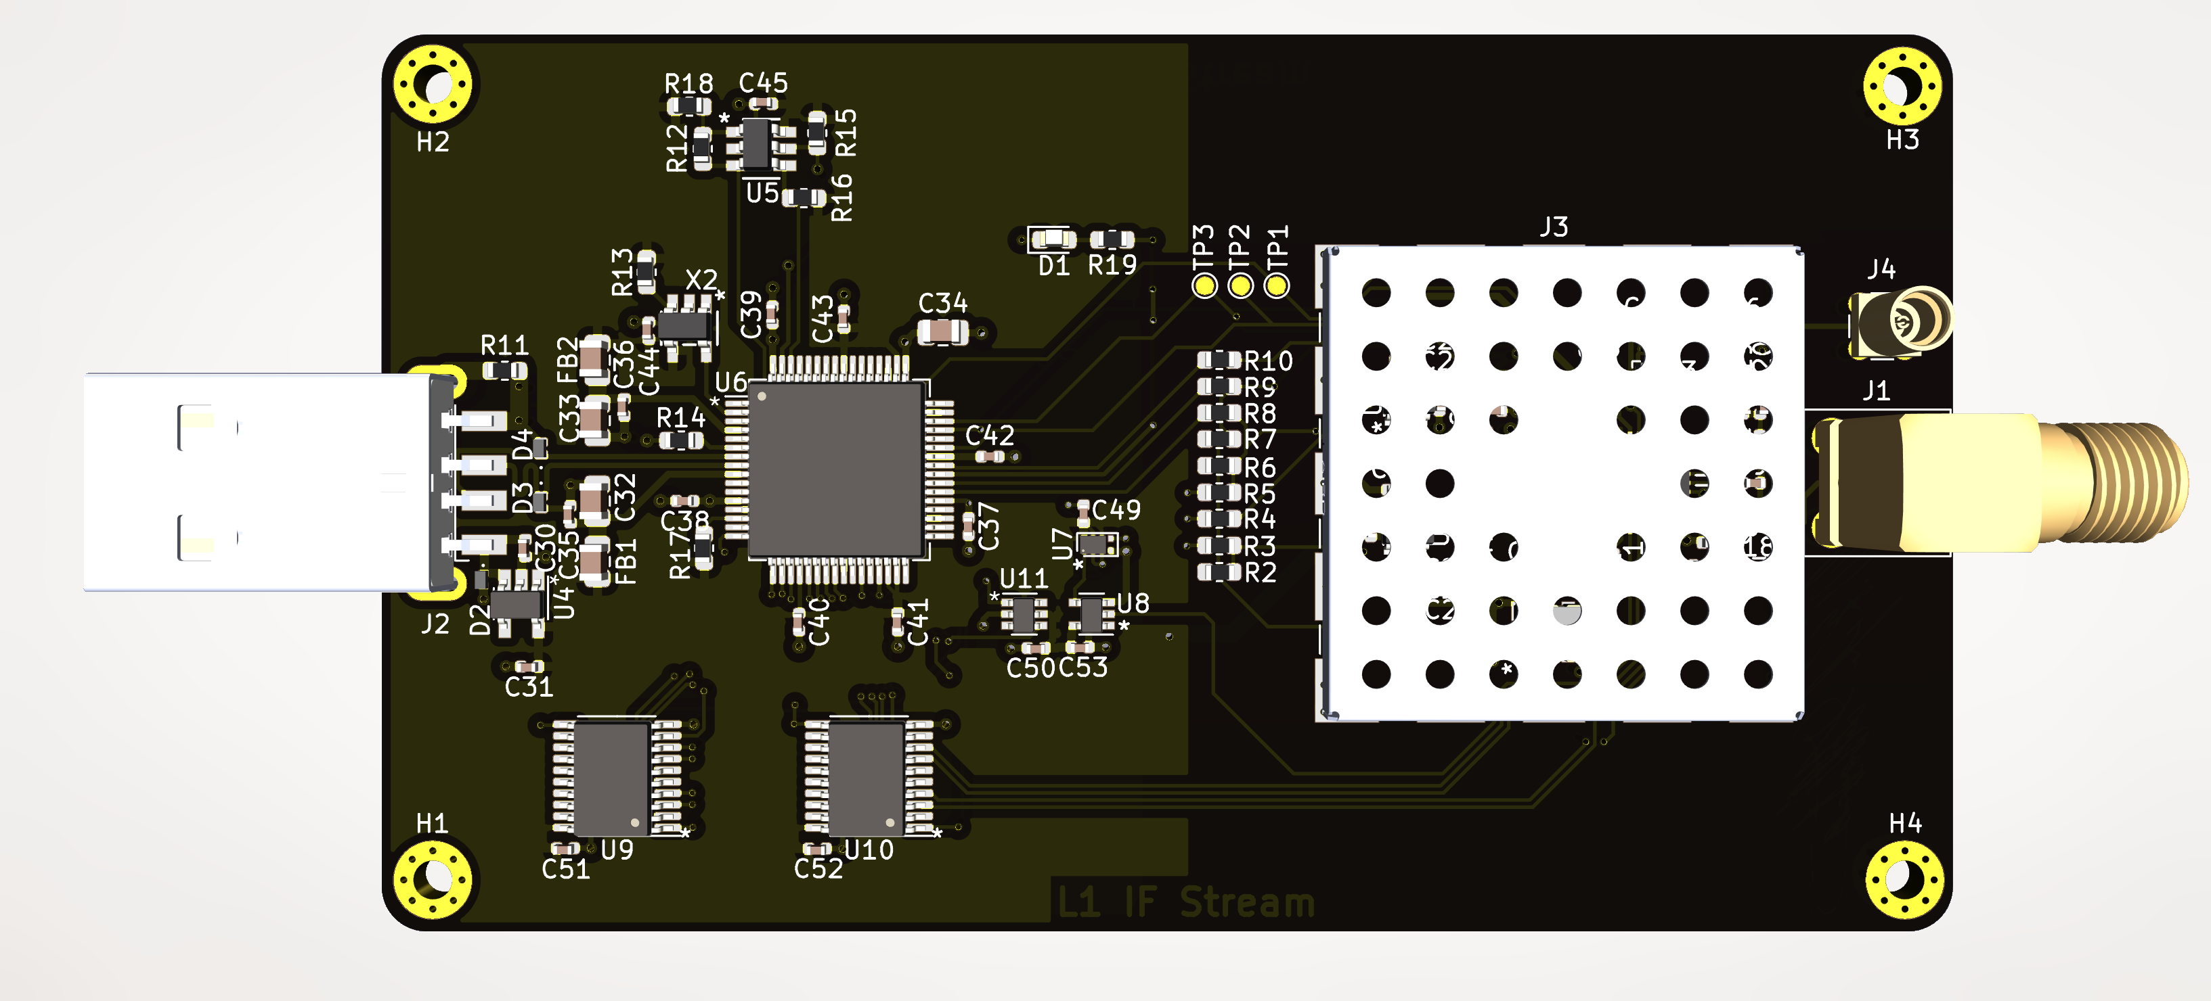

Table of Contents
About 1
Features 2
Connections 2
Communication 2
Configuration 3
Test Points 3
Data Stream Format 3
Software Tools 3

About
The L1IFStream is a USB radio front end (RFE) for software defined receivers (SDRs.) The device provides a first in first out (FIFO) data stream from a Maxim (Analog Devices) 2769B by way of a Future Technologies Devices International Limited (FTDI) 2232H chip. The purpose of the device is to provide a platform for the exploration of navigation band satellite radio signals in the L1 frequency band. The board supports the use of either active of passive antennas. It was designed to provide configuration flexibility to the user by way of configuration jumpers placed on the board as zero Ohm resistors. In the default configuration, the board requires no programming to produce useful data.

Features
- Support for active or passive antenna
- Hardware configurable modes of operation
- Serial Peripheral Interface (SPI) configuration available
- All MEMS oscillators
- Sub-PPM frequency reference
- SAW filter signal conditioning
- Circuit protection diodes on digital and analog interfaces
- Automotive qualified or industrial temperature range devices
- M2 Mounting holes provided to enable robust application implementations

Connections
- USB Type A High Speed
- SMA female for active antenna
- MMCX female for passive antenna

Communication
Communication with the L1IFStream is accomplished through the FTDI 2232H using the D2XX interface. On a Windows based computer, data stream activity may be observed with a terminal program such as TerraTerm or similar, but the data is too fast for a virtual communication port (VCP) to capture correctly. The D2XX interface is required to properly capture the FIFO data stream. The device uses the asynchronous FIFO feature of the FT2232H for the sample data stream. The multi-protocol synchronous serial engine (MPSSE) is utilized to turn the board LED on or off, check the status and send shutdown or idle signals to the MAX2769B, and program the MAX2769B through its SPI port when the board is configured for serial interface.

Configuration
The board may be configured into one of three different hardware configurations. The default configuration implements the device state 2 as described in Table 3 on page 17 of the MAX2769B data sheet. If desired, one may rearrange the zero Ohm jumpers to enable device state 6. Alternatively, one may configure the board to utilize the serial interface to program the MAX2769B via the SPI port. In device states 2 and 6, the board will produce data without any additional programming by the user. If the board is configured to utilize the serial interface, the user must program the MAX2769B registers.

Test Points
Three test points are available outside the RF shield. The first test point indicates whether an active antenna is detected. The second test point indicates whether the phase lock loop (PLL) within the MAX2769B is in lock. The third test point indicates whether the MAX2769B is in shutdown. In normal operation all three of these test points should exceed 3.3V CMOS logic high levels (>2 Volts.)

Data Stream Format
Because the frequency reference used to clock the data out of the MAX2769B is slightly faster than the FTDI 2232H asynchronous FIFO can accept, the data is held in a frequency dividing buffer. The MAX2769B produces four bits of data in a user selected format. In the board’s default configuration, only two of the four bits are used. In this configuration, only the I channel sample is provided with one sign bit and one magnitude bit. The data is clocked into the FTDI chip on every other sample clock which produces byte wide data with the high end nibble containing the first clock period data, and the low end nibble containing the second clock period data.

Software Tools
Software tools are available to verify the status of the board and collect data. The software tools are available to use as is, but are likely best used as example implementations for one’s own development.
Board Status Checking: L1IStat
Board Data Collection: L1IFtap

