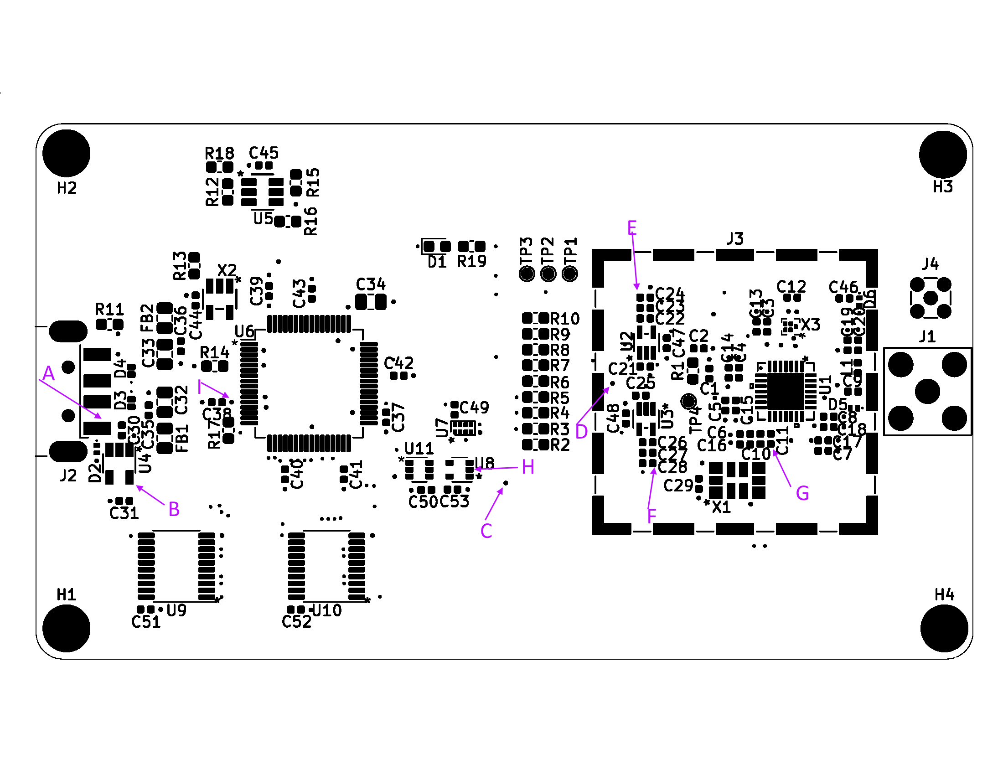

Point A: J2 Pin 1 5 Volts 🞏 __________

Point B: U4 Pin 5 3.3 Volts 🞏 __________

Point C: via near U8 3.3 Volts 🞏 __________

Point D: via between U2 and U3 or Pins 1&3 on U2 and U3 3.3 Volts 🞏 __________

Point E: U2 Pin 5 and connected capacitors 2.85 Volts 🞏 __________

Point F: U3 Pin 5 and connected capacitors 2.85 Volts 🞏 __________

Point G: C11 on side away from U1 16.368 MHz 🞏 __________

Point H: U8 Pin 2 16.368 MHz 🞏 __________

Point I: via between C38 and U6 1.8 Volts 🞏 __________

When plugged into PC USB port, FT_PROG sees a device there? 🞏 __________