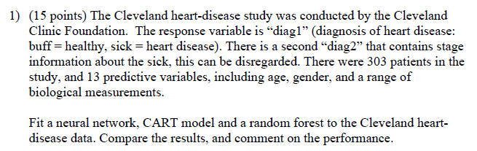Question 1.

**PROCESS**

1. Split data
2. Fit the tree model and get **acc**
3. Get min cp value and Fit the pruned tree model with **acc**
4. Fit the NNET by hidden layer (1:4) and get the best **acc**

**OUT PUTS**

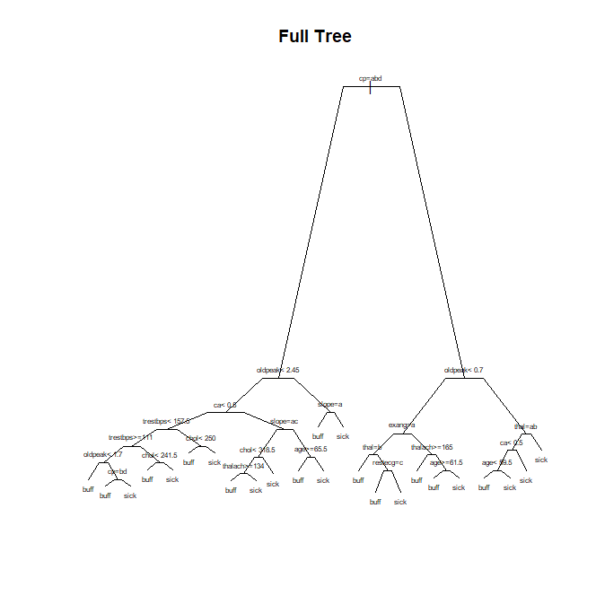

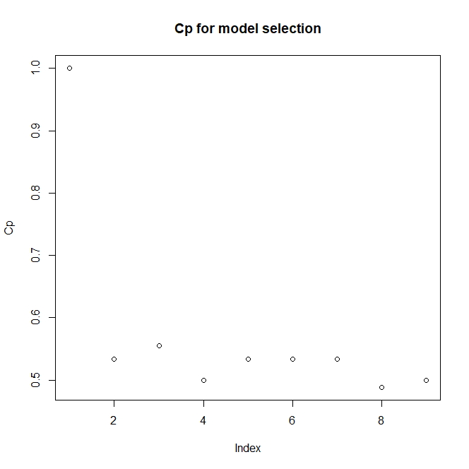

**MIN CP VAL**



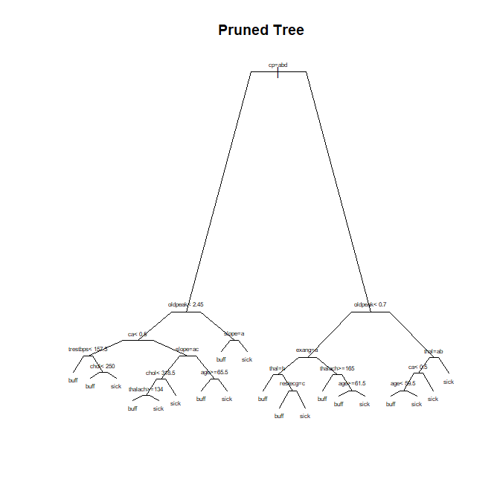 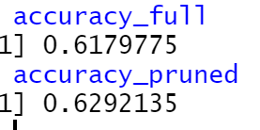

**RANDOM FOREST**

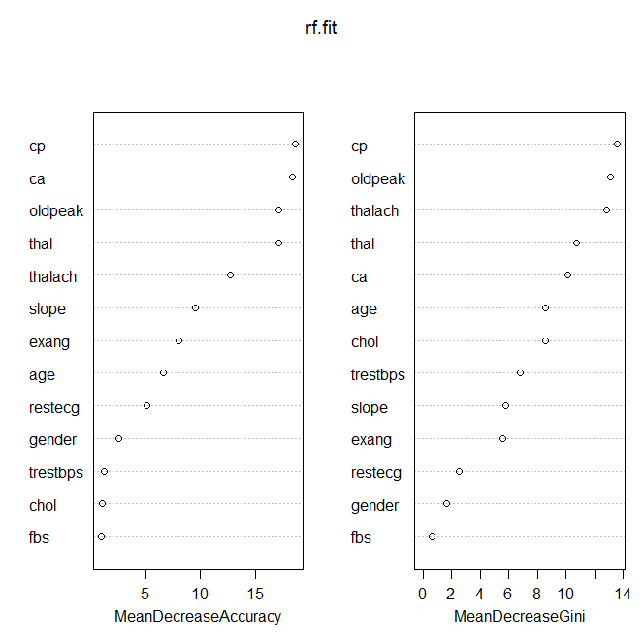

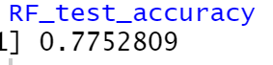

**NNET**

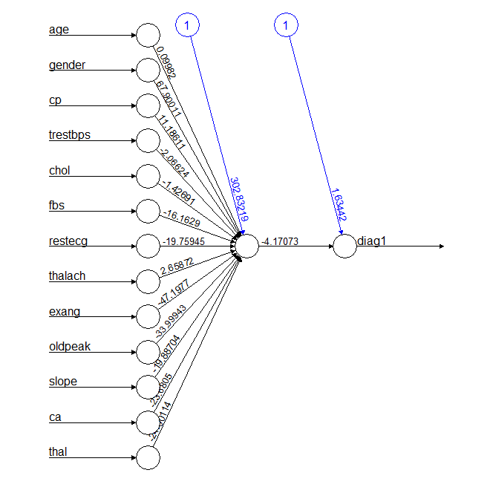

**NNET ERROR RATES BY HIDDEN LAYER (1,2,3,4)**

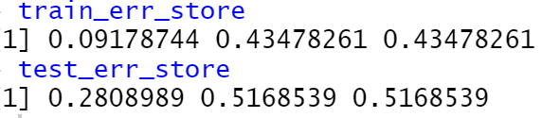

DISSCUSSION

FULL TREE: 62% accuracy

PRUNED TREE (min_cp:8): 63% accuracy

NNET(HL:1): 72% accuray

**NNET shows the best performance among these THREE models.**