Project Name:

Developing Algorithms in QuantConnect and Submitting Alpha (Project Omega)

**Team Members:**

Lim Hong Wen

Alexey Tkachenko

Ngan Kwok Leong

Sum Qing Hong

Antony Cherian

# Contents

C1. Executive Summary

* Summary findings
* Approach taken
* Challenges faced

C2. Phase 1: Introduction

* Approach taken
* Technology infrastructure
* Persona
* Survey methodology

C3. Phase 2 and 3: Short Term Trading Strategy

C4. Phase 4: Long Term Portfolio Strategy

* Passive implementation of S&P 500 using ETFs
* Low volatility investing

C5. Financials

Appendix 1: Codes

Appendix 2: References

# C1. Executive Summary

* Summary findings

At the conclusion of our project, after investigating several strategies, we developed one short term trading strategy and one long term investment strategy which was profitable and met most of the criteria of Alpha Streams. The only criteria which we were not able to meet was the PSR greater than 80% over a period longer than 5 years. Over shorter periods like the most recent two years, we were able to achieve PSR greater than 80%.

* Approach taken

We reviewed the materials related to QuantConnect, data science, general investment theory and technical analysis to develop algo trading strategies. These strategies were tested and further refined.

We also carried out a survey to determine people’s familiarity with algo trading, the types of instruments they were interested in, their return expectations, their concerns and also their willingness to invest using this approach.

* Challenges faced

The biggest challenge we faced was programming in QuantConnect the strategies we wanted to investigate and fine tuning or optimising these strategies to achieve the desired Alpha Streams criteria.

# C2. Phase 1: Introduction

* **Approach taken**

We kicked off the project by reviewing the fundamentals of Python and QuantConnect including attending the Bootcamps.

After reviewing the materials we developed an initial survey questionnaire to get a better understanding of what markets potential investors might be interested in investing in, their knowledge of algo trading and their return expectations.

Following this we focussed on developing appropriate short term and long term trading strategies on Quantconnect for the US stock market. These strategies were developed based on our knowledge of investment theory, technical analysis and algo trading.

We engaged further with a select group of four people which we identified from our initial survey to get a better understanding of their preferences. We chose them because they were already familiar with algo trading and seemed more likely to adopt this investment approach.

* **Technology infrastructure**

In line with the project guidelines, the key technology used was the QuantConnect platform which was used to run the analysis. The Quantconnect platform provides all the necessary analysis tools, market data (e.g. prices) such as prices and marketing platform for clients to subscribe to the strategy.

We also used Git Hub for project management e.g. Kanban board : <https://github.com/iskaspb/project-omega/projects/1>

* **Persona**

The persona is a conservative Singapore based investor who is looking to invest excess funds and generate high risk adjusted returns from his investment portfolio. He is looking to invest in liquid assets classes using investment strategies which can be repeated over time to generate returns. The focus is asset classes with long track records (e.g.US stock market) and strategies which emphasize capital appreciation instead of income.

* **Survey questionnaire and findings for algo trading**

To aid the development and design of trading strategies, services and products which are acceptable and suitable to local potential customers, we have carried out a survey with the below questions.

The target audience for the survey will be those who have reached the minimum legal age to open a trading account, which is 18 years and above. They ought to be aware of what stocks or shares markets are about, though not necessarily be involved or experienced in any financial markets or trading.

37 responses were obtained and we list the questions and findings below. We use any insights gained from the survey for incorporating and formulating algo-trading strategies.

**Question 1:**

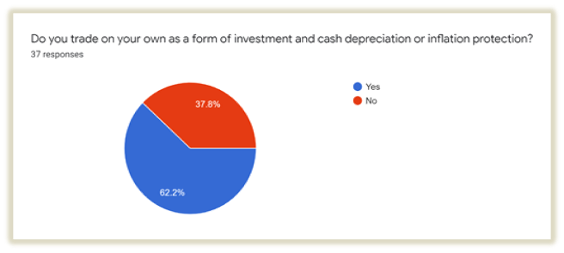

Majority of the surveyed do trade as a form of investment. They most likely recognize the effects of inflation and are taking action to address it.

**Question 2:**

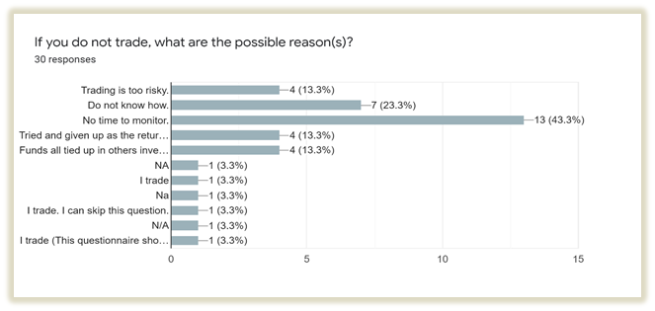

Not surprisingly, the majority responded that time required for monitoring the markets was the main factor for not being involved in trading or engaging in it frequently.

Thus, there is an opportunity for algo-trading as a form of investment , if most are unaware that monitoring of multiple financial instruments and markets can be automated with predefined programmed instructions.

**Question 3:**

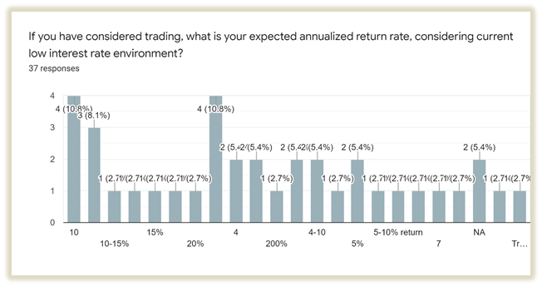

The responses range from low of 3% to a single outlandish 200%. Majority (68%) of those surveyed expected to achieve an annualized return of 3% to 10%, with 18% expecting above 10% to 20% return.

The surveyed are mostly rational and conservative. They are akin towards achievable and sustainable returns with the risk considered.

To be very attractive to potential customers, the target annualized return rate could be at least 15% per annum(p.a.). This is in line with the S&P 500 return of 13.9%p.a. for the past 10-years. (*Source:* [*https://www.fool.com/investing/how-to-invest/stocks/average-stock-market-return*](https://www.fool.com/investing/how-to-invest/stocks/average-stock-market-return)).

We note that past market returns are not indicative of future market returns and the majority of those surveyed expect a return of between 3% -10% especially as the focus is the short term and not long.

**Question 4:**

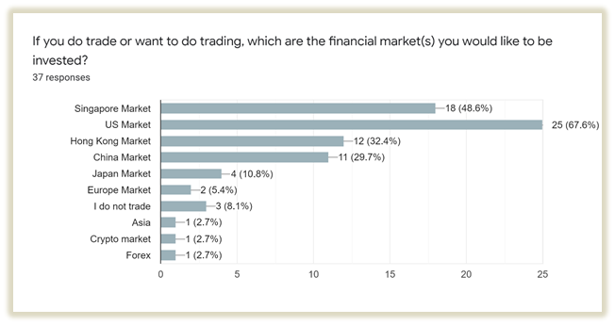

Most have shown interest in the US market, which is considered the most liquid(apart from forex) and offered the most choices of trading instruments.

The US market may well be the focus in developing and exploring the various investment strategies for algo trading and long term investing.

**Question 5:**

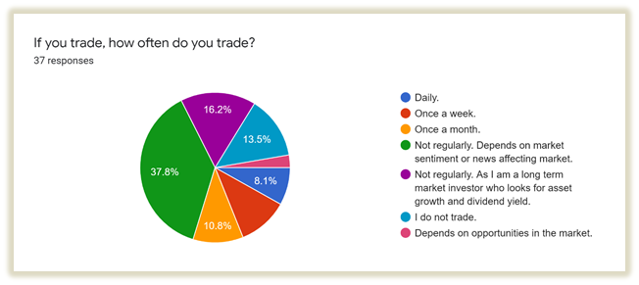

Reinforcing the earlier responses on the bugbear of monitoring time as the main factor for not taking up trading, the majority do not trade regularly.

Most also depended on and referred to “market news” for engaging in trades.

Maybe through the introduction of algo-trading products and services, we can take the opportunity to inform and educate on a systematic, balanced and considered approach towards trading instead of blindly following herd instinct influenced by mass media, or the present trending “meme” stocks by social media.

**Question 6:**

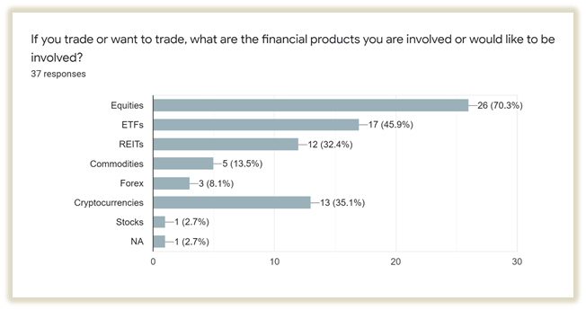

Majority are into or interested in equities or stocks as an investment financial instrument. We see there is a fair share of interest in crypto-currencies which has gained traction and acceptance in recent times as a form of investable financial instrument. However, it is uncertain for how long this interest will be sustained.

We may want to consider offering it as part of an investment trading strategy..

**Question 7:**

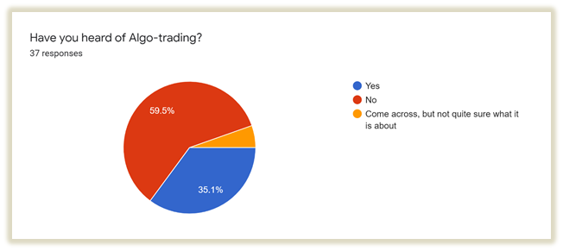

Not unexpectedly, majority do not know about algo-trading and what it can offer.

**Question 8:**

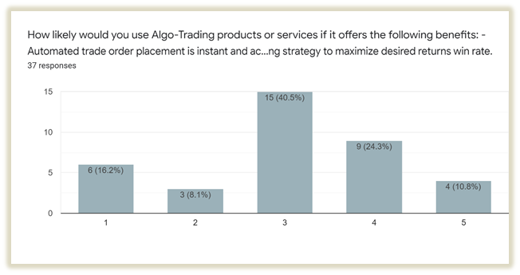

The surveyed are told of the algo-trading benefits:

- Automated trade order placement is instant and accurate (there is a high chance of execution at the desired levels) when trading strategy conditions based on technical analysis criteria are met.

- Algo-trading can be back-tested using available historical data to check if it is a viable trading strategy to maximize desired returns win rate.

35% are receptive to the benefits with ‘4’ and above response. This indicates there is still some degree of scepticism as it is a new concept which only about a third are familiar with (Question 7).

**Question 9:**

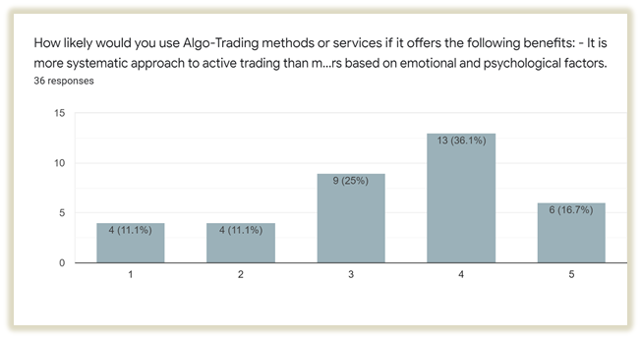

The surveyed were told of the algo-trading benefits:

- It is a more systematic approach to active trading than methods based on trader intuition or instinct.

- It also reduces the possibility of mistakes by human traders based on emotional and psychological factors.

More than half, 52%, are receptive to the benefits with ‘4’ and above response. Much improved from the previous question 8’s 35%.

It indicates most recognize that intuition, instinct and emotion are a disadvantage when making good trading or investment decision.Thus we believe any products or services that can diminish or mitigate these effects will gain wide adoption and reception.

**Question 10:**

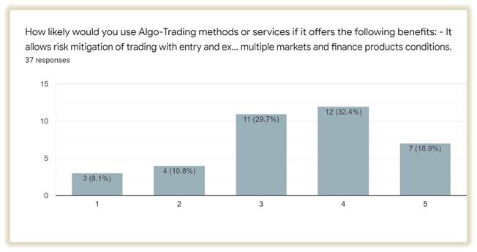

The surveyed were told of the algo-trading benefits:

- It allows risk mitigation of trading with entry and exit strategy with maximized win rates and returns.

- It can monitor simultaneous automated checks on multiple markets and financial instruments.

More than half, 51%, are receptive to the benefits with ‘4’ and above positive response. The persuasiveness of the benefits is similar to the previous question 9.

It indicates most give the same weightage or place the same importance to the benefits here with that of doing away with intuition, instinct and emotion in making good trading or investment decisions.

**Question 11:**

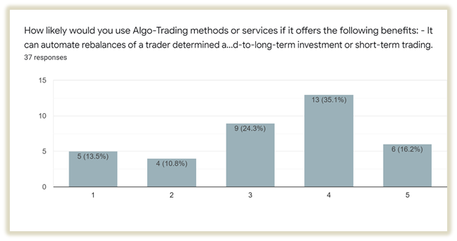

The surveyed were told of the algo-trading benefits:

- It can automate rebalancing of a trader's determined assets portfolio based on his or her risk profile.

- The rebalancing allocation and frequency can be adjusted based on the trader's risk appetite and preference for mid-to-long-term investment or short-term trading.

More than half, 51%, are receptive to the benefits with ‘4’ and above response. The persuasiveness of the benefits is similar to the previous question 10 & 11.

Overall, the 6 benefits mentioned in question 9 to 11 are considered received and agreed by at least 50% of the surveyed. Also, these questions solicited ‘3’ responses, with indication of neutral sentiment, ranging from 24% to 30% of the surveyed. We may need to create greater understanding and knowledge of algo-trading to persuade wider adoption.

**Question 12:**

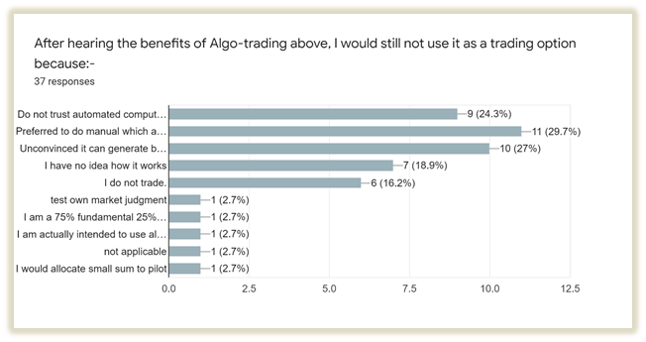

Majority of the surveyed preferred to stick to manual trading, which we feel likely arises from the non-awareness of algo-trading as a trading option, and almost non-existing or little access to financial products and services with algo-trading mechanisms or features.

This presents the opportunity and scope for introducing and incorporating some of these features into new or existing financial products and services. In theory, all automation features can be fully controlled and customizable by the users.

**Question 13:**

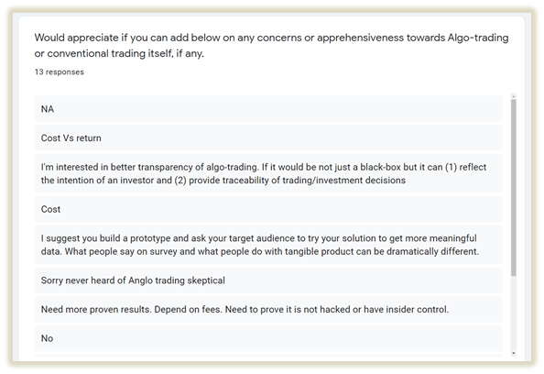

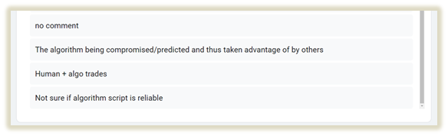

In general, insights gained from the responses received for this last question are:

- Most lack the understanding of algo-trading and the benefits offered.

- Most are skeptical about algo-trading.

- Cost and fee structures are a concern.

- Assurance of transparency on the mechanism and how algo-trading works is important.

- Full autonomy and control by the user on the implementation are essential.

**Further probe with those who have some understanding of algo-trading**

As part of the process to arrive at a strategy which prospects would be interested in subscribing to, we carried out another survey with people who were already familiar with algo trading.

We further engaged and probed with 4 of the surveyed who have basic understanding of algo-trading.

All have indicated they would only want to pay the minimum subscription fee allowed with the Quant-Connect platform, i.e. USD 3 per month per 10K invested for strategy recommendations.

They have also indicated their expected return is between 5% to 10%. They are mainly mid-long term investors who expect the algo-trading strategy to execute at least once a week or a month.

Their greatest concern is the strategy’s capability and effectiveness in meeting the profitability target. Further, they also want to have a better understanding of the algo-trading employed.

Besides trading strategy, they have expressed a desire to have options to choose the types of instruments for a trading strategy that suits an individual's risk profile. They would also want to know the indications of the instruments’ measure of volatility, back-tested result’s Sharpe ratio and absolute returns.

They would prefer a strategy that would consider both time and volume weighted average price of the instrument. Though, they are not particular about any type of strategy employed, as long as the target return is met.

# C3. Phase 2: Strategy Development

The first deliverable for the project was the python script which generates all the important financial parameters like BASS (Beta, Alpha, Standard Deviation and Sharpe ratio) and other indicators. Please refer to Appendix 1 for the python BASS script.

The development of strategy was focused on using technical analysis to create algo trading strategies that qualify for QuantConnect’s Alpha Market. The following are the criteria to qualify for Alpha Market

1. Backtest of at least 5 years.
2. Backtest’s start date cannot be earlier than 7 years ago.
3. Backtest ended at most 7 years ago.
4. Use of the Apha Streams brokerage model.
5. Strategy is profitable.
6. Not using external data sources.
7. PSR greater than 80%.
8. Low correlation with other submissions.
9. Quick drawdown recovery.
10. Backtest has more than 100 insights.

## Short term trading strategy

Initial version of short term trading strategy contained the following components to satisfy the above requirements:

1. Trading signals are calculated using one or more technical indicators. In our case we used only MACD as it’s simple and popular so there is a lot of literature on the topic. There were plans to add more indicators but we were not able to research them well enough to include into final strategy;
2. The strategy monitors several symbols. Initially we made a selection of 20+ symbols and manually explored their performance using MACD indicators with different parameters. There are classical 12, 26, 9 values for fast, slow and signal EMA components of MACD respectively, however we finally selected a “faster” set of parameters (7, 13, 3) as they showed better performance in backtesting. We also made a selection of 6 best performers and dropped all others symbols from the scope of the strategy.
3. Most of the backtesting was done for the period of 2 years (2019 and 2020). We used daily market data updates.
4. At any given point of time we allowed the strategy to hold position for only 3 symbols out of 6 possible. This way we achieved a balance between diversification and performance of individual symbols. This also allowed us to select the best performer at any point of time (although currently this selection is oversimplified as we only use one indicator).
5. The logic of the strategy also tries to avoid jittering buy/sell orders, i.e. when we enter a position we try to hold it as much as it is reasonable.
6. The strategy is “long-only”. We experimented with short-sell but for simplicity we avoided it because of the difficulties of managing the portfolio position;
7. We also experimented with “going into SPY” when we have unallocated holdings. This approach proved to be viable however performance gain was not so large compared to extra transaction costs and opportunity cost. In the end we found that using selection 3 out of 6 produces backtests results without unallocated holdings;
8. In order to control the risk of excessive drawdown we implemented “trailing Stop-loss” logic with the threshold parameter arbitrary taken 93%;

The results were promising within the backtesting range (Compounding Annual Return 59.8, Sharpe Ratio 2.158, PSR 87.7%, Alpha 0.532) however mediocre on the longer run (Compounding Annual Return 18.8, Sharpe Ratio 0.852, PSR 28.1%, Alpha 0.186). You can see generated report here :

1.2019,2020 years backtest : [01-short-term-trading-strategy-MACDTrend.pdf](https://github.com/iskaspb/project-omega/blob/master/reports/01-short-term-trading-strategy-MACDTrend.pdf)

2. 2015-2020 years confirmation backtest : [02-short-term-trading-strategy-MACDTrend.pdf](https://github.com/iskaspb/project-omega/blob/master/reports/02-short-term-trading-strategy-MACDTrend.pdf)

The code of the strategy is here (in particular see function **Initialize_Orig**) : <https://github.com/iskaspb/project-omega/blob/master/src/strategy/MACDTrend/main.py>

# C4. Phase 3: Refinement of Strategy

As part of the process to arrive at a strategy which prospects would be interested in subscribing to, we carried out another survey with people who were already familiar with algo trading but were not already using it.

We include below the findings of this survey.

## Optimized short term trading strategy

The goal of this phase was to improve initial results of the strategy using more advanced analytical methods. Considering limited time and resources we had to find a tool that produces robust results, simple enough for us to use and the insights has to be easily integrated into the final strategy.

### QuantConnect Lean

There are a number of software packages in the area of financial analysis (and technical analysis). Many are implemented in Python or provide a Python interface. It turned out that initially we overlooked native QauntConnect analytical platform - Lean. The time that we used for selection of the analytical platform wasn’t completely wasted - now we have a better understanding of the various TA libraries and their capabilities.

Main features of QC Lean:

1. Supports local development in Python or C#;
2. Offers seamless integration with cloud QuantConnect platform;
3. Provides library implementation of many (if not all) popular TA indicators;
4. Supports Jupyter Notebook;
5. Implements basic backtesting facilities as well as more advanced optimization procedures (both local and cloud);
6. Open and extensible platform : it allows both - using external python libraries and market data from external sources;
7. Easy to install and set up;
8. Has documentation, examples and active community;
9. As an added benefit (I guess not known by many users of Cloud QuantConnect platform) - removes “20 seconds” delay for free tier users.

Just to summarize - QC Lean is on par with other popular TA libraries in terms of TA indicators and on top of that it’s a complete analytical platform that offers a convenient workflow for trading strategy development.

### Data management

Despite the simplicity and openness of QC Lean is a commercial product. Both Cloud QC and QC Lean can be used on “free-tier” however some capabilities will not be available. For instance Cloud QC imposes a “20 seconds” backtest delay for “free-tier” accounts. It also significantly limits compute power and also optimization is charged separately - and for good reason!

QC Lean unlocks the full potential of the QuantConnect platform however there is one thing that may deter potential users - data management. So the data is free in Cloud QC but it’s paid in QC Lean - this is a natural requirement because cloud providers charge clients when their data crosses cloud boundaries.

Fortunately the QuantConnect team allowed Lean users to use external data sources for backtesting. There are 2 issues with this:

1. Integration of external data requires a bit of coding;
2. External data sources may differ from the one used by QuantConnect.

There is no good answer for the second issue. We use YahooFinance as an external data provider and some backtests have slightly different results when executed locally and in the cloud. Just to be clear - for the purpose of AlphaStream certification QC accepts backtesting results generated using their data. Overall it’s not a big issue, just a thing that should be considered during strategy development.

And the first issue was solved with a bit of scripting and configuration. Here is the description of how to set up and start using Lean (together with data preparation): <https://github.com/iskaspb/project-omega/tree/master/src/strategy#readme>

### Optimization process and results

A big question that we tried to solve during this phase is how to improve performance of existing (relatively simple) trading strategy. In the core of the strategy we have a MACD indicator that tries to explain behaviour of several market symbols. Considering we do not significantly change the strategy there are 2 obvious ways to optimize it:

1. Improve the selection of symbols so we consider those which are better explained by MACD during selected time period;
2. Find out what is the best MACD parameters (fast, slow and signal EMA periods).

Both these tasks were solved using “Optimize_MACD.py” script : <https://github.com/iskaspb/project-omega/blob/master/src/strategy/optimize_MACD.py>

This script is configured with the set of “candidate” symbols. For each of the symbols it executes QC Lean optimisation procedure that finds the best performance result of MACD_Simple strategy for pre-generated set of MACD parameters (initially we used ~1800 parameters combinations but later we reduced them to ~600 by removing ones that don’t make sense)

MACD_Simple is a “single indicator-single symbol” strategy that is configured with 2 arguments - MACD parameters and symbol name. It’s located here : <https://github.com/iskaspb/project-omega/tree/master/src/strategy/MACD_Simple>

The optimization criteria is passed in the arguments of “lean optimize …” command, in particular we use the following criteria:

1. Maximize(Compounding Annual Return);
2. Constraint(Sharpe Ratio >= 1.5).

These seem to be reasonable optimization criteria that explains our main goal - robust and profitable trading strategy.

One optimization run takes from 6 to 18 hours on my local machine (which is quite powerful). Here are 2 results of the runs:

1. [optimize_MACD_simple_2019_2021_1628965139.log](https://github.com/iskaspb/project-omega/blob/master/src/strategy/optimize_MACD_simple_2019_2021_1628965139.log)
2. [optimize_MACD_simple_2016_2017_1629036497.log](https://github.com/iskaspb/project-omega/blob/master/src/strategy/optimize_MACD_simple_2016_2017_1629036497.log)

These log files contain executable python code that can be inserted into the MACDTrend strategy (with minor editing). See results of such insertion: <https://github.com/iskaspb/project-omega/blob/master/src/strategy/MACDTrend/main.py>

Please notice functions Initialize_Opt_2019_2021 and Initialize_Opt_2016_2017 with corresponding comments on individual symbol performance statistics.

We wanted to prove 2 hypothesis with this optimization approach:

1. Individual symbol optimization produces “better than average” result for the strategy that combines those symbols;
2. There is a “symbol-specific” component in MACD parameters that explains behaviour of the symbol outside of the initial backtesting time period.

The answer that we got is “yes” for both assumptions, however the first “yes” is stronger. Of course without it we wouldn’t be able to use this optimization method at all so it's good news. The second hypothesis has weaker evidence however we still see performance improvement both over “standard MACD parameters” (or any other arbitrary set of parameters applied uniformly to all symbols). Please notice that the second hypothesis contains 2 statements - “symbol-specific” parameters and “outside of the initial backtesting time period”. The second part is important because without it we wouldn’t be able to use this method for practical application.

So the result of the same 2 years (2019,2020) of backtesting is Compounding Annual Return 90%, Sharpe Ratio 2.84, PSR 95.6%. Not surprisingly results are good - because the parameters are overfitted for the selected time period! See report here : [03-short-term-trading-strategy-MACDTrend.pdf](https://github.com/iskaspb/project-omega/blob/master/reports/03-short-term-trading-strategy-MACDTrend.pdf)

Now let’s check results for the 6 confirmation years (2015-2020) : Compounding Annual Return 41.7%, Sharpe Ratio 1.738, PSR 87.9%. Results are still good although less impressive. See report here : [04-short-term-trading-strategy-MACDTrend.pdf](https://github.com/iskaspb/project-omega/blob/master/reports/04-short-term-trading-strategy-MACDTrend.pdf)

# C4. Phase 4: Long Term Portfolio Strategy

In this section we evaluate several long term investment strategies to outperform the market. The strategies evaluated are:

1. Passive implementation of S&P 500 index using ETFs
2. Low volatility investing

## Passive implementation of S&P 500 index using ETFs

In this strategy we invest in the US Equity market using sector ETFs to passively implement an investment strategy based on the S& P 500. Using this strategy, the portfolio will be rebalanced based on sector weights at the beginning of the portfolio.

We can investigate this strategy by backtesting for the 7 year period from 1st January 2014 to 31st December 2020.

1. Identify the sector weights of the S&P 500 as at 1st January 2014 and purchase the appropriate sector ETFs.

2. At the end of each quarter/ month rebalance the portfolio to the sector weights as at the beginning of the respective quarter/ month.

3. This process of rebalancing will systematically reduce exposure to the sector which performs well and increase exposure to the sector that didn’t perform well.

### Results

The following are the results of the passive implementation of the S&P 500 trading strategy.

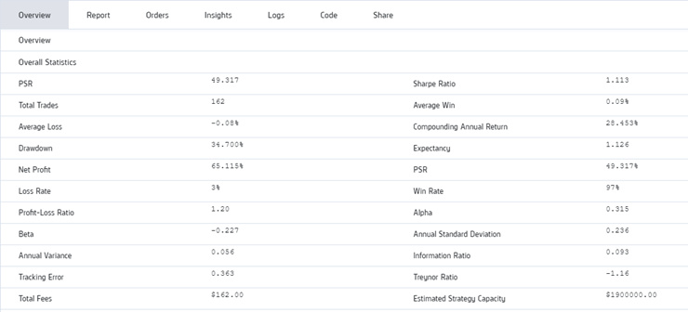

## Low volatility investing

### Investment Universe

All the component stock of the S&P 500 index. This is to ensure high liquidity, low transaction costs and broad representation of the market.

### Steps

§ For the period between 1st January 2015 to 31st December 2017 calculate the volatility of each stock over the 3 year period.

§ Identify the lowest 30, 50 and 100 individual stocks in terms of volatility for the period.

§ Identify a portfolio of 30, 50 and 100 stocks with the lowest volatility over the 3 year period. Ensure a minimum of 5% portfolio weight in each of the 11 sectors which make up the S&P500. (Minimum 5% portfolio weight to ensure diversification across 11 sectors). Doing this calculation at the portfolio level will take into consideration the correlation of the stocks. Rebalance either weekly, monthly or quarterly taking into consideration transaction costs.

§ Compare portfolio stats for the 30, 50 and 100 stock portfolios calculated above with the S&P 500 as the benchmark for the period 2015 to 2017.

§ Invest the same 30, 50 and 100 stock portfolio over the 3 year period beginning 1st January 2018 to 31st December 2020. Rebalance either weekly, monthly or quarterly taking into consideration trading costs

§ Compare portfolio stats for the 30, 50 and 100 stock portfolios calculated above with the S&P 500 as the benchmark for the period 2018 to 2020.

# C5. Financials

Using QuantConnect provides all the necessary tools for analysis, market data and a ready platform (Alpha Streams) for marketing investment strategies. There is currently no cost for developers to use QuantConnect to develop and market their investment strategies.

We have identified two immediate sources of revenue:

1. Alpha Stream
2. Proprietary trading
3. Alpha Stream

Alpha Streams is a global marketplace where clients(Funds) and developers( Quants) meet. QuantConnect acts as an independent party on behalf of both clients and developers. Alpha Streams licensing is performed with a monthly subscription prorated on a daily basis.

There are no costs for developers to use QuantConnect and all licensing fees paid by the client are given to the developers. In addition QuantConnect charges the client 30% of the licensing fee for reviewing, hosting and serving the algorithms.

The subscription fees on Alpha Stream are determined based on the supply and demand for investment strategies. The current subscription fees on Alpha Stream are at US$3/month for US$10,000 invested in the strategy.

In arriving at the financials for this project we have made the following assumptions and maintained the subscription fees at the minimum rate of US$3 per month or US$36 per annum.

In Year 1 we will have 2 strategies listed on Alpha Streams and each of this strategy will have an average of 10 subscribers which invest US$10,000 each. This means the revenue for Year 1 will be US$1,080 (36 x10 x 3).

In year 2, we will add another 3 strategies and the average number of subscribers would be 20. This will translate into revenue in Year 2 of US$4,320 per annum (36 x 20 x 6)

In Year 3, we will add another 3 strategies and the projected average number of subscribers would be 25 each. This will translate into revenue in Year 3 of US$9,720 per annum (36 x 30 x 9).

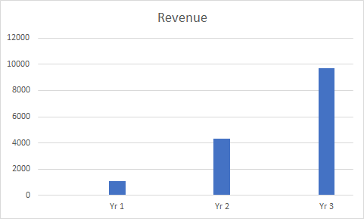

1. Proprietary Trading

If we were to assume a 20% return on US$50,000, the average return would be $10,000 per annum.

## Risk

The key risk for developing strategies on Alpha Stream is firstly that we are unable to develop strategies that meet the criteria. This means our time and energy would have been wasted. However, it would still be possible to earn a return from proprietary trading.

The main risk with proprietary trading is that we suffer a loss of capital. Assuming we have set a maximum loss at 20% for our investments and we are able to exit at that point our loss would be US$10,000 (20% x 50,000)

# Appendix 1 : Codes

**BASS script**

**Short term trading strategy**

**Long term portfolio strategy**

Passive implementation of S&P 500 using ETFs

|  | def Initialize(self): |
| --- | --- |
|  | self.SetStartDate(2019, 1, 1) |
|  | self.SetEndDate(2021, 1, 1) |
|  | self.initialCash = 100000 |
|  | self.SetCash(self.initialCash) |
|  | ''' Allocation example from https://www.etf.com/sections/etf-strategist-corner/sector-sector-sp-500?nopaging=1 |
|  | Information Technology 27.6% VGT XLK |
|  | Health Care 13.5% VHT XLV |
|  | Consumer Discretionary 12.7% VCR XLY |
|  | Communication Services 10.8% VOX XLC |
|  | Financials 10.4% VFH XLF |
|  | Industrials 8.4% VIS XLI |
|  | Consumer Staples 6.5% VDC XLP |
|  | Utilities 2.8% VPU XLU |
|  | Materials 2.6% VAW XLB |
|  | Real Estate 2.4% VNQ XLRE |
|  | Energy 2.3% VDE XLE |
|  |  |
|  | Vanguard Sector ETF: |
|  | 'VGT' : 0.276, |
|  | 'VHT' : 0.135, |
|  | 'VCR' : 0.127, |
|  | 'VOX' : 0.108, |
|  | 'VFH' : 0.104, |
|  | 'VIS' : 0.084, |
|  | 'VDC' : 0.065, |
|  | 'VPU' : 0.028, |
|  | 'VAW' : 0.026, |
|  | 'VNQ' : 0.024, |
|  | 'VDE' : 0.023, |
|  |  |
|  | SPDR Sector ETF |
|  | 'XLK' : 0.276, |
|  | 'XLV' : 0.135, |
|  | 'XLY' : 0.127, |
|  | 'XLC' : 0.108, |
|  | 'XLF' : 0.104, |
|  | 'XLI' : 0.084, |
|  | 'XLP' : 0.065, |
|  | 'XLU' : 0.028, |
|  | 'XLB' : 0.026, |
|  | 'XLRE' : 0.024, |
|  | 'XLE' : 0.023, |
|  | ''' |
|  |  |
|  | self.symbolWeights = { |
|  | 'VGT' : 0.276, |
|  | 'VHT' : 0.135, |
|  | 'VCR' : 0.127, |
|  | 'VOX' : 0.108, |
|  | 'VFH' : 0.104, |
|  | 'VIS' : 0.084, |
|  | 'VDC' : 0.065, |
|  | 'VPU' : 0.028, |
|  | 'VAW' : 0.026, |
|  | 'VNQ' : 0.024, |
|  | 'VDE' : 0.023, |
|  | } |
|  |  |
|  | self.AddEquity("SPY", Resolution.Daily) |
|  | self.initialHolding = [] |
|  | for symbol, weight in self.symbolWeights.items(): |
|  | self.AddEquity(symbol, Resolution.Daily) |
|  | self.initialHolding.append(PortfolioTarget(symbol, weight)) |
|  |  |
|  | ''' Example of different scheduling |
|  | https://www.quantconnect.com/docs/v2/writing-algorithms/user-guides/algorithm-reference/scheduled-events |
|  | https://www.quantconnect.com/docs/algorithm-reference/scheduled-events |
|  | ''' |
|  | self.Schedule.On( |
|  | self.DateRules.MonthStart("SPY"), |
|  | self.TimeRules.AfterMarketOpen("SPY"), |
|  | self.RebalancingCode) |
|  |  |
|  | self.initialSPYPrice = 0 |
|  |  |
|  |  |
|  | def OnData(self, data): |
|  | self.Plot("Data Chart", "SPY", self.Securities["SPY"].Close) |
|  | if self.initialSPYPrice == 0: |
|  | self.initialSPYPrice = self.Securities["SPY"].Close |
|  |  |
|  | self.Plot("Strategy Equity", "SPY", (self.initialCash / self.initialSPYPrice ) * self.Securities["SPY"].Close) |
|  |  |
|  | def RebalancingCode(self): |
|  | self.SetHoldings(self.initialHolding) |

# Appendix 2: References

1. QuantConnect website [Documentation - Home](https://www.quantconnect.com/docs/home/home)

2. Average stock market return. [Average Stock Market Return](https://www.fool.com/investing/how-to-invest/stocks/average-stock-market-return)) .

3. [Sector By Sector In The S&P 500 With ETFs | ETF.com](https://www.etf.com/sections/etf-strategist-corner/sector-sector-sp-500?nopaging=1)

4. [CAGR of the Stock Market: Annualized Returns of the S&P 500 (moneychimp.com)](http://www.moneychimp.com/features/market_cagr.htm)

5. S&P 500 index. [S&P 500® | S&P Dow Jones Indices](https://www.spglobal.com/spdji/en/indices/equity/sp-500/#overview)

6. FTSE Russell: Low Volatility or Minimum Variance: An” eyes wide open” discussion. [01_low_volatility_or_minimum_variance_v02.pdf (ftserussell.com)](https://content.ftserussell.com/sites/default/files/research/01_low_volatility_or_minimum_variance_v02.pdf)