AP Physics C: Mechanics — Unit 1 & Unit 2 Review
Unit 1 Kinematics (10–15% of AP exam)
Unit 2 Force and Translational Dynamics (20–25% of AP exam)

Unit 1 Kinematics

1.1 Scalars and Vectors
- Scalar: magnitude only, no direction. Examples: mass, time, distance, speed, energy.
- Vector: magnitude + direction. Examples: displacement, velocity, acceleration, force, momentum.
Vector operations:
- Components: $A_{x}=Acos⁡θ,A_{y}=Asin⁡θ$
- Magnitude and direction: $A=\sqrt{A_{x}^{2}+A_{y}^{2}},tan⁡θ=\frac{A_{y}}{A_{x}}$
- Tail to tip method
- 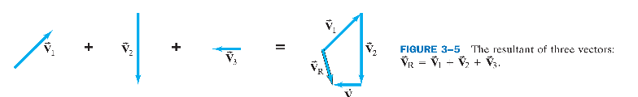
- Parallelogram method
- 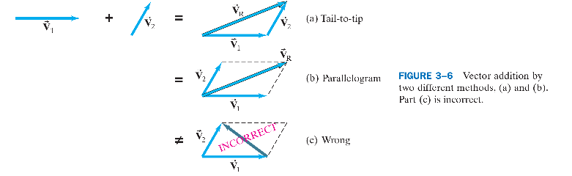
- We can now define the subtraction of one vector from another: the difference between two vectors V 2- V 1 is defined as V 2- V 1 = V 2 +(-V 1 ).
- 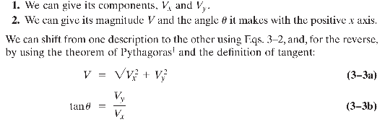
AP C focus: vector addition/subtraction, component method, dot product and cross product basics.

1.2 Displacement, Velocity, and Acceleration (Calculus Core)
- Distance: total path length traveled (scalar).
- Displacement Δx: final position − initial position (vector). $Δx=x_{f}-x_{i}$
- Average velocity: $\overline{v}=\frac{Δx}{Δt}$
- Instantaneous velocity: $v(t)=\frac{dx}{dt}$ (derivative of position).
- Average acceleration: $\overline{a}=\frac{Δv}{Δt}$
- Instantaneous acceleration: $a(t)=\frac{dv}{dt}=\frac{d^{2}x}{dt^{2}}$ (derivative of velocity).
Kinematic equations for constant acceleration only!
$$v=v_{0}+at$$
$$Δx=v_{0}t+\frac{1}{2}at^{2}$$
$$v^{2}=v_{0}^{2}+2aΔx$$
$$Δx=\frac{v+v_{0}}{2}⋅t$$
Speed is simply a positive number, with units. Velocity, on the other hand, is used to signify both the magnitude (numerical value) of how fast an object is moving and also the direction in which it is moving. Velocity is therefore a vector.

1.3 Representing Motion (Graphs)
- Position–time (x–t) graph
- Slope = instantaneous velocity; sign of slope = direction of velocity.
- More precisely, the instantaneous velocity at any moment is defined as the average velocity over an infinitesimally short time interval.
- Curvature indicates acceleration; intersection point = two objects at the same position (meeting)
- 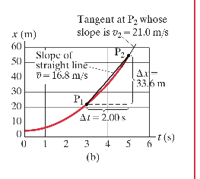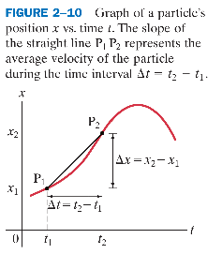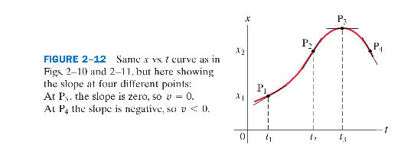

- Velocity–time (v–t) graph
- Slope = acceleration.
- Area under the curve = displacement (area below the t-axis is negative).
- Intersection point = two objects have the same instantaneous velocity.
- 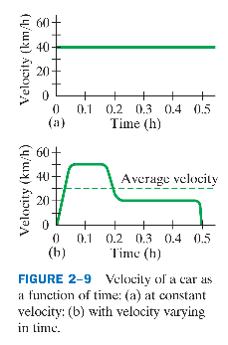
- Acceleration–time (a–t) graph
- Area = change in velocity $Δv$.
- 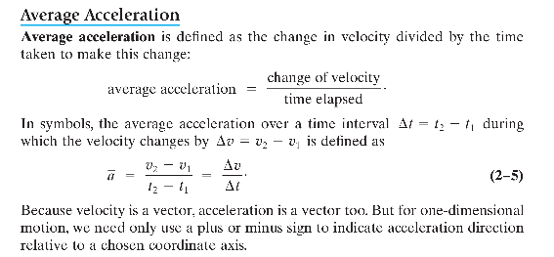
- This can be expressed in equation form: since a = dv/dt and v = dx/dt, the acceleration is equal to the first order derivative of velocity and equals the second order derivative of displacement.
AP C emphasis: use calculus to find slopes and areas; handle non-linear graphs.

1.4 Reference Frames and Relative Motion
Relative velocity formula:
$${\overset{→}{v}}_{A/C}={\overset{→}{v}}_{A/B}+{\overset{→}{v}}_{B/C}$$
- ${\overset{→}{v}}_{A/C}$: velocity of A relative to C.
- Vector operation — always keep track of direction; in 1-D, use positive/negative signs.
Example 1
The same boat (V = 1.85 m/s) now heads directly across the river whose current is still 1.20 m/s. (a) What is the velocity (magnitude and direction) of the boat relative to the shore? (b) If the river is 110 m wide, how long will it take to cross and how far downstream will the boat be then?
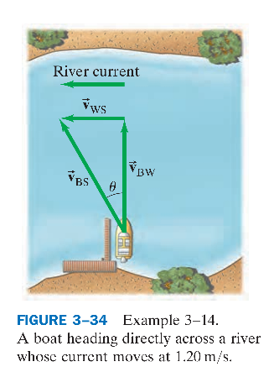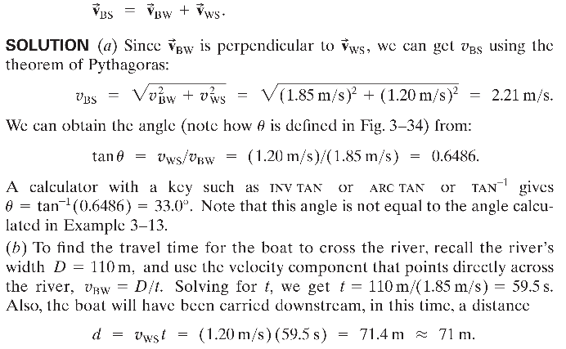

1.5 Motion in Two or Three Dimensions
Key principle: horizontal and vertical motions are independent.

Free fall
- Galileo’s specific contribution to our understanding of the motion of falling objects can be summarized as follows: at a given location on the Earth and in the absence of air resistance, all objects fall with the same constant acceleration.
- We call this acceleration the acceleration due to gravity at the surface of the Earth, and we give it the symbol g.
- Its magnitude is approximately g = 9.80 m/second squared
Example 1
Suppose that a ball is dropped (v0 = 0) from a tower. How far will it have fallen after a time t1 = 1.00 s, t2 = 2.00 s, and t3 = 3.00 s? Ignore air resistance.
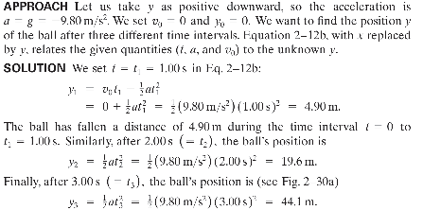

Example 2
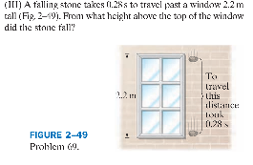
Answer:
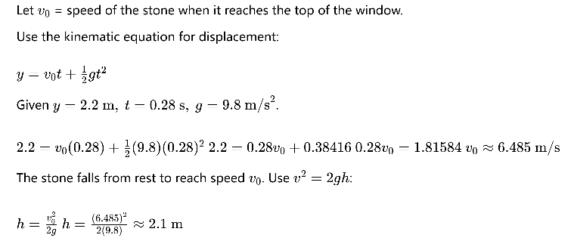
Projectile motion
- Horizontal (x): no air resistance, $a_{x}=0$, constant velocity $v_{x}=v_{0x}=v_{0}cos⁡θ$.
- Vertical (y): constant acceleration $a_{y}=-g$
- $v_{y}=v_{0}sin⁡θ-gt$
- $Δy=v_{0}sin⁡θ⋅t-\frac{1}{2}gt^{2}$
- Range (launch and land at same height): $R=\frac{v_{0}^{2}sin⁡2θ}{g}$
- Velocity at any time: $\overset{→}{v}=(v_{x},v_{y})$; acceleration: $\overset{→}{a}=(0,-g)$ (constant downward).
- 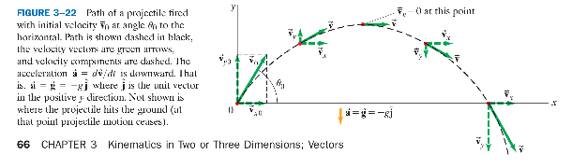
- Vx is constant through the whole motion process
- Vy changes due to gravity at the surface of the earth g
- 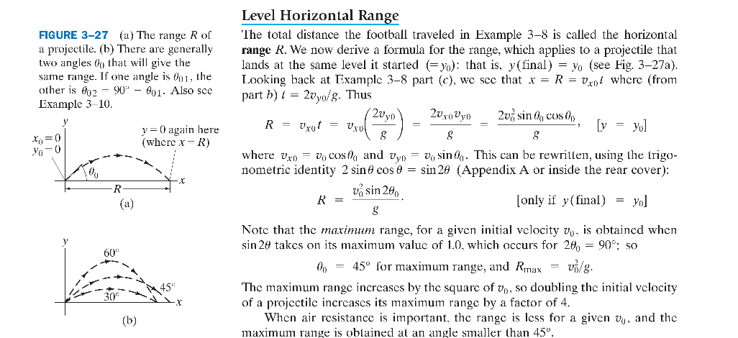

Example 1
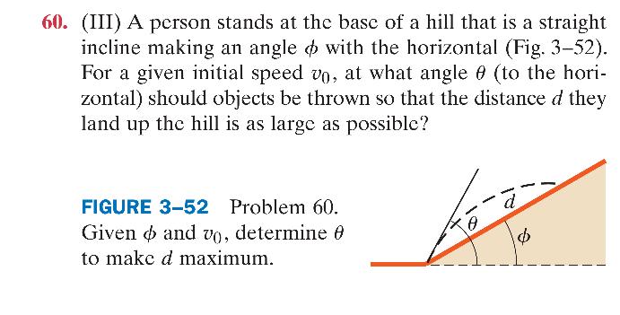

Solution
Horizontal motion: $x=v_{0}cos⁡θ⋅t$
Vertical motion: $y=v_{0}sin⁡θ⋅t-\frac{1}{2}gt^{2}$
From the hill geometry: $tan⁡ϕ=\frac{y}{x}$. Substitute x and y:
$$tan⁡ϕ=\frac{v_{0}sin⁡θ⋅t-\frac{1}{2}gt^{2}}{v_{0}cos⁡θ⋅t}$$
Cancel t and solve for flight time t:
$$tan⁡ϕ=tan⁡θ-\frac{gt}{2v_{0}cos⁡θ}$$
$$t=\frac{2v_{0}(sin⁡θ-cos⁡θtan⁡ϕ)}{g}$$
The distance along the slope is $d=\frac{x}{\cos{ϕ}}=\frac{v_{0}cos⁡θ⋅t}{\cos{ϕ}}$. Substitute t:
$$d=\frac{2v_{0}^{2}cos⁡θ(sin⁡θ-cos⁡θtan⁡ϕ)}{gcos⁡ϕ}$$
Rewrite $tan⁡ϕ=\frac{\sin{ϕ}}{\cos{ϕ}}$:
$$d=\frac{2v_{0}^{2}\left(sin⁡θcos⁡θcos⁡ϕ-\cos^{2}⁡θsin⁡ϕ\right)}{g\cos^{2}⁡ϕ}$$
Use trigonometric identities $2sin⁡θcos⁡θ=sin⁡2θ$, $2\cos^{2}⁡θ=1+cos⁡2θ$:
$$d=\frac{v_{0}^{2}\left[sin⁡2θcos⁡ϕ-(1+cos⁡2θ)sin⁡ϕ\right]}{g\cos^{2}⁡ϕ}$$
$$d=\frac{v_{0}^{2}\left[sin⁡(2θ-ϕ)-sin⁡ϕ\right]}{g\cos^{2}⁡ϕ}$$
To maximize d, maximize $sin⁡(2θ-ϕ)$. The maximum value of sine is 1, achieved when:
$$2θ-ϕ={90}^{∘}$$
$$θ={45}^{∘}+\frac{ϕ}{2}$$

Vectors in three dimensions
- In one dimension, we defined displacement as the change in position of the particle. In the more general case of two or three dimensions, the displacement vector is defined as the vector representing change in position. We call it ∆r, where ∆r= r2- r1. This represents the displacement during the time interval ∆t = t2- t1.
- 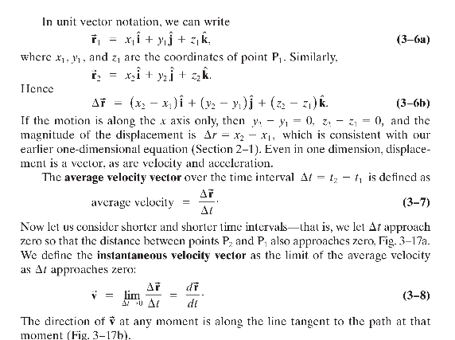
Example 1
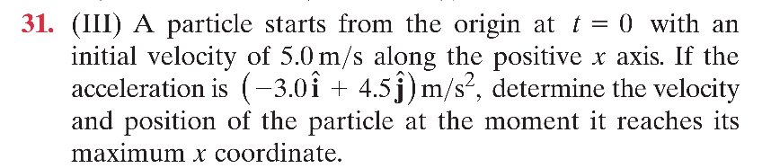

Solution
Initial velocity: ${\overset{→}{v}}_{0}=5.0\overset{^}{i}\text{m/s}$, acceleration: $\overset{→}{a}=(-3.0\overset{^}{i}+4.5\overset{^}{j}){\text{m/s}}^{2}$.
Velocity components as functions of time:
$$v_{x}=v_{0x}+a_{x}t=5.0-3.0t$$
$$v_{y}=v_{0y}+a_{y}t=4.5t$$
At the maximum x coordinate, the x-component of velocity is zero (the particle stops moving in the +x direction and begins moving backward):
$$5.0-3.0t=0⇒t=\frac{5}{3}\text{s}$$

Velocity at maximum x
Substitute $t=\frac{5}{3}\text{s}$ into velocity components:
$$v_{x}=0,v_{y}=4.5×\frac{5}{3}=7.5\text{m/s}$$
$$\overset{→}{v}=7.5\overset{^}{j}\text{m/s}$$

Position at maximum x
Use the kinematic equations for position:
$$x=v_{0x}t+\frac{1}{2}a_{x}t^{2}$$
$$y=v_{0y}t+\frac{1}{2}a_{y}t^{2}$$
Substitute $t=\frac{5}{3}\text{s}$:
$$x=5.0×\frac{5}{3}+\frac{1}{2}(-3.0){\left(\frac{5}{3}\right)}^{2}=\frac{25}{6}≈4.17\text{m}$$
$$y=0+\frac{1}{2}(4.5){\left(\frac{5}{3}\right)}^{2}=6.25\text{m}$$
$$\overset{→}{r}=(4.17\overset{^}{i}+6.25\overset{^}{j})\text{m}$$

Unit 2 Force and Translational Dynamics

2.1 Systems and Center of Mass
Center of mass of a system of particles:
$$x_{cm}=\frac{m_{1}x_{1}+m_{2}x_{2}+…}{m_{1}+m_{2}+…}$$
Center of mass theorem: the net external force determines the acceleration of the center of mass.
$$∑{\overset{→}{F}}_{ext}=M_{total}{\overset{→}{a}}_{cm}$$
- Internal forces do not change the motion of the center of mass; only external forces accelerate the CM.
- 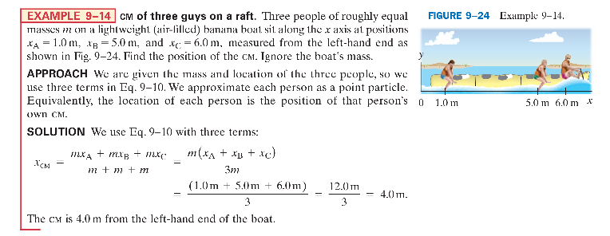

2.2 Forces and Free-Body Diagrams (FBD)

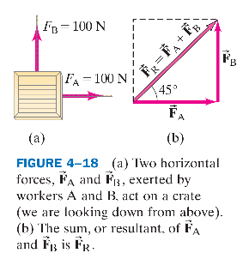

When solving problems involving Newton’s laws and force, it is very important to draw a diagram showing all the forces acting on each object involved. Such a diagram is called a free-body diagram, or force diagram: choose one object, and draw an arrow to represent each force acting on it. Include every force acting on that object. Do not show forces that the chosen object exerts on other objects. To help you identify each and every force that is exerted on your chosen object, ask yourself what other objects could exert a force on it.
How to draw an FBD:
- Draw only forces acting ON the object — never forces it exerts on others.
- Label each force: weight $F_{g}$, normal force $F_{N}$, tension T, friction f, spring force $F_{s}$.
- Set up a coordinate system and resolve forces into x and y components.
- Write equations: $∑F_{x}=ma_{x},∑F_{y}=ma_{y}$.

2.3 Newton's Third Law
Action–reaction pair: ${\overset{→}{F}}_{A→B}=-{\overset{→}{F}}_{B→A}$
Newton’s third law of motion: Whenever one object exerts a force on a second object, the second object exerts an equal force in the opposite direction on the first.
- Equal magnitude, opposite direction; they act on TWO DIFFERENT objects and NEVER cancel each other in a single FBD!
- They are always of the same type: gravity pairs with gravity, normal pairs with normal, etc. 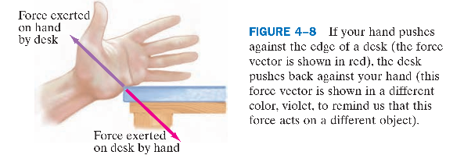
- 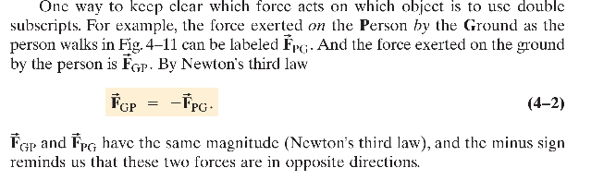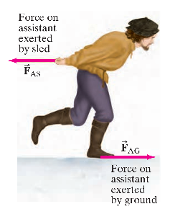

2.4 Newton's First Law (Law of Inertia)
$$∑\overset{→}{F}=0⟺a=0$$
- Net force = 0 → object remains at rest or moves with constant velocity (translational equilibrium).
- In fact, newton’s first law of motion is close to Galileo’s conclusions. It states that every object continues in its state of rest, or of uniform velocity in a straight line, as long as no net force acts on it. The tendency of an object to maintain its state of rest or of uniform velocity in a straight line is called inertia. Newton’s first law is thus often called the law of inertia.
- Inertia: the tendency of an object to resist changes in its motion; mass is the only measure of inertia.
- Physics is easier in reference frames in which Newton’s first law does hold, and they are called inertial reference frames (the law of inertia is valid in them).
- Reference frames where the law of inertia does not hold, such as the accelerating reference frames discussed above, are called noninertial reference frames.

2.5 Newton's Second Law (AP C Core)
- Basic form: $∑\overset{→}{F}=m\overset{→}{a}$
- Calculus form: $∑\overset{→}{F}=\frac{d\overset{→}{p}}{dt}$ (net force = rate of change of momentum).
- 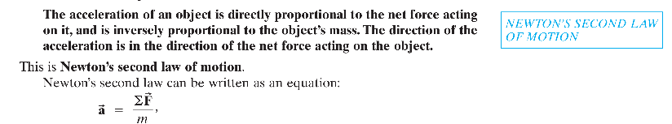

2.6 Gravitational Force
- Near Earth's surface: $F_{g}=mg$, directed vertically downward.
- Newton's law of universal gravitation: $F_{g}=G\frac{m_{1}m_{2}}{r^{2}},G=6.67×{10}^{-11}N⋅m^{2}/{kg}^{2}$
- r = distance between the centers of mass; gravity is always attractive.
- 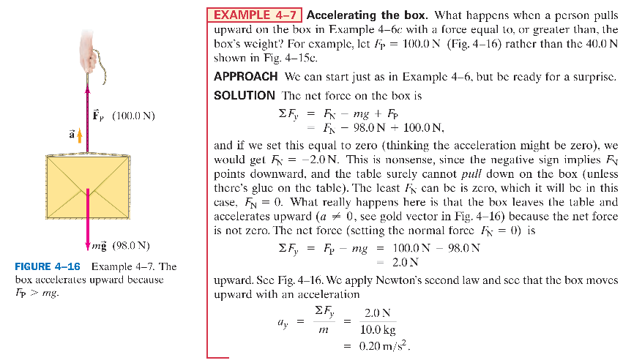
Example 1
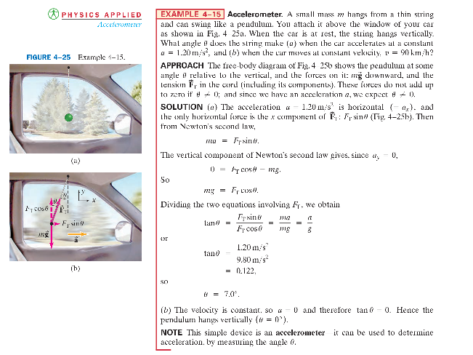

Example 1
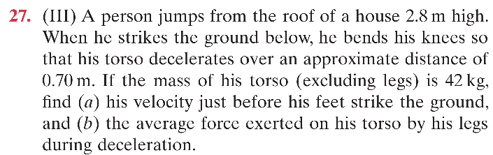

Part (a) — Velocity Just Before Hitting the Ground
Use conservation of mechanical energy for the free-fall drop of height $h_{1}=2.8m$. Initial velocity is zero; gravitational potential energy converts to kinetic energy:
$$mgh_{1}=\frac{1}{2}mv^{2}$$
Mass cancels out:
$$v=\sqrt{2gh_{1}}$$
With $g=9.8m/s^{2}$ and $h_{1}=2.8m$:
$$v=\sqrt{2(9.8)(2.8)}=\sqrt{54.88}≈7.41m/s$$
(a) $v≈7.4m/s$ downward.

Part (b) — Average Force from the Legs

Method 1 — Kinematics + Newton's Second Law
The torso decelerates from $v_{0}=7.41m/s$ to $v_{f}=0$ over displacement $d=0.70m$:
$$v_{f}^{2}=v_{0}^{2}+2ad$$
$$0=v_{0}^{2}+2ad$$
$$a=-\frac{v_{0}^{2}}{2d}$$
Substituting $v_{0}^{2}=2gh_{1}$:
$$a=-\frac{2gh_{1}}{2d}=-\frac{gh_{1}}{d}$$
The negative sign means acceleration points upward. Plugging in numbers:
$$a=-\frac{(9.8)(2.8)}{0.70}=-39.2m/s^{2}$$
Magnitude of upward acceleration: $39.2m/s^{2}$.
Forces on the torso: upward average force $F_{legs}$, downward weight $mg$. Take upward as positive:
$$F_{legs}-mg=m|a|$$
$$F_{legs}=mg+m|a|=m(g+|a|)$$
$$F_{legs}=42(9.8+39.2)=42(49)=2058N$$

Method 2 — Work-Energy Principle (AP Alternative)
Total vertical displacement from roof to the lowest crouched position: $H=2.8+0.70=3.5m$. Work done by gravity plus work done by the legs equals the change in kinetic energy ($ΔK=0$):
$$mgH-F_{avg}⋅d=0$$
$$F_{avg}=\frac{mgH}{d}=\frac{42×9.8×3.5}{0.70}=2058N$$
(b) $F_{avg}≈2100N$ upward (i.e. $2.1×{10}^{3}N$ to 2 significant figures).

Example 2

Part (a) — Pulling Force at Constant Speed
At constant speed, $a=0$, so the net force on the system is zero. Two upward tension forces balance the downward weight $mg$. Taking upward as positive:
$$2F-mg=0$$
$$F=\frac{mg}{2}$$
Plug in $m=78kg$ and $g=9.8m/s^{2}$:
$$mg=78×9.8=764.4N$$
$$F=\frac{764.4}{2}=382.2N≈380N$$
(a) She must pull downward with about $380N$.

Part (b) — Acceleration after a 15% Force Increase
New pulling force:
$$F^{'}=1.15F=1.15×382.2=439.53N$$
Now the net force is not zero. Apply Newton's second law again — two upward tension forces $2F^{'}$ against the downward weight $mg$:
$$2F^{'}-mg=ma$$
$$a=\frac{2F^{'}-mg}{m}$$
Substitute the values:
$$2F^{'}=2×439.53=879.06N$$
$$a=\frac{879.06-764.4}{78}=\frac{114.66}{78}≈1.47m/s^{2}$$

Shortcut (Algebraic Insight)
Since $F=\frac{mg}{2}$ and $F^{'}=1.15\frac{mg}{2}$:
$$a=\frac{2\left(1.15\frac{mg}{2}\right)-mg}{m}=\frac{1.15mg-mg}{m}=0.15g$$
$$a=0.15×9.8=1.47m/s^{2}$$
(b) Her acceleration is about $1.5m/s^{2}$ upward.

2.7 Kinetic and Static Friction
- Static friction $f_{s}$: adjusts to match the applied force — it is NOT a fixed value!
- $0≤f_{s}≤f_{s,max},f_{s,max}=μ_{s}F_{N}$
- When the object is stationary, $f_{s}$ equals the applied force along the contact surface; it reaches its maximum only when the object is about to slide.
- Kinetic friction $f_{k}$: constant once sliding begins.
- $f_{k}=μ_{k}F_{N}$
- $μ_{k}<μ_{s}$; friction always acts parallel to the contact surface, opposing relative motion.
- When an object slides along a rough surface, the force of kinetic friction acts opposite to the direction of the object’s velocity.
- There is also static friction, which refers to a force parallel to the two surfaces that can arise even when they are not moving.
- 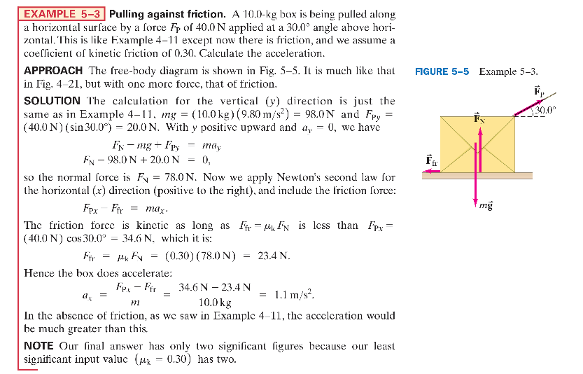
- 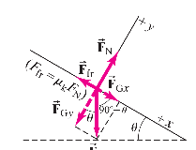
- 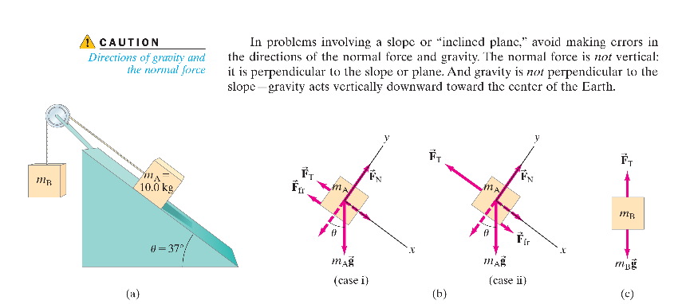

Example 1
A box of mass mA = 10.0 kg rests on a surface inclined at u = 37° to the horizontal. It is connected by a lightweight cord, which passes over a massless and frictionless pulley, to a second box of mass mB, which hangs freely as shown in Fig. 5 9 9a. (a) If the coefficient of static friction is ms = 0.40, determine what range of values for mass mB will keep the system at rest. (b) If the coefficient of kinetic friction is mk = 0.30, and mB = 10.0 kg, determine the acceleration of the system.

Part (a) — Static Equilibrium: Range of m_B
There are two limiting cases depending on which way the system is about to slide. Static friction reverses direction between them.

Case 1 — m_B at Maximum (m_A about to slide UP the ramp)
$m_{B}$ falls down, pulling $m_{A}$ up the incline. Static friction acts down the ramp.
For $m_{A}$ along the ramp:
$T=m_{A}gsin⁡θ+f_{s}$, with $f_{s}=μ_{s}N=μ_{s}m_{A}gcos⁡θ$
For the hanging mass $m_{B}$:
$$T=m_{B,max}g$$
Combine and cancel $g$:
$$m_{B,max}=m_{A}(sin⁡θ+μ_{s}cos⁡θ)$$
$$m_{B,max}=10.0(0.6+0.40×0.8)=10.0(0.6+0.32)=9.2kg$$

Case 2 — m_B at Minimum (m_A about to slide DOWN the ramp)
$m_{A}$ slides down the ramp, lifting $m_{B}$. Static friction acts up the ramp.
For $m_{A}$ along the ramp:
$$T+f_{s}=m_{A}gsin⁡θ⇒T=m_{A}gsin⁡θ-μ_{s}m_{A}gcos⁡θ$$
For the hanging mass:
$$T=m_{B,min}g$$
Cancel $g$:
$$m_{B,min}=m_{A}(sin⁡θ-μ_{s}cos⁡θ)$$
$$m_{B,min}=10.0(0.6-0.40×0.8)=10.0(0.6-0.32)=2.8kg$$
(a) The system stays at rest when $2.8kg≤m_{B}≤9.2kg$.

Part (b) — Kinetic Friction: Find the Acceleration
Since $m_{B}=10.0kg>9.2kg$, $m_{B}$ accelerates downward and $m_{A}$ accelerates up the ramp. Kinetic friction points down the ramp.
Newton's second law for each block:
$$m_{B}g-T=m_{B}a$$
$$T-m_{A}gsin⁡θ-μ_{k}m_{A}gcos⁡θ=m_{A}a$$
Add the two equations to eliminate tension $T$:
$$m_{B}g-m_{A}gsin⁡θ-μ_{k}m_{A}gcos⁡θ=(m_{A}+m_{B})a$$
$$a=\frac{m_{B}g-m_{A}g(sin⁡θ+μ_{k}cos⁡θ)}{m_{A}+m_{B}}$$
Substitute values:
$$a=\frac{10(9.8)-10(9.8)(0.6+0.3×0.8)}{10+10}$$
$$a=\frac{98-98(0.84)}{20}=\frac{98-82.32}{20}=\frac{15.68}{20}=0.784m/s^{2}$$
(b) $a≈0.78m/s^{2}$ — $m_{B}$ accelerates downward; $m_{A}$ accelerates up the incline.

Example 2
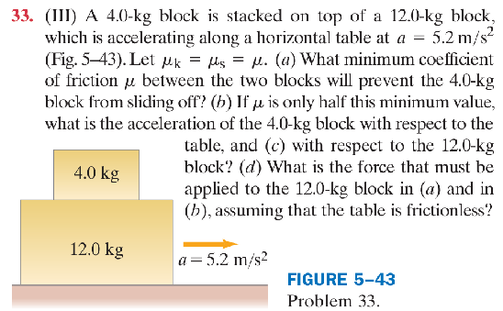

Part (a) — Minimum Coefficient of Static Friction
The upper block gets its acceleration only from static friction between the two blocks.
Newton's second law for the top block:
$$f_{s}=m_{1}a$$
Maximum static friction:
$$f_{s}=μ_{s}m_{1}g$$
Equate them:
$$μ_{s}m_{1}g=m_{1}a$$
The mass cancels:
$$μ_{s}=\frac{a}{g}=\frac{5.2}{9.8}≈0.53$$
(a) $μ_{s}≈0.53$

Part (b) — Top Block's Acceleration Relative to the Table
Set $μ^{'}=\frac{1}{2}μ_{s}=\frac{0.53}{2}=0.265$. Now the blocks slip, and kinetic friction accelerates the top block:
$$f_{k}=μ^{'}m_{1}g=m_{1}a_{1}$$
Mass cancels:
$$a_{1}=μ^{'}g=0.265×9.8≈2.6m/s^{2}$$
(b) $a_{1}≈2.6m/s^{2}$ to the right (relative to the table).

Part (c) — Top Block's Acceleration Relative to the Bottom Block
First find the applied force $F$ from case (a) (it stays the same in case (b)):
$$F=(m_{1}+m_{2})a=(4.0+12.0)×5.2=83.2N$$
For the bottom block $m_{2}$, the kinetic friction opposes the motion:
$$F-f_{k}=m_{2}a_{2}$$
with $f_{k}=μ^{'}m_{1}g=0.265×4.0×9.8≈10.4N$:
$$a_{2}=\frac{F-f_{k}}{m_{2}}=\frac{83.2-10.4}{12.0}≈6.07m/s^{2}$$
Relative acceleration of the top block with respect to the bottom block:
$$a_{rel}=a_{1}-a_{2}=2.6-6.07=-3.5m/s^{2}$$
The negative sign means that relative to the 12-kg block, the 4-kg block accelerates to the left.
(c) $3.5m/s^{2}$ to the left (relative to the 12.0-kg block).

Part (d) — Applied Force on the 12.0-kg Block

Case (a): No Slipping
Both blocks move together as a single system:
$$F_{a}=(m_{1}+m_{2})a=16.0×5.2=83.2N$$

Case (b): Slipping
The applied force is held the same as in case (a):
$$F_{b}=83.2N$$

Example 3
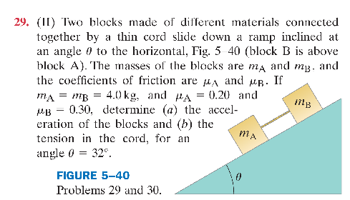

Part (a) — Acceleration of the Blocks
Treat A + B as one combined system. Internal tension cancels, so we only need external forces along the slope.
Total downhill gravity component: $(m_{A}+m_{B})gsin⁡θ$
Total uphill kinetic friction: $μ_{A}m_{A}gcos⁡θ+μ_{B}m_{B}gcos⁡θ$
Newton's second law for the whole system:
$$(m_{A}+m_{B})gsin⁡θ-\left(μ_{A}m_{A}gcos⁡θ+μ_{B}m_{B}gcos⁡θ\right)=(m_{A}+m_{B})a$$
Total mass $M=m_{A}+m_{B}=8.0kg$. Substitute numbers:
$$8.0×9.8×0.5299-\left(0.20×4×9.8×0.8480+0.30×4×9.8×0.8480\right)=8.0a$$
$$41.54-(6.65+9.97)=8a$$
$$41.54-16.62=8a$$
$$24.92=8a$$
$$a≈3.1m/s^{2}$$
(a) $a≈3.1m/s^{2}$ down the ramp.

Part (b) — Tension in the Cord
Isolate block A (the lower block). Along the slope:
- Downhill: gravity component $m_{A}gsin⁡θ$
- Uphill: kinetic friction $μ_{A}m_{A}gcos⁡θ$ and tension $T$ (B pulls A uphill)
$$m_{A}gsin⁡θ-μ_{A}m_{A}gcos⁡θ-T=m_{A}a$$
Rearrange for $T$:
$$T=m_{A}gsin⁡θ-μ_{A}m_{A}gcos⁡θ-m_{A}a$$
Substitute:
$$T=4.0×9.8×0.5299-0.20×4.0×9.8×0.8480-4.0×3.1$$
$$T=20.77-6.65-12.4≈1.7N$$
(b) $T≈1.7N$.

Verification (using block B)
For block B, gravity and tension both pull downhill while friction opposes:
$$m_{B}gsin⁡θ+T-μ_{B}m_{B}gcos⁡θ=m_{B}a$$
$20.77+1.7-9.97=12.5$, and $m_{B}a=4×3.1=12.4$ — consistent within rounding.

2.8 Spring Forces (Hooke's Law)
$$F_{s}=-kx$$
- k = spring constant (stiffness).
- x = displacement from the equilibrium / natural length (stretch or compression).
- The negative sign means the force opposes the deformation, always pointing toward the equilibrium position.
- 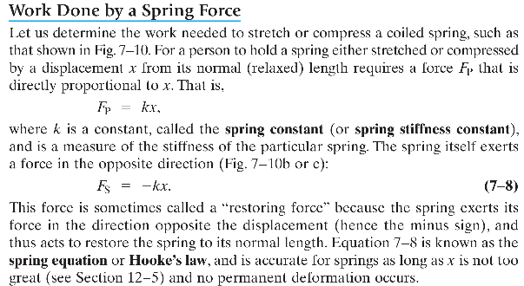
- 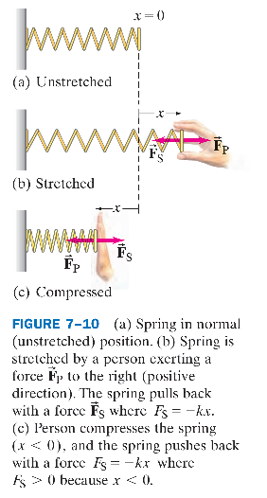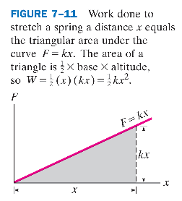
Work is proportional to x squared

Example1

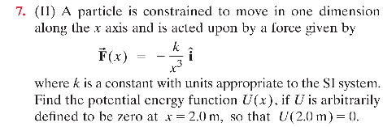Key Relation
For a one-dimensional conservative force:
$$F(x)=-\frac{dU}{dx}$$
Rearranged for integration:
$$U(x)-U(x_{0})=-\int_{x_{0}}^{x}{}F(x^{'})dx^{'}$$
Given:
- $F(x)=-\frac{k}{x^{3}}$
- $U(2.0m)=0$
- Reference point $x_{0}=2.0m$

Step 1 — Substitute the Force into the Integral
$$U(x)-U(2)=-\int_{2}^{x}{}F(x^{'})dx^{'}$$
$$U(x)-0=-\int_{2}^{x}{(-\frac{k}{x^{'3}})}dx^{'}$$
The two negatives cancel:
$$U(x)=k\int_{2}^{x}{}x^{'-3}dx^{'}$$

Step 2 — Evaluate the Definite Integral
$$∫x^{'-3}dx^{'}=-\frac{1}{2x^{'2}}$$
Apply the upper limit $x$ and lower limit $2$:
$$U(x)=k{\left[-\frac{1}{2x^{'2}}\right]}_{2}^{x}$$
$$U(x)=k\left[\left(-\frac{1}{2x^{2}}\right)-\left(-\frac{1}{2(2)^{2}}\right)\right]$$
$$U(x)=k\left(-\frac{1}{2x^{2}}+\frac{1}{8}\right)$$

Final Result
$$U(x)=\frac{k}{8}-\frac{k}{2x^{2}}$$

Verification
Differentiate $U(x)$:
$$\frac{dU}{dx}=\frac{k}{x^{3}}$$
$$F(x)=-\frac{dU}{dx}=-\frac{k}{x^{3}}$$
This matches the given force. At $x=2.0m$:
$$U(2)=\frac{k}{8}-\frac{k}{8}=0$$
which satisfies the zero-potential boundary condition

