The Waikato Linux Users Group
is meeting in TX3 tonight:

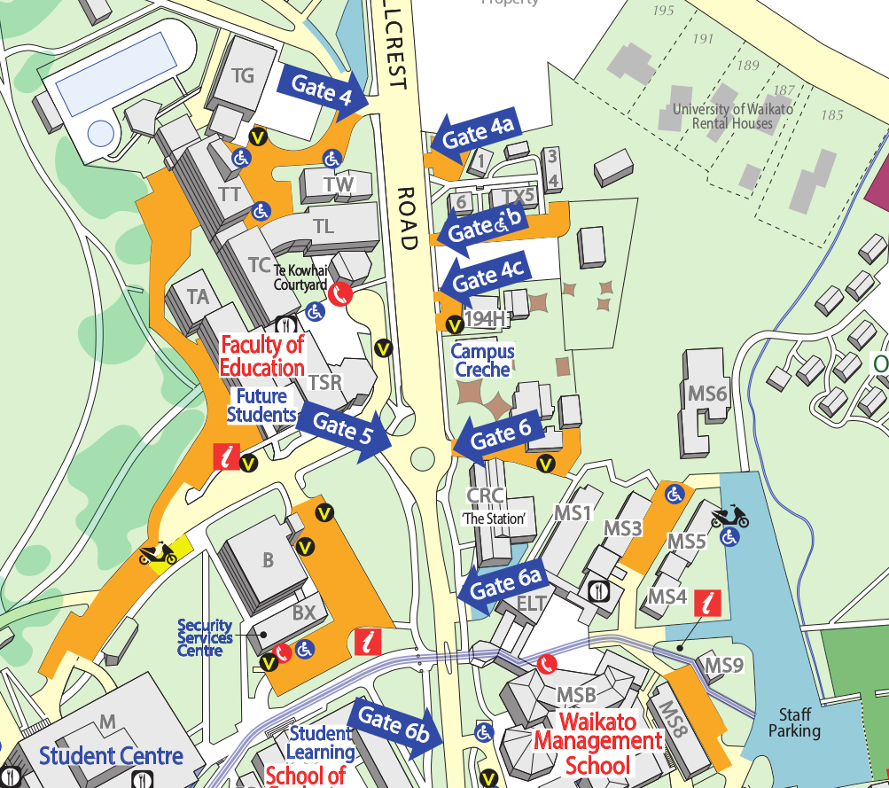
TX3
MS4

You are here

