Tilt Sensing with Accelerometer
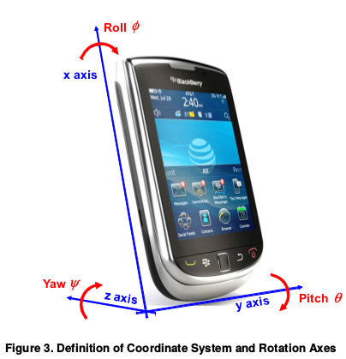
y → x
x → y
z → z
gravity when lying flat: (0, 0, 1)

