**cNORMj - Continuous Norming with cNORM in Jamovi**

[Jamovi](https://www.jamovi.org/) is a very intuitive, free and open source statistical software. We have contributed the module cNORMj to the Jamovi software library, which offers you the essential functionality of the R package cNORM. The method stems from psychometric test construction and was developed to create continuous norms for age or grade in performance assessment (e. g. vocabulary development, A. Lenhard et al., 2015; reading and writing development, W. Lenhard et al., 2017). It can however be applied wherever test data like psychological (e. g. intelligence), physiological (e. g. weight) or other measures are dependent on continuous (e.g., age) or discrete (e.g., sex or test mode) explanatory variables.

The package estimates percentile curves in dependence of the explanatory variable (e. g. schooling duration, age ...) via Taylor polynomials, thus offering several advantages:

* + By optimizing the model on the basis of the total sample, small deviations from the representativeness of individual subsamples, for example due to incomplete data stratification, are minimized.
  + Gaps between different discrete levels of the explanatory variable are closed. For example, in school performance tests, norm tables can be created not only for the discrete measurement point of the normative sample collection (e.g. midyear or end of the year), but also at any time of the school year with the desired accuracy.
  + Norm tables are always determined based on the entire normative sample, not only on the basis of a single cohort or class level. Therefore, in comparison to conventional norming, higher norming quality is achieved even with considerably smaller normative samples (W. Lenhard & Lenhard, 2020).
  + The limits of the model fit can be evaluated graphically and analytically. For example, it is possible to determine where the model deviates strongly from the manifest data or where strong floor or ceiling effects occur. This makes it possible to specify at which points the test scores can no longer be interpreted in a meaningful way.
  + cNORM does not require any distribution assumptions. Therefore, in most use cases the data can be modelled more precisely than with parametric methods (A. Lenhard, Lenhard, & Gary, 2019). This is particularly true for small samples (< 100 per age group or grade) and skewed raw score distributions. Moreover, it applies in particular to those areas that deviate rather strongly from the population average, but often represent precisely those areas that have the highest relevance in diagnostic practice. The computational method can be seen as fitting a hyperplane to the three-dimensional relationship of raw score, norm score and explanatory variable through Taylor polynomials

The aim of cNORM is to generate conventional and continuous norm scores for psychometric test construction and it can be applied to medical or biometric scales as well. It draws on Taylor polynomials to generate norm scores for single groups or to apply regression-based continuous norming. In the most simple case, it can be used to rank data groupwise and to determine percentiles, z , T, IQ scores via inverse normal transformation. Its advantage however lies in its ability to infer statistical regression-based models that improve the quality of the norm scores.

In the second release of the module, we added support for feeding back manifest and modelled norm scores to the dataset und to apply weights in order to mitigate violations of representativeness of the norm samples. Please consult the online-help and Gary et al. (accepted) and the package vignette for further information on post-stratification and its application to norming.

**Norm score generation for single groups**

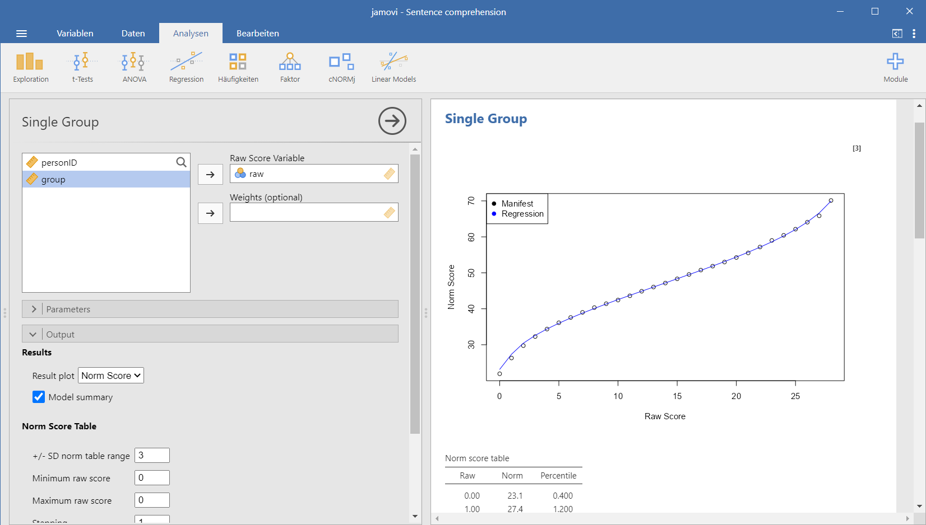

The first part of this module targets single groups and it determines norm scores (either manifest or regression-based). Ranking is based on the Rankit procedure and inverse normal transformation. In order to smooth the norm score data and to close the missings, the functional relationship between raw score and norm score is additionally modeled via polynomial regression up to power 5, using the cNORM package (A. Lenhard, Lenhard & Gary, 2018). Weighting is possible to mitigate violations of representativeness. If applied, the weights of the cases are applied in the ranking process.

Please specify the raw score variable and optionally the weights to obtain the norm table. Additional options:

1. **Data Preparation**
   * **Invert ranking order:** Please activate this option to set the ranking order to 'descending'. In this case, the highest values receive the lowest norm scores.
   * **Type of norm scale:** You can compute T, IQ, z, PISA (m = 500, sd = 100) and Wechsler (m = 10, sd = 3) scales.
   * **Use regression:** Per default, the module uses regression to model the relationship between raw and norm score. If this option is deactivated, it simply reports the manifest percentiles and norm scores on the basis of an inverse normal transformation of the percentiles (bindings are addressed via RankIt). The number of terms specifies the number of predictors in the regression formula (higher values result in closer fit).
2. **Output**
   * **Result plot:** The plot is either set to norm scores or percentiles (cumulative function).
   * **Model summary:** This gives you a report on the regression model.
   * **Norm table range:** Restricts the norm score generation to +/- SD. Usually, it is not advisable to go beyond 3 SD, unless you have a really large dataset. For IQ scores this would result in an interval of IQ 55 to 145.
   * **Minimum raw score** and **Maximum raw score**: You can specify the boundaries of the generated norm score table. Please note that this option is only taken into account, if the maximum score is higher than the minimum score, otherwise, the minimum and maximum raw scores from the data are used.
   * **Stepping:** This option sets the granularity of the norm score table.
3. **Save**

You can specify if the manifest and fitted norm scores and percentile are fed back to the dataset. New variables will show up in your dataset in that case.

**Continuous Regression-Based Norming**

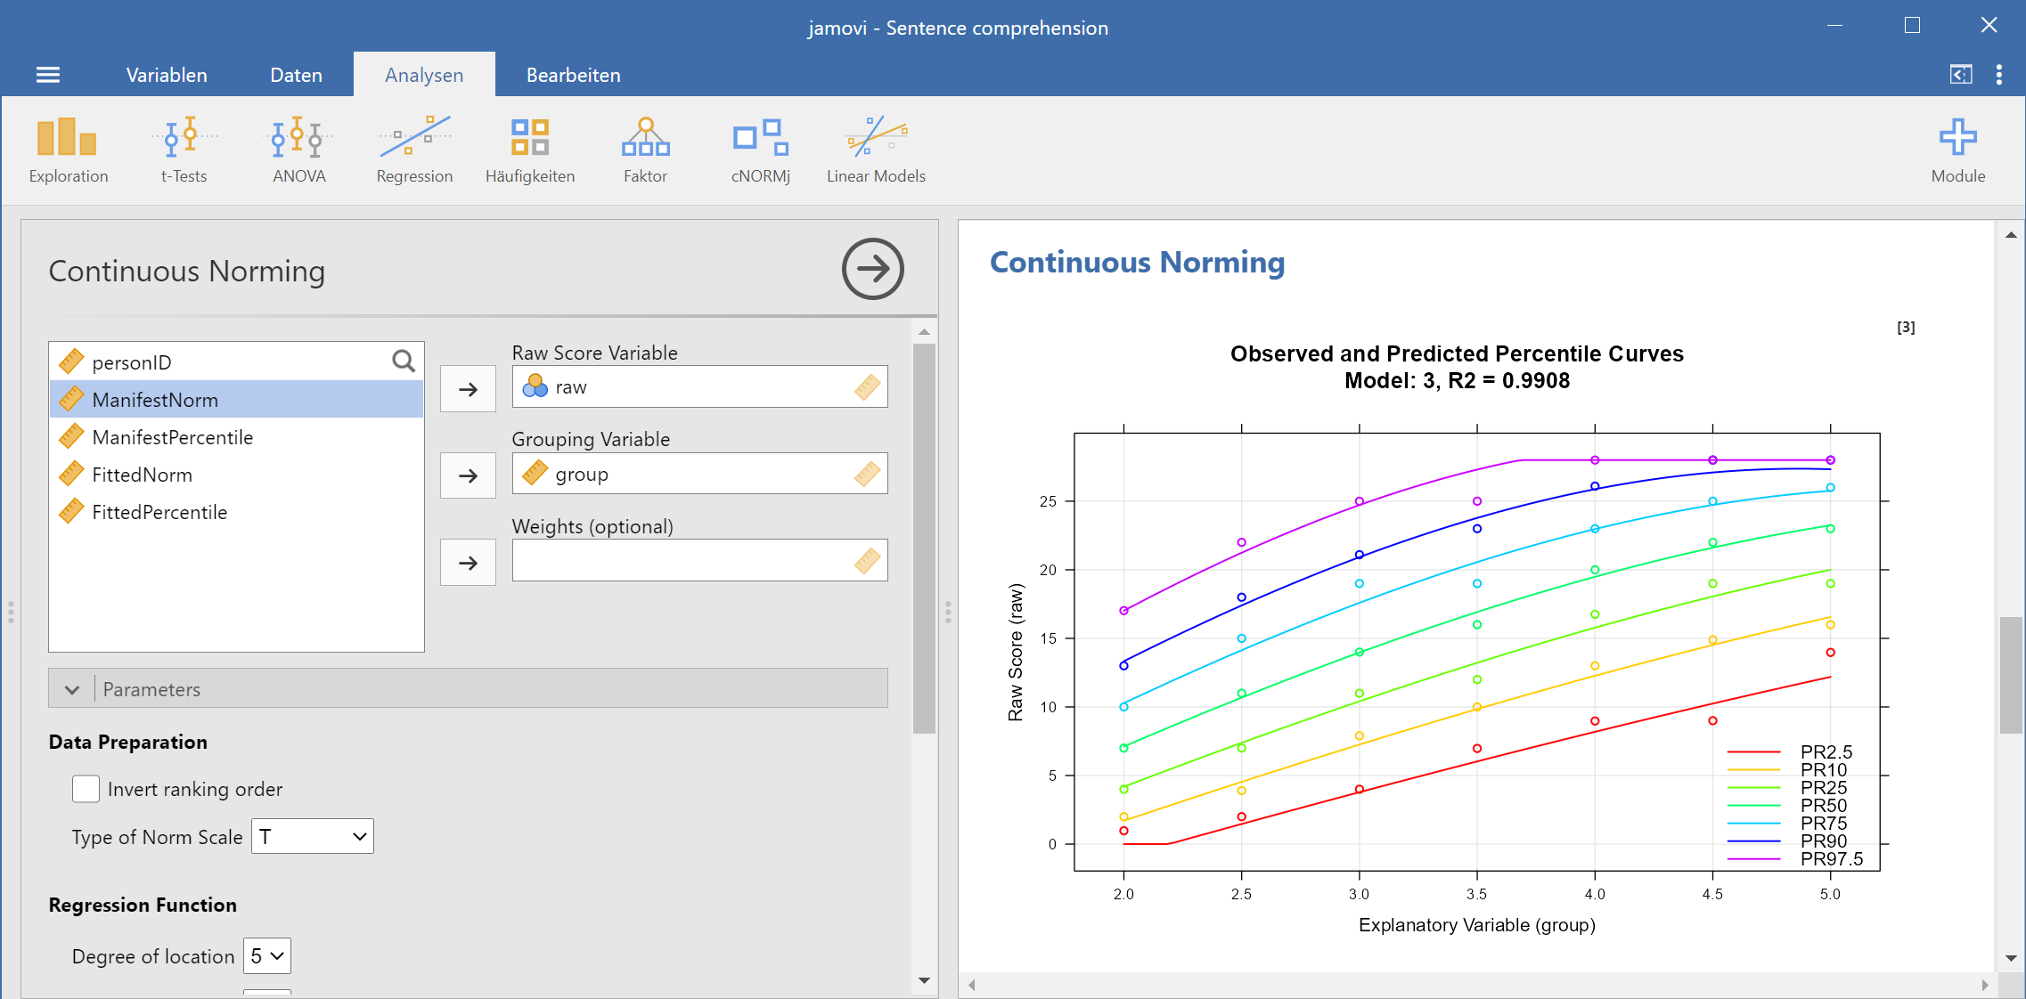

The module estimates continuous norm scores by modelling the functional relationship between raw scores (raw), norm scores (L) and the grouping variable (A; e. g. age, schooling duration ...) using the cNORM package. Select a model with a low number of terms while preserving a high R2 of the model. Avoid intersecting percentile curves. Weighting is possible to mitigate violations of representativeness. If applied, the weights of the cases are applied in the ranking process. The module gives you the following options:

1. **Data Preparation**
   * **Invert ranking order:** Please activate this option to set the ranking order to 'descending'. In this case, the highest values receive the lowest norm scores.
   * **Type of norm scale:** You can compute T, IQ, z, PISA (m = 500, sd = 100) and Wechsler (m = 10, sd = 3) scales.
   * **Degree of location / Degree of age:** cNORM uses polynomial regression based on Taylor polynomials to retrieve the continuous norm score models. The degree specifies the power parameter and thus, which higher order relations are modelled. You can independently set the power for location and age. While it is usually sufficient, to assume a cubic age trajectory in the case of developmental effects – hence power 3 as a default – to increase power of location to 5 showed to be a good choice to model the normal transformation from raw to norm scores. This way, most of the variance in psychometric data is captured. It is advisable to reduce the parameter in smaller datasets to avoid overfitting.
   * **Number of terms:** cNORM tries to find an optimal solution but it might be necessary to fine tune the model. Please vary the number of terms and use visual inspection of the percentile plot to identify good model solutions.
2. **Output**
   * **Model summary:** This gives you a report on the regression model. 'A' in the function refers to the grouping variable 'L' to the norm score. raw ~ L2 + L2A4 would thus mean, the raw score is predicted by the squared norm score and an interaction term of norm score (power 2) and grouping variable (power 4).
   * **Value for norm score table**: Since the models are continuous, you explicitly need to specify the value for generating a specific norming table. In the example above, reading comprehension test data for grade 2 to 5 were used. For example, to generate a table for the first quarter of grade 3 (grouping variable 2.0 to 2.25), you could set it to the mid interval and thus specify a value of 2.125.
   * **Norm table range:** Restricts the norm score generation to +/- SD. Usually, it is not advisable to go beyond 3 SD, unless you have a really large dataset. For IQ scores this would result in an interval of IQ 55 to 145.
   * **Minimum raw score** and **Maximum raw score**: You can specify the boundaries of the generated norm score table. Please note that this option is only taken into account, if the maximum score is higher than the minimum score, otherwise, the minimum and maximum raw scores from the data are used.
   * **Stepping:** This option sets the granularity of the norm score table.
3. **Save**You can specify if the manifest and fitted norm scores and percentile are fed back to the dataset. New variables will show up in your dataset in that case.

**Sample Datasets**

[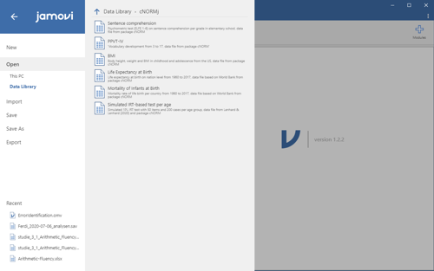](https://www.psychometrica.de/img/cnorm_jamovi_data_big.png)

The cNORMj module includes the dataset from the cNORM package. You can use these to get accustomed to the analyses. To load the dataset, please click on the burger menu at the top left, select 'Open' and you will find the datasets in 'Data Library' in the folder 'cNORMj'.

**Installation**

[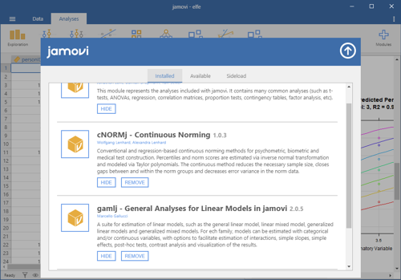](https://www.psychometrica.de/img/cnorm_jamovi_installation_big.png)

The 'cNORMj' module is available via the Jamovi library for all platforms. Please click on the 'Modules' option on the top right. You will find a library for the installation and management of the modules. You can as well download the module for Win64 and install it manually via 'Sideload'.

**References**

Gary, S., Lenhard, A., Lenhard, W. & Herzberg, D. (accepted). Reducing the bias of norm scores in non-representative samples: Weighting as an adjunct to continuous norming methods. *Assessment*.

Lenhard, A., Lenhard, W., Gary, S. (2019). Continuous norming of psychometric tests: A simulation study of parametric and semi-parametric approaches. *PLoS ONE, 14(9)*, e0222279. [doi: 10.1371/journal.pone.0222279](https://doi.org/10.1371/journal.pone.0222279)

Lenhard, A., Lenhard, W., Suggate, S. & Segerer, R. (2018). A continuous solution to the norming problem. *Assessment, 25*, 112-125. [doi: 10.1177/1073191116656437](https://doi.org/10.1177/1073191116656437)

Lenhard, W., & Lenhard, A. (2020). Improvement of Norm Score Quality via Regression-Based Continuous Norming. *Educational and Psychological Measurement(Online First)*, 1-33. [doi: 10.1177/0013164420928457](https://doi.org/10.1177/0013164420928457)

Lenhard, W., Lenhard, A., & Gary, S. (2018). *cNORM: Continuous Norming*. Vienna: The Comprehensive R Network. available via <https://cran.r-project.org/web/packages/cNORM/>

**Further information on weighting:**

* <https://www.psychometrica.de/cNorm_raking_en.html>
* <https://cran.r-project.org/web/packages/cNORM/vignettes/WeightedRegression.html>