1.

5.1：f(n)=n\*f(n-1)

5.3： $a_{n+1}=\frac{1}{1+a_{n}}$

5.5.1

下用数学归纳法证明：

当n=1时，T(0)= $2^{1-1}$ =1满足

假设 1<=n<=k (k为正整数)时T(n)= $2^{n-1}$, 当n=k+1时T(k+1)= $\sum_{i=0}^{k}{T(i)}$ = $1+\sum_{i=1}^{k}{2^{i-1}}$ =1+ $\frac{2^{k}-1}{2-1}$ = $2^{k+1-1}$ 也满足

综合，T(n) = $2^{n-1}$

5.5.2

def f(L):

a = [len(L)-1 for i in L]

b = [-1 for i in L]

for i in range(len(L)-1,0,-1):

X=[]

for j in range(len(L)-1,i,-1):

if L[j]>L[i]:X.append(j)

for k in X:

if a[i] < a[k]+1:a[i]=a[k]+1;b[i]=k

max=0

for i in range(1,len(a)):

if a[i] > a[max]: max = i

X = [L[max]];i = max

while b[i]>=0:

X.append(L[b[i]])

i = b[i]

print(X)

L=[5,2,4,7,6,3,8,9]

f(L)

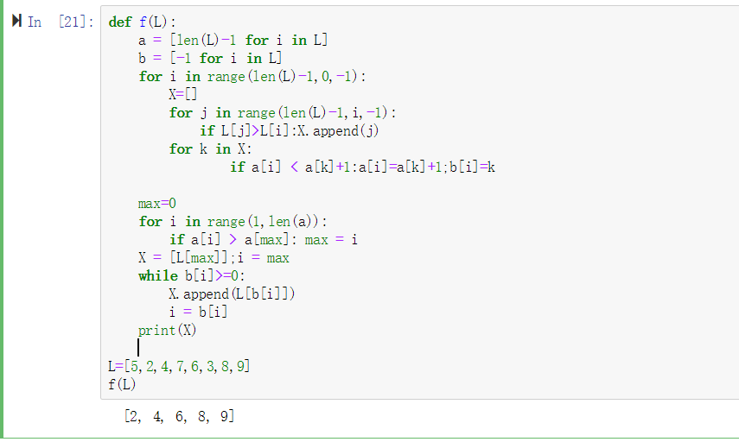

5.6.1

显示迷宫：

[1, 1, 1, 0, 1, 1, 1, 1, 1, 1]

[1, 0, 0, 0, 1, 0, 1, 0, 1, 1]

[1, 0, 1, 0, 0, 0, 0, 0, 0, 1]

[1, 0, 1, 0, 1, 0, 0, 1, 0, 1]

[1, 0, 1, 0, 1, 1, 0, 0, 0, 1]

[1, 0, 0, 0, 1, 0, 1, 0, 1, 1]

[1, 1, 1, 1, 0, 0, 0, 0, 1, 1]

[1, 0, 0, 0, 0, 1, 1, 1, 0, 0]

[1, 0, 1, 1, 0, 0, 0, 0, 0, 1]

[1, 1, 1, 1, 1, 1, 1, 1, 1, 1]

入口：m[0][3]：出口：m[7][9]

显示路径：

[1, 1, 1, 2, 1, 1, 1, 1, 1, 1]

[1, 3, 3, 2, 1, 3, 1, 3, 1, 1]

[1, 3, 1, 2, 2, 2, 2, 2, 2, 1]

[1, 3, 1, 3, 1, 2, 2, 1, 2, 1]

[1, 3, 1, 3, 1, 1, 0, 2, 2, 1]

[1, 3, 3, 3, 1, 3, 1, 2, 1, 1]

[1, 1, 1, 1, 2, 2, 2, 2, 1, 1]

[1, 0, 0, 0, 2, 1, 1, 1, 2, 2]

[1, 0, 1, 1, 2, 2, 2, 2, 2, 1]

[1, 1, 1, 1, 1, 1, 1, 1, 1, 1]

互换后：

显示迷宫：

[1, 1, 1, 0, 1, 1, 1, 1, 1, 1]

[1, 0, 0, 0, 1, 0, 1, 0, 1, 1]

[1, 0, 1, 0, 0, 0, 0, 0, 0, 1]

[1, 0, 1, 0, 1, 0, 0, 1, 0, 1]

[1, 0, 1, 0, 1, 1, 0, 0, 0, 1]

[1, 0, 0, 0, 1, 0, 1, 0, 1, 1]

[1, 1, 1, 1, 0, 0, 0, 0, 1, 1]

[1, 0, 0, 0, 0, 1, 1, 1, 0, 0]

[1, 0, 1, 1, 0, 0, 0, 0, 0, 1]

[1, 1, 1, 1, 1, 1, 1, 1, 1, 1]

入口：m[7][9]：出口：m[0][3]

显示路径：

[1, 1, 1, 2, 1, 1, 1, 1, 1, 1]

[1, 0, 0, 2, 1, 3, 1, 0, 1, 1]

[1, 0, 1, 2, 2, 2, 2, 0, 0, 1]

[1, 0, 1, 0, 1, 3, 2, 1, 0, 1]

[1, 0, 1, 0, 1, 1, 2, 2, 0, 1]

[1, 0, 0, 0, 1, 3, 1, 2, 1, 1]

[1, 1, 1, 1, 2, 2, 2, 2, 1, 1]

[1, 0, 0, 0, 2, 1, 1, 1, 2, 2]

[1, 0, 1, 1, 2, 2, 2, 2, 2, 1]

[1, 1, 1, 1, 1, 1, 1, 1, 1, 1]

2.

5.4

def gcd(a,b):

if a==b:return a

if a==1 or b==1:return 1

x = max(a,b)

y = min(a,b)

return gcd(x-y,y)

def coprime(a,b):

x = gcd(a,b)

if x==1:return a,b

return coprime(a//x,b//x)

def f(n):

L = [1,1]

while n:

L[0],L[1] = coprime(L[1],L[0]+L[1])

n-=1

return L

def main(n):

L = f(n)

print('%d/%d' % (L[0],L[1]))

main(3)

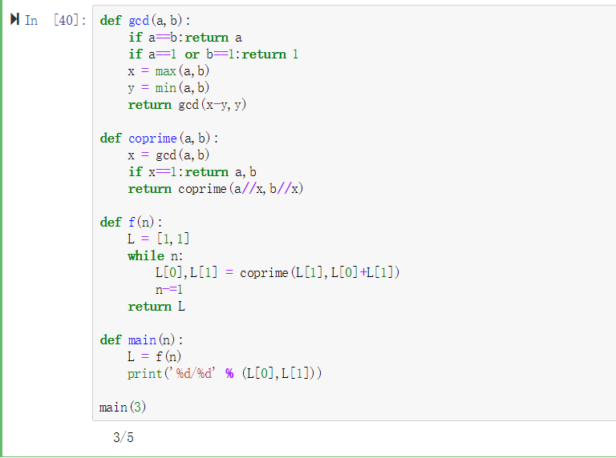

3.

5.7

def swop(x,y):

if len(x)<len(y):

x,y=y,x

return x,y

def add(x,y,B,i=1):

if i == len(y)+1:print(x);return

s = y[len(y)-i]

if len(x)-i>=0:

p = x[len(x)-i]+s

if p>=B:

x[len(x)-i] = p-B

if len(y)-i-1 >= 0:

y[len(y)-i-1] += 1

else:y=[1]+y

else:x[len(x)-i] = p

add(x,y,B,i+1)

else:print([1]+x)

def f(x,y,B):

x,y = swop(x,y)[0],swop(x,y)[1]

add(x,y,B)

B = 11

x = [10,9,9]

y = [9,9]

f(x,y,B)

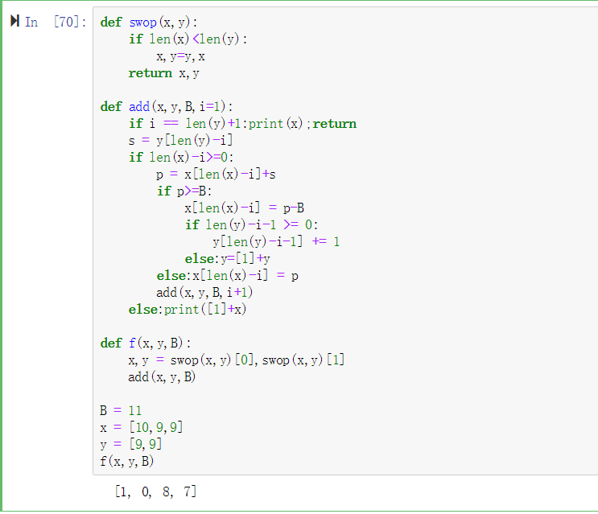

4.

5.9

def f(s,L=[],i=0):

if i < len(s):

L.append(int(s[i]))

return f(s,L,i+1)

else:return L

def main():

s = input()

print(f(s))

del(s)

main()

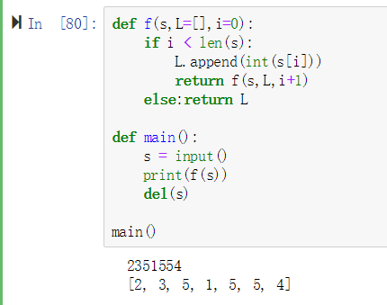

5.

5.14

def F(n):

if n==1:

return 1

if n==2:

return 2

if n==3:

return 4

L=[1,2,4]

for i in range(3,n):

L.append(L[i-1]+L[i-2]+L[i-3])

return L[-1]

for i in range(20,61):

print(F(i))

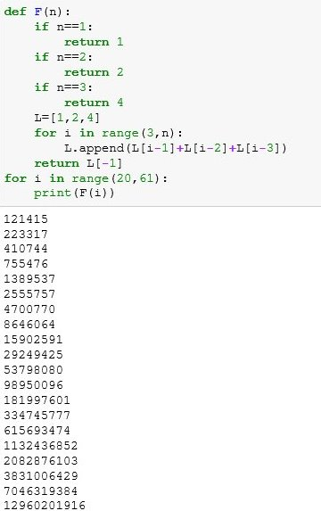

6.

一起上来演示游戏并讲解

赵云翔：程序编写

魏明达：策划+辅助编写

李雨倩：撰写报告

陆泠朴：待定