1.k=0

4.2.4：push: L=[R1]+L

pop: R1=L[0]; L=L[1:]

4.2.6:

k=[]

for i in L:

if i != x:

k.append(i)

L = k

4.2.8:

s = input()

x,y = map(int,s.split('.'))

print('x=%d y=%d' % (x,y))

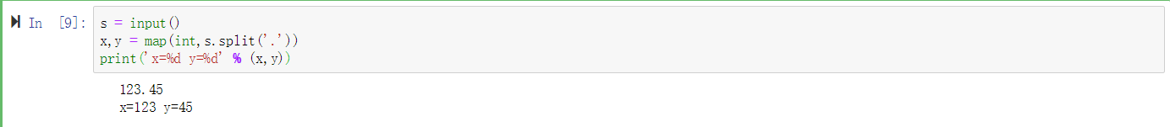

4.2.10:

def replace(s,old,new):

p = len(old) # old的长度

k = s.find(old)

while k!=-1:

s = s[:k]+new+s[p+k:]

k = s.find(old)

return s

s = 'sd,afhk,asf,jld,la,'

s = replace(s,',a', '!')

print(s)

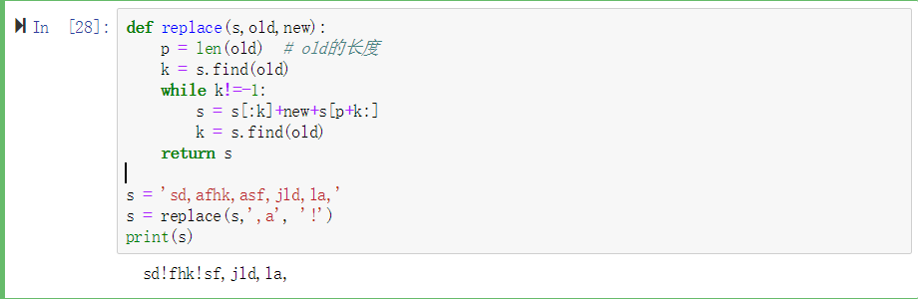

4.2.12:

s = input()

for each in s:

if not each.isalnum():

s.replace(each,' ')

L = s.split()

p = set(L)

dic = {i:0 for i in p}

for i in L:

dic[i]+=1

k = []

for key in dic:

k.append([key,dic[key]])

print(k)

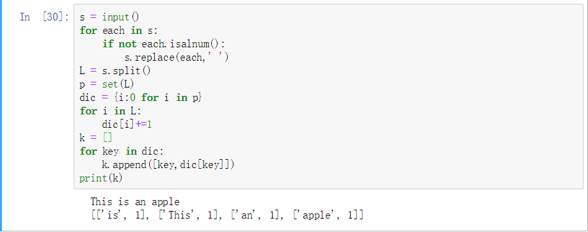

4.2.14:

{'fruit': ['apple', 'banana', 'orange']}

{'name': 'Python', 'price': 70}

{'name': 'Python'}

{'name': 'Python', 'price': '40', 'author': 'Dr.Li'}

4.5.2:

L= [1, 2, 3]

L= [1, 2]

L= [1]

L: [1]

L: [1, 2]

L: [1, 2, 3]

outside recursive_2, X= [1, 2, 3]

4.5.4:

L是局部变量，这个函数每次将变量L去掉第一位直到L==[]，最后算出len(L)+len(L)-1+…+1

2.

4.8.1:

from turtle import *

i = 5

while i:

forward(100)

right(180-36)

i -= 1

Screen().exitonclick()

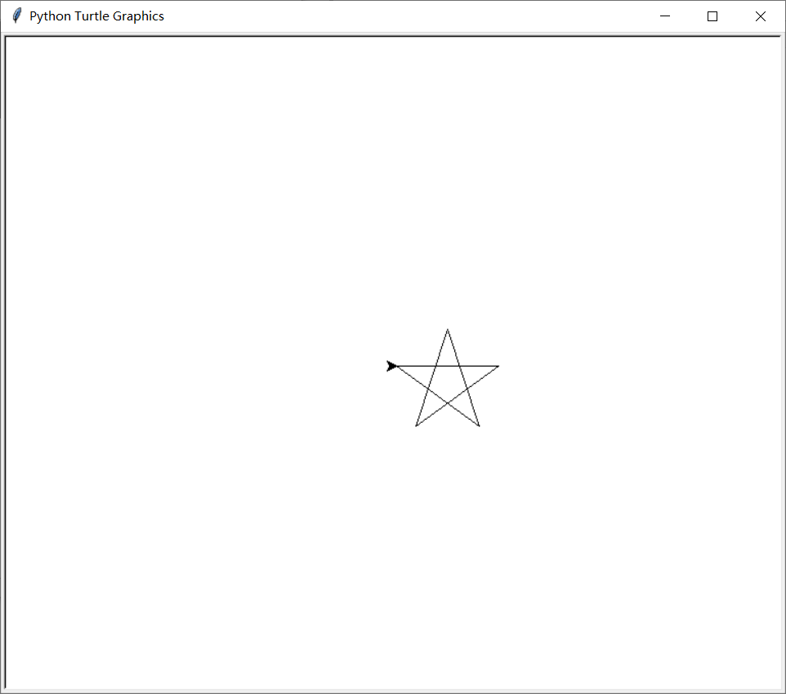

4.8.2

from turtle import *

speed(10)

def square():

pencolor('blue')

for i in range(4):

forward(100)

left(90)

def cir(r):

pencolor('red')

up()

goto(0,-r)

down()

circle(r)

up()

goto(0,0)

down()

cir(50)

cir(70)

cir(90)

cir(110)

for i in range(0,90,6):

left(i)

square()

Screen().exitonclick()

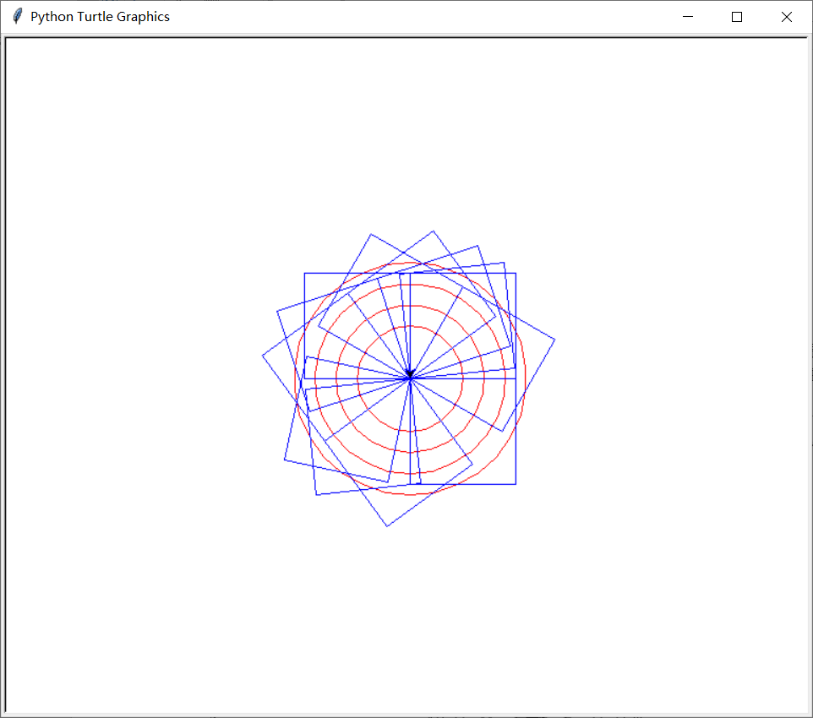

4.8.3:

IN_TIMES负责画外面的20个圆，TIMES画里面的一个圆，并使IN_TIMES画的圆是沿着TIMES的边画的，改变TIMES会改变内圈的圆，改变IN_TIMES改变外圈，注释掉forward(200/TIMES)将没有内圈，变成：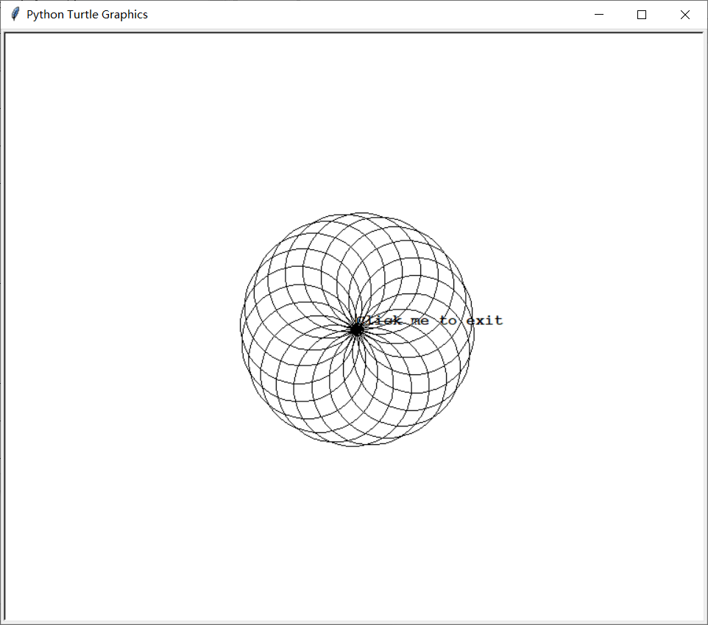

3.

4.3：

（1）X=L使得X的改动改变了L，while里未缩进

（2）

def findP(L):

for i in range(0, len(L)):

a = L[i]; X = L.copy()

if a==0:continue

while a>0:

a-=1;X[i]=a

X.sort()

print(X)

findP([2,3])

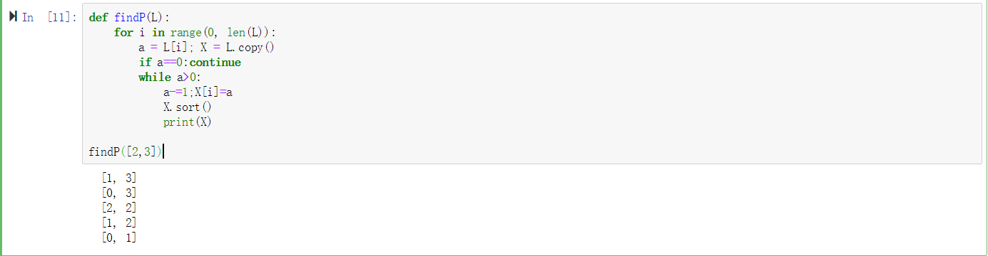

4.6

L1 = ['Aaron','Benson','Howard','Ophlia']

L2 = [['Aaron',300,3,'Benson','Howard','Ophlia'],['Benson',150,2,'Aaron','Ophlia'],['Howard',100,1,'Benson'],['Ophlia',200,2,'Aaron','Howard']]

dic = {}

for i in L1:

dic[i] = 0

for i in L2:

dic[i[0]] -= i[1]

for j in i[3:]:

dic[j] += i[1]/i[2]

for i in dic:

print(i,dic[i],end=' ')

