1. k == 1

练习题2.2.2：

n = 101101  
p = str(n)  
i = 0  
weight = 2\*\*(len(p)-1)  
for s in range(len(p)):  
 if int(p[s]):  
 i += weight  
 weight //= 2  
print(i)

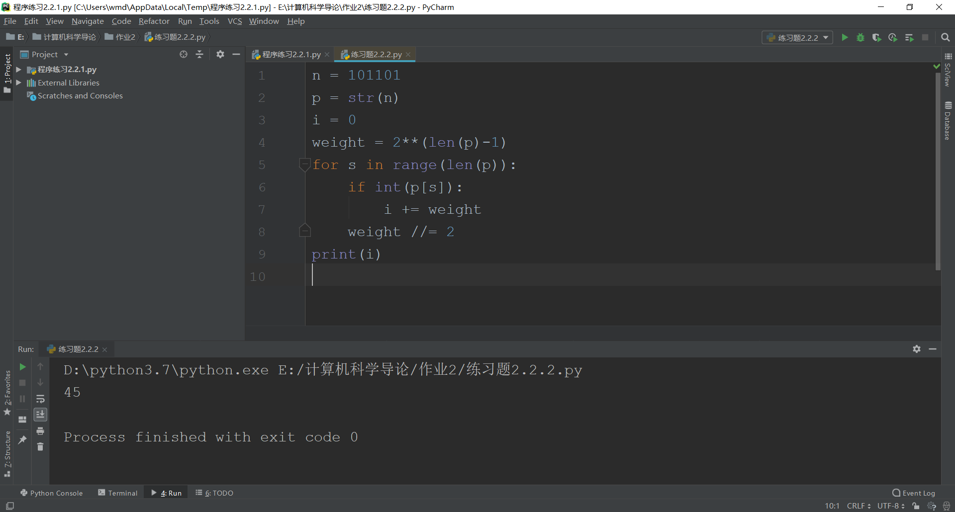

练习题2.2.5

n = 'AA0C'  
print('十进制%d' % int(n, 16))  
p = bin(int(n, 16))[2:]  
print('二进制%s' % p)  
s = oct(int(n, 16))[2:]  
print('八进制%s' % s)

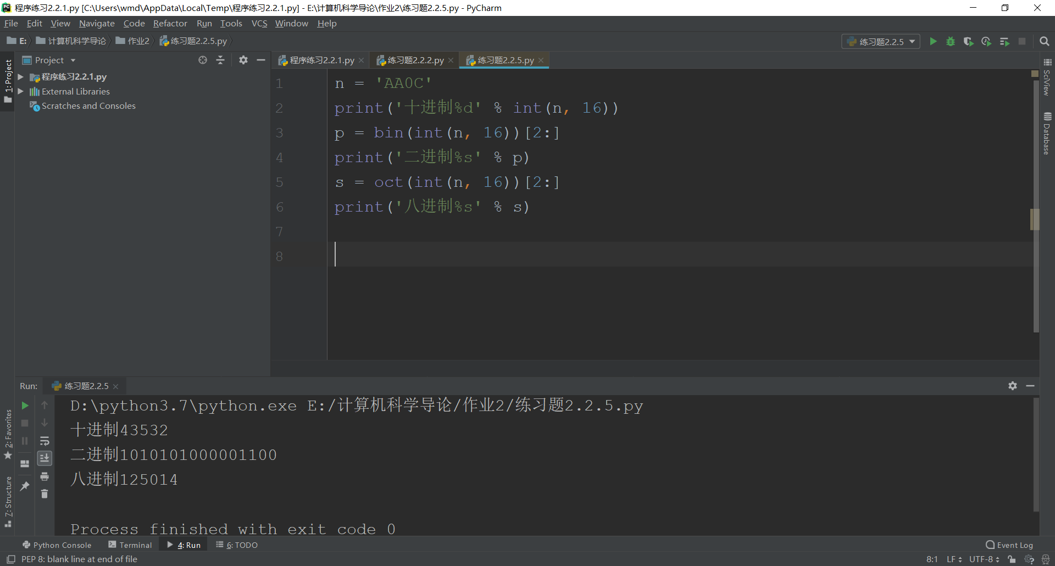

练习题2.2.8：

甲：二进制

乙：八进制

丙：十六进制

丁：十进制

练习题2.2.11

八进制

201

2. k == 0

程序练习2.2.1：

n = input('请输入数：')  
r = int(input('请输入R：'))  
l = len(n)  
k = 0  
weight = r\*\*(l-1)  
for each in n:  
 k += int(each)\*weight  
 weight //

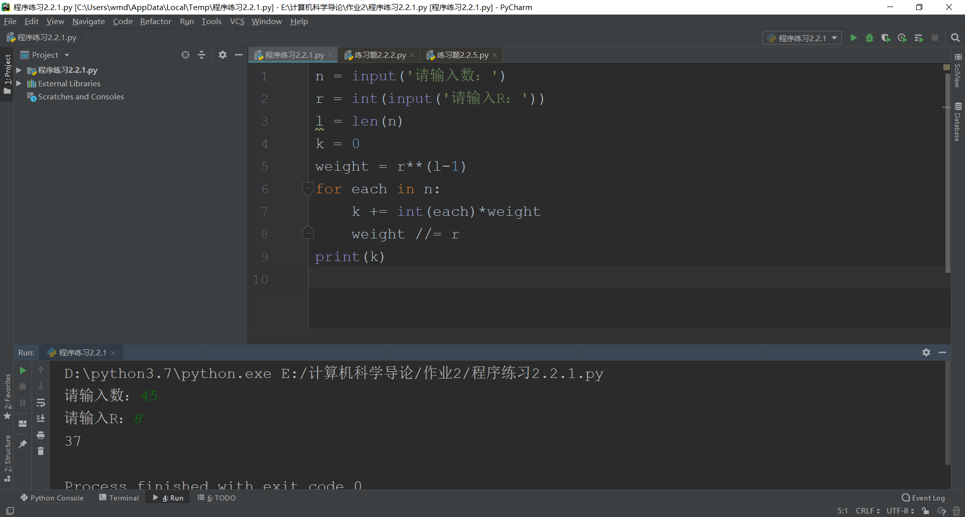

程序练习2.2.3

n = input()  
n = n[2:]  
k = 0  
p = 1/2  
for each in n:  
 k += int(each)\*p  
 p /= 2  
print(k)

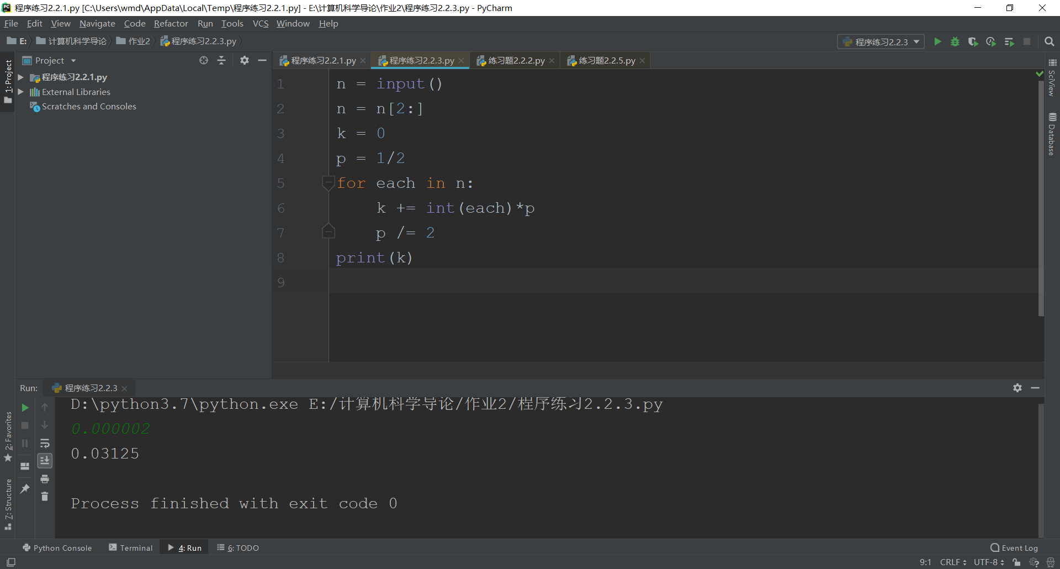

3.

那三进制数各个位上共有2的倍数个1

pf：先将三进制t转换为十进制n，t = t1t2t3…tk

n

而3^(k-i)为奇数

∴那三进制数各个位上共有偶数个1即可

4.

n = 3  
b = 2  
p1 = 1  
p2 = 1  
for i in range(n+1):  
 print(p1\*p2)  
 p1 = p1\*(n-i)//(i+1)  
 p2 \*= b

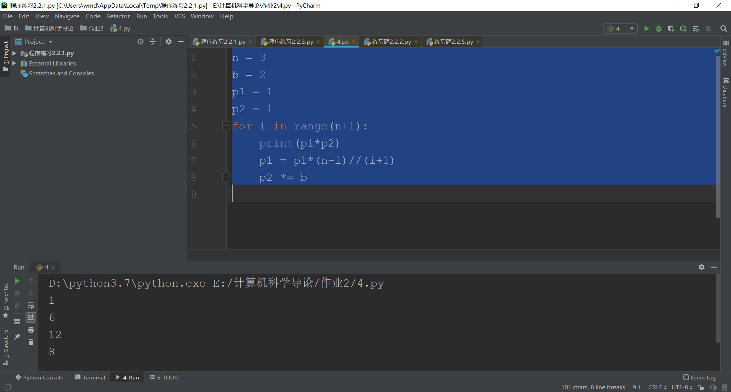

5.

ax = -1; ay = -3  
bx = 3; by = 2  
cx = 2; cy = 0  
up = max(ay, by); down = min(ay, by)  
left = min(ax, bx); right = max(ax, bx)  
if (left < cx < right) & (down < cy < up):  
 print('Yes, C is in the rectangle.')  
elif not((left <= cx <= right) & (down <= cy <= up)):  
 print("No, C isn't in or on the rectangle.")  
else:  
 print('Yes, C is on the rectangle.')

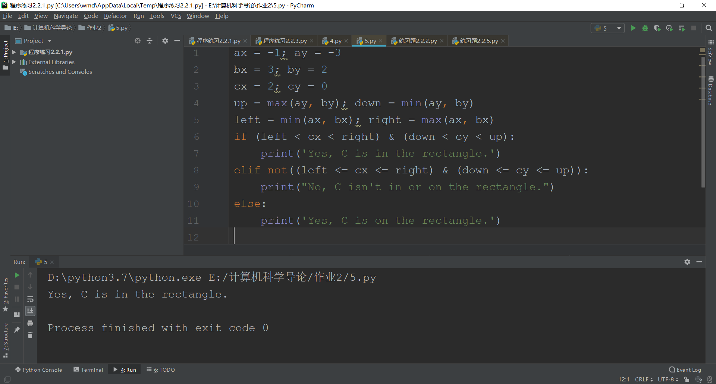

6.

ax = -1; ay = -3

bx = 3; by = -3

cx = 1; cy = 1

dx = 2; dy = -3

p = ((cy - ay)\*(dx - ax)+ay)/(cx - ax)

q = ((cy - by)\*(dx - bx)+by)/(cx - bx)

if cy > ay:

if (p > dy) & (q > dy) & (ay < dy) & (min(ax, bx) < dx < max(ax, bx)):

print("Yes, D is in the triangle.")

elif (p < dy) | (q < dy) | (min(ax, bx) > dx) | (dx > max(ax, bx)):

print("No, D is not in the triangle.")

else:

print("Yes, D is on the triangle.")

elif cy == ay:

print('Wrong, have no triangle!')

else:

if (p < dy) & (q < dy) & (ay > dy) & (min(ax, bx) < dx < max(ax, bx)):

print("Yes, D is in the triangle.")

elif (p > dy) | (q > dy) | (min(ax, bx) > dx) | (dx > max(ax, bx)):

print("No, D is not in the triangle.")

else:

print("Yes, D is on the triangle.")

