1. Traffic Light  
   **FLOWCHART**

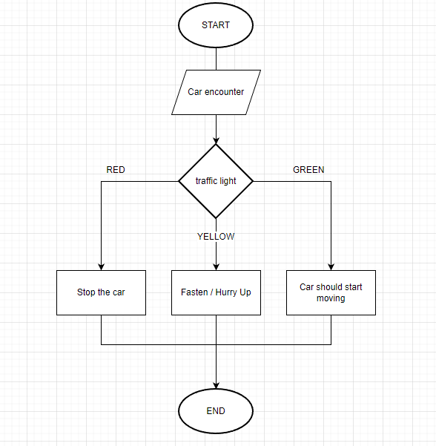  
**PSEUDOCODE**  
1. Car starts moving  
2. Car encounters a traffic light and stops  
3. Check traffic light color  
4. If the color is RED then stops the car  
5. If the color is YELLOW then the car should move faster or hurry up.

6. If the color is GREEN then the car

2. Buying Groceries

**FLOWCHART**  
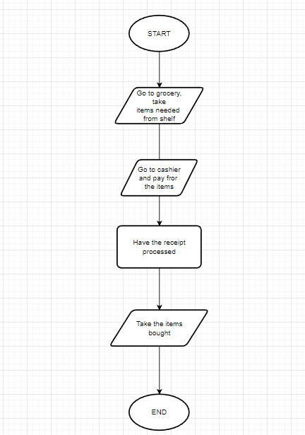 **PSEUDOCODE**1. Go to store

2. Get items from shelf  
3. Go to cashier  
4. Pay for items  
5. Process Receipt  
6. Take items to home

3. Withdraw Cash from ATM  
 **FLOWCHART  
 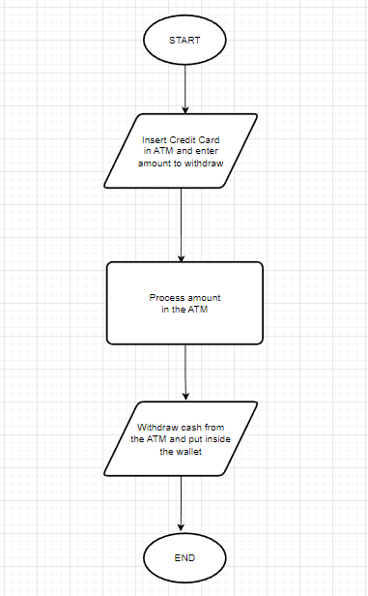  
 PSEUDOCODE** 1. Go to ATM

2. Insert Credit Card

3. Enter amount to withdraw

4. Wait for ATM to process request  
 5. Take the money withdrawn and put back to wallet