# Alex,

# The template that Daren purchased that Tom used to develop the mock ups he created with Daren, was integrated into the application, however Toms work was unusable.

# The application has a system to manage contacts, properties, companies and their relationships (which was slightly redesigned from the first version) . That is all completed.

# The application has a role based permissions system available to admins , this is also completed.

# The application has pages under “resources” menu that manages the lookup data in the system, that was largely finished.

# He application has a dashboard (initial screen) that shows global summaries for different aspects of work flow, pertinent to different employee types.

# Then the application must track lead/proposal through a workflow. There are employees in the contacts but they are just used for program access and to populate certain drop down lists. There is no HR , payroll, etc.

# There is a complex module that performs an “intake” this creates a property, company and contacts related to a job and optionally assign managers and setup an appointment, all in one process. When the form is filled out it creates a new proposal, in the pending phase. This has been completed

# There is also a complex module that is used in the proposal process, it creates a job estimate based on all the services and parameters input from the manager. This module develops the entire job estimate. This is completed and was in testing.

NOTE:While it may seem like there is a lot more to do the reality is that the tasks completed constitute the major programming hurdles of the application. The rest of the application is simple crud operations. The major work on creating a proposal and the proposal estimator has been completed. The rest of the application is simple data entry.

# Work Flow (sections in green are completed)

**Intake Lead/proposal**

**Phase Proposal Pending**

**Create appointment and or assign estimator**

**Create Estimate (Upload Media, Add Notes)**

**Client Approval of proposal**

**Admin Approval of Proposal (pending mockup from Daren to create pdf of proposal)**

Proposal Processing (Manage Permits , MOT, NTO, Lien dates set, Client signature, Deposit rcvd)

Processing completed, Convert To Work Order

Work Order Prescheduling

Work Order Active (scheduled)

Work Order Daily Reports (job Managers)

Work Order Completed

Manager Approves Job Is Completed

Office Billing

Lien Release

**Notes:**

* Content on “Sections developed so far” has been condensed showing only major tasks.
* “Estimated remaining items” lists more specific tasks to provide a better picture of what is left to be developed from our point of view (based on current application feature).

**Sections developed so far:**

1. Database.
   1. Refactored and migrated.
   2. Improved performance structure and table relationships.
2. Mobile ready and SEO compliant frontend interface.
   1. Developed application pages and popup windows using purchased responsive html template.
3. Security.
   1. Authentication based on one way encrypted passwords.
   2. Forgot Password feature.
   3. Authorization system based on roles and permissions.
   4. User side and server side user inputs validation.
4. Main Menu navigation setup.
5. Dashboard setup with 'heads up ' summary sections for Proposals, Work Orders, Scheduled Services, Appointments and Tasks.
6. Top Message Center and task menu.
7. Side Floating Menu for Intake and Tasks.
8. Main Sections finished
   1. Properties (listing grid, search, filter, add, edit).
   2. Contacts (listing grid, search, filter, add, edit).
   3. Companies (listing grid, search, filter, add, edit).
   4. Employees (listing grid, search, filter, add, edit).
9. Create a Proposal Intake Form (Draft).
10. Convert to Pending Proposal
    1. Proposal Listing DRAFT (pending).
    2. Proposal Main Client Data forms.
    3. Proposal Services Estimator forms.
    4. Proposal Upload Forms (upload media drag and drop functionality).
    5. Proposal History Page.
    6. Proposal Status indicator
11. Work Order Listing (filter, search).
12. Services Listing (Filter and Search).
13. Tasks Listing (Filter and Search).
14. Appointments Listing (Filter and Search).
15. Resources Menu Manage Lookup tables.
    1. Company and Contact Categories.
    2. Company Vehicles.
    3. Vehicle types.
    4. Vehicle Log Types.
    5. Company Equipment.
    6. Materials.
    7. Labor Rates.
    8. Company Locations.
    9. Media Types.
16. System Menu.
17. Manage Roles and Permissions.

**Estimated Remaining Items (from our understanding based on current application)**

1. Complete Pending Proposal section: History tab.
2. Complete Proposal PDF (Contract).
3. Record Signed agreement from Client.
4. Convert To Work Order in Processing Phase.
5. Work Order processing Phase Functions.
6. Set 'timer for Lien'.
7. Send MOT.
8. Notice to Client.
9. Record Deposit.
10. Convert to Active Work Order.
11. Assign Job Managers.
12. Process Permits.
13. Schedule Services.
14. Daily Service Calendar, Schedule.
15. Daily Checklist for Field Workers.
16. Client Sign Off (capture signature).
17. Complete Job Estimator Signoff, Office Signoff.
18. Bill the Job (indicate job was paid in full).
19. Process Lien Release.
20. Client Follow up Survey.
21. Print Work Order.
22. Create Sales Reports.
23. Notification system.

Notes on files sent to you.

Included in the zip file provided:

- Database dump containing all the tables needed for the code developed. The structure of those tables has been updated to be compliant with the new development requirements like supporting transactions, file type default values, format, indexes, foreign keys, etc. when the development of the new code needed it. The data from those tables was imported from live DB at the moment of developing new features. That means that a database created from the sql file provided does not have tables that are already present on the current live DB. Also new tables have been created as the new development need them.

- All the source files at the moment the development was stopped.

Get the application up and running:

- Unzip the files on a LAMP server (our development server: Ubuntu 16.04, Apache 2.4, PHP 7.0, MySQL 5.7.25), create database and import the sql file provided (inside sql folder) and define own settings on .evn.

- Make storage folder and subfolders writable for apache.

- Create vhost with a documentroot pointing to public/ folder.

# TESTING

* This testing process was sent to Nash.

# Testing process

Use the forgot password option to setup a new password,

https://allpaving.silvervee.net/login

You will receive an email.

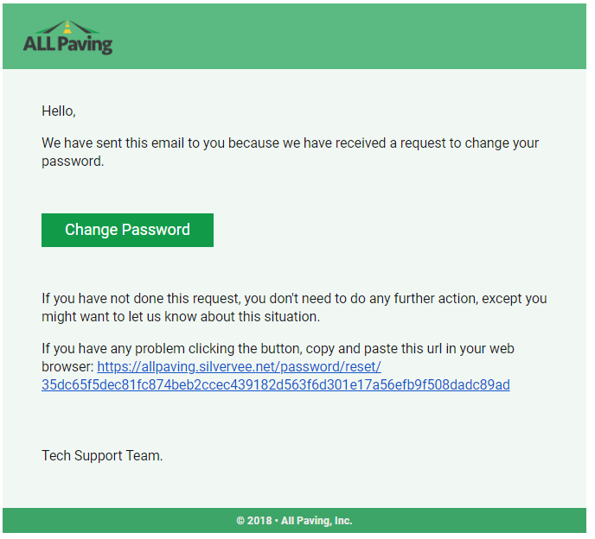

Create a new password for yourself.

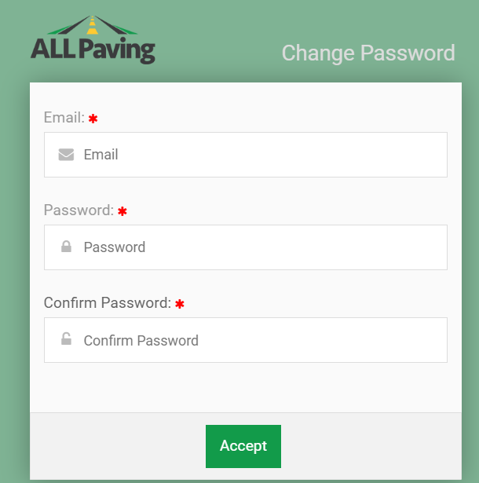

Once you have created your new password login.

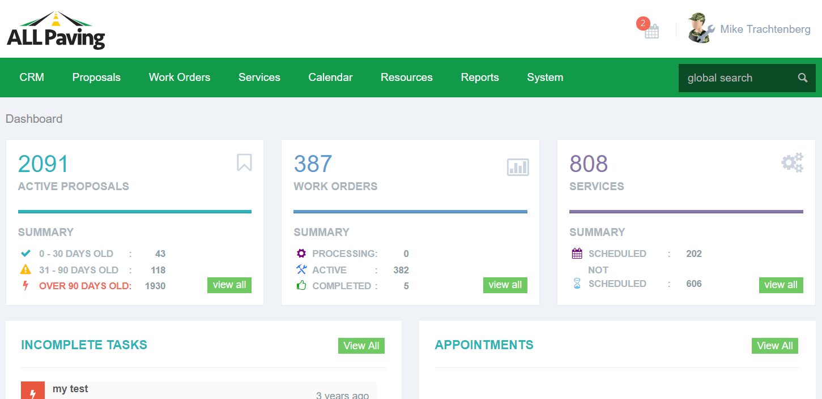

Check out the Dashboard ,

We created a clean looking interface that shows totals for each of three categories,

Proposal, Work Orders And Services from Active Work Orders.

These also display a summary total of different aspects of these categories,

1. Active Proposals _ show total for all active proposals

Summarize totals for age by grouping

total 0 - 30 days old

total 30 - 90 days

total over 90 days

2. Active Work orders show total for All active work orders

total Work orders Completed

total Work orders billed

3. Services - show total number of services to be performed

Summary data

total - Services Scheduled

total - Services not scheduled

Each section has a link to “View All” 

You can use this to link to the full listing page.

We used an older version of the database to populate the new database but loaded the current data in there this last weekend, so you should be able to see more 'up to date' information.

The latest updates also include top header notification (besides user picture) shows 5 oldest unread messages and tasks shows 5 oldest uncompleted tasks, although in both cases, the total number is actually the real amount.



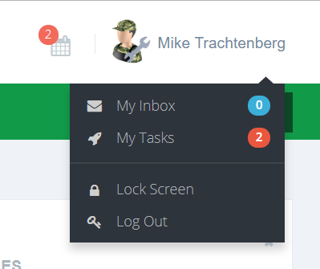

The tasks overdue (showed in red) and pending (showed on blue with the days remaining to the due date.

Messages and tasks are related to the logged in user, admin user can see all entries.

Main Navigation Menu

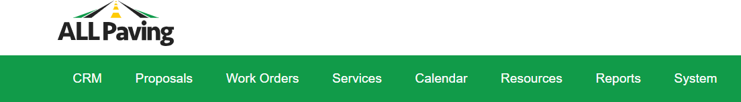

Under the CRM menu please try all the functions

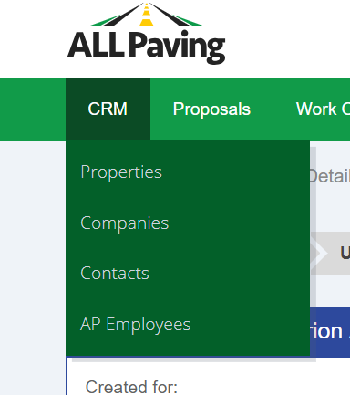

Properties, Companies, Contacts and Employees

Listing Properties

* **In all listing pages there are some fields you can edit right from the listing.**

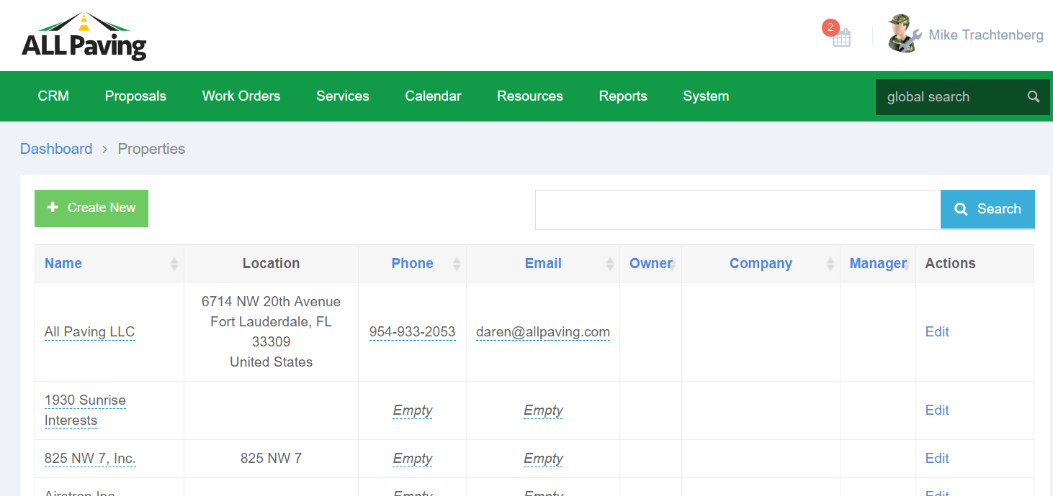

**\*In all pages where you are adding or editing data in a form the “required” fields should be evident and easy to identify.**

Adding Properties

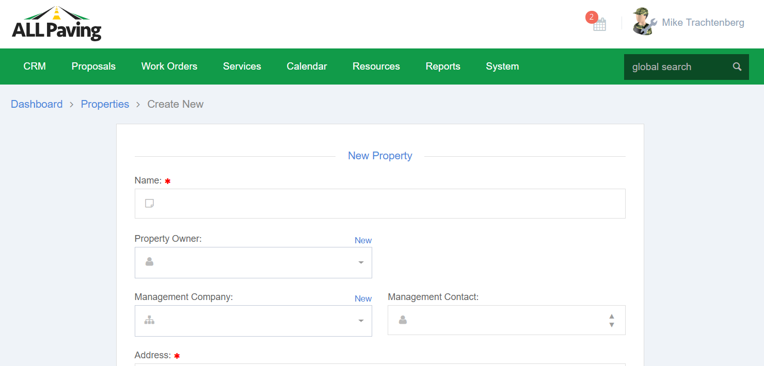

Listing Companies

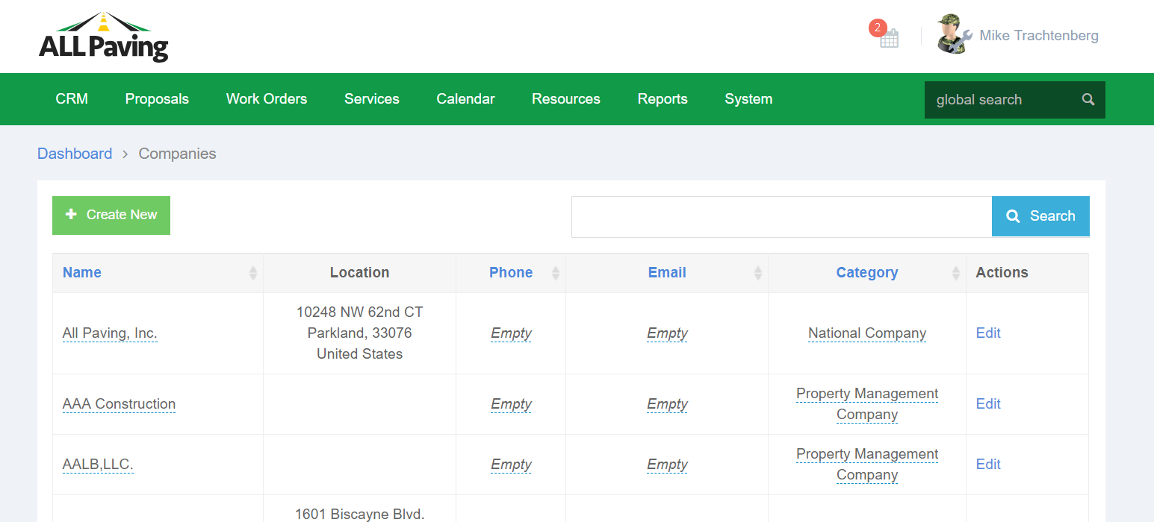

Adding Companies

The “categories” in the companies is important as a filter to be able to select the companies we want.

Companies marked as “Property Management Companies” populate the drop down list when selecting a property management company on a property.

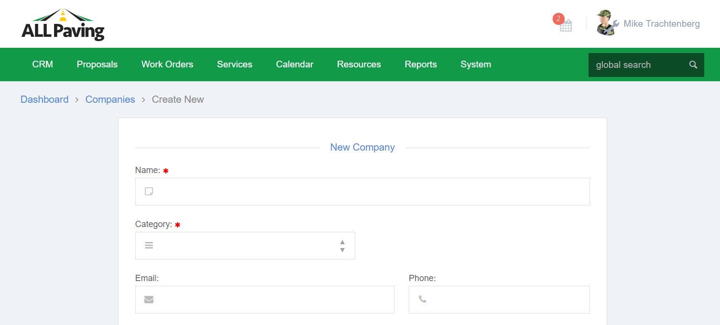

Listing Contacts

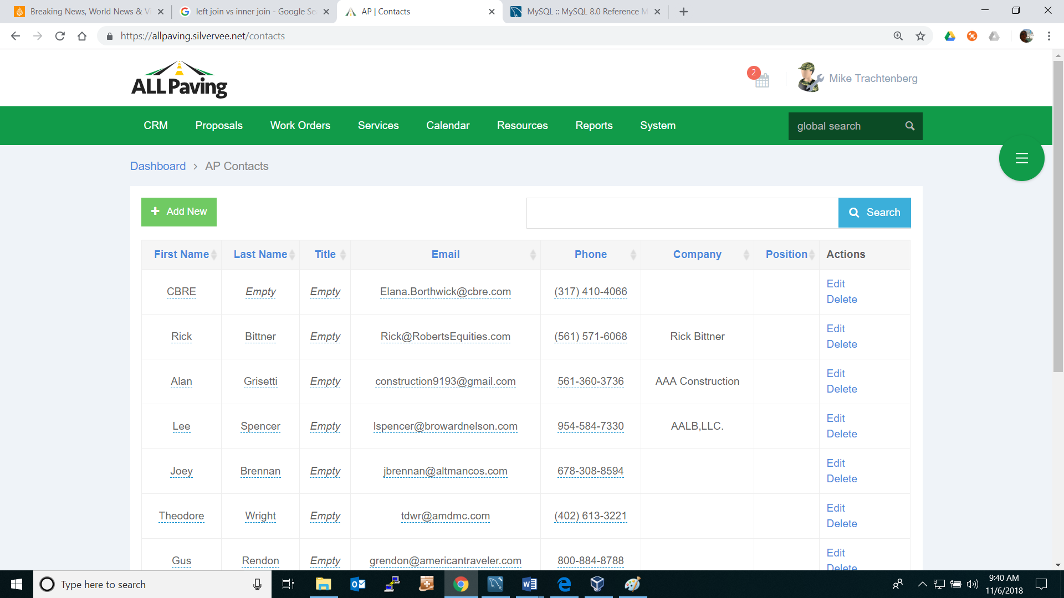

Adding Contacts

The “categories” in the contacts section is very important, a contacts category is used in the application to filter and segregate contacts. For example “Sub Contractors” are used in the estimator, and “Property Owners” are used to populate the drop down list when selecting a properties owner. Putting in the wrong category can mean that you will not find the contact where you expect.

**\*In all pages where you are adding or editing data in a form the “required” fields should be evident and easy to identify.**

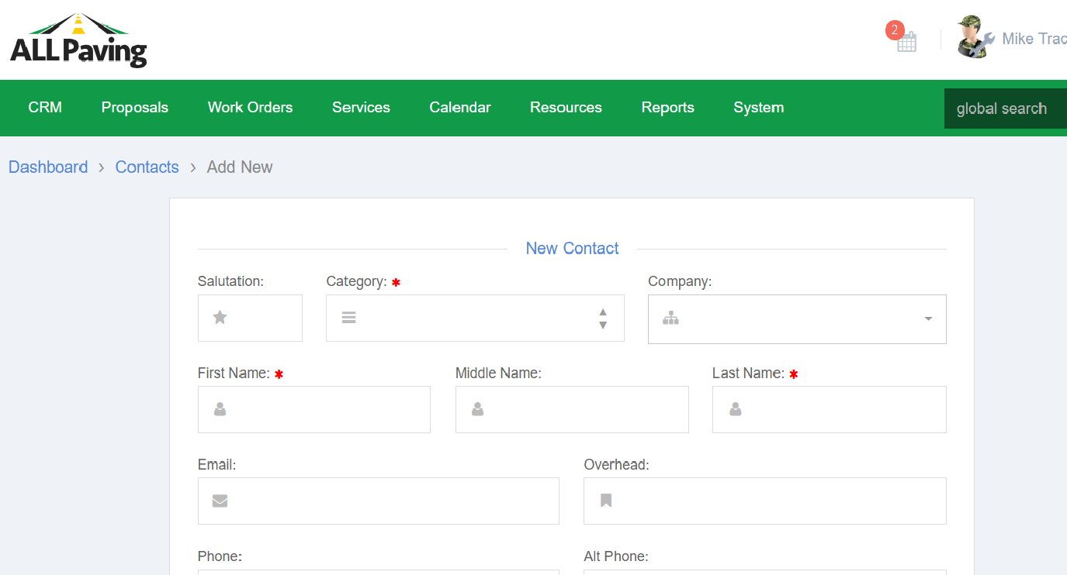

All Users can also be linked to a company.

It is this link that allows the database to create the proper connections to a property.

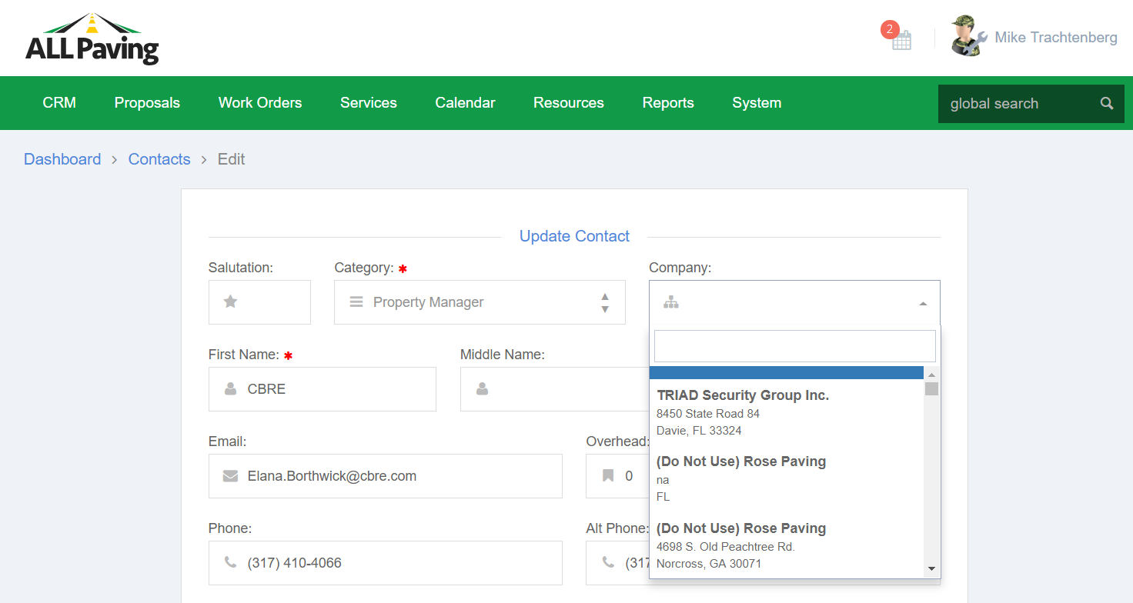

Check out the listing screens for each and try the search, as well as Add New and Edit.

Under the Proposals Menu

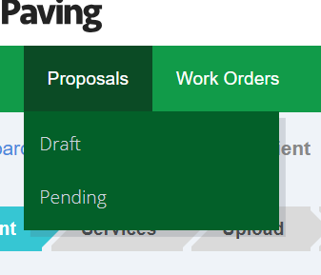

Check Draft and Pending Proposals, to view the data listings for each.

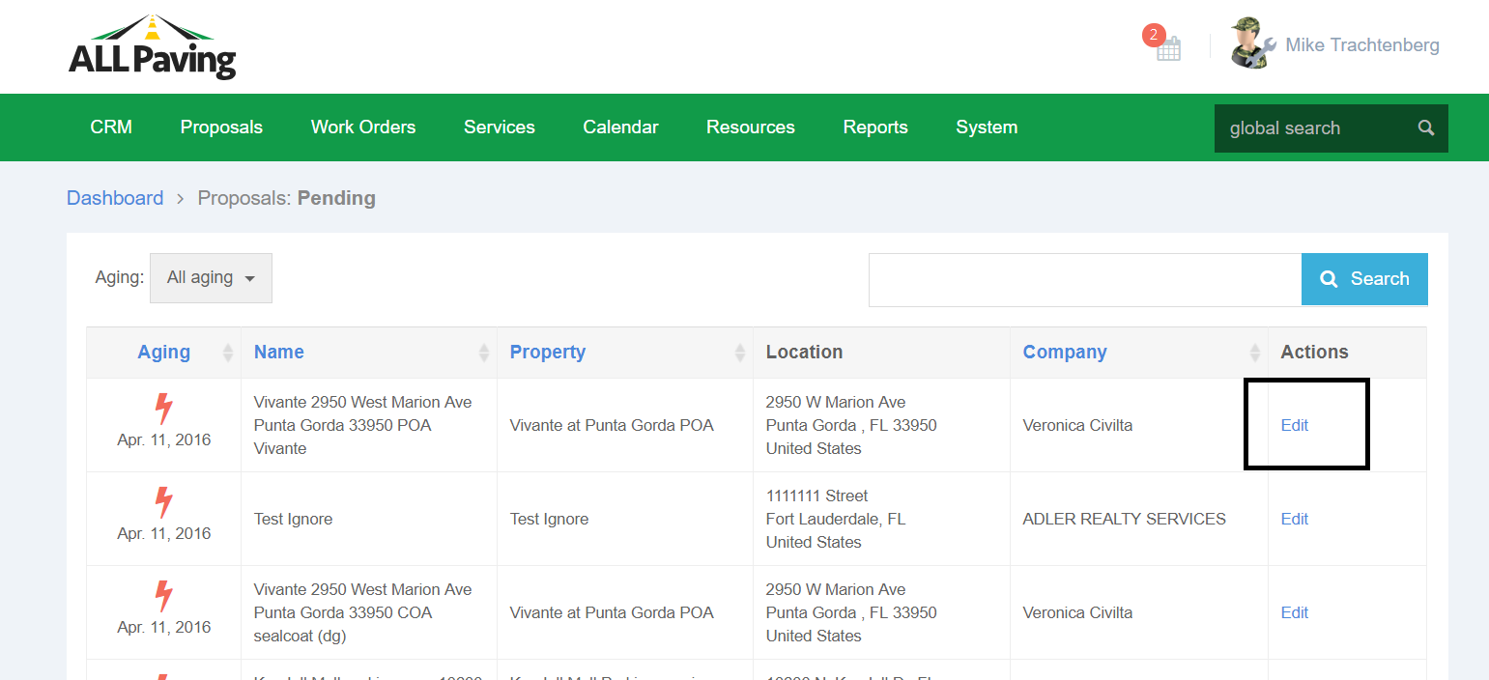

Click Edit to see the tabbed section for Proposals

Proposals and Work Orders are always based on a Property.

Proposals also require a Management Company or Responsible Agent, and a Primary Contact that is always linked to the Company in the database.

In the event we are working with a property where there is no Management Company than the Owner or the Property Manager must also serve as the “Company” for the purpose of the proposal, these must also be entered into the system as a “Company”, as the proposal requires a Management Company be selected. They must also be in the contacts database and linked to the company created as every proposal also requires a Primary Contact.

The Properties designated **“Management Company”** whether a real management company an owner or other entity setup as a management company in the database is always used as the “Billing Entity” on a proposal.

The Designated **“Manager”** that is always linked through the company selected is used as the primary contact on the proposal.

Perform a New Intake

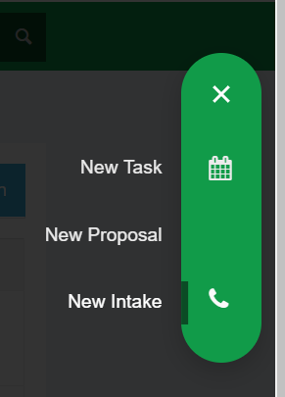

### Property Relationships

It is very important to understand how the database is setup to link properties to their management companies and or owners and contacts.

First understand the relationships between properties, the management company and the contact that works for the management company.

Daren also added a new connection to the property that is “owner”.

Each property can have One owner, that is a Contact in the database, with the category “property owner”. Each property can have a management company linked and a person who works for that management company linked as a primary contact for the property.

**The Property’s Owner currently is used only for certain notifications.**

**The Property’s Management Company is used for Billing purposes**

**The Property’s Management company contact is used as a primary contact for the proposal and other specifics relating to the proposal.**

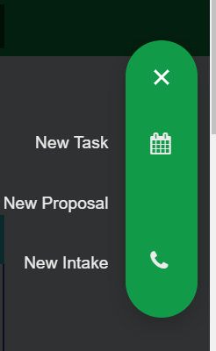

There are many options that can be applied when creating a new Intake,

The property might already be in our database. In which case you can select it.

If not you can add it

The same goes true for the Property Owner, property management company and management company contact.

## New Intake

**\*Always starts with a property.**

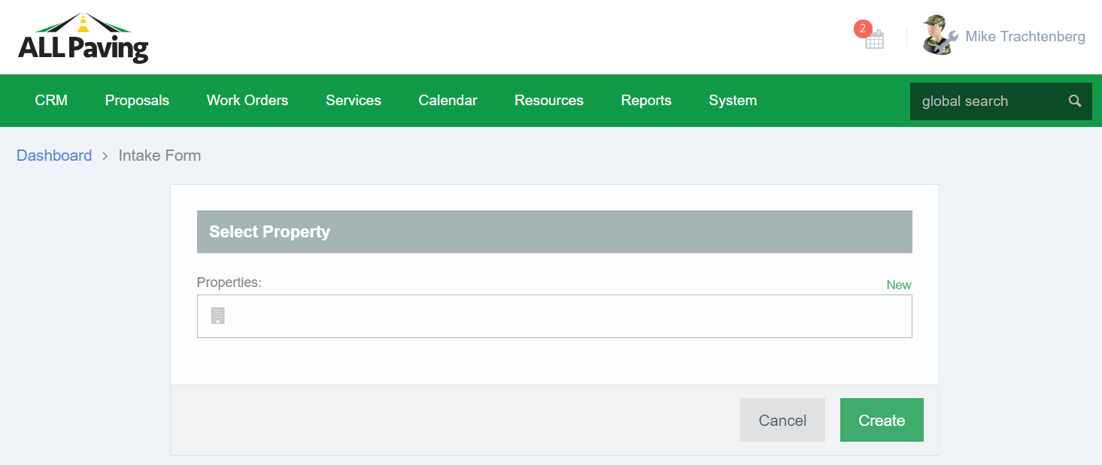

An existing property or Create a new property

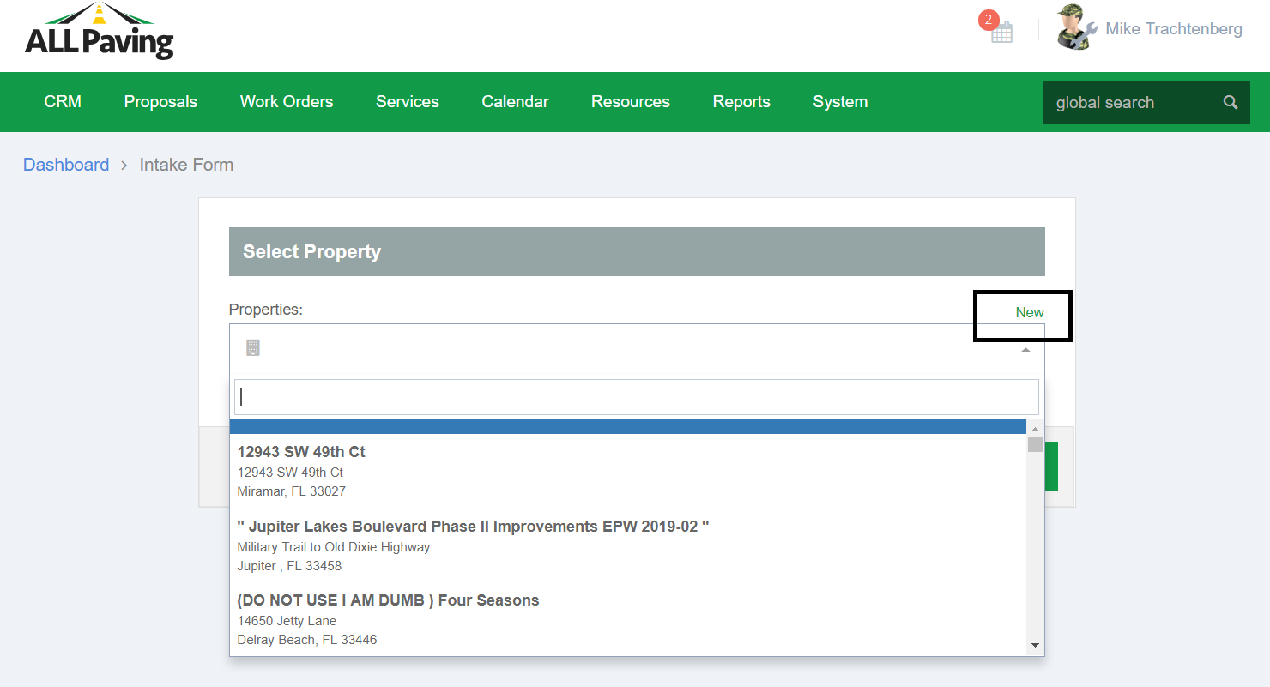

Create A New Property

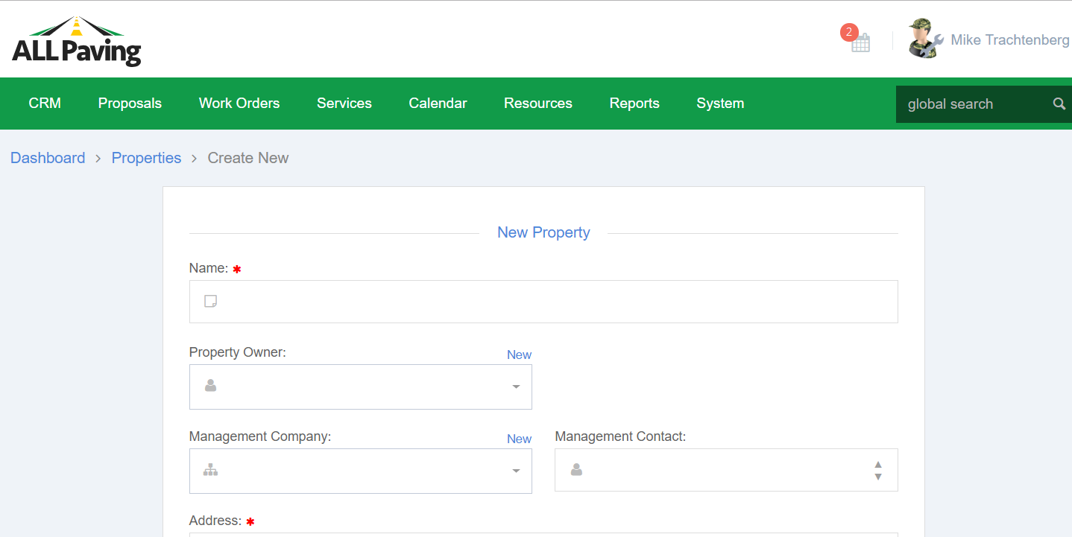

You can create a new property and link it to an existing management company or add a new company. You can then select the manager if any are linked to that company selected or add a new manager.

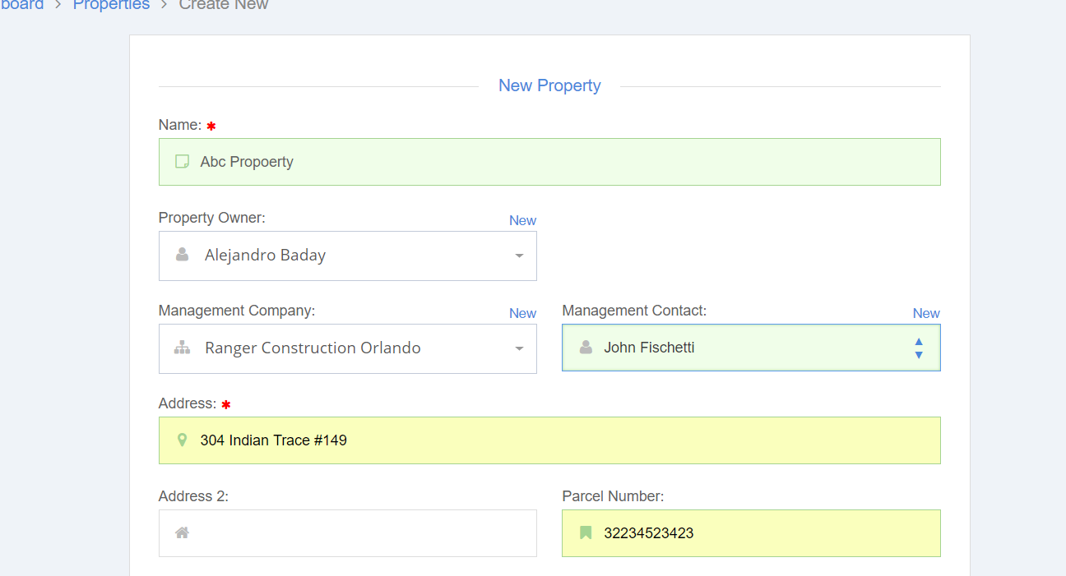

Click Create Property and You are brought back to the Intake Screen with all the new information already filled in.

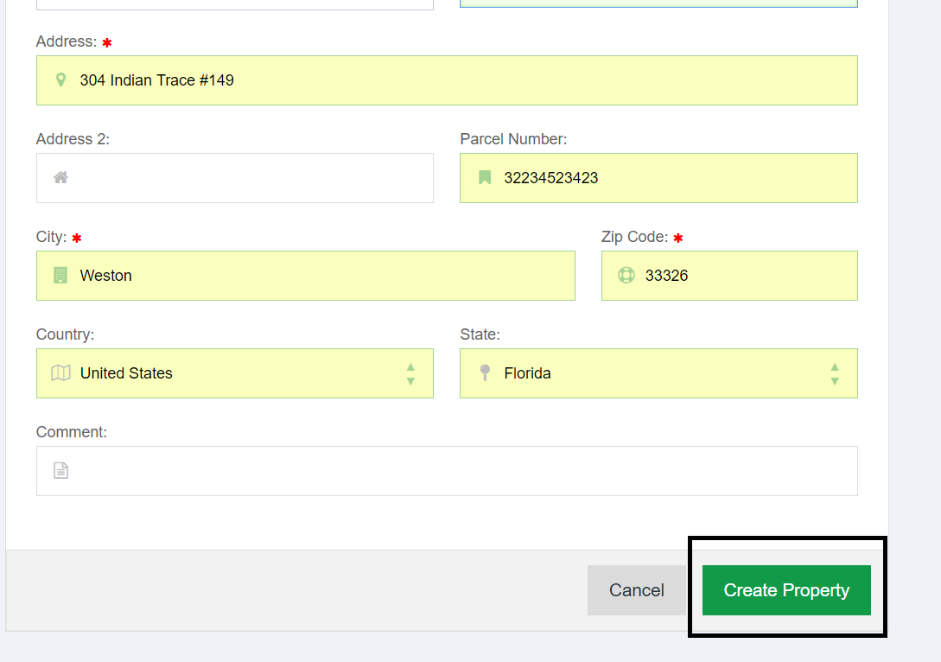

When you click Create to add the new property you are taken back to the intake screen to complete the intake process.

You can assign a Sales manager to this Intake and also create an appointment for that manager with the client.

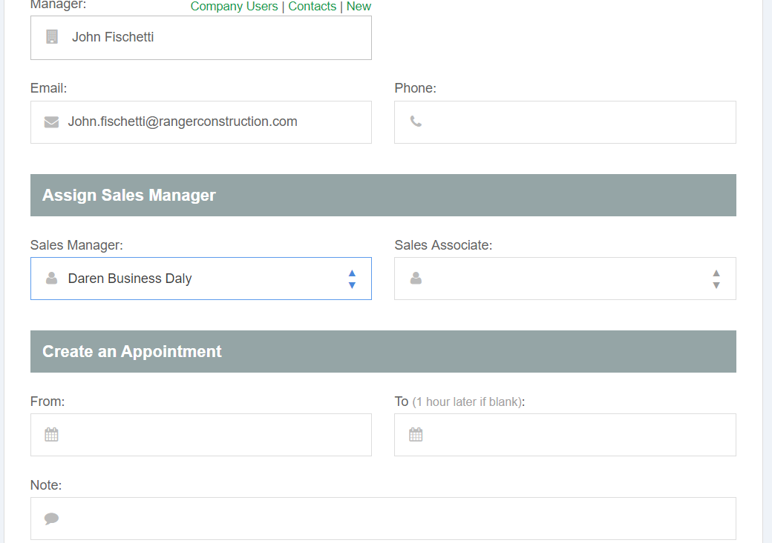

You should now see this new intake in the “Draft” Proposals and if you set an appointment that should appear on the appointments list.

Creating a new intake with appointment should send an email to the client and the Sales manager selected.

After intake the application should take you to the proposal page in Draft Status.

The new intake should also show up on the Proposals Draft Grid.

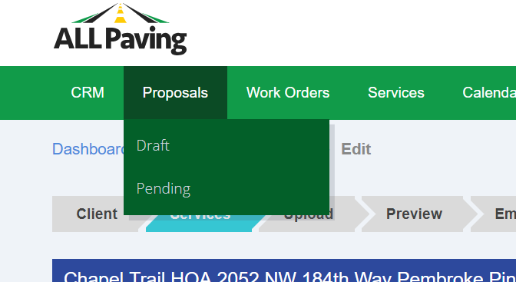

**Proposal Page**

**Add Services**

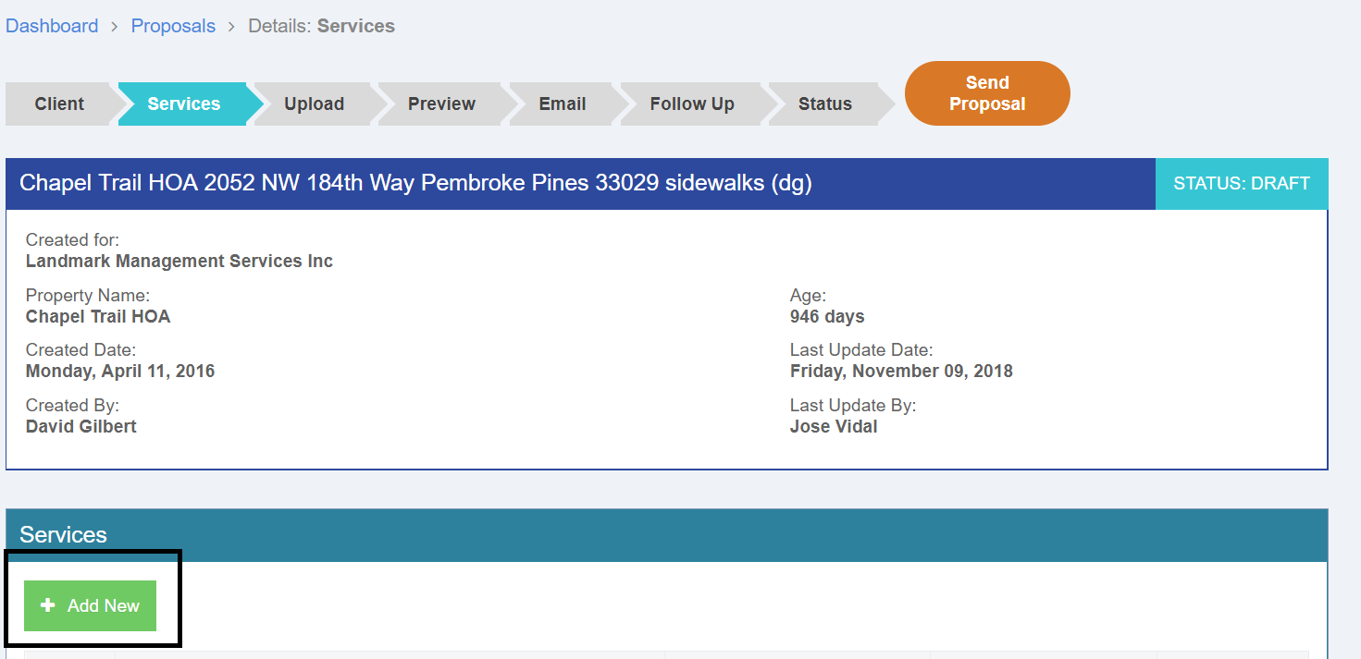

**Adding new services to the Proposal.**

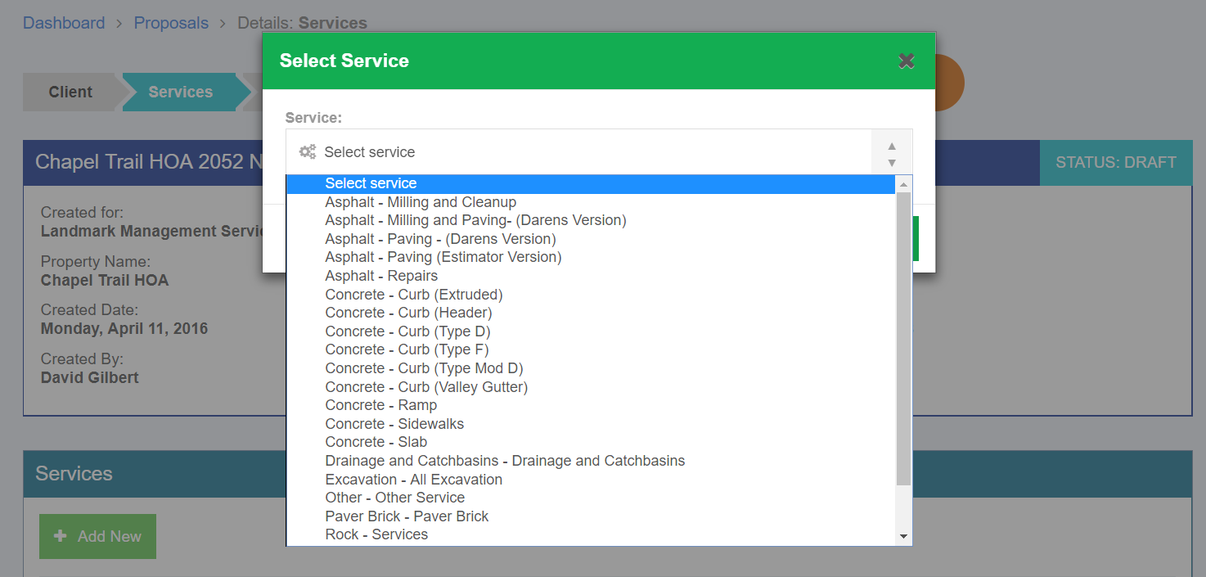

The Estimator

The estimator has several sections for each type of service.

At the top is the main form which is where the estimator enters values specific to that service.

Then there is a text explanation section that can be edited. A section for Service location, Vehicles , Equipment, Labor, Other Costs and Any Sub contractors needed. Sub Sections allow you to add any number of vehicles equipment etc. To the estimate.

The Top Main Section of the form will also show the service estimate total.

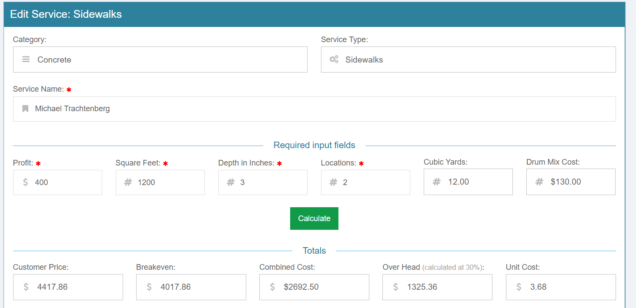

Proposal Text Explanation of Services

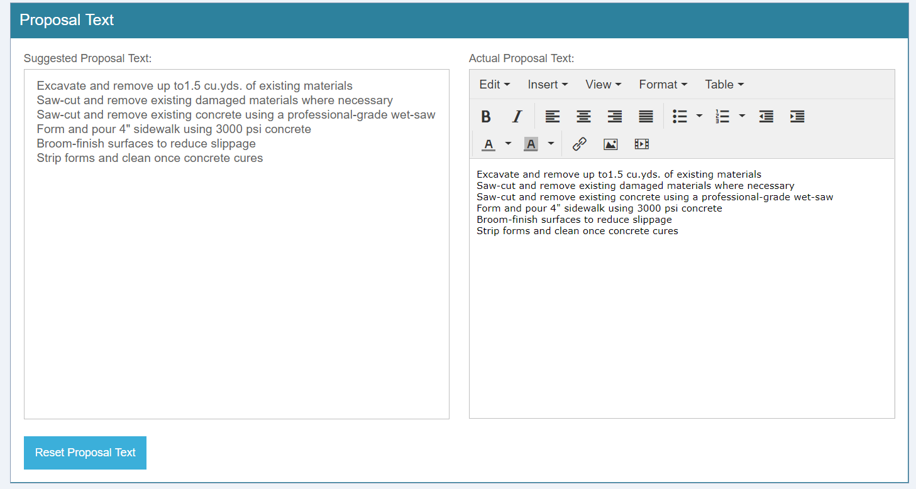

Service location

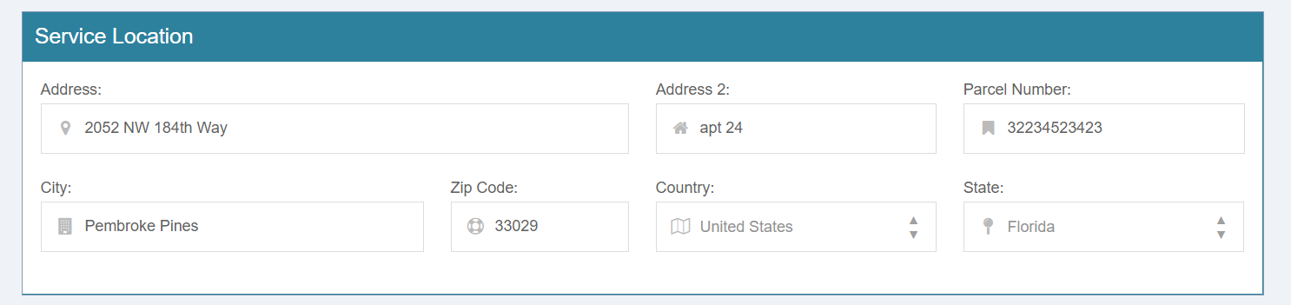

Vehicles

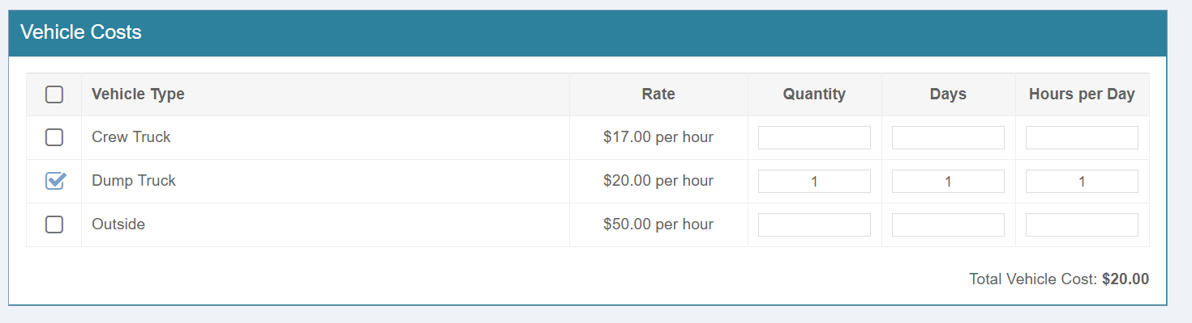

Equipment

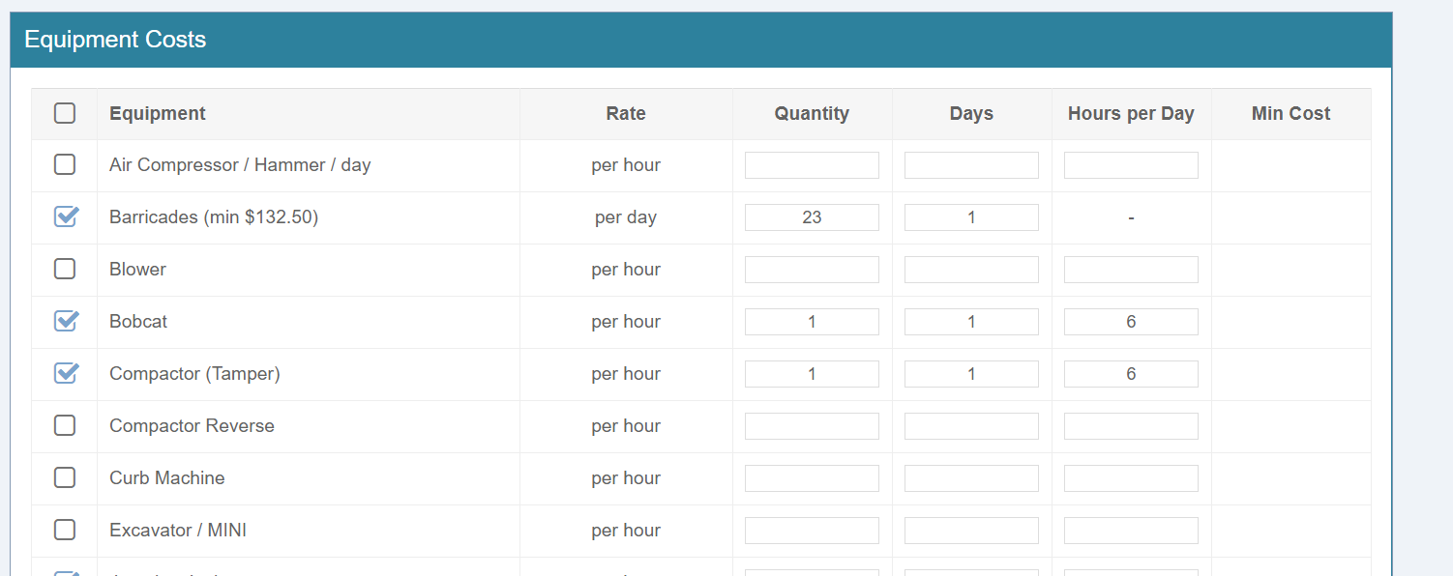

Labor, Other Costs

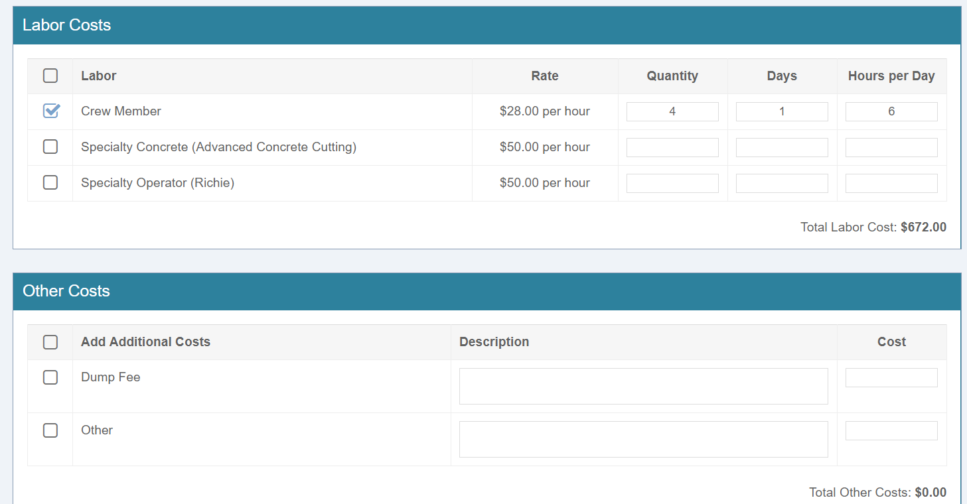

Sub Contractors

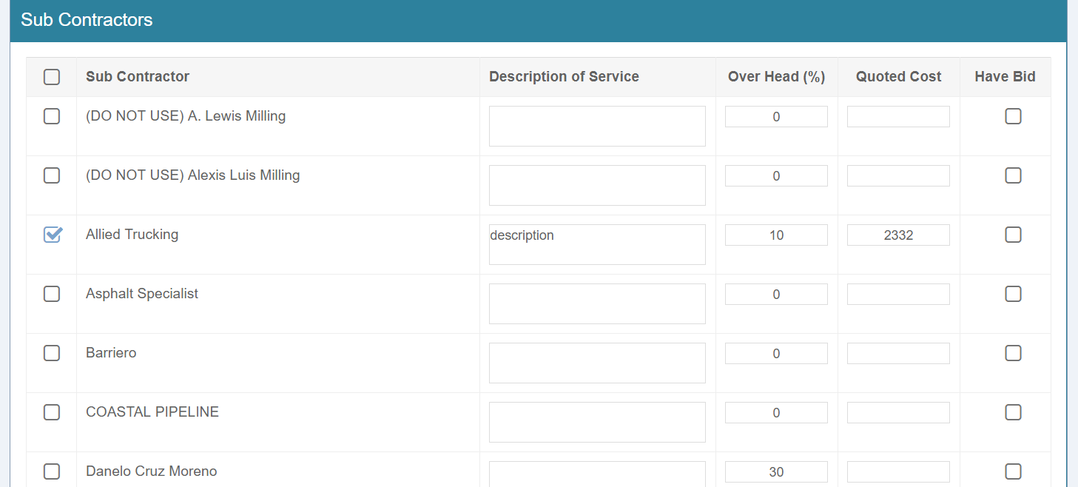

The Submit button is at the bottom of the form and will save all entries at once.

