Title:

Exploring the Link Between Nvidia Sentiment and Stock Price Movement: An Insight into Market Dynamics

Introduction

Methodology

Results

Conclusion

Appendix

Introduction:

In the fast-paced world of finance, where information flows freely and markets react swiftly to news and trends, understanding the relationship between sentiment and stock price movement can be pivotal for investors. In recent years, Nvidia, a leading technology company renowned for its graphics processing units (GPUs), has garnered substantial attention due to several key developments. One notable area of hype surrounds Nvidia's advancements in artificial intelligence (AI) and machine learning (ML) technologies. Nvidia's GPUs, particularly those based on its proprietary architecture such as the Hopper architecture, have demonstrated remarkable capabilities in accelerating AI computations. This has fueled excitement among researchers, developers, and businesses seeking to leverage AI for various applications, ranging from autonomous vehicles and robotics to healthcare and finance.

In light of this trend, Nvidia's stock price has been profoundly influenced by the level of hype surrounding the company's technological advancements, product launches, and strategic initiatives. When Nvidia generates buzz through groundbreaking innovations or significant partnerships, investor enthusiasm tends to drive up demand for the company's shares, consequently boosting its stock price.

At the heart of this investigation lies the question: Does the sentiment surrounding Nvidia, reflected in news articles, social media posts, and analyst reports, have a discernible impact on its stock price? With the hype and people looking to invest in the “future”, we thought of investigating how these phenomena are linked together. This article caters to both non-professional readers and informed investors alike, as it offers some insights into the underlying dynamics that drive market behavior.

For non-professional readers, understanding the concept of sentiment in the context of stock market analysis is crucial. Sentiment refers to the overall tone or attitude expressed in news coverage, social media discussions, and expert opinions regarding a particular company or its stock. Positive sentiment typically implies optimism and confidence in the company's prospects, while negative sentiment signals skepticism or concerns about its performance. In the case of Nvidia, fluctuations in sentiment can influence investor perceptions of the company's prospects, thereby impacting buying and selling decisions that ultimately drive stock price movements. We can see in the graph below of the positive (or negative) fluctuations in Nvidia’s price change plotted against its relative Google searches each month.

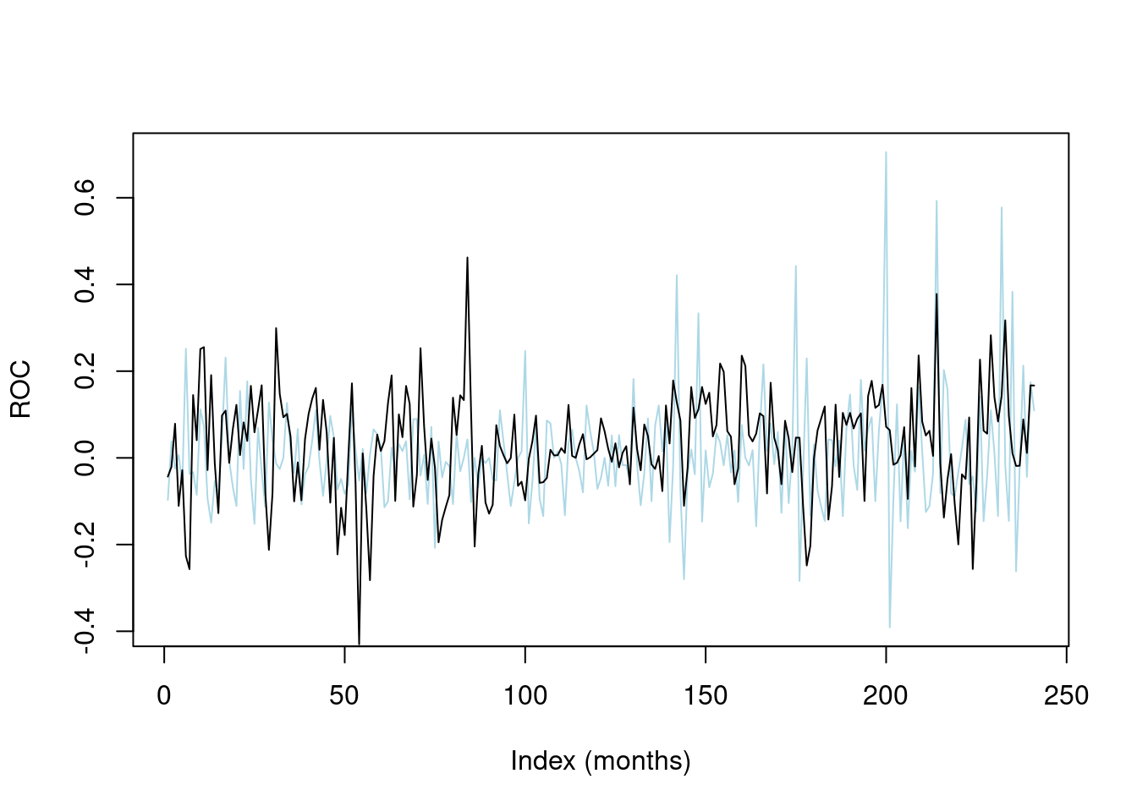

For informed investors, delving deeper into the correlation between Nvidia sentiment and stock price movement unveils intriguing insights into market behavior. Initially, following media, qualitative analysis suggested a strong correlation between sentiment and stock prices, with positive sentiment often coinciding with upward price movements and vice versa. In the case of Nvidia, sentiment analysis techniques, such as natural language processing (NLP) algorithms, can be employed to analyze vast amounts of textual data from news articles, social media platforms, and financial reports to gauge the prevailing sentiment surrounding the company.

[ graph ]

Moreover, sophisticated machine learning models can be trained to identify patterns and trends in sentiment data and predict potential stock price movements. By examining historical data and conducting sentiment analysis in real-time, investors can gain valuable insights into market sentiment dynamics and make more informed trading decisions. However, it's essential to note that while sentiment analysis can provide valuable insights, it is just one of many factors that influence stock price movements, and investors should consider a comprehensive range of indicators and metrics when making investment decisions.

Methodology:

Results:

Conclusion:

In conclusion, the relationship between Nvidia sentiment and stock price movement represents a fascinating area of research that sheds light on the intricate interplay between market sentiment, investor behavior, and financial outcomes. By identifying and understanding the underlying drivers of sentiment, investors can gain a deeper understanding of market dynamics and potentially uncover lucrative investment opportunities in the ever-evolving landscape of finance.

Appendix. A

[ relevant data depictions ]