ADC-V2
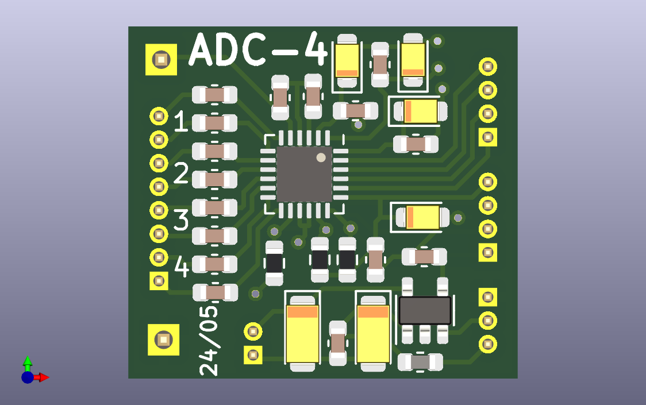
-
+
FSYNC
BCLK
SDOUT
GPIO1
IOVD
SHDNZ
SCL
SDA
GND
VIN_EN
VIN
Left side connection to preamps (differential or single ended+ground)
right side connection to MCU (I2S, I2c)
VIN_EN must be digital high to enable LDO,
SHDNZ must be set to high to activate ADC

