Recorder electronics
Electronic details
If wanted solder pin-headers to preamp and ADC boards
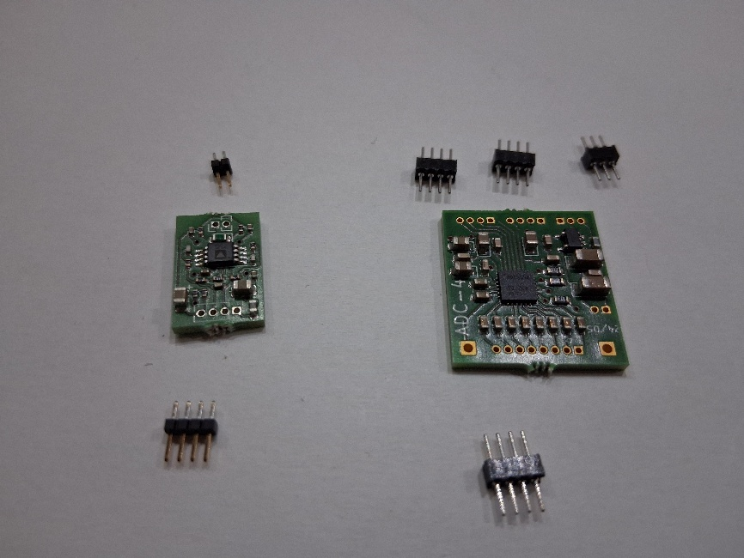
Using the base board to keep pin-headers straight, but without soldering to base board.
First, preamp
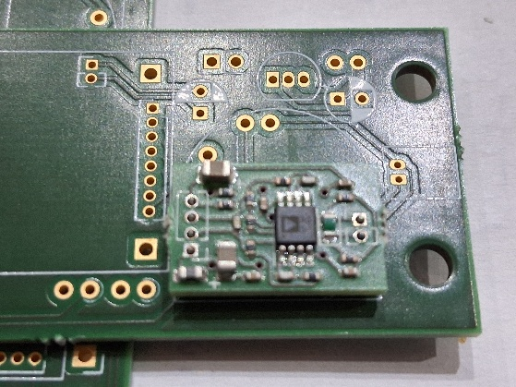
Then ADC board
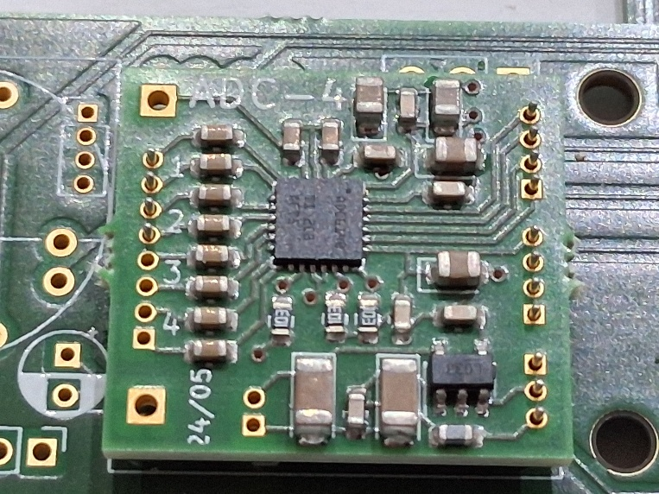
As we only have connections for the first two audio channels, a 4-pin header is sufficient. The preamp uses pins 3,4, while the preamp of Mark (not shown here) would use, pins 1 and 2.
Connect the pins with some wire or solder as shown in next figure
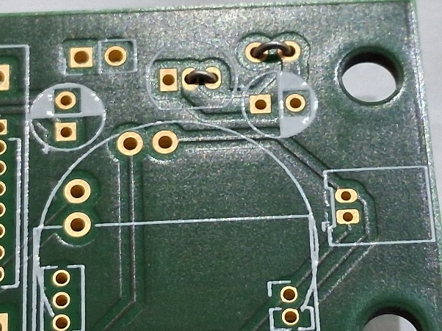

Solder hydrophone header (here pico plade). To have free room for manouver. Header is soldered on be back side as shown in figure.
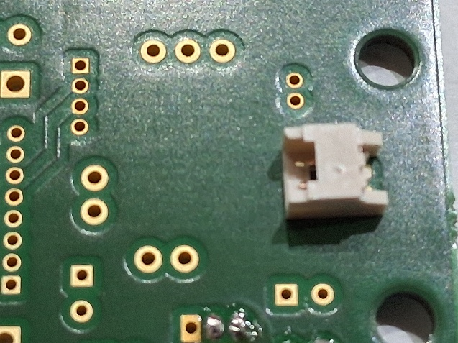
Solder preamp to base board
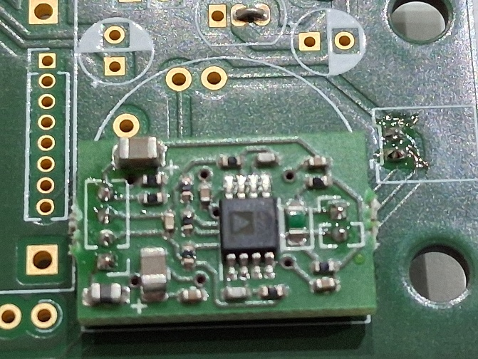

Solder ADC to base board
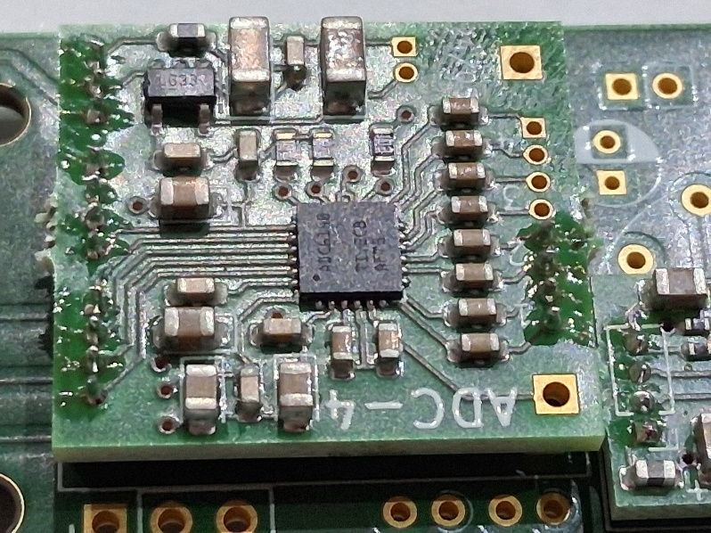
Solder 4 wires to additional connect ADC to base board
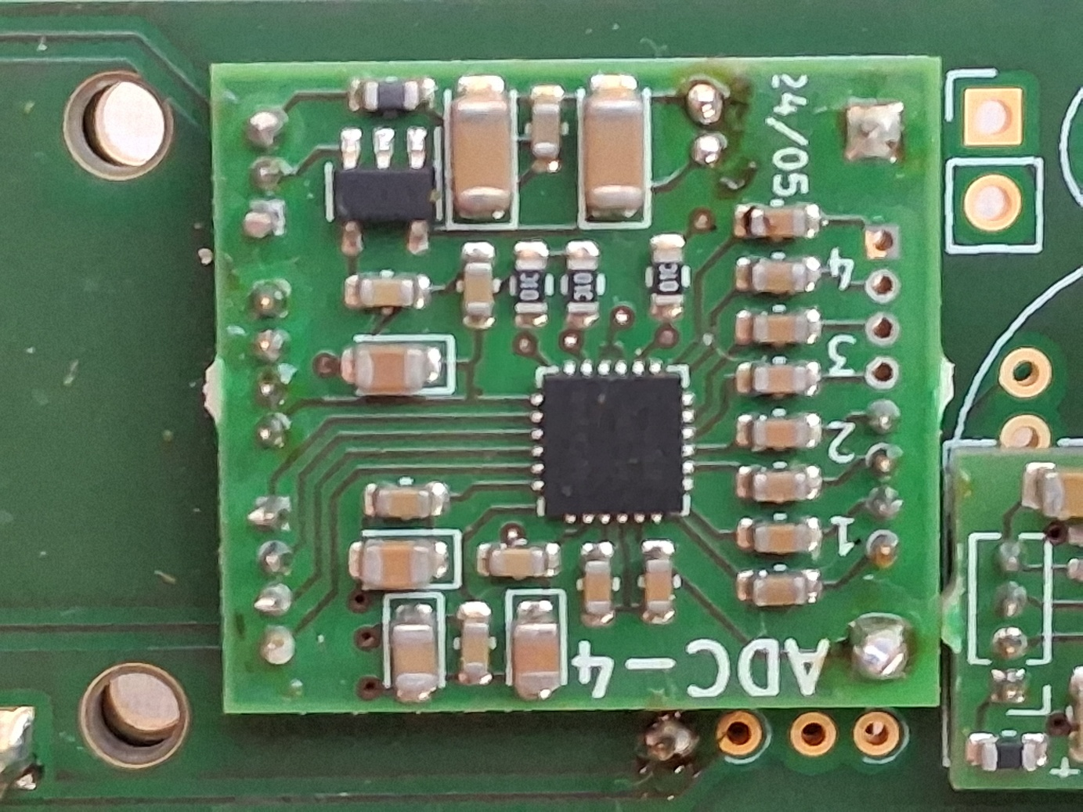

Solder pin header to Adalogger using short headers (short pin and receptacles)
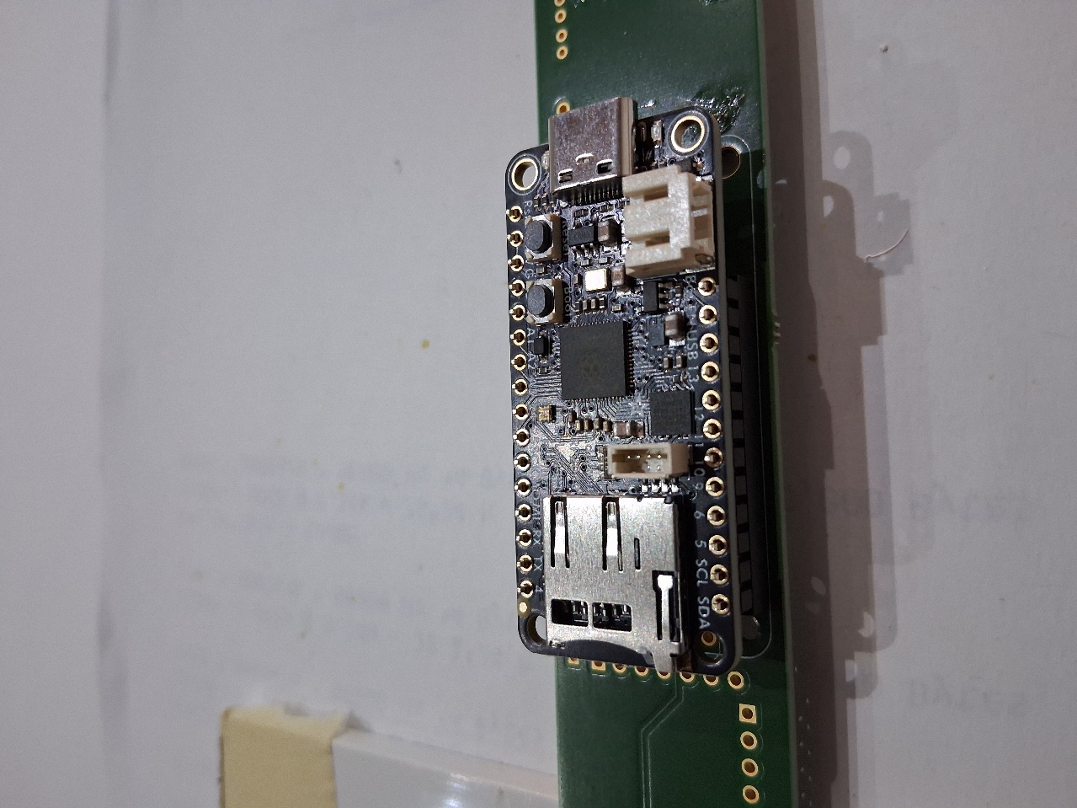
Solder female header from other side to board (having Adalogger still attached)
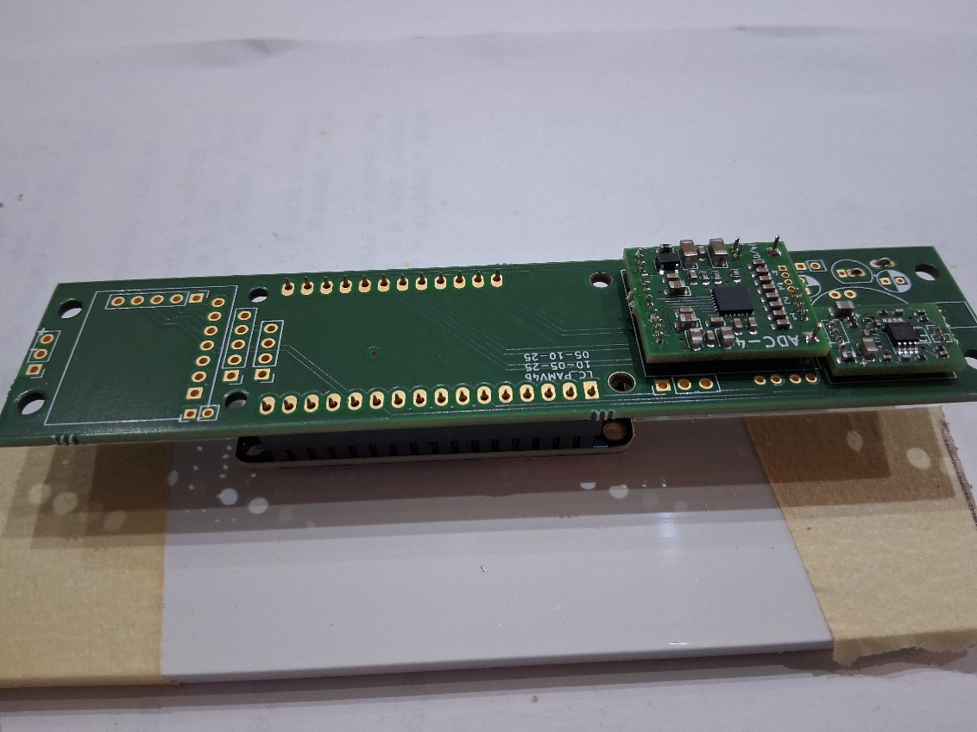
Remove Adalogger (for stability) and solder RTC to pin header. Mabe using the provided receptacle to keep board at 90° . Flip base board and solder pins to board.
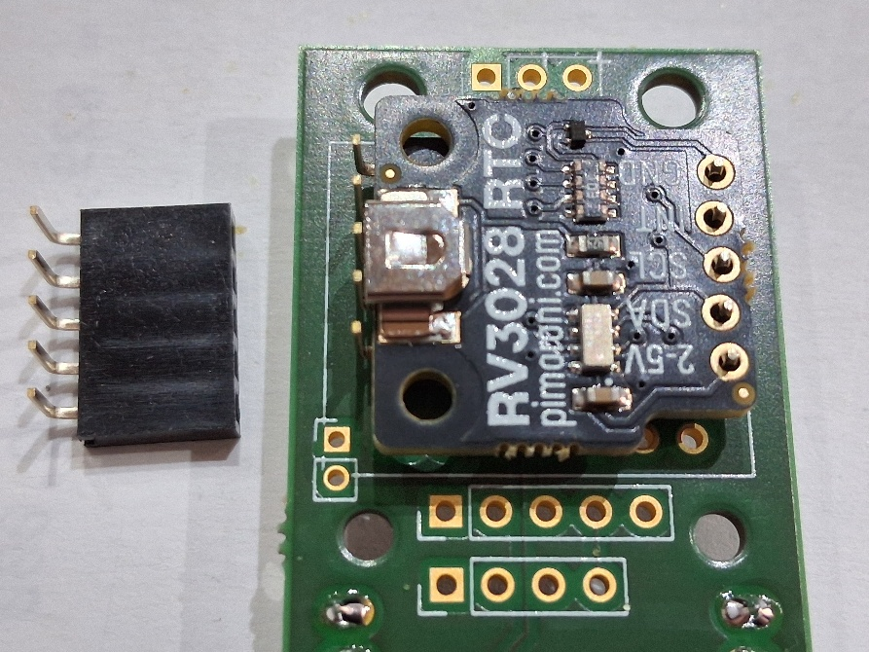

If needed: solder DC/DC converter with similar procedure as RTC clock.
If needed: solder ELCOs

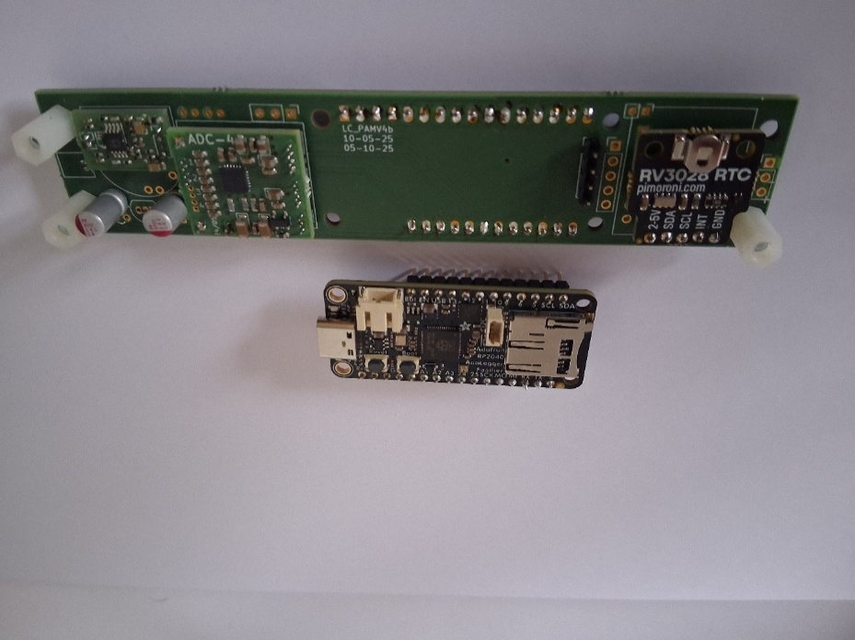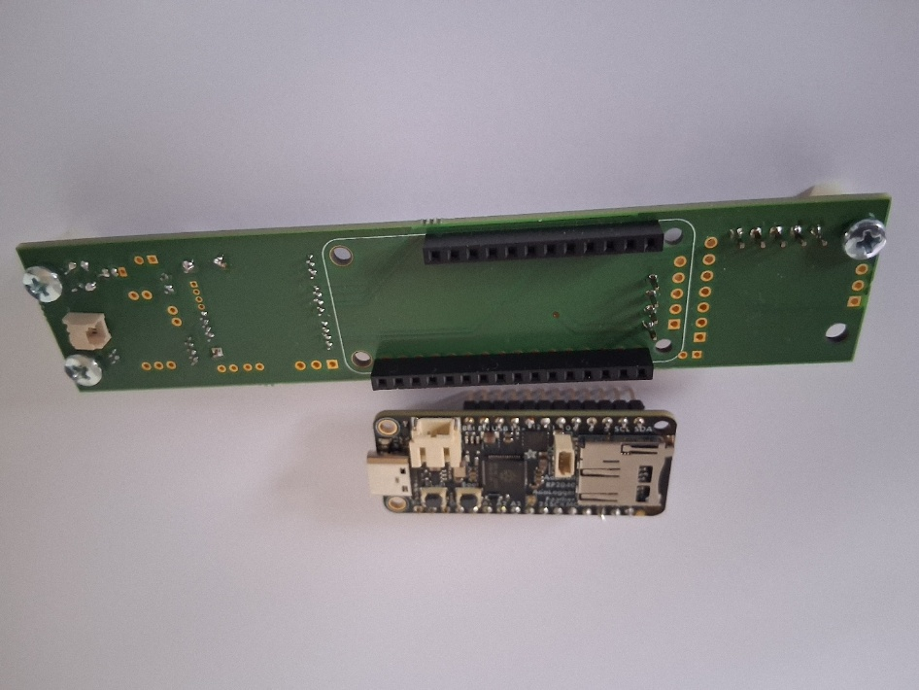
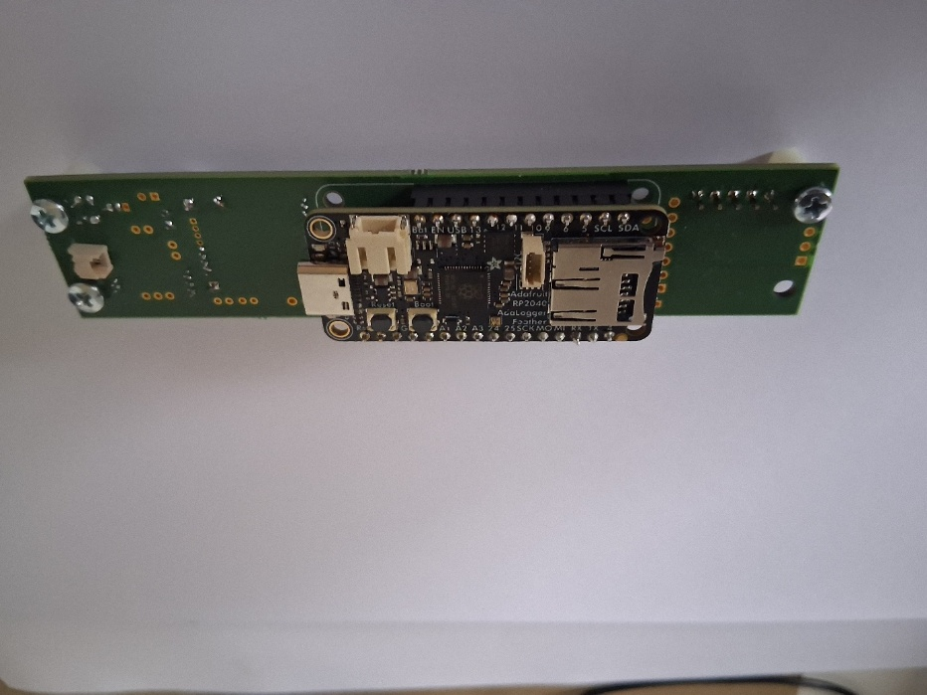

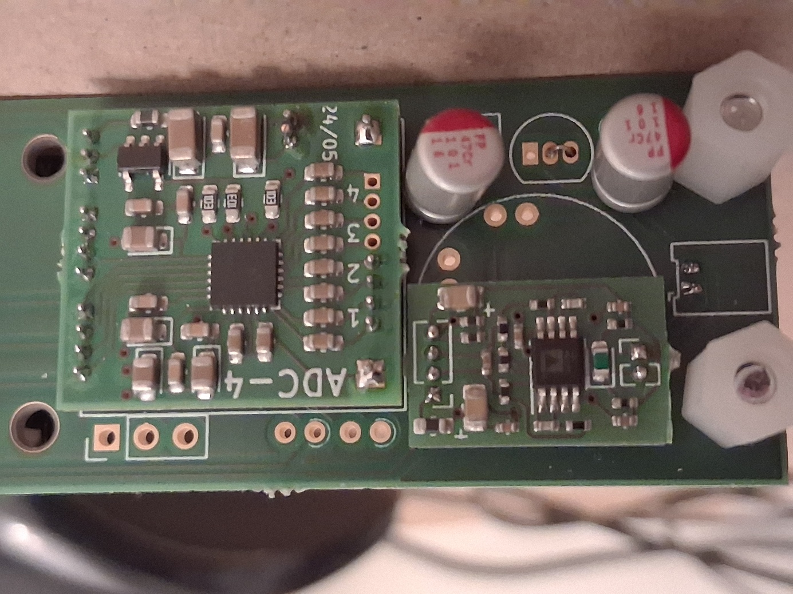

Pressure Container

Endcaps
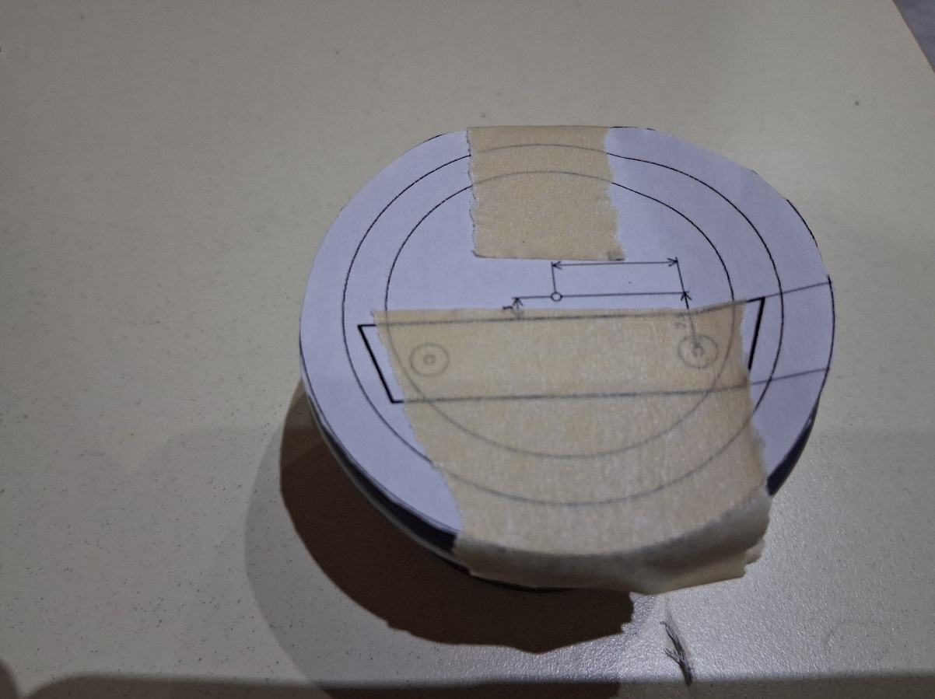
Take 63 mm OD flat endcap, drill 3 mm hole in center
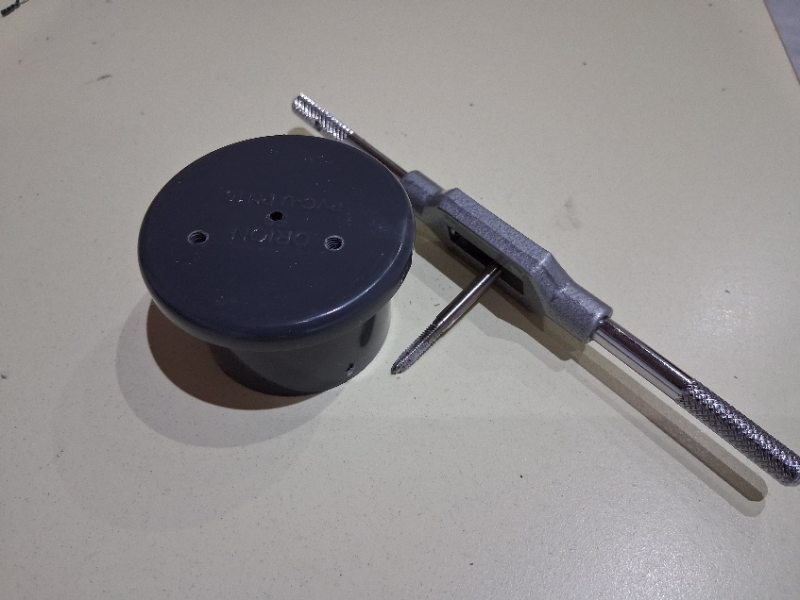

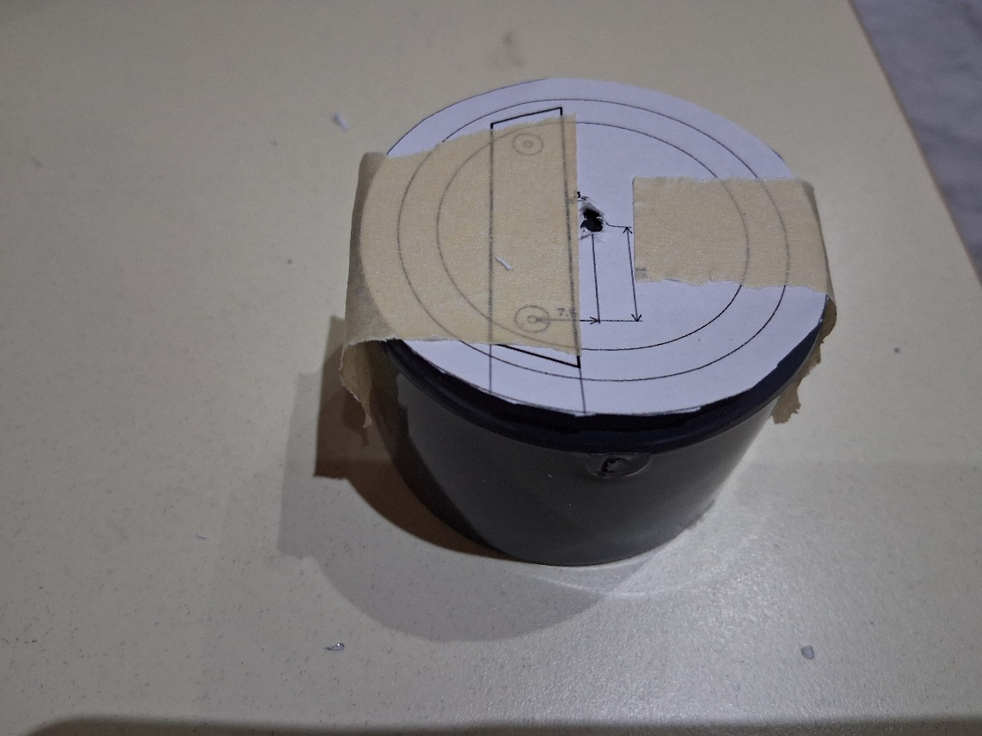
Take endcap with 63 mm top and 500 mm tube, drill 3mm holes also at center

Mounting bar
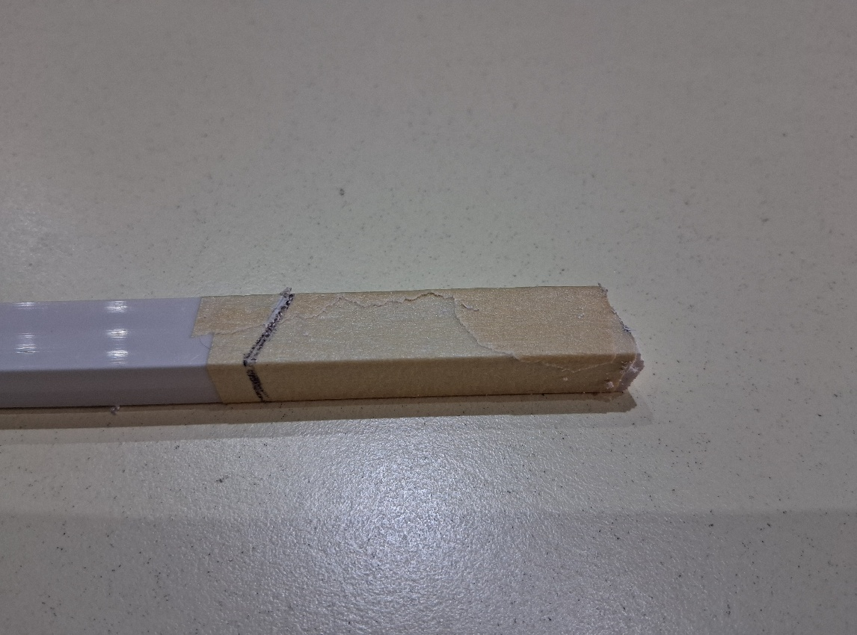
Cut piece from 10 x 10 mm bar
D
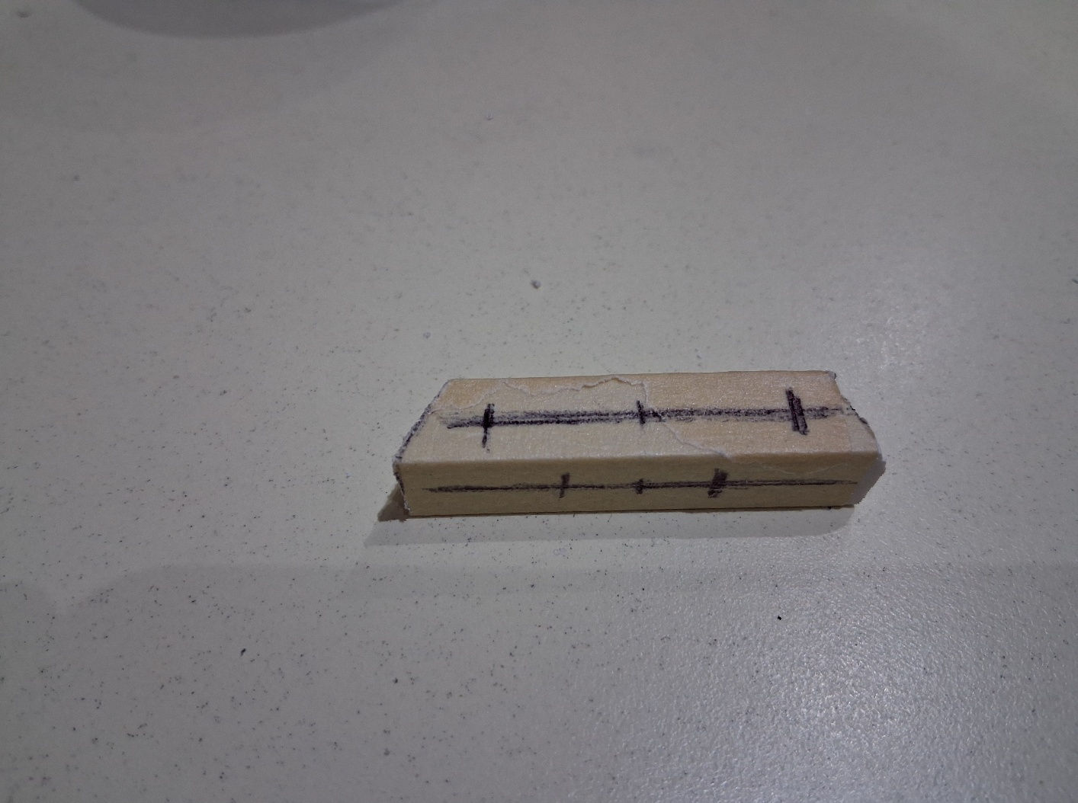
Mark holes to drill (wider correspond to spacings of drawing used for center holes.

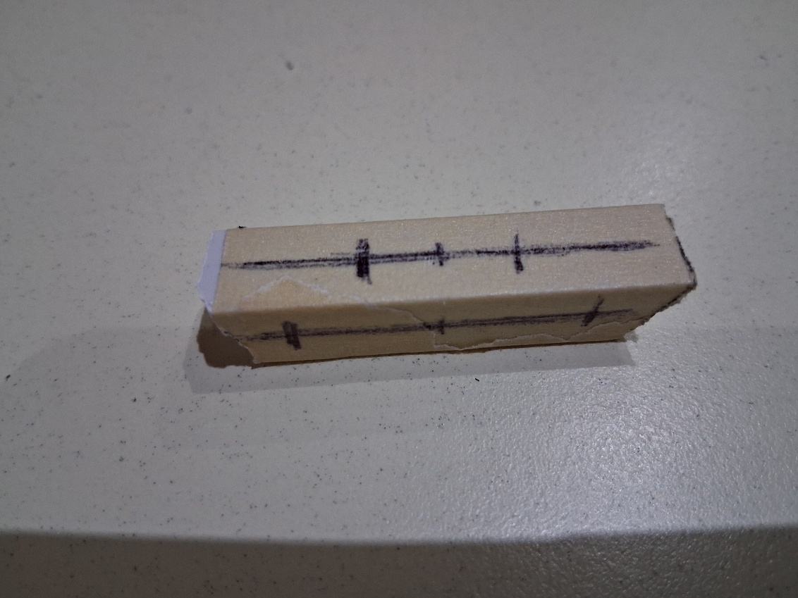
The naroower holes are seperated by half the seperation of the wider holes

Combine mounting bar with Endcap combi
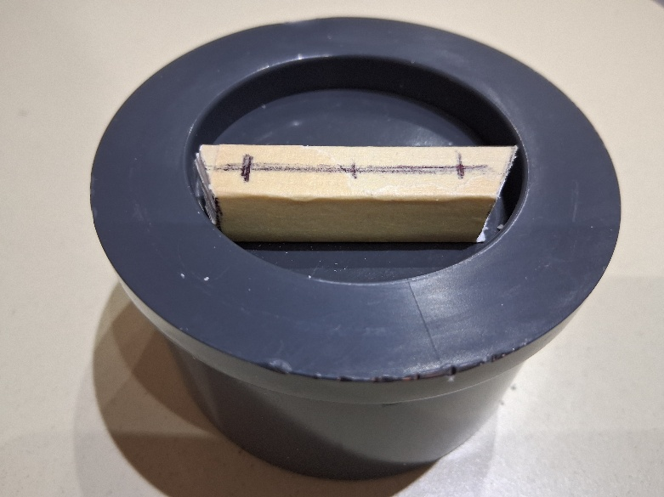
Insert into endcap combi

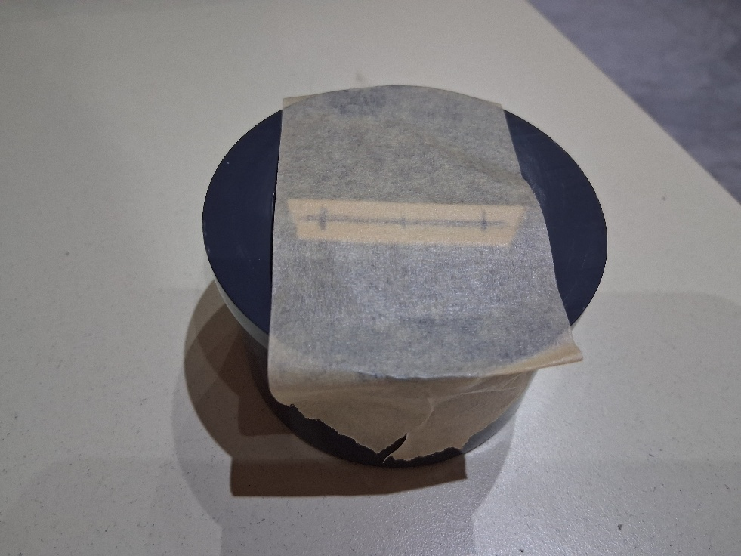
Fix with tape

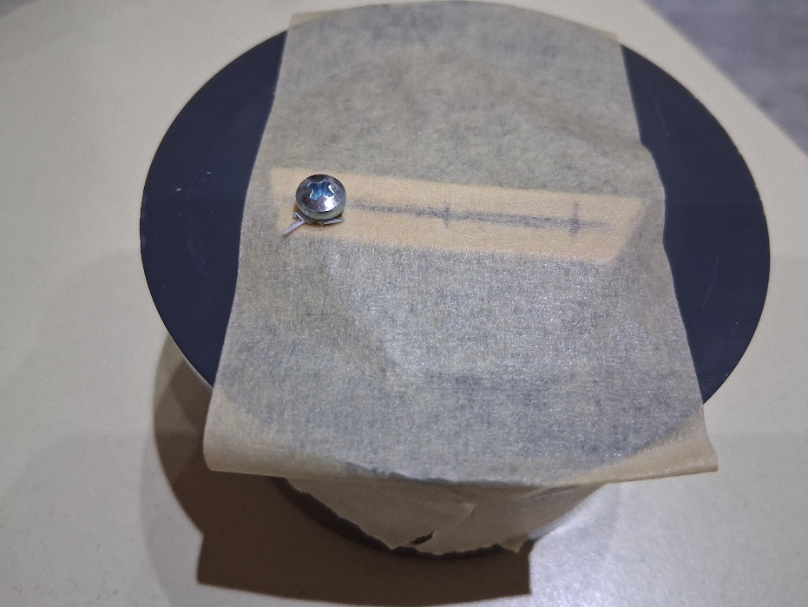
Drill one 3 mm hole and fix with screw before drilling the other hole

Widen holes in bar to 4 / 4.5 mm

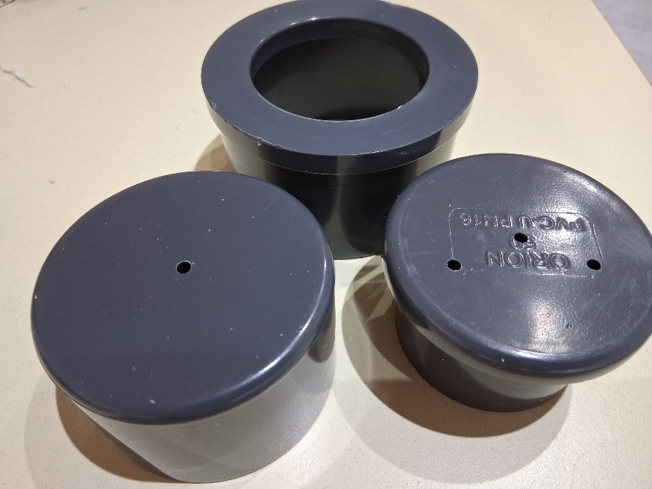
Resulting endcups and holes

Adjust encap combi for hadrophone and mounting bar
Widen the hole in the 63 mm OD endcap to 9 mm using tool to perfectly vertical
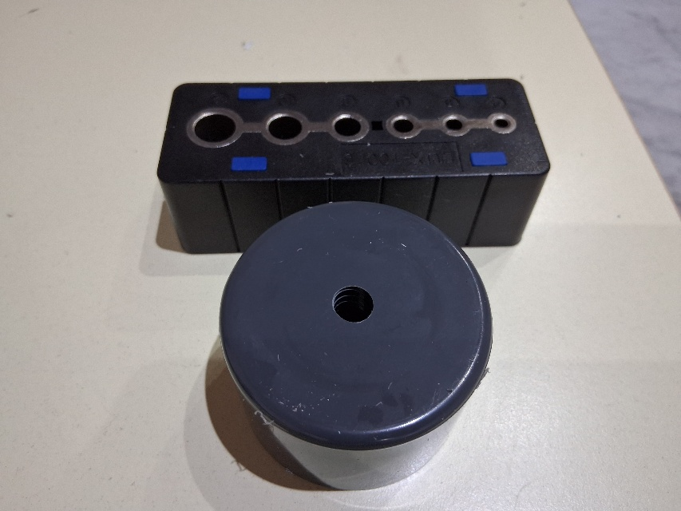

Cut 10 mm thread into hole of 63 mm endcap
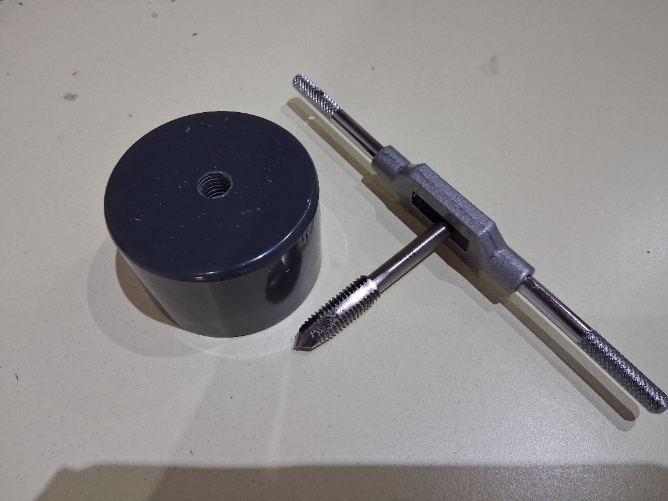

Cut 4-mm thread in tho off-center holes in 50 mm OD Endcap
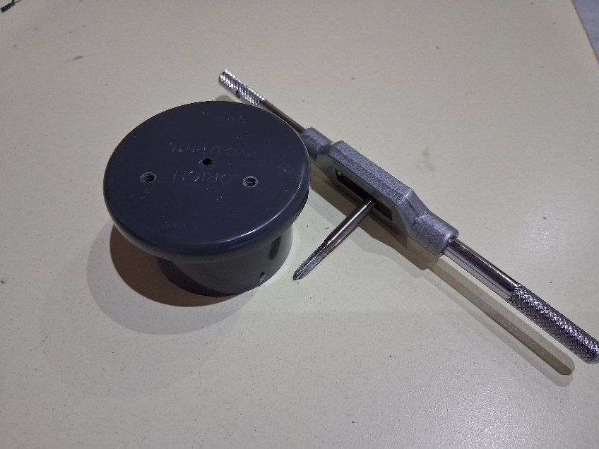

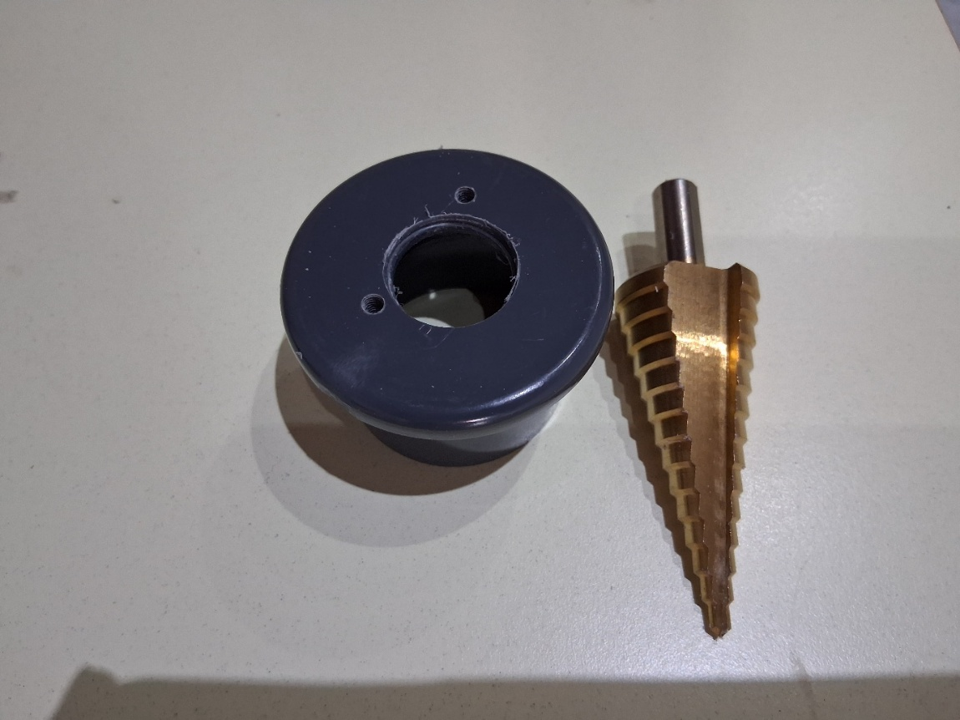
Widen center hole in 50 mm OD endcap to about 24 mm diameter

Combine electronics to flat pvc and alu bar
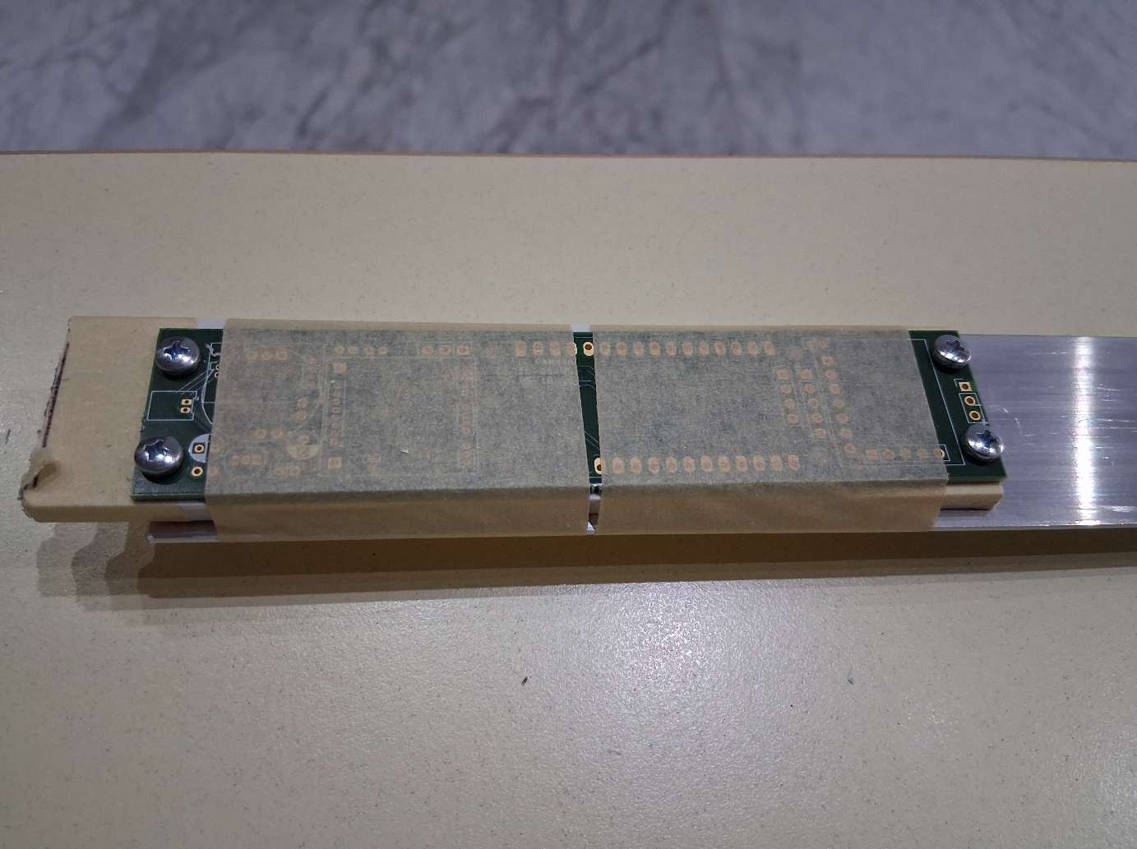
Tape board or stencil om pvc bar and alu bar
Drill 4 holes through pvc and alu plate

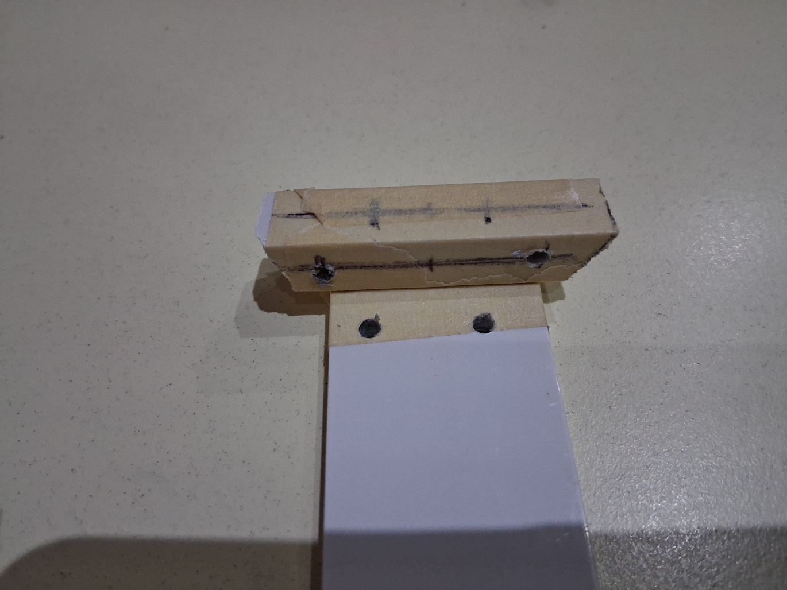
place 10x10 mm bar on flat PVC bar, smaller side touching plate

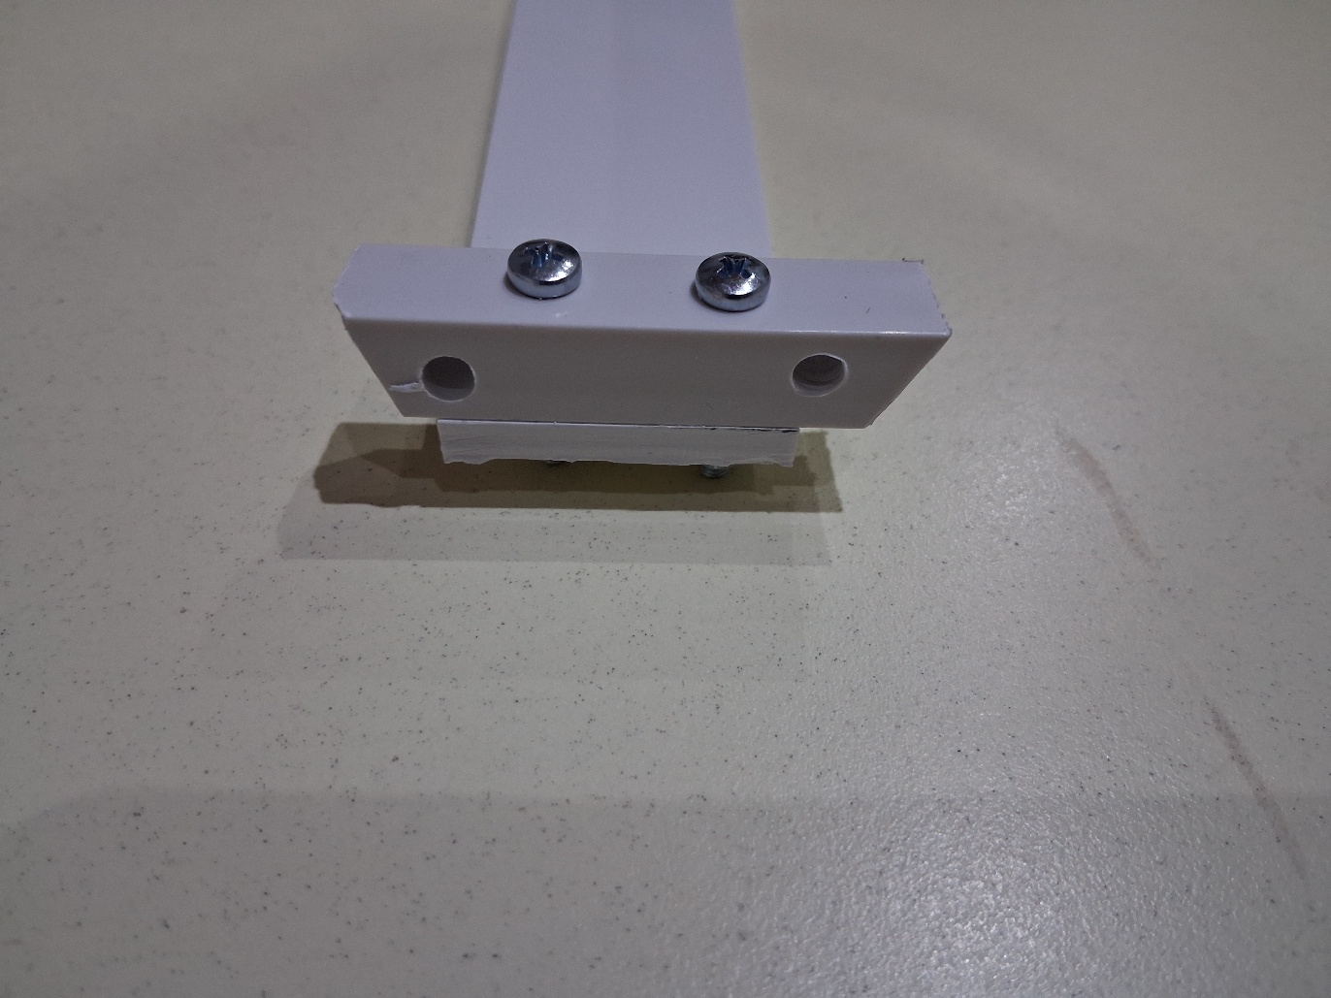
drill two 3 mm holes through bar and plate, fix again with 3mm bolt after first hole

Fix pvc plate to alu plate with 12 mm srews and three 10 mm nylon standoff an one nut
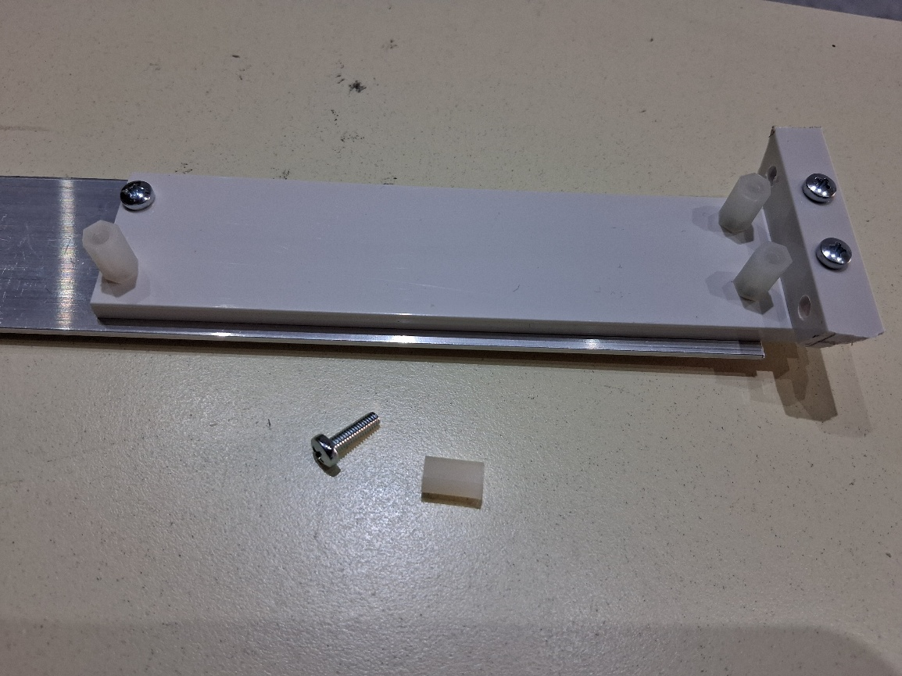

Assemble recorder
Press mounting cap (counter end-cap) into hydrophone end-cap
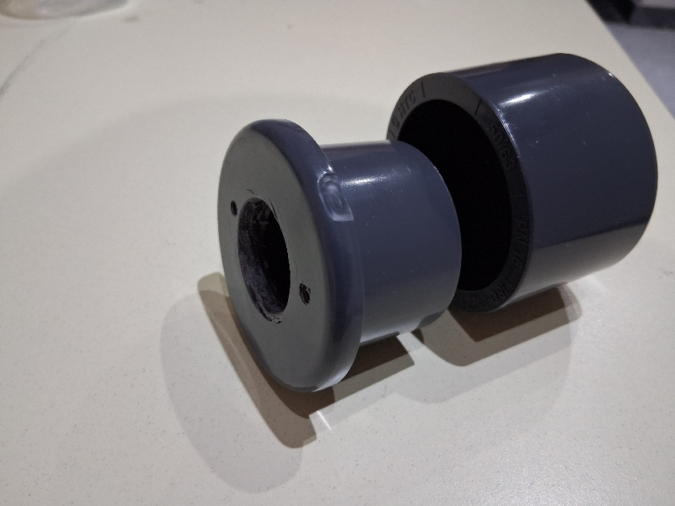
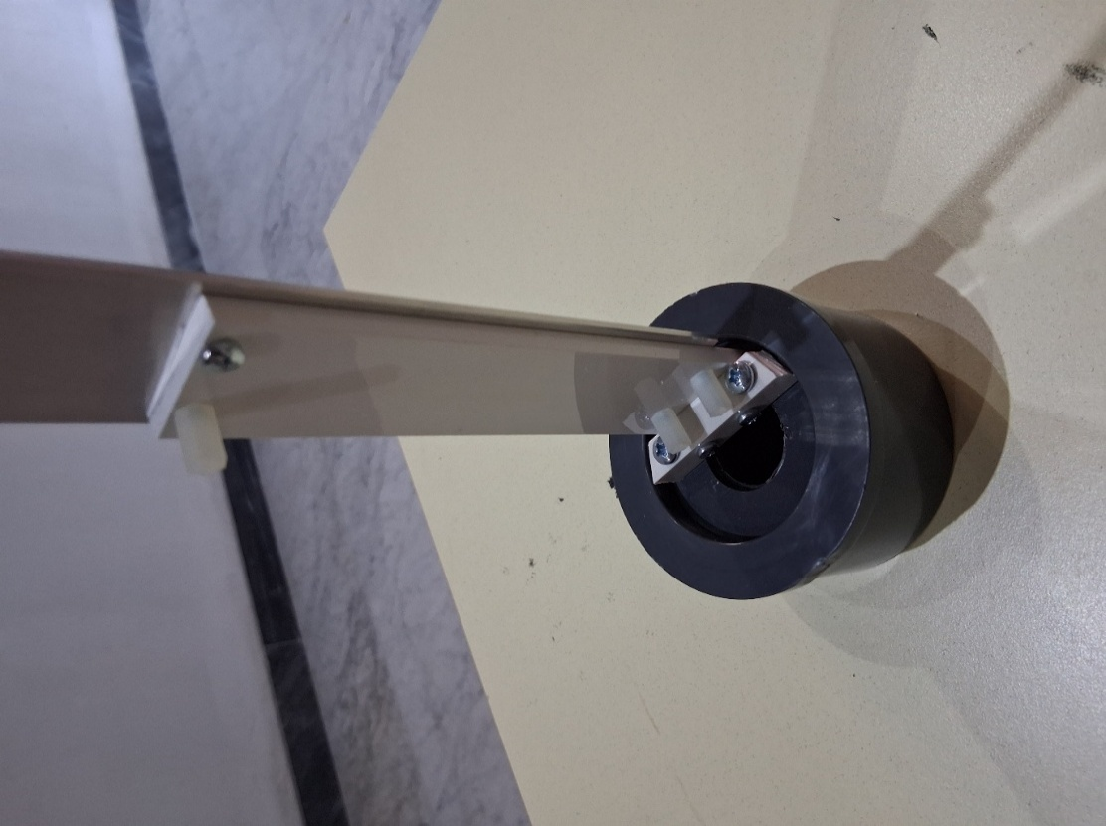
Assemble mounting plate to endcap combi

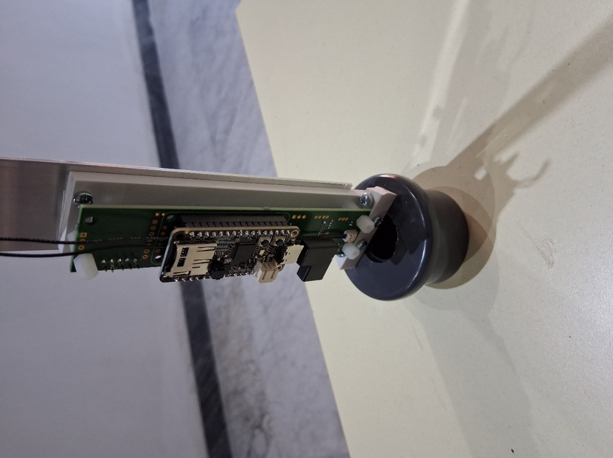
Adding recorder

Place battery packs long side alu plate, place 4 double sided tapes on alu plate and fix battery packs, keeping 1 mm distance from pvc plate. Hydrophone holders may extend over 50 cm alu bar.
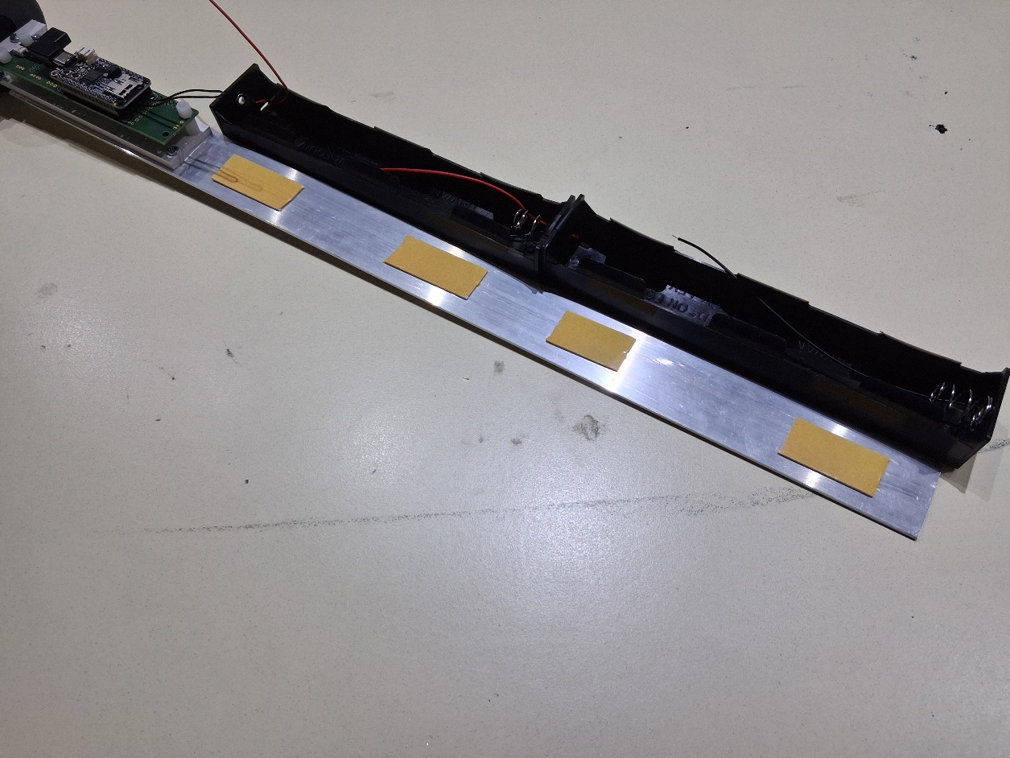

Alternative mounting methods
Au U with 10 mm hex nut attached directly to hydrophone penetrator (here with Teensy 4.1) See below.
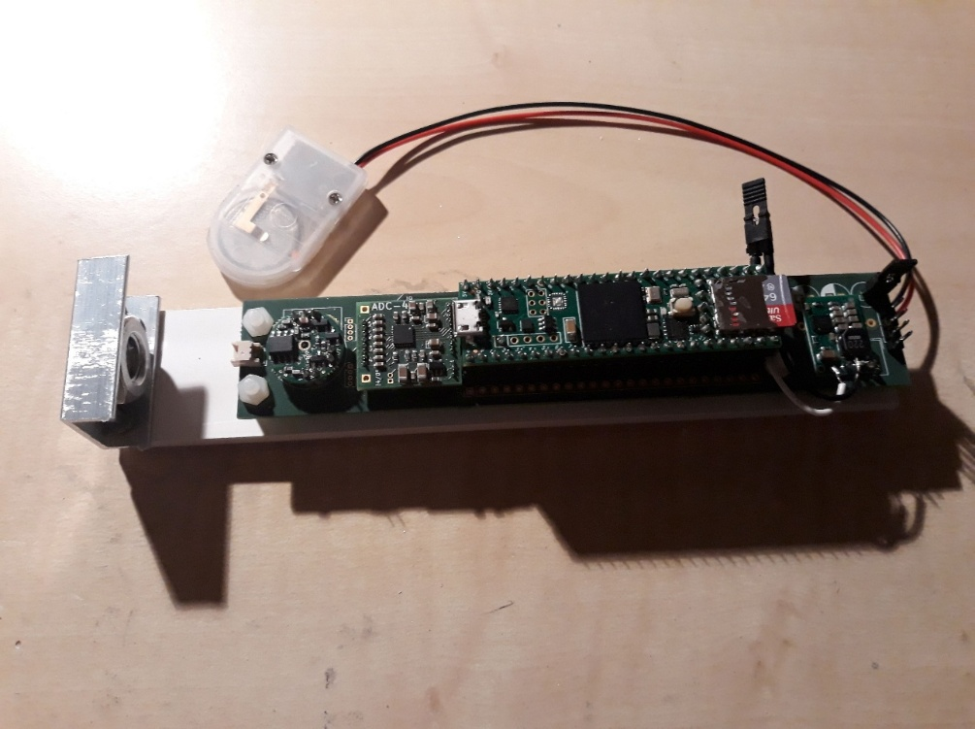
PVC bar screwed onto counter end-cap

3D printed insert replacing counter end-cap
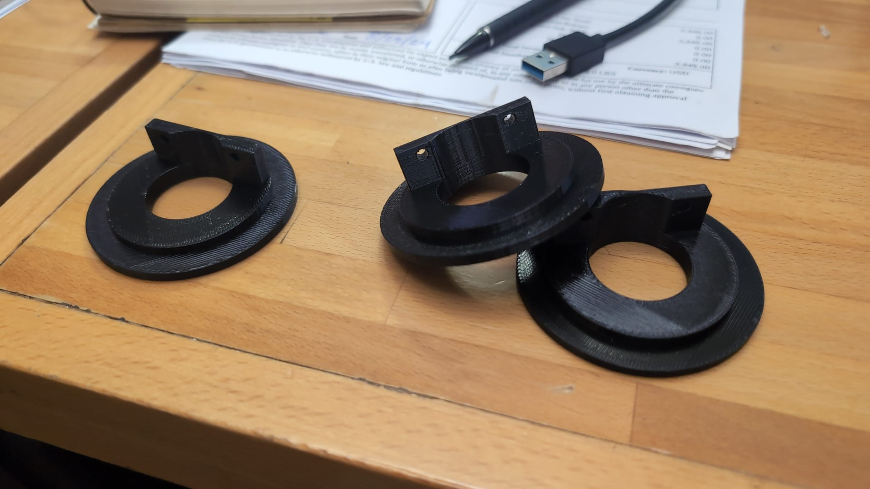

Construction of Alu bracket
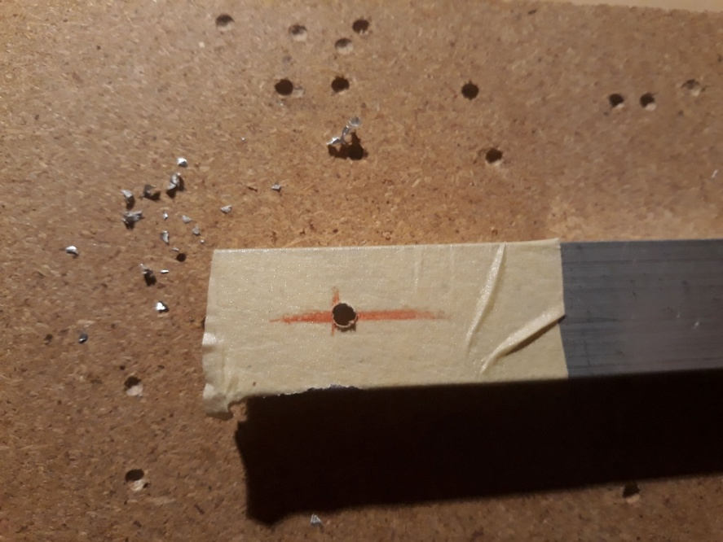
Take an Alu U profile (20 x 10 mm)
mark a point in the middle and about 16-17 mm from the end.
Drill a 3 mm hole as precisely as possible at this point
Drill next a 10 mm hole using for example a drill head as shown in picture
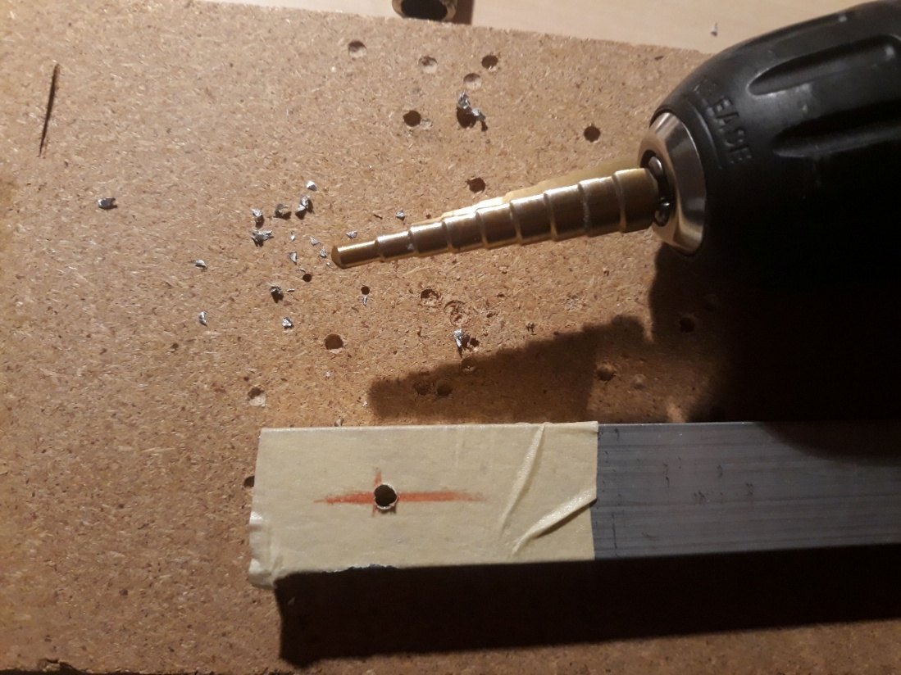
Cut the Alu U profile such that the 10 mm hole is in the middle.
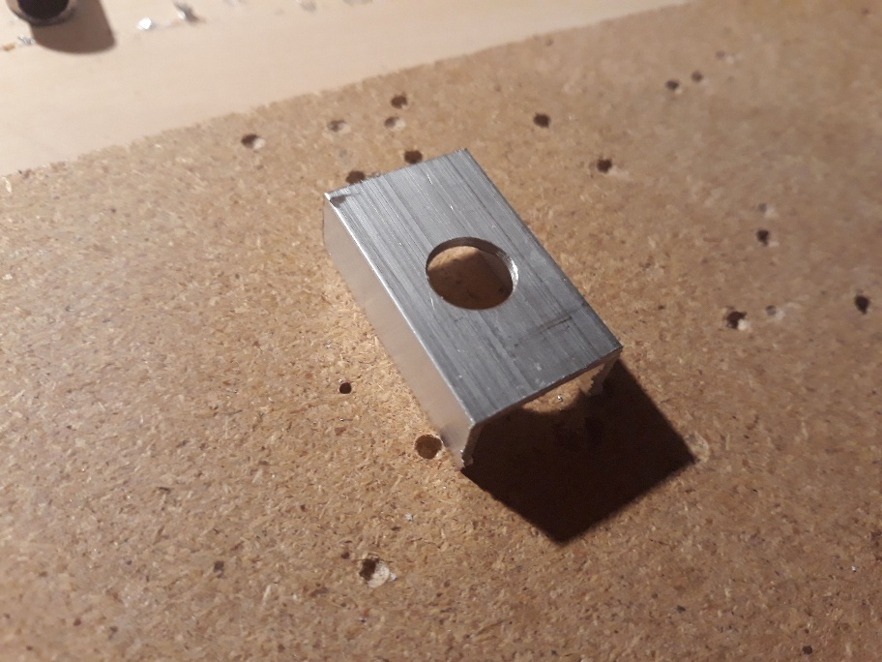

Fix the Alu U profile on top of the plastic bar (were the electronics will be placed)
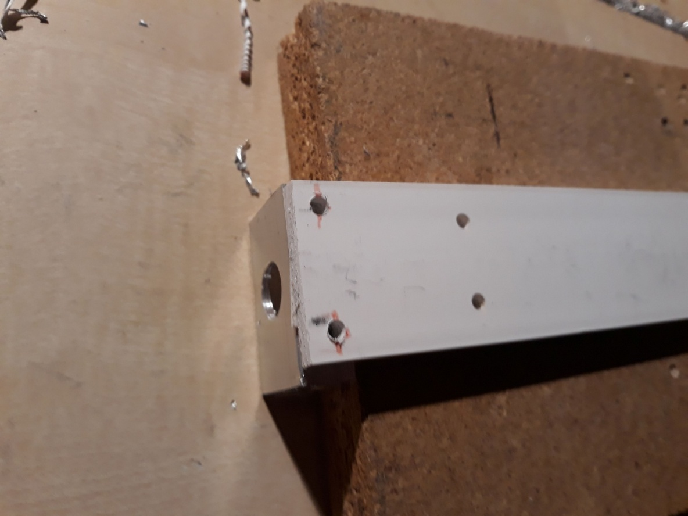

Drill from below two 3 mm holes that are about 5 to 6 mm from the end and 4 mm from the side-
Fix the Alu profile to the plastic bar with M3 bolts.

Gluing PV
Take endcaps and unions

Final Recorder
Glue endcaps and unions together onto tube

