LC-MARE
Walter MX Zimmer
27-07-2024

Objective
Aim of the low-cost marine autonomous acoustic recorder (LC-MARE) is to provide a cost-effective solution to access and record underwater sound. The implementation should be low-cost but without limitations on sound quality.

Use cases
The envisioned use cases are defining the required characteristics of the LC-MARE autonomous recorder, and it is envisioned that LC-MARE,
- generates marine acoustic data that support
  - entry-level scientific research (e.g. for undergraduate and graduate students)
  - environmental monitoring of coastal marine areas (being protected or not)
  - marine bioacoustics in STEM education
- is used up to a water depth of
  - 100 m, if connected to surface buoy
  - 40 m, if placed on bottom by recreational scuba diver
- Is recording acoustic data with or without duty cycling
- may be calibrated to allow comparisons and exchanges of data

Concept
The implementation should be low-cost but without constraints on quality.
There are different levels of complexity and cost factors.
- Commercially available components:
- Piezo ceramic tubes
- Programmable recording system (MCU, microSD card, RTC)
- Pressure housing components
These components are typically produced in quantities and no major cost saving is anticipated.
- Specific made components:
- Analog amplifier
- Analog-digital conversion
- Base board (to avoid cabling)
These components are specific made for LC-MARE and the ‘set-up’ costs are usually higher than the component costs. Therefore, only the production of multiple units (say 100+units) reduces the price-tag per unit to nearly the component costs.
- Custom made components:
- Hydrophone construction
- Pressure vessel construction
- Mounting frame
Depending on the use cases and individual skills these components may be build by the interested users, whereby the hydrophone construction is the most demanding task and may be appropriate only for experienced users. It is expected that, while DIY is possible, for most users the hydrophones are constructed by specialized businesses.
The construction of pressure vessels depends again on the use-cases and assuming shallow water applications (recorder depth <100 m) user build pressure vessels are feasible using pressure-rated PVC tubes and fittings.

Implementation

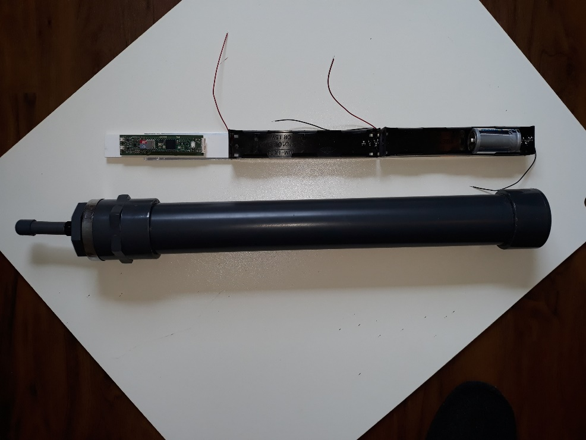
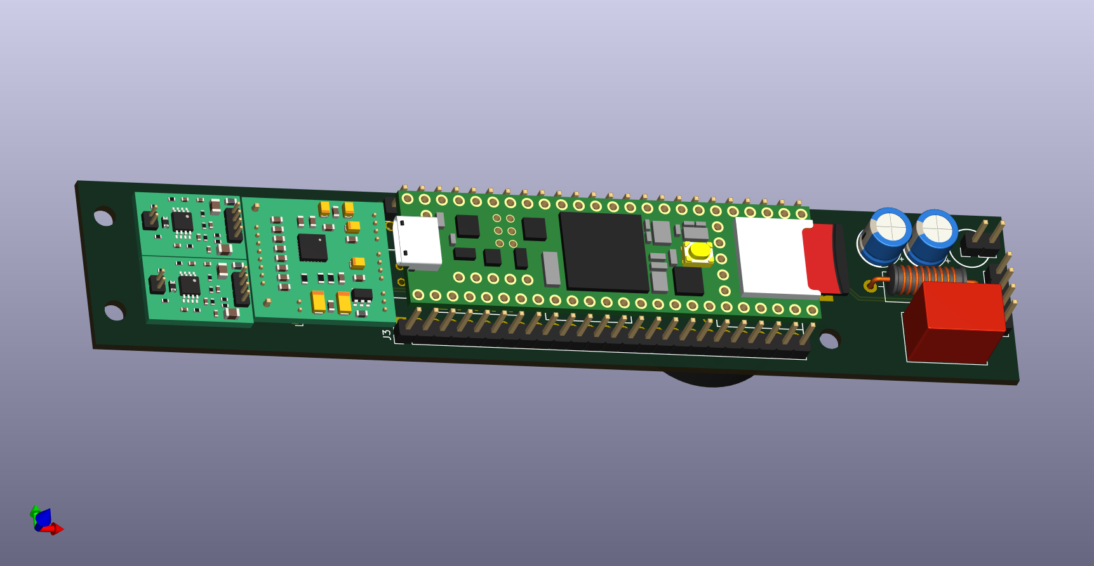
Hardware
Figure 1_ Components of LC-MARE prototype
Power+Container
135 Wh Battery
200 h Endurance
16 bar max pressure
Pre-amp
Gain 21
AD8656
ADC
4-chan
TLV320ADC6140
Recorder
MCU: Teensy 4.1
uSD storage
USB PC-I/O
Electronics
Dual pre-amp
ADC
Recorder
DC/DC converter
DC/DC
5V
Line filter
The components of a first LC-MARE prototype are shown in Figure 1. The electronics is composed of multiple components to facilitate easy replacement of components, if deemed necessary.
Length and diameter of the pressure tube are determined by the size of the battery holders and resulted to 500 x 63 mm for a 6 D-Cell battery pack. Using additional fittings and tubes, the power supply can easily be extended by adding additional four battery containers.
The pressure tube and fittings are 16 Bar rated PVC tubes, commercially made for water pipe constructions, e.g. for swimming pools.

Software
The software is using standard C/C++ code and by being compatible with the Arduino infrastructure it is easily maintained, modified and downloaded to the microcontroller of the LC-MARE. The few parameters that are expected to be modified at sea are provided by a file on the microSD card that can be prepared prior to the at-sea activity.

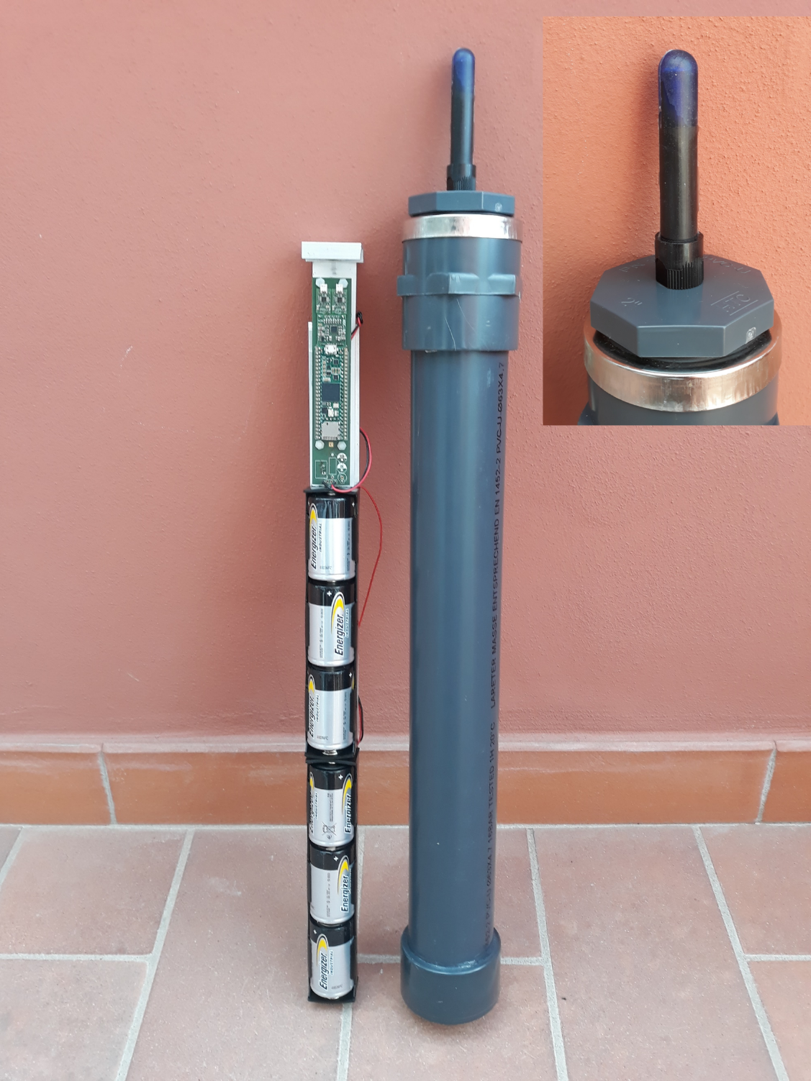
Figure 2: LC-Mare August 2024 version

Implementation details
The LC-MARE implementation will be open source and hard and software implementation will be published at GitHub - WMXZ-EU/LC-MARE: low-cost marine acoustic recorder

Hydrophone
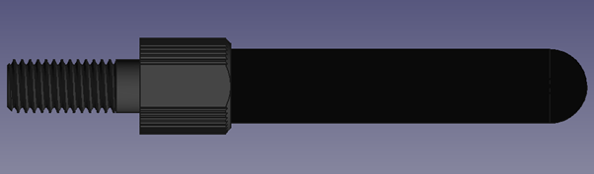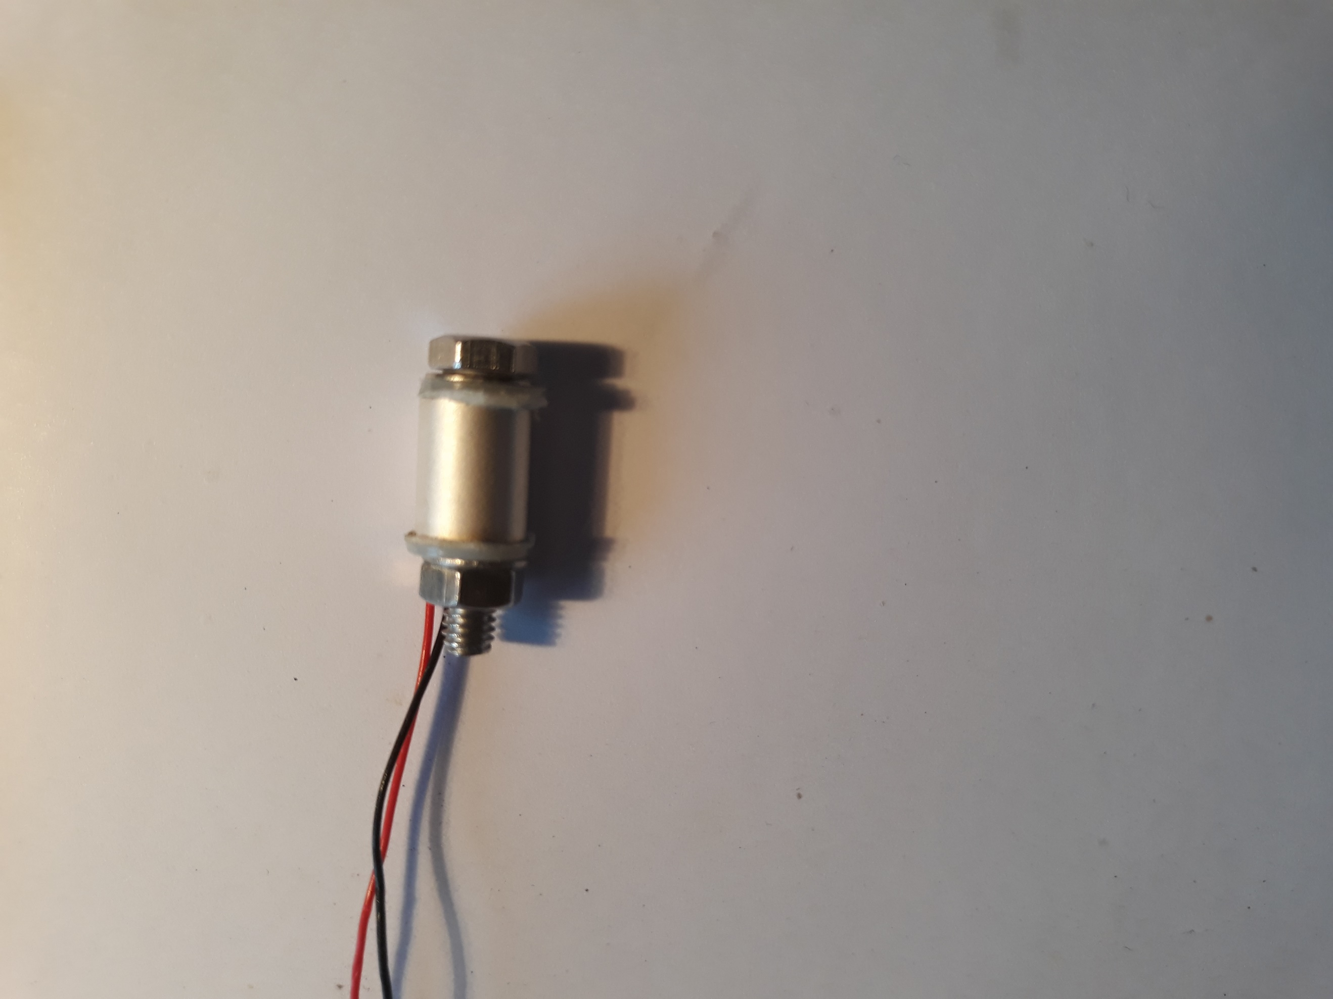
Hydrophone consists of three components: Cylindrical piezo-ceramic tube, BlueRobotics penetrator, and polyurethane rubber. The hydrophone is at some distance from the penetrator to reduce acoustic interference of the pressure container. The use of BlueRobotics penetrators facilitates the changes of hydrophones and pressure containers.

Pressure Container
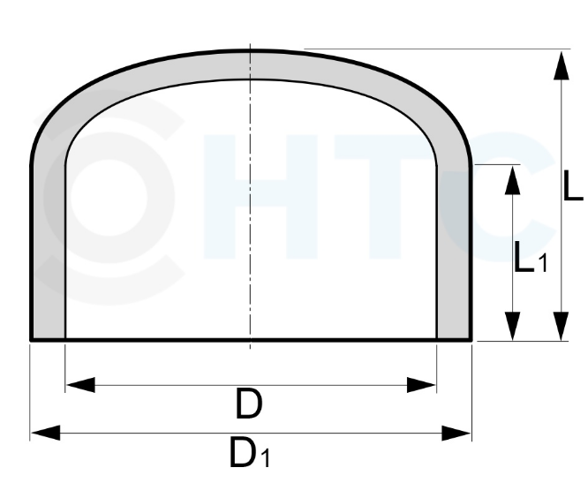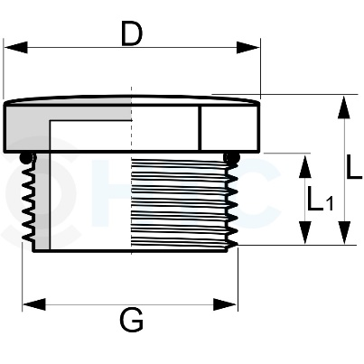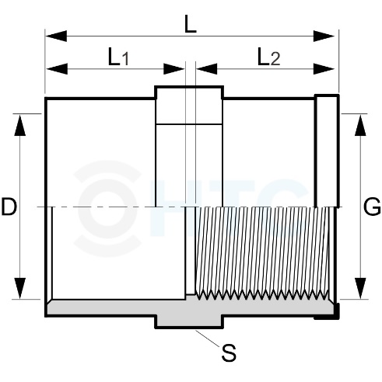
1.25 €
500 mm: 3.00 €
2.67 €
2.20 €
PVC-U: PN16 tube, diameter 63 mm: Euro
LC-MARE pressure container
The pressure container consists of 4 components a 500 mm long tube, an endcap, an adapter with internal thread and a plug with external thread and O-ring. To connect the hydrophone a 10 mm hole will be drilled in the plug. The PVC-U components are rated with PN16 and should withstand 16 Bar internal pressure. It is expected that they also withstand 16 Bar external pressure, which corresponds to a water depth 150 m. The PVC-U tubes and fittings are purchased from an online store (pcv-welt.de) but may be found in hardware stores.

Mounting system
The electronic and battery packs are mounted onto an aluminium plate (35x50x2) by means of double-sided adhesive tapes. To separate electronics from conducting aluminium an additional PVC plate is added. The mounting plate is attached to hydrophone penetrator using an aluminium U frame. All components are from the local hardware store.

Electronics
For the electronics we have following components

Pre-amplifier
The pre-amplifier is a differential-to-differential voltage amplifier, the Spice simulation is shown next:
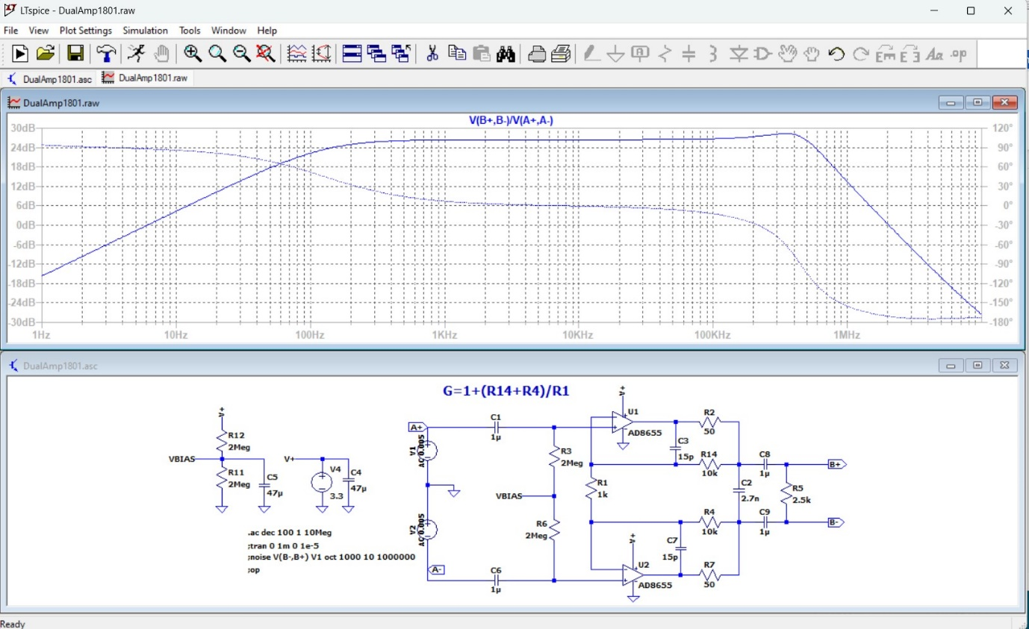
Gain is controlled effectively by the resistor R1. There is still some gain increase at 400 kHz, that can be removed by increasing the feedback capacitors C3, C7 somewhat. The selected OP-AMPS are of CMOS type with 2.7 nV/sqrt(Hz) noise voltage each.
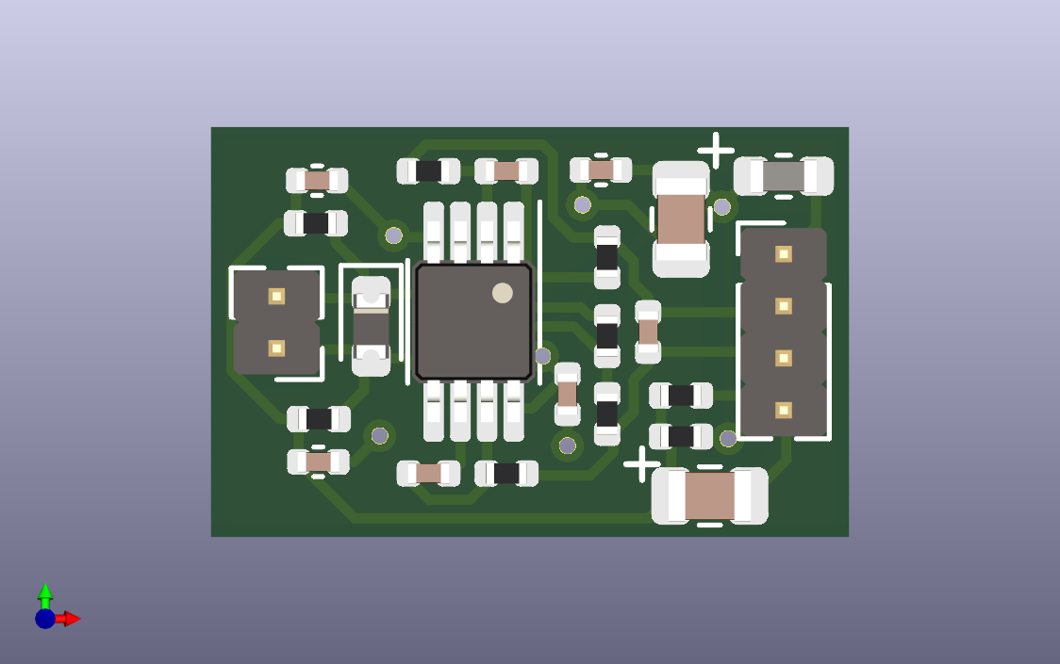
A more lower noise pre-amplifier with FET and ultra-low noise bipolar amplifier would be a possible alternative and is in development.

Analog Digital Conversion
The ADC is based on the Texas Instruments TLV320ADC6140 chip and implements the circuitry of the datasheet.
The ADC features 4 differential input channels each of which can be amplified up to 40 dB. A dedicated LDO regulator provides 3.3V for the analog circuitry.
Sampling frequencies can be up to 768 kHz for a single channel, 384 kHz for two channels and 192 kHz for all four channels. Bit depth is 24 bit.
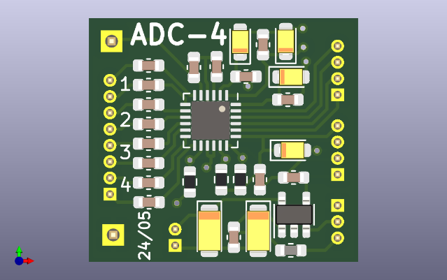

Putting it all together
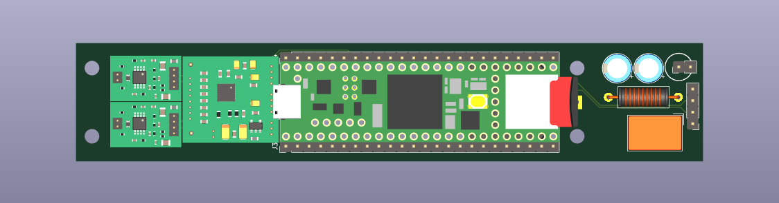
The final electronics board features 1 or 2 pre-amps, a 4-channel ADC, a Teensy 4.1 MCU, a TRACO DC-DC convertor with power-supply filtering and a magnetic proximity switch. An external Coin cell provides a backup battery for the MCU-based Real-Time-Clock.

Software
Fully programmed with C/C++ code but can be compiled and downloaded within the Arduino ecosystem or using Makefiles.
All software is available on GitHub.
Data storage is using ExFat filesystem and after moving the disk, the data can be accessed directly by the PC. This allows also to store/edit configuration files on the disk ahead of closing the pressure container.
TODO: finalize the exact protocol to start deployment (e.g. start recording at a specified day and hour)
Multi-level duty-cycling may be implemented as shown following
Level 1: for deployment
d_on: number of days on (in days)
d_rep: number of days for start of recording block (d_rep >= d_on, otherwise every day)
Level 2: for each day of acquisition:
h_1: on-hours first period
h_2: off hour first period
h_3: on hour second period
h_4: off hour second period
Level 3: for each acquisition period
t_on: recording on in s
t_rep: recording period in s (0 is continuous. 600 means every 10 min)
In case an external connector is implemented that provides USB access to the MCU, data can be retrieved via MTP protocol and parameters may be retrieved and stored via USB serial protocol. To minimize the cost, the LC-MARE does not feature an additional connector.

GUI
The following Python based GUI shows some of the parameters that may be retrieved and stored and may be the basis for a Custom GUI.
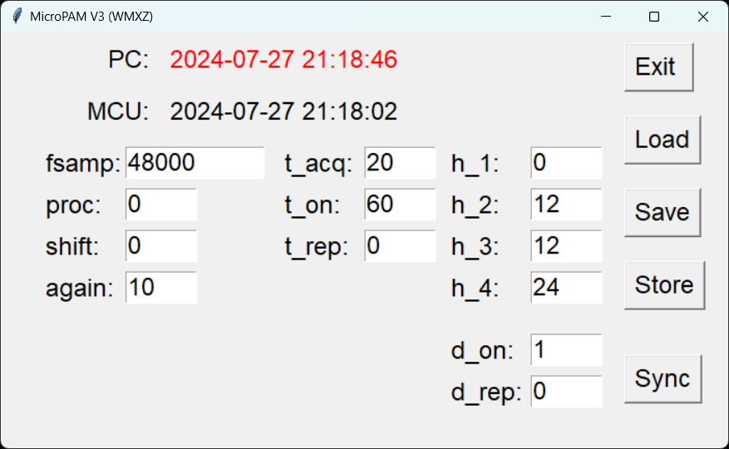
This GUI shows some parameters that are used for controlling the functionality of LC-MARE
The Form will be populated with the ‘Load’ button. The ‘Sync’ button will synchronize the RTC with the PC time. Parameters will be downloaded to MCU using the ‘Save’ button. The ‘Store’ button saves the parameters to MCU and stores them on microSD disk and EEPROM. This is of importance for duty-cycling, where MCU will be switched off.
Parameters shown in GUI:
- fsamp: sampling frequency in Hz
- proc: online processing: 0 wav file; 1: integer loss-less compression
- shift: in case of compression indicates the number of lower bits that are to be ignored
- again: analog gain in dB in ADC

- t_acq: length of files in s
- t_on: length of acquisition block in s
- t_rep: time in s between starts of acquisition blocks in s (0 means continuously)

- h_1: start hour of first acquisition period
- h_2: end of first acquisition period
- h_3: start of second acquisition period
- h_4: end of second acquisition period

- d_on: length of recording block in days
- d_rep: time in days between starts of recording blocks in s (0 means every day)
In above GUI image, the acquisition timing parameters are set for continuous recording

