- Paused right before the API fetch, making sure the user input was successfully captured and sanitized by into the query variable.
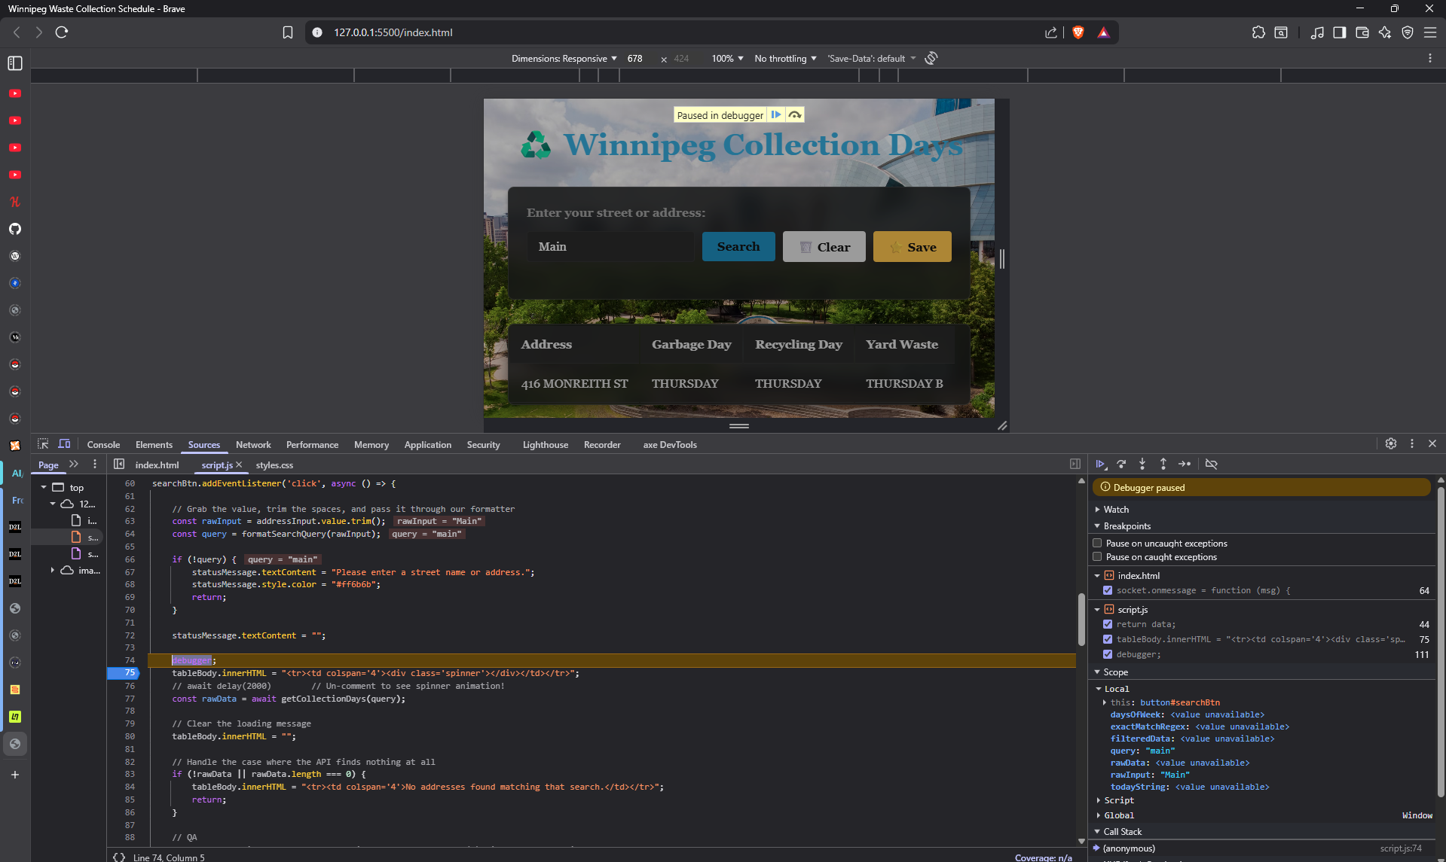

- Paused after the network request resolves, showing the successful HTTP Response object returned by the Sorcrata servers.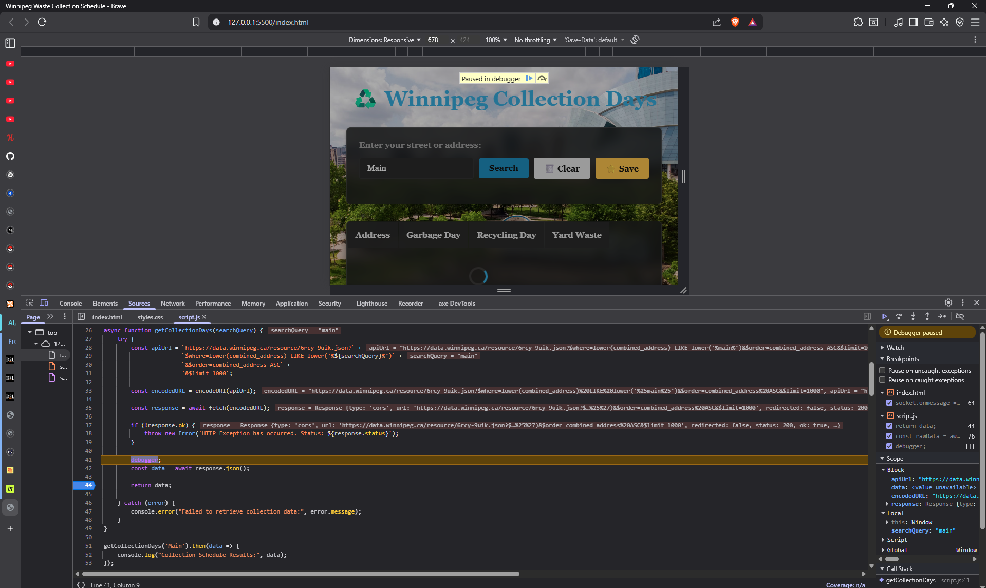

- Used the Console drawer to show JSON payload was successfully downloaded and parsed into a local JavaScript array of objects.
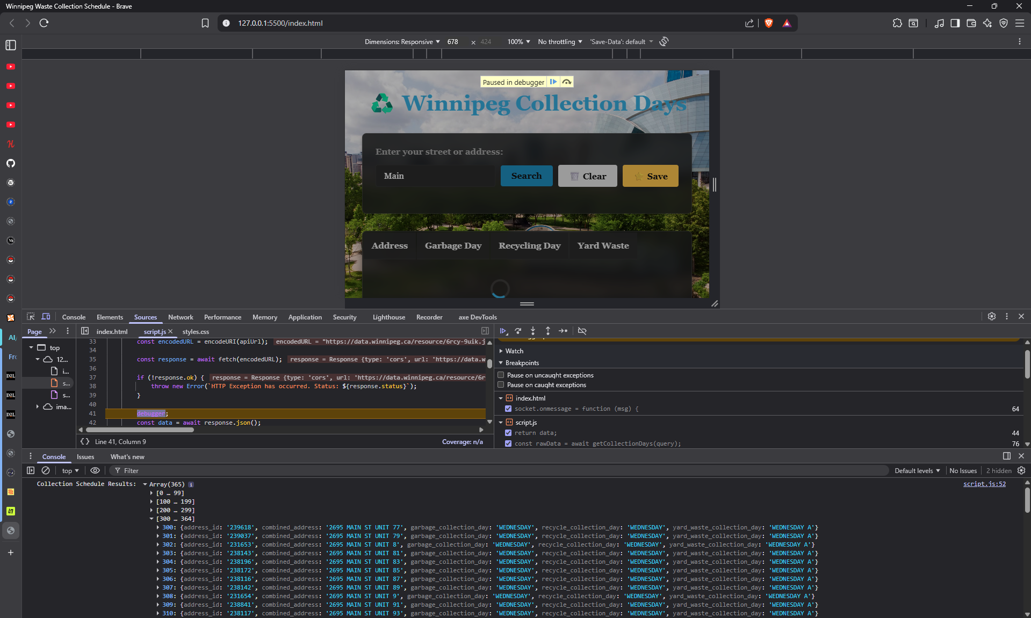

- Paused inside the rendering loop, demonstrating an individual item data object being evaluated right before dynamically generating the HTML row.
